Individual Business Model Canvas with Entrepreneurial Reflection Using an Appropriate Academic Model
BY
Student Name: Rifat Jahan
Student ID: 2211255
Module Name: Entrepreneurship
Module ID: BMIH5001
Tutor Name: Charlotte Joyner
Word Count:2185
Date: 05/02/202

Contents
Introduction 2
Discussion on Business “Green Haven Eco Retreat” 3
Conclusion 7
Reflection 7
References 9
Appendices 11

Introduction
The worldwide hospitality business is experiencing a boom; therefore, this is the ideal time to break into the market and establish yourself. The travel and tourism sector is expected by the World Travel & Tourism Council to account for 7.6% of global GDP, or $9.5 trillion, and to expand at a rate of 22% through 2028 (Bowen, and Morosan, 2019). Moreover, with almost 23% of the worldwide workforce employed by it, it is also the greatest employer in the world. Similar to this, there is a growing need for luxurious experiences, one-of-a-kind modifications, and maximum comfort, which makes this sector an excellent place to invest. In light of this, our eco-friendly hotel will work to give its visitors the utmost comfort and luxury in addition to providing services and entertainment. We will place a lot of emphasis on innovation and the application of cutting-edge technology in our quest to provide the best possible service to our visitors.
Moreover, my hospitality venture, known as Green Haven Eco Retreat, stands out by seamlessly integrating the best features of both the hotel and food and beverage industries, ensuring a unique and exceptional experience for visitors (Bowen and Morosan, 2018). The business aims to cater to a diverse clientele, including event planners, business travellers, and tourists. What sets it apart is not just the claim of being environmentally friendly but a detailed approach to how this is achieved. Through a meticulous examination of local suppliers and competitors, we have crafted a business concept that goes beyond the generic label of an eco-friendly establishment. Our commitment to sustainability is supported by insights from Similar Web and other relevant in-class activities, providing a robust justification for the distinctive parameters that define our business. Hence, the report will demonstrate the effectiveness of the business using a business Canva model, a strategic management tool as Shanbhag, and Pardede, (2022) reported that the BMC for a company concept in the hospitality industry provides an extensive, adjustable, and flexible framework for planning, assessing, and presenting your enterprise.

Discussion on Business “Green Haven Eco Retreat”
Green Haven Eco Retreat stands out in the hospitality sector by offering a comprehensive value proposition. Rather than simply asserting eco-friendliness, the business is committed to tangible actions, such as sourcing from local suppliers and adopting sustainable practices. As reported by El-Kassar, and Singh, (2019), this approach not only contributes to environmental conservation but also positions the business uniquely in the market, providing a competitive advantage over rivals. Moreover, collaborating with renowned hotel management companies, including Marriott, GF Hotels & Resorts, and Hotel Equities, is a strategic move. The reason for opting for such a strategy is that these partnerships as per Donato, (2019), leverage the expertise and resources of experienced operators, ensuring the guests receive exceptional experiences at the hotel properties.
It was studied in the research by Sudirjo, (2023) that engaging with market research firms is significant in understanding industry trends, competitive landscapes, and potential market differentiators. Furthermore, tracking market trends, the competitive environment, new rivals, shifts in customer behaviour, and possible differentiators in the market, helps organizations identify opportunities and challenges in the hotel industry (McDaniel and Gates 2018). Thus, by partnering with such firms, Green Haven aims to identify emerging markets and investment opportunities, gaining insights into consumer trends and preferences. Tahmasebifard, (2018) also claimed that this strategic alliance empowers the business to stay ahead of the competition and make well-informed investment decisions.
It is known that innovation is crucial for the continual growth and competitiveness of the hospitality industry. Consequently, Green Haven collaborates with leading technology companies, such as Microsoft and IBM, to introduce cutting-edge solutions. The reason for such collaboration is that technology has an important role in every sector (Mubarak, and Petraite, 2020). Similarly, these include state-of-the-art security measures, energy-efficient systems, advanced Property Management Systems (PMS), and Energy Management Systems (EMS) (Hossain et al., 2021). These partnerships not only drive innovation but also underscore the business's commitment to eco-friendly practices.
No business can stay successful if the connection is made consistent with top-notch financial firms (Pareek et al., 2023). Similarly, establishing connections with top financial firms, including JP Morgan, Goldman Sachs, and Wells Fargo, aligns with the importance of effective accounting and financial management in the hospitality industry. This strategic decision, supported by the findings of Yelne and Gharat (2019), ensures the business's financial security and flexibility. It positions Green Haven to capitalize on strategic opportunities, emphasizing the significance of securing financing, managing obligations, and optimizing the investment portfolio.
Considering the resources for Green Heaven Eco Retreat, this venture requires various necessary resources to effectively operate its business which will include physical, financial, and human capital. The scholar (Plyushteva, 2021) states that Maintenance and regular upgrades of these physical resources are imperative to deliver high-quality services to guests. Likewise, in terms of physical resources, Green Heaven Eco Retreat relies on a substantial array of assets, such as hotels, resorts, and other facilities essential for business operations
The purchase of property requires a large amount of resources from a financial standpoint. According to Weber (2021), any business needs to keep a healthy cash flow to continue its ongoing process of purchasing new properties and renovating these existing ones. Furthermore, an allocation of financial resources is made for advertising campaigns and a variety of marketing initiatives. In addition, the use of human capital is also key to success since Triatmanto et al., (2019) say that it plays. The research on Green Heaven Eco Retreat underscores the necessity for knowledgeable and skilled staff at all organizational levels. This includes a diverse array of experts, ranging from frontline customer service agents to top-level executives. Ensuring the availability and upkeep of physical resources, sustaining financial stability, and investing in a competent workforce are critical facets for the triumph of Green Heaven Eco Retreat in the highly competitive hospitality industry. These elements collectively contribute to the seamless delivery of exceptional services, ensuring the unique positioning of the business in the market (Karsokiene, and Giedraitis, 2023). It is through this strategic management of resources that Green Heaven Eco Retreat distinguishes itself and establishes a foothold in the flourishing hospitality sector.
In any business that is related to hospitality, some key components are highly valuable. For instance, accommodation holds a paramount role in the hospitality sector, directly impacting customer satisfaction (Agyeiwaah, 2019). Similarly, our establishment, in Green Heaven Eco Retreat seeks to provide an array of accommodation options, including villas, cottages, and hotel rooms, catering to various budgets and preferences. Hence, this will improve customer satisfaction because no business is successful if the customer remains unsatisfied. Furthermore,
Green Heaven Eco Retreat follows a sustainable strategy by providing a range of dining options, including a high-quality restaurant, a relaxed café, and a rooftop bar. These institutions prioritise eco-friendly practices by utilizing locally sourced, organic ingredients to minimize their impact on the environment. For example, the fine-dining restaurant promotes dishes made with fresh, locally sourced ingredients that change with the seasons, while the laid-back café relies on packaging that can be reused and will break down naturally over time. The rooftop bar showcases energy-efficient lighting and furnishings made from recycled materials, thereby enhancing an ecologically responsible atmosphere. This is in line with the current trends in the hotel sector, as it combines culinary delights with a dedication to environmental sustainability, resulting in improved visitor satisfaction. Green Haven Eco Retreat distinguishes itself in the eco-accommodations sector by actively implementing sustainability measures, setting it apart from competitors. Prioritizing tangible actions, unlike EcoLuxe Resorts such as local sourcing and collaborations with renowned hotel management companies, reflects its commitment to environmental responsibility. Engaging market research firms for strategic decisions ensures a unique positioning in the market. Strategic partnerships with technology giants and top financial firms underscore Green Haven's dedication to cutting-edge solutions and financial stability. The array of accommodation options, sustainable dining, extracurricular activities, and community involvement further differentiates Green Haven as a socially responsible choice in the competitive hospitality market. The focus on personalized guest experiences aligns seamlessly with current consumer preferences.
Green Heaven will opt for having some extracurricular activities since it is often stated by many writers for instance, Capineri, and Romano, (2021) which says that hotels with various activities, such as cooking classes, fitness workshops, and cultural experiences can enhance the overall guest experience but also contributes to the establishment's unique identity in the competitive market. Moreover, our company will leverage technology to enhance guest experiences which includes personalized recommendations based on past behaviours, and preferences, and the convenience of a user-friendly website and mobile app for seamless reservations Walker, (2021) states that with the unique combination of contemporary facilities and engaging activities, a restaurant differentiates itself as an advanced technology that caters to the demands of its visitors, making it stand out in the hospitality sector.
Sustainability is a key pillar of our business model. Consequently, Green Heaven Eco Retreat prioritizes eco-friendly practices, from the use of sustainable products to energy-saving measures. This commitment is not just an environmental responsibility but also caters to the growing demand for eco-conscious choices among contemporary consumers (Yahya et al., 2021).
Community involvement is another critical aspect that contributes to the brand identity of a hotel (Casidy et al., 2018). Green Heaven Eco Retreat actively engages with the local community by supporting nearby businesses and promoting social events. This not only strengthens the brand but also aligns with the trend of socially responsible businesses. Hence, drawing comparisons with other hotels, our unique approach of integrating accommodation, diverse culinary experiences, engaging activities, personalized services, and a strong commitment to sustainability sets Green Heaven apart. By aligning with current consumer preferences and industry trends, our business is poised for success in the competitive hospitality market.
To fulfil the demand within the Canva model, Green Heaven strategically divides its audience, including event organizers, business travellers, and tourists. Considering that, it was reported in the study of Adegaridehkordi et al., (2021) that the approach, informed by marketing research and understanding the unique needs of each segment, enhances the business's ability to tailor campaigns and services. One of the aims which is set up for this business after being an environmentally friendly organization is to customers and win their retention. Client relations are prioritized through a range of customer-centric initiatives, including support services, self-service options, automated interactions, and personalized, technology-driven solutions. Mladenović, (2023) says that business will stay for the long term if customers have the same loyalty with you.
Additionally, diversifying revenue streams is a key aspect of the business model, with income derived from activities, food and beverage sales, accommodation bookings, and event hosting (Andler, and Goddard, 2018). This approach aims to enhance profitability and ensure sustainable financial viability. While many establishments claim environmental friendliness, our detailed integration of various services and community engagement ensures a unique and appealing experience for guests. This strategic alignment with current market trends and preferences positions our business for success in the competitive hospitality industry

Conclusion
It is obvious from looking at the Green Sanctuary Eco Withdraw business model canvas that the organization contains a strong premise for victory within the lodging segment. The organization has different predominant properties that are wisely situated in essential markets around the world. Green Haven also has a strong brand reputation that sets it apart from its competitors. The Company focuses on both room income and food and beverage revenue while maintaining a well-diversified revenue stream. Additionally, Green Haven has partnered with other businesses to offer extra services like entertainment and transportation. Important Partners, Activities, and Resources. For Green Haven to successfully fulfil its value propositions and run, it will need important resources like personnel, real estate, technology, and partnerships with other companies. Product development, production, and distribution, as well as problem-solving and platform/network administration, will be crucial tasks. External businesses or suppliers who will assist in completing important tasks will be considered essential partners. The demands and specifications of the market and the company model guided these judgments.

Reflection
As I set out to discover my managerial and entrepreneurial characteristics, the questionnaires and assessments that we completed in class proved to be essential tools for reflection. I will examine my own managerial and entrepreneurial motives using the Gibbs Reflective Cycle, examining them from the perspective of scholarly models and frameworks.
Considering the description, I discovered a mixture of entrepreneurial and management characteristics inside my personality. The results demonstrated an equilibrium, indicating a tendency towards both innovation and structured organizational abilities. The observed answers demonstrated a flexible balance that may effectively meet the changing demands of entrepreneurial activities and managerial responsibilities.
Upon first realization of this personal entrepreneurial motivation, I experienced a feeling of satisfaction. Realizing I showed characteristics from both extremes gave me faith in my capacity to handle the challenges of management and entrepreneurship. Nevertheless, a sense of doubt remained and I began to wonder how these qualities could be most usefully directed towards achievement. However, considering McClelland's Achievement Motivation Theory, every person has one of three main driving motivators, the need for achievement, affiliation, or power (Brunstein, and Heckhausen, 2018). These motivators are not inherent; we develop them through our culture and life experiences. Achievers like to solve problems and achieve goals (Ryan et al., 2021).
When evaluating my entrepreneurial and managerial motivations, I can relate to Herzberg's Two-Factor Theory denoted in the study of Hur, (2018). The happiness that comes from motivational factors, like achieving goals and receiving recognition in entrepreneurial activities, is due to the theory's focus on internal motivators. At the same time, the hygiene factors, which reflect managerial responsibilities, establish a foundation for satisfaction that is essential for a productive work environment.
On deeper analysis, guided by the Theory of Planned Behaviour, it becomes apparent that my intentions and motivations towards entrepreneurial and managerial roles are determined by my attitudes, subjective norms, and perceived behavioural control (Tornikoski, and Maalaoui, 2019). The favourable outlook on entrepreneurship, along with a developing social atmosphere and a sense of autonomy in managing tasks easily encourages a comprehensive approach to business activities.
Based on this thoughtful study, it is clear that my determination to be an entrepreneur and my desire to be a manager are not conflicting but instead work well together. This combination can be compared to Mintzberg's Managerial Roles, as it demonstrates how entrepreneurial habits and managerial responsibilities are closely connected (Canbek, 2020). The recognition of this cooperation motivates me towards a full understanding of my position in the corporate environment.
Therefore, my action plan is clear I want to make the most of this good mix going forward by using an innovative leadership style. According to the Transformational Leadership Theory, this method focuses on inspiring and pushing people to reach their full potential (Reza, 2019). By creating a space that supports new ideas and keeps things running smoothly, I hope to use my skills as an entrepreneur and a manager to help my business grow in the long term.

References
Bowen, J. and Morosan, C., 2019. Beware the hospitality industry: the robots are coming. Worldwide Hospitality and Tourism Themes, 10(6), pp.726-733. https://www.travelweekly.com/Travel-News/Government/WTTC-global-tourism-sector-closes-on-prepandemic-peak
Shanbhag, N. and Pardede, E., 2022. The Blitz Canvas: A Business Model Innovation Framework for Software Startups. Systems, 10(3), p.58.
Pramudita, A.S., 2018. Formulasi model bisnis hostel di Bandung dengan pendekatan value chain dan business model canvas (Studi kasus: Pinisi Backpacker). ISEI Business and Management Review, 2(1), pp.32-38.
McDaniel Jr, C. and Gates, R., 2018. Marketing research. John Wiley & Sons.
Hossain, M.S., Kannan, S.N. and Raman Nair, S.K.K., 2021. Factors influencing sustainable competitive advantage in the hospitality industry. Journal of Quality Assurance in Hospitality & Tourism, 22(6), pp.679-710.
Yelne, T. and Gharat, S., 2019. Banking and Finance: Ten Years after the 2007-2008 Financial Crisis. Journal of Management Research, 11(1), pp.71-77.
Weber, R., 2021. The “financialization” of urban redevelopment: Implications for historic preservation. Preservation Education & Research, 13, pp.1-24.
Agyeiwaah, E., 2019. Exploring the relevance of sustainability to micro tourism and hospitality accommodation enterprises (MTHAEs): Evidence from home-stay owners. Journal of Cleaner Production, 226, pp.159-171.
Bisoi, S., Roy, M. and Samal, A., 2020. Impact of artificial intelligence in the hospitality industry. International Journal of Advanced Science and Technology, 29(5), pp.4265-4276.
Cassidy, R., Wymer, W. and O'Cass, A., 2018. Enhancing hotel brand performance through fostering brand relationship orientation in the minds of consumers. Tourism Management, 66, pp.72-84.
Yadegaridehkordi, E., Nilashi, M., Nasir, M.H.N.B.M., Momtazi, S., Samad, S., Supriyanto, E. and Ghabban, F., 2021. Customer segmentation in eco-friendly hotels using multi-criteria and machine learning techniques. Technology in Society, 65, p.101528.
Aaker, D.A. and Moorman, C., 2023. Strategic market management. John Wiley & Sons.
Mladenović, D., Rajapakse, A., Kožuljević, N. and Shukla, Y., 2023. Search engine optimization (SEO) for digital marketers: exploring determinants of online search visibility for blood bank service. Online Information Review, 47(4), pp.661-679.
Andler, S.M. and Goddard, J.M., 2018. Transforming food waste: how immobilized enzymes can valorize waste streams into revenue streams. npj Science of Food, 2(1), p.19.
Triatmanto, B., Wahyuni, N. and Respati, H., 2019. Continual human resources empowerment through human capital and commitment to organizational performance in the hospitality industry. Quality Access to Success, 20(173), pp.84-91.
Plyushteva, A., 2021. Commuting and the urban night: Nocturnal mobilities in tourism and hospitality work. In Tourism and the Night (pp. 37-51). Routledge.
El-Kassar, A.N. and Singh, S.K., 2019. Green innovation and organizational performance: The influence of big data and the moderating role of management commitment and HR practices. Technological forecasting and social change, 144, pp.483-498.
Donato, R., 2019. Global mindset strategies for increasing hotels' performance (Doctoral dissertation, Walden University).
Sudirjo, F., 2023. Marketing Strategy in Improving Product Competitiveness in the Global Market. Journal of Contemporary Administration and Management (ADMAN), 1(2), pp.63-69.
Tahmasebifard, H., 2018. The role of competitive intelligence and its sub-types on achieving market performance. Cogent Business & Management, 5(1), p.1540073.
Mubarak, M.F. and Petraite, M., 2020. Industry 4.0 technologies, digital trust and technological orientation: What matters in open innovation? Technological Forecasting and Social Change, 161, p.120332.
Pareek, R., Sahu, T.N. and Gupta, A., 2023. Gender diversity and corporate sustainability performance: empirical evidence from India. Vilakshan-XIMB Journal of Management, 20(1), pp.140-153.
Karsokiene, R. and Giedraitis, A., 2023. Systematic Post-Crisis Tourism Supply Chain Transformation Towards Resilience in the Context of Tour Operators. European Journal of Studies in Management and Business, 28, p.18.
Capineri, C. and Romano, A., 2021. The platformization of tourism: From accommodation to experiences. Digital Geography and Society, 2, p.100012.
Walker, J.R., 2021. The restaurant: from concept to operation. John Wiley & Sons.
Yahya, W.K., Husin, N., Rahim, N.A., Rozila, N., Masdek, N.M. and Daud, S.R., 2021. Assessing motivations towards green product purchase behaviour among young Malaysia: Empirical evidence. International Journal of Academic Research in Business and Social Sciences, 11(11), pp.222-237.
Ryan, R.M., Deci, E.L., Vansteenkiste, M. and Soenens, B., 2021. Building a science of motivated persons: Self-determination theory’s empirical approach to human experience and the regulation of behaviour. Motivation Science, 7(2), p.97.
Reza, M.H., 2019. Components of transformational leadership behaviour. EPRA International Journal of Multidisciplinary Research, 5(3), pp.119-124.
Brunstein, J.C. and Heckhausen, H., 2018. Achievement motivation. Motivation and action, pp.221-304.
Hur, Y., 2018. Testing Herzberg’s two-factor theory of motivation in the public sector: is it applicable to public managers? Public Organization Review, 18, pp.329-343.
Tornikoski, E. and Maalaoui, A., 2019. Critical reflections–The Theory of Planned Behaviour: An interview with Icek Ajzen with implications for entrepreneurship research. International Small Business Journal, 37(5), pp.536-550.
Canbek, M., 2020. Artificial Intelligence Leadership: Imitating Mintzberg's Managerial Roles. In Business Management and Communication Perspectives in Industry 4.0 (pp. 173-187). IGI Global.

Appendices
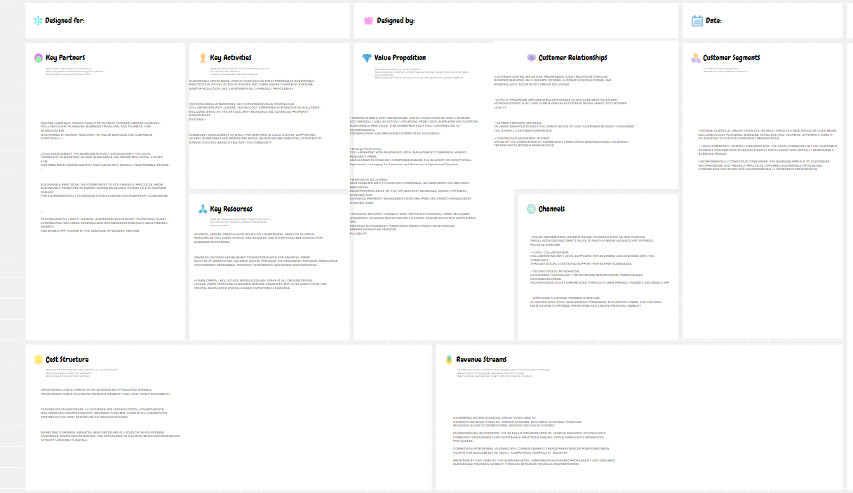

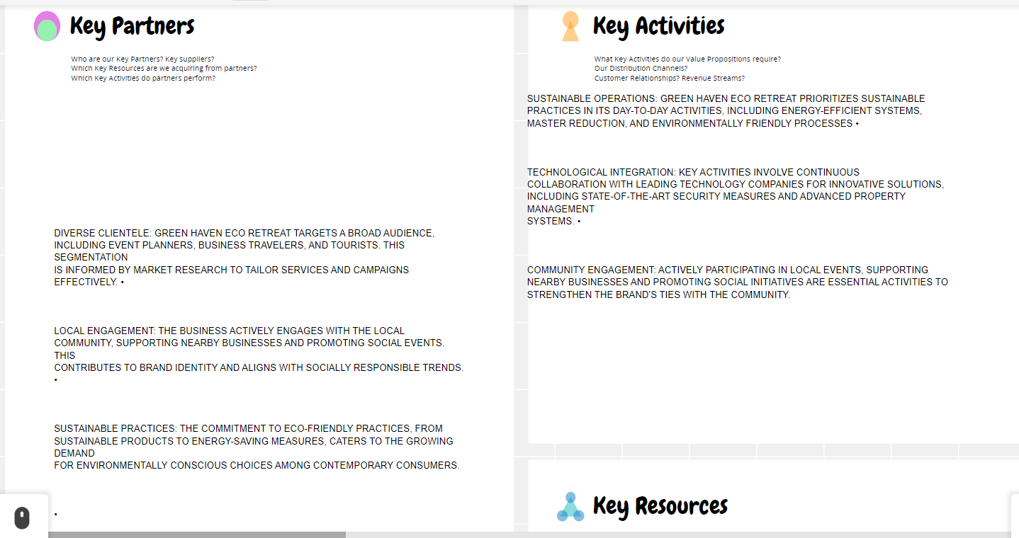

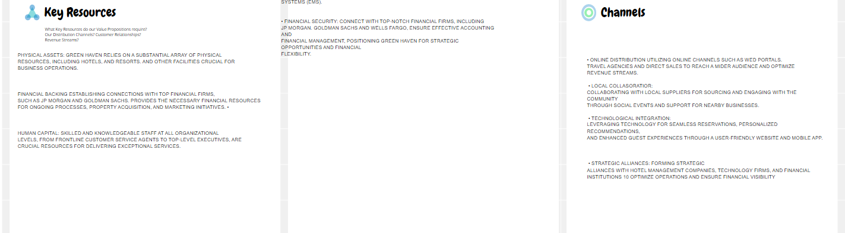

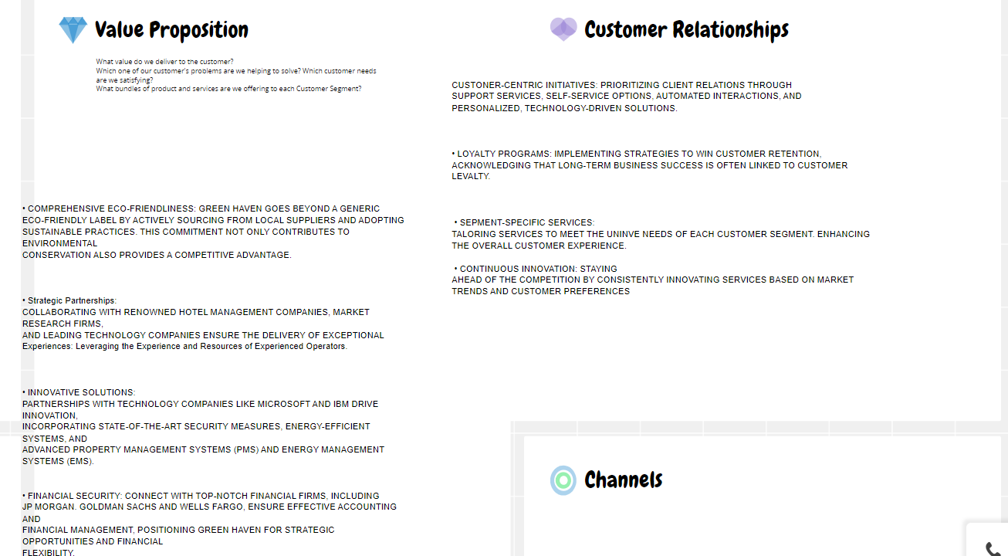

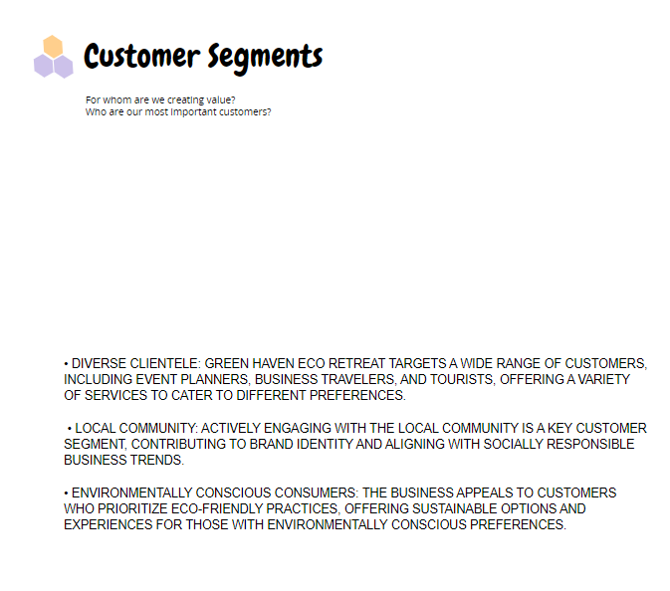
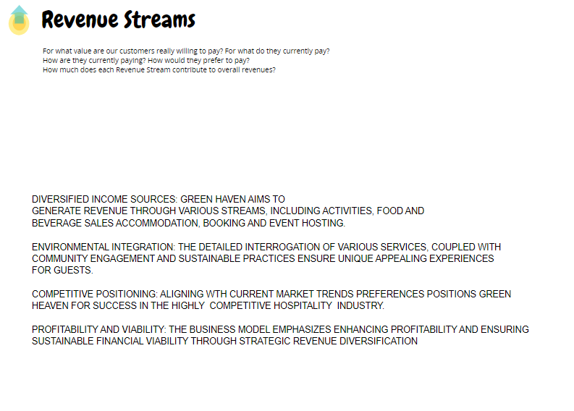
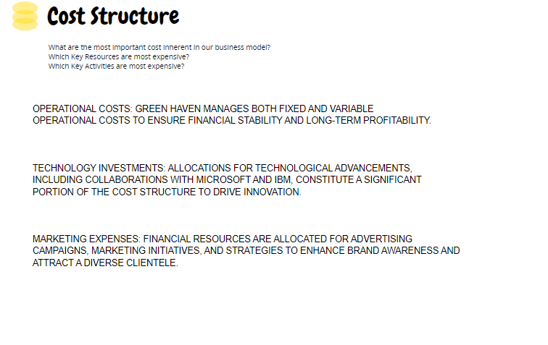

Figure 1 BMC (Green Haven Eco Retreat) CONCEPT BOARD



