

Component 1 – mEALSWIFT Website Redesign
PrOJECT
Module NaMe: Business and Web Management
Module Code: ACCA5019
Student NAME: Maria del carmen serrano
sanchez
Student ID: 2328383

27/03/2026

Table of Contents

Introduction 2
1. MEALSWIFT WEBSITE REDESIGN 3
1.1 Design Objectives……………………………………………………………………………………. 4
1.2 Design Phases…..……………………………………………………………………………………. 6
1.2.1 Mood Board creation………………………………………………………….………….…..… 6
1.2.2 Wireframe Design…………………………………………………………………………………7
1.2.3. Interactive prototype………………………………………………………….………………. 8
2. RESPONSIVE DESIGN IMPLEMENTATION…………………………………..…………….……… 9
3. IMPLEMENTATION SECTION………………………………………………………………………….10
3.1 Screenshots………………………………………………………………………………………..10
3.2 Explanation of Design Relationship: Influence of Mood Board, Wireframes and Prototype…………………………………………………………………………………..……….12
CONCLUSION…………………………………………………………………..……………………………14
REFERENCES……………………………………………………………..………………………………….15

INTRODUCTION

This report presents the redesign of MealSwift’s digital platform to improve usability, customer retention, and overall business performance. The project applies a user-centred UI/UX design process, including mood board creation, wireframing, and interactive prototyping.
The current website limitations are analysed, and solutions are proposed to improve navigation, responsiveness, accessibility, and user engagement. The report also evaluates the importance of responsive design in modern e-commerce and explains how structured UX methods can support both user satisfaction and business objectives.

1. MEALSWIFT WEBSITE REDESIGN

The current MealSwift platform presents several design and usability limitations that negatively affect user experience and customer satisfaction, particularly in navigation, visual presentation, and mobile performance.
The interface lacks clarity, with unintuitive navigation and outdated visuals that reduce trust. Limited restaurant and menu information, together with low-quality imagery, weakens visual appeal and credibility. The ordering process is inefficient, as complex checkout steps and poorly positioned calls to action increase user effort and cart abandonment. Ineffective search and filtering also obstruct users from quickly locating relevant restaurants or dishes.
The lack of personalised recommendations reduces engagement and repeat purchases, while limited compliance with accessibility standards restricts usability for a wider range of users, especially on mobile devices.
These problems can be analysed using Peter Morville’s User Experience Honeycomb model, which defines key dimensions of effective UX. The platform fails to meet several of these: it is not easily findable due to weak search functionality, lacks accessibility due to poor contrast and limited zoom capability, and does not appear fully credible or desirable due to outdated visuals and low-quality media.
These limitations emphasise the need for a comprehensive redesign that improves usability, enhances accessibility, and increases overall platform effectiveness, better aligning with customer expectations and business objectives.

  - Design Objectives

The principal objective of the MealSwift website redesign is to create a user-centred, efficient, and visually appealing digital platform that aligns with business goals and user expectations. The redesign is guided by the following key objectives:

- Upgrade User Experience (UX): Simplify navigation, refine visual hierarchy, and streamline the ordering process to create an intuitive, effortless user journey across all devices.

- Increase Conversion Rates: Reduce cart abandonment by optimising performance, simplifying the checkout process, and executing clear, well-positioned calls to action.

- Strengthen Brand Identity: Develop a consistent, modern visual language that enhances brand recognition, builds trust, and differentiates MealSwift in a competitive market.

- Personalise User Interaction: Incorporate data-driven features such as personalised recommendations and targeted promotions based on user behaviour.

- Guarantee Accessibility and Equity: Apply WCAG 2.1 AA standards to build an inclusive platform for users with multiple needs.

- Optimise Performance and Responsiveness: Adopt a mobile-first approach to ensure consistent usability, speed, and visual clarity throughout all devices.

The following table summarises the key usability issues identified and the corresponding design solutions proposed (see Table 1).

Identified Issue | Proposed UX Solution
Poor navigation | Enhance User Experience (UX): Simplify navigation, improve visual hierarchy, and clarify the user flow.
Outdated visual design | Strengthen Brand Identity: Redesign the visual language with a modern, luxurious, and consistent aesthetic.
Non-responsive layout | Mobile-first design to ensure accessibility on all devices.
Inefficient ordering and checkout process / high cart abandonment | Increase Conversion Rates: Improve loading speed, optimise the checkout experience, and highlight clear calls to action.
Low-quality media | Invest in professional images, videos, and graphics for better engagement.
Lack of personalisation | Personalise User Interaction: Integrate smart recommendations based on user history and preferences.
Accessibility issues | Ensure Accessibility and Inclusivity: Apply WCAG 2.1 AA standards and inclusive design principles.
Slow performance and low overall satisfaction | Optimise Performance and Responsiveness + Enhance UX: Create lightweight, efficient interfaces with a clear, well-structured layout.

Table 1: Summary of Identified Usability Issues and Proposed UX Solutions

The proposed redesign is based on established UX principles and aims to improve both usability and overall platform performance.

  - Design Phases

The design process for the MealSwift website followed a structured UI/UX methodology, progressing from concept development through wireframing to an interactive prototype. Each stage addressed identified issues and translated design objectives into functional solutions.

    - Mood Board Creation

The mood board defined the visual identity and emotional mood of the redesign before wireframes and the prototype were developed, preserving consistency throughout the process and supporting a user-centred approach.
The visual concept merges luxury and sustainability, positioning MealSwift as a premium, trustworthy platform that embodies quality, reliability, and responsible values in e-commerce.
The colour palette reinforces these values: Wine Burgundy (#4C1F32) conveys refinement and warmth, Deep Green (#0E3B2C) represents freshness and sustainability, and Champagne Gold (#D1B694) adds an elegant accent. Neutral tones such as Off-White Cream (#F6F3EE) and Charcoal Black (#1A1A1A) ensure readability and a clean interface.
Typography balances clarity and usability, using a sans-serif font for headers to establish hierarchy and an easy-to-read font, such as Garamond, to support accessibility.
High-quality food photography, natural textures, and light shadows create a warm, realistic atmosphere. These items informed later layout decisions, ensuring consistency between the mood board, wireframes, and prototype.

    - Wireframe Design

Following the visual direction defined in the mood board, wireframes were created to establish the interface's structural organisation, focusing on usability, navigation flow, and functional clarity prior to applying visual styling.
The wireframe design addressed key issues, including confusing navigation, inefficient ordering processes, weak calls to action, and a lack of mobile optimisation. Defining the structure early ensured a logical user journey, reduced mental effort, and improved task efficiency.

Five main pages were designed:

• Home Page – Provides access to search, featured restaurants, and personalised recommendations through clear navigation and prominent calls-to-action.
• Restaurant Page – Displays menus, images, prices, ratings, and reviews in an organised hierarchy to support decision-making.
• Login / Account Page – Allows users to manage personal information and retrieve previous orders, supporting personalisation and retention.
• Checkout Page – Simplifies the ordering process by presenting key information clearly, reducing confusion and cart abandonment.
• Order Tracking Page – Provides live updates through visual indicators, improving transparency and customer confidence.

The layouts ensured consistency throughout all pages and provided a foundation for the interactive prototype. A mobile-first approach supported flexibility across different screen sizes while maintaining usability. Key interface elements, such as navigation menus, search bars, filters, and calls to action, were clearly created to ensure a consistent experience.

Design decisions were guided by established usability principles. A grid-based layout maintained alignment and consistency, while a clear hierarchy ensured key elements remained visible. These choices reflect Nielsen’s usability heuristics, including visibility, consistency, and user control.
The design was further informed by recognised UX laws. Fitts’s Law guided the positioning of interactive items, while Gestalt principles such as proximity and similarity were used to organise content coherently, boosting user understanding and interaction.

    - Interactive Prototype

The final stage involved creating an interactive prototype based on the wireframes and visual identity defined in the mood board, ensuring consistency in layout, colour scheme, typography, and overall client experience.
The prototype included five interconnected pages representing the main user journey: Home Page, Restaurant Page, Login/Account Page, Checkout Page, and Order Tracking Page, linked via interactive items to simulate real navigation.
Interactivity was implemented through clickable buttons, icons, and menus, permitting users to search for restaurants, select items, log in, complete orders, and track deliveries. Features such as calls to action, shopping cart interactions, and order status indicators were included to demonstrate functionality and usability.
The prototype reflects responsive design principles through a mobile-first structure, ensuring usability across several devices.
This stage enabled the design to be evaluated before implementation, demonstrating how the redesigned interface improves usability, strengthens brand identity, and supports business objectives through a clearer, more effective user experience.
Due to technical limitations during submission, some prototype images could not be fully displayed. However, the prototype was developed to accurately represent the intended layout, navigation, and functionality described in this section.

2. RESPONSIVE DESIGN IMPLEMENTATION

Responsive design in e-commerce involves creating websites which adapt to different screen sizes and devices, assuring a consistent experience across smartphones, tablets, and desktop computers. It uses flexible layouts, scalable images, and adaptive navigation to preserve readability, usability, and visual sharpness.
Its implementation has considerable effects on user experience and business performance. In modern e-commerce, many users access websites via mobile devices, and purchasing decisions are often made on smartphones. When a website is not optimised for smaller screens, users may experience navigation difficulties, slower load times, or unclear content, causing higher abandonment rates and reduced sales. In contrast, responsive design improves usability and supports higher conversion rates, particularly in mobile commerce.
In this project, a mobile-first approach was applied, designing for smaller screens before adapting to larger devices. This secures that key elements such as navigation menus, search bars, and calls to action remain visible and easy to use. Breakpoints were used to reorganise content by screen size, maintaining clarity across resolutions.
Typography and spacing were designed to remain readable without zoom, supporting accessibility. Flexible grid layouts maintained alignment while allowing content to adapt, improving visual balance and clarity.
Design decisions were guided by established standards, including WCAG 2.1 accessibility guidelines and Material Design principles, assuring consistency and usability.
Applying responsive design confirms that the platform continues accessible and efficient across devices, while supporting business objectives by reducing cart abandonment and stimulating repeat purchases. As mobile commerce grows, responsive design is still essential for long-term success.

3. IMPLEMENTATION SECTION

3.1 Screenshots
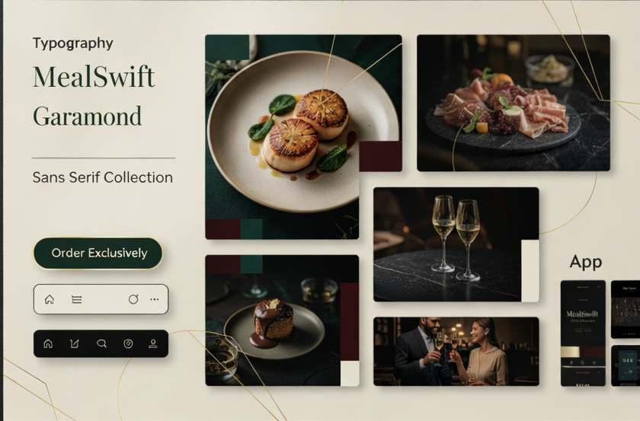

Figure 1. Mood board image

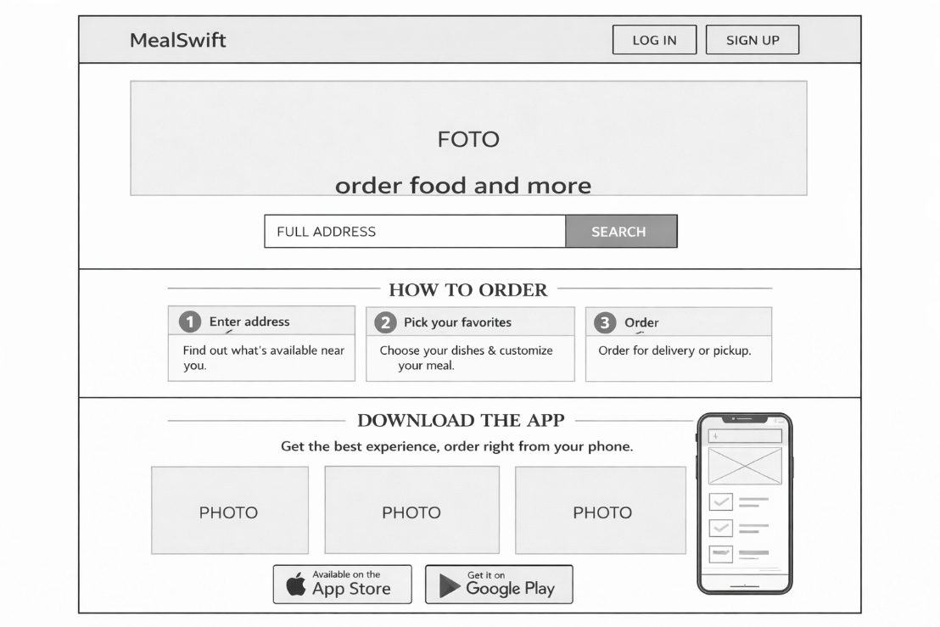

Figure 2. Homepage wireframe image
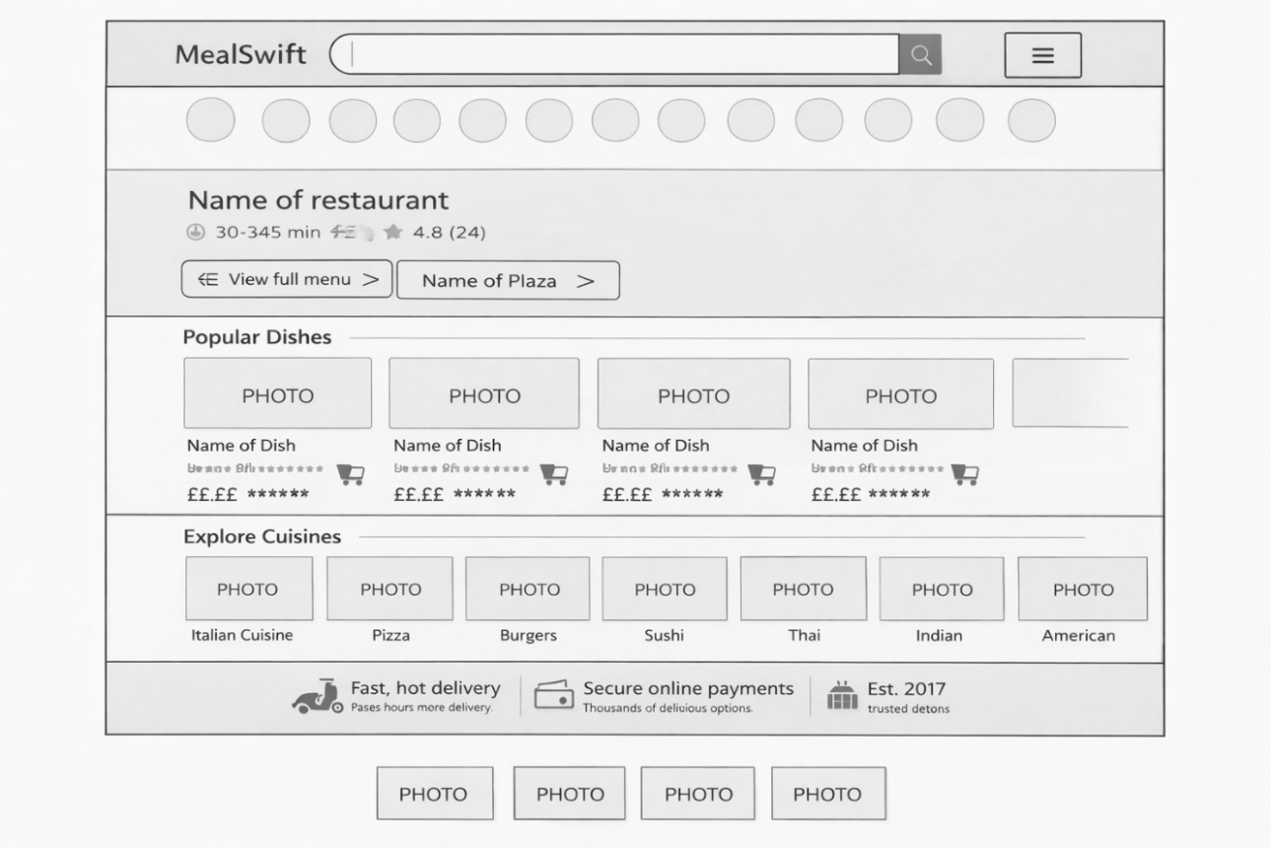
Figure 3. Restaurant wireframe image

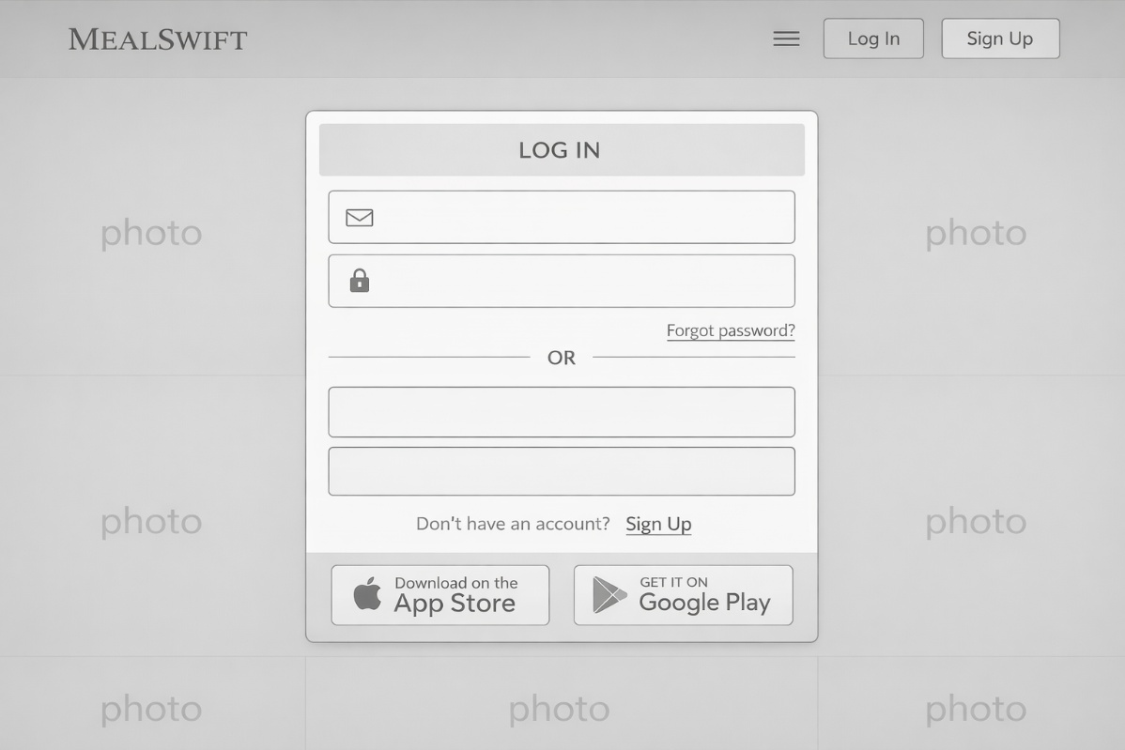

Figure 4. Account wireframe image
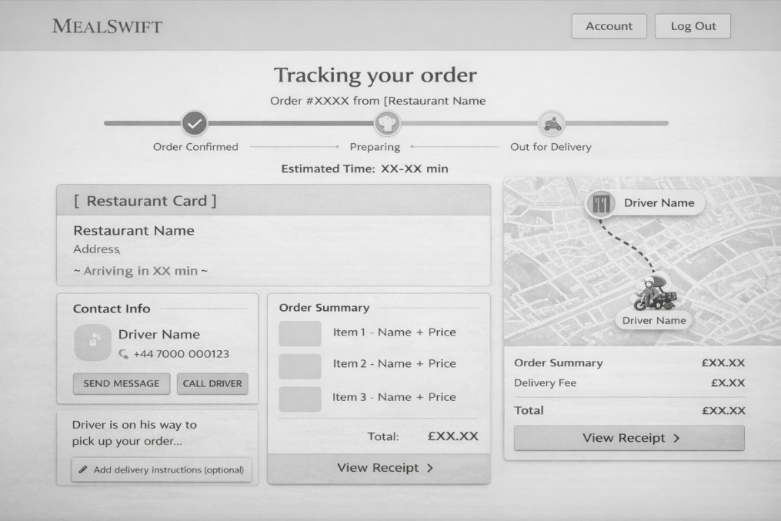
Figure 5. Tracking wireframe image

Prototype link: https://thorn-pro-66376245.figma.site

3.2 Explanation of Design Relationship: Influence of Mood Board, Wireframes and Prototype
The design of the MealSwift website followed a structured user-centred process in which the mood board, wireframes, and interactive prototype were closely interconnected, guaranteeing consistency and accordance with UX principles.
The mood board established the platform's visual direction, leading the development of the wireframes. This foundation influenced layout decisions, supporting a clear hierarchy and the effective placement of key elements such as search functions and calls to action.
The wireframes translated this direction into a systematic interface, providing a blueprint for the interactive prototype. This enabled the implementation of primary functionalities, including navigation, search, login, and checkout, while keeping consistency across pages.
Throughout the process, refinements improved the relationship between visual design and functionality. Adjustments to spacing, element sizing, and contrast enhanced readability and user-friendliness, while responsive design ensured usability across devices.
As a result, these stages produced an integrated, user-centred interface in which visual identity, structure, and interaction work effectively together.

4. CONCLUSION

This project helped me understand the importance of a structured UX/UI design process for creating a user-centred and effective e-commerce platform. Working through mood boards, wireframes, and interactive prototypes demonstrated how design decisions influence usability, navigation, and overall user experience.
One of the key learnings was the importance of clarity and simplicity in design. By improving navigation, reducing unnecessary steps, and positioning key elements effectively, the proposed solutions can enhance user satisfaction, reduce cart abandonment, and increase conversion rates, showing how UX design supports business performance.
The project also highlighted the value of designing with the user in mind at every stage. Even small decisions, such as spacing, layout, or button placement, can significantly impact user interaction and experience.
Furthermore, I learned how to use Figma as a key design tool. Initially, I believed that uploading images could create functional web pages; however, I learned that Figma is mainly used for design and prototyping, where images act as visual references. Functionality must be implemented separately through coding, helping me distinguish between design and development.
With more time or a collaborative team, I would prioritise user testing and analytics-based validation to refine the design and identify usability issues earlier.
This experience reinforced the importance of an iterative approach, where continuous testing and refinement are essential to developing a high-quality, user-centred, and commercially effective digital product.

5. REFERENCES

[1] All Things Web, “UX Design Principles for Websites: Increasing Visitor Engagement,” 2025. [Online]. Available: https://allthingsweb.co.uk/blog/ux-design-principles-for-websites-increasing-visitor-engagement/. [Accessed: Mar. 06, 2026].
[2] UXPin, “UX Honeycomb: Definition and Use in UX Design,” 2024. [Online]. Available: https://www.uxpin.com/studio/blog/ux-honeycomb-definition-and-use/. [Accessed: Mar. 08, 2026].
[3] Nielsen Norman Group, “10 Usability Heuristics for User Interface Design,” 2024. [Online]. Available: https://www.nngroup.com/articles/ten-usability-heuristics/. [Accessed: Mar. 12, 2026].
[4] GoDaddy, “Website Redesign: A 12-Step Guide,” 2025. [Online]. Available: https://www.godaddy.com/resources/skills/website-redesign. [Accessed: Mar. 12, 2026].
[5] Dynamologic Solutions, “What is UI/UX Design?,” 2024. [Online]. Available: https://www.dynamologic.com/what-is-ui-ux-design/. [Accessed: Mar. 20, 2026].
[6] Toptal, “Use Your Inspiration – A Guide to Mood Boards,” 2024. [Online]. Available: https://www.toptal.com/designers/visual-identity/guide-to-mood-boards. [Accessed: Mar. 23, 2026].
[7] Figma, “What is Wireframing? The Complete Guide,” 2024. [Online]. Available: https://www.figma.com/resource-library/what-is-wireframing/. [Accessed: Mar. 24, 2026].
[8] Coding Brush Up, “How to implement responsive design in your web projects,” CodingBrushUp. [Online]. Available: https://codingbrushup.com/how-to-implement-responsive-design-in-your-web-projects/ [Accessed: Mar. 24, 2026].
[9] Elsevier, “Interactive Prototype,” ScienceDirect Topics. [Online]. Available: https://www.sciencedirect.com/topics/computer-science/interactive-prototype [Accessed: Mar. 24, 2026].
[10] “Responsive Web Design Tutorial,” YouTube. [Online]. Available: https://www.youtube.com/watch?v=nJ3ObsOC6qQ [Accessed: Mar. 28, 2026].
[11] Guía WCAG, “Guía WCAG,” Guía WCAG. [Online]. Available: https://guia-wcag.com/es/ [Accessed: Mar. 28, 2026].

