

Final Business Plan

Laura Bucurean
Beata Beck
64 The Greenway
SA10 6JB Llandracy
01792 324 725

www.mesotreat.com
sales@mesotreat.com

Table of Contents
- Table of Contents 2
- Executive Summary 4
- Description of Business 5
3.1 Company Ownership/Legal Entity/Location
3.2 Mission statement
3.3 Location
3.4 Product description
3.5 Start up and Financial Management
- Human Resources
- Marketing 8
5.1 Market Analysis
5.2 Market Segmentation
5.3 Competition
5.4 Pricing
- Conclusion 11

2. Executive Summary
1 in 8 women are diagnosed with cancer in their lifetime. Breast cancer is the most common cancer in females worldwide.

The Food and Drug Administration (FDA) has approved some of these new techniques for clinical use, but many are in earlier stages of development and have not been used outside a research setting.

According to breast cancer care, some women believe that they do not need to check their breasts, others are ashamed or do not know how to check.

Mammography can pick up tiny cancers sometimes indicated only by flecks of calcification in tissue. Some small cancers may grow to become life threatening; others may remain dormant or even disappear.

This amazing Breast-i Non-Diagnostic Self-Examination Device has been tested by women in Nigeria and India and has successfully identified cases of breast cancer that would not have shown up with traditional hand screening examinations.

Cancer is a deadly disease which is growing rapidly and is one of the most significant public health challenges of the 21st Century. MesoTreat comes along with Breast-I Non Diagnostic Breast Examination Device with the help to prevent any spotting changes in women breast.

3.0 Description of the Business

3.1 Company Ownership/Legal Entity

MesoTreat is a new independent business based in UK and unlike other businesses owned by several partners. MesoTreat is set up as a limited company with two directors: Mrs Beata Beck and Miss Laura Bucurean.
The directors came from oversees - Poland (Beata) and Romania (Laura). We met in our workplace; accountancy practice and became very good friends. We immediately clicked and were perfect team because our skill sets complemented each other. We are a very enthusiastic and with passion for business, we decided to become business partners.
We are at the early stage of our business, we have an amazing product and we are a fantastic team.
We are set to challenge and shake up the current market and take MesoTreat Limited through a success journey.

“Best friends are usually the best partners”!

3.2 Mission Statement/Aim and Objectives of Business

Mission is to help beat cancer!!!

MesoTreat is leading the way with a unique product for self-examination BREAST-i Screening Device by UK scientists.
With no history behind it, MesoTreat can proudly say that although new, its goals are very clear straightforward - to introduce BREAST-i Screening Device to all women in the world and encourage women to all ages to check their breast to prevent breast cancer.



MesoTreat aim is to promote to the world Breast-I self Examination Device development into fighting cancer.

Breast-i focuses on few major areas:
- detecting any spotting changes in the breast
- HOPE that could lead and result in saving more life’s in the future.

The company is also looking to expand the business and focuses in research for a device designed for detecting testicular cancer and potentially give men the “all –clear for life “.
There is a reason why this kind of research is headlined globally: there’s currently no screening program for prostate cancer.
The research is still in the early stages but we are confident that we can come out with the similar device as Breast-I self examination device to make sure all men’s testicular cancer are caught early enough while is still possible to cure.

Research kills cancer!

With the current market leaning towards Combat Cancer the growing production of the Breast I self examination device could be the way forward.

Objectives

In the first year MesoTreat Limited revenue model has been set up in three simple steps:

- Creating customer value by targeting U, Polish and Romanian market in hospitals, Gp’s, pharmacies and online through our website.
- Marketing –the device is registered under Trademark License Agreement -MesoTreat Limited aim is to make the Breast –I Non Diagnostic self examination device worldwide brand.
- Selling offline and online through website

In the second and third year the company is planning to expand globally and start distribution in other countries like America, Australia and New Zealand
Within this period, the company will continue to analyze the market, monitor the competitors and keep innovating to become the market leader in this industry. We will also identify companies that we can form strategic alliance with the aim of sharing knowledge, acquisition of resources and more capabilities. This will give us a competitive advantage.

3.3 Location

MesoTreat will be located in Carmarthen area, with a focus on the UK, Polish and Romanian market.
The company decided to rent an office in Scarlet Court in Llanelli. Carmarthenshire area is a prime location for MesoTreat business.
Also we found out that any business in this area can take advantage from government grants.

3.4. Product Description

Scientifically proven non diagnostic BREAST-i screening device for self breast examination introduced by MesoTreat is a device which can be used at home offering peace of mind self breast check against the breast cancer illness. This product has been introduced a few months ago in the countries where the medical sources were very limited. The result in self check and further diagnosis was shocking. The product sensitivity showed that 87% was benign disease and 94% was related to breast cancer.
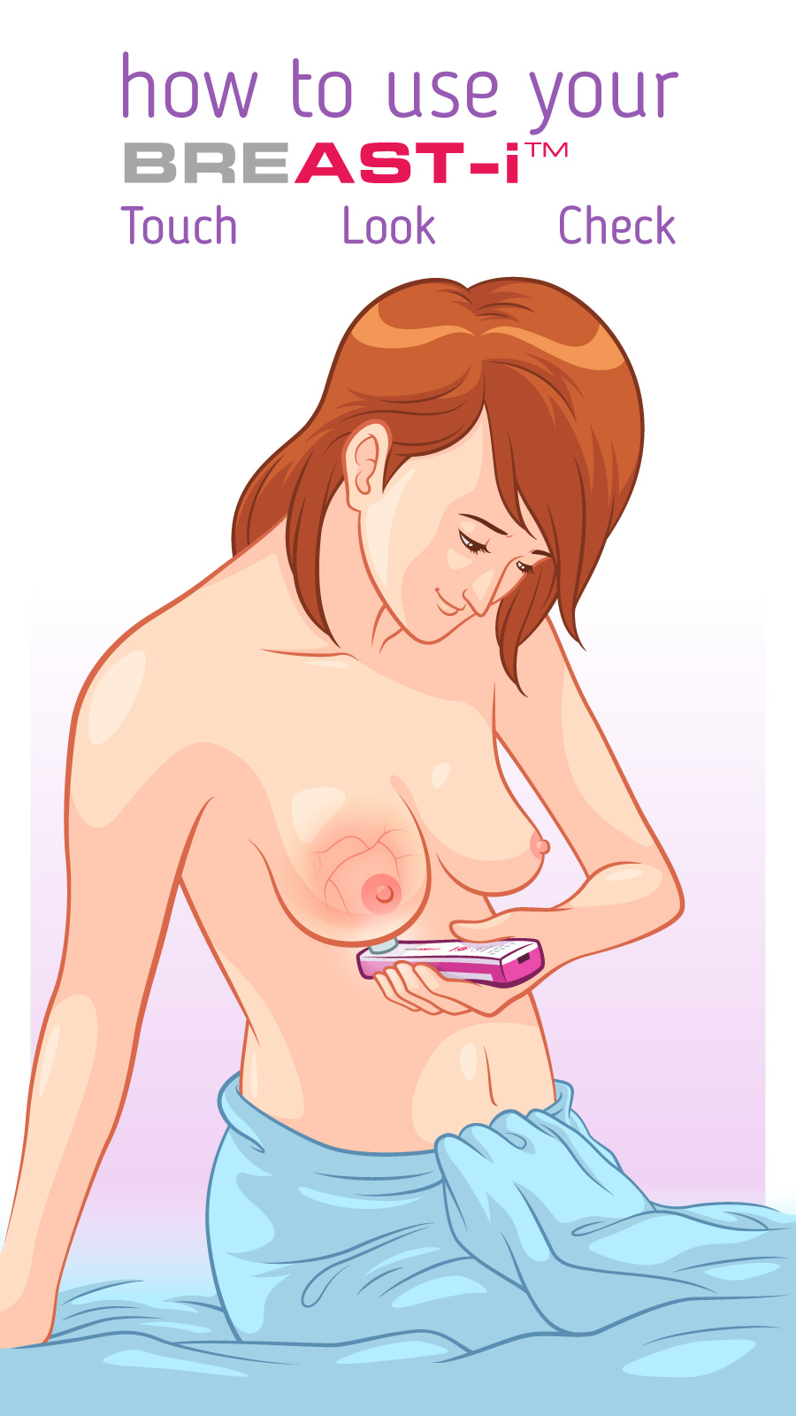

Switch on and place the device under the breast. Gently press the lens into the breast, light is transmitted through breast tissues. Adjust the brightness until the skin is a uniform pink or red color with darker lines representing the presence of blood vessels. Move the device to screen the breast.
It must be realized that X-rays and light are monitoring different features of the breast tissues. Should a women spot shadows or clusters with the device they should take the information to a doctor to see if it warrants further testing. Early detection is the key to survival!

3.5. Start up and Financial Management

MesoTreat directors come from accountancy environment. One of the director hold professional accountancy license which is a very helpful at the beginning of starting the business. The second director has over 6 years’ experience in administration and Tax department.
Each director will supply personal loan of £7,000 to the company. This money will cover basic expenses to start up the business. One of the director husbands is a professional web designer. The cost of the website is minimized to zero, including SEO and blogging,
The amount of funding needed to launch the business will come from a bank loan of £100,000 arranged with Development Bank of Wales with additional support coming from family .investors. This money will cover stock, advertising and marketing.
Further to that the company will apply for the grant to cover expenses related to the computer equipment.

Projected Income Statement
The Income statement reflects one year projection where MesoTreat initially makes profit of £52,804.50
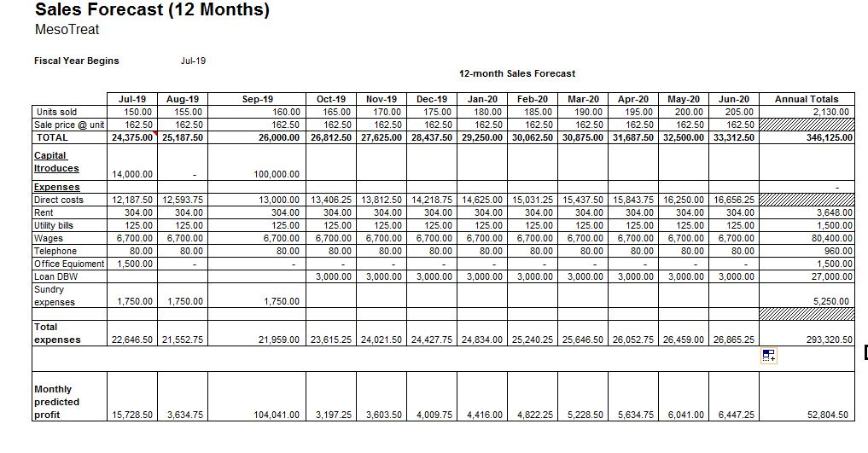
4. Human Resources
The annual HR plan is fundamental to our company strategy to meet our goal.
Human resource planning is 'the process for ensuring that the human resource requirements of an organization are identified and plans are made for satisfying those requirements'.
In the first year both directors will work full time to cut the cost of employing other people. Also they will gain incredible experience of setting up the business under their rules.
At the beginning Laura will be in charge of business administration between the clients and in house office transactions as well as looking after the needs of the business.
After we achieved our profit margin the company will need to employ more staff as following:
- Sales online and offline – this position will be covered by both directors and it will be paid through director salaries.
- Marketing – family member will be responsible for website and social media – This person will be paid through money that both directors introduced to the company
- Finances – Beata will cover this position, in the future the company will employ professional bookkeeper
In the second year the company will consider employing managers in Wales, England, Scotland and Ireland as the directors will focus on international sales in Poland and Romania.
Per annum the salary will be based upon experience also the directors are willing to pay percentage from sales in mentioned above areas.
The company is looking to employ three area managers around UK. ; Scotland, Ireland, England and Wales as Beata and Laura will start international sales.
The company is looking to employ sales product managers responsible for selling the device, dealing with Hospitals, Gp’s and other clinics and also specializing in supplying this amazing device. This is a very consultative sell and is highly rewarding.
We are seeking experienced person in selling medical devices; a prior experience would be highly advantageous with a must attitude achiever in the role.
We offer to the successful candidate a package including -£22k /annum, bonus, car, pension and healthcare insurance.
At this stage the company is also looking to employ an experienced bookkeeper to work as part of the sales manages team.
Key responsibilities will include – processing sales and purchase invoices, profit and loss balance sheets, provide reports to clients and managers as required and prepare monthly management accounts.
The successful candidate will preferably hold an AAT qualification with experience in accountancy field or finance environment. Excellent communication and good Excel kills are required; also experience in using Xero and Sage software.
The successful candidate will have an attractive salary starting with £17 k / annum with the opportunity of progression in the role as the business is going to expand.

5. Marketing Activities
The number of projects around the development of Cancer Research is a clear indication that there is a need in the market for a device such as what Breast-I Self examination Device is offering.
5.1 Market Analysis
We conducted a survey to find out the need for our product and collected data from individual women at different ages.
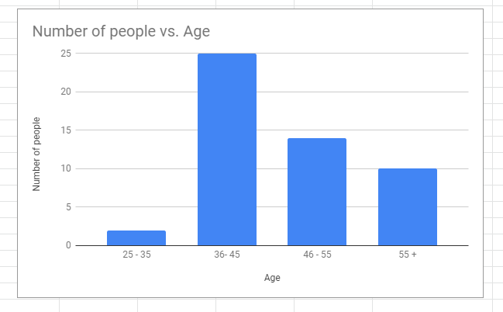
The survey displayed their interest in our service and we are confident that our product benefits will go beyond their expectation. The results also pointed out the need and an interest in our product can help save their life and majority women over 35 will definitely use the device.
MesoTreat set out 3 simple steps to prepare market analysis
Industry - The goal of marketing is to connect the business value to all women in the world. In other words, the key to success are digital strategies which will be conducted online.
So far MesoTreat has good excluded access to the Breast –i Non-Diagnostic Self Examination Device. The company signed the contract with GM Instrument the manufacturer and MesoTreat is only one who can supply this product in the UK. No competition gives MesoTreat a big chance to expand as they predicted. To achieve this, the company focuses on Master Classes, support cancer conferences, cancer charity events. This all activities will include presentation how to use Breast – I Self Examination Device.
Marketing – Based on the information provided above we drawn a list of current Strengths and Weakness of the proposal together with an action plan using SMART targets.

SWOT ANALYSIS
STRENGTHS |  | WEAKNESSES
- First company to lounge Breast-I Device |  | - NHS provides free consultation
- Excellent Device –Save Life’s!!! |  | - Only for self-check up
- No Competitors |  | - Non -Diagnostic
- Only one distributor in UK, Poland & Romania |  | - Not tested yet for breast implants
- Affordable Price
- One Device can be shared

The company’s strengths will be shown as this is a growing niche market. With the unfortunate number of cases rising in cancer, Breast-i Self Examination device could be the way forward in detecting and treating the “DESEASE” on time.
This niche market can be effectively voiced to the unknowing public advertising through Google website, Social media as Tweeter and Face Book, YouTube, Bogging and Breast Cancer Research Charities.

SMART Analysis
Specific – The purpose of this product is only for breast self-check
Measurable - MesoTreat wants to be visible in the UK but also wants to target European countries.
Achievable – Breast – I device was already introduced in African countries and the results were phenomenal. UK market will demand this type of the product.
Realistic – The device is CE certified (Chartered Engineers Cert) and applies with EU Regulation.
It has been tested and received positive feedback.

Time based – The Company set 1 year to introduce the product in the UK. 2-3 years to start selling worldwide.
5.2 Market Segmentation
MesoTreat market strategy operates under differentiation business strategy. This means that the company provides a range of unique product not only for qualified customers in health industry but for every woman.
5.3 Competition
At this stage MesoTreat has no competitors. Our business is the only one providing Breat – i. self examination Device. The business will look into current competitors and their proposed products.
The greatest risk we face today is the 'ever changing technology'. MesoTreat plans to invest in Research and Development, which will ensure that we stay at par with the latest technology and continue to innovate on the go.
5.4 Pricing
Breast-i Self Examination device will cost £195 including VAT. The cost of the device is still negotiable with manufacturer. The Customer will be invoice on the day that the goods are dispatched. For the avoidance of doubt description, specification and illustration will be enclosed with the device.

  - Conclusion
The core contribution of the business plan is recognition that Breast –I Non Diagnostic Self Examination Device has a functional performance in monitoring and constructively helping to identify breast problems and working towards a cure for cancer. As mentioned previously Breast I device is for self checkup, Any discovered problems need to be consult with medical practicioner.
In conclusion, the use of Breast-I self examination device should be a high priority because molecular markers show promise for breast cancer screening, diagnosis. But, these molecular markers require much more study and development before their usefulness in breast cancer detection can be evaluated.

References:

A. McLellan (2016) HJS Health Service Journal for Healthcare Leaders.Vol.3 Page4-5
Breast Cancer Research aid http://breastcancerresearchaid.org.uk/
Breast-i Non-Diagnostic Breast Self-Examination Device
Cancer is a deadly disease https://www.google.com/search?q=cancer+is+a+deadly+disease&rlz [Accessed 25/06/2019 ; 20:20 ]
https://www.cancerresearchuk.org/
https://www.mesotreat.com/product-category/breast-i/ (Accessed 02/06/2019)
https://www.youtube.com/watch?v=wp7vQTYD5_g&feature=youtu.be
Human Resources Policy https://www.inc.com/encyclopedia/human-resource-policies.html (accessed 08/06/2019, 12:45)
M.Dickmann (2019)The International Journal of Human Resources Management Nr3-4. Vol 30.Page
MesoTreat https://www.mesotreat.com/
Research, N., 2001. Mammography And Beyond: Developing Technologies For The Early Detection Of Breast Cancer: A Non-technical Summary. National Academies Press.
Strategic Human resource planning (2018) https://en.wikipedia.org/wiki/Strategic_human_resource_planning (Accessed 05/06/2019 , 18:50)



