Matthew Simons
29/06/1997
Student No. - 1704660

Are we born with an innate moral compass or is it something we develop as we grow?

For centuries upon centuries, philosophers have argued whether or not human beings are born inherently good or inherently evil. We as human beings are capable of great things while also being capable of monstrous atrocities. Since humanity was spawned, there have been people who are almost universally deemed as evil. Adolph Hitler, King Leopold of Belgium II and Josef Stalin are people who for the most part share one common consensus amongst the world’s population; they are all ‘evil’. But do people who are ‘evil’ have evil intentions? Or do they see themselves as the protagonist of their own personal life journeys?
If you asked 1000 people who the most morally bankrupt person in human history is the most common answer would certainly be Adolph Hitler. His horrific crimes against humanity will certainly echo throughout the ages but I cant help but loathe to use the word evil to describe him simply because it’s a horrific thought that a human being, made up of the same matter as myself can commit such atrocities without being insane. I think the thing that’s so scary about the ‘inhuman’ is that inhuman acts and people are quite clearly not.

Newborn babies are seen by society as pure and innocent and are almost deified and untouchable to most people. However, people’s blind adoration of babies tends to end when they are old enough to have a personality of their own. Being born is one thing that everyone has gone through, whether you’re Jesus Christ or Jeffrey Dahmer, everyone has gone through the birthing experience.
Sigmund Freud considered babies to be a moral ‘blank slate’ and that all behaviours/mannerisms are leant. However, Paul Bloom thinks that we have a deep sense of right and wrong instilled in us at the time of birth.

‘Americans in particular believe that religion (usually Christianity) is important for morality, but Bloom says, “Any simple claim that you need religion to be good is flat wrong.”
The main way young children communicate is through tattling—pointing out something that they think is wrong.
Racism doesn't appear to be hardwired at birth, but babies will look for and seize on whatever similarities they find with others and fall into one group over another. We see that continue throughout life.
Babies are empathetic, and empathy is important in developing morality. But Bloom is sceptical that it's the key to morality. He said empathy more of a catalyst for morality because it motivates one to want to help someone else who is in pain or is suffering.’ (https://www.wnyc.org/story/origins-good-and-evil/ )

Paul Bloom’s take is an incredibly interesting one to think about and dissect. Do we have this innate to empathise due to thousands of years of evolution or were we given it through divine intervention? Looking back at human history this ‘deep sense of empathy’ that Bloom talks about is clearly missing, as humanity has been incredibly violent and genocidal in years gone by. Even in the past 70 years, which in the grand scheme of time is basically yesterday, humanity has endured the bloodiest and most destructive war on our planet in World War 2. World War 2 highlighted just how dangerous humans can be when they dehumanise other people. Propaganda and fear killed 12 million people during the holocaust and countless other lives lost on the front lines.
However, it is now universally agreed that we are living in the most peaceful time of human history. There are no major wars going on and we are now safer than ever in day-to-day life. Could this be because humanity is learning that violence and killing are wrong or could this be it is not worth going to war with a country from a geo-political standpoint anymore?
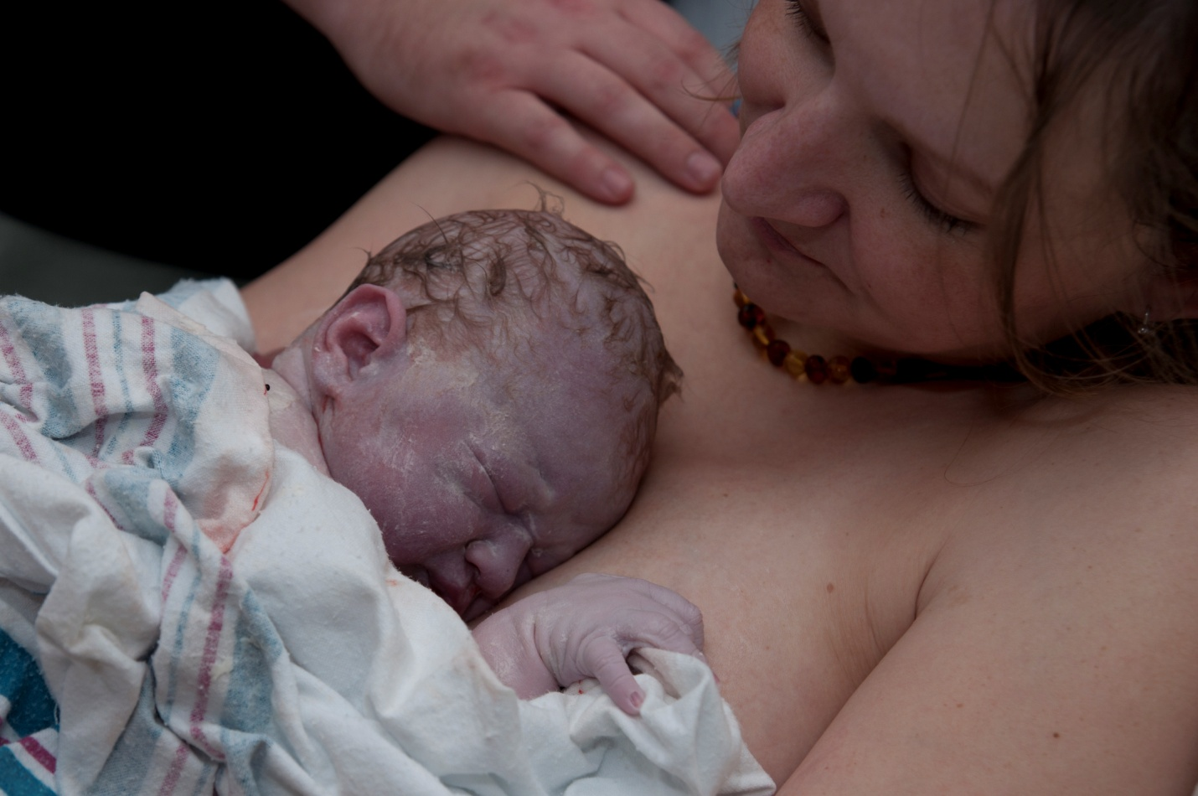

(https://www.yourbirthconnection.com/about-evelyn )

The above photo from Evelyn Conrad strikes me a very complex photo. It shows a new-born baby who is worlds apart from what most would consider a baby. I say this because it has purple skin and matted down white-ish hair due to the birthing process, however, this is completely normal. Contrasting this image of the visceral marks of bodily fluids/blood on the baby is the mother staring back at him/her with complete adoration. The baby in the picture could grow up and become. A humanitarian or a thief. A saint or a sinner. The question is however, is this already predetermined? I personally am of the belief that man is born and then man is formed.

Morality is described as being the distinction between right and wrong and good and bad behaviour. However, the issue with this is that people have conflicting views of what right and wrong is. While most people do have pretty similar moral codes for the most part, eg. Killing is wrong, stealing is wrong etc.… there are some grey areas that people have conflicting views on. These often stem from religion as different religions teach different things.

‘Many people regard morality as evidence for supernatural intervention in human development. In every major religion, a divine influence is proposed as inspiration for texts that dictate our moral principles. Whether it is the Ten Commandments, the Five Pillars of Islam, the Eight Fold Path, or the Hindu Purusarthas, each decree guarantees a pleasant afterlife because each is endorsed by the god(s).
Adherents of these faiths are unwilling or unable to theorize how right and wrong could have arisen without divine prescription. Nevertheless, it is of paramount importance that we understand the origins of our moral leanings. The justice system is derived from our conclusions on morality, and the actions of those who deviate from moral norms can only be understood once the root of our acceptable behaviour is delineated. The dismissive quality of religious thought has prevented this understanding by attributing our good nature to supernatural beings.’ – Thomas Swan (https://owlcation.com/humanities/What-is-the-relationship-between-religion-and-morality )
Swan’s writings explain that each major religion has their own set of rules that basically say the same thing throughout each faith. Christian’s for example base their moral code of conduct on the 10 commandments handed from God to Moses. The fact that religion has such deep roots in people’s morality begs the question, what would humans be like without religion? Would it be some kind of Wild West ‘free-for-all’ rife with guns, violence and killing, or it would be a utopia since the world would have been without the dark ages?

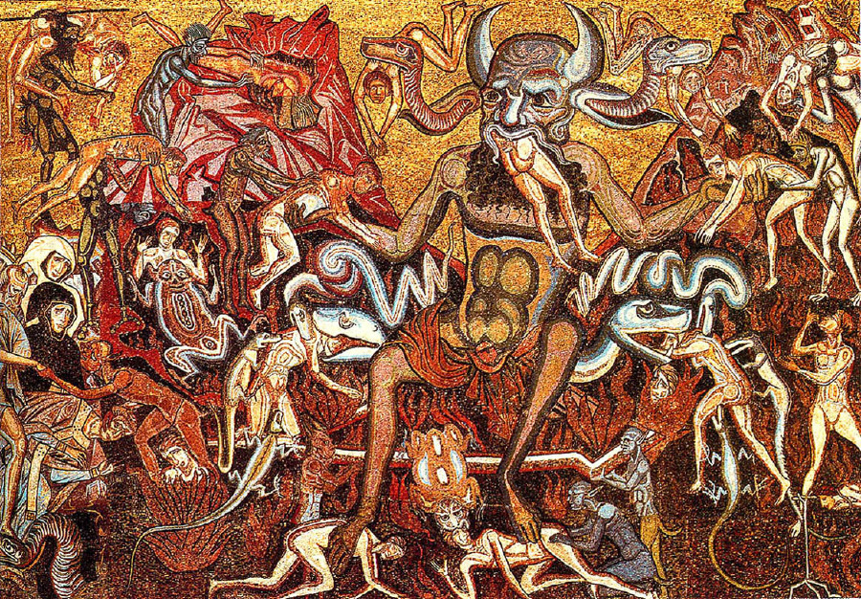
(https://guff.com/15-different-interpretations-of-hell-in-art/13 )

Depictions of hell have been used since the middle ages to scare people into conforming to the Christian’s ’10 commandments’ view on morality. As you can see from the above painting by Coppo Di Marcovaldo (1225 – 1276), the depiction of hell has to be visceral and frightening. The above picture shows the devil devouring human flesh while demons in the background torture other damned souls. Of course nobody has actually seen hell and from a first hand perspective so this is a good interpretation of what people in that age deemed as hellish, complete with the Devil in the form of a boar.
It’s interesting to note that followers of Abrahamic religions believe we are made in god’s shape, they refuse to depict us as looking like the devil, almost as if they don’t want to acknowledge that we are capable of quite hellish things.
Aristotle said that ‘men create god in their own image’, but it seems like acknowledging the potential to be ‘evil’ within us is something we would rather not explore.


(https://www.bbc.co.uk/news/world-europe-46991969 )

This painting depicts a peaceful setting of a man sitting by a river. The use of pale blues in this painting depicts a brisk setting and the mountains in the background of the painting give this art a sense of grandeur. Looking at this painting, you would be forgiven for thinking that the artist was a peaceful man. This however, would be wrong. The artist is Adolph Hitler. Adolph Hitler is of course responsible for millions upon millions of deaths and is arguably the sole catalyst for World War 2. So how can such a violent and erratic man paint such a calm, peaceful and wholesome painting despite having such a conflicting moral compass to someone like Coppo Di Marcovaldo, who painted the hellish image shown before?
Due in part to religion, society shares what could be called a ‘moral consensus’ in which things are universally celebrated and condemned. Examples of acts that are universally celebrated would be:
- Helping people in need
- Giving money to poor
- Raising a family

There are a lot more acts that are universally condemned, the mail ones being:
- Murder
- Stealing
- Lying
- Paedophilia
- Rape
While most people don’t live their lives as saints handing out money to anyone who needs it, they also don’t live their lives, as total immoral creatures that kill and harm at will. I think that we live in a moral grey area where things aren’t black and white.

Although we as humans tend to stop growing physically in our early – mid twenties, the age in which we stop growing mentally is widely debated and speculated about. The frontal lobe of the brain is the part of the brain, which is used for decision making and distinguishing right from wrong. This lobe continues growing well into your twenties.

‘We know well enough that we are equipped with an innate drive for physical growth; that the human animal is geared to keep developing towards its outward mature form, adding muscle and bone and fatty tissue, in a spontaneous process of development that begins in our earliest days in the womb and ends around our sixteenth year.
What is less obvious is that we are marked by an equally innate, equally powerful, although here life-long, drive towards emotional growth. Without anything mystical being meant by this, unless we are impeded by internal or external obstacles, we are set on an ineluctable path towards emotional development.
An obvious conceptual difference between the two drives is that we can know easily enough what it means to be fully grown physically, but it is rather harder to pin down what equivalent emotional maturity might look like.’ – The Book Of Life (https://www.theschooloflife.com/thebookoflife/how-to-end-a-friendship/ _

This passage shows that unlike physical growth, emotional growth is subjective rather than objective. The passage from The Book of Life explains that emotional maturity is hard to quantify as it is not black and white like physical growth. For example, ‘You are 6 foot 4’ is a lot harder to argue against than ‘you are not emotionally mature’.
If humans have the capability to mentally grow practically throughout their lives, then surely they must also have the ability to mentally regress. Illnesses like Alzheimer’s and Dementia can revert elderly people back to the emotional age of a child.
In 1995, a UK-based American artist by the name of William Utermohlen was diagnosed with Alzheimer’s disease. A common misconception about Alzheimer’s is that it just affects the memory of someone who has unfortunately got the disease. This is wrong. Alzheimer’s also affects the part of the brain that is responsible for personality as well as the part of the brain that is responsible for visualising capabilities, absolutely crucial for a painter.

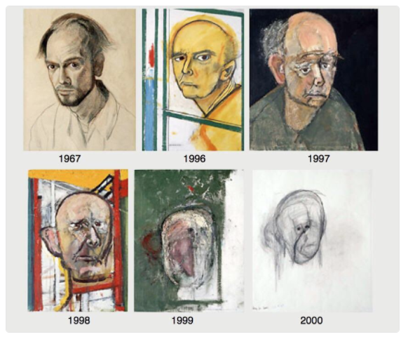
(https://www.boredpanda.com/alzheimers-disease-self-portrait-paintings-william-utermohlen/?utm_source=google&utm_medium=organic&utm_campaign=organicn )

This compilation shows self-portraits made by William Utermohlen throughout his battle with the disease. As you can see from the final few portraits, his depiction of himself barely looks human. This is so beautifully sad to me as it shows that humanity and art will always find a way, but also crushing as it shows that the disease has left him almost a husk of a person. Alzheimer’s is colloquially referred to as ‘the long goodbye’ because of how much it robs a person of what makes ‘them’, ‘them’. It is clear to see that Utermohlen style drastically changed throughout his progression with the illness, it became more abstract toward the end and used colour more sparingly. I can't imagine what he thought at later stages if he was able to see his own work and recognize the progression. I also wonder how much of his portraits were how he viewed himself or what he viewed his current mental state as.

These three key words will help me create a dissertation next year as they are very thought provoking and profound. I have chosen this question because it is such a hotly debated issue’s and world-renowned thinkers rarely have the exact same view on the question. I think that this question can give such a massive insight into the human psyche and explain why people do the things they do what most people would like to do and bury their heads in the sand and call anyone who commits atrocities such as Ted Bundy, John Wayne Gacey and Peter Sutcliffe ‘mentally unwell’. I think that if this question is properly answered and researched, we can not only help those who are showing signs of a malfunctioning moral compass, but help bring closure to families who have been affected by people who don’t conform to societies moral consensus, whether or not they are related to a psychopath or related to a psychopaths victims.
Knowing whether we are born with a moral guideline also alludes to divine intervention, so it would be a massive discovery if it was found that we as humans were ‘pre-programmed’ if you will, to act in a certain manner and to not harm others. It would almost mirror Isaac Asimov’s three laws of robotics.

Isaac Asimov's "Three Laws of Robotics"
- A robot may not injure a human being or, through inaction, allow a human being to come to harm.
- A robot must obey orders given it by human beings except where such orders would conflict with the First Law.
- A robot must protect its own existence as long as such protection does not conflict with the First or Second Law.
(http://webhome.auburn.edu/~vestmon/robotics.html )

