

Programme: Master of Business Administration
Module Code: LCMB7024
Module Name: Marketing Management
Title of the assignment: Assessment component 2: Marketing Portfolio
Lecturer name: Dian Mayasari
Student name: MD Abdul Kadir Chowdhury
Student ID: 2435894
Date of submission: 19th of November

Table of Contents
1. Introduction 3
2. Element 1: STDP Analysis 4
2.2 Market Segmentation 4
2.3 Targeting Strategy 4
2.4 Differentiation 4
2.5 Positioning 6
3. Element 2: Marketing Mix (4Ps) 7
3.1 Product – Features, Design, Technology 7
3.2 Price – Premium Pricing Rationale, AppleCare+ & Financing 8
3.3 Place – Omnichannel Distribution & Global Roll-out 8
3.4 Promotion – Key Message, Campaign Channels, Ecosystem Integration 8
4. Element 3: Marketing Strategy Pitch 10
5. Element 4: Reflection 12
5.1 Learning Experience 12
5.2 Skill Development . 12
5.3 Future Improvement 12
6. Conclusion 13
7. References 14

1. Introduction
Apple Inc. is a multinational company based in technology that is famous due to its innovative nature, high design, flawless integration of hardware and software ecosystems. Through user-centred products like the iPhone, Apple Watch and Home Pod, the company religiously redefines the current consumer technology. As part of its mission to make the world smarter, healthier, and more sustainable, Apple presents Apple Atmos, a smart 360 degrees’ air purifier which is tailored to modern domestics. The new brand expands Apples ecosystem into the field of wellness technology and its modules learning outcomes manifested in the demonstration of the critical application of marketing innovation and strategic brand development and anticipation of the future trends which are influenced by technology and sustainability.

2. Element 1: STDP Analysis

2.2 Market Segmentation
With the fast-growing home-air-purifier market, several consumer groups arise on the basis of the demographic, psychographic, behavioural and geographic factors. In terms of demographics, high-income professionals between 30-55, dual-income families and tech-savvy millennials residing in urban areas are also a target segment; this segment has disposable incomes, as well as interest in owning high-quality wellness-home technology. Psychographically, health-conscious, sustainability-focused and smart-home cohabiting consumers make up another set of consumers - studies indicate that the awareness of the riskiness of indoor air-quality is pushing consumption of purification technologies. To give an example, the market of home-use air purifiers throughout the world has been estimated to be USD 11.65 billion in 2024 and is estimated to increase at a fast rate with any rise in indoor air-quality awareness (Stellar Market Research, 2025). In terms of location, consumers in urban and suburban areas with high populations in developed nations (e.g. North America, Western Europe, Japan) and expanding middle-income metropolises in Asia are essential, due to increased demand by urban pollution and lack of indoor ventilation (Mordor Intelligence, 2025). Early adopters of smart-home devices, brands loyalty, and frequent upgraders basing their decisions on the convenience and design find a common point, creating a niche; the study shows that information-navigation proficiency and perception of comfort/energy-efficiency benefits are significant predictors of smart-home product adoption (Lin et al., 2025).

2.3 Targeting Strategy
Based on the segments, the target segment of a proposed product, Apple Atmos, will be urban, well-to-do professionals between 30-50 years old who are already deep into the Apple world (iPhone, Apple Watch, HomeKit) and are interested in wellness, sustainable living, and smart-home automation. This segment is consistent with the brands DNA: they demand a high level of connectivity, high design, and integrated experiences in place of only functional devices. They are their target because their behaviour, including early adoption of smart-home technologies, readiness to spend more on design and ecosystem synergy, make them ideal in a differentiated and integrated air-purifier offering. Their requirements (clean air, simplicity, automation, aesthetic unity) are highly aligned to our offer and their buying behaviour (loyal to Apple, upgrade-driven, value convenience and brand prestige) justifies a highly focused targeting strategy.

2.4 Differentiation
Apple Atmos as a brand stands out among its competitors like Dyson, Philips and Xiaomi, based on three fundamental dimensions of the brand, which include; integration of the ecosystem, high-end design and sustainability. First, Atmos, unlike other stand-alone purifiers, is fully connected to the Apple ecosystem: HomeKit-supported automatic features using an iPhone or Apple Watch, automatic Siri voice control and adaptive AI learning user behaviour. Studies emphasize the fact that the strengths of the ecosystem give competitive advantage in developed markets (Chang, 2025). Second, the product will take on Apples standard aesthetics of minimalism and premium materials: this makes the device more of a lifestyle item than the more industrial-appearing products. Third, eco-friendly and health-optimized attributes, including NanoFiber True HEPA filters, recyclability, extreme noise and energy efficiency, react to the increasing consumer demand for responsible tech.

2.5 Positioning
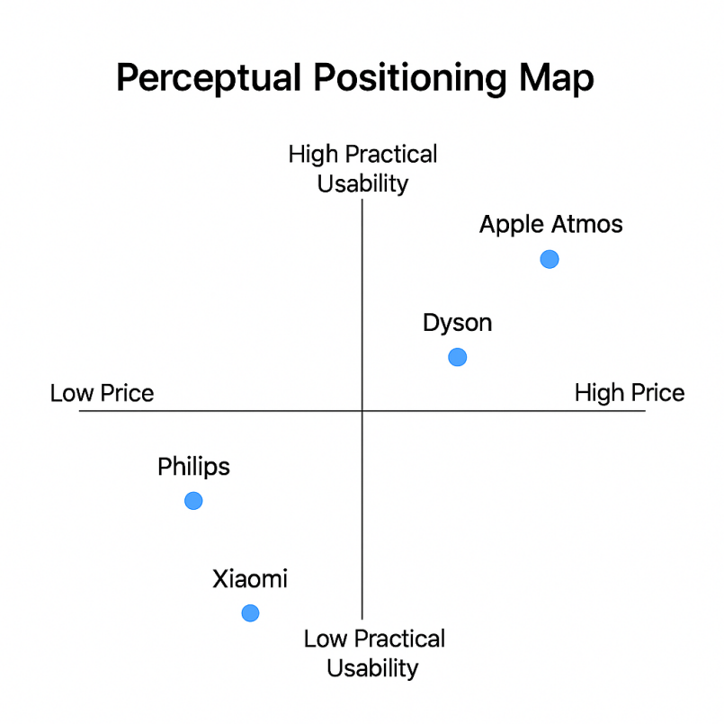
Figure 1: Perceptual Positioning Map
(Source: Self-developed)

The brand is functional in providing automatic and high-efficiency air purification with the ability to purify up to 2,000 ft in an hour, real-time air-quality monitoring and smartphone/Watch control. Psychologically, it gives tranquility of mind, the beauty of enjoying and the glory of possessing a well-made product in the Apple universe. Apple Atmos has a positioning map (see appendix) where it occupies the high design premium, high ecosystem connectivity quadrant (versus low-design/value purifiers, such as the mid-range Xiaomi, and feature-intensive visual less refined competitors, such as Dyson models). Apple Atmos finds a unique niche between wellness-tech and high-end lifestyle by focusing on the synergy of the ecosystem + design + sustainability.

3. Element 2: Marketing Mix (4Ps)

Marketing Mix (4Ps) | Description
Product | Apple Atmos 360° Air Purifier features NanoFiber True HEPA filtering, 360° air intake, AI-driven monitoring, and HomeKit integration. Variants include Mini, 360 and Pro. Designed for wellness, sustainability, and premium living.
Price | Premium pricing strategy (£299–£699) reflecting innovation and Apple quality. Supported by AppleCare+, filter subscriptions, and flexible financing to reinforce value perception.
Place | Distributed via Apple Stores, Online Store and selected retail partners worldwide. Integrated logistics ensure fast delivery and Apple-standard after-sales service.
Promotion | Key message – “Breathe the Apple Way.” Promoted through digital campaigns, keynote events, and wellness influencers. CSR focus on energy efficiency and recyclable filters.

Table 1: 4 Ps of Marketing Mix
(Source: Self-developed)

3.1 Product – Features, Design, Technology
The concept of a new brand, Apple Atmos, is of a highly sophisticated smart home air-purifier brand, an integration of a high-tech product, high-design, and high-wellness features. Its main characteristics are a NanoFiber True HEPA filter that can provide 360 degrees air intake and filtering up to approximately 2,000 ft in one hour; WiFi and Apple HomeKit/Siri support that lets the device automatically sense the air quality and be voice activated; ultra-low noise (less than 30 dB) and recyclable and energy-efficient advancements to indicate its sustainability values. Variants of the product are Atmos Mini (small rooms/bedrooms), Atmos 360 (living spaces), and Atmos Pro (large open-plan rooms or luxury suites). Its design language is a copy of the minimalist aluminium-fin look of Apples purifier which enables the purifier to serve as a life-style device, rather than an appliance. This innovation-driven product is in line with the trends that focus on wellness at home and the consumer preference of smart-home health products (Kapferer and Bastien, 2012) and forms the foundation of differentiation based on health, connectivity and design.

3.2 Price – Premium Pricing Rationale, AppleCare+ & Financing
Apple Atmos uses a premium pricing approach based on the brand equity and design leadership and technological integration to charge a higher price and indicate exclusivity. The studies suggest that willingness-to-pay premiums can be maintained by strong brands that have distinctive qualities and brand power (Wong and Merrilees, 2024). Pricing levels may be in the following way, Atmos Mini GBP299, Atmos 360 GBP499 and Atmos Pro GBP699. The additional support comes in the form of AppleCare+ filter subscription, warranty and financing options through Apple Card. This strengthens value perception and the overall Apple brand with high service quality and ecosystem. Pricing research confirms that the customer retention and brand loyalty are stronger when the value perception is equal to the price (Padamali and Fernando, 2016) and it needs to be aligned with brand positioning to prevent loss of trust (Gao and Zhang, 2023). Apple Atmos maintains its luxury-tech branding and warrants high margin back by pricking high above mass-market competitors and offering ecosystem-providing services as a bundle.

3.3 Place – Omnichannel Distribution & Global Roll-out
Apple Atmos distribution is based on an omnichannel strategy, which involves both direct channel and retail channel. It will be sold in the Apple Stores, Apple Online Store and the chosen high-end retailers with the help of which smooth integration between online ordering, in-store demonstration areas and home delivery/installation services will be offered. Consumer electronics empirical literature demonstrates that customer experience and satisfaction in relation to the use of omnichannel retailing are improved when channel integration is performed properly (Thaichon et al., 2024). A typical logistic process involves delivery through Apple distribution centres, delivery to home/delivery to store, and delivery returns/service through the Apple service network, which is the integration of backward/forward channels as Hubner et al. (2016) describe. The international product launch will focus on the large urban markets (US, UK, Japan, Canada) and then on the rapidly developing smart-home markets (South Korea, Singapore, UAE) to assist in premium positioning and consistency of the worldwide Apple ecosystems. After-sales service network incorporates repair networks such as changing filters through subscription, IoT updating the firmware through iCloud and local service centres in order to facilitate maintenance operations which are used to strengthen the high-touch premium experience.

3.4 Promotion – Key Message, Campaign Channels, Ecosystem Integration
The general idea of the promotion of Apple Atmos is: Breathe the Apple Way. This launch program will be carried out on Apple keynote events, digital social-media teasers (Instagram, Tik Tok), and influencer relationships in the wellness/home design, as well as interactive in-store demonstration where the customer is exposed to air-quality displays using iPhones and Apple Watches. It is focused on integration into the Apple ecosystem: i.e. notifications in Apple Watch when air-quality is bad, Siri voice-activated Purify now, and cross-promotion using Apple Fitness+ and HomeKit newsletters. This is a strategy that cuts across health, lifestyle and technology. Recent studies suggest that marketing communications should focus on experience, the value of brand ecosystem and sustainability to attract the premium consumer (Gao and Zhang, 2023). CSR messaging (e.g., recyclable filters, low-energy mode) and sustainability will also be featured to address the growing demands among the consumers to have eco-responsible brands. The promotional channels will focus on the digital and experiential touchpoints, which will be in line with Apples philosophy of developing brand-based craving rather than price-based decree.

4. Element 3: Marketing Strategy Pitch
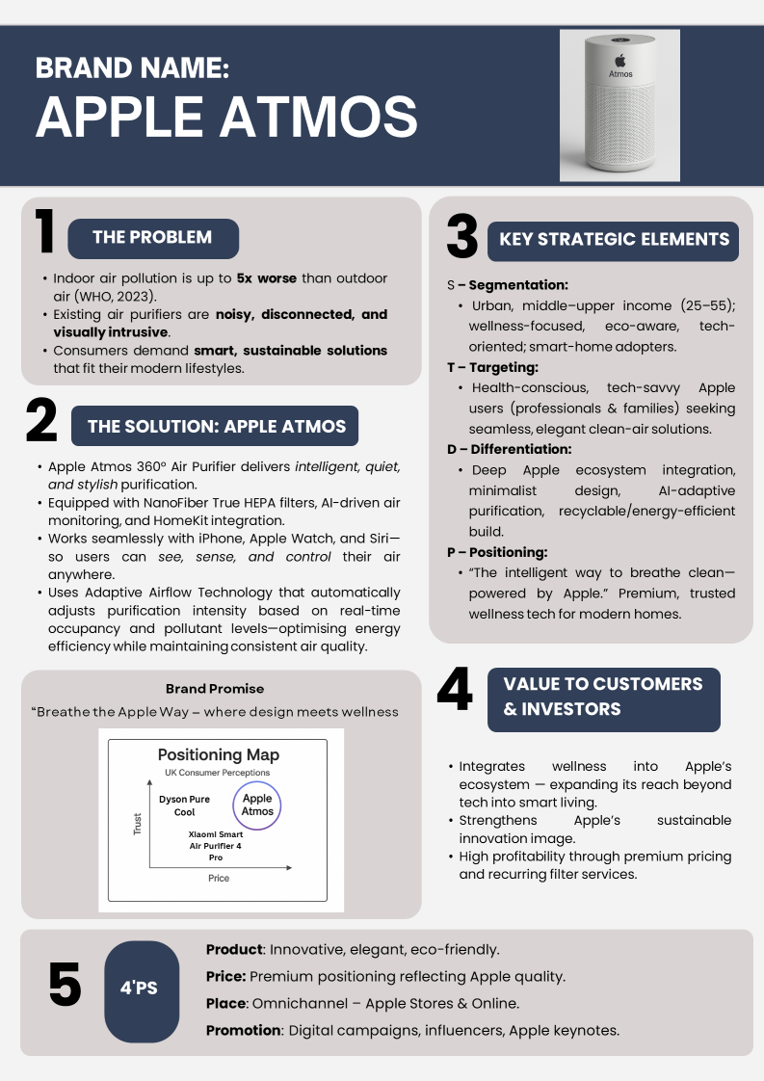
Figure 2: Poster
(Source: Self-developed)

Explanation of the Poster
The Apple Atmos poster is a graphic summary of the most important marketing strategy of the brand and the way it combines innovation, wellness, and sustainability. The design is based on Apples minimalist aesthetic including clean design, white space, and simple typography to demonstrate sophistication and confidence. It precisely outlines the issue of increasing indoor air pollution and suggests Apple Atmos as the smart remedy to the problem with the help of AI-controlled purification, the creation of an Apple ecosystem, and 360 degrees filtration. The poster conveys the positioning of the brands- Breathe the Apple Way and how it provides high-quality value to consumers, who are tech-savvy yet health-conscious. In general, the poster is well-integrated in terms of its strategy, design, and purpose to make a case to both customers and investors.

5. Element 4: Reflection

5.1 Learning Experience
The creation of the Apple Atmos brand has helped me gain more knowledge about the STDP framework (Segmentation, Targeting, Differentiation, and Positioning), as well as the 4Ps marketing mix. I gained the skills of how to translate the formulas of theoretical marketing in a consistent brand strategy that mirrors the consumer needs and market trends. The use of STDP assisted in the discovery of particular market segments and positioning Apple Atmos as a technology-integrated product that is health-oriented. The 4Ps also helped me develop a balanced approach between product innovation, high price, omnichannel distribution, and integrated promotion.

5.2 Skill Development .
In the course of this project, I enhanced some critical professional and academic competencies that are important in marketing practice. The strategic thinking skills arose due to the study of market trends and the development of a logical brand orientation. My creative skills in branding were honed through my ability to create convincing positioning statements and crafting campaign messages that were in line with the identity of Apples. The second effect was on my data analysis skills because I evaluated consumer trends in health technology and sustainability. In addition, the project sharpened my team and communication skills since I helped in integrating the different views to form a single marketing plan. On the whole, these experiences promoted analytical accuracy and innovation, which is essential in the future in marketing positions.

5.3 Future Improvement
When preparing and giving the marketing pitch, I learnt that I need to be precise and clear with the storytelling and use it as a visual representation. Though my pitch was effective in communicating the key ideas, the future brand project would require additional empirical market data and be more consumer-insightful. I also seek to improve my presentation and persuasion abilities by incorporating more potent visual narration and the means of audience engagement. Also, the time management will be refined on project stages to facilitate easier coordination. Altogether, the project has revealed the points of constant improvement in the synthesis of creativity, evidence-based approach, and confident communication to achieve effective brand marketing results.

6. Conclusion
Apple Atmos project is a successful example of how the STDP framework and the 4Ps marketing mix can be implemented to promote a new product in accordance with the recent trends in consumer behavior. The brand is taking advantage of Apples innovation, high-end design, and integration into the ecosystem by appealing to the health-aware and technologically inclined consumer in order to develop a specific niche in the market. The integrated approach of product design, pricing, distribution and promotion helps to strengthen the idea of sustainability and lifestyle improvement which Apples follows. Finally, Apple Atmos would provide great benefits to Apples portfolio as it would venture into smart wellness sector, enhance its innovation reputation, and facilitate its ability to enhance future growth in connected home technology.

7. References
Chang, J.H., 2025. Secret power of the product ecosystem: A network-theory perspective on Apple. Journal of Business Research.
Gao, R. and Zhang, J., 2023. On the Importance of Pricing Strategy in Marketing Strategy: A Case Study of Lululemon. Frontiers in Business, Economics and Management, 10(1), p.158.
Hübner, A., 2016. Distribution systems in omni-channel retailing. Operations Research Perspectives, 3–4, pp.1–10.
Kapferer, J.N. and Bastien, V., 2012. The Luxury Strategy: Break the Rules of Marketing to Build Luxury Brands. 2nd ed. London: Kogan Page.
Khalid, M.A. and Vida, V., 2023. Strategic Marketing Plan for Apple Inc. Network Intelligence Studies, XI(21), pp.63–75.
Lin, J.Y., et al., 2025. Factors Influencing Consumer Buying Behavior for Smart Home Technologies. Sustainability, 17(7), p.2992.
Mordor Intelligence, 2025. Smart Home Air Purifier Market – Growth, Trends, and Forecasts (2024–2029).
Padamali, G.M. and Fernando, P., 2016. Product Attributes and Premium Price Strategy: A Study of Tea Consumers in Middle and High-End Markets. SSRN.
Stellar Market Research, 2025. Global Home-Use Air Purifier Market Report.
Thaichon, P., Quach, S., Barari, M. and Nguyen, M., 2024. Exploring the Role of Omni-Channel Retailing Technologies: Empirical Insights and Future Research Directions. Australasian Marketing Journal.
Wong, H. and Merrilees, B., 2024. Crafting Robust Brands for Premium Pricing: Understanding the Role of Brand Attachment, Brand Strength, and Brand Loyalty. Journal of Brand Management.
World Health Organization (WHO), 2023. Household Air Pollution and Health.
Zou, Y., 2023. Apple’s Brand Marketing Strategy: A Case Study on Brand Image and Customer Engagement. Highlights in Business, Economics and Management, 23, pp.712–715.

