Connor Osborne (1800742)
University of Wales Trinity Saint David
Database Design (accb4013)

Contents
Design 1
Supplier 1
Staff 1
Staff Order 2
Customer 2
Customer Order 3
Stock 3
ERD 4
Table 5
reports 7
Forms 7
Main 7
Book 8
Customer 8
Customer Orders 9
Staff 9
Staff orders 10
Supplier 11
User guide. 11

In this report the writer will be designing and making a database for a bookstore. The database will need to be menu driven and the user needs to be able to view books, stocks and customer information and add and delete information. The database also needs to be able to transfer their previous database which is a collection of customer names and addresses typed into a word document.

Design

Supplier

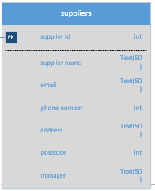
Suppliers is the table used to store data such as which business they will use to make orders. As the orders are made to the store, the table is useful as it allows for orders to be made easily. The field that is used is mainly for contacting the supplier as the order is made from the table for the store. The fields used are supplier ID, supplier Name, email, phone number, address, postcode, manager. This is mainly with the order for placing it with the supplier. No foreign keys are used with this table as it is solely for storing information from different tables.

Staff

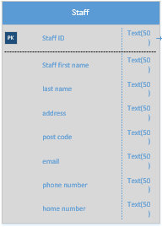
Next, we have the staff table. The staff table is used to store the information of the staff. The fields mainly contain information to contact the staff member. The primary key is the staff ID as that would be used to allow the staff to access the system. No foreign keys are used as the table is mainly storing the staff member information.

Staff Order

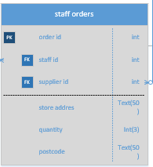

Here we have the staff orders. This table is used to record order made by staff to the store. The fields used are to store the books that are bought. The fields such as store address and postcode are to know which store the books are going to. The primary ID is the order ID. This is done so that when the user orders to the store the data is stored. The foreign keys used are staff ID and Supplier ID so that with the order they know who made the order and from where.

Customer

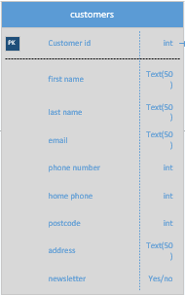
This table is for the customer information to be stored. This is used to know where the person lives and to send their books to them. The fields used are mainly used to contain the information of a user. A newsletter field is added so a query can be made to know who to send the newsletter to. No foreign keys are used as the table doesn’t link to any other table. the design meets the requirements as the user information can just be added from the word document they have.

Customer Order

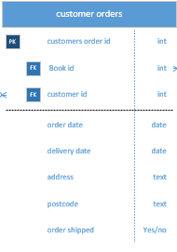
Customer orders is used to store what the customer orders. The only fields that could be redundant is delivery date and also order date. Order date can be seen as useful as it is used to know when the order was made and shipped can be used to notify the customer that the book is on its way. The table relates to the stock table as the book id is used to know which book to check in stock and find the book.

Stock

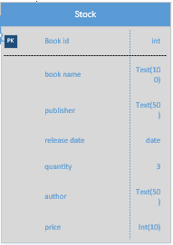
Here we have the stock table. the stock table is used to know what books are in stock and their price are stored. The fields are used to store when the books are released, how many and the cost of them. No foreign keys are used as the table is done by itself.

ERD

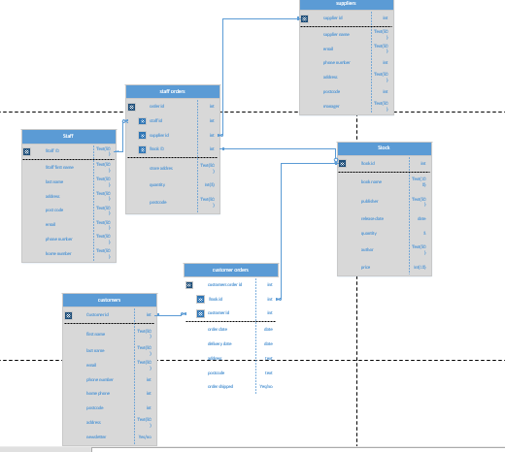
This table overall meets the user’s requirements as the database as a stock id with the names of books, quantity and price. The database also has the customerID and a table for customer orders.

The design meets the user’s specification as they mainly have a collection of names and addresses. This can simply be imputed into the database with only needing to know their number and if they want the newsletter. The database meets the requirement with if the book is first edition and normal copies. This would be added into the title so B001 could be the first edition and B002 could be the normal one. A staff order table is used to order the books they want in a table and then order them at the end of the day. A customer order table is made so that a customer could ring, give them their ID and book name in which the book is ordered like that. The database meets almost all the requirements as some changes could be made to make it better.

Table
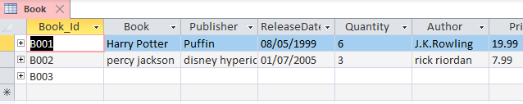
Here we have the book table. The original name was going to be stock but was later changed to book table. The fields are the same as in the erd above as the changes are not needed as the minimum was already in the table.

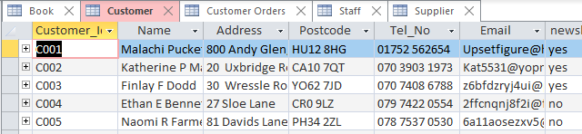
Next, we have the customer table. Unlike the erd design. The home telephone and mobile numbers are changed into one field. As people are commonly glued to their phone, it was more important to keep the mobile number, as it is a more reliable option.

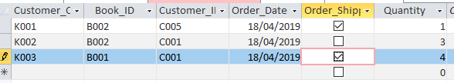
The customer table was reduced of some fields. This was done so that reports can be used to see what books are ready to be shipped. This can then be done so that a report can be made of who ordered what book and their address.

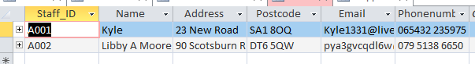
Next, we have the staff table. The staff table has the basic information such as their name and address. As not many people work there a last name and first name is not needed. A field that could be added is emergency contact information.

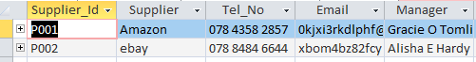
Finally, we have the supplier table. This table mainly contains the Email and telephone number of the supplier. This is the basic table to contact the supplier as the orders are made by contacting them by phone or email. 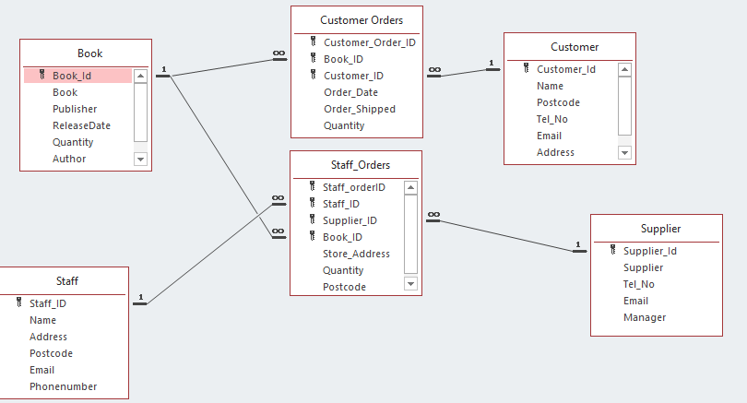

This relationship diagram connects all the tables together. The staff orders and customer orders are the bridge table to connect the table. the customer orders and staff orders have multiply keys added to them which in return they need to be filled out with all fields filled.

reports

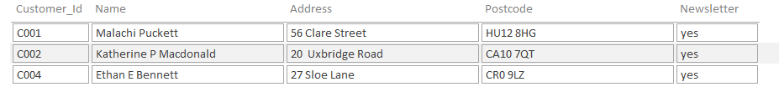
This report is used to know who wants the newsletter and where they live. This is done so that they know where and how many to send to people.

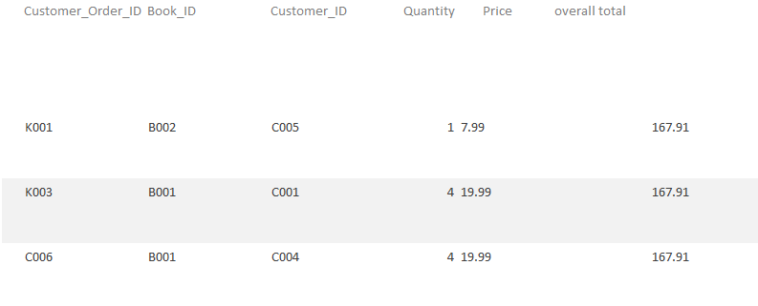
This report is to know todays profit. This is done to know who ordered what and how many of the books and get a total that sadly appears at the end of all the fields.

Forms

Main

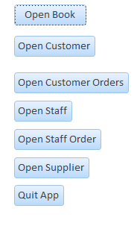
Here we have the main form to navigate the database. This is used to navigate between forms and so on. An option to shut down the form was added to allow a person to completely shut down the form. This was mainly added to the main form to avoid the mistake of people closing the form when adding data.

Book

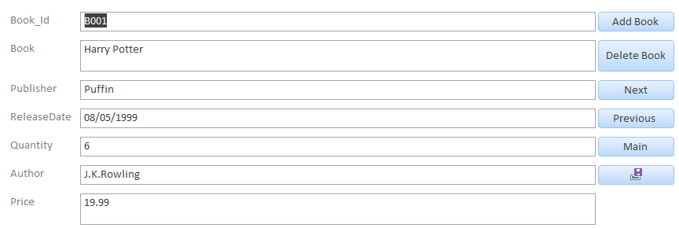
Next, we have the book form. This form has the basic data that needs to be added and then we have the buttons. The first two are to add and delete books. Then we have next and previous which are used to navigate the data base. Then we have main, this button is used to go back to the main menu. Finally, we have the save button. This is used to save the newly added book to the data base.

Customer
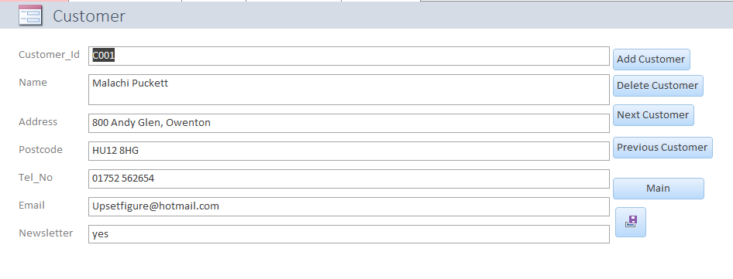

Here we have the customer Form. The customer form has all the customer details such as Name and postcode. The details are all required as the information is needed as the data would be used to create a report. The buttons on the side are used to navigate the form as you have add customer and delete customer to add another customer or delete them. You then next and previous to look through them. Finally, you have main and save to save the customer added and main to go back to the main page.

Customer Orders

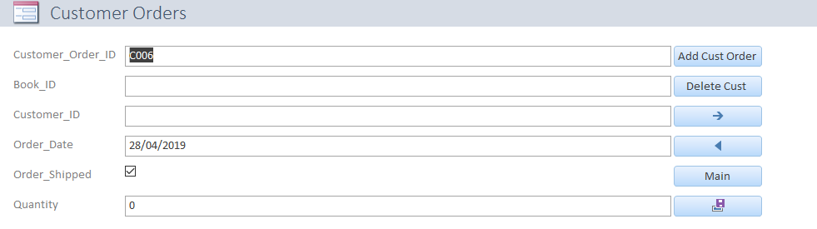
Here we have customer order. The form used as the Order ID, Book ID and customer ID. This is done so that a report ca be made to know what book is being send to whom. The order date and order shipped are to be known when it was ordered and to send a message to the person that the book is shipped. All the buttons are the same except that next and previous are switched with arrows going back and forward.

Staff

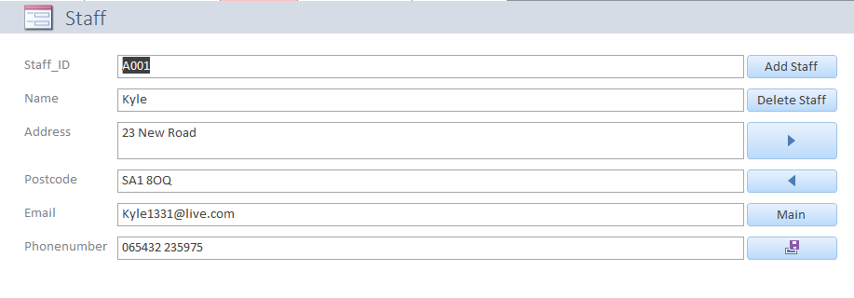
Here we have the staff form. This from unlike the customer one has a reason to only have the name field. This is because only three people at max would be working there. The next and previous fields are changed to arrows pointing and are the same instead of the customer order.

Staff orders
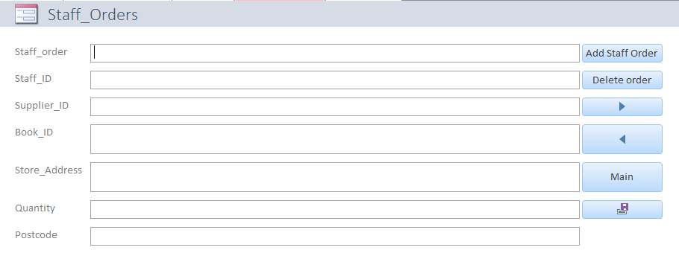
The staff orders table is the most annoying to use as three foreign keys are used when making an order. This is mainly done as the store may want to add in more books and they need the staff ID to know who made the original order.

Supplier
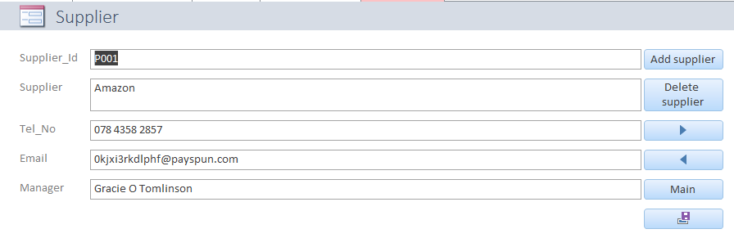
Finally, we have the supplier form. This form is mainly adding what the supplier are. This could be major stores or buying books from certain people. This form isn’t that big as it all depends on the people, they are getting them from.

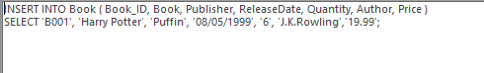

This screenshot is information being added with SQl. The information added is the B001, Harry potter, puffin, 08/05/1999, 6, J.K.Rowling and £19.99

User guide.
When you open the application, you should be greeted with a screen that looks like this.
From here you can navigate to multiple forms to complete certain navigations. To look at books you need to click on open books. This page will load.
The book ID starts with B001 as the first book and progresses with B002 and so on. The next field is Book which contains the same of the book. From here you would contain the full name and in bracket if it is first edition or not. The publisher field is the company that released the book. This is done so that a person could ask If they have any books from that publisher. You then have the release date. This is needed to know when the book came out. The price is then how much you are selling the books for.

Next, we have the navigation. Add books is for allowing new data to be added. This is about all the data that can be seen above. Next is delete book. This is to delete books on the data base. This is mainly added in case a new book comes out but is immediately recalled or some data is added in wrong. Next and previous are to navigate between the books. Main is to return to the main menu and to proceed from their and finally we have the floppy disk. This is to save the new book. After the books are added, you can go back to the main page and go to a different form.

From the main menu you can go to the customer table. on the customer table the navigation is the same as the rest. The first is Customer ID starts with C001 and so on so forth. The other fields are the basic fields that need to be filled for a person such as name, address and postcode. These are the fields used to send the books in the mail. The address field includes the house number, street and city. The next two fields are the contact information such as telephone number and email address. The final field is newsletter which is uses a yes or no to determine who wants the newsletter.

Next, we have the staff table. The staff table navigation is different with the fact that the next and back are arrows pointing ether way. The way that the staff table works is almost the same except the staff ID is different. The staff ID has been set as A001 as it is the first table that would have the data stored.

The next table is the customer orders. The navigation is the same as the other tables. The order ID uses K001 as the starting ID. Next, we have the book Id that needs to be filled in. this would be done as by copying the ID when the user asks for the book to be found first. The customer ID is then added from the customer and then the quantity is put in. the order date is the day that the order was made and then the order shipped is ticked when the order is shipped.

The next form is the supplier table. the supplier ID starts with P001. The rest of the details are how to contact the supplier when making the order using reports and queries to know who to make orders to.

Finally, we have Staff order ID. The first field is staff order ID. This field has yet to be filled so the starting letter can be anything. The staff, supplier and book ID are to know who ordered what from there. The final three fields are which store it is being sent to and how books are meant to go.

In conclusion. The database meets the requirements from the bookstore as the database is menu driven, allows for the names of books to be searched and some system flexibility. The user can add and delete information, view all relevant tables and view on going orders. Overall the database meets the customer requirements.

