Reflective Review on Employability Skills (report)

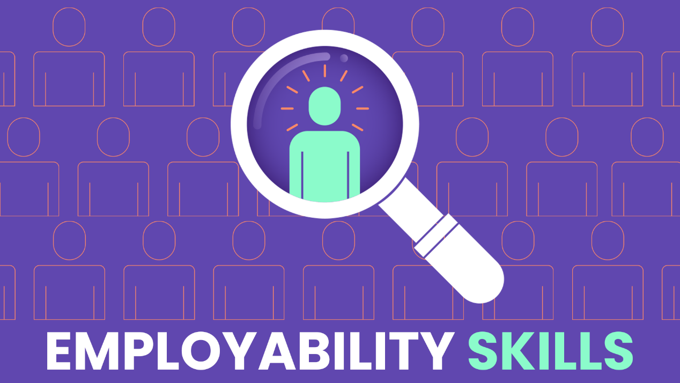

Student Name | Farhana Musharrath Tahura
Student ID | 2109147
Module Code | BMSW4001
Assignment Section | Task 2
Lecturer | Alex Worth

Table of Contents

Introduction 3
Employability Skills 4
Presentation 4
Teamwork 5
Research 5
Gibbs Reflective Cycle 6
Feedback 8
CRAAP 10
The 4 Ds of Time Management 11
Personal Development Plan 12
References 13

Introduction

This module has helped me to understand, learn and develop a range of employability skills such as: presentation, teamwork, and research skills and more. I will be explaining what employability skills are and why they are desired by employers or educational institutions then I will be going through how I used these throughout my time doing this module and if and how I have used these skills to improve my overall work ethic. I will then be moving onto explaining what Gibbs model of reflection is and how I used it then explaining what feedback I received for my presentation on the 4 Ds of time management and my feedback from my first assignment too. After which I will explain how I used the CRAAP test and the 4 Ds of time management. Lastly, I will go over my personal development plan where I go over what my strengths are and what my weaknesses but also what I will do to target those areas I lack in and how I intend to use my personal development plan in the future to improve my time management skills.

Employability Skills

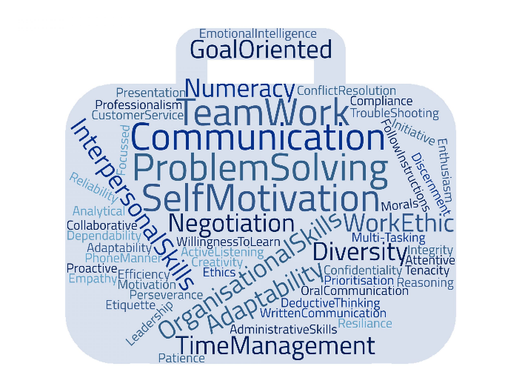
Employability skills are skills that are very important for your future they are skills that employers look for when hiring. Employers look for these skills because it lets them know that you are right for the job and that you will do it well Nisha and Rajasekaran explain this as “Employability skills mold students’ career by helping them in building and improving their communication skills, presentation skills, teambuilding skills, leadership skills, time management skills, interview skills and interpersonal skills.” There are soft skills and hard skills, soft skills are defined as personal traits and skills that employers look for when hiring (Nisha, and Rajasekaran, 2018, p. 1) Then there are hard skills which was described well in an article “Employability Skills That Recruiters Demand” by Mishra it was said that “Hard skill can be measured. Hard skills are the teachable abilities like singing, dancing, and knowledge of foreign languages, typing, software knowledge to handle, and operating machines.” (Mishra, 2014, p. 2)

Presentation

Presentational skills are very important it is the ability to confidently and clearly speak in front of an audience and is the most transferable skill, it is required when applying to jobs and it may be needed for a job where presentational skills are part of the job role and during academic work too. (Emden and Becker, 2016 p. vii) This module has helped me gain presentation skills by making me team up into a group and present in front of other students this was a good way to practice and let me know what I can expect later in the future. I now know to speak slower and more clearly, to make eye contact and to have better body language when presenting and because I know all this, I will be able to do much better next time round.

Teamwork

Teamwork is working together in a group of people with the same goal, being friendly with them and committing to your work in the group. (Mueller and Procter and Buchana, 2000, p. 2) My teamwork skills have improved throughout this module after having been placed in a group and having to communicate with my team members to get the work done. We had to do the work ourselves which made us rely on one another more. We communicated well whilst in class and decided who would do what for our presentation. Although my teamwork skills have improved since the start of the term and my team and I communicated well in class, we still have plenty of room for improvement such as communicating outside of the class to help each other and make sure we do the best we can for whatever project we do.

Research

Research skills are simply put finding things out. You should do research before buying something so you know you’re getting your money's worth whether it be for the price or quality although the research done wouldn’t give a definitive answer as to whether you should buy that item or not because at the end of the day you still have the final say. (Allison et al. 2016, p. 3) My research skills have strengthened the most out of all the employability skills I’ve mentioned and the ones I haven’t mentioned. Since starting this module I have learnt where I need to look for references. I now know how to use Google Scholar and other resources such as the university library much better than when I first started. I have a better understanding of how things work, and I am positive I will keep improving with time and practice.

Gibbs Reflective Cycle

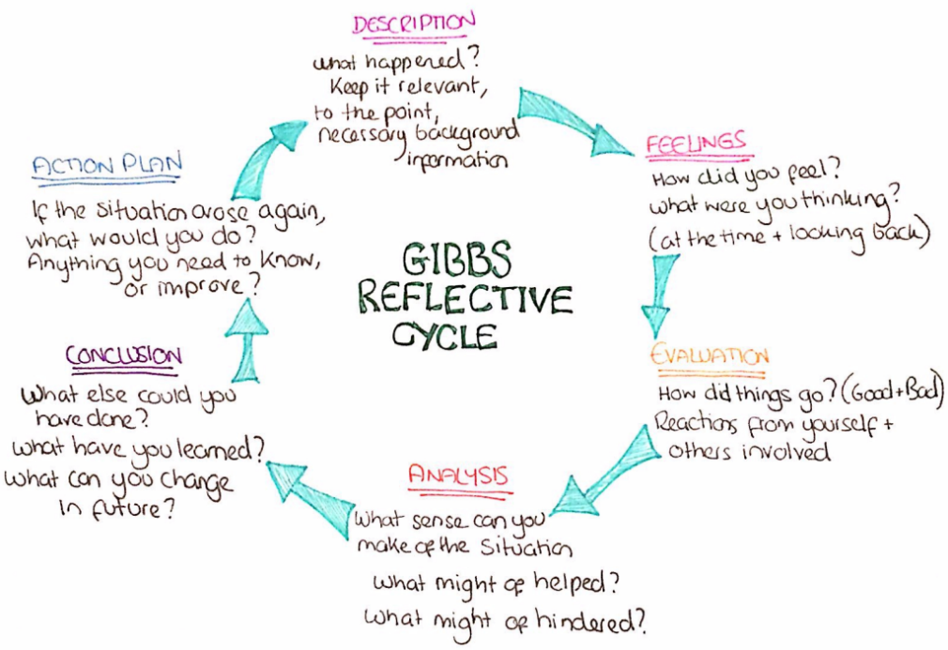
Graham Gibbs developed the theory Gibbs reflective cycle in 1988 which suggests that the person needs to go through an experience to be able to reflect on that experience. (Husebø and O’Regan and Debra Nestel, 2015, p. 2) Gibbs reflective cycle contains 6 steps: the first step is to describe what happened then you will need to say how you felt and what your though process was during that moment, after that evaluate the good and bad, analyse why did things go well or bad? The fifth step is the conclusion what have you learned and lastly the action plan what will you do differently. I used the Gibbs reflective cycle method during my presentation with my group during a class activity where we got into groups and discussed Donna’s time management issues. My group and I decided to each answer one question there were three questions and as there were three of us, we each took one, my question was to identify and list Donna’s time management problems. We hadn’t prepared much other than the one day in class when the groups were chosen after that we didn’t communicate. Throughout the day I had been nervous because I had never been good at presentations although looking back, I shouldn’t have been so nervous as most of the class were doing online classes so there were only around ten people in the room. When it came our turn to present, we went one by one whilst other teams after us had gone up together as a team this was because we hadn’t discussed how we would present our work if we were going to present together or separately and because we were the first group to present in class we didn’t know how others would present theirs, we were unprepared. In my group I went second whilst doing the presentation I felt as if we hadn’t prepared much and so I spoke too fast and didn’t make enough eye contact due to being up there myself I felt as though I was more nervous than I would have been had my group presented together. I couldn’t tell if things had gone good or bad during my presentation because I had been avoiding looking at others and although I didn’t do terribly as I did get my point across, I think being in front of everyone as a group would have helped my nerves settle. I’ve learned that I need to speak slower, stop to breathe, and make eye contact with people in the room and if I were in that situation again, I would know to communicate with my team more and practice, practice, practice.

Feedback

After presenting in front of my class and teacher my teacher gave me some feedback which was that I need to improve my body language whilst presenting, speak slower and take pauses and breathe. I had also told me what I did well in understanding what the task was asking for and that I had done the task well. During my first assignment before my teacher left and was replaced by another, I had been given feedback by the first teacher on what I needed to add to my draft assignment one I had only started my assignment that week, so I hadn’t had much time to prepare so there were a lot of things missing. The feedback mentioned that I needed to improve on the following I needed to include a table of contents, a suitable introduction that identifies my topic and if it mentioned the main concepts I will discuss, evidence that I had researched the topic, evidence of my points, if I had used recommendations and examples relevant to my assignment, did I answer the question, did my conclusion support my work and research, did the conclusion summarise the main points if I used different forms of research and lastly if I had edited and proof read my work at the end. Everything that had been ticked in the box of need for improvement I had corrected. The feedback helped me see what I needed to add which made doing the assignment easier because I knew what was needed to be done to improve.
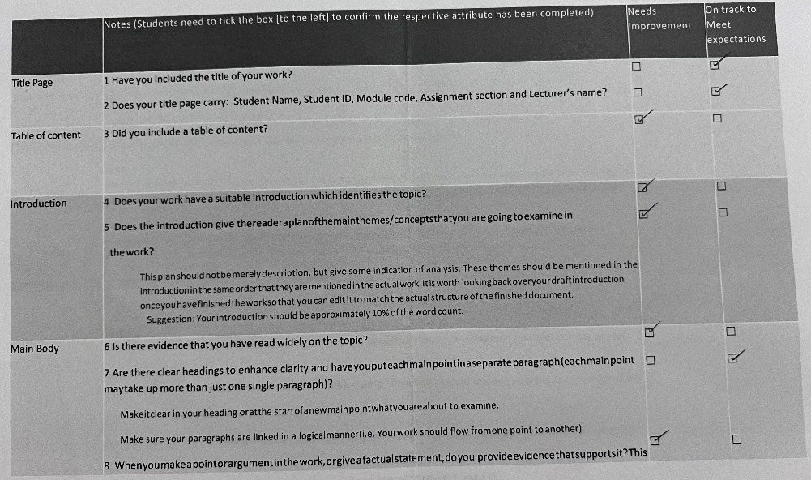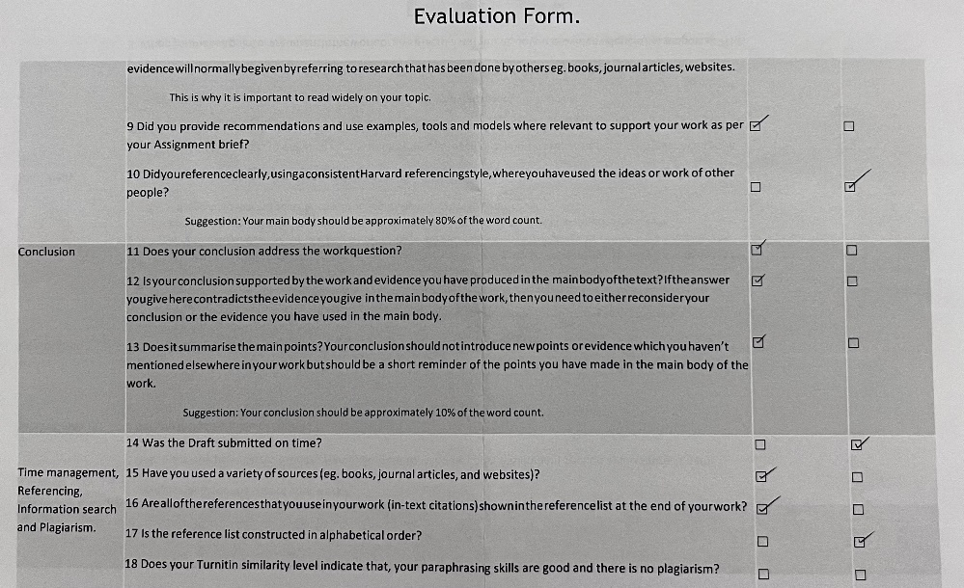
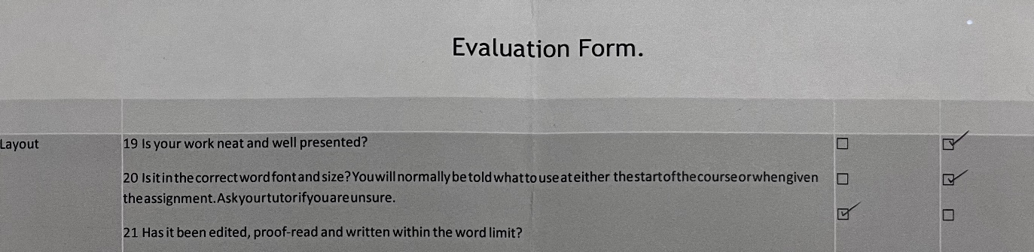
This is my evaluation form from assignment one.

CRAAP
The CRAAP test is an acronym for the word’s currency, relevance, authority, accuracy, and purpose. It is like a checklist to make sure that the information you acquire is reliable for your needs. It makes you check if the information is current, relevant, who the source is, the accuracy and the reason as to why the information to exists. It was created by Sarah Blakeslee it’s short and simple which makes it easy to remember. (Blakeslee, 2004, pp.1-2) I used the CRAAP test whilst researching sources for my assignments. I thought that it was a good tool to use because it’s a checklist to make sure you’re getting sources that are relevant for your needs. I think it’s fairly simple to use and memorable, so you don’t forget it when you need it.

The 4 Ds of Time Management
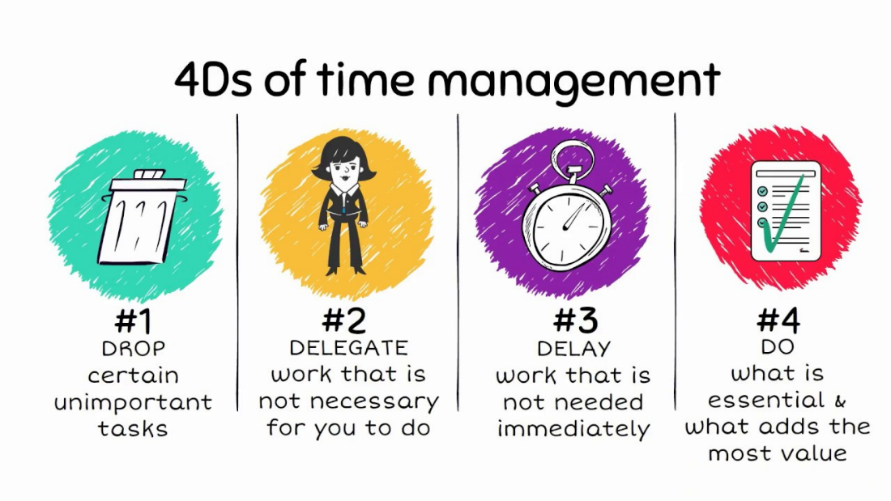
Drop, delegate, delay and do are the 4 Ds of time management this strategy helps you figure out which tasks to prioritise and which can be done at a later date. Drop any tasks that aren’t important, delegate is to give a task to someone else to do because it won’t matter who does that specific task, you should delay any work that doesn’t require your attention straight away and do your important tasks first. (Collins, 2018) I used the 4 Ds of time management during my presentation with my group it was simple and straight to the point and one of the easier models to use.

Personal Development Plan

Target | Action Plan | Achieved By
Presentation | Prepare more ahead of time practice using more eye contact | Next term
Teamwork | Communicate more with team members | Next term
Research | Research | Next term

I intend to implement my personal plan as soon as possible but a realistic and set date I hope to achieve these targets by the next term.

References

Allison, B. and Hilton, A. And O'Sullivan, T. and Owen, A. and Rothwell, A. (2016) Research Skills for Students. Routledge. Available at:
https://www.google.co.uk/books/edition/Research_Skills_for_Students/r9dqCwAAQBAJ?hl=en&gbpv=0 (Accessed: 4 December 2021)

Blakeslee, S. (2004) The CRAAP Test. California State University, Chico Available at:
https://commons.emich.edu/cgi/viewcontent.cgi?referer=https://scholar.google.com/&httpsredir=1&article=1009&context=loexquarterly
(Accessed: 5 December 2021)

Collins, B. (2018) How To Use The 4 Ds Of Effective Time Management. Forbes. Available at:
https://www.forbes.com/sites/bryancollinseurope/2018/06/14/effective-time-management/?sh=1cce948f1938 (Accessed: 5 December 2021)

Emden, J.V. and Becker, L. (2016) Presentation Skills for Students. Macmillan International Higher Education. Available at:
https://www.google.co.uk/books/edition/Presentation_Skills_for_Students/yGFLDAAAQBAJ?hl=en&gbpv=0 (Accessed: 4 December 2021)

Husebø, S.E. and O’Regan, S. and Nestel, D. (2015) Reflective Practice and Its Role in Simulation. Clinical Simulation in Nursing. Available at:
https://www.sciencedirect.com/science/article/pii/S1876139915000389 (Accessed: 5 December 2021)

Mishra, K. (2014) Employability Skills That Recruiters Demand. IUP Journal of Soft Skills. Available at:
https://web.s.ebscohost.com/ehost/detail/detail?vid=0&sid=16d575df-64a9-4cf4-a2b9-9209d8e50a5d%40redis&bdata=JnNpdGU9ZWhvc3QtbGl2ZQ%3d%3d#AN=99267879&db=bth (Accessed: 3 December 2021)

Mueller, F. and Procter, F. and Buchana, D. (2000) Teamworking in its Context(s): Antecedents, Nature and Dimensions. SAGE Publications. Available at:
https://journals.sagepub.com/doi/abs/10.1177/00187267005311001?casa_token=FcLAWWAStrIAAAAA:yrX-HfqlVt9E5KVNl7SNE6L9kB4NgDAmgOm63rgTSidvq1pP-K8lZ76xpnkTggSdURxpPxxTAPA (Accessed: 4 December 2021)

Nisha, S.M. and Rajasekaran, V. (2018) Employability Skills: A Review. IUP Journal of Soft Skills. Available at: https://www.proquest.com/docview/2027474049?pq-origsite=gscholar&fromopenview=true

