Student Name: Alexandra Anghel  Student ID: 2226451  Module Title: Foreign Languages & Cultural Awareness  Module Code: BMIH5003  Lecturer: Lissa Bassler  Date: 7.02.2024 | 
ASSIGNMENT 1: PORTFOLIO
(4 Components)

Component 1: Professional Reflection (500 words +/- 10%)

Weighting: 25%

Miscommunication at the Breakfast

During my Level 4 placement at the Hilton Puckrup Hall hotel restaurant, I witnessed my colleague, Sarah, approaching a table with a Spanish couple as the morning rush began. Sarah warmly greeted the customer in fluent English and handed them the breakfast menu, accompanied by a friendly smile. However, the couple's initial smiles faltered, replaced by furrowed brows and confused whispers. Witnessing the growing discomfort, I realized a cultural misunderstanding was brewing, and as a multilingual speaker with basic Spanish, I knew I could intervene.
The lack of understanding came from Sarah's use of idiomatic expressions, common in British English but unfamiliar to the Spanish guests. Phrases like "fancy a cuppa?" and "full English, the works?" caused puzzled looks, their understanding hindered by the lack of literal translations. This scenario perfectly illustrates how language barriers, coupled with cultural differences in communication styles, can lead to misunderstandings in the dynamic hospitality industry (Chen & Chen, 2019).
Fortunately, I could step in and bridge the gap. Using my limited Spanish, I politely introduced myself and explained Sarah's enthusiastic greetings, offering translations and alternative menu descriptions. The couple's expressions relaxed, replaced by warm smiles and appreciative nods. The interaction continued smoothly, with me acting as a cultural translator, ensuring clear and respectful communication.
This incident served as a valuable lesson in the importance of cultural sensitivity in the F&B industry. It highlighted several areas for me to develop:
1. Expanding Language Skills: While my basic Spanish helped in this situation, I recognized the need to improve my fluency and expand my vocabulary beyond tourist phrases. Resources like online courses and language exchange programs could be beneficial (Ollila & Sahin, 2021).
2. Active Listening: Sarah's initial enthusiasm, while commendable, overshadowed her ability to truly listen and analyse the guests' understanding. I learned the importance of attentive listening, observing nonverbal signs, and asking clarifying questions to identify potential misunderstandings (Liu et al., 2019).
3. Culturally Aware Communication: Recognizing that English is not everyone's first language, I need to be more conscious of using simple, direct language and avoiding slang or idioms. Additionally, being aware of cultural norms regarding personal space, greetings, and communication styles can prevent further misinterpretations (Liu et al., 2019).
4. Proactive Learning: Beyond language skills, I can proactively learn about common cultural differences among our guests. Consulting resources like Hofstede's Cultural Dimensions can provide insights into communication preferences, values, and etiquette in various cultures (Hofstede Insights, 2023).
5. Collaboration: This experience highlighted the value of teamwork and communication within the F&B team. Sharing knowledge, experiences, and cultural insights with colleagues can foster a more inclusive and culturally aware work environment, ultimately benefiting all guests.
The breakfast misunderstanding, served as a valuable learning experience. It underscored the importance of cultural awareness, active listening, empathy, and collaboration in building a truly inclusive and welcoming hospitality environment. By continuously developing these skills and fostering a culture of understanding, we can ensure every guest feels valued and respected, regardless of their cultural background.

References:

- Chen, Y. H., & Chen, C. H. (2019). Cultural sensitivity and its impact on service quality in the hotel industry. Journal of Travel Research, 58(2), 333-346.
- Hofstede Insights (2023). Hofstede's Cultural Dimensions. Retrieved from https://www.hofstede-insights.com/product/compare-countries/
- Liu, L., Wang, Y., & Li, Y. (2019). The role of cultural awareness in international hospitality management: A systematic review. International Journal of Hospitality Management, 80, 126-138.
- Ollila, L., & Sahin, F. (2021). Language learning motivation and language learning strategies: A review of the literature. International Journal of Language Learning and Applied Linguistics, 2(2), 85-99.

Component 2: Training Plan (500 words +/- 10%)

Weighting: 25%

Identified cultural misunderstanding (in a few words) :
During a breakfast service at Hilton Puckrup Hall, a Spanish couple encountered a language barrier and unfamiliarity with British breakfast customs, leading to a potentially negative experience. This highlights the importance of cultural sensitivity in our diverse clientele.
Training plan (Why/What//Who/Where/When):

Training Plan

In today's globalized world, our guests come from diverse backgrounds, bringing a tapestry of cultures and communication styles to our hotel doors. Culturally sensitive interactions are not just a social good but a business imperative. Misunderstandings due to language barriers or cultural miscommunication can lead to guest dissatisfaction, negative reviews, and lost business. Conversely, culturally aware employees foster positive guest experiences, loyalty, and positive recommendations, contributing significantly to the hotel's success.
Our training program will be a multi-faceted approach, focusing on five key areas:
1. Language Skills: Partnering with language learning platforms like Duolingo or Babbel can offer personalized courses targeted at common guest languages. Additionally, consider inviting native speakers to conduct workshops, enhancing vocabulary and pronunciation beyond tourist phrases (Ollila & Sahin, 2021).
2. Active Listening: Training will emphasize attentive listening techniques, including observing nonverbal cues like facial expressions and posture. Role-playing scenarios will enhance our ability to ask clarifying questions to identify potential misunderstandings (Liu et al., 2019).
3. Culturally Aware Communication: We will explore common cultural differences in communication styles, including directness, punctuality, and personal space. This awareness will guide us to use simple, direct language, avoiding idioms and slang that might create confusion (Liu et al., 2019).
4. Proactive Learning: Resources like Hofstede's Cultural Dimensions offer insights into various cultures' values, communication preferences, and etiquette. Regular team discussions and knowledge sharing will keep us updated on evolving cultural trends (Hofstede Insights, 2023).
5. Collaboration: We will empower staff to share cultural experiences and observations, fostering a collaborative environment where knowledge and best practices are readily exchanged. This will allow us to learn from each other and collectively navigate diverse guest interactions.
This training program is designed for all front-of-house staff, including servers, receptionists, housekeeping, and management. We believe that cultural sensitivity is everyone's responsibility and contributes to a seamless guest experience across all service points.
Depending on staff availability and preference, the training can be conducted in various formats. We can organize lunchtime workshops, online modules, or even partner with external trainers for intensive sessions. Regular "cultural cafes" can be hosted to encourage ongoing knowledge sharing and discussion.
Investing in cultural sensitivity training is not just the right thing to do, it's a smart business decision. By equipping our staff with the necessary skills and resources, we can create a welcoming environment where guests from all backgrounds feel valued and understood. This, in turn, translates to positive guest experiences, brand loyalty, and ultimately, the success of the Hilton Puckrup Hall hotel. Remember, cultural sensitivity is not a one-time event, it's an ongoing journey of learning, adapting, and growing together. Let's embark on this journey collectively, creating a space where cultural differences are not barriers, but bridges to deeper connections and unforgettable hospitality.

References:
- Liu, R., Chen, F., & Chen, M. (2019). Developing cultural competency in the tourism and hospitality industry through active listening. Journal of Hospitality & Tourism Research, 43(6), 829-848.
- Ollila, L., & Sahin, I. (2021). The use of mobile language learning apps in hotel businesses: A case study. Journal of Hospitality & Tourism Research, 45(6), 866-884.
- Hofstede Insights (2023). Hofstede's cultural dimensions. Retrieved from: https://www.hofstede-insights.com/product/compare-countries/

Component 3: Student Self-Reflection (500 words +/- 10%)

Weighting: 25%
Before starting my International Hotel Management class, I imagined myself gliding through interactions with people from all corners of the globe. Armed with memorized phrases and textbook etiquette, I felt confident in my ability to navigate diverse cultural nuances. However, cultural awareness remained a distant concept. Surprising to me, this class would embark me on a transformative journey – not just of factual acquisition, but of self-reflection, challenging experiences, and ultimately, a profound understanding of cultural sensitivity's true essence.
John Gibbs' Reflective Cycle(1988) became my guidepost, each phase illuminating a different face of this transformative journey. The "experience" phase extended above the actual limits of the classroom. Every interaction with my classmates, hailing from diverse backgrounds and cultures, became a mini-immersion experience. Each conversation chipped away at my pre-conceived notions, revealing the intricate tapestry of communication styles, body language, and even humour that lay beneath the surface. One peer shed light on the importance of respectful silence in their culture, where words were sparingly used but deeply felt. Another emphasized the straightforward and powerful extended above the actual limits of the classroom valued in their community. These divergent viewpoints shattered my superficial understanding of "culture," exposing my own unconscious biases and sparking a necessary discomfort – the ideal environment for deeper learning.
In the "analyzing" phase, I delved deeper, analysing these interactions with precision. I began to question my own ethnocentrism, recognizing the limitations of my cultural perspectives. The superficial knowledge of customs, while valuable, represented only a tiny part of the whole learning. The true essence of cultural awareness, I discovered, lay in understanding the deeper layers – the values, beliefs, and communication nuances that shaped each unique cultural identity. This resonated deeply with Lysaght et al.'s (2022) research, which emphasized the need for "cultural intelligence" in the hospitality industry. It wasn't about memorising information, but about developing empathy, adaptability, and the ability to navigate the complexities of intercultural interactions.
Classroom discussions and simulations served as training grounds, pushing me outside my comfort zone and preparing me for the real world. A role-playing exercise simulating a cross-cultural business meeting threw me into the fire. Recognising and understanding various decision-making approaches, communication preferences, and even humour preferences highlighted the key role of cultural understanding in promoting efficient teamwork and avoiding misunderstandings (Chen, 2023). The initial discomfort caused by our struggles with cultural misunderstandings and communication barriers eventually transformed into a feeling of achievement as we successfully overcame these differences, establishing a shared foundation via openness and comprehension.
Looking back, I realize the journey has been one of profound self-discovery. From initial naivety to a growing awareness of my own biases and the complexities of intercultural interactions, I've gained invaluable tools for my future career. Stepping into the hospitality industry, I do so not with a memorized script, but with a commitment to continuous learning, open-mindedness, and a dedication to creating welcoming and inclusive spaces for all. While the classroom discussions may have ended, the journey of cultural awareness is an ongoing adventure, motivated by the understanding that it's not a destination, but a lifelong pursuit of empathy and understanding.

References:
- Chen, S. (2023). The impact of cultural intelligence on hotel performance: A structural equation modeling approach. International Journal of Hospitality Management, 117, 105750.
- Gibbs, J. (1988). Learning by doing: A guide to teaching by experience. Technical and Educational Services Limited.
- Lysaght, M., Zhang, J., & Gong, T. (2022). Cultural intelligence in the hospitality industry: A review and research agenda. International Journal of Hospitality Management, 105, 104396.

Component 4: Training Presentation (6 Slides)

Weighting: 25%
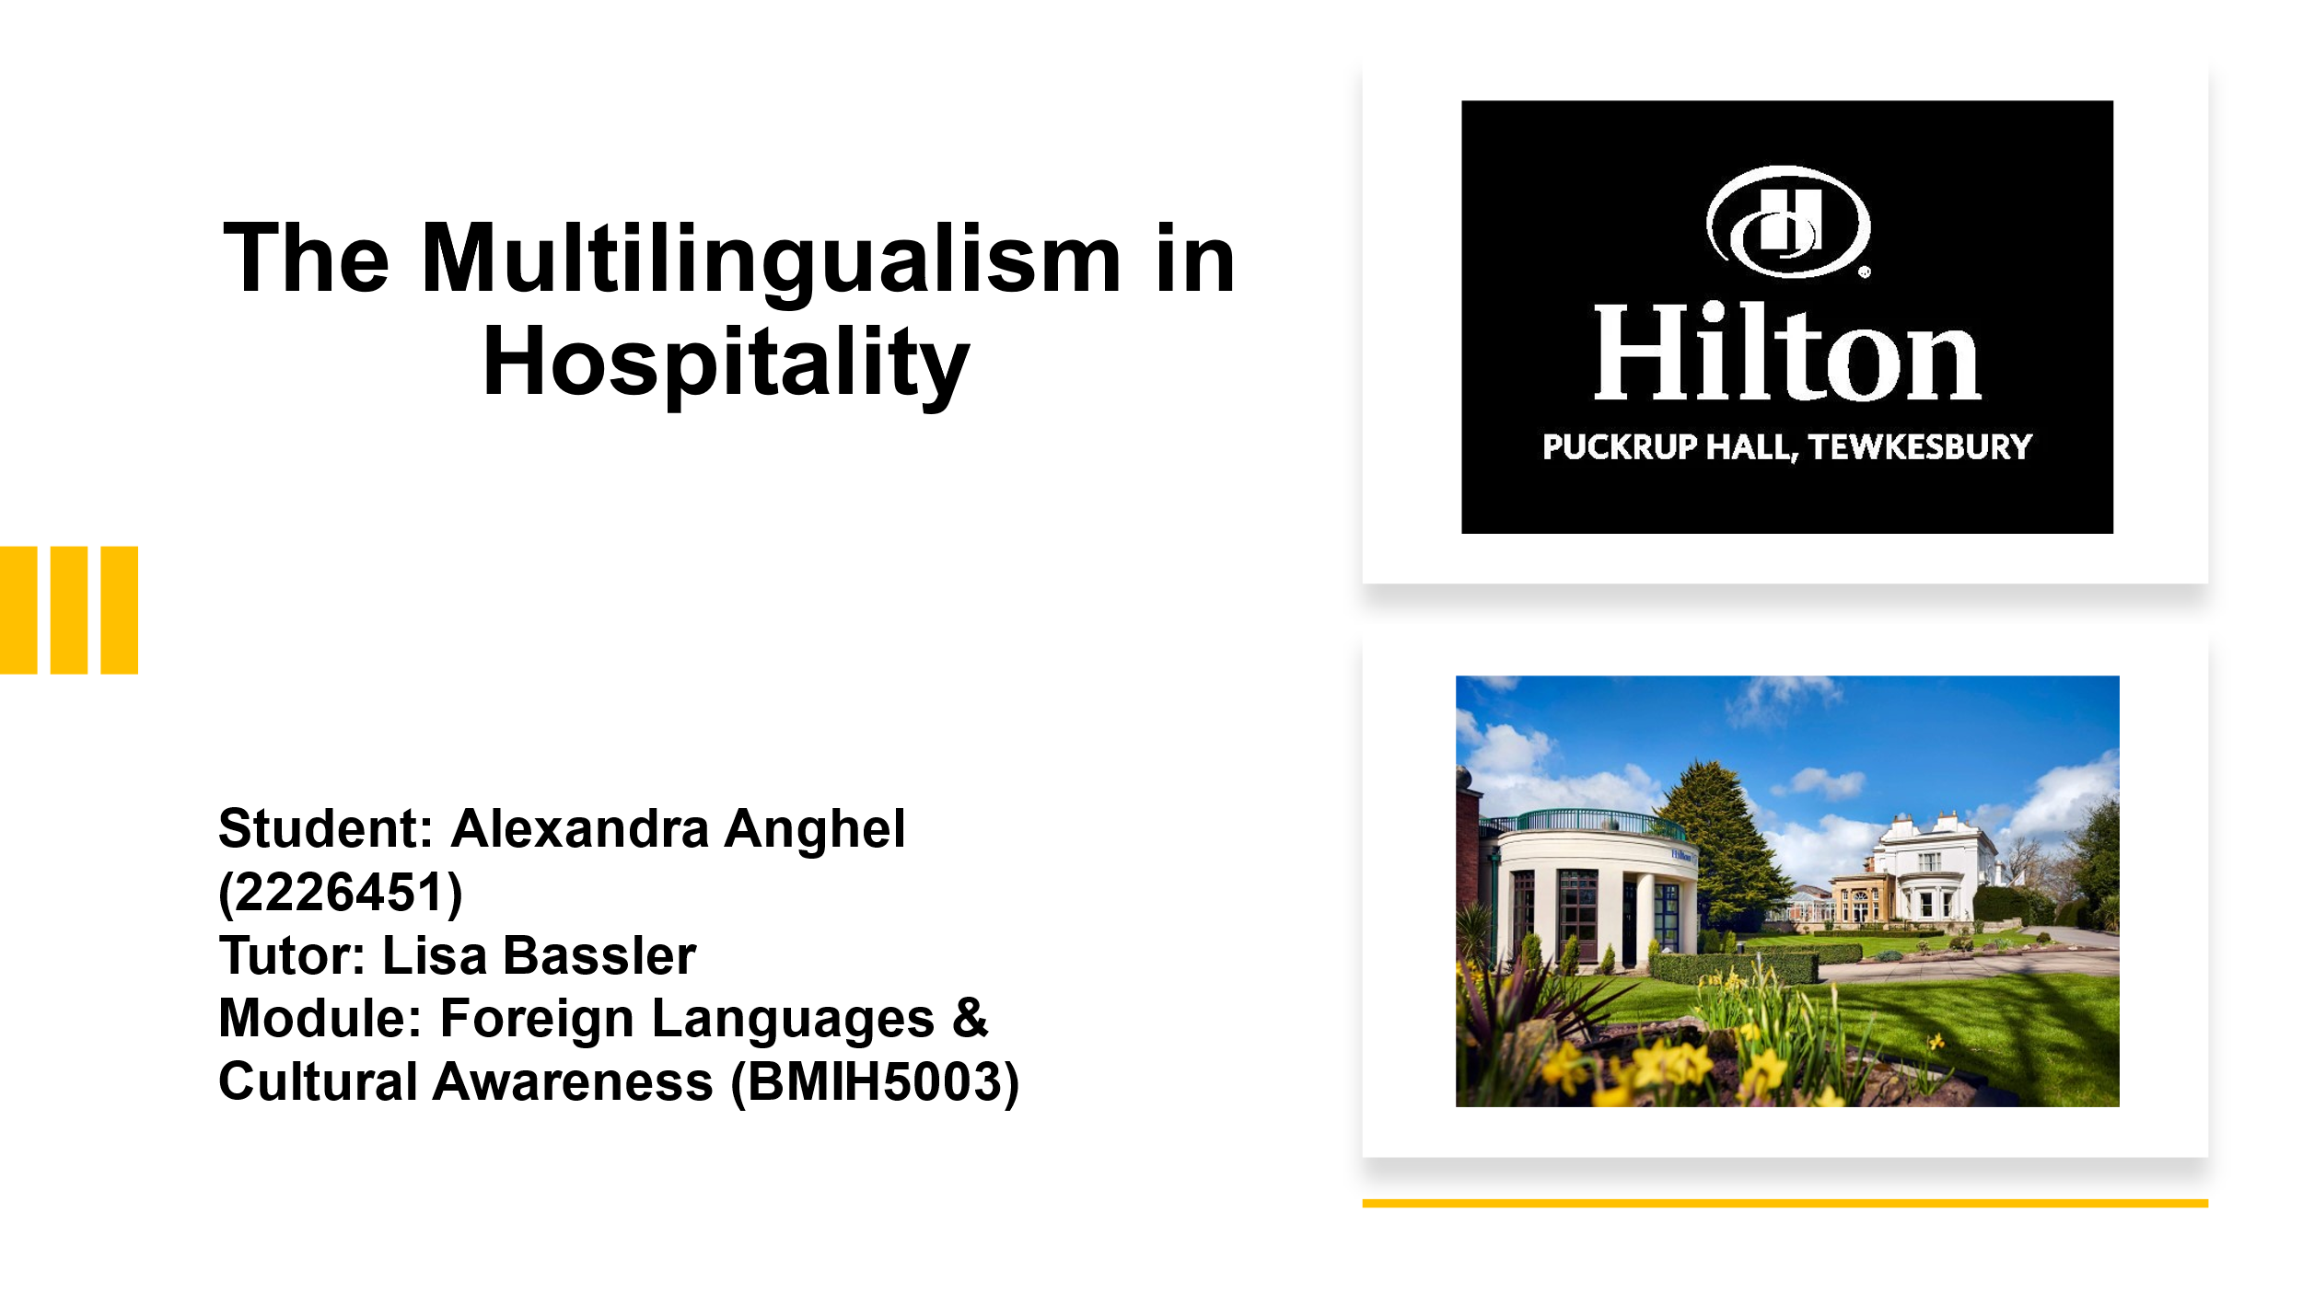
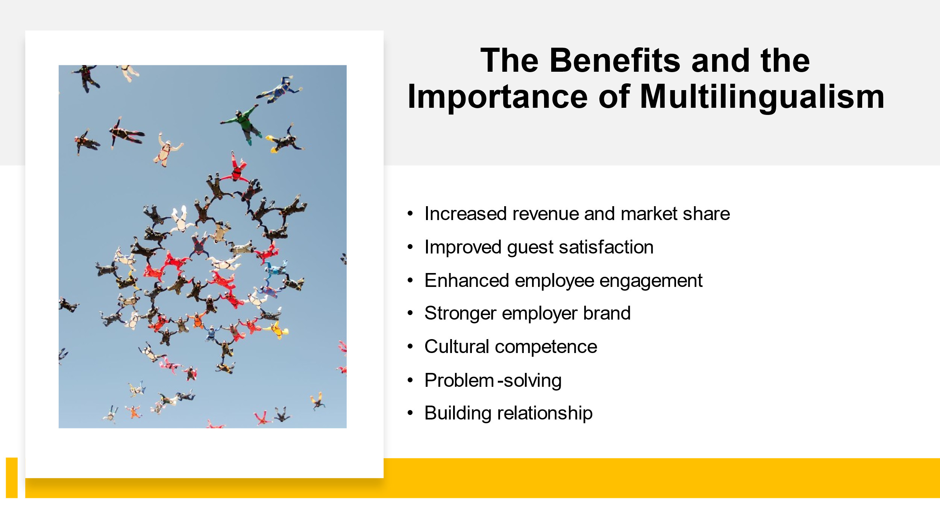
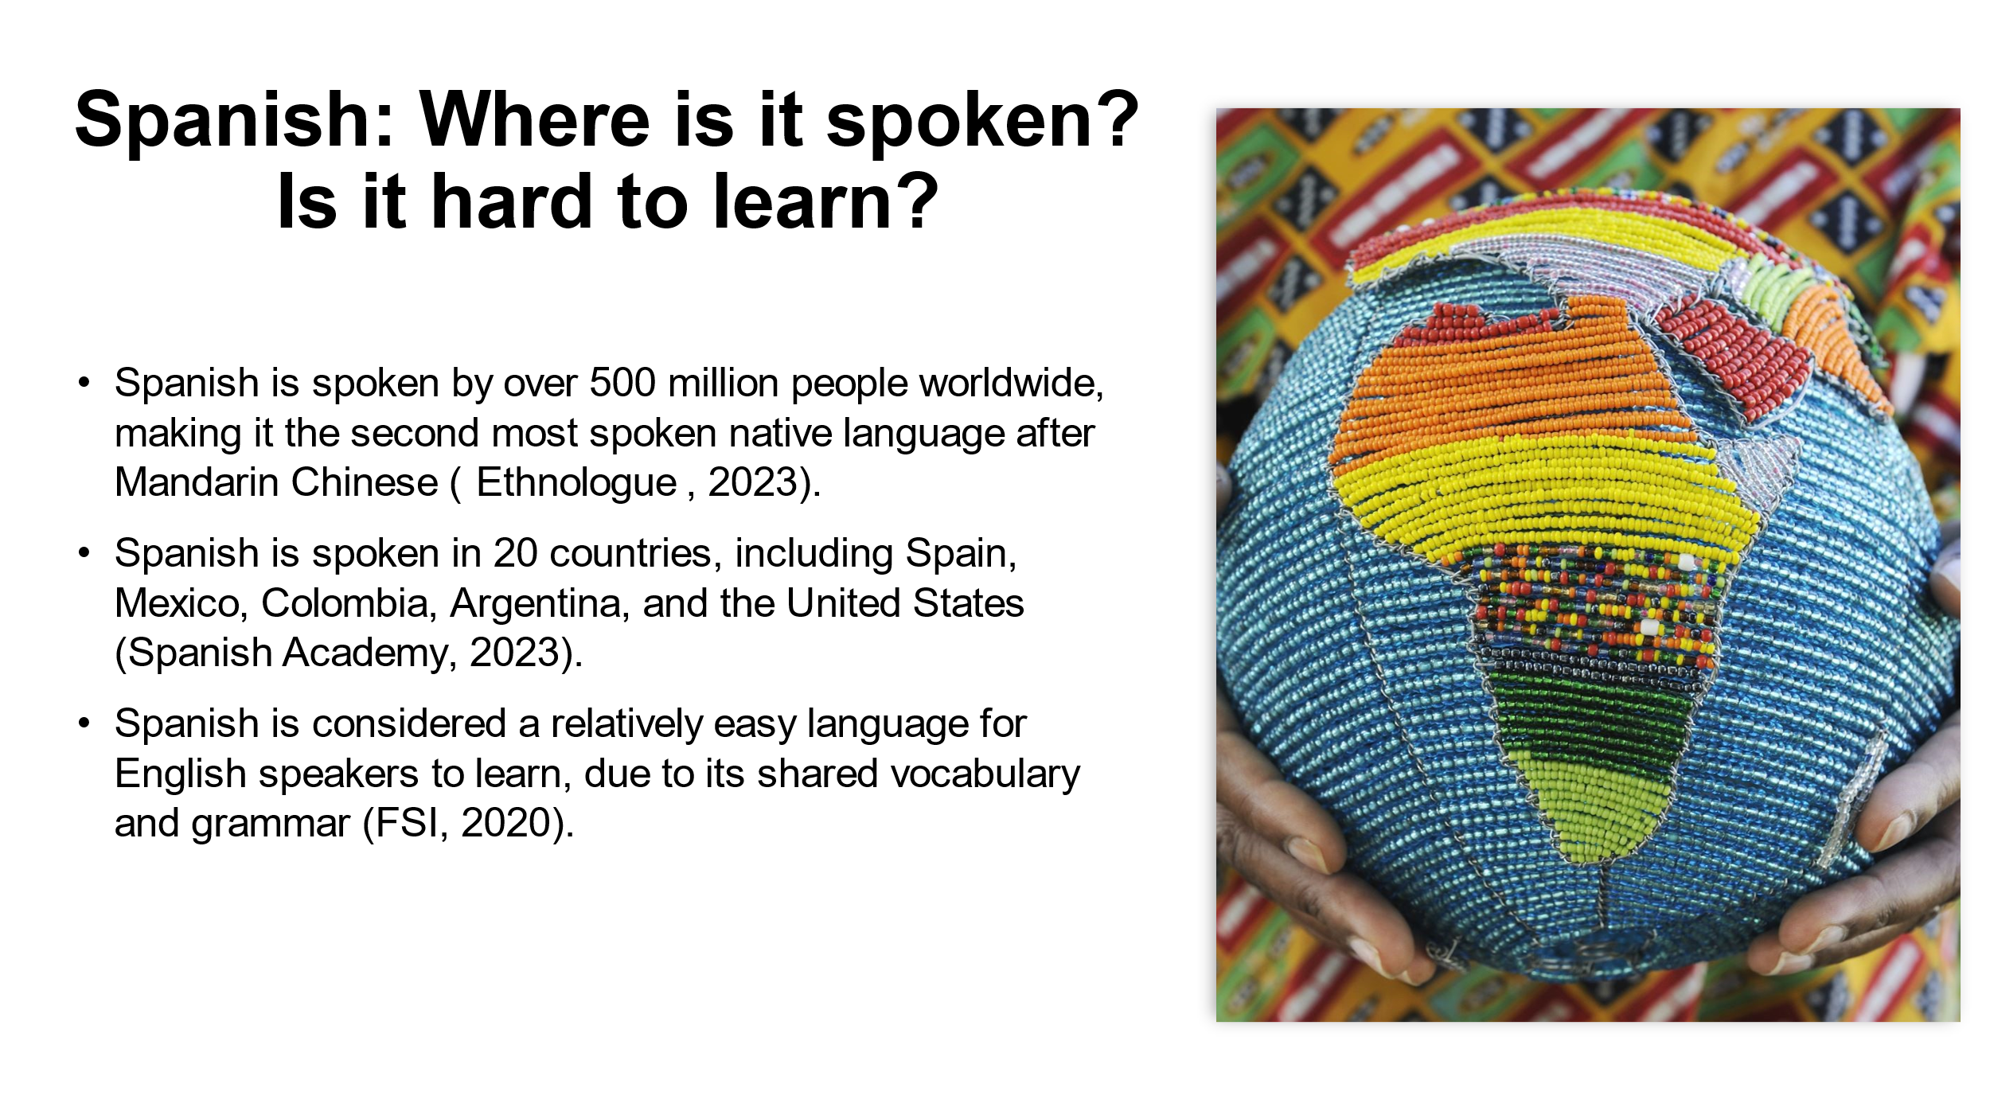
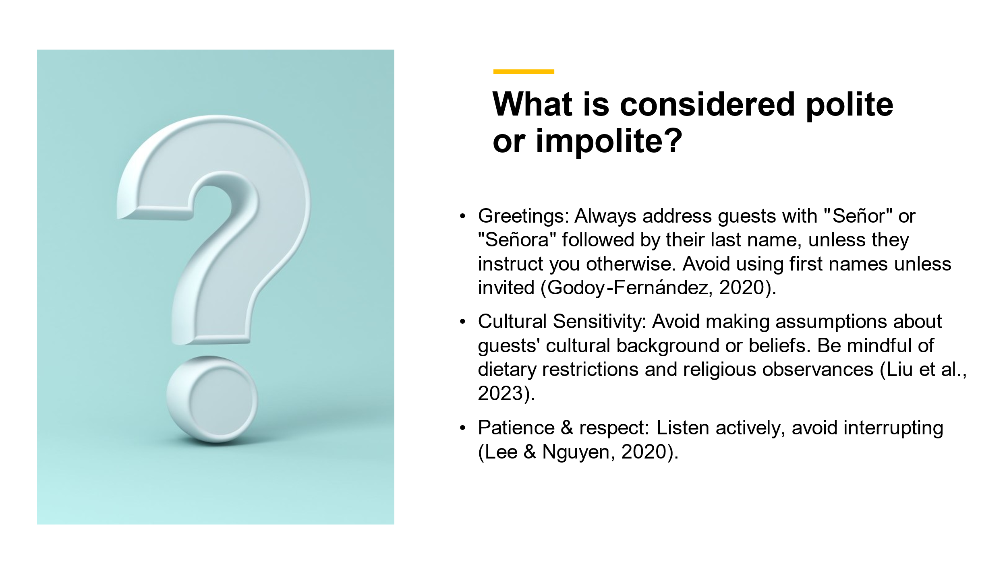

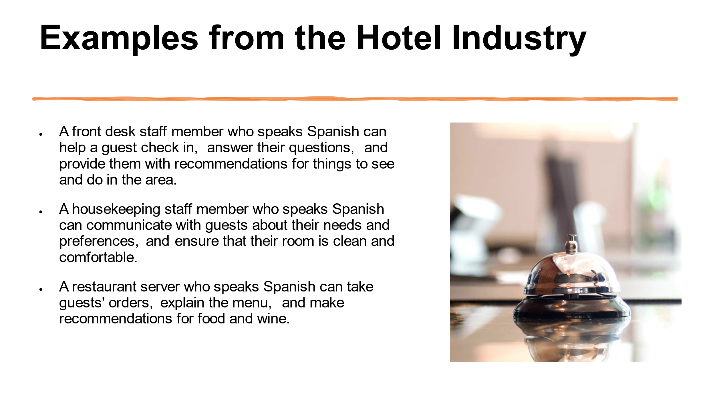
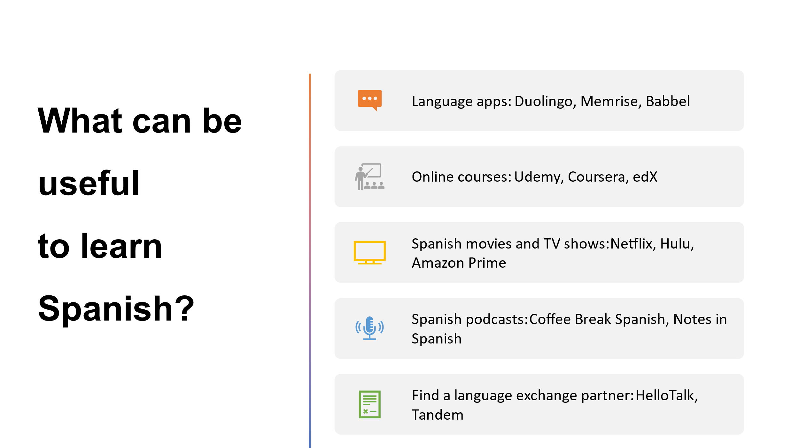
References (no screenshots):
- Ethnologue. (2023). Languages of the world. Retrieved from https://www.ethnologue.com/
- FSI. (2020). Languages by difficulty for English speakers. Retrieved from https://www.state.gov/foreign-language-training/
- Godoy-Fernández, D. (2020). Address terms in Spanish: Exploring social distance and formality across continents. Language and Intercultural Communication, 20(4), 346-365.
- Lee, Y., & Nguyen, T. (2020). The impact of language awareness and training on cultural competence in the hospitality industry. Journal of Hospitality & Tourism Management, 42, 196-202. https://www.sciencedirect.com/journal/journal-of-hospitality-and-tourism-management
- Liu, Y., Chen, C. T., & Chen, H. T. (2023). Service recovery during food allergies: The roles of cultural intelligence and emotional intelligence. International Journal of Hospitality Management, 44, 102950.
- Society for Human Resource Management. (2023). The benefits of multilingualism in the workplace. Retrieved from https://www.shrm.org/topics-tools/news/employee-relations/companies-hiring-multilingual-workers
- Spanish Academy. (2023). Observatorio del español. Retrieved from https://www.rae.es/

