Electrical and Electronic Engineering
Electrical Power Assignment
GOEE5000
Dafydd John Llewelyn Evans

Contents
1. Cover Page
2. Contents
3. Introduction
4. Research

Task A
7. Solar System
10. PV Systems
11. Selecting Solar Panel
12. Inverter
13. Battery
14. Reliability + Cost Breakdown
15. Fixed Monthly Tariff + Comparison To National Grid

Task B
17. Wind Turbine System
21. Inverter
22. Battery
23. Cost Breakdown
24. Comparison To National Grid
26. Feed In Tariff

26 Conclusion
27. References

Introduction
The aim of this assignment is to provide renewable power to a small village in North Wales. To start off I needed to calculate all the power that is needed for the village. Here are all the calculations that I have done using excel.
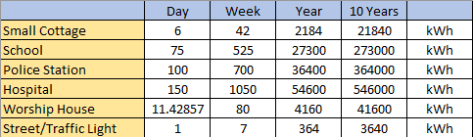

I was given the values for either 1 day or a week of required power for each type of building. These are all the values I’ve calculated.
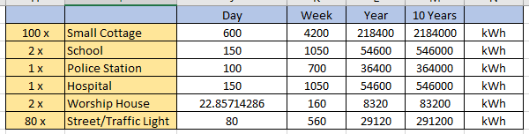

These are the values for the 100 cottages, 2 schools, police station, hospital, 2 worship houses and 80 streetlights. I have worked out the values for 1 day, 1 week, 1 year and 10 years.
I have been asked as an Electrical and Electronic Engineering specialist by the local council to design a small off grid of Renewable Solar Energy System.

There are two tasks:

Task-A) Renewable Solar Power System
Task-B) Renewable Wind Energy System

Research
The first thing I needed to do is do research on the small town and calculate the cost of the electricity supply by the National Grid for a period of 10 years, assume fixed electricity tariff.

https://powercompare.co.uk/electricity-prices/
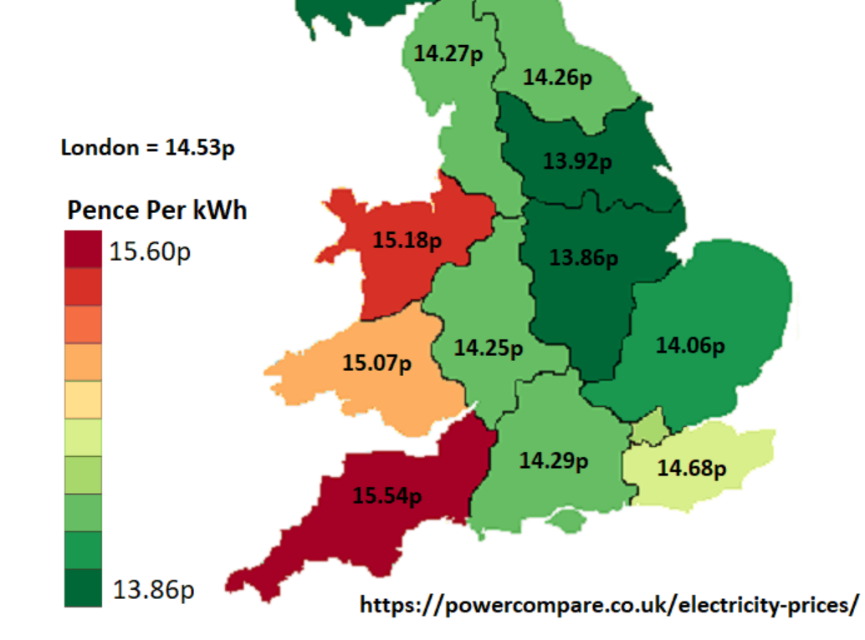

This shows that the pence per kWh in the village is 15.18p.


This then shows the average price per day for the village


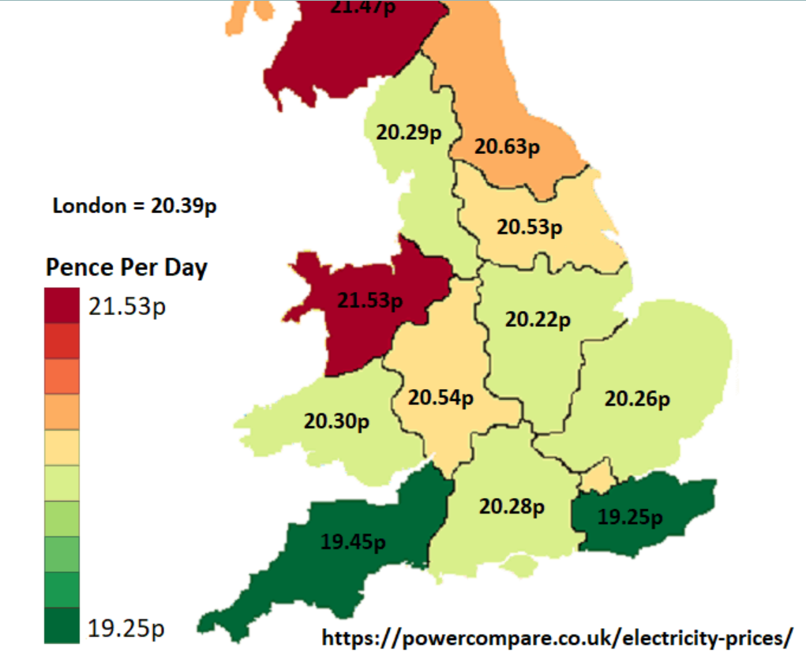

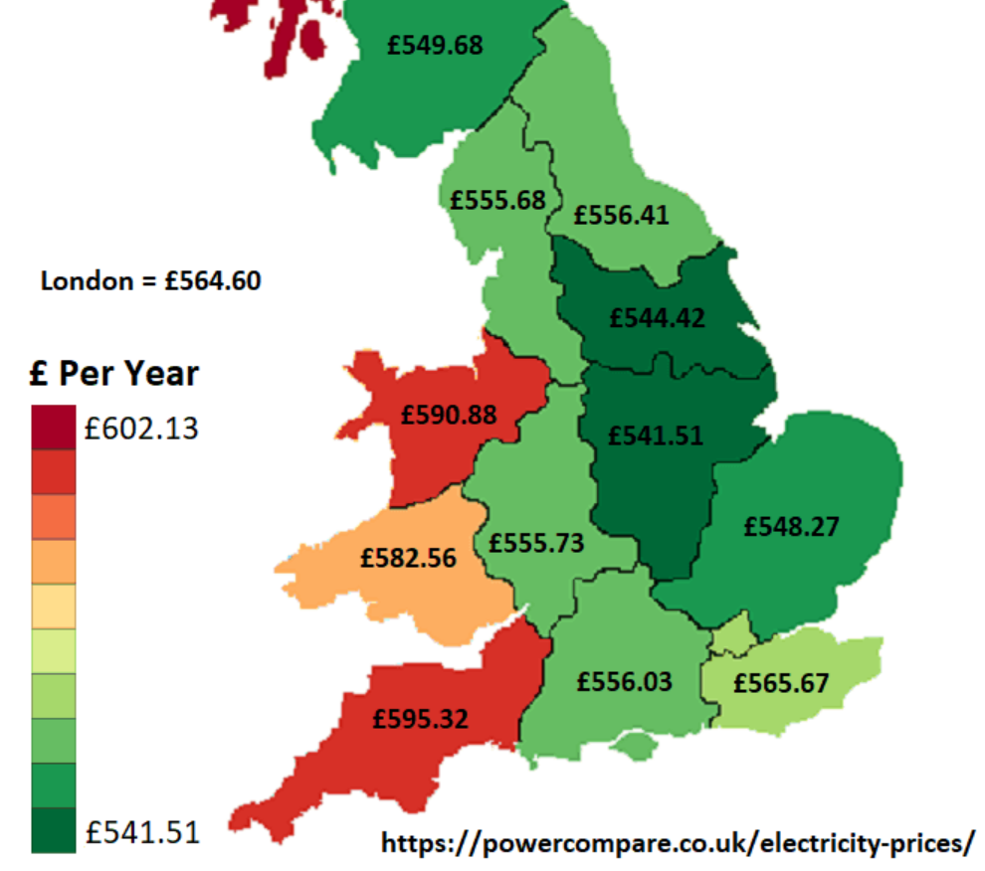

This shows that the annual value for the village is £590.88.
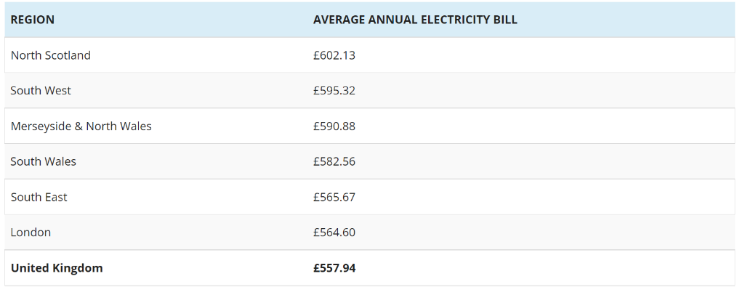

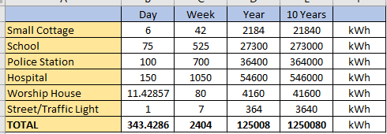
From the research I have found, the 10-year price for the national grid to provide power is

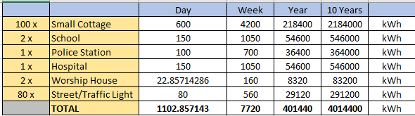
As the average pence per KWh in North Wales is 15.18, the cost for the entire village will be:

Week – 15.18 x 7720 = 117190p = £1,171.90
Year – 15.18 x 401440 = 6093859p = £60,938.59
10 Years – 15,18 x 4014400 = 60938592p = £609,385.92

This shows that to power the village on the national grid with an assumed fixed tariff will cost just under £610k.
Now that I have the price for the village on the national grid, I need to justify the use of a renewable solar power and wind system.
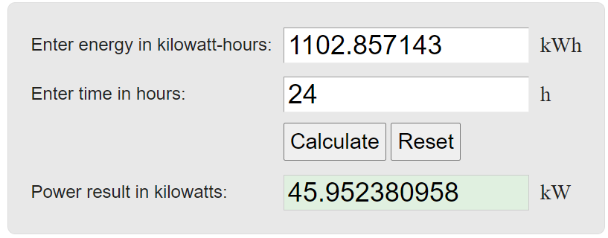

Power for the day.
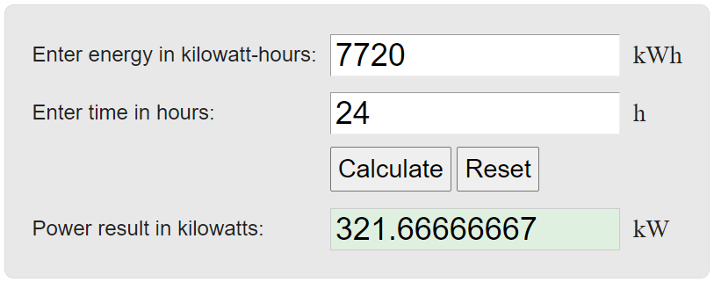

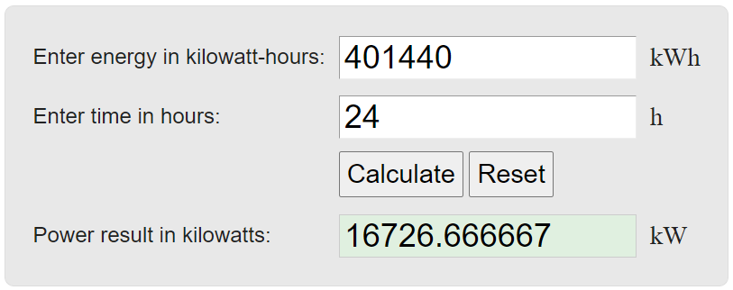
Power for the week.

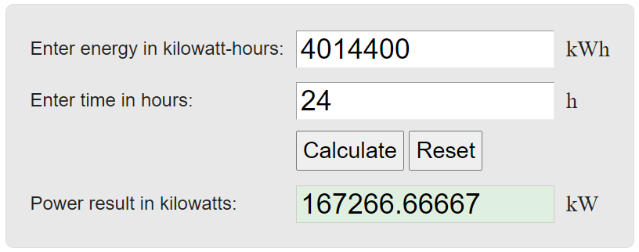

Solar System – Task A
I will need to justify the Implementation of the solar power system. For this, I will need to research all the different aspects that will affect the system.

Firstly, I will need to research the weather in the village to see how well the solar panels will work.

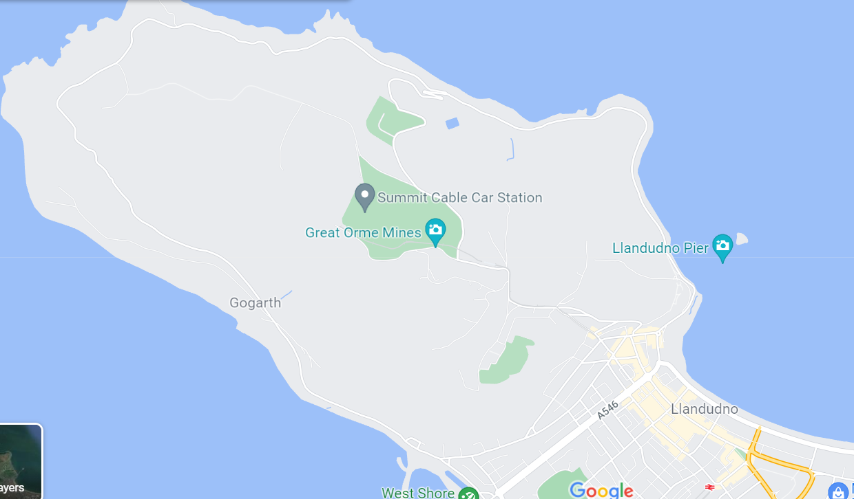

https://www.google.com/maps
I have used the weather values for Llandudno because no website I could find gave the weather for Great Orme. Great Orme is only a mile away from Llandudno so the weather values would be similar.

The photos of the weather information have all been taken from this website as it had the most adequate information/graphs.

https://weatherspark.com/y/37922/Average-Weather-in-Llandudno-United-Kingdom-Year-Round

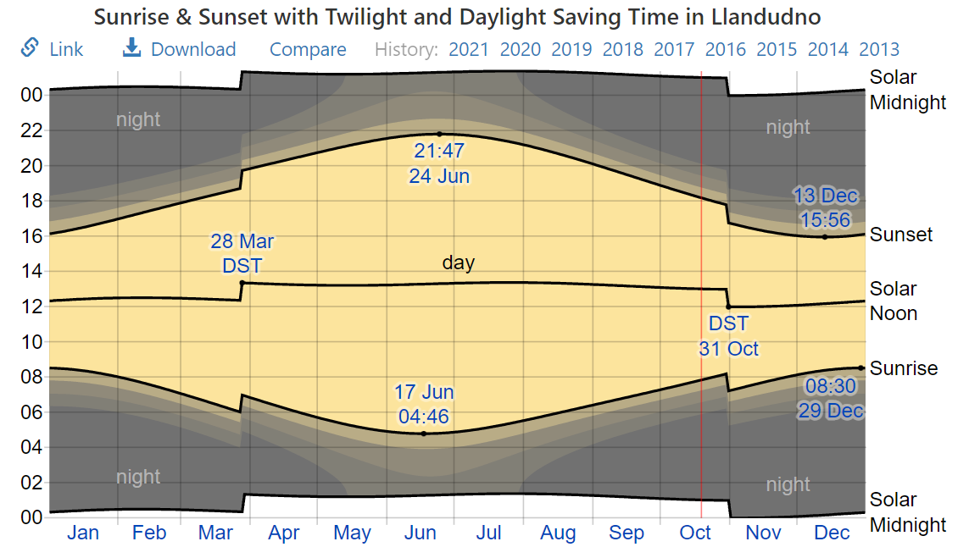

This graph is showing the amount of daylight throughout the year.
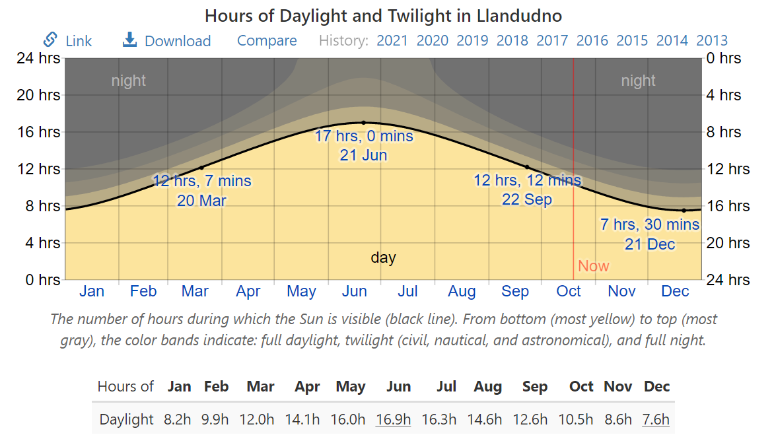
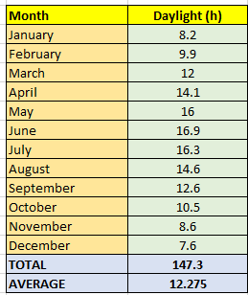

This is showing the hours of daylight in Llandudno. I have made a table to the right of the image to make it clear. It shows the average daylight of each month, then I have calculated the average daylight hours for the entire year. From this I will use the value of 12.28h of daylight.
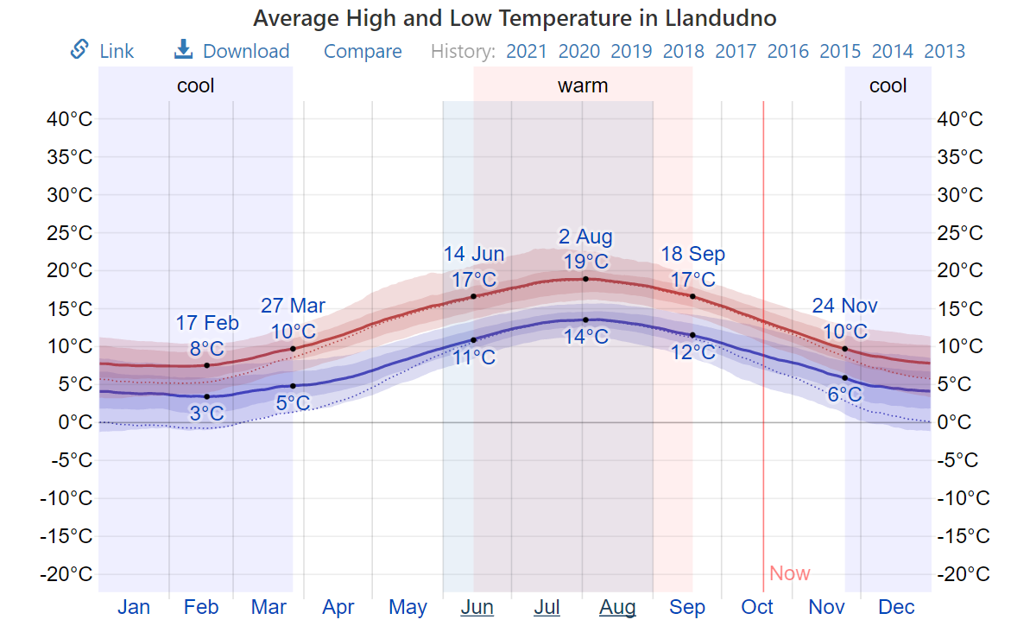

This graph is showing the average temperature in Llandudno. At a first glance you would assume that these are quite cold temperatures. After doing some research into solar panels, they are surprisingly more efficient in cold temperatures. That's because solar panels absorb energy from our sun's abundant light, not the sun's heat. In fact, colder climates are optimal for solar panel efficiency. As long as sunlight is hitting a solar panel, it will generate electricity.
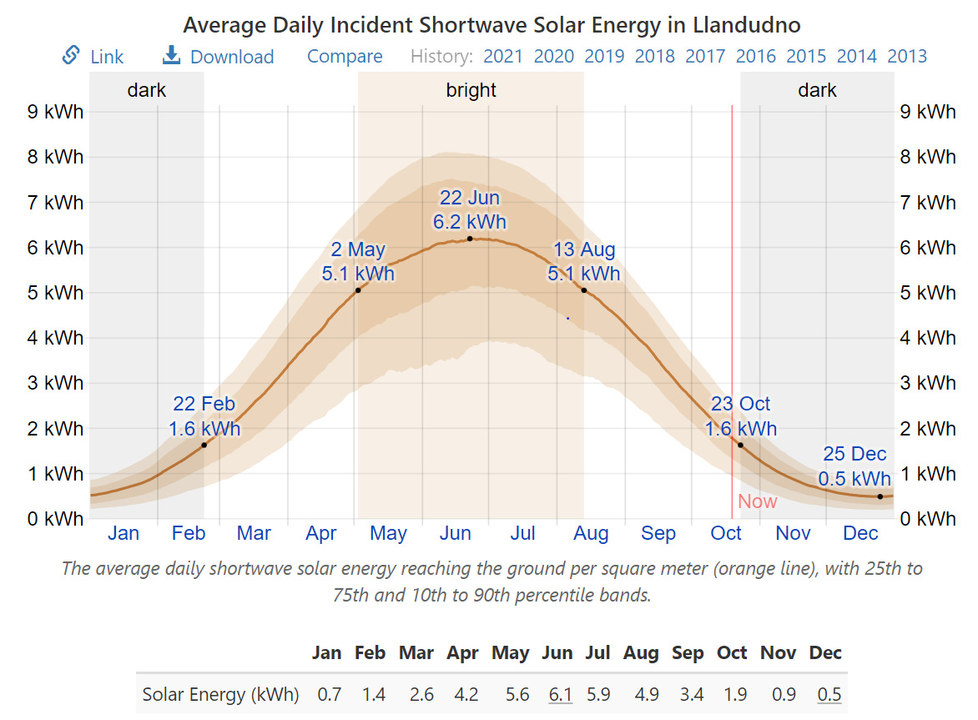
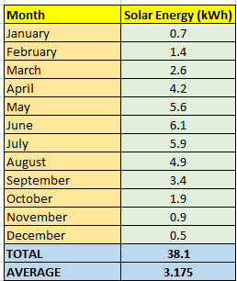

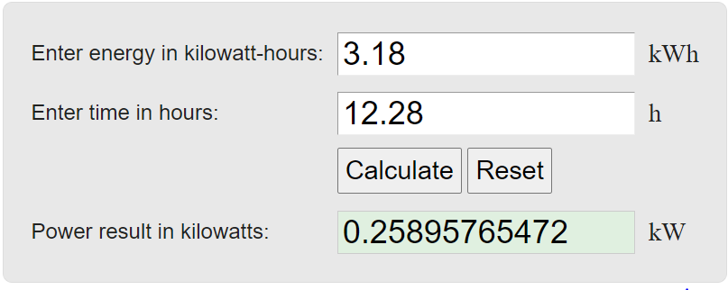
This graph is showing the average daily solar energy that reaches the ground per square meter. Again, I have made a table to the right of the graph to make things clearer. It shows the average daily solar energy for each month, then I have calculated the average daily solar energy for the entire year. From this I will use the value of 3.18 kWh solar energy.

This shows that the daily solar energy for the village is 0.2589kW per square meter.

PV Systems
There are three main types of solar PV and storage systems:
Grid-tied – this is the most common type; it is where the panels are connected to the grid so that the customers can save on electricity bills but still be connected to the grid. Any excess power will not be able to be stored and will be sent straight back to the grid.
Grid/hybrid – This is a combination of solar energy storage with the connection to the national grid. The system provides the flexibility to be able to store the power generated into batteries instead of it getting fed back to the grid.
Off-grid – This is where there is no connection to the grid at all. All energy generated will be stored and used from there. The electricity is usually used from stored battery bank/s.

I will be choosing the off-grid option as it is the most sustainable. The brief also states that there is poor or insufficient power in the village, this means I will have to generate it myself.

Selecting Solar Panel
I will now be researching for a suitable solar panel for the village PV system.
After some thorough research, I have decided to go with this solar panel.
https://www.sunstore.co.uk/product/3900w-48v-11-0kwh-professional-off-grid-solar-system/
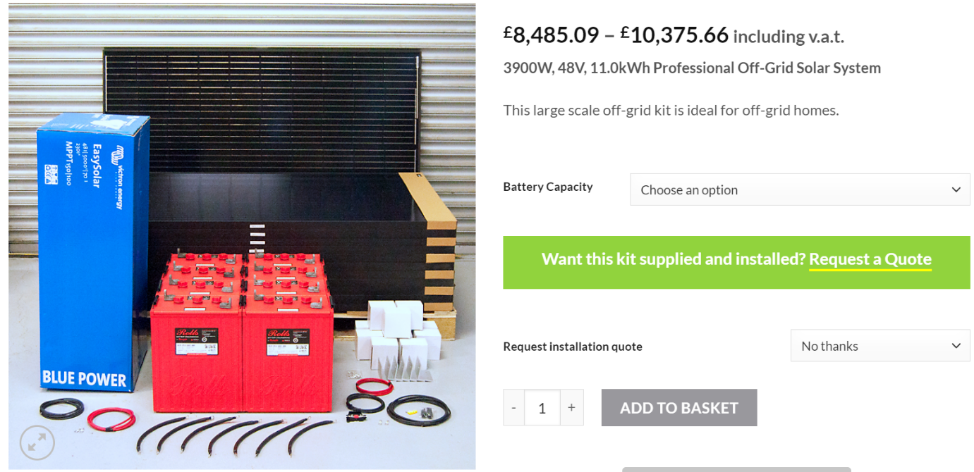

I have chosen this 3.9kW, 48V off grid solar system.

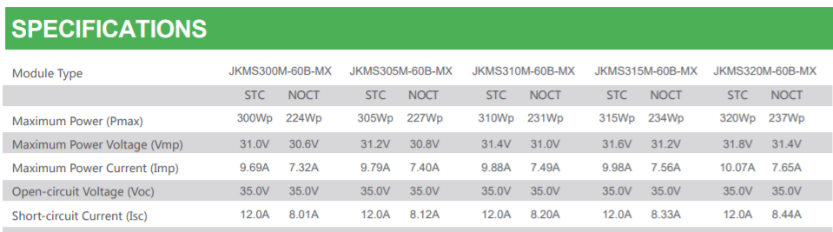

This is ideal as the power required for the village is 45.95 KW. This would mean I will be having 13 of these systems to power the village. This would take the power generated to an average of 50.7kW. This gives the village a good tolerance to work with. Obviously, the panels are not going to be generating 50.7kW consistently every day. These values would differ as the weather changes. Therefore, I have kept a generous tolerance to make sure the village has the power it needs.
I will be using the price of £8,485.09 for the system as I haven’t selected any extras to the product. As I will be using 13 of the panels, this will bring the total price of the system to:
13 x 8,485.09 = £110,306.17 Total Panel Cost
You will also need to include maintenance costs for the system. From the brief it states to assume the cost of operation and maintenance to be 10% the value of the overall value per year.
110,306.17 x 0.1 = £11,030.62 Maintenance Cost Per Year
I would also employ two part time technicians to maintain the turbines annually. After researching, the average salary of a technician in the UK is £30k. I will assume that the salary of each part time technician is £15k, making a total salary of £30k.

Inverter
A solar inverter is an electrical converter which changes the direct current electricity captured by solar panels, into alternating current, which is the standard flow of electricity required for electrical circuits and domestic appliances. This means the electricity generated can be used by the village.

The inverter I have gone for is,

https://energetechsolar.com/25kw-sdp-off-grid-inverter

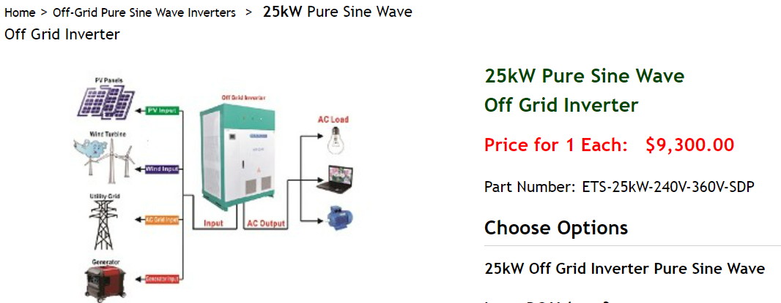

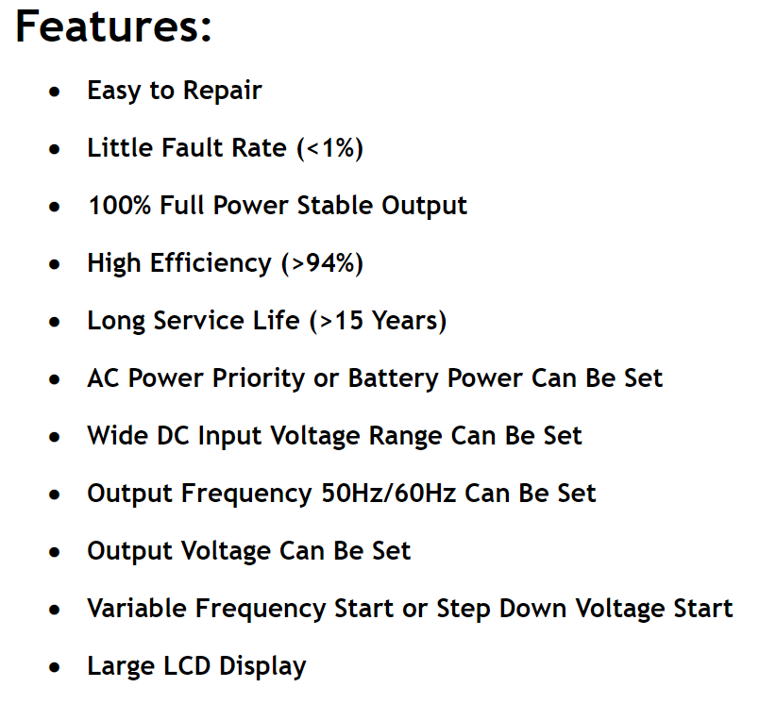

This is an excellent choice of inverter as the features fit the purpose. It is easy to repair with less than 1% fault rate. This means less maintenance is required. It is also very efficient for an inverter (94%) and has a long service life, which is perfect for the village. My calculation for the village output is 45.95 Kw. Therefore, I would need to have an equivalent of two inverters. This would be 50 kw, which is sufficient as it is giving a tolerance if they were to fall slightly short.
The cost of the inverters is $9,300 x 2 = $18,600.
Convert this to sterling - £13,795.53

Battery
For the system to work properly, I will need a battery/s. I would use the battery to store energy in case of the panels not producing the power required by the village. There isn’t going to be constant sun in village as the weather will vary. This means that there could be days where there will be little to no sun at all. This is where the batteries come in. The batteries will cover the missing power required. I will need to do the calculations to decide what battery/s that I will need.
The equation I will use is:
A = (P x T) / (DOD x Ein x Eba x Vb)
The A is the amp-hour capacity of a battery bank. P is the power required by the village. T is the working days; I will choose 2. DOD is the depth of discharge of the battery, I will assume this to 80%. Ein is the efficiency of the inverter, which is 94%. Eba is the efficiency of the battery bank, I will assume this to be 90%. Vb is the battery rated voltage, which is 48v.
A = (45.95kW x 2) / (0.8 x 0.94 x 0.9 x 48V)
A = (91.9kW) / (36.096)
A = 2,545.99 Ah
Now I need to look for batteries to support this. This is what I’ve found.
https://www.alibaba.com/product-detail/50KWH-LFP-Lithium-Battery-48V-1000Ah_60828090314.html?spm=a2700.7724857.normal_offer.d_title.63cb4183FBV6le
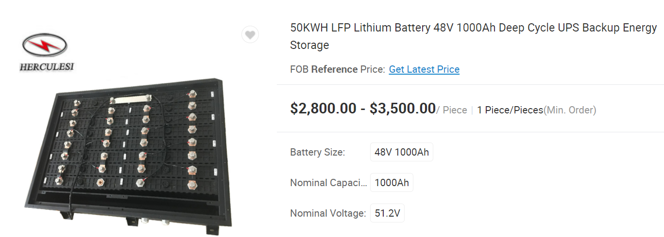

Here is the battery I have chosen. It is a 50 kWh, 48V 1000Ah lithium backup. As my total value is 2794.94 Ah, I will need to include 3 of these batteries to the village system. I will connect the batteries in parallel. Parallel battery configuration helps increase the duration in which batteries can power equipment, but due to the increased amp-hour capacity they can take longer to charge than series connected batteries. Using the value shown on the site, 3 batteries at $2.8k equals to $8.4k. After converting dollars to sterling, the final price of the batteries is £6,227.

Reliability
It is important in whatever products I chose for my system; I need to ensure that they are reliable. This is a system that will be supplying electricity for an entire village after all. It is essential that everything that is chosen/calculated is to the correct standard. The system I put in place will be there for the foreseeable future. This means everything needs to last enough time and to be looked after. Renewable energy is as reliable as they come, as long as there is wind blowing through the air and the sun in the sky, there is energy ready to be harnessed. The only part of the system that is slightly vulnerable is the physical parts. Therefore, it is of high importance to select the correct products. Most products come with long term warranties, so if something was to occur, it is covered. The average solar panel have a fault rate of >1%. This shows just how reliable it is.

Cost Breakdown
I will now show the cost breakdown of the entire solar system.
13 x Solar Panels - £110,306.17
10 Year Maintenance - £110,306.2
10 Year Technicians Salary - £300,000
2x Inverters - £13,795.53
3 x Batteries - £6,227

The total cost of the village system over the 10 years;
110,306.17 + 110,306.2 + 300,000 + 13,795.53 + 6,227 = £540,634.9

Fixed Monthly Tariff
I will now calculate the fixed monthly tariff for each cottage in order for the payback period for this project is 10 years. Assuming that the interest rate on the capital is 0%.
Firstly, I will need to break the 10-year total cost into months.
10 years - £540,634.9
1 year - £54,063.49
1 month - £4,505.29
There are 100 cottages in the village, so I will divide the monthly cost by 100.
Per Cottage - £45.05
This is the fixed monthly tariff that each cottage will be paying.
To compare with other figures, I will now calculate what each cottage will be paying throughout the 10 years.
Single cottage for 1 month - £45.05
Single cottage for 1 year - £540.6
Single cottage for 10 years - £5,406

Comparison To National Grid
Here I have compared the village being powered by the national grid with the solar system I have designed. I have created a table to show the comparison of the values clearly.
Firstly, I will show the overall value of the village. Then I will show the price per cottage.

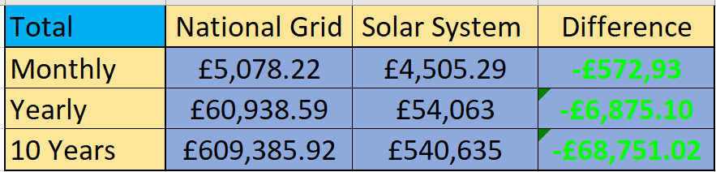

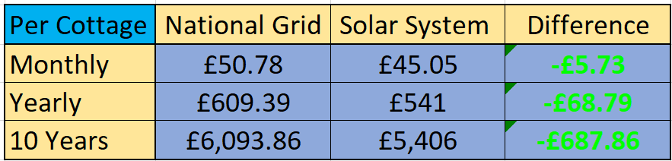

As you can see, the Solar system is clearly cheaper than the national grid. With the village going with the solar system, each cottage would be paying £5.73 less each month. Bear in mind that this price is with the residents in the cottages paying for the public buildings. The residents of the cottages will be paying for the power of the 2 schools, police station, hospital, 2 worship houses and 80 street/traffic lights. Even though they are paying for the public buildings, it still works out cheaper. This is a great outcome. The village would be saving £68.75k over the 10 years. It also benefits the environment as it is completely green. Using the solar system over the national grid has its benefits. The system is self-sufficient as it uses the suns power, which is renewable. The sustainability of the system is tremendously better than the national grid. It has an inexhaustible energy source that produces clean energy. And to top it all off it is environmentally friendly that will help to slow down climate change.
But why stop there? What if the village kept on with this system for another 10 years?
The only extra prices that would occur is the maintenance and the labour.
10 Year Maintenance - £110,306.2
10 Year Technicians Salary - £300,000
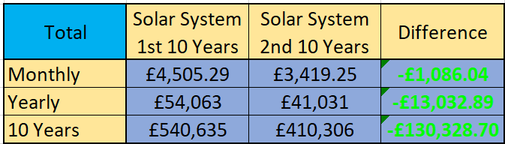
110,306.2 + 300,000 = £410,306.2

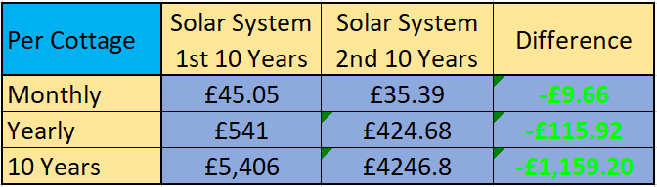

As you can see from the table, the price per cottage has decreased by £9.66 over the second 10-year period.

Wind Turbine System – Task B
I will need to justify the Implementation of the wind turbine system. For this, I will need to research all the different aspects that will affect the system.

Firstly, I will need to research the weather in the village to see how well the wind turbines will work.

https://www.google.com/maps
Again, I just want to clarify that I have used the weather values for Llandudno because no website I could find gave the weather for Great Orme. Great Orme is only a mile away from Llandudno so the weather values would be similar.

The photos of the weather information have all been taken from this website as it had the most adequate information/graphs.

https://weatherspark.com/y/37922/Average-Weather-in-Llandudno-United-Kingdom-Year-Round

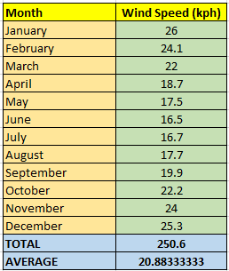
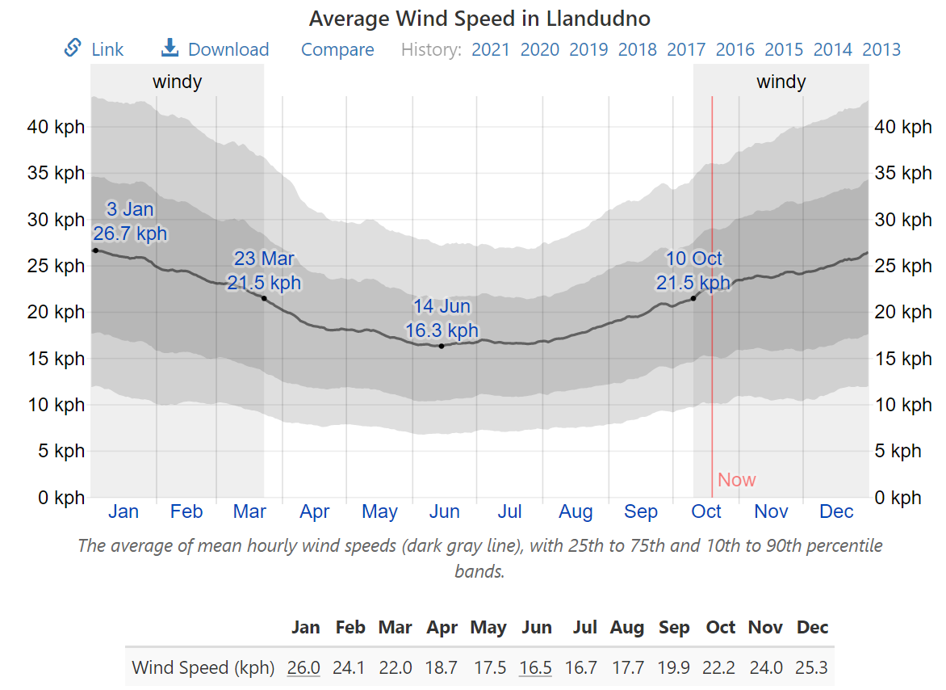

This graph shows the average wind speed in Llandudno. It shows the values of each month. To the right of the graph, I have created a table to make the values clear. I have shown the average wind speed of each month, then I have calculated the average wind speed for the year. The value I will use for the wind speed will be 20.88 kph. This works out to be 5.8 m/s.
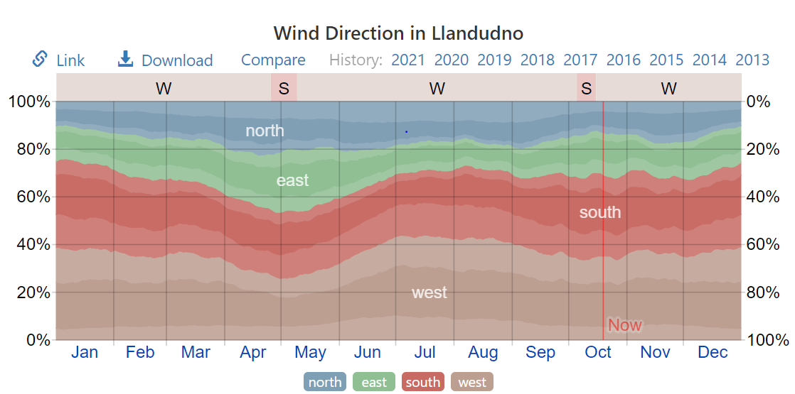

This graph shows the percentages of the wind directions across the year. From this it shows that the average wind speed from each direction:
North – around 10%
East – around 15%
South – around 35%
West – around 40%
From this I would make sure that any turbines I choose will be facing the west as it has the most percentage of wind speed.
After looking at a few websites, I have found 2 wind turbines.
https://en.wind-turbine-models.com/turbines/1681-hummer-h25.0-200kw
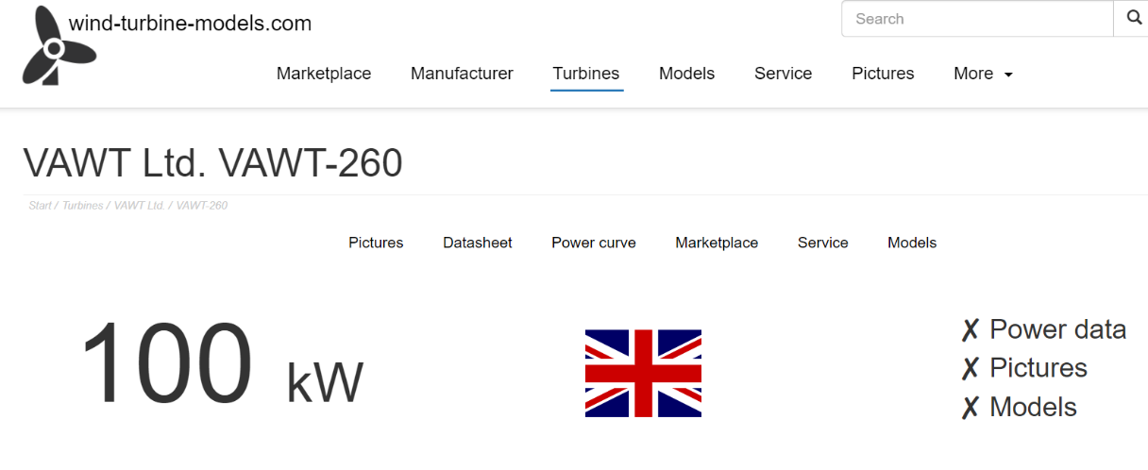

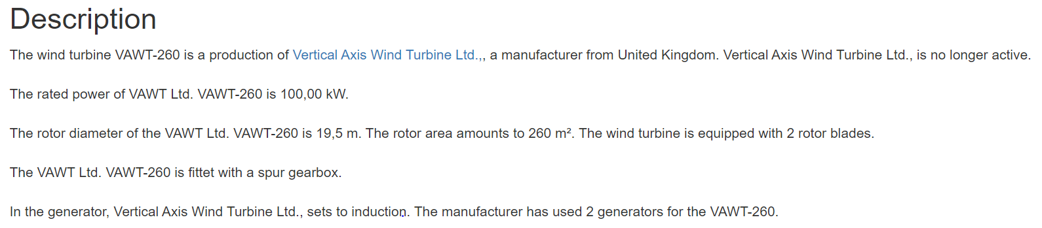

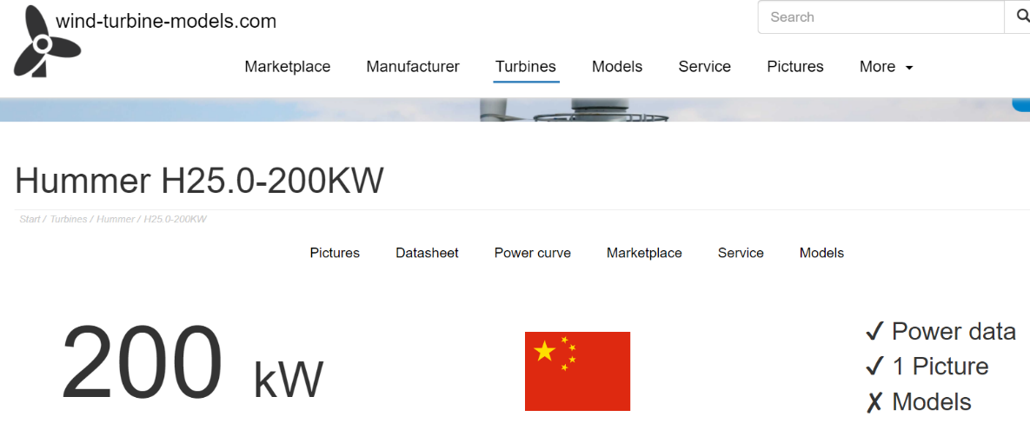

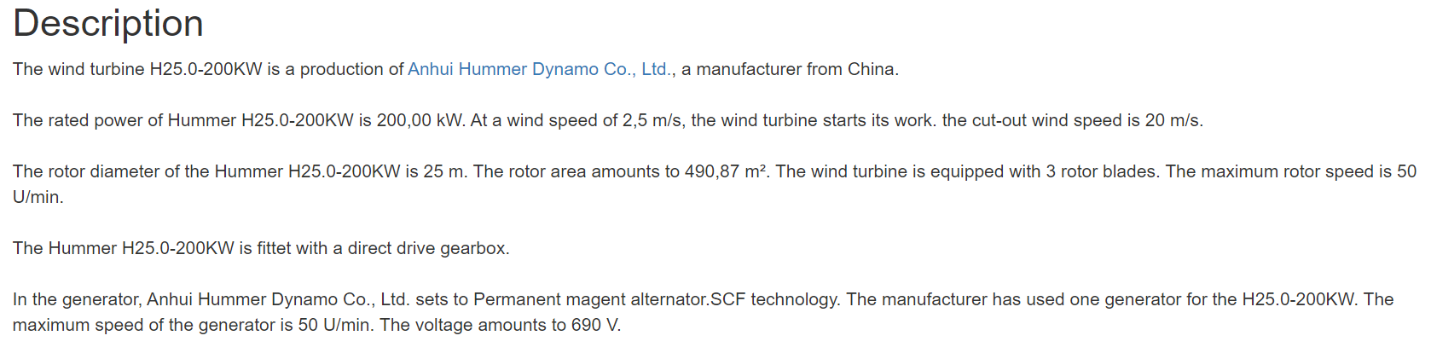

I have decided to go with the hummer wind turbine. It has more information and I will need less of them to provide electricity for the village.
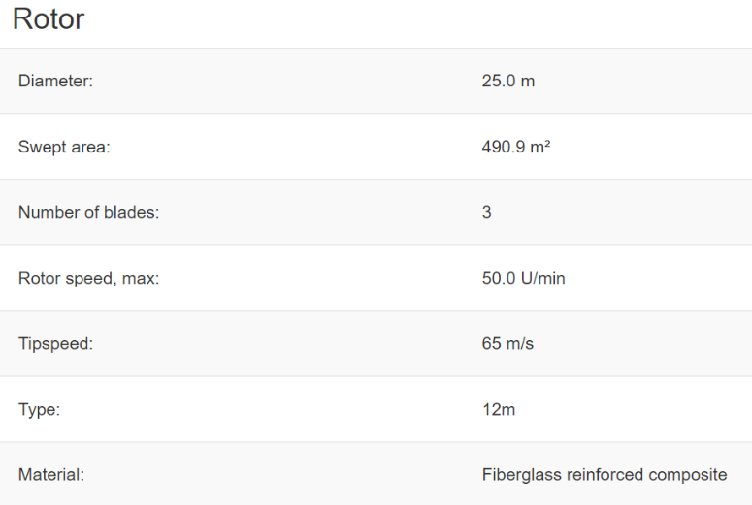
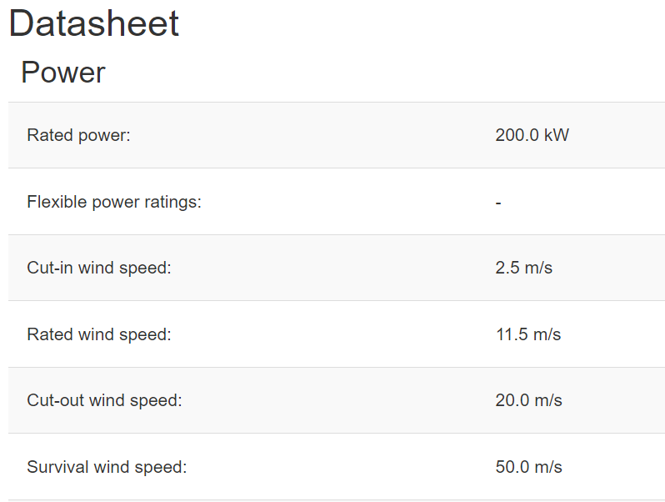

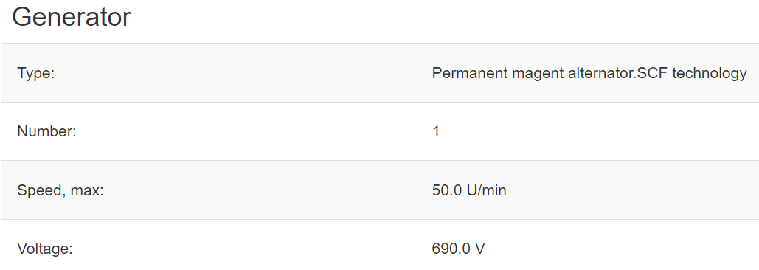

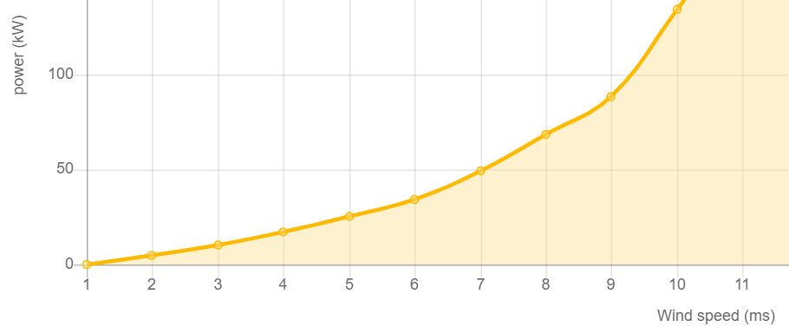

This is the graph that is showing the power output of the turbine. The average wind speed I have calculated is 5.8 m/s. 6 m/s wind speed generates 34 KW of power. So, 5.8 m/s wind speed will generate an average of 32.2 KW. This is ideal as the power required for the village is 45.95 KW. This would mean I will be having 2 of these turbines to power the village. This would take the power generated to an average of 64.4kW. This gives the village a good tolerance to work with. Obviously, the turbines are not going to be generating 64.4kW consistently every day. These values would differ as the wind changes. Therefore, I have kept a generous tolerance to make sure the village has the power it needs.


Here is the price for the turbine. I will use the price of $283 k as this is in the middle of the range. $283k in UK sterling is £207,712.10. So the price the village would be paying is :
207,712 x 2 = £415,424 Total Turbine Cost
You would also need to pay for maintenance on the turbines.
https://www.renewablesfirst.co.uk/windpower/windpower-learning-centre/how-much-does-a-wind-turbine-cost-to-operate/
Here is an average cost for operating and maintenance for typical turbines.
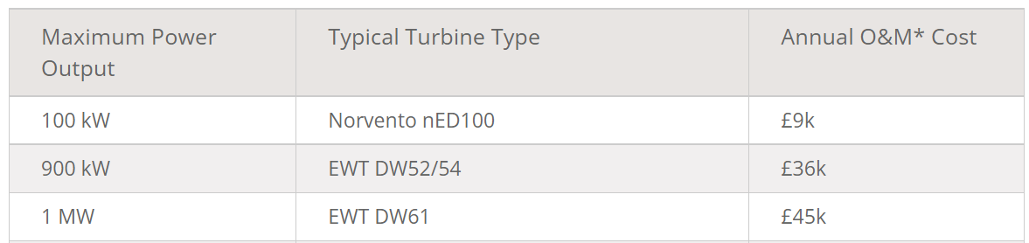

From the brief it states to assume the cost of operation and maintenance to be 3% the value of the overall value per year.
£415,424 x 0.03 = £12,463 Maintenance Cost Per Year
I would also employ two part time technicians to maintain the turbines annually. After researching, the average salary of a technician in the UK is £30k. I will assume that the salary of each part time technician is £15k, making a total salary of £30k.

Inverter
After researching all different inverters, I have found a suitable one to use.
https://www.aimscorp.net/12000-Watt-Inverter-Charger-48-volt-120-240vac.html

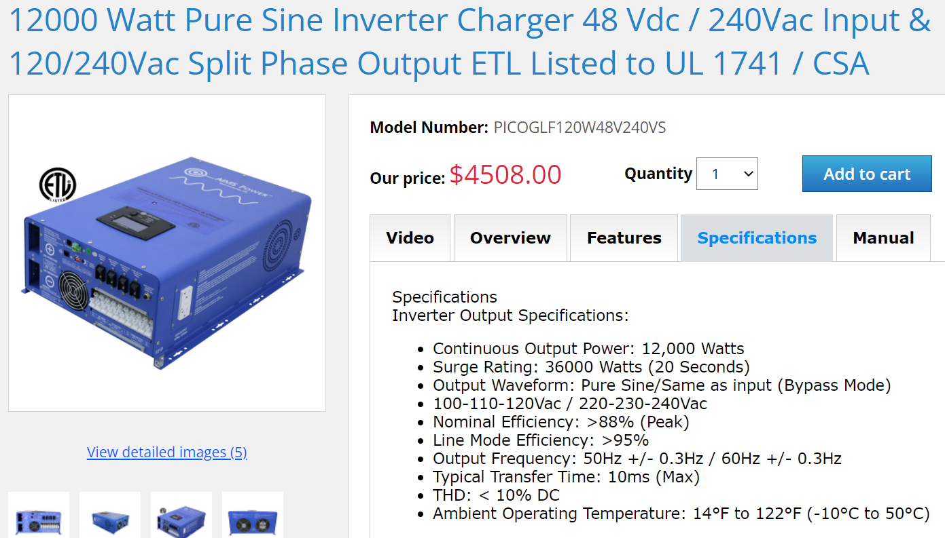

This is a 12 kW 48 V DC – 240 V AC. My calculation for the village output is 45.95 Kw. Therefore, I would need to have an equivalent of four inverters. This would be 48 kw, which is sufficient as it is giving a tolerance if they were to fall slightly short. This also has a high line mode efficiency percentage of 95% and a nominal efficiency of 88%. This is great as it means it would be reducing energy costs and heat output. Exactly what you would look for in a reliable inverter. These inverters will be connected in parallel. You need an inverter for the stability of the system. The inverter converts the DC (direct current) to AC (alternating current). We do this because AC is what the electrical grid uses. So, the power we generate becomes AC to power the village.
Cost:
4508 x 4 = $18,032
Convert this to sterling; £13,368

Battery
For the system to work properly, I will need a battery/s. I would use the battery to store energy in case of the turbines not producing the power required by the village. There isn’t going to be constant wind in village as the weather will vary. This means that there could be days where there will be little to no wind at all. This is where the batteries come in. The batteries will cover the missing power required. I will need to do the calculations to decide what battery/s that I will need.
The equation I will use is:
A = (P x T) / (DOD x Ein x Eba x Vb)
The A is the amp-hour capacity of a battery bank. P is the power required by the village. T is the working days; I will choose 2. DOD is the depth of discharge of the battery, I will assume this to 80%. Ein is the efficiency of the inverter, which is 88%. Eba is the efficiency of the battery bank, I will assume this to be 90%. Vb is the battery rated voltage, which is 48v.
A = (45.95kW x 2) / (0.8 x 0.88 x 0.9 x 48V)
A = (91.9kW) / (30.4128)
A = 2794.94 Ah
Now I need to look for batteries to support this. This is what I’ve found.
https://www.alibaba.com/product-detail/50KWH-LFP-Lithium-Battery-48V-1000Ah_60828090314.html?spm=a2700.7724857.normal_offer.d_title.63cb4183FBV6le

Here is the battery I have chosen. It is a 50 kWh, 48V 1000Ah lithium backup. As my total value is 2794.94 Ah, I will need to include 3 of these batteries to the village system. I will connect the batteries in parallel. Parallel battery configuration helps increase the duration in which batteries can power equipment, but due to the increased amp-hour capacity they can take longer to charge than series connected batteries. Using the value shown on the site, 3 batteries at $2.8k equals to $8.4k. After converting dollars to sterling, the final price of the batteries is £6,227.

Cost Breakdown
I will now show the cost breakdown of the entire wind system.
2 x Wind Turbines - £415,424
10 Year Maintenance - £124,630
10 Year Technicians Salary - £300,000
4 x Inverters - £13,368
3 x Batteries - £6,227
The total cost of the village system over the 10 years;
415,424 + 124,630 + 300,000 + 13,368 + 6,227 = £859,649

Fixed Monthly Tariff
I will now calculate the fixed monthly tariff for each cottage for village in order the payback period for this project is 10 years. Assuming that the interest rate on the capital is 0%.
Firstly, I will need to break the 10-year total cost into months.
10 years - £859,649
1 year - £85,964
1 month - £7,163.6
There are 100 cottages in the village, so I will divide the monthly cost by 100.
Per Cottage - £71.64
This is the fixed monthly tariff that each cottage will be paying.
To compare with other figures, I will now calculate what each cottage will be paying throughout the 10 years.
Single cottage for 1 month - £71.64
Single cottage for 1 year - £859.68
Single cottage for 10 years - £8,596.8

Comparison To National Grid
Here I have compared the village being powered by the national grid with the wind turbine system I have designed. I have created a table to show the comparison of the values clearly.
Firstly, I will show the overall value of the village. Then I will show the price per cottage.
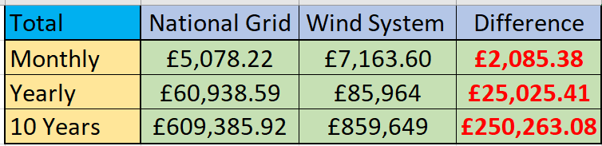

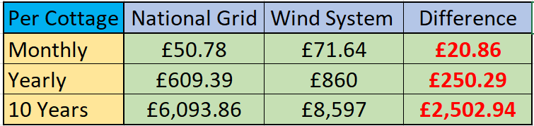

As you can see, the Wind system is clearly more expensive than the national grid. With the village going with the wind system, each cottage would be paying £20.86 extra each month. Bear in mind that this price is with the residents in the cottages are paying for the public buildings. The residents of the cottages will be paying for the power of the 2 schools, police station, hospital, 2 worship houses and 80 street/traffic lights. This means the total price was always going to be more than original. But this doesn’t mean it is a bad thing. When you think of it, £20 extra per month to most people is not that much. It is quite reasonable when you think they are powering the rest of the town. It also adds to the community spirit that the village coming together to make the town run off green energy. It also benefits the environment as it is completely green. Using the wind turbine system over the national grid has its benefits. The system is self-sufficient as it uses the winds power, which is renewable. The sustainability of the system is tremendously better than the national grid. It has an inexhaustible energy source that produces clean energy. And to top it all off it is environmentally friendly that will help to slow down climate change.
I will now show what the price will be after the 10 years.
10 Year Maintenance - £124,630
10 Year Technicians Salary - £300,000
After 10 Years of Wind power - 124,630 + 300,000 = £424,630
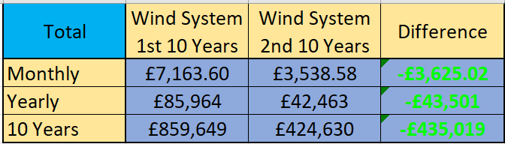
This is the price for the second period of 10 years.

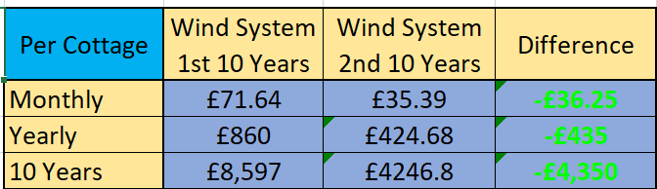

From looking at the prices for the second 10-year period, the village saves a lot of money. In the second period, the monthly cost per cottage is slashed by £36.25. This will save the village £4,350 over this time.
This shows that the wind turbine system is a viable option for the village as in time, it does save the village money. What more could you want than cheaper electricity bills and having completely green energy.

Feed In Tariff
There is a way to make the system cheaper. It is possible to sell any excess power produced by the system back to the national grid. As the village power demand is 45.95kWh and the output I have calculated for my system is 64.4kWh, there is excess power that could be sold back to the national grid. As I left a generous tolerance for the system, there is a possibility to sell around 10kWh of power. After researching the feed in tariff rate is 5.57p.
https://www.ofgem.gov.uk/publications/feed-tariff-fit-tariff-table-1-april-2021
From this, if we have 10kWh per day excess. Over 10 years you could sell 36,500kWh to the grid. This will calculate to 5.57 x 36,500 = 203305p = £2,033.05
This is not a substantial amount compared to the cost of the entire village, and it will only reduce the monthly cost per cottage by 17p. But anywhere where you can save money is important. It could even go towards extra maintenance cost if need be.

Conclusion
To conclude I have created colour graded tables showing the cheapest to the most expensive.
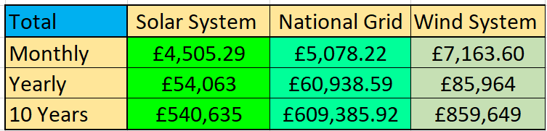

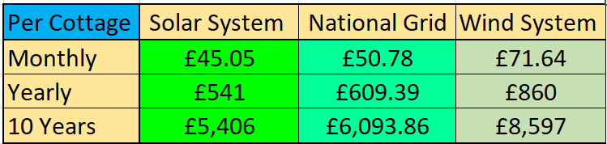

The Wind turbine system has come out to be the most expensive option. Having to wait for the second 10-year period for the system to pay off. Going into this assignment, this is the system I would have thought to come out on top. Clearly the prices on turbines are too high for the system to be affordable. Although the residents would only be paying £20 more each month, they would have a completely self-sustainable green energy village.
The solar system has surprisingly been the most viable option for the village. Although there was little sunlight in the village, the cheap reliable solar panels have beaten the price of the national grid. Alongside being the cheapest, it is also fully self-sustainable. This system leaves the residents paying £5 less each month, even though they are paying for the public buildings. If the system was to be implemented for the 10 years, it would be saving the town almost £69k. If they system was still in place for a further 10 years, it would save the town just over a quarter of a million pounds.

References
Electricity prices –
https://powercompare.co.uk/electricity-prices/
Map of the village –
https://www.google.com/maps
All weather information –
https://weatherspark.com/y/37922/Average-Weather-in-Llandudno-United-Kingdom-Year-Round
Solar panels –
https://www.sunstore.co.uk/product/3900w-48v-11-0kwh-professional-off-grid-solar-system/
Solar inverter –
https://energetechsolar.com/25kw-sdp-off-grid-inverter

Solar and wind battery –
https://www.alibaba.com/product-detail/50KWH-LFP-Lithium-Battery-48V-1000Ah_60828090314.html?spm=a2700.7724857.normal_offer.d_title.63cb4183FBV6le
Wind turbine –
https://en.wind-turbine-models.com/turbines/1681-hummer-h25.0-200kw
Turbine Inverter –
https://www.aimscorp.net/12000-Watt-Inverter-Charger-48-volt-120-240vac.html
Feed in tariff –
https://www.ofgem.gov.uk/publications/feed-tariff-fit-tariff-table-1-april-2021

