Software Engineering Principles and Practice
ACCA6027
Connor Ellement 1803452
Web Development

Contents
1) Introduction (100 words) 2
2) Design (800-900 words) 3
2.1) E.D.I.P.T (Maybe move to after CRC cards) 3
2.2) User Stories and User Story Maps 4
2.3) CRC Cards 6
2.4) Wireframe 6
2.5) Strengths 6
2.6) Weaknesses 6
2.7) Evaluation 6
3) Software Testing (600 words, 200 each section) 6
3.1) Blackbox Testing 6
3.2) Whitebox Testing 6
4) Testable code (200-300 words) 6
5) Version Control (600 words, 200 each section) 6
5.1) Advantages 6
5.2) Discussion 6
6) GIT (Want to say about 200 words) 6
7) Conclusion (100-200 words) 6

Introduction
In this report, the aim by its end is to be able to effectively evaluate one’s own work using various approaches of design and testing methods, as well as develop an application for the game, Connect 4, using the C# coding language. These methods include using user story maps to lay out a plan of what a project should do and how it should do it, CRC Cards to back up the plan laid out inside the user stories. These lead onto using black box and white box testing to test the application created with the methods included inside black and white box testing.

Design
As already mentioned, one of the aims of this project and assignment was to be able to create an application for the globally known game, Connect 4. To be able to start even thinking about coding the application, various design methods had to be looked at first. This was achieved in a team of about 6 with various team meetings. The objective of these meetings was to be able to produce wireframe designs of the application, user stories and a user story map, as well as Class-Responsibility-Contributor cards. These methods allowed us as a team to get a firm idea of what needed to be designed for the application, and more notably, how to pull it off. On top of these methods, the 5-stage design thinking process of Empathise, Define, Ideate, Prototype and Test was also looked upon.

2.1) E.D.I.P.T
E.D.I.P.T stands for Empathise, Define, Ideate, Prototype and Test and is a 5-stage design process, and in the teams, this process was applied. [1]
The first stage of this method is Empathise and this is used to get an understanding of the situation a person is face with. This later on help developers (and anyone facing a situation) the perspective of being able to separate themselves from their own thoughts and assumptions and gain an insight into what needs to be done. In the team, this step was used to step back and get a basic understanding to what would be needed in a Connect 4 game.
Next up is define, and this is used to define the problem at hand using the knowledge gained from the first step. In the case of this project, this step was used to identify the issues that might be faced when designing the Connect 4 application, such as how to code certain aspects of the game, and if the modifications to the game (such as the capture counter) were able to be implemented. By using the define stage, it allowed the team to be able to come up with a design that would aid in the development of the application, later backed up by User Stories and CRC cards. [1]
Ideate is used to wrap up the first two steps of the process. You have a better understanding of what is required for the solution and have defined what issues may arise in Empathise and Define stages. As a team, brainstorming was used to gather ideas from everyone of how to implement the functions for the application and make sure they work effectively. It allowed the team to come up with various ways of approaching and tackling the development. This allows the team later on to use different approached so that everyone own application is not entirely the same and allows them other methods to fall back on if needed.
Logically, after defining ways to tackle a problem is usually when prototyping comes in to play. Prototyping is a great way of being able to develop an application (or whatever the problem you are facing requires) and begin to implement the features and ideas discussed in the ideation step. Each developer can then get a further understanding of what areas of the application are trickier and what are easier. In coding, you are always taught to put in order what you know you can do first, then tackle what is more difficult at a later time, and ideation makes this process easier to follow. This allowed individual team members to split up the functions by what they personally thought was easier or harder to do and tackle them when able to.
Testing is the final step in this design process and is the conclusion to all other steps before it. This is where everything comes together for the application, and all functionality is tested to make sure it works as intended. It gives individual members of the team a chance for a final review of the application they have created and fix any issues that they may have missed in the development. [1]

2.2) User Stories and User Story Maps
User stories are tools used in Agile Software and are descriptions of many functions and features of a software system. They are used to capture what is wanted and needed from an end-user point of view. User stories help describe what types of users might use the system, what they would want to use it for, and why they would want to use it for that purpose. This is also referred to as the ‘As a, I want’ method. A user story map is an enlarged version of a user story that incorporates all aspects of a project rather than just one. This means that developers can view all requirements of an application together and follow a story on how to implement certain features of the application being developed. [2] [3] [4]
User story maps and user stories were applied to this project and was extremely helpful for laying out what essentially became a to do list for the application with how it laid out the tasks that had to be tackled, why it was needed and how to do it. This helped give the developer a wider perspective on the task at hand and aided in the progression and development of the Connect 4 application. By using the ‘As a, I want’ story structure in junction with the user stories really allowed the developer to be able to break down the problems and issues found in building the Connect 4 application. This was beneficial as it meant the developer could prioritise what parts of the application to focus on first down to what was easier to implement, or what they knew they could implement. [3] [4]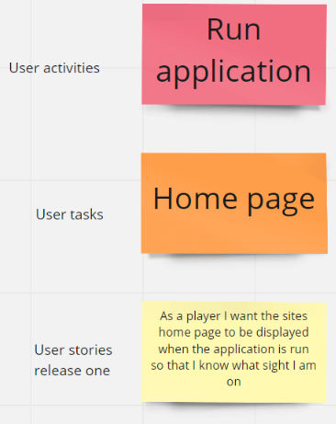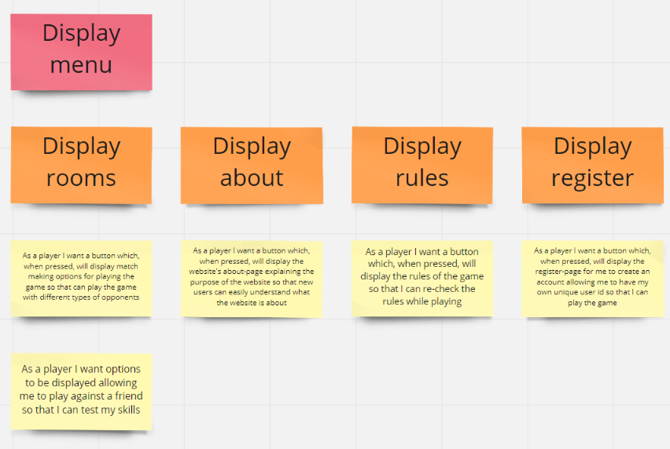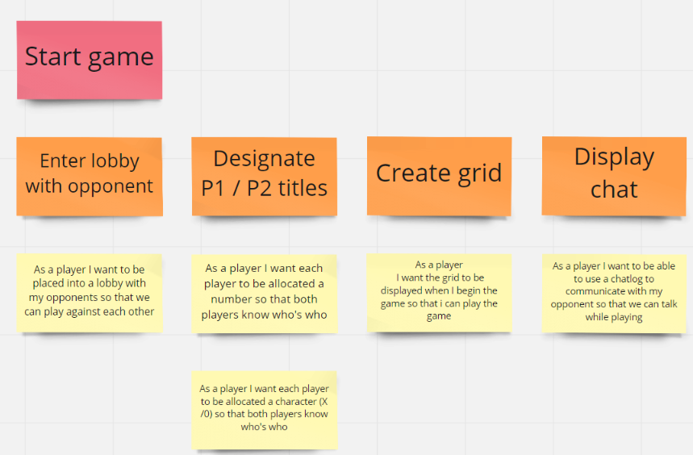
For full view of ALL user stories and the user story map created by the developer and their team please go to this Miro whiteboard link: https://bit.ly/3n9Bgnw.

2.3) CRC Cards
CRC stands for Class, Responsibilities and Collaborators. A CRC card is created by a user tackling a project, and this project can be anything, and a CRC card can be applied to pretty much any scenario, from software development, game development, film making etc. [5] [6]
CRC cards are an approach often used in the analysis and design phase of a development cycle. The aim of the approach is to be able to identify classes as real-world objects, then define what responsibilities that class would have. The collaborators then come in later when multiple CRC cards have been made. The collaborators are used to say which CRC card might make use of another CRC card. [6] [7]
A traditional CRC card looks like this:
[Figure 1] [1]
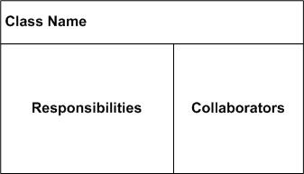
A class is a representation of objects that are similar to one another, and can be a person, event, concept etc. or whatever is relevant to the current system. The responsibility is for anything that class needs to know or do. For example, if you had a class called ‘Customer’, customers have names, addresses and phone numbers. Customers can also perform actions such as making an order or making a payment. These are things a customer knows and does, so they fall into the responsibilities. There may come a time when a card has a certain responsibility, however, it does not have enough information to perform the responsibility. This is when a card would collaborate with another card that has the sufficient information to perform the required responsibility. [8] [9] [5]
Designing CRC cards can offer many benefits to a developer and or team if working in one. The fact they are not physical objects, they are portable between meetings and working devices, so this means they can be used anywhere which makes it easy to be used during team meetings. They are tangible me meaning anyone viewing a CRC card, be it a solo developer or team can easily examine the card. They help not over complicate Object-Oriented Programming (OOP), meaning someone with limited OOP knowledge would be able to follow the cards, making them almost simple. Also, as previously mentioned it gives the user of the approach to break down aspects of whatever they are using the approach to tackle, and plan accordingly. [9] [7]
Some of the cards designed by the author are below. [10]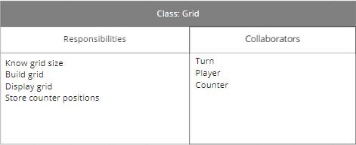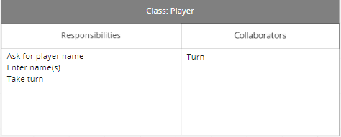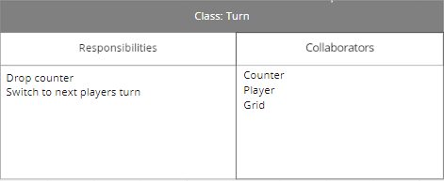
For full view of ALL CRC created by the developer and their team please go to this Miro whiteboard link: https://bit.ly/3n9Bgnw.
An overall aim hoped to be achieved while using CRC cards is for the cards to have the ability to provide a sufficient amount of detail, so that anyone viewing the CRC cards is able to get enough information and actually implement what is written on the cards. In terms of the cards created by the author of this report and their team, it is felt that they do offer a sufficient level of detail to the point that someone viewing the CRC cards would be able to get a good idea of the project being built, how to implement the cards, and why they are there.

2.4) Wireframes
Wireframes are another integral aspect to the design phases in a development cycle and are predominantly used to create a design for a specific website service at its most basic level, however they can be applied to lots of other real-world scenarios. [11]
Think of a wireframe as a story board. When a film director has a script that they need to turn into a film, they will go through key scenes from the script, and draw small tiles of the scenes. Do these tiles need to be Van Gough esc drawings? No. They can be simple stick figures doing an action, but the point is for the director to be able to give an impression and a rough idea of how they see the scenes going. This is exactly what wireframing is. [12] [13]
The aim of a wireframe it to be able to display a visual idea of what the project will look like in its final state. The fact that they are designed so simply is key to the process as it means they are tentative and can be changed when and as needed to get the development process under way. [11]
[Figure 2] [2]
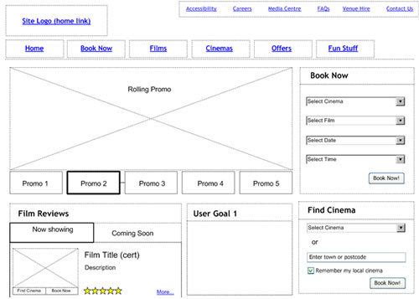
Wireframing has various advantages for those who use it. Wireframing allows users to be able to review the wireframes as a very early form of feedback in the development cycle. Using this design process allows the user to prioritize certain content depending on what they deem most valuable. Lastly, wireframing is a very cheap design process as they can be drawn on pieces of paper, or even simply using the application Paint. [14]
Various wireframes have been created by the author of this report. They provide a basic view of how the Connect 4 application is intended to look towards the end of the development process, however, still provides sufficient information for a developer to follow and start implementation.
Some of the wireframes created can be seen below: [10]
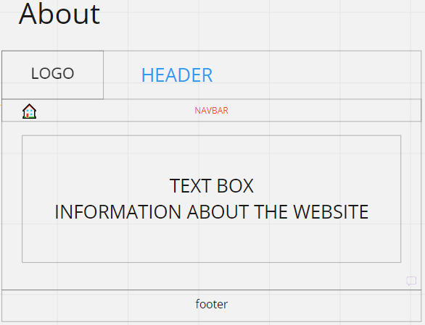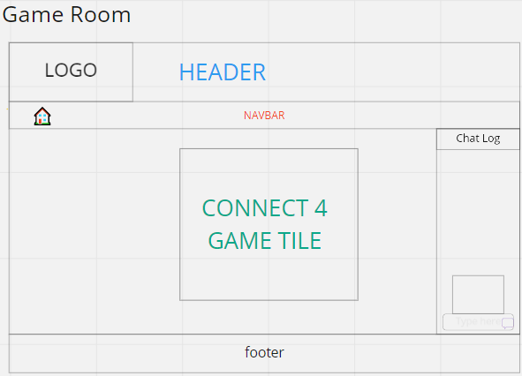
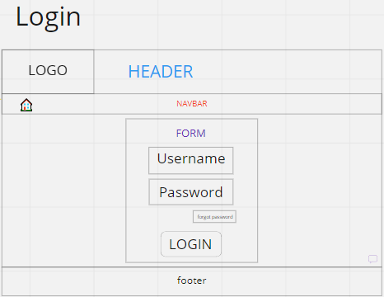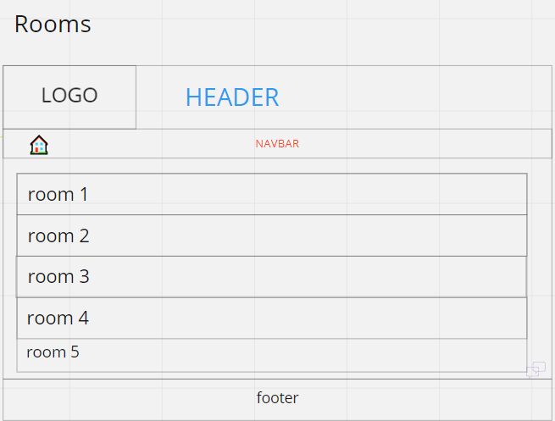
For full view of ALL wireframes created by the developer and their team please go to this Miro whiteboard link: https://bit.ly/3n9Bgnw.

2.5) Strengths
By using the design methods of E.D.I.P.T, User Story maps and User Stories, Wireframes and CRC cards, they provide various strengths for the project to the author. [15]
- Cost Effective: All of the methods spoken about above are essentially free to do, except for the cost of owning a computer being the maximum cost, and even then, it is not essential. These methods can be done on pen and paper if required. There is not anything being developed as of yet, in this stage of the development cycle, so these methods are cheap to use.
- Tentative: These methods all use basic and simple design principles to give an idea of how the project will look towards the final stages. Due to the fact that nothing actually gets implemented, just designed at its most basic stage means that everything can be changes easily as and when needed.
- Portable: Similarly, to the previous point of the methods being cost effective, because these methods can just be done of pen and paper, paint, or a simple word document, they are extremely portable. It is not hard to put them of a USB stick or folder and take them to each team meeting or separate work locations to be examined.
- Prioritize: Using these design methods allows the author to be able to prioritise what implementations should occur first according to how important they are deemed, or what they know they can implement. This saves the author time in the long run by not trying to implement less important and do-able features first.
- Communication: These processes aid in communication, whether it be between a team of developers, or a developer and their client. The developer can provide what they have created using these processes and provide them to the client for a very early form of feedback and make changes accordingly.
[9] [12] [3] [11] [13]

2.6) Weaknesses
When a process or processes have strengths, it is most likely they will have some weaknesses as well.
- Not Beautiful: The fact that the designs are so basic and simple is indeed an advantage, but also can hinder a project. Often, when a client is looking for progress and updates on a project, they have commissioned they will want to see well designed pages and screenshots of the development, so when they see just see some design scribbles along with some black and white cards, they might be left disappointed by the progress not knowing that this stage of the development is important.
- Too Designed: As the early design process is so important, it is easy to get side-tracked by focussing too much on it. This can lead to doing too much early design that the project gets forgotten.
- Focus: Prioritising the important features of an application is important, but the less important functions are also important to the overall completion of the project, so by only focusing on the important implementations, the lesser get forgotten.
[9] [12] [3] [11] [13]

2.7) Evaluation of design
Overall, for the design stage of the development cycle, the author would call it a success. A lot of information has been made available by the various methods discussed. E.D.I.P.T within its 5 steps helped identify potential problems that may be faced and break them down and apply solutions to the potential problems faced. The User Stories and map aided in laying out an overall to-do list for the Connect 4 application identifying what would be needed from the application for a player to be able to play the game as intended. The CRC cards helped further break down and identify what was needed from the application in more of a technical way by separating the requirements into the cards, along with applying what that requirement needs to do and say what it will need to achieve it. The wireframes were helpful to the author because they give a view on how the application should look at the end, as well as also make note of features that need to be implemented.

Software Testing
Software testing is a very important step inside the development cycle. It is a method used by developers to test if the product they are creating matches up with the requirements set to them and to see if it follows along with what they outlined inside their design phase. There are many different ways to software test, but usually the outcomes are the same whichever way you do it. Software Testing involves expecting something to happen in the developed program, trying it, and seeing if it worked as expected or if it failed. Some of the different methods of Software Testing is unit tests, integration tests, End-to-end tests, and acceptance testing. This step is important because it allows developers to go back over their work and use it as a form of feedback for themselves. By testing their created product, they can see what works and what does not, it is the perfect time to make revisions if anything is discovered about the project, for instance an error with some of it, or maybe the developer spots something that they can make a change to so that it is more efficient. [16] [17]

3.1) Blackbox & Whitebox Testing
Another way of Software testing is a process called Blackbox testing. This is the process of testing functionalities inside an application without knowing the internal structure of the code. Whitebox Testing is the opposite to Blackbox testing as it tests the internal structure of an application and tests the code. Blackbox focuses on the requirements of the application, and has tests performed based the requirements without knowledge of the code. For example, with Connect 4, it is expected that a player will place a counter, so a Blackbox test for that scenario could be ‘Input: Player places counter. Expected result: Counter places where player wanted. Actual result: Counter was places where specified’ and this test can be performed without any knowledge of the actual code. Whitebox testing is called that because it refers to the ‘Whitebox’ being clear because the tester can see the code. It is also referred to as Clear box testing for this reason. [18] [17] [19]

3.2) Test Cases & Examples
To show examples and scenarios of both Whitebox and Blackbox testing, the author will use Functional testing for Blackbox and Unit testing for Whitebox.

3.2.1) Functional testing
Test No. | Input (Requirement) | Expected Result | Output
1 | Players Names | Game should ask for players names, then welcome them to the game | Application asked for the names, players entered them, and game welcomed them to the game
2 | Grid dimensions | The grid used to play the game should be displayed | Using the height of 6 and width of 7, the grid displayed correctly
3 | Players column choice | Player chooses column for a counter to be placed, and the counter gets places according to the column request | Players counter gets places in the correct column

3.2.3) Unit testing
Test No. | Test | Steps | Expected Result | Actual Result | Passed? (Y/N)
1 | Pressing start to display a blank grid for players to reference | Either player presses a key | Code should display a blank version of the grid | Code dis not display blank grid | N
2 | “” | “” | “” | “” | Y
3 | Placing counter goes to lowest available space | Player chooses a column to place counter | Counter should go to lowest available slot according to the players choice | Counter goes to lowest space in correct column | Y
4 | Players take turns | Game switches players | After each players’ turn, it should swap to the other player | After player ones turn, player two took theirs, and then repeated | Y
5 | Chosen column is full | Player places counter in full column | Game should tell them that the column is full and to select a new column | Code crashed due to error | N

Testable code
Testable code is a version of code that helps automate the testing process which makes it easier and less time consuming. Testable is code that is able to be verified programmatically. When someone performs a test, they want to be able to get a certain result from it, and if it is a failed test then you would want it to tell you what went wrong so that is can be fixed. This aids the developer debug the code, as well as keep the developer focused of producing software that does what it is supposed to. Using Testable code means that the verification process can be automated, meaning that no matter what happens, there will be a releasable version of the application available. The important last-minute changes to code are easier to do and are pretty much free, and the Testable code will be code of higher quality. [20] [21] [22]

Version Control
Version Control is a practice of attempting to track and manage changes to a piece of software’s code. When using Version control software, it makes note of any changes to the code being controlled inside a database, and if a mistake arises, helps the developer perform a rollback and compare the current code to older versions of code to identify what is causing the error. [23] [24]

5.1) Advantages
- Compare – By having a version of each previous iteration of software, it allows developers to be able to compare versions against each other. This is extremely helpful if an error pops up and a developer needs to compare the current not working code, to previous working code to uncover the source of the issue. [23]
- Version History/Backups – Adding on to the point above, having a complete collection of previous versions is very helpful for any loss of work as the work can be easily recovered. [24]
- Branching and Merging – When it comes to working as a team, having multiple team members work at the same time is almost a must do. Version Control makes this easier to do, by creating branches off the software, it allows team members to do their own individual work and then merge it together at a later date.

5.2) Discussion
The following statement has been given to the author to analyse and debate, “Version control software is a key tool in the software development process” [3]. Due to the benefits provided to a developer by using Version Control, the author would find it hard not to agree with the statement given. Version control aids in keeping work safe by having all versions of a piece of software stored, and losing work is one of the most devastating occurrences that can happen to a developer. Allowing team members to work co-efficiently also offers the ability to work faster and more effectively. [23] [21]

5.3) GIT
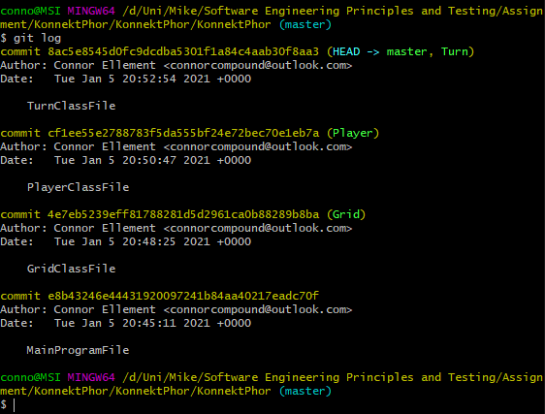

Conclusion
The goal of this report was the analyse various design techniques and processes, as well as develop a further understanding of testing and develop a Connect 4 application. In this conclusion, it is in the opinion of the author that this goal has been reached, with multiple design techniques being researched and applied to their own learning and code. Further knowledge on why these techniques, and methods of testing are important has been gained and will be able to be used in future work cases. If the author would have done anything differently it would have been to make more detailed notes whilst in lecture and clip any sections of the recorded lectures that they themselves deemed important and worth noting.

Bibliography

[1] | R. F. D. &. T. Y. Siang, “5 Stages in the Design Thinking Process,” Interaction-Design.org, 2020.
[2] | M. Cohn, “Advantages of the "As a user, I want" user story template”.
[3] | Visual Paradigm, “What is User Story?,” [Online]. Available: https://www.visual-paradigm.com/guide/agile-software-development/what-is-user-story/. [Accessed 29 12 2020].
[4] | F. D. J. M. E. M. v. d. W. S. B. Garm Lucassen, The Use and Effectiveness of User Stories in Practice, 2016.
[5] | Programming Paradigms, “The CRC Card,” 2011. [Online]. Available: https://sites.google.com/site/cs4217jan2011team2/programming-paradigms/the-crc-card. [Accessed 01 01 2021].
[6] | Agile Alliance, “CRC Cards,” Agile Alliance, [Online]. Available: https://www.agilealliance.org/glossary/crc-cards/#q=~(infinite~false~filters~(postType~(~'page~'post~'aa_book~'aa_event_session~'aa_experience_report~'aa_glossary~'aa_research_paper~'aa_video)~tags~(~'crc*20card))~searchTerm~'~sort~false~sortDirection~'as. [Accessed 01 01 2021].
[7] | University of Cape Town, Class-Responsibility-Collaborator cards, 2011.
[8] | OpenLoop, “Introduction to CRC Cards”.
[9] | S. W. Ambler, “CRC Modeling:,” AmbySoft Inc., 1998.
[10] | C. Ellement, “User Stories, CRC and Wireframes,” 2020. [Online]. Available: https://miro.com/app/board/o9J_lcvjJIg=/. [Accessed 02 01 2021].
[11] | ExperienceUX, “What is wireframing?,” What is wireframing?, [Online]. Available: https://www.experienceux.co.uk/faqs/what-is-wireframing/. [Accessed 02 01 2021].
[12] | W. Craig, The Benefits of Wireframing a Design, 2011.
[13] | E. Malone, “THE PROS AND CONS OF WIREFRAMING IN A WEBSITE REDESIGN,” 2017.
[14] | M. Redka, “5 Obvious Advantages of Wireframing,” 2019.
[15] | V. Thakur, “Design Thinking- EDIPT,” 2019.
[16] | Guru99, “What is Software Testing? Definition, Basics & Types,” Guru99, [Online]. Available: https://www.guru99.com/software-testing-introduction-importance.html. [Accessed 02 01 2021].
[17] | T. Doln, “The Ultimate Guide to Software Testing”.
[18] | Guru99, “What is BLACK Box Testing? Techniques, Example & Types,” Guru99, [Online]. Available: https://www.guru99.com/black-box-testing.html. [Accessed 03 01 2021].
[19] | Guru99, “What is WHITE Box Testing? Techniques, Example & Types,” Guru99, [Online]. Available: https://www.guru99.com/white-box-testing.html. [Accessed 03 01 2021].
[20] | L. Brandon, “The Importance of Writing Testable Code,” 2014.
[21] | D. Bernstein, “Writing Testable Code,” 2019.
[22] | M. Renze, Writing Testable Code, 2017.
[23] | I. Azarian, “A Review of Software Version Control: Systems, Benefits, and Why it Matters,” 2013.
[24] | BitBucket, “What is version control?,” Atlassian, [Online]. Available: https://www.atlassian.com/git/tutorials/what-is-version-control#:~:text=Version%20control%2C%20also%20known%20as,to%20source%20code%20over%20time.. [Accessed 04 01 2021].
[25] | M. Dacey, “Software Engineering Principles and Practice Brief,” 2020.
[26] | Interaction-Design, “Design Thinking,” Interaction-Design, [Online]. Available: https://www.interaction-design.org/literature/topics/design-thinking. [Accessed 02 01 2021].

Appendix

Git Logs
conno@MSI MINGW64 /d/Uni/Mike/Software Engineering Principles and Testing/Assignment/KonnektPhor/KonnektPhor/KonnektPhor (master)
$ git log
commit 8ac5e8545d0fc9dcdba5301f1a84c4aab30f8aa3 (HEAD -> master, Turn)
Author: Connor Ellement <connorcompound@outlook.com>
Date: Tue Jan 5 20:52:54 2021 +0000

TurnClassFile

commit cf1ee55e2788783f5da555bf24e72bec70e1eb7a (Player)
Author: Connor Ellement <connorcompound@outlook.com>
Date: Tue Jan 5 20:50:47 2021 +0000

PlayerClassFile

commit 4e7eb5239eff81788281d5d2961ca0b88289b8ba (Grid)
Author: Connor Ellement <connorcompound@outlook.com>
Date: Tue Jan 5 20:48:25 2021 +0000

GridClassFile

commit e8b43246e44431920097241b84aa40217eadc70f
Author: Connor Ellement <connorcompound@outlook.com>
Date: Tue Jan 5 20:45:11 2021 +0000

MainProgramFile

conno@MSI MINGW64 /d/Uni/Mike/Software Engineering Principles and Testing/Assignment/KonnektPhor/KonnektPhor/KonnektPhor (master)

Connect Four Code

Main Program
using System;

namespace KonnektPhor
{
public enum CellStatus { EMPTY, PLAYER_ONE, PLAYER_TWO };

class Program
{

static void Main(string[] args)
{
bool game = true;
bool turn = false; //FALSE = PLAYER 1, TRUE = PLAYER 2

Grid board = new Grid();
Player PlayerOne = new Player();
Player PlayerTwo = new Player();

Console.WriteLine("Welcome {0} & {1} to Konnekt Phor! Press SPACE to start!", PlayerOne.getPlayerName, PlayerTwo.getPlayerName);
Console.ReadKey();
Console.WriteLine();

board.DrawGrid();

while (game == true)
{
PlayerOne.takeTurn(board, turn);
board.DrawGrid();
turn = true;

PlayerTwo.takeTurn(board, turn);
board.DrawGrid();
turn = false;
}

}

}
}

Player Class
using System;
using System.Collections.Generic;
using System.Text;

namespace KonnektPhor
{
public class Player
{
//Attributes

string _playerName;

private int _colChoice;

//Consturctors
public Player()
{
_playerName = GetName();
}

//Properties

public string getPlayerName
{
get { return _playerName; }

}

//Methods
public static string GetName()
{
Console.WriteLine("Player, please enter your name: ");
return Console.ReadLine();
}

public void takeTurn(Grid grid, bool turn)
{
Console.WriteLine("{0} please enter a column number to put a counter in (1-7)", _playerName);
_colChoice = int.Parse(Console.ReadLine()) - 1;
Turn.DropPiece(grid.getGrid, _colChoice, grid.getHeight, turn);
}

}
}

Grid Class
using System;
using System.Collections.Generic;
using System.Text;

namespace KonnektPhor
{
public class Grid
{
//Attributes
static CellStatus[,] _grid;
static int _width;
static int _height;

//Constructors
public Grid()
{
_width = 7;
_height = 6;
_grid = new CellStatus[_width + 2, _height + 2];
}
//Properties
public CellStatus[,] getGrid
{
get { return _grid; }
set { _grid = value; }
}

public int getHeight
{
get { return _height; }
}

public int getWidth
{
get { return _width; }
}

//Methods
static void DrawCell(CellStatus status)
{
switch (status)
{
case CellStatus.PLAYER_ONE:
Console.Write("X");
break;
case CellStatus.PLAYER_TWO:
Console.Write("O");
break;
case CellStatus.EMPTY:
Console.Write("-");
break;
}
}
static void DrawRow(CellStatus[,] grid, int y, int width)
{
for (int x = 0; x < width; x++)
{
DrawCell(grid[x, y]);
}

}
public void DrawGrid()
{
for (int y = 0; y < _height; y++)
{
Console.Write("|");
DrawRow(_grid, y, _width);
Console.Write("|");
Console.WriteLine(); // Next row
}
}
}
}

Turn Class
using System;
using System.Collections.Generic;
using System.Text;

namespace KonnektPhor
{
public class Turn
{
//Attributes
//Constructors
//Properties
//Methods

public static void DropPiece(CellStatus[,] grid, int col, int row, bool turn)
{

bool end = false;
int height = row - 1;
int column;
do
{
if (turn == false)//If player ones turn
{
column = CheckFull(grid, col, row);
if (grid[column, height] == CellStatus.EMPTY)
{
grid[column, height] = CellStatus.PLAYER_ONE;
end = true;
}
else
{
height = height - 1;
}
}
else//If player twos turn
{
column = CheckFull(grid, col, row);
if (grid[column, height] == CellStatus.EMPTY)
{
grid[column, height] = CellStatus.PLAYER_TWO;
end = true;
}
else
{
height = height - 1;
}
}
} while (end != true);
}

static int CheckFull(CellStatus[,] grid, int col, int row)
{
if (grid[col, 0] != CellStatus.EMPTY)
{
do
{
Console.WriteLine("Column full! Please choose a new column");
col = int.Parse(Console.ReadLine()) - 1;
} while (grid[col, 0] != CellStatus.EMPTY);
return col;
}
else
{
return col;
}
}
}
}

