Introduction to Leadership and Management
Component 1: Essay
Module Code: LCBB4008
Lecturer: Dr. Laila Maazouz
Student Name: Roxana Olaru
Student ID: 2213775

Table of Contents
Introduction 3
Choosing Organization and Leadership Style 3
Describing Personal Experiences 7
Integrating Personal Experiences with Theory 7
Conclusion 8
References 9

Introduction
Leadership and development are two components that are integral to organizational growth as well as success. Along with this, the capability to motivate, influence, and lead people or groups of people toward the same goals is the core of leadership (Kragt and Day, 2020). A combination of abilities, dispositions, and actions that enable people to do their best work is what makes a leader effective. On the other hand, development intends to raise each person's potential and abilities inside an organization by providing them with mentorship, coaching, and training opportunities.
Leadership has played an essential part in promoting innovation, collaborating with others, and managing change in the fast-paced and competitive business world of today. Investing in the development of great leaders at all levels gives businesses an advantage in the marketplace in addition to increasing employee retention and satisfaction. Significantly within the human, social, and cultural dimensions, there is no development without leadership so it is extremely important to have a relationship between leadership and sustainable development. This present report aims to determine theories and perspectives of leadership and management from a range of diverse environments. Along with this, the report will also focus on evaluating the various leadership styles as well as how management and leadership styles contribute to organizational effectiveness within the value and ethics framework. In addition to this, it will also discuss the behavior of leadership and management that impact the vision and mission of the organization.

Choosing Organization and Leadership Style
Transformational leadership
Motivating and encouraging subordinates to attain extraordinary performance and acquire greater achievement is an essential component of transformational leadership. This type of leadership is characterized by charisma, vision, and the capacity to foster team member development. Under Jeff Bezos's direction, Amazon is one business that is well-known for its revolutionary leadership. A strong focus on customer obsession is a defining feature of Amazon's leadership style. Motivated by innovation and continual improvement, leaders put the needs of their customers first and look for methods to improve their entire experience (McCauley and Palus, 2021). At Amazon, data and metrics play a major role in decision-making processes. To make decisions that are well-informed and provide measurable results, leaders employ data analysis. Be it recognizing failure as a necessary component of the creative process or being willing to take measured chances, Amazon is well known for its risk-taking tendencies. Amazon has been able to disrupt a number of industries thanks in large part to this risk-taking mentality. Rather than concentrating on quick profits, Amazon's executives prioritize long-term objectives and investments. Amazon's ongoing development and success can be attributed to the long-term vision that informs strategic decisions and investments. Managers as well as employees at Amazon are encouraged to explore and create an innovative culture. As evidenced by the creation of new services and devices like Kindle, Echo, and Alexa, this emphasis is on creative thinking.
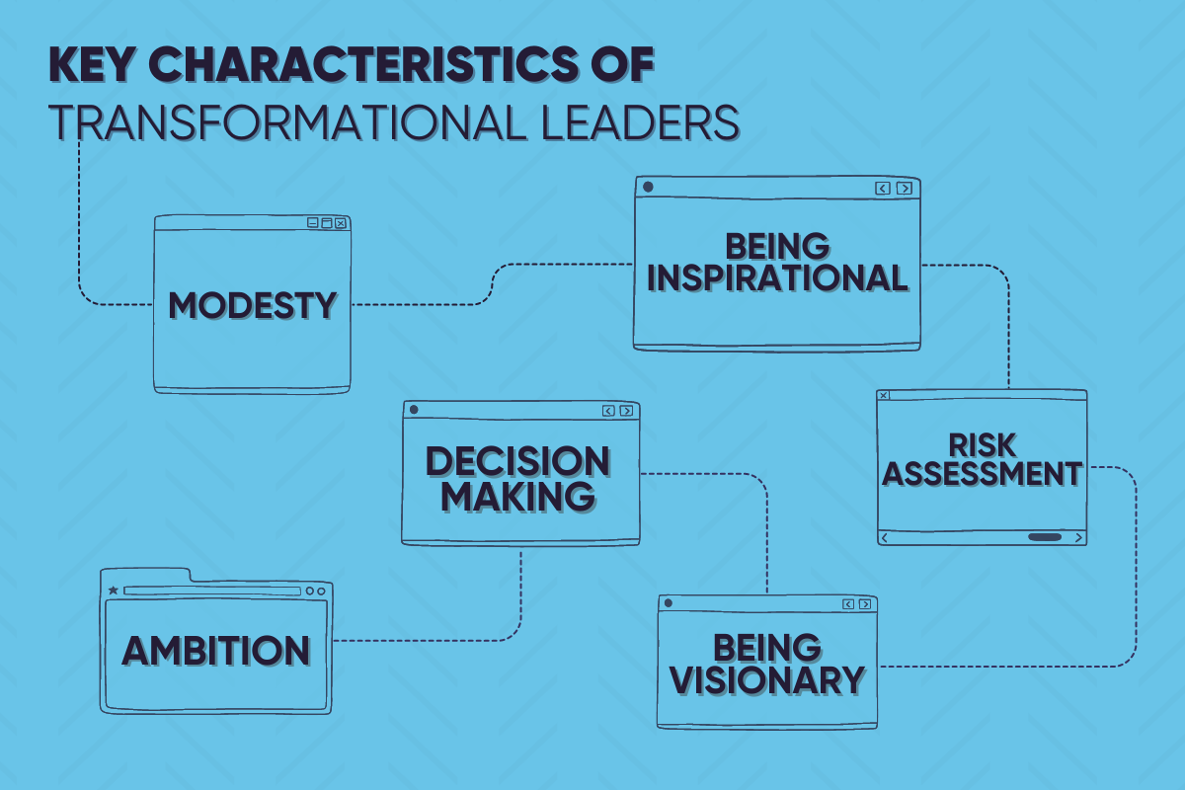
Figure 1: The power of transformational leadership
(Source: Purple Quarter, 2023)
Advantage of transformational leadership
- Through the promotion of an innovative and exceptional culture, transformational leaders motivate their workers to go above and beyond.
- Employees may achieve their full abilities when they work under transformational leaders who prioritize personal development and empowerment.
- Organizations can adapt to change and obstacles with more effectiveness when they adopt this approach, which fosters innovation and flexibility.
Disadvantages of Transformational Leadership
- Team members may become dependent on the leader when they depend too much on their charisma and vision.
- If not well managed, the high standards that transformational leaders establish might result in burnout.
- With this leadership style, things change quickly, which could be difficult for specific individuals to adjust to.
Transformational leadership can work very well in situations where creativity, invention, and adaptation are critical, especially in startups dealing with disruptive developments or fast-paced industries like technology (Ayoobzadeh and Boies, 2020). However, an alternative style of leadership might be more appropriate in situations that are more stable or while handling everyday activities that call for regularity and predictability.
Servant Leadership
Prioritizing the growth and well-being of staff members, together with acting as an inspiration for their success, is the hallmark of servant leadership (Siangchokyoo, Klinger, and Campion, 2020). For example, under Mark Zuckerberg's direction, Facebook operates as an example of servant leadership, putting employees' welfare first while creating a positive work atmosphere. An employee's requirements are at the core of the leadership approach of a servant leader such as Zuckerberg. Prioritizing his team members' growth, well-being, and development allows Zuckerberg to foster an encouraging working environment where staff members are valued, respected, and inspired to give everything they have. Employee feedback and helpful suggestions are something that Mark Zuckerberg is renowned for aggressively seeking out. Employees are encouraged to voice their thoughts, worries, and suggestions due to Facebook's open communication culture, which fosters a welcoming and safe work environment.
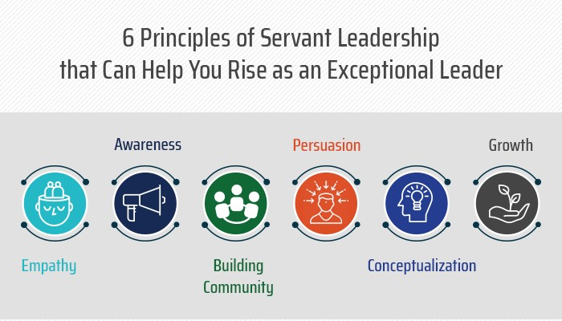
Figure 2: Principles of Servant Leadership
(Source: Matt Cecil, 2019)
Advantage of servant leadership
- Loyalty and engagement in the workplace are increased when servant leaders put a lot of effort into developing close bonds with their team members.
- Servant leaders establish a culture where people accept responsibility for their jobs by prioritizing the needs of others.
- The long-term success of an organization is facilitated by this style, which produces a culture of sustainability, trust, and teamwork.
Disadvantage of servant leadership
- Servant leaders may find it difficult to take charge in situations requiring for quick or difficult decisions.
- Conflicts or inefficiencies may result from workers making use of the leader's altruism.
- Some workers cannot be accountable or directed if there are uncertain performance objectives.
In settings that encourage collaboration, collaboration, and staff development such as service-oriented businesses or socially conscious organizations servant leadership is especially successful. Still, another leadership approach might be more suitable for situations requiring for strong guidance or rapid choices.

Describing Personal Experiences
I served as the leader of a student organization, which was one of my major leadership experiences. Leading a group of committee members to plan different activities and events for the student body was my responsibility in this position (Asbari, 2020). During this experience, I improved my time management, organization, and project management skills. To ensure that events are carried out successfully, I learned how to assign tasks in an efficient manner, prioritize them, and assign duties successfully. Through frequent interactions with colleagues, stakeholders, and outside partners, I also gained good interpersonal and communication skills. Making decisions, applying critical thinking, and solving problems were all facilitated by my leadership experience. I had to use both analytical and imaginative thinking to get beyond a lot of difficulties and barriers in my role as the leader of the student organization. I learned how to approach challenges carefully, weigh potential answers, and make decisions based on the information at hand whether it was handling logistics for events, settling problems within the team, or adjusting to unexpected developments. Leadership has significantly contributed to the advancement of my career. Exposure to other individuals, races, and viewpoints enhanced my cultural, emotional, and interpersonal development.

Integrating Personal Experiences with Theory
Situational leadership model
According to Wuryani et al. (2021), it is imperative for situational leaders to align their followers' skills. The presence of diverse team members with varying levels of skill, experience, and motivation necessitates the implementation of numerous leadership styles in order to optimise potential and attain objectives. I collaborated with teams comprising individuals with varied skill sets and goals. I employed situational leadership to adjust to each individual.

Delegative leadership enables competent and independent team members to take action. The lessons I learned encompassed ownership, accountability, performance, and innovation. The guidance, feedback, and assistance provided to my colleagues were unambiguous. With assistance and equipment, I enhanced my confidence, skills, and teamwork. Situational leadership effectively addressed the needs and talents of team members. The amicable atmosphere facilitated the success of both myself and my colleagues. Customising my leadership approach resulted in enhanced team performance.
Transformational leadership theory
Transformational leaders inspire both success and followers. The valuation of organisational goals is influenced by individuals. Elon Musk revolutionises the concept of leadership. Musk's business and ideas exhibit notable innovation. Elon Musk is motivated by his ambitious future vision to accomplish significant objectives and advance novel technologies. The group is driven to achieve ambitious objectives and propel technological progress. Pawar et al (2020). investigated Musk's innovative management of Tesla. According to the report, Musk's invention has had a positive impact on both Tesla's automotive and renewable energy sectors. Elon Musk revolutionised various sectors and enterprises. Elon Musk demonstrates leadership through a propensity for risk-taking and experimentation. He motivates his staff to engage in experimentation, question established norms, and embrace failure. The creative and agile culture of Tesla facilitates the development of prompt market and technological solutions.

Musk motivates others by surmounting challenges. His passion and ambition served as a source of inspiration for me. Elon Musk expects both himself and his staff to strive for perfection in order to enhance performance. Musk demonstrated that innovative leadership has the power to revolutionise Tesla. Musk's groundbreaking advancements revolutionised various sectors and inspired emerging players.

Conclusion
Communication abilities can be transferred by studying leadership styles and applying theory to personal experiences. Transformational, situational, and servant leadership taught me empathy, vision-setting, and empowerment. This extensive study taught me how these abilities improve leadership and organisation. Applying theoretical principles to real-world circumstances and reflecting on personal experiences has improved my leadership and understanding. I lead teams, motivate people, and solve complex problems. I adapt, motivate teammates, and succeed with my new leadership and communication skills. This method provided me the confidence to tackle different situations and help businesses succeed.

References
Kragt, D. and Day, D.V., 2020. Predicting leadership competency development and promotion among high-potential executives: The role of leader identity. Frontiers in Psychology, 11, p.537420.
McCauley, C.D. and Palus, C.J., 2021. Developing the theory and practice of leadership development: A relational view. The Leadership Quarterly, 32(5), p.101456.
Ayoobzadeh, M. and Boies, K., 2020. From mentors to leaders: leader development outcomes for mentors. Journal of Managerial Psychology, 35(6), pp.497-511.
Siangchokyoo, N., Klinger, R.L. and Campion, E.D., 2020. Follower transformation as the linchpin of transformational leadership theory: A systematic review and future research agenda. The Leadership Quarterly, 31(1), p.101341.
Asbari, M., 2020. Is transformational leadership suitable for future organizational needs?. International Journal of Social, Policy and Law, 1(1), pp.51-55.
Wuryani, E., Rodlib, A., Sutarsib, S., Dewib, N. and Arifb, D., 2021. Analysis of decision support system on situational leadership styles on work motivation and employee performance. Management Science Letters, 11(2), pp.365-372.
Pawar, A., Sudan, K., Satini, S. and Sunarsi, D., 2020. Organizational servant leadership. International Journal of Educational Administration, Management, and Leadership, pp.63-76.
Purple Quarter, 2023. The power of transformational leadership. [Online]. Accessed through: < https://www.linkedin.com/pulse/power-transformational-leadership-inspiring-positive-change>. [Accessed on: 16th March 2024].
Matt Cecil, 2019. Principles of servant leadership. [Online]. Accessed through: < https://www.linkedin.com/pulse/6-principles-servant-leadership-can-help-you-rise-leader-matt-cecil>. [Accessed on: 16th March 2024].

