From Players to Leaders:
Exploring Leadership Development Through Esports Participation in young adults aged 16 – 25 years

From Players to Leaders: Exploring Leadership Development Through Esports Participation in young adults aged 16 – 25 years

Programme: Doctorate in Education (EdD)
Module: ECDE7013 – Exploring Contemporary Issues in Education 2

Word count 11780

Table of Contents
Table of Contents 3
Abstract 5
Chapter 1. Introduction 7
1.1 Research Background 7
1.2 Research Focus and Contribution 9
1.3 Theoretical Framework 10
1.4 Significance of the Study 11
Chapter 2. Literature Review 13
2.1 Introduction 13
2.2 The Theoretical Framework 14
2.2.1 The Social Change Model of Leadership Development (SCM) 14
2.2.2 Kouzes and Posner’s (2009) Five Practices of Exemplary Leadership 17
2.2.3 Constructivist Theories of Leadership 19
2.3 Existing Empirical Studies on Esports 24
2.3.1 Distributed and Collaborative Leadership in Esports 24
2.4 Conclusion 30
Chapter 3. Research Methodology 31
3.1 Introduction 31
3.2 Epistemological and Philosophical Framework 32
3.3 Research Design 32
3.4 Sampling and Participants 33
3.5 Data Collection 35
3.5.1 Gameplay and communication analysis 36
3.5.2 Semi-structured interviews 36
3.6 Data Analysis 37
3.6.1 Coding Framework Development 39
3.6.2 The Process of Transcribing and Coding 41
3.7 Ethical Considerations 44
Chapter 4. Findings & Discussion 46
4.1 Introduction 46
4. 2 REFLECT: Metacognition and Evaluation 47
4.3 Strategy: Tactical Thinking and Emergent Leadership 48
4.4 Self-Development: Leadership Identity and Personal Growth 50
4.5 Comparative Analysis: Reflect, Strategy and Self-Development 51
4.6 Interview Perspective: Organisational Leadership 53
4.6.1 Game-Level Variations in Leadership Expression 57
4.7 Discussion 60
Chapter 5. Conclusion & Recommendations 61
5.1 Contributions to Existing Knowledge 61
5.2 Limitations 62
5.3 Practical Implications 63
5.4 Future research 64
References 65
Appendix A: 51 Original Coding terms 79
Appendix B: Blank Participant Consent Form 83
Appendix C: Player Semi-structured Interview Questions 86
Appendix D: CEO Semi-structured Interview Questions 88
Appendix E: Interview Schedule 90
Appendix F : NVivo Output 91
Appendix G: Game/Participant Metadata 92
Game results per filename 92

Abstract
This study investigates whether participation in Esports fosters leadership development among young adults aged 16–25, aiming to create a new leadership framework grounded in three already established models: the Social Change Model (SCM), Kouzes and Posner’s Five Practices of Exemplary Leadership, and Constructivism.
Data collection involved transcribing and coding over 27 hours of team gameplay and post-match interviews with approximately 60 participants across 6–10 Esports teams. Participants were recruited via the Discord App by joining the Esports Wales group, where players expressed enthusiasm to participate. Transcripts were converted into Excel format and imported into NVivo 14 for thematic coding, employing a condensed framework of ten leadership categories, refined from an initial set of 51 codes.
Analysis revealed three dominant leadership themes: REFLECT (524 references), STRATEGY (452), and SELF_DEV (326). The prominence of REFLECT underscores the centrality of cognition and self-assessment, reinforcing the constructivist approach that leadership is constructed through lived and reflective experience. STRATEGY references reflect dynamic, real time decision-making and tactical adaptations, aligning with Kouzes and Posner’s principles of “Challenging the Process” and “Inspiring a Shared Vision.” SELF_DEV codes illustrate personal growth, confidence, and leadership identity development, underscoring the SCM’s values and consciousness of self.
Two games that were played in particular exhibited high levels of coded leadership activity (ref: IESF06 and Esports633). These teams exhibited strong reflective and strategic behaviours, correlated with superior performance and more effective communication. In contrast, direct leadership commands and conflict resolution codes were less frequent, suggesting a preference for shared, non-hierarchical leadership models among high-performing teams, characterised by autonomous unspoken contributions from each member. The findings of this study support the view of leadership as a collective entity, a shared process, fostering peer support and experiential learning. It offers practical insight into how Esports aligns with educational goals and frameworks such as the Well-being of Future Generations (Wales) Act, 2015. Further, it provides evidence for educators and policymakers that Esports is more than entertainment, it is a suitable platform for leadership education.

Chapter 1. Introduction

1.1 Research Background
Leadership has long been a topic of extensive academic research and practical application, with studies investigating its relevance in various settings such as industry, education and personal development (Toor, 2011; Hogan and Kaiser, 2005; Silva, 2016). Leadership development interventions often begin early in life through programs such as the Scouts and other youth organisations, where young people are encouraged to develop responsibility, lead peers and build autonomy (Zavala, 2023; Burns, 2012). The need to develop leadership outdoes organisational effectiveness; it concerns the development of individuals learning to guide themselves towards goals whilst potentially supporting others in their journey (Sadler, 2003). The existing literature illustrates the increasing number of platforms through which leadership can be fostered (Day, 2000, 2011; Moldoveanu and Naravandas, 2019). In this regard, it is critical to examine which environments are most effective for generating these skills.
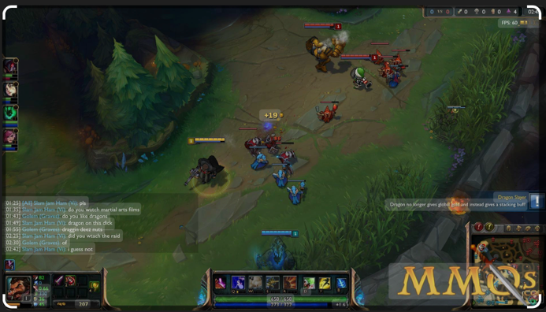
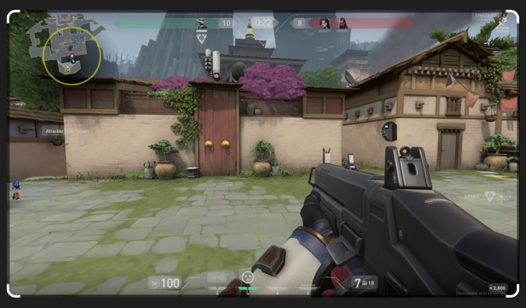
One such environment, which is often overlooked in formal educational settings, is competitive digital gaming or Esports (Reitman et al., 2020). With the widespread popularity of video games among young people (Chan et al., 2022), Esports offers an opportunity which is promising and yet underexplored context for developing competencies such as strategic thinking, self-regulation and collaboration (Nuangiumnong, 2016). Esports, which is short for electronic sports, refers to organised, competitive video gaming where individuals or teams compete in multiplayer titles such as Valorant and League of Legends (see Figures 1 and 2). Unlike casual gaming, Esports has structured tournaments, ranking systems, team coordination, and often professional coaching and sponsorship (Tucker, 2022). These games demand complex decision making, high levels of communication and coordinated execution; skills that are integral to effective leadership (Ghossoub, 2024). As the Esports industry continues its rapid growth, with projected revenues reaching $19.2 billion by 2030 (Grand View Research, 2025), there is growing potential for structured programs to harness this platform not only for entertainment but also for educational and developmental purposes. Smith and Johnson (2024) have proposed integrating skills-based frameworks into Esports, where participants gain recognition not just for competitive success, but also for developing those transferable skills such as problem solving, adaptability and leadership.
Figure 2: League of Legends
Figure 1: Valorant
However, the ethical application of Esports within educational and developmental contexts remains contested (for example Nuangiumnong, 2016). Despite its popularity, parents, educators, and institutions still perceive gaming as a trivial or even harmful activity, similar to earlier doubt about the value of television or early computer use (Trepanowski et al., 2024; Yani-de-Soriano et al., 2025). Concerns are voiced about health, too much screen time, addiction, and distraction from academic duties (Chung et al., 2019). Yet, these criticisms often fail to account for the benefits including cognitive, social and strategic demands of Esports, when implemented constructively and with purpose. This study adopts a more broadminded perspective, investigating the extent to which Esports can serve as a meaningful platform for developing leadership and collaborative competencies in youth. A compelling example of this potential is the story of Jann Mardenborough, who transitioned from playing Gran Turismo in his home in Cardiff to winning the GT Academy competition in 2011, and ultimately leading to a professional racing career, including participation in the esteemed 24 Hours of Le Mans (Piccotti 2025). His journey illustrates one such instance of exactly how digital platforms can nurture real-world skills such as discipline, focus and decision-making; traits that are equally relevant in competitive gaming and leadership development (Matuszewski et al., 2020). Mirroring this as a useful application of a digital platform, the study explores how leadership skills and competencies can be developed within Esports environments. Through further investigation, this research seeks to contribute to the field and to a more informed and evidence based understanding of Esports for leadership education. The following section outlines the research focus, theoretical framework, and the contribution this study seeks to make within the existing literature.

1.2 Research Focus and Contribution
This research seeks to address the question:
Can Esports and gameplay be used to facilitate leadership development?
Research on the connection of leadership development and Esports remains relatively scarce, with several publications recommending further investigation to better understand how gaming environments can contribute to leadership and professional skill development (Białecki et al., 2024; Archibald, 2024; University of Warwick, 2023; Sanz-Matesanz et al., 2024; Tholl and Soffner, 2024). Given the growing popularity of Esports worldwide, greater research interest and attention should be paid to its potential as a developmental space where young individuals can develop these skills, to be transferable to organisational contexts and future employment. Emerging research suggests that Esports can foster a range of cognitive and physical skills crucial for success in both gaming and professional environments (Matsui, 2023; Semenova et al., 2020). Kilci et al. (2025) further highlight how Esports helps develop mental agility and the ability to perform under rapidly changing and high-pressure conditions, an environment which closely mirrors the demands placed on modern organisational leaders; Directors, Company Owners, CEO’s.
The current literature on leadership in gaming contexts tends to focus on broad leadership and management paradigms, there is a lack of specifically examining leadership development within Esports environments (see for example, Williams, 2023; Xu and Hao, 2024; University of Pennyslvania, 2024; Surbakti et al., 2023; Richard and McDowell, 2019; Byme, 2023; Forlenza, 2023; Xue et al., 2024; Egan, 2022; Hewett, 2022; Jenkins and Pickett, 2022). This study addresses this gap by exploring how the unique structure of Esports serves as a suited dynamic platform for developing leadership competencies through teamwork, strategic decision-making and resilience under pressure. This study draws on three key theoretical frameworks to guide its analysis: The Social Change Mode of Leadership Development (Dixon et al., 2018), Kouzes and Posner’s (2009, 2013) Five Practices of Exemplary Leadership, and Constructivism (Bartlett, 1932; Piaget, 1952). As a collective, these models provide a foundation for understanding how leadership skills can be acquired and expressed in digital gaming environments.

1.3 Theoretical Framework
The Social Change Model of Leadership Development (Dixon et al., 2018) positions leadership as a collaborative, socially constructed process rather than a hierarchical position of authority. It emphasises values in social leadership and community engagement, aligning well with the cooperative nature of team-based Esports. Adams et al. (2023) describe the model as leadership through dialogue, where the leader’s role is to serve and support the team rather than dominate it. This perspective is especially relevant in gaming environments, where leadership emerges organically via effective communication and mutual respect rather than a formal authority (Gonzaga University, n.d.).
Kouzes and Posner’s Five Practices of Exemplary Leadership (2009; 2013) further refine this understanding by identifying specific behaviours that effective leaders demonstrate: modelling the way, inspiring a shared vision, challenging the process, enabling others to act, and encouraging the heart. These practices offer a practical lens via which leadership behaviours within Esports can be observed, analysed and cultivated (Kouzes and Posner, 2012).
Constructivism provides the epistemological underpinning for this research. Originating from the work of Bartlett and Piaget (Howes and Davies, 2014), constructivism suggests that individuals actively construct meaning through interaction and reflection. Applied to leadership development, it suggests that players develop leadership competencies by engaging in collaborative gameplay, experiencing real-time challenges, and reflecting on these experiences (David, 2022; McHenry et al., 2005; Johnston, 2016; Smorczewska, 2018; Koch, 2023). Johnston (2016), in particular highlights innovative methods for evaluating leadership, such as self and peer assessments, field-based testing, and dynamic learning processes, all of which can be integrated into Esports in context.

1.4 Significance of the Study
Designing leadership development frameworks within Esports and online gaming offers a unique opportunity to engage young adults in an environment where they are already highly active. These spaces promote the development of key leadership competencies such as communication, strategic thinking, teamwork and resilience (Tucker, 2022). Moreover, they provide inclusive and accessible avenues for youth who may face barriers to traditional leadership development pathways, offering real-time feedback and opportunities for continuous learning and growth. Recognising the diversity of youth experiences, shaped by factors such as ethnicity, class, gender, disability and sexuality, is crucial in this context. Supporting leadership development through Esports means creating learning spaces where all young people can participate meaningfully and influence decisions that impact their lives and communities. Despite the growing relevance of Esports, academic research on its role in leadership development is still emerging. Since the industry developed, with a formalisation until around 2019 (see details on Dota 2 competition which surpassed $30m prize, Webster 2019), there has been a notable lack of comprehensive publications on this topic. However, there is increasing interest in understanding how participation in Esports can contribute to the development of leadership skills (Karadakis and Painchaud, 2022; Xu and Hao, 2024; Gray and Bartlett, 2024).
The study is particularly significant because it addresses a clear gap in both leadership research and educational practice. Esports, as a youth-driven field, offers a powerful platform for developing this social awareness, collaboration and well-being (Kong et al., 2024), aligning with broader initiatives in Policy such as the Well-being of Future Generations Act (2015). The findings of this research have potential implications for curriculum design, extracurricular programming, and the integration of Esports into broader educational frameworks. By providing evidence based insights, this study aims to inform future decisions regarding how Esports can be used and leveraged as a legitimate and effective tool for leadership development in educational and professional contexts.

Chapter 2. Literature Review

2.1 Introduction
This chapter presents a comprehensive overview of the theoretical and empirical literature that is relevant to the research topic. It begins by exploring the theoretical frameworks that will offer a conceptual lens for exploring the research aims. This study is underpinned by the Social Change Model of Leadership Development (Dixon et al., 2018), which frames leadership in a social context and is acted out as a collaborative process. The Constructivist approach supports the application of the ‘Social Change Model’ and is understood through the participation and reflection afterwards, as is the usual case with activities like competitive team games. In addition, Kouzes and Posner’s Five Practices of exemplary leadership offer the lens through which the leadership actions and decisions can be reviewed, analysed and reflected upon. Each of these models approaches leadership from a different philosophical perspective, e.g. the SCM from values in conversation and how knowledge is an active engagement that is constructed and not passively absorbed (Sol and Heng, 2022). The SCM is built on assumptions of conversation and how it changes over time, and a development through engagement over a period which may be unsuitable if teams have a turnover of members leaving and new ones joining. A holistic discussion of these models in this chapter will offer conceptual tools for understanding how leadership behaviours can be cultivated in Esports. This discussion will be supported by an overview of the empirical literature, to highlight existing gaps and, by doing so, the significance and original contribution of the current study.

2.2 The Theoretical Framework
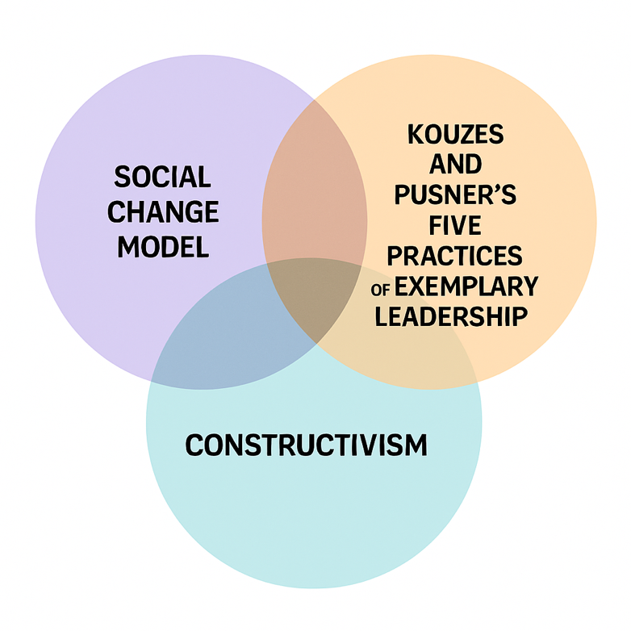

2.2.1 The Social Change Model of Leadership Development (SCM)
Originally formulated for higher education in the 1990s, the SCM conceptualises leadership as a purposeful, collaborative and values-driven process (Adams et al., 2023). It promotes leadership as a socially responsible, community-oriented act rather than a hierarchical role. At its core, the SCM is rooted in the belief that leadership is most effective when it promotes positive social change (Astin and Astin, 1996). It encourages individuals and groups to act in ways that improve the community and support the common good (Komives, 2009). The model is structured around three levels of development: individual, group and societal or community values (French, 2017). The framework further promotes seven core values of the 7Cs, believed to form the foundation of leadership development: consciousness of self, congruence, commitment, collaboration, common purpose, controversy with civility and citizenship (Skendall, 2017). Its emphasis on reflection, interpersonal development and shared accountability and responsibility aligns well with contemporary understandings of leadership as a relational and developmental process (Nagda and Roper, 2019).
Though not designed specifically for gaming contexts, the SCM has been successfully applied in various sectors, demonstrating its adaptability (Adams et al., 2023). For example, in nursing education, the SCM has been shown to support leadership groups among underrepresented students via the promotion of self-awareness, commitment, and a sense of social responsibility (Read et al., 2016; Harclerode and Reynolds, 2003). The commitment and resilience demonstrated by these nursing students offer a parallel to the insights evidenced in the motivational dynamics observed in dedicated Esports players, many of whom voluntarily commit significant time to team development and improvement under competitive pressure (Musick et al., 2021). Such intrinsic motivation, often driven by community recognition or team success, could mirror the reflective and ethical values embedded in the SCM. The model has also been effectively employed in campus-community collaborations, where it demonstrated a development of mutual understanding and adaptive leadership via shared projects (Sgoutas-Emch and Guerrieri, 2020). These collaborative efforts, such as the joint development of community gardens, illustrate how diverse groups can build trust and achieve common goals by engaging in iterative planning, reflection and adjustment. Similarly, in Esports teams, success often hinges on mutual accountability and shared vision, both of which are key principles of the SCM. Post-match reviews and pre-match planning in Esports environments can be likened to these reflective cycles (Musick et al., 2021; Gisbert-Perez et al., 2024).
In the context of educational reform, Peer and Webster (2016) describe SCM as a tool for inclusive and sustainable change. The scholars highlight its cyclic and iterative nature whereby planning, action and reflection contribute to continuous improvement (Peer and Webster, 2016). This process is directly applicable to Esports team development, where leadership must evolve concurrently with gameplay strategy, interpersonal dynamics and changing team compositions (Tucker, 2022). Reflection after gameplay, which presents an opportunity to discuss strengths, missteps and goals, may enable teams to cycle through leadership in a manner that is meaningful (Peer and Webster, 2016).
A notable challenge in applying the SCM to Esports, however, is the often impersonal and fast-paced nature of online communication. In contrast to face-to-face settings, digital interactions may lack emotional nuance, which may lead to miscommunication or increased conflict (Musick et al., 2021). Players must often interpret communication with feedback or criticism during high-stakes gameplay, where tensions may rise. However, as Willink and Babin (2015) suggest, strong leaders can turn struggling teams around by fostering psychological safety, clarity of roles, and mutual accountability; goals which align with the core values of the SCM.
Chowdhury (2024) expands on this by identifying five critical elements of effective team leadership: trust, conflict, commitment, accountability and results orientation. The SCM supports these through value-based communication and shared goals. In Esports, leaders who internalise these practices can help create environments where healthy conflict and open dialogue improve team performance rather than hinder it.
While the SCM focuses on long-term community-oriented leadership, Kouzes and Posner’s (2009) Five Practices framework offers a more action-oriented framework which may be more directly applicable to Esports, where leadership often unfolds in real time and under pressure (Gray and Bartlett, 2024). The ensuing section discusses this model in further detail.

2.2.2 Kouzes and Posner’s (2009) Five Practices of Exemplary Leadership
The first iteration of the leadership model appeared in 2009 (Kouzes and Posner, 2009) and has been refined through several editions (Kouzes and Posner, 2012, 2024). This model reconceptualises leadership not as a trait or positional authority, but as a series of learnable behaviours that individuals exhibit within a group context. It is rooted in a transformational leadership (Burns, 1978) tradition but emphasises practical application and behavioural observation strongly, making it a useful analytical tool in settings where leadership is informal or situational, such as in Esports teams. It also draws upon social learning theory (Bandura, 1977) and experiential learning (Kolb, 1984), but reinterprets these traditions into a more accessible and behaviour-based.
The model outlines five essential leadership behaviours:
1) model the way,
2) inspire a shared vision,
3) challenge the process,
4) enable others to act, and
5) encourage the heart (Kouzes and Posner, 2009).

Each of these behaviours reflects a dimension of leadership that can emerge across various contexts and at different levels of team hierarchy. Crucially, Kouzes and Posner (2024) argue that leadership is not the exclusive domain of those in formal positions, but something that can be demonstrated by anyone within a team that has the right mindset, and also if the environment they are working/playing in accepts such an approach. This can be classes as a decentralised view of leadership and aligns with emerging research on distributed leadership in Esports (see, for example, Williams, 2023), where leadership may shift during the game among team members based on in-game roles, decision points, or emotional dynamics.
Although this model was not developed with digital or gaming contexts in mind, it offers a strong conceptual lens for exploring how leadership might manifest within Esports teams. The model provides a framework for analysing the behaviours players exhibit in real-time collaboration and the following post-game reflection, both of which are central to high-level team performance (Gray and Bartlett, 2024). Specifically, the Five Practices invite inquiry into how leadership functions without assuming a fixed hierarchy, which makes it particularly suitable for Esports environments where leadership may be shared, rotating or transitioned through situations. For example, model the way, which focuses on setting an example through consistent actions and values (Kouzes and Pousner, 2024), raises questions about how players are able to demonstrate commitment, composure, or ethical conduct in high-pressure gaming environments. Inspire a shared vision considers how teams align around goals and strategies (Kouzes and Pousner, 2024), which is relevant to how leaders influence team motivation or manage morale across matches or tournaments. Challenge the process encourages innovation and calculated risk-taking (Kouzes and Pousner, 2024), indicating how leaders in Esports encourage creative gameplay or adaptive tactics in response to unpredictable challenges. Enable others to act refers to empowerment and trust (Kouzes and Pousner, 2024), key dynamics in multiplayer games where fast decision-making often requires distributed authority and mutual reliance. Finally, encourage the heart addresses recognition, emotional support and resilience (Kouzes and Pousner, 2024), potentially highlighting different dimensions of team leadership, which may influence performance, cohesion, and player well-being. By applying this framework, the present study aims to explore whether these behaviours occur, but how they might be identified, interpreted or developed within Esports contexts. The Five Practices functions as both a diagnostic lens and a developmental guide that can help to structure questions around how leadership is learned, shared or experienced within digital team environments.
The SCM and the Five Practices framework support a more holistic understanding of leadership in Esports. The SCM contributes a developmental and ethical foundation, while the Five Practices framework offers a structure for analysing leadership in action. This dual theoretical approach aligns with the present study’s broader aim, which is to explore how leadership competencies may be developed through Esports and to determine the behaviours and processes that facilitate leadership development in this fast-paced, collaborative, digital environment. Alternatively, constructivism attempts to explain how individuals make meaning from experiences within such environments by emphasising the reflective process behind leadership growth and development.

2.2.3 Constructivist Theories of Leadership
Constructivist leadership theory offers a developmental and learner-focused lens through which how leadership emerges, evolves, and is internalised by individuals through experience, interaction, and reflection can be understood. It is rooted in broader educational and psychological constructivism (Piaget, 1952; Vygotsky, 1978) and assumes that knowledge and, by associative extension, leadership competence, is constructed actively by individuals as opposed to passively received from external authorities (David, 2022). In leadership contexts, constructivism reframes the leader not simply as an authority figure, but as a participant in a dynamic, socially embedded learning process (Shapiro, 2022). Within this framework, leadership is viewed as contextually situated, co-constructed with others, and continuously shaped by dialogue, reflection and experience.
Johnston (2016) builds on this foundational understanding by proposing constructivism as a useful framework for evaluating and supporting leadership development, particularly in informal and experiential settings. He emphasises tools such as learner-centred assessment, self-and peer-evaluation, and reflective analysis to track leadership growth over time (Johnston, 2016). Although Johnston’s (2016) discussion of evaluation tools is broad and lacks specificity, his argument that leadership can and should be understood as a dynamic and evolving construct is especially relevant in environments such as Esports, where leadership is often informal, peer-based, and exhibited by performance under pressure (Tucker, 2022).
Zin et al. (2024) extend the application of constructivist learning theory into digital and gamified contexts, identifying technologies such as AI, mobile learning, virtual /augmented reality, and gamification platforms as ideal vehicles for constructivist, experiential learning. Zin et al. (2024) argue that gamification promotes active engagement, decision-making, and personal agency, traits that closely mirror the conditions of engagement in Esports competitions. As Esports players engage in complex team dynamics, tactical choices and real-time collaboration; they are not just playing a game; they are constructing meaning, adapting leadership roles, and learning through performance and feedback (Gisbert-Perez et al., 2024).
Crucially, Zin et al. (2024) position gamification not as a stand-alone pedagogical solution, but as a framework that supports deeper learning when aligned with constructivist principles, including learner autonomy, iterative problem-solving, and meaningful engagement with tasks. These principles are inherent to the Esports experience, making constructivist theory particularly relevant for analysing how players may develop leadership skills within the game environment itself as opposed to through external instruction.
Traditional models of hierarchical leadership may fall short in explaining how players coordinate, make decisions, and adjust roles in response to evolving gameplay. Constructivism permits researchers to frame leadership as a fluid and experiential process that is developed over time through trial and error, group negotiation, and shared sense-making. Sachar (2025) introduces social constructionism as a closely related perspective, where leadership is conceptualised as co-created through social interactions and dialogue rather than possessed by an individual. This view challenges traditional notions of leadership as a trait or position (see Dickson, 2023; Zaccaro, 2007; Hunt and Fedynich, 2019), instead viewing it as a relational achievement. Sachar (2025) also incorporates the human relations tradition, which values trust, open communication and mutual support as essential components of effective leadership. These relational and contextual qualities closely resemble collaborative team dynamics found in agile project environments, where roles are fluid, and leadership is both situational and shared (Jain et al., 2024). As Sabandar (2023) suggests in a somewhat metaphorical fashion, the leadership model resembles a round table dynamic; each team member contributes, leads when needed, and releases the position when appropriate. Distributed leadership and mutual reliance are essential in achieving success under time-constrained and high-stakes conditions.
The strength of constructivism for this study lies in its capacity to explain how leadership is developed, rather than merely categorising what leadership looks like. It provides a powerful lens for exploring the developmental, identity-forming and interpersonal skills aspects of leadership within the evolving world of Esports, particularly in team-based contexts, where learning, communication and adaptation are central. Both the SCM and Five Practices framework also offer valuable insights into leadership development and provide adaptable frameworks for understanding how leadership may emerge and evolve in Esports contexts.

Model | Pros | Cons | Relevance to Esports
Social Change Model | Ethical, community-driven, reflective | Assumes shared values and community | Best for long-term development, less effective in short-term team member turnaround
Five Practices | Actionable, motivational | Sole leadership responsibility | Useful in performance settings, but may clash with Esports structures
Constructivism | Reflective, learner-focused, Esports compatible | Lacks clear intervention, assumes that all members facilitate and self self-motivated | Useful for post-game analysis and leadership development
Table 2.1 Overview of Theoretical Framework

While previous studies have explored these models in educational, community, and professional domains, their integration into Esports remains underdeveloped. There is limited empirical research that examines how these theories translate into leadership behaviours within competitive gaming environments, particularly in youth or educational Esports programs. Further investigation is needed to explore how Esports can act as a so called incubator for leadership skills that transfer to real-world educational, or professional contexts. The present study thus makes a timely contribution to the literature via its adopted theoretical framework.

2.3 Existing Empirical Studies on Esports
The intersection of leadership and Esports has emerged as a growing area of academic and educational inquiry, though the field remains relatively underexplored. Existing studies have examined various aspects of leadership theory, skill development, and team dynamics within Esports contexts, offering a foundation for further investigation into its potential as a space for leadership cultivation.

2.3.1 Distributed and Collaborative Leadership in Esports
One prominent theme in the literature is the concept of distributed leadership within Esports teams. Williams (2023) argues that the leadership role in this environment is often decentralised, with players collectively contributing to decision-making based on the information and stimuli available to them in real time. This approach fosters autonomy, trust and situational responsiveness, traits that align with modern, non-hierarchical leadership models (Zaccaro, 2007). Similarly, Jenkins and Pickett (2022) explore the dynamics of adaptive leadership in Massively Multiplayer Online Games (MMOGs), identifying parallels between in-game challenges and the fast-paced, high-pressure decision-making required in real-world leadership scenarios. Their work highlights how gameplay environments promote the development of situational awareness, collaboration, and strategic leadership under stress.
Hewett (2022) further supports this perspective through an investigation into games like World of Warcraft (a popular multiplayer online game), identifying three core components of effective team interaction: dynamic role rotation, strategic coordination, and communication proficiency. These features mirror essential collaborative leadership competencies, reinforcing the argument that Esports contexts can serve as practical environments for developing such skills.

2.3.1.1 Leadership Skill Development and Transferability
Another body of literature examines the development and transfer of leadership skills through Esports. Xu and Hao (2024) highlight the role of Esports in fostering global leadership, defined as the ability to lead across cultures and communicate effectively in an interconnected world (University of Pennsylvania, 2024). Their work positions Esports as an emerging context for cultivating leadership traits relevant to globalised professional environments.
Byrne (2023) explores how Esports can support leadership education in formal settings, particularly for students in STEM disciplines. Through experiential learning frameworks, Esports are used to teach bystander leadership and collaborative decision-making, promoting real-time application of theoretical principles. Likewise, Egan (2022) examines immersive game-based learning environments, such as role-playing games and escape room scenarios, as experiential platforms where leaders develop problem-solving, team coordination, and conflict resolution abilities all important aspects for an effective leader.
Xue et al. (2024) extend this discussion by addressing the application of Esports leadership beyond the gaming domain. Their work advocates for translating in-game leadership behaviours into transferable workplace competencies, including strategic thinking, team motivation, and reflective decision-making.

2.3.1.2 Team Dynamics, Performance, and Coaching
Surbakti et al. (2023) focus on the relationship between leadership and team performance in Esports, arguing that effective leadership significantly enhances team cohesion and outcomes. Their findings suggest that certain leadership styles are better suited to competitive gaming contexts, especially those that promote trust and quick decision-making. The role of coaching is also highlighted as a key factor in supporting psychological readiness and strategic execution.
A related study by Forlenza (2023) introduces the concept of “imagined partners,” where players improve performance not only by reacting to present stimuli but by anticipating and interpreting opponents’ behaviours. This mental modelling can enhance strategic understanding, an important attribute in both gaming and traditional leadership roles.

2.3.1.3 Gender and Inclusion in Esports Leadership
Richard and McDowell (2019) address issues of gender and inclusion within Esports leadership. Their study acknowledges the male-dominated history of competitive gaming, including the roles of marketing, game design, and cultural expectations, which contribute to gender inequality in leadership representation. This area of inquiry is critical for ensuring that leadership development opportunities in Esports are accessible and inclusive.
Some existing studies in the literature document how leadership can be developed through reflective, intentional, and socially mediated learning processes. These perspectives can offer insights into how personalised, learner-driven approaches and social-environmental factors play a critical role in cultivating leadership identities, which can be applied to Esports contexts.
Recent research highlights the importance of learner-centred and personalised learning approaches in fostering effective team dynamics and leadership development. Hopkins (2019) argues that when individuals take ownership of their learning by identifying knowledge gaps, setting personal goals and creating tailored learning plans, they become more motivated and better equipped to contribute meaningfully to collective outcomes. This model of self-directed learning aligns with the Esports environment, where players must often adapt to emerging technologies, refine tactical skills, and address individual weaknesses in real time. The inherently fast-paced and evolving nature of Esports demands that team members remain autonomous and can think for themselves as learners while contributing to shared objectives. In this sense, leadership emerges not just through role assignment, but through initiative, adaptability and collaborative learning.
In support of this, Keçeci̇ and Yıldız (2024) offer a qualitative analysis of the social environment within Esports teams, identifying five key dimensions that propose how leadership may be enacted and perceived: physical characteristics, personality traits, professional qualifications, technical skills, and management skills. These attributes are not necessarily confined to formal roles; rather, leadership is shown to be a fluid and situational process, often negotiated through informal team interactions. Their study underscores the multifaceted nature of Esports leadership, drawing attention to the interaction between individual characteristics and team culture. Particularly important is their call for further investigation into how technological change continues to shape leadership behaviours and expectations in competitive gaming contexts. This recognition of complexity and technological evolution is echoed in a comprehensive systematic review by Gisbert-Pérez et al. (2024), which synthesises existing empirical work on team structures and processes in Esports. The review identifies several underexplored yet critical dimensions of team leadership and performance:
Organisational Structure: A well-defined organisational framework can enhance team dynamics, coordination and performance. Even highly skilled teams struggle to succeed without clarity in leadership roles and task division (Keçeci̇ and Yıldız, 2024).
Team Development Stages (Keçeci̇ and Yıldız, 2024): Effective management of team formation stages (e.g., storming, norming, performing) contributes to cohesion and long-term success. Esports research still lacks sufficient detail on how these stages unfold in competitive team settings.
Team structure (Keçeci̇ and Yıldız, 2024): Beyond formal organisation, this refers to how team members interact, communicate, and reflect together during and between matches. Reflection and iterative learning are essential yet remain poorly understood in Esports contexts.
Team variables and processes (Keçeci̇ and Yıldız, 2024): Psychological factors such as trust, motivation, cohesion and communication are central to team effectiveness. These mirror established leadership theories but require further study within Esports-specific conditions.
Leadership (Keçeci̇ and Yıldız, 2024): Despite the increasing recognition of its importance, leadership remains conceptually underdeveloped in the Esports literature. Few studies provide clear frameworks for understanding leadership behaviours or strategies beyond performance metrics.
Lack of experience in team integration (Keçeci̇ and Yıldız, 2024): The lack of empirical research on how teams integrate new players highlights a gap in understanding how leadership supports team adaptation and continuity, especially vital in competitive seasons with high player turnover.
The final category in the systematic review concerns the Holistic and Integral Perspective (Keçeci̇ and Yıldız, 2024), which encompasses an urgent call for more comprehensive approaches to studying team dynamics; ones that go beyond isolated behaviours to examine leadership in conjunction with identity, emotion, skill, and culture.
Together, these studies point to a key conceptual insight: no single leadership framework is sufficient for capturing the complexity of Esports leadership. Instead, effective leadership in Esports emerges through a combination of structure, personal motivation, collaborative processes, and social learning. This reinforces the relevance of integrating multiple theoretical perspectives to develop a more nuanced understanding of how leadership is developed, enacted, and sustained in Esports environments.
From a practical perspective, this body of research underscores the timeliness and significance of further investigation into leadership development in Esports. As the industry continues to grow in scale and legitimacy (Market.us, 2025), its demand for effective leadership, mirroring challenges found in traditional organisational and team settings, will only increase. Further insight into how Esports may cultivate leadership is therefore pertinent.

2.4 Conclusion
Collectively, the literature suggests that Esports holds significant promise as a developmental platform for leadership, particularly through its emphasis on collaboration, adaptability, and real-time decision-making. While the current research remains rather divided, ranging from performance and coaching to gender inclusion and skill transfer, the growing academic interest reflects a recognition of Esports’ potential to mirror, support, and even extend traditional leadership learning environments. This study builds upon these foundations to explore how structured Esports participation can be purposefully harnessed for leadership development in youth.

Chapter 3. Research Methodology

3.1 Introduction
In selecting a research methodology, Saunders et al. (2019) developed an approach that simplifies the process in the form of a research onion (see Figure 3.1). The research onion depicts several layers which comprise the research process. This chapter presents a comprehensive discussion of all aspects of the research process, including its epistemological framework, approach, sampling process, data collection method, and analytical framework.
Figure 3.1 The Research Onion (Saunders et al., 2023, p.177)
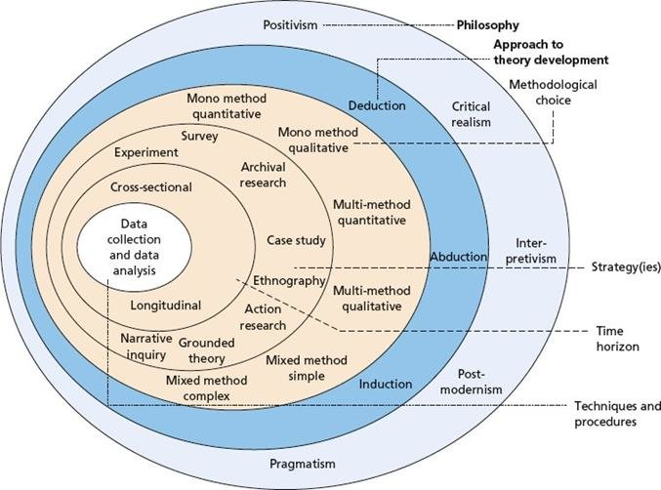

3.2 Epistemological and Philosophical Framework
The study is rooted in a constructivist epistemology and interpretive philosophy. This orientation recognises leadership as a socially constructed process (Iszatt‐White and Saunders, 2019; Billsberry and O'Callaghan, 2024). The interpretivist stance, as defined by Saunders et al. (2023), supports a data collection and analysis process that explores multiple subjective realities, enabling the research phenomenon to be viewed through different lenses. As noted by Alharahsheh and Abraham (2020):
Interpretivism developed through critique of positivism with subjective perspective. Interpretivism is more concerned with in-depth variables and factors related a context, it considers humans as different from physical phenomena as they create further depth in meanings with the assumption that human beings cannot be explored in a similar way to physical phenomena. Therefore, social sciences research requires this distinction and should be different from natural sciences research. Interpretivism considers differences such as cultures, circumstances, as well as times leading to development of different social realities. (p.41)
This approach therefore supports researchers to consider different factors such as behavioural aspects by drawing upon participants’ experiences, in line with the aims of this study.

3.3 Research Design
This study adopts a multi-method qualitative design, which seeks to find meaning from various qualitative sources including interviews, observations, in-game interactions and communication logs, keywords and themes. This study will also utilise quantitative data, albeit to a lesser extent, for the purpose of capturing game results and drawing conclusions relevant to answering the research questions.
A case study strategy (Gustafsson, 2024) has been employed to support engagement with Esports teams and help to understand leadership development in this habitat over a specific timeframe. The time frame of the study spans a series of games in a tournament setting. A case study approach was adopted to enable an in-depth exploration of the leadership phenomenon within the context of Esports. This method allowed for an in-depth analysis of how leadership emerges and how leaders manage team dynamics during fast-paced gameplay. It provided a focused lens through which to observe events as they unfolded in real time. Additionally, this approach facilitated the identification of recurring contributing factors across different teams, offering valuable insight into consistent patterns of leadership and team behaviour.
Given the involvement of multiple Esports teams, a cross-case analysis approach was used to identify and compare leadership behaviours across different contexts. This strategy permitted the study to explore:
- Which leadership behaviours emerge repeatedly.
- Different leadership styles.
- Whether teams which align with the SCM demonstrate more effective reflection and learning behaviours.
- Sections of the interactions (or gameplay, where possible) where the leadership has been more developed.
- And, where appropriate, the extent to which observed behaviours align with the goals of the Well-being of Future Generations (Wales) Act (2015).

3.4 Sampling and Participants
Purposive sampling (Bell et al. 2023) was used to select individuals already involved in Esports who could therefore offer rich insights for this study. Purposive sampling is:

“the deliberate choice of a participant due to the qualities the participant possesses. It is a non-random technique that does not need underlying theories or a set number of participants. Simply put, the researcher decides what needs to be known and sets out to find people who can and are willing to provide the information by virtue of knowledge or experience” (Etikan et al., 2016, p.2).

This sampling approach enabled well-informed participants, on the basis of their experience and knowledge, to be selected for this study. The selection criteria were as follows:
- Active participation in team-based Esports competitions determined by the team involvement (Valorant and League of Legends)
- Age range (16 – 25)
- Willingness to participate in interviews and consent to game communication being recorded
- Schedule determined by fixtures and availability of participating teams. Matches were observed across several months (January, February and March 2025). Each observation was performed live, with post processing performed (see p.37)
According to Bell et al. (2023), theoretical saturation is a key determinant in identifying the subject set, whereby data collection continues until no new insights emerge. Guided by this principle and the research question, the anticipated sample size was estimated at 8 to 15 participants, drawn from approximately 2 to 3 teams.
Rather than recruiting individual Esports teams independently, the study partnered with Esports Wales, the national governing body for Esports in Wales since its establishment in 2018 (Esports Wales, 2025). Esports Wales manages teams and organises tournaments such as the Welsh Masters, providing a rule-based environment for gameplay. Through this partnership, the study gained access to a diverse network of players and team leaders, identified by their in-game usernames such as CamRHope and LJPH.
Originally, the study intended to focus on participants aged 16 to 18; however, practical and ethical challenges, particularly related to consent procedures and access to game recordings, necessitated a revision. Furthermore, the age demographic of existing teams was not limited to this range. As a result, the age scope was broadened to include participants aged 16 to 25. This adjustment better reflected the typical age profile of individuals involved in Esports Wales and ensured a more ethically sound and logistically feasible research process.
The final participant group consisted of individuals engaged in competitive Esports activities organised or supported by Esports Wales. This included:
- Young people and adults, primarily within the 16 to 25 age range (updated from the original 16–18 scope).
- Mixed-ability teams involved in organised gameplay, including college students and other members of the Esports Wales community.
- Willing participants were recruited through Esports Wales’ networks, affiliated colleges, and local community gaming initiatives.
- An expected total of 50 to 60 participants across 6 to 10 teams, with each team comprising 3 to 6 members.
- Additionally, the study benefited from the potential involvement in tournaments sanctioned by the International Esports Federation, which included participation by Esports Wales teams. This presented an opportunity for cross-case comparison to evaluate whether observed patterns were consistent across broader competitive contexts.

3.5 Data Collection
The data collection process involved multiple qualitative methods, enabling triangulation and enhancing the reliability of the findings. These methods included gameplay and communication analysis, and semi-structured interviews.

3.5.1 Gameplay and communication analysis
The study involved a detailed review of both gameplay and the communication that occurs during competitive Esports matches. Applying the leadership framework established in the literature review, the research aimed to explore how leadership emerges and functions in a dynamic, fast-paced virtual environment. Specifically, the study investigated several key domains:
Role assignment and role transition: Who is selected for in-game roles, and do these shift throughout the match?
Verbal and non-verbal cues: The analysis focused on verbal communication and any observable non-verbal cues to understand their impact on pacing, strategy and decision-making.
Conflict resolution: How effective is this, and does it change before/during and after the game?
Adaptive leadership: A central question was how teams respond when a designated leader is unable to make a decision or is otherwise disengaged.
Leadership Communication and Influence:
Leadership directive: How does the overall leader communicate with team members, and does this have an influence?
Emotional tone: Is this an authoritative instruction or a friendly instruction? Does this influence the team?

3.5.2 Semi-structured interviews
To complement the observational and gameplay data, participants were invited to participate in post-game interviews conducted in a semi-structured format. This approach provided a consistent framework for questioning while allowing the flexibility to explore individual insights, experiences and reflections in greater depth (Adeoye-Olatunde and Olenik, 2021).
The interviews were designed to achieve a greater understanding of players’ perceptions of leadership, both within and beyond the game environment. Key areas of focus included:
- Experiences of leadership, whether this is in the game or outside
- Communication and team dynamics
- Individual and team decision-making processes
- Reflection on the game result and how the leadership handled the wins and losses
All interviews were audio recorded, with supportive field notes taken during the conversation to capture non-verbal cues and contextual observations. This format provided valuable qualitative insights to support and triangulate the findings from the gameplay analysis and leadership framework coding. It enabled the study to focus on how players develop, perceive and interpret leadership over time, offering a richer understanding of the leadership dynamics that emerge in competitive Esports environments.

3.6 Data Analysis
To support the analysis of 27 hours, 59 minutes and 14 seconds of recorded Esports gameplay, a combined analytical framework was developed by integrating three key models of leadership and learning: the SCM, Kouzes and Posner’s Five Practices of Exemplary Leadership, and Constructivist Learning Theory. Rather than applying these models as separate analytical tools, they were synergised into a composite lens, offering overlapping yet distinct contributions.
Table 3.1 Analytical Framework Components
Model | Contribution to Framework
Social Change Model | Values-based, ethical leadership and collaboration
Five Practices | Behavioural insights—what effective leadership looks like in action
Constructivism | Explains how learning and leadership develop over time through reflection and engagement

This integration enabled a triangulation process, where data from observations, interviews and gameplay analysis could be interpreted through multiple lenses of leadership theory. Each model was aligned to both data collection and analysis methods:
Table 3.2 Framework-to-data alignment
Model | Data Collection Focus | Analysis Focus
Social Change Model | Survey questions on values, team commitment and observations of development | Thematic coding of group interactions
Five Practices | Observation of in-game behaviours, team roles | Audio/video cue analysis for leadership action
Constructivism | Post-game reflections and interviews | Reflexive thematic analysis

3.6.1 Coding Framework Development
To manage the complexity of the data and reveal leadership-related behaviours in communication, a detailed coding framework was developed. This included 51 initial codes drawn from the three models, which were then synthesised into ten overarching themes for practical application (See Appendix A for full code list).
Table 3.3 Coding Framework
Tag Code | Description | Framework alignment
SELF_DEV | Self-awareness, identity, values alignment, and meaning-making (COS, IDENT_D, ALIGN) | SCM, Constructivism
REFLECT | Reflection, metacognition, and self-assessment (REFL, METACOG, SELF_A) | Constructivism
LEAD_ACT | Demonstrating leadership through behaviour, role modelling, vision, and example (MODEL_W, LEAD_E, S_VISION) | Five Practices, SCM
ENABLE_OTH | Enabling others, motivating, feedback, and empowerment (ENAB, MOTIV, SUPPO, ENCO) | Five Practices, SCM
TEAMWORK | Collaboration, trust, shared goals, community, and role coordination (COLL, TEAM_T, COMM_P, GAME_ROLE) | SCM, Constructivism, Five Practices
COMM_SKILL | Communication clarity, voice tone, and feedback integration (COMM_CL, VOICE, FEEDB_IN) | Constructivism, Five Practices
CONFLICT | Conflict resolution and emotional control under stress (CONFL, CONF_RES, EMOT_R, COMPOS) | SCM, Constructivism
STRATEGY | Tactical coordination, adaptive strategy, and risk taking (CHAL_P, STRAT_SHIF, ADAPT_S, RISK_T) | Five Practices, Constructivism
PERFORMANCE | Performing under pressure, resilience, and focus (PRESSURE, LOSS_F, RESIL) | Five Practices, Constructivism
SOC_RESP | Social responsibility, ethical decision making, and citizenship (S_RESPON, E_DECIS, CITIZ, S_ORIENT) | SCM

This model-driven, theory-integrated approach permitted the research to systematically identify leadership behaviours within the fast-paced, communication-heavy context of competitive sports.

3.6.2 The Process of Transcribing and Coding
To support the in-depth analysis of nearly 28 hours of Esports gameplay, a transcription workflow was implemented using a feature originally designed for media production. This functionality was successfully repurposed to facilitate the transcription of game recordings.
Amazon Web Services (AWS) was used to upload and process the audio extracted from gameplay recordings, producing subtitle files in .SRT format. These subtitle files contain time-stamped text entries that correspond to in-game communication, offering a detailed, chronological record of team interaction. The transcription files were prepared for coding through the following process:
- Each .SRT file was first opened using a text editor.
- The files were then imported into Microsoft Excel, where each subtitle entry was separated into three columns: Start Time, End Time, and Transcript.
- To aid later analysis, all transcripts were converted to uppercase to standardise entries and make coded instances easier to identify during manual review.
NVivo 14 was employed as the primary tool for organising and coding qualitative data drawn from the transcripts. The ten leadership categories developed from the literature review (e.g., REFLECT, STRATEGY, SELF_DEV) were manually entered into NVivo as nodes. The prepared Excel files were then imported into NVivo using the dataset import function with the codable text field feature enabled. This allowed coded references to be linked directly to specific transcript segments, including their original time stamps. Each transcript was also organised and labelled by team identity to support case-based analysis. During coding, the leadership framework was applied to identify and tag instances of leadership behaviours, communication patterns and other relevant dynamics.
NVivo 14’s capabilities allow a large amount of qualitative information to be processed and investigated for patterns, but with limitations. The data needed to be manually adjusted first, which was a lengthy process. It involved going through each line of the resulting subtitles and deciding which one(s) of the codes it evidenced. Although NVivo had the capabilities to import 3822 rows of transcript data, the end result still required manual intervention and required the results to be arranged in ascending order, after which the code was applied manually (see Figure 3.2 below).

Figure 3.2 Applying the Codes to the Imported Dataset
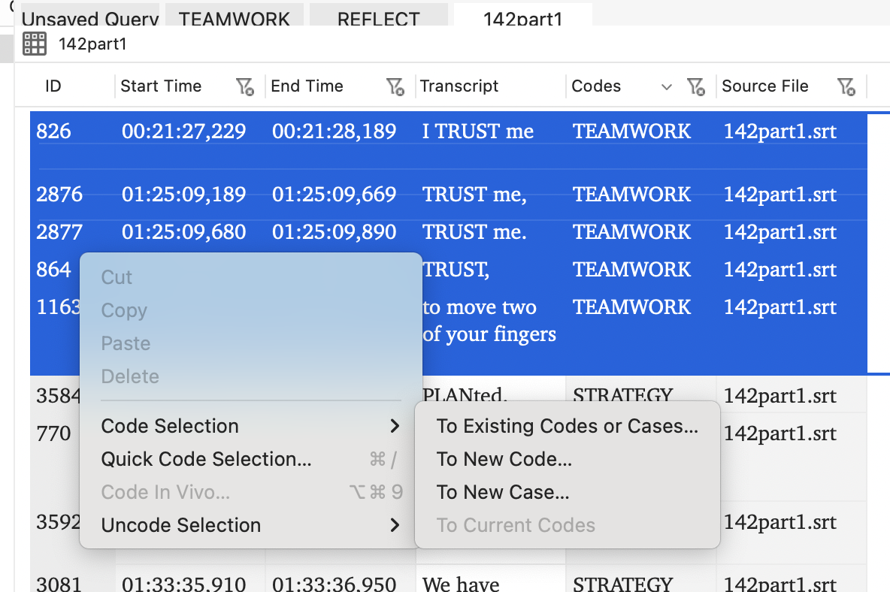
While applying the leadership coding framework to the transcriptions, it is acknowledged that some subjectivity is inherent in the coding process. Deciding which of the ten codes best applied to particular dialogue or interaction segments occasionally involved interpretation, especially where meaning was context-dependent. For example, the phrase “TRUST me”, as shown in the transcript, was coded under the TEAMWORK category. This interpretation was based on the collaborative context in which the phrase was used. While others might interpret such a phrase differently in isolation, the surrounding gameplay context and tone provided justification for its categorisation. Although the possibility of inconsistencies in coding exists due to the nuanced nature of language and context, the use of a structured, theory-informed framework helped provide consistency and rigour throughout the analysis. This reflective and theory-guided approach enabled a positive outcome, allowing the coding process to reveal meaningful patterns in communication and leadership dynamics across teams.

3.7 Ethical Considerations
Partnering with an external organisation such as Esports Wales brought important ethical considerations to the forefront of this research. One key concern was the potential influence the organisation could have on participants’ willingness to take part. Given that Esports Wales manages and represents competitive teams, players might have felt subtle pressure to participate due to their affiliation, which could challenge the voluntariness of consent. To mitigate this, the study made clear to all participants that involvement was entirely voluntary, that choosing not to participate would have no impact on their relationship with Esports Wales, and that they could withdraw at any point without consequence.
Another significant ethical implication related to confidentiality and data management. Since data collection was facilitated through Esports Wales, it was vital to establish clear protocols to protect participant privacy and ensure that sensitive information was handled securely. The research team developed agreements with Esports Wales outlining data ownership, access limitations, and strict confidentiality measures to reassure participants that their information would not be shared beyond the research context.
Additionally, there was a recognition of potential bias arising from the partnership. As a governing body invested in the promotion of Esports, Esports Wales might have inadvertently influenced recruitment processes or shaped participants’ responses, potentially limiting critical or unorthodox perspectives. To address this, the study maintained independence in data analysis and interpretation, ensuring that findings were grounded in the participants’ authentic experiences rather than external organisational interests.
Finally, the collaboration with a single organisation naturally narrowed the participant pool, raising questions about inclusivity and representativeness. While this was a practical necessity, the study acknowledges this limitation and suggests future research consider broader recruitment strategies to capture a more diverse range of Esports experiences.

Chapter 4. Findings & Discussion

4.1 Introduction
This chapter presents a thematic analysis of the coded data, highlighting the three most prominent themes identified during the coding process: Reflect, Strategy and Self-Development. Per Table 4.1, these themes emerged most frequently: Reflect (524 references), Strategy (452) and Self-Development (326), indicating a strong presence of leadership characteristics across the data set, particularly cognitive processing, tactical coordination and personal growth. The significance of these themes will be explored in detail, offering insight into how leadership manifests within Esports teams.
Table 4.1 Frequency of Code References

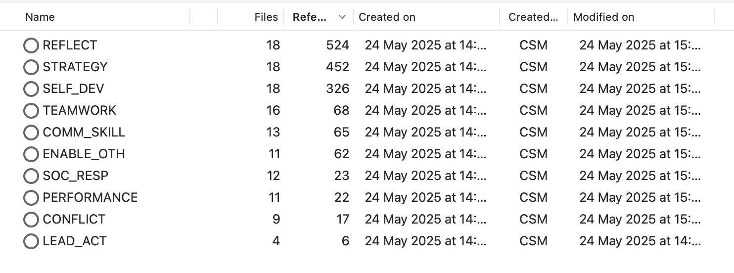

In contrast, the themes Lead_Act (6), Performance (9), and Conflict (17) appeared far less frequently. This suggests a more distributed and collaborative leadership style, rather than one rooted in overt command or individual performance. The low occurrence of conflict-related codes further implies high levels of team cohesion and trust, potentially reducing the need for conflict resolution, even if such conflicts were present but remained unspoken.
The application of the coding framework was most effective in games where players were more communicative. For example, IESF06 (245 references), IESF05 (132), and Esports633 (106) showed the highest engagement, with IESF06 standing out for its rich evidence of both Reflect and Strategy codes. Conversely, games like Esports617 (29), IESF08 (46), and IESF04 (46) featured lower coding frequency, which may warrant further investigation. This could be attributed to shorter match durations or dominant players limiting team-wide communication. Following the discussion of these dominant themes in the ensuing parts of this chapter, the subsequent section will draw on interview data to further contextualise and deepen the understanding of leadership dynamics within Esports teams.

4. 2 REFLECT: Metacognition and Evaluation
Reflective thinking emerged as the most frequent leadership behaviour observed across all datasets, with 524 coded references. These codes encompassed metacognitive processing, self-evaluation and decision justification, aligning with Constructivist theory and its proposition that leadership and learning co-develop through experience (Howes and Davies, 2014; Johnston, 2016). This pattern was especially visible in teams with open communication styles, where players articulated their thoughts during high-stakes gameplay. The repeated use of the phrase “I think” in participants’ narratives was a strong indicator of active reflection and cognitive evaluation. For example:
“I think they would have lost more of their base if they had done that.” (IESF06F Transcript)
This form of real-time reasoning aligns with the view that Esports environments function as experiential learning spaces, whereby leadership emerges via active decision-making, social collaboration and personal reflection (Tucker, 2022). According to Byrne (2023) and Egan (2022), these contexts are ideal for leadership development through action, rather than through formal instruction or hierarchical command. In one case, a player reflected aloud, saying:
“I think that’s a little bit of a mistake on our part.”
In this example, the player not only criticises previous action but does so in a collaborative manner, suggesting a shared ownership of outcomes, a critical component of distributed leadership (Harris, 2009). These reflections contribute to team sense-making and adaptive strategy formulation. Further, such assertions indicate that these reflections were not merely superficial but were often tied to strategic reasoning. In some cases, players reassessed their past decisions, implying a trial-and-error learning cycle which illustrates cognitive adaptability and in-the-moment evaluation, which are hallmarks of reflective leadership (Castelli, 2016).
The high prevalence of the REFLECT code across high-performing teams indicates that reflective thinking was a core cognitive process which enabled leadership. This aligns with Kouzes and Posner’s (2013) leadership practices, such as ‘Enable Others to Act’ and ‘Model the Way’, albeit in a more fluid, non-hierarchical Esports context.

4.3 Strategy: Tactical Thinking and Emergent Leadership
The second most common theme was Strategy, with 452 coded references across the dataset. This category encompasses tactical thinking, strategic planning and real-time decision-making, all of which are foundational to adaptive leadership in dynamic team environments such as Esports, as documented by Ghossoub (2024). Strategic behaviour often emerged in response to changing in-game conditions, as players negotiated tactical adjustments and constructed new approaches in a collaborative way. This behaviour aligns with Kouzes and Posner’s (2013) leadership practices, particularly “Challenge the Process” and “Inspire a Shared Vision.” Players were not passively reacting to gameplay events; rather, they were proactively constructing game plans and guiding group actions, often in shared leadership formats such as:
“I need you to PLANT the bomb in a specific spot.”
“Let’s HOLD arcade.”
“What’s the PLAN?”
The frequent usage of words like PLAN, HOLD, FLANK, and ROTATE points to strategic gameplay structures. Further, these examples highlight that strategic direction was also a collective act, reinforcing that leadership in these teams was emergent and distributed, rather than tied to formal roles or hierarchy. This finding aligns with the research of Gronn (2002). Players took initiative in a fluid way, depending on the context and their expertise. This is consistent with the distributed leadership model outlined by Williams (2023) and Forlenza (2023), who suggest that Esports leaders are more often predictive than reactive, using foresight to anticipate outcomes and shape strategy accordingly. Players’ tactical dialogue per the examples provided above supports the idea that Esports teams function as real-time leadership incubators, where decision-making is not only rapid and adaptive, but also situational and collaborative. These findings further support the experiential learning theory (Byrne, 2023; Egan, 2022), where leadership is formed via active participation, feedback, and the testing of strategies iteratively within high-pressure team settings.

4.4 Self-Development: Leadership Identity and Personal Growth
The Self Development theme appeared 326 times, making it the third prevalent code in the dataset. This theme captures how players expressed personal growth, confidence, emotional awareness, and a growing sense of autonomy within their roles. These findings indicate that players were not only operating effectively within teams but also cultivating their own leadership identities in a parallel manner. A high frequency of the Self-Development code suggests that players were self-aware, self-motivated, and actively shaped their leadership style via experience. This behaviour thus reflects the tenets of constructivist learning theory, which views development as a direct result of meaningful engagement (Howes and Davies, 2014; Johnston, 2016). It also aligns with the SCM model of leadership and its framing of leadership as a personal and values-driven journey, where individuals grow through reflection, experimentation and connection with others (Adams et al., 2023). Players’ statements such as those below reflected a strong sense of ownership and emotional self-recognition.
“I believe in myself.”
“I’m still playing for myself, though.”
“That’s when you know I’m feeling good about myself.”
In these statements, players articulate moments of confidence, persistence and personal purpose. The repetition of the word ‘myself’ underscores the individual agency that coexists within teamwork in high-functioning Esports contexts. Importantly, this theme reinforces the idea that Esports leadership is not only about command or coordination, but also about internal development, where players grow as leaders via introspection, risk-taking, and the process of stepping into leadership roles even in the absence of formal titles. This was especially visible in high-performance games such as IESF06F and Esports633F, where players’ commentary was reflective of a deepening awareness of their contribution, not only to team outcomes, but to their own growth trajectories. The emphasis on phrases such as “I believe in myself” suggests a shift from external validation to intrinsic motivation, which Carter et al. (2012) show is a key component of sustainable leadership development.
In keeping with the SCM’s Individual Values domain, which includes consciousness of self, correspondence and commitment, the findings concerning this theme suggest that Esports environments foster leadership as a personal journey, with significant emotional and cognitive dynamics. This growth is not always visible in team metrics but becomes clear through language, self-referencing, and players’ expressed sense of agency.

4.5 Comparative Analysis: Reflect, Strategy and Self-Development
The three most dominant emergent codes collectively offer nuanced insight into how leadership is both formed and practised in Esports settings. While each category captures a different dimension, collectively, they reveal a situated, emergent and developmental model of leadership that aligns with, and in some ways, extends existing leadership development frameworks (see Ardichvili et al., 2016).

The prominence of ‘Reflect’ points to how metacognitive processes are central to the leadership behaviours of players. Frequent verbal cues such as ‘I think’ not only suggest tactical evaluation but a publicly shared inner dialogue which suggests a form of cognitive apprenticeship (Collins et al., 1991) whereby reasoning is externalised for collective interpretation. This finding reinforces constructivist viewpoints of leadership development (Harris and Kuhnert, 2008). What is evident in the Esports context, however, is the speed and fluidity of this reflection. In contrast to structured reflective practice linked to formal leadership programs (Martineau and Johnson, 2011), these players engage in rapid, iterative reflection, often mid-action. This suggests that Esports may uniquely cultivate real-time evaluative judgment, which is a skill that is important for decision-making under pressure (Reale et al., 2023). It also positions reflection not as a solitary or post-hoc exercise, but as a socially situated leadership act that forms part of group sense-making in high-stakes environments.

The ‘Strategy’ codes further illustrate how players co-constructed tactical plans often collaboratively. Phrases such as “What’s the plan?” demonstrate not only simple coordination but emergent leadership moments during which individuals briefly assume direct roles based on real-time expertise of positional awareness. This behaviour echoes the literature on distributed leadership (Sachar, 2025), which conceptualises leadership as an interactive practice that is dispersed across members of a group, rather than fixed to a formal role. It also aligns with situational leadership theory (Thompson and Vecchio, 2009), where leadership functions shift fluidly and are contingent upon the context. In Esports, players do not rely on fixed hierarchies, but rather demonstrate what Williams (2023) refers to as responsive authority, a temporary, adaptive form of leadership that emphasises competence and credibility rather than status.

Importantly, this challenges more traditional, hierarchical leadership development models (Clarke, 2013). As opposed to learning to lead from the top down, these players practice horizontal leadership, reinforcing Forlenza’s (2023) argument that Esports is a prime environment for peer-driven tactical leadership. Consequently, Esports may be especially relevant to preparing leaders for contemporary, team-oriented professional settings, where agility and collaboration are valued over command-and-control authority.

The self-development theme speaks to a more internal and identity-focused dimension of leadership development. Statements such as “I believe in myself” reflect moments where players articulate personal agency, ownership and confidence in their evolving leadership role. This theme directly supports the SCM approach to leadership, particularly its focus on consciousness of self, congruence and commitment. In contrast to more programmatic models of identity development, such as formal mentoring or self-assessments (Rothstein and Burke, 2010), Esports offers what Adams et al. (2023) refer to as a naturally occurring lab where individuals experiment with leadership which is devoid of the constraints associated with formal structures or supervision. This supports a view of leadership development as non-linear, messy and emotionally charged, as documented by Tucker (2022). This finding also contributes to the argument that leadership development is inseparable from personal development, a notion that has gained traction in recent leadership literature (Brandenberger, 2023). In the Esports context, this development is accelerated via emotional intensity, competitive pressure, and continuous feedback, making it a rich site for identity formation and leadership experimentation.

4.6 Interview Perspective: Organisational Leadership
In addition to gameplay transcripts, a one-on-one interview was conducted with the CEO of Esports Wales to compare in-game perceptions of leadership and gain insight into gamers’ perspectives. These insights are presented in this section. To help triangulate the distribution of leadership behaviours emergent from the interviews, the recordings were once again processed using the same approach described (transcribe, convert to Excel format, import to NVivo), capturing the visual frequency of references in relation to each leadership code or category. The findings from the CEO interview present a contrast to the players’ perspectives discussed later, where reflection strategic planning and self-development were among the most frequently observed leadership behaviours. In contrast, the CEO described a more traditional leadership model, emphasising team support, vision-setting, and active, directive leadership (See Figure 4.1). Interestingly, lower frequencies for conflict, teamwork, and reflection in the CEO’s account suggest that these aspects may be more formally structured or systematised within Esports Wales’ organisational approach. For instance, the CEO referred to specific policies such as zero tolerance for bullying or swearing, reflecting the need to manage potential interpersonal conflict, which can be prevalent in competitive gaming environments. While anonymous case study examples were mentioned, the CEO’s focus on policy-driven resolution strategies points to a leadership style grounded more in organisational control than in the emergent, peer-based leadership seen within gameplay itself.

Figure 4.1 NVivo-coded Leadership Themes from the CEO Interview Transcript

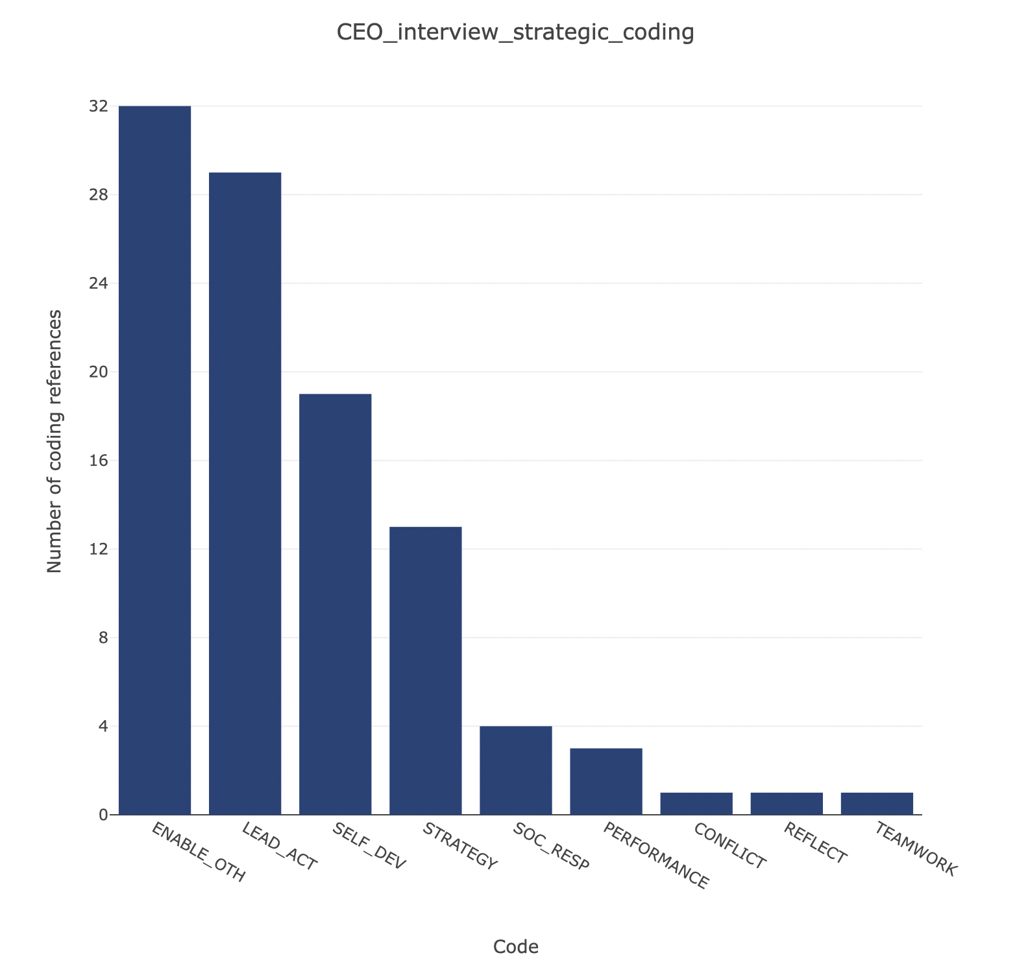

The players’ perspectives are visually illustrated in Figure 4.2.

Figure 4.2 Players’ Leadership Perspective
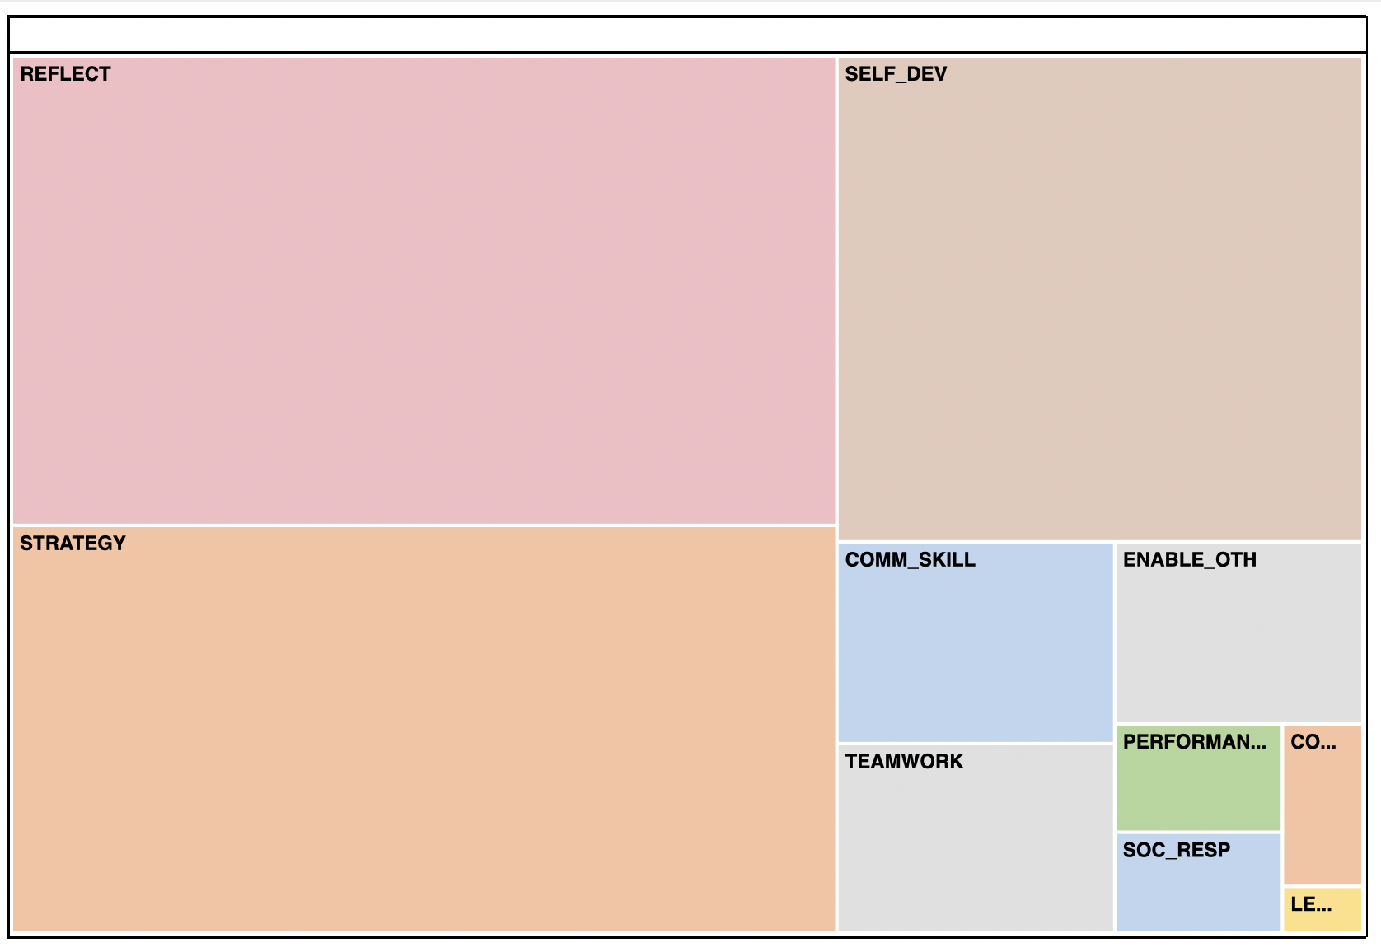
The most dominant themes identified were reflection (REFLECT), self-development (SELF_DEV), and strategy (STRATEGY), which together accounted for the majority of coded content. This suggests that interviewees most frequently described leadership in terms of cognitive reflection, personal development, and strategy or tactical planning. These findings reinforce the earlier NVivo results, highlighting that leadership within these Esports teams is often an internal and distributed process, rather than something directed by a singular figure.
While themes such as lead action (LEAD_ACT), conflict (CONFLICT), and social responsibility (SOC_RESP) appeared less frequently, they were still present and therefore contribute to a more nuanced view of leadership. Their lower frequency aligns with the idea that leadership within these Esports teams tends to be an internal process, and distributed between team members automatically. One particularly insightful observation, not fully captured by the coding framework, emerged during the interviews. Several leaders described deliberate training approaches such as placing players in intentionally challenging or unwinnable scenarios to evaluate and develop their resilience and problem-solving skills. Others adopted a more collaborative and mentoring approach, providing guidance and supporting their development in real time. This qualitative detail enriches earlier findings: while the in-game transcripts showed these behaviours occurring, the interviews provided critical context about how these leadership dynamics were cultivated in advance. An attempt was made to generate further insights by importing the data into Power BI for visualisation. However, beyond what was already found through the manual process, no significant additional patterns emerged.

4.6.1 Game-Level Variations in Leadership Expression
To further contextualise the coding results, three matches were examined more closely due to their high frequency of leadership-related codes and diversity in outcomes: Esports619, Esports633 and IESF06F. These matches provide insight into how different gameplay contexts enabled varying forms of leadership expression.
Esports619 demonstrated moderate levels of ‘reflection’, ‘self-development’ and ‘enabling others’. Despite a mixed outcome (multiple losses followed by a final victory), the transcript shows evidence of adaptive leadership where players reflected on mistakes and adjusted roles or tactics accordingly. Though lacking consistency, this match highlighted the transitional development of leadership, not in dominance, but in the effort to adapt and support each other as the game progressed.
The two extracts below show the two highest-scoring coded entries:
In Esports633, leadership through communication and reflection was far more pronounced. Sixteen distinct references to verbal clarity were coded, alongside strong instances of reflection (44) and self-development (27). The leadership here appeared more peer-oriented, with players coordinating, correcting, and supporting each other without explicit hierarchy. This aligns with existing research on distributed leadership in online teams (Sachar, 2025). However, it was IESF06F that demonstrated the clearest evidence of comprehensive leadership development, combining high levels of strategic planning and team coordination. This match culminated in a convincing 13-6 win, and the transcript was densely coded across multiple leadership domains. The interaction in this file mirrors what Kouzes and Posner (2013) describe as vision-driven, collaborative leadership with shared responsibilities and clear communication. This case supports the notion that high-functioning leadership behaviours, especially reflection and strategy, contribute directly to team success in Esports environments (Sanz-Matesanz et al., 2024; Semenova et al., 2020).

4.7 Discussion
In response to the research question of this study, Can Esports and gameplay be used to facilitate leadership development?, the findings of this study support the argument that Esports can be an effective and underexplored site for leadership development, especially when viewed via those lenses of reflection, strategic collaboration, and identity. In contrast to leadership programs that separate learning from practice, Esports offers a naturally embedded, real-time environment in which leadership is not only discussed but also enacted, often under pressure. Consequently, Esports is situated within the realm of experiential and socially constructed leadership development (Kolb, 1984; Raelin, 2003), where knowledge is generated through doing, thinking, and being with others. Moreover, the data suggests that Esports supports distributed and peer-based leadership, aligning with emerging trends in leadership theory, which challenge the idea of the singular leader (Sanz-Matesanz et al., 2024; Semenova et al., 2020). It is particularly well-suited to developing contemporary leadership competencies such as adaptability, metacognitive awareness and collaboration (Velcu-Laitinen, 2024).
The immersion of players into an environment that requires real-time decision-making and communication illustrates that it constitutes a safe learning environment for team dynamics. The freedom to explore these options is, however, contingent upon cohesion in the team. In the context of high-pressure environments, a lack of cohesion may culminate in resentment. Overall, this study contributes to the leadership literature by showing how leadership can be cultivated in non-traditional, digital and youth-centric spaces where learning is immersive, identity is in flux, and leadership is constantly negotiated.

Chapter 5. Conclusion & Recommendations
This study has explored how participation in Esports games and activities can be a platform for the development of leadership skills among participants whose age range was 16 to 25. It revealed that the most prolific leadership categories were: reflective thinking (524 codes applied), strategic planning (452) and self-development (326). In the games IESF06 and Esports633, the teams were high-performing and worked extremely efficiently under pressure. In contrast, the less frequently cited categories were comments of direct leadership (6) and conflict resolution (17). This suggests that leadership in Esports is largely distributed and collaborative from the onset. Reflection was the most consistent leadership behaviour, which supports a constructivist model of leadership development
Strategy and teamwork reinforce the previous key finding, illustrating leadership in action. Experienced high-performing players demonstrated self-development, a key leadership quality, by actively learning from their mistakes and failures. Additionally, communication and peer support (or teamwork) further supported earlier observations, highlighting that without clear, shared communication, other aspects of performance may not be accurately recognised. Communication forms the foundation of team coordination; without it, there is no effective starting point. Importantly, in well-formed teams, trust and established social dynamics also play a crucial role in facilitating seamless collaboration.

5.1 Contributions to Existing Knowledge
This research contributes to understanding Esports across multiple dimensions and responds, in part, to the calls from scholars who have highlighted existing gaps in the literature, particularly in the area of leadership. The findings demonstrate that Esports can serve as an effective platform for leadership development. Far from being solely recreational, gameplay in this context offers significant opportunities for teaching and learning.
The study reveals that within the high-pressure environment of competitive gameplay, a distributed model of leadership naturally emerges, indicating that leadership functions as a shared process among team members. A newly developed leadership framework, integrating principles from Constructivism, the Social Change Model, and the Five Practices of Exemplary Leadership, has been effectively applied. This framework aligns well with the real-time, dynamic nature of Esports and offers practical insights into how digital gameplay can act as a constructive and influential tool. It challenges the often negative perceptions of Esports, positioning it instead as a valuable medium for personal and leadership development.

5.2 Limitations
While this study made important contributions to the literature, it was associated with some limitations. Specifically, participants were drawn from a limited number of available teams primarily within the UK Esports ecosystem. This limits the generalisability of the findings. Although the games were carefully watched and notes were taken and compared with the transcriptions to minimise errors, the emotional tone may still be misrepresented, as transcription tools can inaccurately capture how things sound or present statements out of context. Further, the study focuses on verbal communication, as body language was largely unobservable. While players occasionally spoke to each other with their cameras on at the start of some games, this was not consistently the case once the games were underway.

5.3 Practical Implications
Esports can serve as a powerful platform for developing soft skills such as leadership and communication. Post-game analysis plays a crucial role in this developmental process, particularly when combined with the rotation of leadership roles within teams. In this study, the process of reviewing games using thematic codes proved pivotal, not only as a research method but also as a practical tool that could be adopted for post-game analysis by teams themselves. There is growing recognition of Esports as a legitimate tool for leadership development, aligning with several of the national well-being goals outlined in the Future Generations (Wales) Act 2015:
- A Prosperous Wales: Esports supports the development of employable skills, digital fluency, and strategic thinking, key competencies in the modern economy.
- A More Equal Wales: The Esports space has the potential to address inequalities in access to leadership development, including gender, disability, and socio-economic factors, promoting inclusion and trust.
- A Healthier Wales: While not the primary focus, Esports can contribute to mental wellbeing by developing social connection, setting personal goals, and encouraging self-development.
- A Globally Responsible Wales: The nature of Esports encourages international communication and collaboration, significantly enhancing communication and strategic skills.
- A Resilient Wales: Players regularly face challenges and setbacks, developing the resilience and adaptability necessary for future work environments characterised by uncertainty.
- A Wales of Vibrant Culture and Thriving Welsh Language: Esports provides a global stage on which Welsh identity and language can be celebrated. While not directly observed in this study, there have been instances of players communicating in Welsh. Furthermore, organisations like Esports Wales help position Wales as a competitive global player in the Esports arena.

5.4 Future research
Future studies can research other teams and other countries to evaluate and unpack similar dynamics. Time-scaled studies can also be conducted to determine whether players develop skills similar to those found in this study, onwards into their professional careers. Further research into gender differences, especially how leadership roles are negotiated in a male-dominated environment, can further enhance the literature. Comparative approaches to game studies can also assist in determining whether different game genres determine leadership outcomes.

References
Adams, J.S., Patterson, S. and Skendall, K.C. (2023) ‘Socially responsible leadership and the social change model’, New Directions for Student Leadership, 2023(180), pp. 61–71. Available at: https://doi.org/10.1002/yd.20581 (Accessed: 27 April 2025).
Adeoye‐Olatunde, O.A. and Olenik, N.L. (2021) Research and scholarly methods: Semi‐structured interviews. Journal of the american college of clinical pharmacy, 4(10), pp.1358-1367.
Alharahsheh, H.H. and Pius, A. (2020) A review of key paradigms: Positivism VS interpretivism. Global academic journal of humanities and social sciences, 2(3), pp.39-43.
Archibald, S. (2024) Examining the impact of esports program on higher education: A systematic literature review. Doctor of Science in Information Technology dissertation. Middle Georgia State University. Available at: https://comp.mga.edu/static/media/doctoralpapers/2024_Archibald_0917114300.pdf (Accessed: 5 June 2025).
Ardichvili, A., Natt och Dag, K. and Manderscheid, S. (2016) Leadership development: Current and emerging models and practices. Advances in Developing Human Resources, 18(3), pp.275-285.
Astin, H.S. and Astin, A.W. (1996) A social change model of leadership development guidebook. Washington, DC: The National Clearinghouse of Leadership Programs.
Bell, E., Bryman, A. and Harley, B. (2023) ‘Sampling in qualitative research’, in Business research methods. 6th edn. Oxford: Oxford University Press. Available at: https://doi.org/10.1093/hebz/9780198869443.003.0030 (Accessed: 11 May 2025).
Białecki, A., Michalak, B. and Gajewski, J. (2024) ‘Esports training, periodization, and software — a scoping review’, arXiv preprint. Available at: https://arxiv.org/abs/2409.19180 (Accessed: 5 June 2025).
Billsberry, J. and O'Callaghan, S. (2024) ‘The social construction of leadership, implicit leadership theories, leader development, and the challenge of authenticity’, Journal of Leadership Studies, 18(3), pp. 6–22. Available at: https://doi.org/10.1002/jls.21886 (Accessed: 11 May 2025).
Brandenberger, J.W. (2023). Investigating personal development outcomes in service learning: Theory and research. Research on service learning, pp.133-156.
Burns, J.M. (2012) Leadership. Open Road Media.
Byrne, A.M. (2020) ‘Using esports to teach bystander leadership and collaboration for students in STEM’, About Campus, 25(2), pp. 23–26. Available at: https://doi.org/10.1177/1086482220919246 (Accessed: 13 April 2025).
Carter, L., Ulrich, D. and Goldsmith, M. eds. (2012) Best practices in leadership development and organization change: how the best companies ensure meaningful change and sustainable leadership. John Wiley & Sons.
Castelli, P.A. (2016) Reflective leadership review: A framework for improving organisational performance. Journal of Management Development, 35(2), pp.217-236.
Charlie Health (2023) Video games and mental health. Available at: https://www.charliehealth.com/post/video-games-and-mental-health (Accessed: 24 March 2025).
Chan, G., Huo, Y., Kelly, S., Leung, J., Tisdale, C. and Gullo, M. (2022) The impact of eSports and online video gaming on lifestyle behaviours in youth: A systematic review. Computers in Human Behavior, 126, p.106974.

Chung, T., Sum, S., Chan, M., Lai, E. and Cheng, N. (2019) Will esports result in a higher prevalence of problematic gaming? A review of the global situation. Journal of behavioral addictions, 8(3), pp.384-394.
Clarke, N. (2013) Model of complexity leadership development. Human Resource Development International, 16(2), pp.135-150.
Collins, A., Brown, J.S. and Holum, A. (1991) Cognitive apprenticeship: Making thinking visible. American educator, 15(3), pp.6-11.
Creswell, J.W. & Poth, C.N., 2023. Qualitative inquiry and research design: Choosing among five approaches. 5th ed. Thousand Oaks, CA: SAGE Publications.
David, D.J. (2022) ‘Constructivism’, in Haynes, F. (ed.) Routledge encyclopedia of education. London: Routledge. Available at: https://doi.org/10.4324/9781138609877-ree32-1 (Accessed: 27 April 2025).
Day, D.V. (2000) Leadership development:: A review in context. The leadership quarterly, 11(4), pp.581-613.
Day, D.V. (2011) Leadership development. The SAGE handbook of leadership, 22, pp.37-50.
Dickson, R.K. (2023) Analysis of the traditional leadership theories: A review of contemporary leadership approaches and management effectiveness. In Information and Knowledge Management, 13( 5), pp. 9-23.
Dixon, D.P., Maia, A., Pennington, J.R. and Calega, S. (2018) ‘Social change model of leadership development: a 4-year program’, Management Teaching Review, 4(1), pp. 10–20. Available at: https://doi.org/10.1177/2379298118810845 (Accessed: 10 May 2025).
Egan, J.D. (2022) ‘Exploring terms and proposing a framework for leadership learning through games’, New Directions for Student Leadership, 2022(174), pp. 21–30. Available at: https://doi.org/10.1002/yd.20496 (Accessed: 19 April 2025).
Etikan, I., Musa, S.A. and Alkassim, R.S. (2016) Comparison of convenience sampling and purposive sampling. American journal of theoretical and applied statistics, 5(1), pp.1-4.
Forlenza, S.T. (2023) ‘Using imagined partners to enhance esports performance’, Journal of Imagery Research in Sport and Physical Activity, 18(s1). Available at: https://doi.org/10.1515/jirspa-2022-0022 (Accessed: 13 April 2025).
French, A. (2017) Toward a New Conceptual Model: Integrating the Social Change Model of Leadership Development and Tinto's Model of Student Persistence. Journal of Leadership Education, 16(3).
Ghossoub, C.S. (2024) From Casual Player to In-Game Leader: A Pathway to Successful leadership in Tactical Shooter esports.
Gisbert-Pérez, J., García-Naveira, A., Martí-Vilar, M. and Acebes-Sánchez, J. (2024) Key structure and processes in esports teams: a systematic review. Current Psychology, 43(23), pp.20355-20374.
Gonzaga University (n.d.) Social Change Model of Leadership. Available at: https://www.gonzaga.edu/student-life/student-affairs/our-departments-and-programs/payne-center-for-leadership-development/social-change-model-of-leadership (Accessed: 5 June 2025).
Graham, T.T. and Tainsky, S. (2021) ‘Sensemaking of novelty: the dynamic nature of integrating esports within a traditional sport organization’, Sport Management Review, 24(5), pp. 870–894. Available at: https://www.researchgate.net/publication/352439538_Sensemaking_of_novelty_The_dynamic_nature_of_integrating_esports_within_a_traditional_sport_organization(Accessed: 19 April 2025).
Grand Canyon University (2025) ‘Technology in the classroom: benefits and the impact on education’, Teaching & School Administration Blog, 13 May. Available at: https://www.gcu.edu/blog/teaching-school-administration/how-using-technology-teaching-affects-classrooms (Accessed: 5 June 2025).
Gray, A. and Bartlett, J. (2024) ‘Exploring the Potential of Utilizing Esports in the Development of Workforce Communication and Collaboration Skills’, Proceedings of the Society for Information Technology & Teacher Education International Conference, pp. 1220–1224.
Gisbert-Pérez, J., García-Naveira, A., Martí-Vilar, M. and García-García, J. (2024) ‘Key structure and processes in esports teams: a systematic review’, Current Psychology, Advance online publication. Available at: https://doi.org/10.1007/s12144-024-05858-0 (Accessed: 10 May 2025).
Grand View Research (2025) Esports market size, share & trends analysis report by revenue source (sponsorship, advertising, merchandise & tickets, media rights), by streaming, by region, and segment forecasts, 2025–2030. Available at: https://www.grandviewresearch.com/industry-analysis/esports-market (Accessed: 7 May 2025).
Grinspoon P. (2020) The health effects of too much gaming. Available at: https://www.health.harvard.edu/blog/the-health-effects-of-too-much-gaming-2020122221645 (Accessed: 24 March 2025).
Gronn, P. (2002) Distributed leadership. In Second international handbook of educational leadership and administration (pp. 653-696). Dordrecht: Springer Netherlands.
Gustafsson, J. (2024) ‘Case studies’, in Advanced research methods for applied psychology. 2nd edn. London: Routledge, pp. 111–121. Available at: https://doi.org/10.4324/9781003362715-11 (Accessed: 11 May 2025).
Harclerode, P. and Reynolds, D. (2003) Gurkha: the illustrated history. Stroud: Sutton Publishing.
Harris, A. (2009) Distributed leadership: What we know. Distributed leadership: Different perspectives, pp.11-21.
Harris, L.S. and Kuhnert, K.W. (2008). Looking through the lens of leadership: A constructive developmental approach. Leadership & Organization Development Journal, 29(1), pp.47-67.
Hewett, K.J.E. (2022) ‘Embracing video games for strategic thinking, collaboration, and communication skills practice’, in Information Resources Management Association (ed.) Research anthology on fandoms, online social communities, and pop culture. Hershey, PA: IGI Global, pp. 296–314. Available at: https://doi.org/10.4018/978-1-6684-4515-0.ch017(Accessed: 19 April 2025).
Hogan, R. and Kaiser, R.B. (2005) What we know about leadership. Review of general psychology, 9(2), pp.169-180.
Hopkins, D. (2019) ‘Leadership of personalised learning’, Australian Educational Leader, 41(1), pp. 18–23. Available at: https://www.profdavidhopkins.com/assets/docs/Leadership%20of%20PL%2C%20AEL%20-%20Vol%2041%20Issue%201%202019.pdf (Accessed: 7 May 2025).
Hunt, T. and Fedynich, L. (2019) Leadership: Past, present, and future: An evolution of an idea. Journal of Arts and Humanities, 8(2), pp.22-26.
Jain, A., Kamat, S.V., Saini, V., Handa, A. and Kaushik, M. (2024) ‘Agile leadership’, in Chatterjee, S., Das, R. and Nayak, M. (eds.) Leadership and management strategies for creating resilient organizations. Hershey, PA: IGI Global, pp. 43–60. Available at: https://doi.org/10.4018/979-8-3693-3318-1.ch003 (Accessed: 10 May 2025).
Jenkins, H. and Pickett, C. (2022) ‘Getting your leadership game on in virtual environments’, in Smith, J. and Lee, A. (eds.) Adaptive leadership in esports: insights from MMOGs. New York: Routledge, pp. 45–62.
Johnston, L.M. (2016) ‘Constructivist theories of leadership’, in Farazmand, A. (ed.) Global encyclopedia of public administration, public policy, and governance. Cham: Springer. Available at: https://doi.org/10.1007/978-3-319-31816-5_1916-1 (Accessed: 27 April 2025).
Johnston, J. and Patton, D.L. (2022) ‘Toward understanding development of team resilience during stress exposure training’, Proceedings of the AHFE International Conference, 84, pp. 403–410. Available at: https://doi.org/10.54941/ahfe1001494 (Accessed: 27 April 2025).
Karadakis, K. and Painchaud, R. (2022) ‘Esport Knowledge, Skills, and Abilities: Perspectives from Subject Matter Experts’, Athens Journal of Sports, 9(2), pp. 85–102.
Kearney, T. and Dye, S. (2024) ‘team resilience’, in Eccles, D.W. and Tenenbaum, G. (eds.) The Cambridge handbook of expertise and expert performance. 2nd edn. Cambridge: Cambridge University Press. Available at: https://doi.org/10.1017/9781108976770.010 (Accessed: 27 April 2025).
Keçeci̇, O. and Yıldız, M. (2024) ‘A qualitative study on e-sports players’ leadership perceptions regarding their team coaches’, Pamukkale Journal of Sport Sciences, 15(1), pp. 14–27. Available at: https://doi.org/10.54141/psbd.1380150 (Accessed: 7 May 2025).
Kilci, A.K., Yalçıner, S. and Bekir, S. (2025) ‘Mental competence in esports: The mediating role of cognitive flexibility in the relationship between negative problem orientation and social problem-solving competence’, Research Square [Preprint]. Available at: https://doi.org/10.21203/rs.3.rs-5868921/v1 (Accessed: 14 June 2025).
Komives, S.R. (2009) Leadership for a better world: Understanding the social change model of leadership development. John Wiley & Sons.
Kong, J.S.L., Kwok, R.C.W., Lai, G.C.H. and Law, M. (2024) Motivational profile and knowledge creation in eSports: examining the roles of mutualistic co-presence. Internet Research.
Kouzes, J.M. and Posner, B.Z. (2009) ‘The student leadership challenge: five practices for exemplary leaders’, Journal of College Student Development, 50(4), pp. 446–449. Available at: https://doi.org/10.1353/CSD.0.0065 (Accessed: 27 April 2025).
Kouzes, J.M. and Posner, B.Z. (2017) The leadership challenge: how to make extraordinary things happen in organisations. 6th edn. Hoboken, NJ: Wiley.
Kouzes, J.M. and Posner, B.Z. (2024) The student leadership challenge: five practices for becoming an exemplary leader. 4th edn. Hoboken, NJ: Wiley.
Kwan, J. (2025) ‘The Impact of Esports on the Development of 21st Century Skills and Academic Performance’, Biomedical Journal of Scientific & Technical Research, 62(1), pp. 54292–54293.
Lee S. and Kim J. (2024) Mental competence in esports: the mediating role of cognitive reappraisal and expressive suppression. Available at: https://doi.org/10.21203/rs.3.rs-5868921/v1 (Accessed: 13 April 2025)
Market.us (2025) ‘Esports market revenue projected at USD 16.7 billion by 2033’, EIN Presswire, 22 January. Available at: https://www.einpresswire.com/article/779225607/esports-market-revenue-projected-at-usd-16-7-billion-by-2033 (Accessed: 5 June 2025).
Martineau, J.W. and Johnson, E. (2011) Preparing for development: Making the most of formal leadership programs (Vol. 92). John Wiley & Sons.
Matsui T. (2023) Esports as a new playground. Available at: https://scispace.com/pdf/esports-as-a-new-playground-4qxu387sx3.pdf (Accessed: 24 March 2025).
Matuszewski, P., Dobrowolski, P. and Zawadzki, B. (2020). The association between personality traits and esports performance. Frontiers in Psychology, 11, p.1490.
Mayo Clinic Health System (2023) Are video games and screens another addiction? Available at: https://www.mayoclinichealthsystem.org/hometown-health/speaking-of-health/are-video-games-and-screens-another-addiction (Accessed: 24 March 2025).
Moldoveanu, M. and Narayandas, D. (2019) The future of leadership development. Harvard business review, 97(2), pp.40-48.
Musick, G., Zhang, R., McNeese, N.J., Freeman, G. and Hridi, A.P. (2021) Leveling up teamwork in esports: Understanding team cognition in a dynamic virtual environment. Proceedings of the ACM on human-computer interaction, 5(CSCW1), pp.1-30.
Nagda, B.R.A. and Roper, L.D. (2019) Reimagining leadership development for social change through critical dialogue practices. New directions for student leadership, 2019(163).
Nuangjumnong, T. (2016). Development of leadership through esports. Unpublished doctoral thesis) Waseda University, Graduate School of Asia-Pacific Studies, Tokyo.
Peer, K.S. and Webster, M.C. (2016) ‘Bystanders to upstanders: using the social change model of leadership to embrace educational reform’, Athletic Training Education Journal, 11(4), pp. 170–174. Available at: https://doi.org/10.4085/1104170 (Accessed: 26 April 2025).
Piccotti, T. (2025) The Gran Turismo movie tells a remarkable true story – with one big exception. Biography. Available at: https://www.biography.com/movies-tv/a44796145/gran-turismo-movie-true-story-jann-mardenborough (Accessed: 3 June 2025).
Pizzo, A.D., Funk, D.C., and Baker, B.J. (2022) ‘Integrating esports into traditional sports organizations: navigating leadership challenges and opportunities’, Sport Management Review, 25(3), pp. 345–360. Available at: https://doi.org/10.1016/j.smr.2021.10.005 (Accessed: 19 April 2025).
Posner, B.Z. and Kouzes, J.M. (2013) The student leadership challenge: five practices for becoming an exemplary leader. 2nd edn. San Francisco, CA: Jossey-Bass.
Read, C.Y., Pino Betancourt, D.M. and Morrison, C. (2016) ‘Social change: a framework for inclusive leadership development in nursing education’, Journal of Nursing Education, 55(3), pp. 164–167. Available at: https://doi.org/10.3928/01484834-20160216-08 (Accessed: 26 April 2025).
Reale, C., Salwei, M.E., Militello, L.G., Weinger, M.B., Burden, A., Sushereba, C., Torsher, L.C., Andreae, M.H., Gaba, D.M., McIvor, W.R. and Banerjee, A. (2023) Decision-making during high-risk events: a systematic literature review. Journal of Cognitive Engineering and Decision Making, 17(2), pp.188-212.
Reitman, J.G., Anderson-Coto, M.J., Wu, M., Lee, J.S. and Steinkuehler, C., (2020) Esports research: A literature review. Games and Culture, 15(1), pp.32-50.
Rothstein, M.G. and Burke, R.J. (2010). Self-assessment and leadership development: an overview. Self-Management and Leadership Development, p.1.
Sabandar, E. (2023) ‘King Arthur’s Round Table: A leadership analogy for the modern era’, Medium, 9 December. Available at: https://medium.com/@erik.sabandar/king-arthurs-round-table-a-leadership-analogy-for-the-modern-era-8cdbc96e7725 (Accessed: 7 May 2025).
Sachar, S. (2025) ‘Exploring distributed leadership models in education’, Research and Innovation Journal of Contemporary Issues in Advanced Management, 4(1), pp. 22–34. Available at: https://doi.org/10.59298/rijciam/2025/412326 (Accessed: 30 April 2025).
Sadler, P. (2003) Leadership. Kogan Page Publishers.
Sanz-Matesanz, M., Martínez-Aranda, L.M. and Gea-García, G.M. (2024) ‘Effects of a physical training program on cognitive and physical performance and health-related variables in professional esports players: A pilot study’, Applied Sciences, 14(7), 2845. Available at: https://www.mdpi.com/2076-3417/14/7/2845 (Accessed: 5 June 2025).
Saunders, M., Lewis, P. and Thornhill, A. (2023) Research methods for business students. 9th edn. Harlow: Pearson Education Limited.
Semenova, M., Lange, A., Koposov, D., Somov, A. and Burnaev, E. (2020). Personality traits and coping strategies of eSports players. In 2020 7th International Conference on Behavioural and Social Computing (BESC) (pp. 1-5). IEEE.
Shapiro, A. (2022). Constructivist Leadership. In The Palgrave Handbook of Educational Leadership and Management Discourse (pp. 243-260). Cham: Springer International Publishing.
Silva, A. (2016) What is leadership?. Journal of business studies quarterly, 8(1), p.1.
Singh, J., Michaelides, G., Mellor, N., Lomas, J., Fletcher, L. and Cartwright, S. (2024) ‘The effects of individual and team resilience on psychological health and team performance: a multi-level approach’, Current Psychology, Advance online publication. Available at: https://doi.org/10.1007/s12144-024-06861-1 (Accessed: 27 April 2025).
Skendall, K.C. (2017) An overview of the social change model of leadership development. Leadership for a better world: Understanding the social change model of leadership development, pp.17-40.
Smith, A. and Johnson, B. (2024) ‘The impact of artificial intelligence on the future of work: An empirical study’, Journal of Emerging Technologies, 12(3), pp. 45–60. Available at: https://doi.org/10.1234/jet.2024.123456 (Accessed: 7 May 2025).
Sol, K. and Heng, K. (2022) ‘Understanding epistemology and its key approaches in research’, Cambodia Journal of Educational Research, 2(2), pp. 70–85. Available at: https://doi.org/10.62037/cjer.2022.02.02.05 (Accessed: 11 May 2025).
Surbakti, R.T., Deti, R. and Septina, N. (2023) ‘The impact of leadership on esport team performance’, International Journal of Modern Trends in Social Sciences, 6(25), pp. 21–30. Available at: https://doi.org/10.35631/ijmtss.625002 (Accessed: 26 April 2025).
Trepanowski, R., Li, W. and Hamari, J. (2024) ‘Perceptions of esports and esports athleticism among gamers’, in Proceedings of the 8th International GamiFIN Conference 2024, Ruka, Finland, 2–5 April 2024. CEUR Workshop Proceedings, 3669. Available at: https://ceur-ws.org/Vol-3669/paper2.pdf (Accessed: 7 May 2025).
Tholl, C., Soffner, M. and Froböse, I. (2024) ‘How strenuous is esports? Perceived physical exertion and physical state during competitive video gaming’, Frontiers in Sports and Active Living, 6, Article 1370485. Available at: https://www.frontiersin.org/articles/10.3389/fspor.2024.1370485/full (Accessed: 5 June 2025).
Thompson, G. and Vecchio, R.P. (2009) Situational leadership theory: A test of three versions. The leadership quarterly, 20(5), pp.837-848.
Toor, S.-u.-R. (2011) ‘Differentiating leadership from management: An empirical investigation of leaders and managers’, Leadership and Management in Engineering, 11(4), pp. 310–320. Available at: https://doi.org/10.1061/(ASCE)LM.1943-5630.0000138 (Accessed: 7 May 2025).
Tucker, J.C. (2022) A study of leadership behaviors in esports contexts (Master's thesis, Utah State University).
University of Pennsylvania (2024) Global leadership: navigating challenges and inspiring change in a connected world. Available at: https://lpsonline.sas.upenn.edu/features/global-leadership-navigating-challenges-and-inspiring-change-connected-world (Accessed: 13 April 2025).
University of Queensland (2024) Excessive gaming causing health issues. Available at: https://www.uq.edu.au/news/article/2024/03/excessive-gaming-causing-health-issues (Accessed: 24 March 2025).
University of Warwick (2023) ‘Academics investigate how gaming can train crucial employability skills’, Press release, 4 August. Available at: https://warwick.ac.uk/news/pressreleases?newsItem=8a1785d7898c29940189bfd9ee610a5e (Accessed: 5 June 2025).
Velcu-Laitinen, O. (2024) Developing adaptive leadership in post-information societies: The possible role of creative orientation, identity and metacognition. Possibility Studies & Society, 2(1), pp.9-24.
Webster, A. (2019) ‘Dota 2 tournament The International 2019 surpasses $30 million prize pool, topping Fortnite’, The Verge, 22 July. Available at: https://www.theverge.com/2019/7/22/20703528/dota-2-the-international-9-prize-pool-battle-pass-fortnite (Accessed: 23 April 2025).
Westover, J. (2024) ‘You’re more resilient than you give yourself credit for: building resilience in times of change and challenge’, Human Capital Leadership Review, 13(2), pp. 78–85. Available at: https://doi.org/10.70175/hclreview.2020.13.2.5 (Accessed: 27 April 2025).
Williams B.W. (2023) Factors that influence the development of mental toughness and resilience in esports athletes. PhD thesis. Utah State University. Available at: https://digitalcommons.usu.edu/cgi/viewcontent.cgi?article=9560&context=etd (Accessed: 13 April 2025).
Willink, J. and Babin, L. (2015) Extreme ownership: how U.S. Navy SEALs lead and win. New York: St. Martin’s Press.
Willink, J. and Babin, L. (2018) The dichotomy of leadership: balancing the challenges of extreme ownership to lead and win. Expanded edn. New York: St. Martin’s Press.
Xu, A. and Hao, T. (2024) ‘Developing global leadership skills through esports’, Proceedings of the Hawaii International Conference on Education (HICE). Available at: https://www.researchgate.net/publication/377082657_Developing_Global_Leadership_Skills_through_eSports (Accessed: 13 April 2025).
Xue, Y., Smith, J., and Lee, K. (2024) ‘Expanding the scope of esports leadership: beyond gameplay’, Journal of Esports Leadership Studies, 5(2), pp. 45–60. Available at: https://doi.org/10.1234/joels.v5i2.2024 (Accessed: 19 April 2025).
Yani-de-Soriano, M., Marques, T.R.F., Veludo-de-Oliveira, T. and Battistella-Lima, S.V. (2025) Devoted or addicted? Modeling gaming addiction in eSports. Computers in Human Behavior, 162, p.108470.
Zaccaro, S.J. (2007) Trait-based perspectives of leadership. American psychologist, 62(1), p.6.
Zin, Z.M., Nordin, N., Musa, M., and Hassan, R. (2024) ‘The constructivist learning theory: exploring key technological advancements in learning management systems’, International Journal of Management and Education, 6(23), pp. 412–425. Available at: https://gaexcellence.com/ijmoe/article/download/4588/4216/16218 (Accessed: 30 April 2025).

Appendix A: 51 Original Coding terms
Social Change Model (SCM) Tags
Focus is on values, collaboration and ethical leadership:
• Consciousness of self (COS)
• Alignment of values and actions taken (ALIGN)
• Commitment (COMM)
• Collaboration (COLL)
• Common purpose (COMM_P)
• Handling conflict respectfully (CONFL)
• Citizenship (CITIZ)
• Community engagement (C_ENGAG)
• Shared values (S_VALUES)
• Service orientation (S_ORIENT)
• Ethical decision making (E_DECIS)
• Social responsibility (S_RESPON)

Five Practices of Exemplary Leadership Tags
These are behaviour based and focus on leadership qualities:
• Model the way (MODEL_W)
• Shared vision / inspire (S_VISION)
• Challenge the process (CHAL_P)
• Enable others to act (ENAB)
• Encourage the heart (ENCO)
• Lead by example (LEAD_E)
• Supportive feedback (SUPPO)
• Motivation (MOTIV)
• Risk taking (RISK_T)
• Celebrating small wins (CELEB_S)
• team trust (TEAM_T)
• Adaptive strategy (ADAPT_S)
• Decision making under pressure (DECIS_PRES)

Constructivism Tags
These highlight learning processes, identity, and reflection:
• Reflection (REFL)
• Experiential learning (EXP_L)
• Peer learning (PEER_L)
• Identity development (IDENT_D)
• Meaning making (MEAN_M)
• Learning through action (LEARN_A)
• Self assessment (SELF_A)
• Collaborative learning (COLL_L)
• Role adaptation (ROLE_ A)
• Emotional response (EMOT_R_
• Knowledge construction (KNOW_C)
• Feedback integration (FEEDB_IN)
• Metacognition (METACOG)
• Perspective taking (PERSP_T)
There may also be actions or behaviours taking place in Esports that are worth recording
• Leadership transfer (LEAD_TR)
• Communication clarity (COMM_CL)
• Conflict resolution (CONF_RES)
• Tactical coordination (TACT_COORD)
• team dynamics (TEAM_DYNAM)
• In game roles (GAME_ROLE)
• Tilt or loss of focus (LOSS_F)
• Resilience (RESIL)
• Composure under stress (COMPOS)
• Voice tone authoritative, collaborative (VOICE)
• Strategy shift (STRAT_SHIF)
• Performance under pressure (PRESSURE)

Appendix B: Blank Participant Consent Form
Consent Form for Participation in Research Study
Study Title:
From Digital Battlefield Warriors to Young Leaders: An investigation into how participation in esports influences leadership skill development.

Researcher Details:
Name: Christopher Steven Manley
Email: 0251465 @uwtsd.ac.uk
Supervisor: Dr. Catherine Morgan (University of Wales Trinity Saint David)

Purpose of the Study:
This research aims to explore how participation in esports contributes to leadership skill development. It also seeks to identify specific interventions in esports that can enhance leadership training.

Consent Declaration
1. I have read and understood the information sheet about this study and have had the opportunity to ask questions.
2. I understand that my participation is voluntary, and I can withdraw from the study at any time without providing a reason, up until the final analysis of data.
3. I understand that my anonymity will be protected. My name and personal details will not appear in any reports or publications.
4. I consent to the collection and use of data as described in the information sheet, including:
- Surveys and questionnaires
- In-game recordings and observations
- Post-game interviews
5. I understand that my data will be stored securely in compliance with GDPR regulations and that any personal identifiers will be anonymized or pseudonymized.
6. I understand that if I am under 18, my parent/guardian must also provide consent for me to participate.

Consent Options

Please initial the boxes to confirm your consent for each of the following:
- I consent to my participation in this study. [ ]
- I consent to the video/audio recording of gameplay for analysis. [ ]
- I consent to being contacted for follow-up questions if necessary. [ ]
- I agree to the use of anonymized quotes or data from this study in publications or presentations. [ ]

Participant Name (Printed): _________________________
Participant Signature: _________________________
Date: _________________________

For Participants Under 18:
Parent/Guardian Name (Printed): _________________________
Parent/Guardian Signature: _________________________
Date: _________________________

Appendix C: Player Semi-structured Interview Questions
Section 1: Personal and Gameplay Background
1. Can you tell me about your role in your esports team and how long you’ve been playing?
2. What types of games do you usually play competitively?
3. How often do you participate in team-based gameplay?

Section 2: Leadership Experiences
4. In your experience, what does leadership look like during gameplay?
5. Can you recall a time when you took the lead in a match? What happened?
6. Do you think everyone in your team has a chance to lead at some point? Why or why not?
7. What makes someone a good leader in an esports team?

Section 3: Strategy, Reflection, and Decision-Making
8. How are tactical decisions made in your team?
9. Do you often reflect on your gameplay after a match? Can you give an example?
10. Do players in your team help each other improve, or is improvement mostly individual?

Section 4: Communication and Collaboration
11. How important is communication in your team during matches?
12. How do you deal with disagreements or stress during high-pressure games?
13. Are there certain players you trust more during matches? Why?

Section 5: Self-Development and Learning
14. Has playing in an esports team helped you develop confidence or personal skills?
15. Have you noticed any ways in which your in-game leadership has transferred into your life outside of gaming?
16. What do you feel you’ve learned about yourself through esports?

Section 6: Inclusion, Culture, and Future Aspirations
17. Do you feel esports is accessible and inclusive for players of different backgrounds?
18. Do you see esports as a potential career path or leadership training space?
19. How do you think esports in Wales (or your local area) could be improved for young players?
20. What advice would you give to someone new joining a team who wants to develop leadership skills?

Appendix D: CEO Semi-structured Interview Questions

CEO
Organisational Vision and Strategy
1. How would you describe the mission and vision of Esports Wales?
2. What role does leadership development play in your strategic goals for players and teams?
3. How do you see esports contributing to skills development more broadly in Wales?

Leadership in Esports Contexts
4. From your perspective, what does effective leadership look like in an esports team?
5. Do you see differences in leadership styles across different game types or levels of competition?
6. How do you think distributed leadership — where multiple players contribute to decisions — works in practice?

Education, Skills, and Youth Development
7. How is Esports Wales currently supporting leadership or personal development among young players?
8. Are there plans to integrate esports more formally into education or skills pathways in Wales?
9. Have you observed specific leadership traits emerging in players over time? How are these recognised or supported?

Inclusivity, Policy, and the Future of Esports
10. How does Esports Wales address issues of inclusion, such as gender diversity or accessibility, within leadership pathways?
11. In what ways does your work align with the Well-being of Future Generations (Wales) Act 2015?
12. Do you think esports is sufficiently recognised by policymakers and educational institutions in Wales as a developmental platform?

Vision and National Impact
13. How do you see the role of Esports Wales in putting Wales on the global esports map?
14. What would success look like for Esports Wales in five years, in terms of player development and national recognition?
15. What advice would you give to educators, policymakers, or researchers looking to use esports as a leadership development tool?

Appendix E: Interview Schedule
9th June 2025 CamRHope
10th June 2025 LJPH
11th June 2025 Ping
12th June 2025 John Slayer (CEO)

Appendix F : NVivo Output

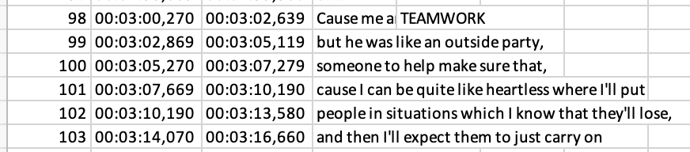
Figure 16: Excerp of transcript showing codes added

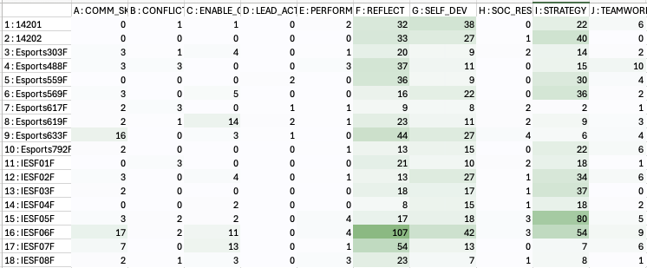

Appendix G: Game/Participant Metadata

Game results per filename
142
Game: Valorant
Match Result: Victory (promoted to Immortal 3)
Players: Leon (main), with teammates including Jake, Emily, Mitch, etc.
Agent Played: Omen (by Leon)
Rank Progression: From Immortal 2 to Immortal 3, top 2K players

303
Game: Valorant
Match Result: Victory (Group Stage Win)
Players: Kobe, Jake, Mitch, Kyle, Emily, Leon, Jacob, JPH, Heyho
Agent Played: Brimstone, Cypher, Raze, Yoru, Fade, Sage
Rank Progression: Not specified (but team is reported as 4–0 in group stage, indicating strong performance)

488
Game: Valorant
Match Result: Victory (score: 13–7)
Players: Kobe, OJ, Leon, Jake, Kyle, Emily, Toby, Mitch, Carl, Jack
Agent Played: Phoenix, Sova, Cypher, and others (specific picks varied across maps)
Rank Progression: Not specified (casual tournament setting, win acknowledged by players)
Voice-based team coordination and leadership evident

559
Game: Valorant
Match Result: Victory (likely 13–11 based on context)
Players: Chris, Jake, Mitch, Kyle, Jack
Agent Played: Breach, Cypher, Phoenix, Killjoy, Fade, Viper
Rank Progression: Not specified (Premier standings mentioned; team believed to be outside qualifying positions)
Match was closely contested
Included agent role swaps and coordinated site executes
Strong communication with some leadership moments and mid-round adaptations

569
Game: Valorant
Match Result: Victory (exact score not stated; likely around 13–11 based on “we went 11 on Fracture”)
Players: Jake, Chris, Lilith, Luna, Leon (Amelia mentioned in chat)
Agent Played: Breach, Cypher, Phoenix, Killjoy (based on ability references and typical comp)
Rank Progression: Not specified (practice and Premier context; aces and lineup testing suggest competitive prep)
Multiple lineup tests and post-plant utility checks were conducted for bomb defusal strategies using mollies.
Participants engaged in a custom match for practice and strategy validation.
Participants Mentioned: Jake (ace), Chris (ace), Lilith, Luna, Leon (assisting, practicing, or spectating), Amelia (mentioned in chat)
Other Games Mentioned: Post-match, participants discussed and played Marvel Rivals, an Overwatch-style team shooter.

617
team Name: Not specified
Game: Valorant
Match Result: Victory (team is 4–0 in the Welsh Youth Esports League group stage)
Players: Not individually named in transcript (team defeated Wizards, Wolfhound, and GGS)
Agent Played: Not specified
Rank Progression: Not specified (progress within group stage of league; top performance against strongest teams)
Confidence Level: The speaker indicates high confidence in future matches, saying, “I don’t see us struggling.”
Casual Tone: The conversation moves toward Media Monday—a community content-sharing stream—after the match review.

619
Game: Marvel Rivals
Match Result: Mixed (multiple losses followed by a final victory)
Players: Unnamed speaker (likely streamer) with rotating teammates
Agent Played: Iron Man, Storm, Rocket, Moon Knight, Magneto, Black Panther, Doctor Strange, etc.
Rank Progression: Dropped from GM1 rank due to losses; slight recovery after win using Storm

633
Game: Valorant (with some segments covering Marvel Rivals and Minecraft)
Match Result: Unspecified, but highlights include multiple aces, 1v5 clutches, and high-skill plays.
Players: Damien (featured prominently for back-to-back aces), Chloe, Emily, Jake, Libte (Killjoy), and others mentioned in clips and commentary.
Agent Played: Multiple agents, notably Killjoy and Jett (Libte).
Rank Progression: Damien is mentioned as being 17 and playing at a high level (Radiant-level opponents such as Glacial). Specific rank progression not detailed, but performance suggests top-tier ranked lobbies.

792
Game: Valorant
Match Result: Loss (Fracture Premier match, acknowledged lack of practice on the map)
Players: Jake (main), Kyle, Mitch, Teho, Kirs, Emily, Jack, possibly Leon and LJPH mentioned
Agent Played: Not fully clear per player, but mentions of Breach, Raze, Cypher, Brimstone, Omen
Rank Progression: No rank progression noted, focus was on competitive Premier match, not ranked queue

986
Game: Marvel Rivals
Match Result: Mixed performance; highly competitive matches with team frustrations
Players: Leon (main speaker), with teammates including Emily, Mitch, Jake, Chloe, Luna, and Kyle
Agent Played: Iron Man (by Leon), mentions of Punisher, Hulk, Spider-Man, Loki, Cloak, and others
Rank Progression: No specific rank progression noted; discussions suggest participation in Premier and GM-level lobbies

IESF1
Game: Valorant
Match Result: Loss (final round score 13–5 against)
Players: Not directly named in the file, but players were competing against a team that played well-coordinated strategies (e.g., strong Fade and Skye usage)
Agent Played: Not clearly attributed, but opposing team used Fade, Skye, Sage, Raze, and Killjoy
Rank Progression: Not mentioned (appears to be a tournament setting with international context, possibly IESF event)

IESF2
Game: Valorant
Match Result: Victory (final score 13–4 in favour of the speaker’s team)
Players: Individual names not specified, but the transcript shows coordinated team play, successful site executions, and clean post-plant holds
Agent Played: Not directly stated, but references to Skye, Fade, Killjoy, Raze, and Cypher suggest standard competitive agent compositions
Rank Progression: Not stated

IESF3
Game: Valorant
Match Result: Victory (final score 13–3 in favour of the speaker’s team)
Players: Not named individually in the transcript, but coordination and control were evident throughout the match
Agent Played: Not directly specified, though common agents like Raze, Sage, Skye, and Killjoy are implied based on utility usage and callouts
Rank Progression: Not mentioned

IESF4
Game: Valorant
Match Result: Victory (final score 13–4 in favour of the speaker’s team)
Players: Not individually named; team demonstrated consistent control and clear communication throughout
Agent Played: Not explicitly mentioned, but the style of play and ability references imply common agents like Fade, Killjoy, Skye, Raze, or Cypher
Rank Progression: Not stated; context suggests a continued strong showing in a structured/tournament setting, likely the IESF competition

IESF5
Game: Valorant
Match Result: Victory (final score 13–7 in favour of the speaker’s team)
Players: Not named individually, though team coordination and situational awareness were strong throughout
Agent Played: Not directly specified, but consistent with typical Valorant tournament compositions — likely includes Skye, Killjoy, Fade, Raze, or Cypher
Rank Progression: Not mentioned

IESF6
Game: Valorant
Match Result: Victory (final score 13–6 in favour of the speaker’s team)
Players: Not individually named, but communication suggests a well-practiced and cohesive unit
Agent Played: Not directly stated; references suggest typical meta agents such as Skye, Killjoy, Raze, Sage, or Fade
Rank Progression: Not mentioned; appears to be part of the IESF tournament match series

IESF7
Game: Valorant
Match Result: Victory (final score 13–7 in favour of the speaker’s team)
Players: Not individually named; strong communication, site executions, and post-plant setups observed
Agent Played: Not specifically stated, but agent abilities and team roles suggest common competitive picks such as Skye, Killjoy, Fade, Raze, or Cypher
Rank Progression: Not mentioned

IESF8
Game: Valorant
Match Result: Victory (final score 13–5 in favour of the speaker’s team)
Players: Not individually named; gameplay demonstrates strong synergy and strategic control
Agent Played: Not directly specified, but inferred from utility use and structure—likely agents include Skye, Killjoy, Fade, Raze, or Cypher
Rank Progression: Not mentioned; continues the team’s winning streak in the IESF tournament series

International Esports Federation games reference IDs (that were played against Esports Wales players)
Esports Wales games reference IDs

