

Assessment 1 – Reading Task Template
Upload your photo of your A3 in-class notes here:
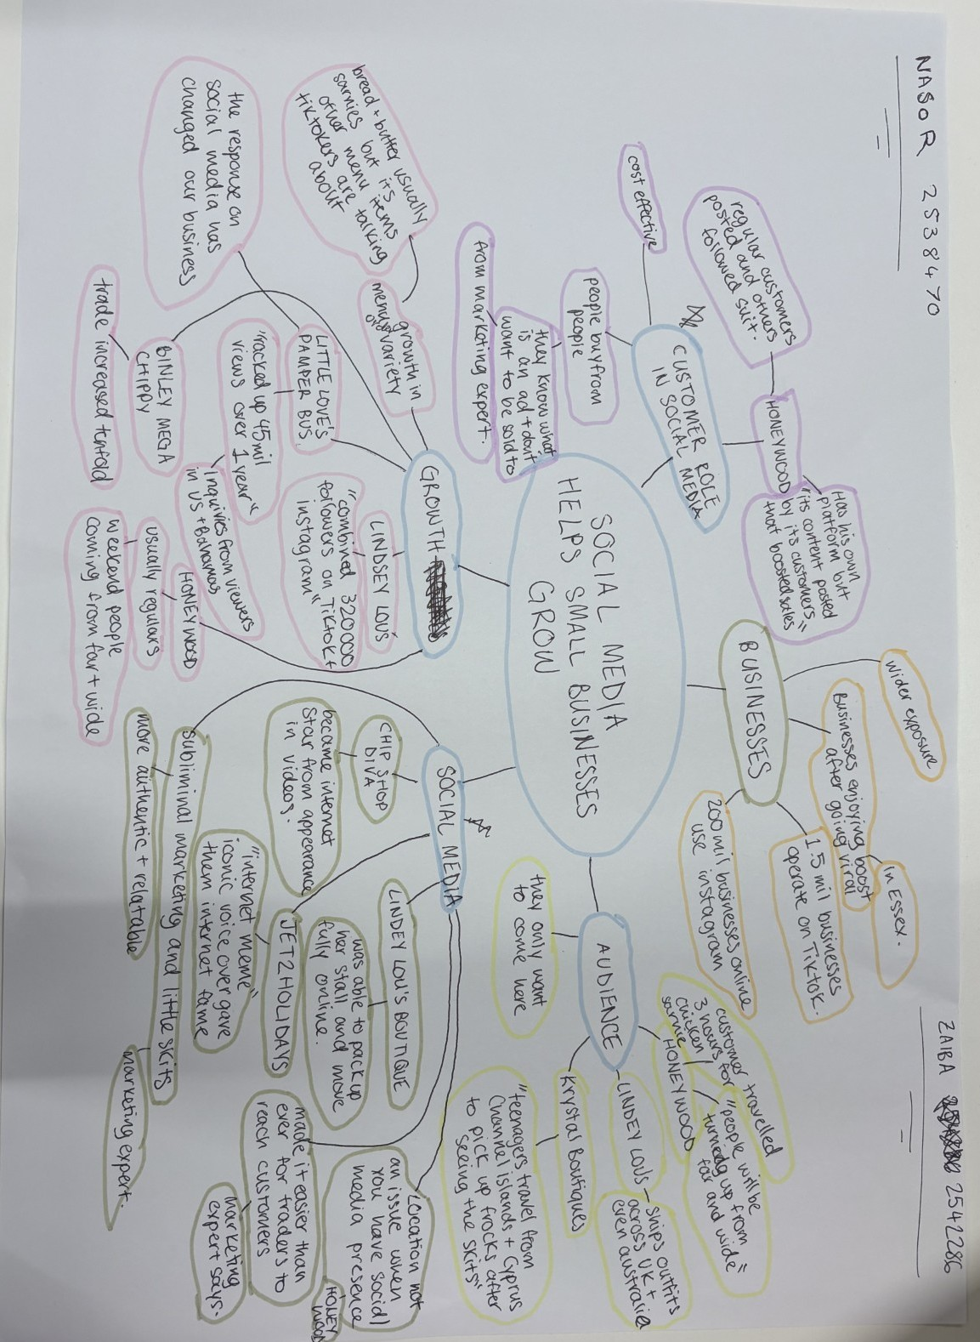

1. Answer these questions using the sentence starters below
a. What is the main idea of the text?
The main idea of the text is that social media is helping small businesses gain recognition and, in some cases, can change the business’ future for the better. This is supported by the plethora of examples used in the article as well as the headline ‘If you post it, they will come: the businesses turning likes into livelihoods’. From the title alone, we can interpret the main idea of the text as businesses taking advantage of the advancement of technology and mainstream social media to advertise their companies. The outcome for some of these businesses has turned dreams into reality from just a few posts going viral on TikTok or Instagram. This is what I have taken away as the main idea of the text.
b. What are two key points?
One key point is that not only do these businesses gain local customers, but social media has aided global recognition for their companies. For example, Krystalls Boutique started posting on social media platforms for roughly 18 months after her grandson encouraged her and now has ‘teenagers travel from the Channel Islands and even Cyprus to pick out frocks after seeing the skits.’ This is a huge success for the business and is one the many examples of how social media has made connecting with others from around the world much easier through a viral video or post.
Another key point is that the way people advertise their business and products is changing. ‘People know what is an ad and they don’t want to be sold to. People buy from people’ says marketing expert Faye Martin. The public do not want products being sold to them in the traditional way, instead they are more likely to buy when the product or service is advertised through a skit or subliminally. So, advertisements will have to adapt to these changes in consumer preferences to compete with the rapid changes of trends and other businesses.
c. What part of the text did you find most important? Why?
The most important part is how much of a positive impact social media has had on these businesses. Reading the article, you can see just how grateful and happy the business owners have become after their social media posts have gone viral. ‘The response on social media has changed our business’ says Chloe Higgins and Ross Bliss, who have collectively racked up ‘about 45 million views in under a year’. A business that started off being a side hustle has now got inquiries from viewers in the United States and the Bahamas. This young couple have had their lives completely changed for the better in a year thanks to social media platforms helping promote their business.
d. Was anything unclear or difficult to understand?
I would say this task was clear and straightforward. Unfortunately, I did not find anything unclear.
e. How did your group help you understand the text better?
My group helped me by adding extra ideas from perspectives I would not have thought of such as how the customers role plays a part in the growth of some of these businesses. I also got some help organising the mind map to make it easier to read for others by circling and grouping the ideas.
2. One sentence reflection
Question: What did you find challenging about this task?
The hardest part was choosing 2 key points only to talk about and assessing which 2 points were important enough in my opinion.

