
BA (Hons) Leadership and Management Skills in the Workplace
Module Assignment Submission
Student Name: | ANGEL BRAZIER-LEWIS
Student Number: | 1702844
Module No: | BMSK5012
Module Title: | Understanding and Engaging in the Customer Experience

Statement of Confirmation of Authenticity
By the act of making this submission, the student declares that this is the work of the student named above. The work has not, in whole or in part, been knowingly presented elsewhere for assessment, or where assessment has been built on a previous assessment, this has been identified. Where materials have been used from other sources it has been properly acknowledged. If this statement is untrue, the student acknowledges that an assessment offence has been committed.
Attention is drawn to the plagiarism and unfair practice policies of UWTSD.

Table of Contents
Introduction 3
Critically analyse the factors that impact on your organisations ability to maximise customer value. 3
What is customer value? 3
What maximises customer value? 3
Factors that impact on the organisations ability to maximise customer value. 3
Value Creation 4
Value Creation Ideas 4
What strategies do organisations use to maximise customer value and what are the advantages and disadvantages? 5
Measuring Customer Value 6
Value and purpose of customer relationship management (CRM) 6
Customer Relationships 6
Analyse the customers’ experience of an organisation. 7
Critically evaluate the benefits and challenges of developing and maintaining good customer relationships. 8
Appendices 9
Appendix A 9
References 9

Introduction
The first section of this assignment will critically analyse the factors that impact on the organisations ability to maximise customer value. This assignment will draw connections among ideas and differentiate, compare, contrast, and examine the impact. This will identify the challenges and opportunities to make recommendations that would lead to maximisation of customer value.
This will also analyse the customers’ experience of the organisation. This is a critical process that helps businesses to understand how customers interact with their brand. A customer experience comprises of all the interactions a customer has with a business, this will be analysed in this assignment. Businesses must have a clear understanding of the customer journey to optimise it.
The remaining part of the assignment will critically evaluate the benefits and challenges of developing and maintaining good customer relationships. Maintaining customer relationships is crucial to the success of any business. The evaluation of this will help the organisation to understand what needs to be done to maintain customer loyalty and trust.

Critically analyse the factors that impact on your organisations ability to maximise customer value.
To critically analyse is to draw connections between ideas. To differentiate, organise, relate, compare, contrast, and examine. (Bloom et al., 1956) Criticality is the ability to analyse and evaluate ideas and arguments. It involves the assessment of the strengths and weaknesses of the content, considering different ideas and views, evidence, and assumptions. (Chatfield, 2018)

What is customer value?
Customer value is how much a product or service is worth to a customer. It takes into consideration factors such as price, quality, branding and reputation, customer service, convenience, and emotional connections. (Cerasale & Stone, 2004) Customer value can be divided into two segments. Desired value is what the customer wants. Perceived value is the benefit that customer believes is received post-purchase. Customer value maximisation (CVM) is a service model that goes above customer relationship management (CRM) and focusses on capturing the maximum potential for prospective customers.

What maximises customer value?
Customer value can be maximised in various ways and can also be created. When creating customer value, Cerasale & Stone (2004) suggest that identifying and fulfilling the needs and expectations of customers can create loyal, long-term relationships. However, there are limitations and factors that impact on the organisations ability to maximise customer value, which will be explained below.

Factors that impact on the organisations ability to maximise customer value.
There are several factors that impact on the organisations ability to maximise customer value. They can be split into 4 categories. Functional factors are the qualities of the brand, product, or service. Emotional factors are the way the brand, product or service makes the customer feel. Life changing is the way the brand, product or service alters the life of the customer. Finally, the social impact is the way the brand, product or service alters the life of others through self-transcendence.
Customer knowledge is one of the fundamental factors that impact on the organisation’s ability to maximize customer value. DeBonis, Balinski, E. W., & Allen, P. (2002) suggests that organisations must understand their customers to be able to create customer value and is the first step in achieving bottom-line success. However, this explanation tends to overlook the fact that it takes time and research to fully understand customers, who will tend to lean towards companies with a strong market and brand presence.
Technology also plays a critical role in maximizing customer value. Companies that have the most up to date and market-leading technology can offer better services to their customers. This enhances the overall customer experience. The limitation of this factor is that not all organizations can stay up to date with the newest technology, as it comes into play. Companies and organizations plan years in advance and budget accordingly. Sometimes, they do not have the finances and resources to change roadmaps and action plans in time to compete with newer technologies. One problem that the organization faces is that they require approval from the FDA and other regulatory bodies, which often take months to years of planning and testing.
A similar factor is the competitive environment in which an organization operates. Companies in highly competitive markets need a focus on innovation and continuous improvement to stay ahead of their competitors, thus offering the best product to their customers at any given time.
Customer engagement is another crucial factor in maximizing customer value. Buttle. (2012) suggests that companies that engage with their customer regularly, can create a positive relationship and spread good word-of-mouth. However, the author does not explain that their argument relies too heavily on customers to speak to their peers and spread word-of-mouth. It can be argued that to increase customer engagement, companies must provide an approachable and accessible platform to do so.
Employee engagement also adds value to the customer experience. Bari, M., Abrar, M., & Alaverdov, E. (Eds.). (2022) suggests that employees have an impact on how customers perceive a brand, as the employees are the ones who connect with the customer from the outset. Companies that have engaged employees tend to deliver better customer service, resulting in higher rates of customer satisfaction. The main weakness with this theory is that not all employees share the same values and work ethic, which could impact on the way they treat and serve customers.

Value Creation
Value creation refers to the process of adding value to a product or service. Value can be added in many ways, such as innovation, technology, marketing, customer service and product development. Value creation is centered around what customers need and want, and then developing and delivering products and services that meet and exceed their expectations. Successful value creation generates customer satisfaction, loyalty, and revenue.

(International Federation of Accountants, 2020)
“Value creation can be achieved through a management process of defining, creating, delivering and sustaining value.” - (International Federation of Accountants, 2020)

Value Creation Ideas
Value creation ideas are strategies and actions taken to maximize the perceived worth and benefits of a product or service to customers and stakeholders. Ideas could be aimed at improving processes, improving quality, reducing costs, innovation, increasing brand awareness and recognition, or introducing initiatives or loyalty schemes to enhance customer satisfaction. In manufacturing, there are many different value creation ideas that can maximize customer value.
The organization could argue that implementing lean manufacturing and streamlining the production process would minimize waste, increase efficiency, and reduce costs. However, this leaves truly little room for error from a procurement perspective, as the organization has faced several supply chain shortages, and by bringing in the bare minimum of materials for lean manufacturing would leave the organization in a critical situation if it were to experience supply chain issues again. From a financial point of view, lean manufacturing leaves room for the price of production to be reduced, as the process will not consume as many valuable resources. In turn this should reduce costs for customers.
Innovation and investing in advanced technology like artificial intelligence could add value. For example, in software generation, artificial intelligence could speed up the time it takes to code software and create treatment presets in the systems. This would save resources and finances which could be passed down to the customer, creating a cost saving.
Sustainability can also add value to an organization’s services and products. Many customers prefer to buy sustainable products that reduce harm to the environment. The organization could develop products that could have the capability to upgrade software, instead of replacing the whole unit when it becomes obsolete. This would also save the customer money, which would give the company a competitive advantage.
Collaboration can also add value to services and products. The organization already works with suppliers and partners to ensure customers are receiving quality products that are innovative and better quality. There are arguments within the organization to become a one-stop shop for all products, as the partnerships and suppliers take a percentage in commission. However, such arguments overlook the exposure in the market that these partnerships and suppliers deliver.

What strategies do organisations use to maximise customer value and what are the advantages and disadvantages?
Organisations use many strategies to maximise customer value, and these all have their own advantages and disadvantages.
Offering customised products to customers is a strategy to maximise customer value. By tailoring packages and systems to customers’ needs and wants, they get a feeling of exclusivity which increases their perceived value. The weakness of this strategy is that the organisation will then have a portfolio of specific systems and devices tailored to only a small percentage of customers and users. This can limit the number of customers able to use the product, who may choose a competitor with a more generalised system.
Having an efficient supply chain is another strategy to increase customer value. Value engineering is a term used in the manufacturing industry, which is a systematic, organized approach to providing the general functionality of a product at the lowest cost. By having an efficient supply chain, this allows the purchasing department and engineers to choose materials and suppliers at the best cost, without compromising on quality. The advantage of this is that the cost saving can be filtered down to the customer. The disadvantage of this is that the organisation will need to deal with an increased volume of suppliers to maintain stable pricing.
One of the ways the organisation adds value for the customers is by offering service and maintenance packages for all systems and software. This is usually included free of charge for the first 7 years, which satisfies regulatory boards globally. Customers perceive this to be an added benefit, although it is a mandatory service the organisation must offer in some countries. The advantage of this is that it builds trust and loyalty in the customer base. The disadvantage of this is that service and maintenance costs are unpredictable, and service technicians must be always hired globally to cover any service requests, which is costly.

Measuring Customer Value
The first action in measuring customer value, is understanding the customer base. Understanding the needs and preferences of customers can be done by conducting surveys, focus groups and analysing customer data. The organisations customer base is predominantly in the research and clinical market. These markets are extremely competitive, with each customer scouring the market for the best product to suit their research and practice. By evaluating the customer base, they can be segmented by the value to the company. Measuring the customer lifetime value also assists in prioritizing which customers are the most valuable to the organisation, as it helps to understand the potential revenue and profitability of retaining that customer over a period.
Assessing product performance is the next action in the process. By evaluating how well the products and services are meeting customer requirements and expectations, this measures what is missing and what can be improved. Collecting feedback, running customer trials and clinician workshops can generate invaluable feedback. Tracking customer loyalty and repeat business can also suggest customer value. Identifying which customers place repeat business and conducting feedback sessions with them can help to understand the true value to the customer.

Value and purpose of customer relationship management (CRM)
Customer relationship management (CRM) refers to the process of managing any interactions and relationships between a business and its customers. Creating long-lasting, fruitful, and profitable relationships with clients is the overall objective of CRM.
CRM systems collect and organise data about customers and interactions in a centralised database, which is easily accessible by employees for the purpose of managing the customer relationship and journey. CRM systems should facilitate collaboration between departments, ensuring consistent and efficient communication at all touchpoints. CRM systems store data from various sources, such as sales, marketing, customer service interactions and social media.
The CRM can analyse the data and segment customers according to their behaviour, demands and needs, and preferences. This helps organisations to measure and understand their customer base. Some systems can also automate communications such as requesting reviews and feedback.
However, CRM does have limitations. The implementation of a CRM requires the investment of time and resources. It also relies on the data being entered, if the data is questionable, it may not produce the desired result. The use of CRM needs to be heavily monitored to understand if it is working in the correct way. There are also maintenance fees and data protection requirements that are not straightforward for smaller businesses.

Customer Relationships
There are 5 stages of customer relationships. The first is stage is pre-relationship. Pre-relationship refers to when a customer becomes aware of a brand, and their products and services. Organisations need to make a good impression and have a stable brand to ensure that the customer moves to the next level.
The second stage is consideration, or sometimes called ‘Early’. This is where customers are considering whether to buy into a service or product. Marketing and word of mouth are especially important here, where customers will look at product reviews and seek opinions from others who have used the brand. Customers may contact the company, and the salespeople will need to create interest and promote the brand and its products.
Acquisition is the next stage. This is where the customer makes their purchase. The company should focus on their customer service, as it is important to deliver a positive experience to encourage and prompt future purchases and loyalty to the organisation. Good service also prompts the customer to leave good reviews and tell their peers about the product.
The company then needs to retain the customer. The organisation will provide aftersales advice and support, while there may be a service contract in place.
The final stage is advocacy. If the customer is happy with the product, they will be inclined to share their experience with others. Sometimes, they may even make referrals to secure the organisation further sales.

Analyse the customers’ experience of an organisation.
The organisation has a process for interacting with customers, however there are criticisms that can be made about the customers experience.
Customers often interact with the organizations across many different platforms and channels. The biggest platform used is social media. This is where the organisation showcases upcoming events, releases, and demonstrations. Many customers are happy to interact with the organisation this way, however it can be argued that it leaves out a significant portion of customers. Not all customers have access to social media, for different reasons such as barriers because of age, location, and knowledge. These customers often only interact with the business via traditional methods such as over the phone, or by reading paper articles and reports.
The customer journey can be mapped as per the diagram in appendix A. By mapping the customer journey, it can be analysed and areas for improvement can be identified. Looking at the customer activities, these are the areas that will be analysed as it focusses on the customers experience and journey.
At the consideration stage, customers only have access to what is available on the website to do research on the organisation’s products compared to the competitors. There is limited information available without having to consult a distributor or sales representative. This could impact on making a sale if other competitors have this information readily available on their websites. By changing this, the customer has more freedom to make a choice without outside input.
At the decision stage, the customer needs to contact the sales team for a quotation. This is quite a lengthy process as the sales representative will need to meet with the customer or conduct a telephone call to understand which package and system they would like to purchase. This could be made better by introducing a package creator application on the website, which automatically generates a quotation. The good thing about having to contact a sales representative is that the sales representative can make recommendations and persuade the customer to buy the product.
Between the purchase and installation stage, a lot goes on behind the scenes. The customer may experience delays due to supply chain shortages, which is a familiar circumstance as of late. This is frustrating for both the organisation and the customer. To alleviate this issue, the organisation should implement better stock holding of their integral components.
At the installation stage, the customer will need to book an installation and training session with the organisation. The system may have already been with the customer for a few weeks, sometimes months, depending on the demand for installation in their country and area. For installation, a service technician and sales representative must be present. The actual installation only takes a few hours, but these few hours are a large amount of time for clinicians, doctors, or researchers to waste. Training is the most important part of the installation; every customer and user must be trained to use the system and equipment safely. This is also time consuming but is a necessary step.
The customer journey also doesn’t show where there are out of box failures or damages that have occurred in transit – which is a regular occurrence now where there are transport issues and changes. Many packages and deliveries lately have had water and general damage which has affected the system. Resolving these issues quickly is a main priority – however where there are supply chain issues with some components – there are not always spares to be sent out to customers. These scenarios are of utmost resolution importance, as the organisation is aware that bad customer care and service leads to poor customer feedback and loyalty. The organisation simply cannot afford for customers to be unhappy in such a competitive and volatile market.
Aside from out of box damages and failures, the organisations quality processes are of an exceptionally high standard. Due to producing medical devices and surgical disposables, the factory and the business is audited to International Organisation of Standardisation regulations. The organisation holds ISO 9001:2015 which regulates its Quality Management System, ISO 27001:2022 which regulates cybersecurity and IT systems, ISO 17025 which regulates test procedures and calibration and most importantly – ISO 13485:2016, which regulates medical devices. These have been analysed below.
By complying with ISO 9001:2015, This standard is founded on several quality management tenets, such as a strong focus on clients, top management involvement and motivation, the process method, and continuous improvement. The quality management principles of ISO provide an expanded clarification of these ideas. Utilising ISO 9001 contributes to ensuring that clients receive dependable, high-quality goods and services, which has positive effects for businesses.
The most widely used standard for information security management systems (ISMS) and related requirements is ISO/IEC 27001. More than a dozen standards in the ISO/IEC 27000 family include additional best practises in data protection and cyber resilience. Together, they make it possible for businesses of all sizes and industries to manage the security of assets like financial data, intellectual property, employee information, and third-party information. Collectively, they make it possible for businesses of all sizes and industries to manage the security of assets including financial data, intellectual property, employee information, and third-party information.
Organisations engaged in the design, production, installation, and maintenance of medical equipment and related services will be users of ISO 13485. Additionally, it can be applied by internal and outside parties, including certification organisations, to support their auditing procedures. The ISO 13485:2016 standard was created to address the most recent trends in quality management system practises, as well as adjustments to regulatory standards and evolving technological needs. The new edition places more emphasis on risk management and risk-based decision-making, and it makes adjustments to reflect the stricter regulatory constraints placed on the supply chain.
Quality control is an important aspect of the organisation. As the organisation is held to such high standards, testing, inspection, and calibration are integral in assessing quality of goods and products. All incoming parts are inspected by a quality engineer, ensuring that parts conform to internal drawings and specifications. They are then tested by a test engineer, who then releases the parts to stores ready for production. Postproduction, the systems must pass through rigorous and specific testing to release the goods to quality control (outbound). Quality control make final checks and then instruct goods out to dispatch systems to the customer. The inspection and quality control process are time consuming and require resource – however this cannot be shortened and must be carried out.

Critically evaluate the benefits and challenges of developing and maintaining good customer relationships.

There are different benefits and challenges of developing and maintaining good customer relationships. A benefit of a good customer relationship is that customers who feel valued and appreciated are much more likely to remain loyal to a brand. However, it takes time to develop customer trust and loyalty, it is not earned overnight.
Another benefit is that customers are more likely to be retained if they have a good relationship with the organisation. Retaining customers costs less than finding new ones. However, to retain customers, providing offers and discounts to existing customers turns less of a profit than new customers.
Good customer relationships will also result in good word-of-mouth. The weakness with relying on customers to spread good word-of-mouth is that customers may also share negative feedback with their peers and prospective customers.
High customer expectations are also a challenge. Customers that have received a high level of service will always expect it, if they are let down, the results could be catastrophic to the business depending on their value. As a company grows, it is not always realistic to provide the personalised and tailored experience a customer may have once had.

Appendices

Appendix A
Organisations customer journey map. Created by Angel Brazier-Lewis 28.05.2023.
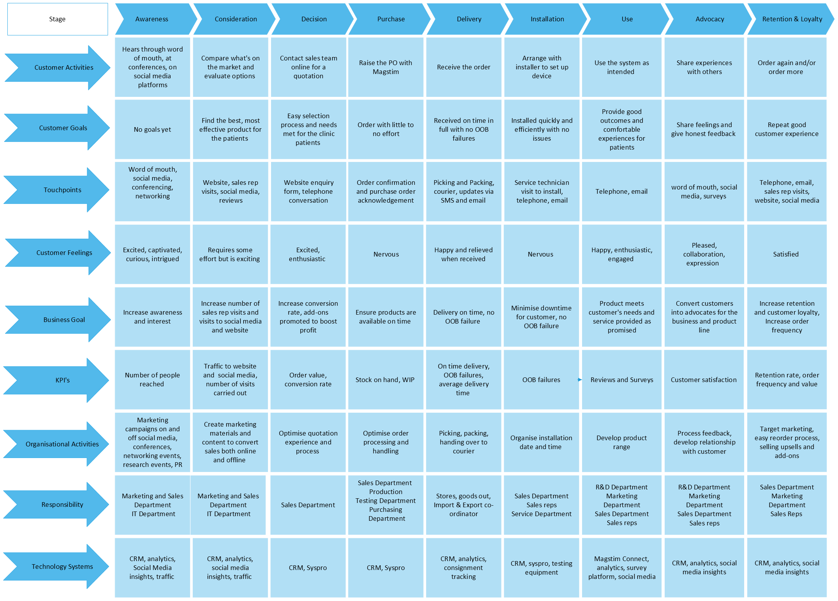

References

Bari, M. W., Abrar, M., & Alaverdov, E. (2022). Antecedents and outcomes of employee-based brand equity. Business Science Reference.
Bloom, B. S., Engelhart, M. D., Furst, E. J., Hill, W. H., & Krathwohl, D. R. (1956). Taxonomy of educational objectives : the classification of educational goals / Handbook 1 : Cognitive domain. Longman.
Buttle, F. (2009). Customer relationship management : concepts and technologies (2nd ed.). Butterworth-Heinemann.
Cerasale, M. V., & Stone, M. (2004). Business solutions on demand transform the business to deliver real customer value (1st ed.). Kogan Page.
Chatfield, T. (2018). Critical thinking : your guide to effective argument, successful analysis & independent study. Sage.
International Federation of Accountants, (. (2020). Understanding Value Creation . (2020).IAC. https://www.ifac.org/_flysystem/azure-private/publications/files/Understanding-Value-Creation_0.pdf

