Student name: Eridan Saliasi
Programme: BA Leadership and Management
Module: Design Thinking and Innovation
Module code: LCLM 6002

Assignment Title: Innovation and Customer Journey

Table of Contents
Introduction 2
Key Consumer and Industry Trends 2
Part 1: Critical Analysis and Assessment of Tesco 5
Innovation Ambition Matrix 5
Core Innovation 6
Adjacent Innovation 6
Transformational Innovation 6
Current Customer Journey Map 7
Critical analysis of Tesco’s current design thinking 8
Opportunities for Innovation 9
Part 2: Proposed Digital Strategy for Tesco 9
Overview 9
Description of the Initiative 10
Improved Consumer Journey 11
Strategic Value 12
Measurement of the Success 13
Risks and Mitigation Measures 14
Conclusion 14
Reference List 16

Introduction
With increased competition in the global market, firms are engaging in various design thinking and innovation initiatives to capitalise on new opportunities (Lockwood and Papke, 2017). It not only helps address changing consumer needs and preferences but also achieves sustainable competitive advantage in the long run. This report aims to apply two frameworks, namely, Innovation Ambition Matrix and Customer Journey Mapping, to Tesco and identify potential design thinking and innovative principles and customer journey mapping undertaken by the firm. This enables Tesco to identify new opportunities for digital innovation while recognising pain and gain points of its target customers.
Tesco PLC is a UK-based multinational grocery chain with around 27% share in the UK market. It is one of the traditional ‘big four’ supermarkets alongside Sainsbury’s, ASDA and Morrisons (Statista, 2025). As of 2025, Tesco comprises 4300 stores in the UK and the Republic of Ireland. Despite facing fierce competition, supply chain pressures during COVID-19 and high inflation, the firm has retained its top position in the UK market. Apart from Tesco’s Clubcard, ranked as the best-known loyalty program, the firm also remains a leader in technology adoption, with its online shopping starting in 1984 and a significant increase in e-commerce sales (Statista, 2025).

Key Consumer and Industry Trends
In the United Kingdom, physical supermarket visits are being replaced by online grocery shopping due to deals, time efficiency, and crowd avoidance. Since 2016, this penetration rate of online shopping among British individuals has increased significantly, thereby driving online purchase behaviour of grocery customers (Ou, 2025). The sudden demand spike in online grocery was observed during the pandemic in 2020 and 202, thereby resulting in a substantial increase in sales for Tesco and other supermarkets. In this context, Millennials demonstrate the highest eagerness towards purchasing groceries online in the UK, followed by Gen Z consumers (Watty, 2025). As a result, consumers aged between 27 and 42 years mainly comprise the online grocery market target group. As per the BBC (2020) report, in the UK, more than three-quarters of people engaged in some online grocery shopping since the outbreak of the pandemic. Along with the pandemic, the rise in technology and increased competition are also driving factors of changing consumer behaviour in the UK grocery retail market. While online grocery shopping offers improved convenience, customers still expect seamless digital experiences, thereby putting pressure on Tesco to innovate without disrupting its profit margins.
Furthermore, apart from online shopping, discount grocery shopping and cross-shopping have also emerged as new trends in the UK. For instance, 41% consumers shopped from their primary shoppers in June 2025, with around 20% market share occupied by discount shoppers (Corbin, 2025). With a rise in cross-shopping preferences, Tesco may face structural tensions while retaining customers through loyalty schemes. This increases complexities as they look forward to optimising values across different retailers.
Figure 1: Consumers’ preference towards buying local
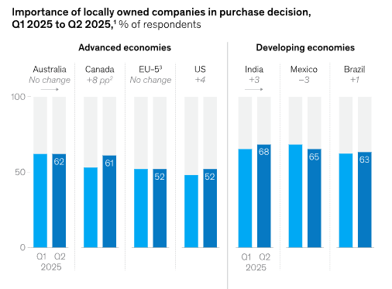
Source: McKinsey, 2025
Figure 1 illustrates that instead of buying from global, multinational brands, consumers now prefer purchasing products locally from their own markets. According to McKinsey's (2025) report, while making purchase decisions, around 47% global consumers consider locally owned companies. Besides, despite consumers remaining active over various social media platforms, their purchase decisions are influenced most by friends and family while least by these digital media (McKinsey, 2025). This increases strategic challenges for Tesco as it should balance its scale efficiencies with localisation strategies to address community-based buying behaviours.
Moreover, around 67% of grocery transactions in 2025 were made from smaller frequent shops to purchase immediate household items (Corbin, 2025). As a result, a continued decline in brand loyalty has been observed among consumers towards supermarkets. However, exceptions are evident with supermarket chains using personalised loyalty schemes and convenient multichannel experiences to retain their customers, which has resulted in maintaining 42% of their market share since 2019 (Briggs, 2025). These trends highlight that while consumer loyalty decreases, they still prefer personalised digital ecosystems, which demonstrates that loyalty may be redefined in grocery shopping.
Figure 2: Attitude Towards Grocery Shopping
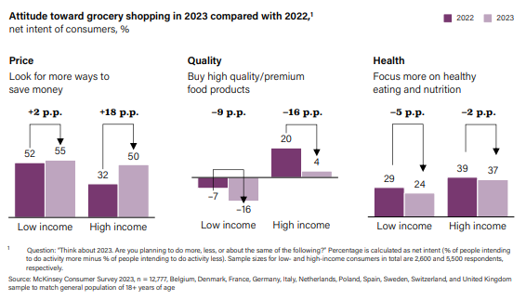
Source: McKinsey & Company, 2023
Figure 2 demonstrates how high and low-income consumers have been displaying different attitudes towards grocery items. Price, quality and health are the three top concerns for these customers, with top priority being saving money on food. While high-income consumers prefer high-quality and premium food products, low-income customers look for various ways to save money (McKinsey & Company, 2023). Moreover, there has been an increased focus on consuming healthy and nutritious products. This can make developing a value proposition difficult for Tesco, thereby forcing it to redesign its approaches by focusing on both cost sensitivity and value-based products without harming brand credibility.
PR Newswire (2024) shows that both traditional and online shopping channels are utilised in the UK grocery retail market. However, these traditional retailers such as supermarkets, department stores, hypermarkets and speciality stores are experiencing increased competition from e-commerce. To boost sales, increase customer interactions and improve shopping experiences, technologies including 3D sensor tech, IoT devices and metrics are used. Some significant trends shaping this industry are convenience, home delivery services and curbside pickup (PR Newswire, 2024). By rapidly adopting these technologies, Tesco’s focus may shift from customer needs to operational efficiency. Thus, it should adopt design thinking principles for integrating technology while enhancing customer experience.
Moreover, increased automation, artificial intelligence (AI) algorithms and supply chain disruptions have taken place to provide targeted recommendations, improve customer experience and increase efficiency. These enable supermarkets and traditional retail chains to remain competitive in the market. Similarly, McKinsey & Company (2023) shows that retailers are using analytics and generative AI across various areas, including category management, store operations, supply chain management, marketing and support functions. However, these grocery retail stores also face increased scrutiny due to data security risks and experience increased pressure for transparency and traceability in their supply chain (PR Newswire, 2024). Additionally, concerns regarding trust and privacy emerge despite data-driven personalisation enhancing engagement. Thus, Tesco must focus on balancing innovation with increased transparency and personal data use.
These trends highlight that while convenience-based and value-focused grocery channels have been displaying better performance, e-commerce and warehouse clubs emerge as the most beneficial ones. Nevertheless, UK grocery retail firms continue to face four fundamental forces or trends, which they must manage (Euromonitor, 2023). These include increasingly demanding consumers, intensifying competition, uncertain macroeconomic environment and rapid digitalisation. As a result, both small players and big firms like Tesco must engage in effective design thinking and innovative principles to strike a balance between efficiency, empathy and sustained customer value.

Part 1: Critical Analysis and Assessment of Tesco
This section presents the innovation ambition matrix and consumer journey map for Tesco

Innovation Ambition Matrix
Table 1: Innovation Ambition Matrix
Innovation Type | Strategy Focus | Tesco’s Current and Future Initiatives
Core | Increasing Customer Loyalty | Clubcard Real Time Dynamic Pricing
Adjacent | Enhancing Customer’s Convenience | Whoosh Rapid Delivery
Transformational | Transforming the Shopping Experience | GetGo Autonomous Stores
Source: Self-made

Core Innovation
As a core innovation, Clubcard pricing plays a key role in Tesco’s competitiveness compared to other food retailers. Real-time dynamic pricing based on artificial intelligence not only matches the competitors' prices but also rewards customer loyalty. For example, dynamic pricing helps Tesco compete against brands such as Aldi. Low prices on a wide range of family products also represent an advantage of Tesco’s Clubcard pricing for the customers. Over 80% of Tesco’s sales in the UK involve more than 20 million Clubcard holders who save around 390 pounds a year (Tarry, 2024). However, Tesco’s dynamic pricing is also criticised for increasing some prices under the pressure of inflation in the UK. The price of a main, snack and drink increased from 3.60 Pounds to 3.85 Pounds for Clubcard holders (Meierhans, 2025). Furthermore, the collection of personal data to analyse buying behaviour makes customers apprehensive of this system. Thus, Tesco is also losing customers due to Clubcard pricing.

Adjacent Innovation
Tesco further supports its core innovation of Clubcard pricing through the adjacent innovation of rapid delivery. E-commerce operations based on ‘Whoosh’, Tesco’s rapid delivery service is a key growth driver for the company. Rapid delivery enables Tesco to integrate physical and digital services for a seamless buying experience. This rapid delivery service is available with more than 1000 Tesco stores delivering groceries within an hour of placing the order. The service accounts for 34% of the online grocery market share (Mazidi, 2025). Convenience and speed are the two strength areas for the rapid delivery service. It also supports the Clubcard system in increasing customer loyalty for Tesco. Nonetheless, rapid delivery services, including Tesco ‘Whoosh’, Sainsbury’s ‘Chop Chop’ and Ocado ‘Zoom’, typically restrict geographical availability and are less convenient for larger orders (Urquhart et al., 2022).

Transformational Innovation
In a challenging retail environment characterised by inflation and capacity constraints, Tesco opened its first autonomous ‘GetGo’ store in East London (BBC, 2021). This is a transformational innovation that aims at customer satisfaction driven by check-free purchases. Inspired by Amazon, these autonomous stores allow customers with the Tesco app to pick up groceries without a scan. A combination of cameras and weight sensors detects the purchases and charges the customers directly through the app. The autonomous stores not only save time but also transform the buying process into a completely seamless experience. Nevertheless, a large number of supermarkets in the UK are experimenting with autonomous stores (BBC, 2021).

Current Customer Journey Map
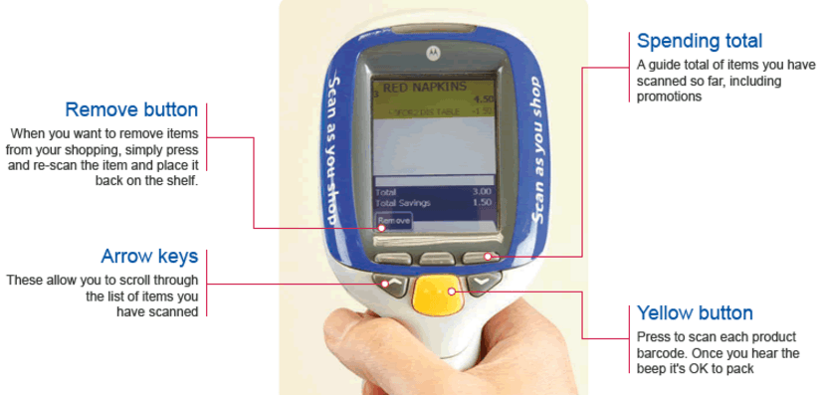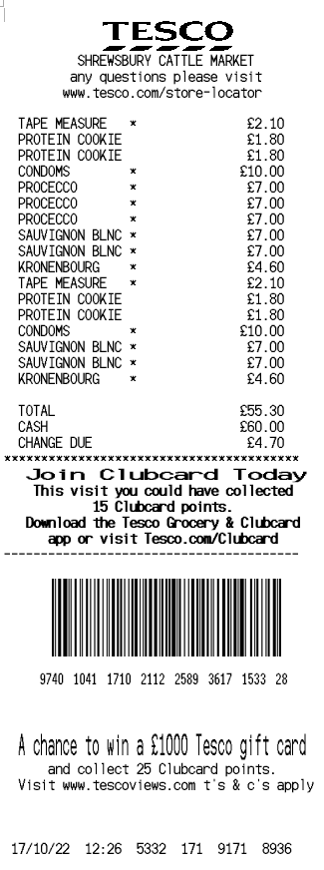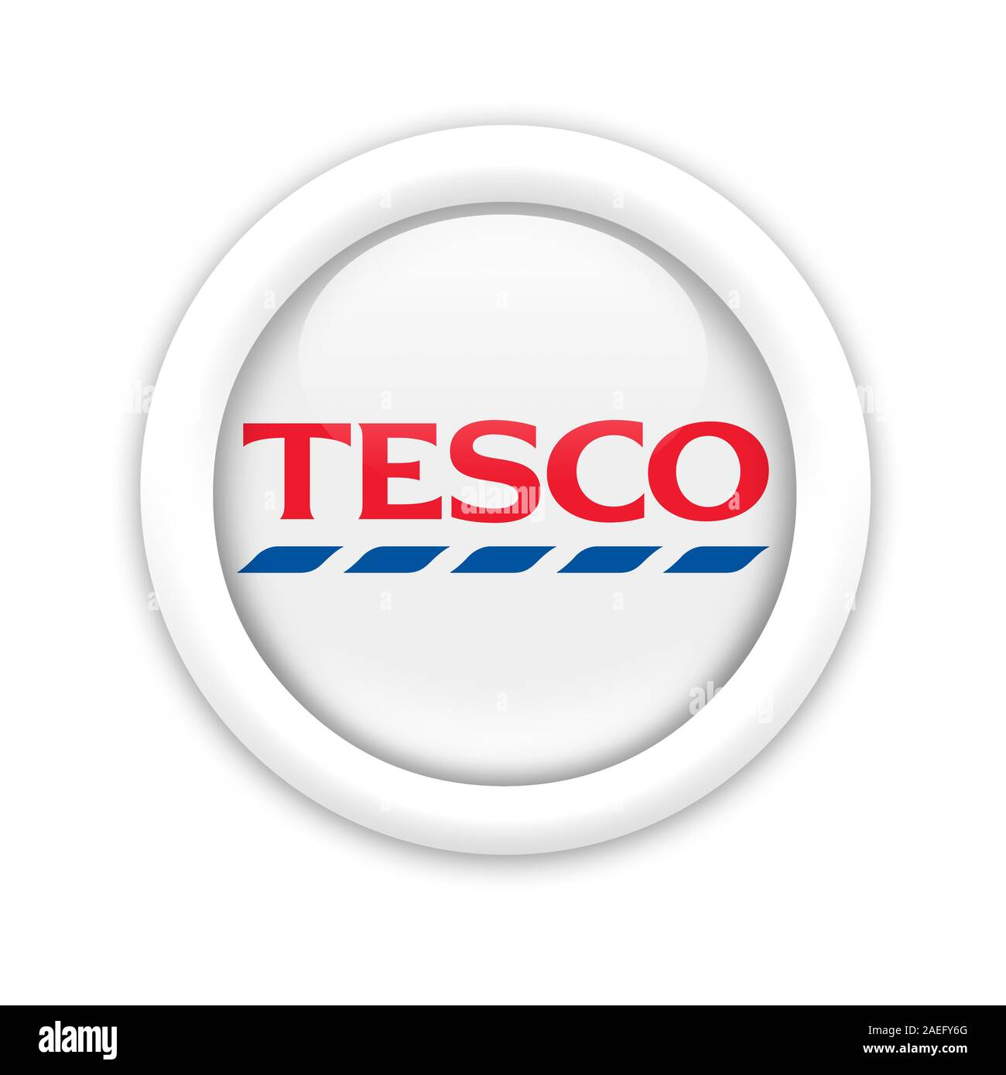
Steps
Plan
Select
Shop
Checkout
Receive
Respond
Stage
Browse Offers
Choose Products
Scan and Add
Pay
Receive Receipt
Feedback
Thoughts
“I want good deals”, “I hope Tesco knows what I buy”
“There are too many items”, “I want to find this quickly”
“This is convenient”, “I hope I do not miss discounts”
“Why is it taking time?”, “I want to avoid queues”
“Did I get the best value?”, “Where is my receipt?”
“I want to rate this”, “Feedback should be easier”
Touchpoints
Actors
Emotions

The various gain points, pain points and innovation opportunities at each stage of the consumer journey are provided in the table above. It showcases the four stages of planning, selection, checkout and post-purchase in the customer journey.

Critical analysis of Tesco’s current design thinking
The present design thinking framework of Tesco is customer-centric and values time, money and convenience (Dam and Siang, 2021). Unlike a technology-based approach, Tesco’s approach focuses on design thinking as it understands the pain and gain points of the customers of the firm. The company uses feedback loops, experimentation, and journey mapping to analyse the problems and resolve them using technology. Like, Clubcard services of the brand were introduced to enhance efficiency and reduce customer frustration. Moreover, it helped save time for the consumers and drive their perceived value. This human-centred strategy differentiates Tesco and its design thinking approach from top-down innovation measures. It aims at a seamless shopping experience which prioritises the customer’s choices and objectives. The application of advanced digital technology for personalisation reflects how Tesco has adopted a customer-centric approach aligned with operational efficiency and product planning (Fader, 2020). The brand seeks to ensure that its products sold through online portals and retail stores align with consumer needs and strategic business goals. This makes it possible to critically analyse the various touch points in the consumer journey to clearly identify pain points and gain points (Towers and Towers, 2022). The opportunities for innovation lie in overcoming the pain points and optimising the gain points. For this purpose, Tesco relies on multiple tools and techniques, including data analytics, consumer profiling, customer surveys and real-time feedback.
The Clubcard system, autonomous stores and rapid delivery services are some key examples of design thinking-driven innovation at Tesco (Azan and Karimah, 2022; Gimžūnė, 2024). Some other important aspects of this innovation ecosystem include mobile applications, personalisation, omnichannel shopping and real-time feedback. Customers can use the Tesco app to scan QR codes on multiple media, including billboards and product packages (Alexander, 2020). Such innovation not only enhances the speed and convenience of mobile purchases but also streamlines the shopping experience. Such an innovation culture is driven by participative decision-making, bottom-up communication, experimentation, empowerment and diverse perspectives (Albors-Garrigos, 2020). Tesco has further translated design thinking into strategic alignment between technological innovation, corporate objectives and consumer choices.

Opportunities for Innovation
First, there is further opportunity to leverage the potential of artificial intelligence and big data analytics for enhancing personalisation. Such personalisation primarily concerns product planning, customer recommendations and developing distribution systems (Haas and Morschett, 2023). Moreover, Tesco can improve the shopping experience by using real-time transactions and introducing unified baskets. These innovations enhance security and convenience in purchases, alongside saving customers’ time. Further digitalisation will help customers completely avoid queues and also eliminate manual errors. Similarly, the real-time conversations of chatbots with customers and instant feedback improve customer relationship management (Aarthi et al., 2020). The digital strategy recommended for Tesco in the following section capitalises on these opportunities.

Part 2: Proposed Digital Strategy for Tesco

Overview
The overall analysis of Tesco suggests that the company has encountered several challenges in the recent past like decline in consumer loyalty, inflationary pressure on customers leading to price sensitivity, and demand for personalised experience. Although the company operates effectively through the Clubcard, online, and Grocery App options, the systems operate through diverse touchpoints (Mason & Jarvis, 2023). Hence, to ensure ease in customer interface, the digital strategy proposed to Tesco is to develop a SmartShop+ initiative. This AI-powered tool would combine Clubcard data and in-store technology into the mobile application. The main objective of the digital initiative is to move from a transaction-based retailer and integrate personalisation and customer-centricity within the system. This would allow Tesco to maintain its price leadership while creating value for its offerings (Evans & Mason, 2018). The SmartShop+ strategy aligns with the main principles of feasibility, desirability, and viability. The desirability factors are addressed considering budget control, personalised offers, and hence, reducing shopping friction. Feasibility is enhanced by the digital infrastructure of Tesco. Viability is attained with financial returns, retention rate, and operational expenses. All these aspects are measurable. Framing the strategy through this triad ensures that SmartShop+ not only proposes creative solutions but is also sustainable for the brand in the long run.
Although SmartShop+ utilises tools that are essential in retail firms, its originality is based on how it structures the value proposition of Tesco. The SmartShop+ initiative positions the brand as a “shopping partner”, rather than competing in aspects of speed or price. Hence, the aim is to ensure that customers manage budgets, save time, and have diverse choices for their daily shopping needs. This tactic is contrasting with less effective digital measures in the sector that only focus on technology change rather than identifying its impact on consumer relationships.

Description of the Initiative
This platform helps Tesco improve its digital infrastructure and not replace it. The strategy would use Clubcard and AI data of the customers to generate information, and include the following components:
- Developing personalised shopping options by analysing the purchasing data of customers.
- Making recommendations to the consumers based on their budget and spending patterns.
- Dynamic pricing and promotional measures for every household.
- Suggestions to the customers while shopping in stores or by using real-time subscriptions.
This strategy would allow Tesco to identify consumers' actual needs and target them accordingly. For example, a consumer spends around £100 per week while shopping in Tesco. The AI assistant can provide suitable options to customers and help them cope with inflation.
The SmartShop+ digital initiative would integrate the grocery and Clubcard options of customers within the system. The consumers can start preparing their cart online, attain digital receipts, generate data regarding real-time spending, self-scan, or make quick visits to analyse the stocks of a store. This strategy would respond to 60% shoppers in the UK, who seek smaller and more frequent shopping options (Wade & Navarro, 2024). The platform would also integrate Clubcard members and provide them with additional discounts. Micro-segmented Clubcard offer, rewards based on the purchasing and diet patterns of customers, and rewards based on consumer behaviour would drive personalised demands of the people. For example, rather than achieving a £10 voucher on the Clubcard, the customers can receive £5 off on their most-purchased brand and £5 cashback. The platform would also help integrate ethical consumption trends, which is a priority for Tesco (Pulker et al., 2018). The application would provide details regarding the carbon footprint of each product, low-waste products, and even provide rewards to customers for making sustainable purchases. Since the younger groups, like Gen Z, are major customers of smart retailing in the UK, the application would include options like personal shopping lists, reminders, gamified challenges, and meal planning recipes (Priporas, Stylos & Fotiadis, 2017). The initiative would follow the main stages of design thinking. The firm emphasises the customer frustration and habits, defines problems like price stress, ideates using a personalised tool, prototypes through application and stores. Lastly, customer feedback is used to analyse performance. This structured process indicates the presence of a design thinking approach in the digital adoption strategies of the firm.

Improved Consumer Journey
The customer journey highlights the interaction of customers with a brand (Okeke et al., 2024). Based on the analysis, Tesco used to follow a simplified consumer journey map by providing discounts, competitive prices, and online shopping options. This allowed the company to ensure brand recognition, broaden its overall product range, and ensure flexibility for the customers. However, it led to several challenges like lack of personalisation, generic messaging options, disconnected channels, privacy issues for customers, and a lack of engagement. Also, it led to a weak emotional connection and risk of consumers shifting to competitor brands. Hence, to overcome these challenges, an enhanced customer journey map is prepared based on the SmartShop+ initiative.
Table 2: New Consumer Journey
Stage | Customer Actions | Digital Improvements | Gains
Awareness | Opening the SmartShop+ application | Offers and reminders based on AI | Promotion based on relevance. Helps overcome customer issues in repeated searching for their products.
Planning | Development of a smart shopping list | Tracking of customer preferences and budgets | Controlling costs and allowing more personalisation to customers.
Shopping Options | In-store or online shopping flexibility | Real-time spending and unified basket options | Generates convenience for customers.
Checkout | Application-based checkout options | Digital receipt and the ability to overcome any queues. | Time saving and driving customer satisfaction.
Post-purchase | Rewards, insights, and customer support | Personalised feedback options | Drives customer engagement and loyalty.
Source: Self-made
The new digital initiative is essential for Tesco to overcome pain points like a lack of personalisation, in-store queues, and the absence of follow-up or engagement. Hence, the strategy is expected to create an efficient customer experience, personal relevance, reduce friction between bands and purchases, and create emotional loyalty. All these factors create value and drive consumer loyalty.

Strategic Value
The innovative digital transformation strategy of Tesco is expected to create strategic value for the company. Initially, the strategy would drive customer retention of Clubcard members by 5%. This would help increase 20% of the overall profit margins of the company, as the brand has around 20 million Clubcard members as of 2022 (Tesco, 2022). The SmartShop+ strategy is further expected to retain 4% of the customers of the brand. However, the link between profit outcome and retention growth is not automatic. Existing research shows high retention with a rise in margins, but the impact is based on adoption rates, consumer responses, and implementation costs. SmartShop+ might encounter diminishing returns in case personalisation becomes repetitive. Also, the company can face challenges in case customers resist a data-driven targeting approach due to privacy concerns. In addition, upfront training costs and technology investments might minimise the short-term margins of the firm. Hence, the projected increase in revenue can be considered as conditional and not guaranteed (Refer to Figure 3).
Figure 3: Customer Retention
(Source: Excel Sheet)
Figure 4: Personalisation Benefits
Source: Excel Sheet
As per Figure 2, personalisation would create strategic value and lead to a 5% increase in consumer purchases. The contribution would result in an £800 contribution to revenue for the brand. Hence, minor adjustments to the costs and business strategy are expected to create a substantial effect on the revenue of the firm.
Creating perceived value for the products is more effective for Tesco than providing a blanket discount. The targeted promotional tactics would minimise waste of promotion and increase grocery shopping revenue by 10%. Also, the SmartShop+ would help create savings for the consumers through the process.
The initiative to develop digital receipts and AI-based demand can help overcome queue congestion, paper costs, and inefficiencies in stock margins. Hence, the operational costs of the firm are expected to reduce by 1%. Since the operating costs of Tesco in 2025 were £3128 million in 2025, a 1% reduction in costs would lead to savings of £3128 (Tesco, 2025).

Measurement of the Success
The success of SmartShop+ would be evaluated using specific performance indicators. These factors would allow Tesco to determine whether or not the plan devised is effective for the entity.
Table 3: Measuring the Success of SmartShop+
Customer Metrics | - Usage rate of Clubcard members increased by 10%  - Consumer retention rate increased by 3%  - NPS scores increased by 5%
Financial Metrics | - Average basket value of the customers rose by 5%  - Revenue received per consumer.  - Improvement of ROI
Digital Engagement Metrics | - Using the SmartShop feature  - Active users every month  - Digital checkout numbers
Sustainability Metrics | - Analysing the number of eco-labelled items.  - Number of carbon-aware items.  - Waste reduction through efficient forecasting
Source: Self-made

Risks and Mitigation Measures
The SmartShop+ initiative of Tesco offers financial and strategic benefits for the company. This strategy allows the firm to manage risks effectively. One major risk of facing the digital initiative is the reduction of customer trust as their privacy is affected (Bandara, Fernando & Akter, 2021). The new strategy of the firm indicates that it would rely extensively on the purchasing habits of the consumers. Therefore, while using customer data analytics, any misuse can lead to penalties as per the GDPR (General Data Protection Regulation). Hence, to overcome the risk, the company needs to use blockchain, which is an immutable digital ledger, to protect the data (Stančić & Bralić, 2021). Also, transparency in data usage, attaining consumer consent, and effective cybersecurity systems would drive trust in the platform.
Another risk affecting the company is digital exclusion. Many customers of Tesco intend on shopping in stores and are less tech-savvy. It would be difficult for the users to access the advanced SmartShop+ tool. To mitigate the risk, the company can maintain traditional check-points at stores, offer personal staff to assist the customers in stores, and offer simple tutorials on the website. This strategy would help attract the older customer groups.
An increased reliance on technology creates operational complexity for Tesco. Hence, it can lead to short-term disruptions for the company. Tesco can mitigate the problem by conducting pilot testing in selected stores in the UK. Learning from these programmes would help identify any operational constraints and adopt strategies to mitigate them.
Lastly, analysing return on investment is a concern for the company. To implement the SmartShop+ digital input, the company would need to make investments in training and technology. This would require huge costs. To ensure suitable returns, developing clear benchmarks, tracking the KPIs, and measuring the current profits against expected earnings would be effective for the firm. All these strategies would ensure the SmartShop+ technology remains sustainable and customer-centric.

Conclusion
The integration of design thinking and innovation at Tesco is targeted at market opportunities in a highly competitive UK retail sector. The analysis shows that the design thinking approach in large-scale retail firms is less about radical creativity and more involved in balancing the desirability of the customers. The case of Tesco showcases a strategic tension, which is to embed human-centred design with standardised data-driven systems. Balancing both aspects is expected to reduce reliance on the technology-led solutions. The analysis in this report shows how aligning corporate objectives and consumer choices offers a sustainable competitive advantage. The innovation opportunities indicated by these tools are the basis of the recommended digital strategy for Tesco. Categorising Tesco’s initiatives into three innovation types indicates different dimensions of its strategy. Similarly, the different touch points in the consumer journey are mapped to identify innovation opportunities. Identifying Tesco’s customer-centric approach and defining its innovation ecosystem are the key takeaways from the customer journey mapping. The company faces both challenges and opportunities, which are considered while recommending the digital strategy. The proposed strategy is based on personalised products, distribution systems and recommendations. The recommended SmartShop+ digital initiative adds new elements such as gamification to Tesco’s existing digital ecosystem. This digital strategy can be more effective in attracting younger customer cohorts, including Gen Z. Tesco’s innovation ambition matrix, alongside the current and improved journey maps, are the critical elements in the analysis.

Reference List
Aarthi, N.G., Keerthana, G., Pavithra, A. and Pavithra, K., (2020). ‘Chatbot for retail shop evaluation.’ International Journal of Computer Science and Mobile Computing, 9(3), pp.69-77. https://www.academia.edu/download/62365433/V9I3202023.pdf
Al Prince, A., Siddiqui, H.A., Lakho, M.B., Ahmad, S. and Asghar, A., (2025). ‘Leveraging artificial intelligence for hyper-personalized marketing: Opportunities and challenges in the Digital Era.’ Journal of Social Sciences, 4(3), pp.274-287. https://invergejournals.com/index.php/ijss/article/download/166/311
Albors-Garrigos, J., (2020). ‘Barriers and enablers for innovation in the retail sector: Co-innovating with the customer. A case study in grocery retailing.’ Journal of Retailing and Consumer Services, 55, p.102077. https://riunet.upv.es/bitstream/handle/10251/163754/Albors%20-%20Barriers%20and%20enablers%20for%20innovation%20in%20the%20retail%20sector%3A%20Co-innovating%20withthe%20custome....pdf
Alexander, I.N., (2020). The influence of technological innovations on organization's competitive advantage: Case study on Irish food retail company (Tesco) (Doctoral dissertation, Dublin, National College of Ireland). https://norma.ncirl.ie/4717/1/ibrahimngashangalexander.pdf
Azan, M.E.M. and Karimah, W.N., (2022). ‘The Relationship between Customer Loyalty Program and Customer Retention at Tesco.’ Research in Management of Technology and Business, 3(2), pp.174-184. https://publisher.uthm.edu.my/periodicals/index.php/rmtb/article/download/9730/2951
AZIDI, S., (2025). The Digital Shift: An Overview of the Retail and Delivery Sectors Post-COVID-19. Mazidi_Soheil.pdf
Bandara, R., Fernando, M. and Akter, S. (2021) ‘Managing consumer privacy concerns and defensive behaviours in the digital marketplace’, European Journal of Marketing, 55(1), pp.219-246. https://d1wqtxts1xzle7.cloudfront.net/97622109/343451399-libre.pdf?1674350306=&response-content-disposition=inline%3B+filename%3DManaging_consumer_privacy_concerns_and_d.pdf&Expires=1769252480&Signature=O2zhjAmyN2i1LzZv76VlUnc7MNJ-tJYDhV0i9Ekz49k0X-NL7IaOMoUbdcn1dNLNE~diETB9BrAFJQCt517X4pjI9Gf0cDkYvKTbKa7OJRKeZuq-KBA5olS~jRSZyCDiEN0Ok-uHoWsMJ8x9tQsvvvtBSQBKSSDbVex9QhxJKRpkQUODTLpNg5TYOBJ0PysYZ7Gy3tGaN~JKUA~0P19v0wcpYf8d9s-TyzR6ftyw~ZOUUF-7d40F7iPyooqbHo86snIjLWyMxWdqr-b4EPTx8EHzJ2-tLFqaBkdxVNk7XWYptwlHyX6c-yFYxBucTlW-sUNQO~VNGNSe60jDv93ACA__&Key-Pair-Id=APKAJLOHF5GGSLRBV4ZA
BBC (2020) 'Three quarters of UK does grocery shopping online'. Available at: https://www.bbc.com/news/uk-wales-53840920 (Accessed: 24 January 2026)
BBC (2021), Tesco opens its first checkout-free store, Available at: Tesco opens its first checkout-free store (Accessed: 24 January 2026)
Briggs, F. (2025) Supermarket loyalty wanes as 41% of consumers switch from main grocer, Retail Times. Available at: https://retailtimes.co.uk/supermarket-loyalty-wanes-as-41-of-consumers-switch-from-main-grocer/ (Accessed: 24 January 2026)
Corbin, T. (2025) Report shows Supermarket loyalty decline with increase in top up and cross-shopping. Available at: https://www.talkingretail.com/news/industry-news/report-shows-loyalty-decline-with-increase-in-top-up-and-cross-shopping-29-07-2025/?utm_source=chatgpt.com (Accessed: 24 January 2026)
Dam, R.F. and Siang, T.Y., (2021). What is design thinking and why is it so popular? https://eclass.aueb.gr/modules/document/file.php/MISC418/Lecture3_Reading-Design_Thinking.pdf
Euromonitor (2023) The State of Grocery Retail in 2023. Available at: https://www.euromonitor.com/the-state-of-grocery-retail-in-2023/report (Accessed: 24 January 2026)
Evans, B. and Mason, R. (2018) The lean supply chain: managing the challenge at Tesco. New York: Kogan Page Publishers.
Fader, P., (2020). Customer centricity: Focus on the right customers for strategic advantage. University of Pennsylvania Press. https://executiveeducation.wharton.upenn.edu/wp-content/uploads/2019/01/Customer-Centricity-Excerpt-2019.pdf
Gimžūnė, L., (2024). Innovative business models and startups and their impact on existing companies financial performance and evaluation in retail industry (Doctoral dissertation, Vilniaus universitetas.). https://epublications.vu.lt/object/elaba:192051493/192051493.pdf
Haas, G. and Morschett, D., (2023). Personalisation in Retail Marketing: Effects and Examples https://www.unifr.ch/intman/en/assets/public/intman/files/news/2023-07-13_HaasGuillaume_Personalisation_in_Retail_Marketing_(Master%20Thesis%20Uni%20Fribourg).pdf
Lockwood, T. and Papke, E. (2017) Innovation by design: How any organization can leverage design thinking to produce change, drive new ideas, and deliver meaningful solutions. Red Wheel/Weiser. Available at: http://103.203.175.90:81/fdScript/RootOfEBooks/E%20Book%20collection%20-%202020%20-%20A/MANAGEMENT/InnovationbyDesignHowAnyOrganizationCanLeverageDesignThinking-1.pdf (Accessed: 24 January 2026)
Mason, T. and Jarvis, S. (2023) Omnichannel retail: How to build winning stores in a digital world. New York: Kogan Page Publishers.
McKinsey & Company (2023) The State of Grocery Retail 2023 –Europe. Available at: https://www.mckinsey.com/~/media/mckinsey/industries/retail/our%20insights/state%20of%20grocery%20retail%20europe%202023/living-with-and-responding-to-uncertainty-the-state-of-grocery-retail-2023-europe_mid.pdf (Accessed: 24 January 2026)
McKinsey (2025) State of the Consumer 2025: When disruption becomes permanent. Available at: https://www.mckinsey.com/industries/consumer-packaged-goods/our-insights/state-of-consumer#/ (Accessed: 24 January 2026)
Meierhans, J. (2025), Tesco meal deal price rises to £3.85 for Clubcard holders, Available at: Tesco meal deal price rises to £3.85 for Clubcard holders (Accessed: 24 January 2026)
Okeke, N.I., Alabi, O.A., Igwe, A.N., Ofodile, O.C. and Ewim, C.P.M. (2024) ‘Customer journey mapping framework for SMEs: Enhancing customer satisfaction and business growth’, World Journal of Advanced Research and Reviews, 24(1), pp.2004-2018. https://www.researchgate.net/profile/Olufunke-Alabi/publication/389680208_Corresponding_author_Nnenna_Ijeoma_Okeke_Customer_journey_mapping_framework_for_SMES_Enhancing_customer_satisfaction_and_business_growth/links/67ccb8a6d7597000650725cc/Corresponding-author-Nnenna-Ijeoma-Okeke-Customer-journey-mapping-framework-for-SMES-Enhancing-customer-satisfaction-and-business-growth.pdf
Ou, X. (2025) Online grocery shopping in the United Kingdom (UK) - statistics and facts, Statista. Available at: https://www.statista.com/topics/3144/online-grocery-shopping-in-the-united-kingdom/?srsltid=AfmBOookrpVELxH88zzH7U4Sf8QT50_jOs0jyRcp_tp27AL8yeoj_pd-#topicOverview (Accessed: 24 January 2026)
PR Newswire (2024) Grocery Retail Market In UK size is set to grow by USD 44.8 billion from 2024-2028, rapid urbanization and rising consumer spending to boost the revenue- Technavio. Available at: https://www.prnewswire.com/news-releases/grocery-retail-market-in-uk-size-is-set-to-grow-by-usd-44-8-billion-from-2024-2028--rapid-urbanization-and-rising-consumer-spending-to-boost-the-revenue--technavio-302314959.html (Accessed: 24 January 2026)
Priporas, C.V., Stylos, N. and Fotiadis, A.K. (2017) ‘Generation Z consumers' expectations of interactions in smart retailing: A future agenda’, Computers in human behavior, 77, pp.374-381. https://www.sciencedirect.com/science/article/pii/S0747563217300729
Pulker, C.E., Trapp, G.S., Scott, J.A. and Pollard, C.M. (2018) ‘Global supermarkets’ corporate social responsibility commitments to public health: a content analysis’, Globalization and health, 14(1), p.121. https://link.springer.com/content/pdf/10.1186/s12992-018-0440-z.pdf
Stančić, H. and Bralić, V. (2021) ‘Digital archives relying on blockchain: overcoming the limitations of data immutability’, Computers, 10(8), p.91. https://www.mdpi.com/2073-431X/10/8/91
Statista (2025) Tesco PLC - statistics & facts. Available at: https://www.statista.com/topics/3807/tesco-plc/?srsltid=AfmBOorXg3hbUGw8rjxGqIf6iyjMvdfhcOIKn3gbi5-imJ4VKGMRteFF#topicOverview (Accessed: 24 January 2026)
Tarry, J. (2024), Making Clubcard Prices even clearer for customers, Available at: Making Clubcard Prices even clearer for customers (Accessed: 24 January 2026)
Tesco. (2022) Tesco Bank launches innovative new way to shop for 20 million Clubcard members, available at: https://bank.tescoplc.com/news/2022/tesco-bank-launches-innovative-new-way-to-shop-for-20-million-clubcard-members/ (Accessed 24 January 2026).
Tesco. (2025) Annual Report, available at: https://www.tescoplc.com/media/ky0bfwpo/tesco_ar25_interactive.pdf (Accessed 24 January 2026).
Towers, A. and Towers, N., (2022). ‘Framing the customer journey: touch point categories and decision-making process stages.’ International Journal of Retail and Distribution Management, 50(3), pp.317-341. https://www.emerald.com/ijrdm/article-pdf/50/3/317/1081992/ijrdm-08-2020-0296.pdf
Urquhart, R., Newing, A., Hood, N. and Heppenstall, A. (2022). ‘Last-mile capacity constraints in online grocery fulfilment in Great Britain.’ Journal of Theoretical and Applied Electronic Commerce Research, 17(2), pp.636-651. jtaer-17-00033.pdf
Wade, B. and Navarro, A. (2024) UK Consumers Worry About the Economy and Spending, available at: https://www.bcg.com/publications/2024/uk-consumers-worry-about-the-economy-and-spending (Accessed 24 January 2026).
Watty, F. (2025) Share of shoppers buying groceries online in the UK 2023, by generation, Statista. Available at: https://www.statista.com/statistics/1307070/online-grocery-shoppers-by-generation-united-kingdom/ (Accessed: 24 January 2026)

