Executive summary

This report provides an analysis and evaluation of innovation which took place in The Guild of Property Professionals. Methods of analysis are based on the knowledge from literature and relevant articles. All important analysis models can be found in the appendices. Results of data analysed show that the company used an innovative service during Covid 19 pandemic to enhance buyers to buy properties. Recommendations discussed include ideas for a new development in the future.

1.0 Introduction

The spread of the coronavirus pandemic around the world is pushing companies to develop new ideas to stay competitive on the market. During the first lockdown in March 2020 estate agents were forced to close their premises and only essential house moves were allowed to be realized. The companies had to turn into innovative ways to enable potential buyers to view properties. A London Estate Agent called “The Guild of Property Professionals” decided to improve their services and started to offer digital house viewing for its customers. The high demand on the house market in the coronavirus outbreak pushed companies to adapt to existing conditions. The company has noticed that many people avoid putting their homes up for sale because of the visitors. On 1 april 2020 the company launched an innovative method of viewing properties through a virtual tour (Guild Property, 2021).
In the current world everything is changing fast and unpredictability makes that the world will not be the same in the next few years because everything changes in the blink of an eye. Therefore, if businesses would like to follow the world then the necessary requirements are creativity and innovation. Creativity is related to 'imagination' but innovation is related to 'implementation'. Creativity has a significant impact on the success of a company in times of crisis, which makes companies open to solve the problems quickly and effectively (Felber, 2020). The main difference between creativity and innovation is that the creativity refers to a new idea or plan, while the innovation means introducing something new to the market that has not been introduced before. Innovation is closely related to creativity. Applying creative ideas into action is an innovation whose consequences should be positive. It is the process of doing something better for the first time, which no individual has done before (Business Insider, 2013). Richard Branson, the successful British entrepreneur said once that “business opportunities are like buses, there's always another one coming”.

2.1 Internal Analysis

The Guild of Property Professionals introduced an innovative system that allows users to share videos on social media, by email and other digital platforms. Thanks to that people are able to view properties instantly with comfort and safety measures from their own home or from anywhere in the world. Augmented reality shows a 3D content of actual home surroundings, while VR fully puts the person into a virtual world. Thanks to the professional Virtual Reality headset, potential buyers are transported into a 360-degree view of desired property. This kind of development increases visibility of individual listings and allows potential buyers to easily view the property. It also saves important time and helps to serve all needs for parties involved (Le guay ,2019). Thanks to the innovative way of providing services to people, buyers and sellers who are aware of contact with other people because of Covid-19, now will be able to view or offer the property in detail online. This will create a group of people who might be more interested in the property and avoid the group of people who will not see the property as their future home. Thanks to that sellers will be not disrupted by too many viewings and buyers will be able to clearly see all details that the property might offer. On the other hand buyers and sellers who do not use the internet might be left out and definitely viewing properties in reality brings more experience to potential buyers. Another weakness is the fact that sellers might lose the opportunity to sell the property in situations when the buyer will decide to buy the property after online viewing and then realize that the property is not suitable for him/her (Maunder, 2020).
The property market was closed during the first lockdown. Thanks to the innovative way of digital house viewing, the property market might be open even in case of Covid-19 outbreak. This gives the opportunity to keep the sales on the same level as before the pandemic and even increase the sales because of high demand for new homes from remote working buyers. The unemployment rate in the UK at the moment is 4.9% and increased from the time the pandemic has begun (King, 2021). Virtual house viewing might create new jobs for digital workers who will be responsible for advertising and also for protecting users from fraudulent activities. This will also have an impact on society transformation due to world digitalization.

2.2 Type of innovation

According to Davilia (2012) there are four different types of innovation:

- Technological innovation
- Business model innovation
- Incremental innovation
- Radical innovation

To categorize innovations it might be helpful to classify them into two different dimensions: the market where it operates and the technology which it uses. The innovation matrix is a useful tool to describe and visualize the most popular types of innovation (Kylliäinen, 2019).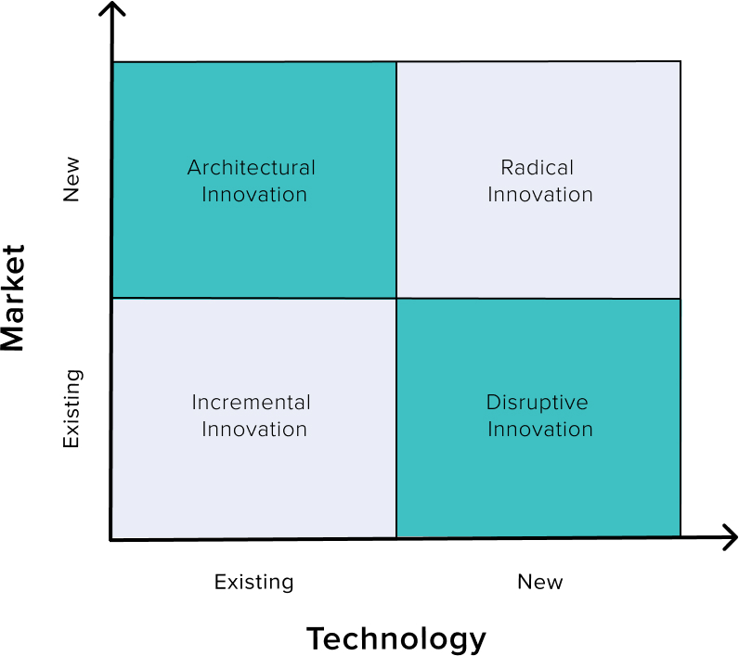

The most common type of innovation is an incremental innovation which is continuous improvement of existing concepts, products and services in the market which already exists. In overall these non expensive improvements might help to differentiate the company from its competitors. This kind of innovation is the most accessible form of innovation and it could be applied without requiring reorientation of the company’s strategy (Hough, 2020).
The continuous demand from customers that place on businesses to receive new products results in more than 30 000 products and services released every year. According to professor Christansen around 95% of these products fail to adapt into the market (Carleton, 2019).
Many estate agents have implemented virtual house viewing into the existing market (online property market) and existing technology (virtual reality headset tours) which makes it an incremental innovation. According to analysis of Rightmove listings there is a significant increase of virtual house viewing options in the portal. Between November 2019 and May 2020 the total number of lettings with virtual viewings increased by 180% when the number of videos increased by 280% in the same period. The lockdown has forced estate agents to provide new services and become creative and innovative in the letting zone to stay competitive on the market (Norwood, 2020). The most innovative VR technology might be helpful for real estate agents to grow their businesses, get more customers and provide top level services. According to a survey made by the National Association of Realtors around 95% of home buyers look for the property on the internet and 71% of millennials are happy to use VR headset (Gleb, 2020). This low cost incremental innovation could be an important tool to increase website visits and thus better promotion for the company that uses this technique.
2.3.1 Open and Closed Innovation

Innovation and creativity are crucial factors for the company that want to survive on the market. The innovation might be divided into two different types of innovations:

- Open innovation
- Closed innovation

The main difference between both innovations is based on the process where the innovation comes from. Businesses that develop innovations in a self-contained environment are closed ones while the companies that use external knowledge ideas for their innovative system are open ones. Generally the closed innovations take place inside the company. Every step from creative initial ideas to innovative new products remains under the company control. This older type of model still works well for many companies existing on the market currently.
Open innovations are continuously growing especially with the progres of new technologies and theories. It is based on wisdom from sources not belonging to the company and this might allow improvements and developments in a business innovative structure (Kleber, 2019).
The Guild of Property Professionals - London Estate Company in case of VR tours has been using the open innovation process. The company does not produce and does not provide VR Headsets and the whole technology comes from different manufacturers. Thanks to the technology estate agents are able to provide sophisticated tours that were not existing in the past (GPEA, 2019).

2.3.2 The Innovation Process

According to Joe Tidd and Jon Bessant there are four stages in the innovation process:

- Recognising the opportunity
- Finding the resources
- Developing the idea
- Capturing value (Tidd, Bessant, 2018)

The Guild of Property Professionals innovation process:

- The Estate Agent noticed the opportunity to grow in the technology sector to provide best services to its customers and to become open during the Covid 19 outbreak. For the company it is important to keep the sales on the high level and to be attractive for its new and existing customers.
- VR headsets are available in the UK and many people can afford this technological gadget. The internet website existed already when the pandemic began.
- The company had to implement virtual tours into the website. They need to arrange video tours from the properties that are ready for sale or rent. Additionally the company offers to send videos by customers.
- The company stays competitive on the market and might allow potential buyers to view properties without difficulties caused by Covid 19 pandemic. Also it saves important time and reduces contact with other people. Virtual viewing will not replace viewing in reality forever but it is an additional tool to meet the expectations from customers.

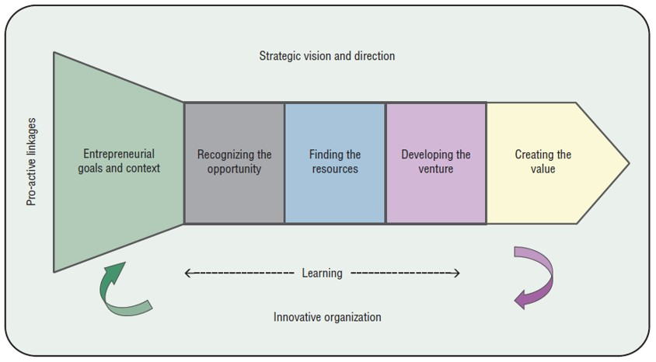

2.3.3 4P’s to Innovation

Innovation could be a wide range of different forms but this number might be reduced to four directions of change:

- Product/service innovation - it is a change for the products or services that the company offers to the market.
- Process innovation - it is a change in the ways how they are delivered and created
- Position innovation - it is a change in the context of how the product or service is introduced
- Paradigm innovation - it is a change of underlying mental models which shows what the company is doing. Completely radical way of doing something and it could be anything (Bessant, 2014).

Product or service innovation could be an idea that shows absolutely new methods or is original and advanced. Therefore, this kind of innovation could be applied when the product has been improved or there is an invention of completely new and different product or service. Technology progress might be a reason for small changes in the product and even material improvement could be called an innovation (Brown, 2013).
In the case of Estate Agent the VR house viewings are a new and also developed product that already existed on the market. Virtual house viewing was available before. Videos were uploaded by companies and individuals before. The VR tours are something new in the growing industry and the product has been accepted by the environment.

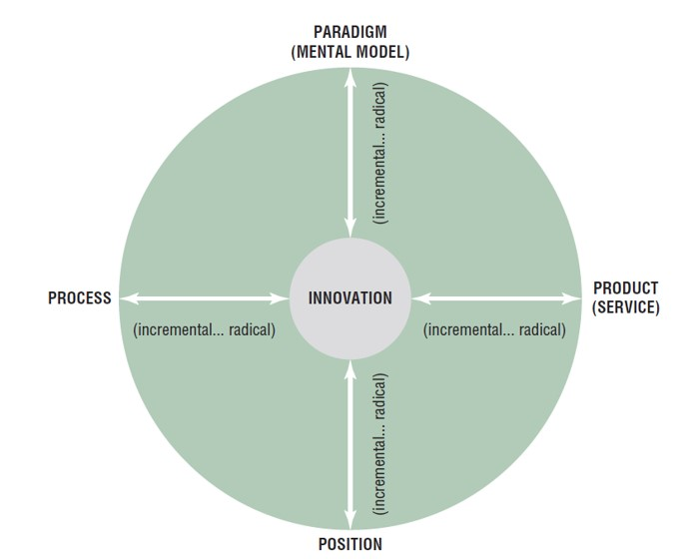

2.4 Assessment of the Effectiveness 300

Force Field Analysis was introduced by social psychologist Kurt Lewin in 1940. The analysis is widely used in business environment for making important decisions in the company (MindTools, 2020)
The analysis is a useful tool to analyse the future decisions of the company. To be an effective tool it has to show that forces that resting change are weaker than forces to change (Lucidity, 2021).
During the Covid 19 outbreak people were interested in buying properties due to change of their daily lives. People work from home much more than ever and would like to change their houses into larger ones (BBC, 2020). Potential buyers would like to view properties even during lockdown when the businesses had to close their premises. Virtual house viewings are a great addition in business but it might be a barrier for some of the potential buyers due to lack of technological knowledge. Many people are afraid to contact other people because of Covid 19 infection spreading and VR tours might be a great tool where potential buyers will be able to view the property from any place in the world. On the other hand, lack of contact with salesmen at the first sight may lead to abandoning the idea of buying property because of misinformation about the property. This is why Estate Agents decided to not replace personal viewings which are more valuable for the potential buyer but only add an extra service of VR tour to their portfolio. Thanks to the high quality 3D images the customer might imagine and understand the property better than from normal photos. This kind of photos have to be done in different than usual ways and it could be a barrier for staff to take advanced pictures of properties. Therefore, it also creates an opportunity to take advantage over the competitors on the market which leads to higher website viewings and better promotion (GPEA, 2019). This finally leads to increased sales.

2.4.1 Barriers and Risks

- Technological barriers for some of the potential buyers - the older generations might have the problem to use new gadgets
- Lack of contact at first sight - the potential buyer might have a question about the property where real estate agent could be advisable
- Viewing in person gives better experience - VR tours will not replace viewings in person. Not many customers will take a risk and buy a property after an online viewing
- Every property needs specially created photos which could be a barrier for staff - the property needs new pictures that show the 3D illustration of the property. Advanced pictures might be too difficult to take by estate agents.
- It is more time consuming to create VR listings than use of normal photos - making a normal photos is less time consuming what makes them cheaper to be done.
- Lower payments for estate agents - in case of replacing personal viewings by virtual tours, agents might expect lower earnings due to sales made by online viewing. This will be caused by lower commissions from sales (Archistar, 2020).

3.0 Conclusion

The innovative idea of virtual house viewing is a good addition to services provided by estate agents. High quality 3D pictures are more practical for the potential buyer than regular photos of the property. The analysis of the business environment shows that people despite the pandemic are still looking for new properties and creative and innovative tools provided by estate agents are helpful for better organization of systems. The fact that people are afraid to visit other people makes virtual viewing very popular in recent months but one thing is for sure, online viewing is only an enhanced addition to personal viewing in the property. The innovation models show that the company uses open innovation thanks to the technology provided by manufacturers around the world. With the VR technology, customers will be able to visit properties from any place and at any time they would like to. This kind of service innovation was available before as video viewings but now improved products make it more valuable for potential buyers.

4.0 Recommendation

- Going step forward with virtual tours the company may introduce haptic and kinaesthetic communication to VR
- The latest technology might allow people to feel the sense of touch and see their own hands in virtual world
- The potential buyers might be able to open the doors, cupboards and interact with surrounding environment when viewing virtual property
- Further developments might introduce new feelings such as smell or taste
- Investment in this development sector will be an important factor to achieve competitive advantage on the market

References

GPEA, (2020) Digital House Viewings. Available at: www.guildproperty.co.uk [Accessed: 10.04.21]
Felber, J. (2020) The Importance Of Creativity In Business. Available at: www.forbes.com [Accessed: 10.04.21]
Business Insider, (2013) There's A Critical Difference Between Creativity And Innovation. Available at: www.businessinsider.com [Accessed: 10.04.21]
Le guay, B. (2019) The power of virtual reality tours in real estate. Available at: www.meero.com [Accessed: 10.04.21]
Maunder, S. (2020) Should you buy or rent a house based on a virtual viewing? Available at: www.which.co.uk [Accessed: 10.04.21]
King, B. (2021) Unemployment rate: How many people are out of work? Available at: www.bbc.co.uk [Accessed: 10.04.21]
Kylliäinen, J. (2019) Types of Innovation – The Ultimate Guide with Definitions and Examples. Available at: www.viima.com [Accessed: 10.04.21]
Hough, C. (2020) 14 Different Types Of Innovation: Why One Size Doesn’t Fit All. Available at: https://ideadrop.co/ [Accessed on: 10.04.21]
Carleton, S. (2019) What is Incremental Innovation? Available at: www.northeastern.edu [Accessed: 10.04.21]
Gleb, B. (2020) Five Innovative Ways You Can Use Virtual Reality in the Real Estate Business. Available at: https://rubygarage.org/ [Accessed: 10.04.21]
Kleber, (2019) Open and Closed Innovation: what are the differences? Available at: www.mjvinnovation.com [Accessed: 10.04.21]
GPEA, (2019) How Virtual Reality is changing the property sector. Available at: www.guildproperty.co.uk [Accessed: 10.04.21]
Bessant, J. Tidd, J. (2018) Managing Innovation: Integrating Technological, Market and Organizational Change, 6th Edition. Available at: https://books.google.co.uk/ [Accessed: 10.04.21]
Brown, S. (2013), Strategic Operations Management, Routledge. Available at: https://books.google.co.uk/ [Accessed: 10.04.21]
Bessant, J. (2018) 4P’s Innovation Strategy Framework. Available at: www.innovation-portal.info/ [Accessed:10.04.21]
MindTools, (2020) Force Field Analysis. Available at: www.mindtools.com [Accessed: 10.04.21]
Lucidity, (2020) Introduction to Force Field Analysis. Available at: https://getlucidity.com/ [Accessed: 10.04.21]
BBC, (2020) Covid-19: Working from home leads to house price rise in Wales. Available at: www.bbc.co.uk [Accessed: 10.04.21]
Archistar, (2020) Four Major Issues that VR May Create in the Property Development Sector. Available at: https://academy.archistar.ai/ [Accessed: 10.04.21]

Appendices

Strengths:  - Reduced contact with other people  - Buyers restricted by time will be able to view properties online and avoid properties that they do not like.  - Build a first impression of the property  - Sellers will not be disrupted by too many viewings  - Buyers will be able to clearly see all options  - Building a popularity of an advert  - Many buyers are looking for new home due to pandemic and remote working jobs | Weaknesses:  - Buyers and sellers who do not use internet might be left out  - Real viewing brings more experience  - Buyers could make an offer to buy after online viewing might be disappointed  - Sellers might lose the opportunity for sale by bad decision made by online buyer
Opportunities:  - The property market can be open even in a pandemic situation.  - Market sales might stay on the same level  - Creates a new digital job opportunities  - World digitalization | Threats:  - Online cyber attacks  - Issues with the connection to the network

New VR house viewings offered by Estate Agent

Forces for change:
- Customers would like to view properties even during pandemic - 4
- Reduced contact with other people - 3
- Buyers expect easier access in property viewings - 2
- VR tour offers more realistic view of property than images - 4
- Technological advance over competitors - 3
Forces resisting change:

- Technological barrier for some of the potential buyers - 2
- Lack of contact at first sight - 2
- Viewing in person gives better experience - 4
- Every property needs specially created photos which could be barrier for staff - 3
- It is more time consuming to take create VR listing than use of normal photos - 2

