
Programme: Master of Business Administration
Module: International Marketing: Principles and Practices
Module code: LCMB7026
Assignment Title: Assessment component 1: Individual report
Lecturer : Dain Mayasari
Topic: International Market Entry Strategy and Marketing Mix of KFC in India and the UK
Student Name : Pratikkumar Jagdishbhai Kevadiya
Student ID : 2435897
Word Count: 5322
Table of Contents
Section 1: Report on the International Market Entry Strategy and Marketing Mix 3
1.1 Introduction 3
1.2 A comparative analysis of the market in India and the UK 3
1.3 A comparative analysis of STP and Marketing Mix 11
1.3.1 STP Analysis 11
1.3.2 Marketing Mix (7P) 16
1.4 An analysis of the brand’s directional development strategies in India 21
1.5 Ethical issues related to this brand’s marketing mix in India and the UK 23
1.6 Recommendations on International Marketing Strategies 24
1.7 Conclusion 26
Section 2: Reflective Account 27
2.1 Description 27
2.2 Feelings 28
2.3 Evaluation 28
2.4 Analysis 29
2.5 Conclusion 29
2.6 Action Plan 30
Reference list 31

Section 1: Report on the International Market Entry Strategy and Marketing Mix

1.1 Introduction
This report compares the international market entry strategy and marketing mix of KFC both in India and the United Kingdom, which have different economic, cultural, and regulatory environment. The study assesses KFC adaptation of its strategies to the local conditions, using frameworks of PESTEL, STP, the 7Ps marketing mix and the Ansoff Matrix. The report also discusses the ethical issues and gives strategic recommendations that can contribute to sustainable international growth.

1.2 A comparative analysis of the market in India and the UK
PESTLE Analysis
Political Factors
India
The political environment in India is dictated by a federal system that has the central and state governments as stakeholders in the regulations of the quick-service restaurants such as KFC. Indirect taxation inside the states was also made easy through policies like the goods and services tax (GST) that made it difficult to have cost complexity among food chains (Sureka and Bordoloi, 2025). KFC may be able to leverage favourable FDI policies to accelerate expansion in high-growth urban markets. Furthermore, simplified GST structures are helpful for better cost control and pricing efficiency, supporting competitive positioning.
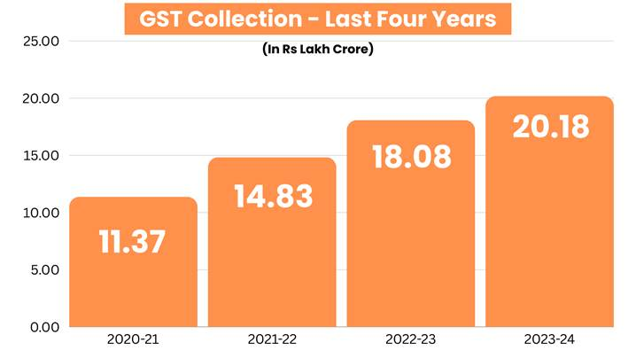
Figure 1: GST collection in India
(Source: pib.gov.in. 2024)
United Kingdom
The UK has a secure political stability (0.24 in 2024) that is supported by good legal factors and clear business legislation. Food importation standards, labour mobility regulations have changed after the Brexit trade policies (TheGlobalEconomy.com. 2024). KFC may be able to capitalise on the UK’s stable political environment to make long-term investment and expansion decisions with lower risk. Additionally, adapting to post-Brexit regulations and leveraging government support programmes may be helpful for operational efficiency.
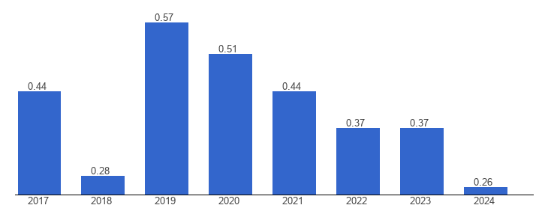
Figure 2: Political stability in UK
(Source: TheGlobalEconomy.com. 2024)
Comparative Evaluation
The political support of foreign brands is also provided in both countries, but the UK has a relatively predictable and consistent regulatory environment throughout the country, which reduces the risk of conducting business. The regional policy variations in India make it complex yet provide state level incentives that might be useful to expansion.
Economic Factors
India
India is an emerging major economy in the world and the GDP growth rate (6.5% in 2024-25) is usually more than 6 percent per year which is due to the growing middle-class income and urbanisation (pib.gov.in. 2025). The Indian QSR market has experienced high growth by double figures with the growth in disposable incomes causing an increase in the frequency of eating out.
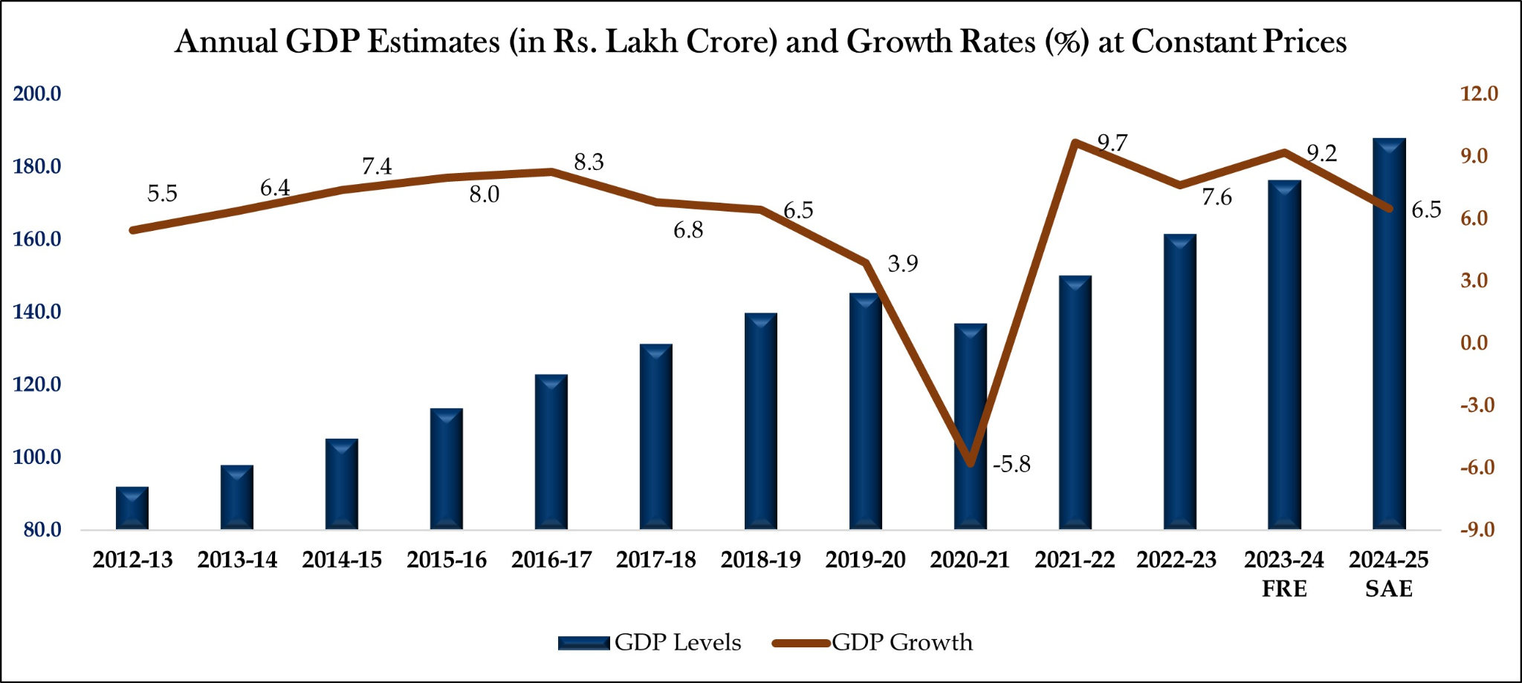
Figure 3: India GDP growth rate
(Source: pib.gov.in. 2025)
United Kingdom
The UK is a developed economy that experiences slower growth rates in its GDP (5.069% in July 2025), average inflation and per-capita income is high (ceicdata.com. 2025). Demand in the form of consumer spending on eating out and takeaways has not declined and the UK market in the fried chicken and poultry sector is worth billions (annually, 3 bn +) of pounds (Roe et al., 2024). KFC may be able to utilise strong consumer spending by maintaining premium pricing while offering targeted promotions to attract cost-conscious customers. Furthermore, stable demand in the food service sector supports continued expansion and revenue growth in the UK market.
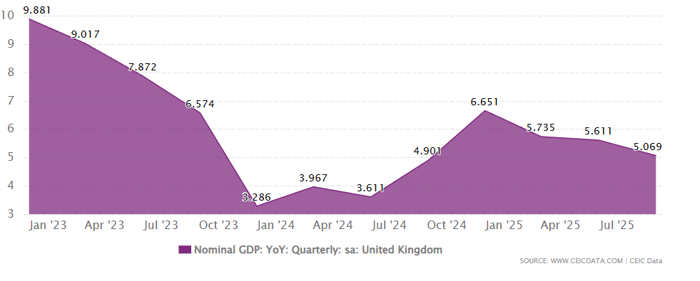
Figure 4: GDP growth rate in UK
(Source: ceicdata.com. 2025)
Comparative Evaluation
The Indian market has potentials of high growth and volumes of markets because of the large population and increasing incomes but the average purchasing power is low thus necessitating competitive pricing and value-oriented products. The UK, which has greater disposable levels per consumer, tolerates higher prices and greater average value of sales, but growth is lower.
Social Factors
India
The population of India is young, the median age is less than 30 years, and the population is quickly becoming urbanised. Modification of lifestyles and exposure to the global food cultures have stimulated the rise of demand of Western QSR brands (Kumar, Kulkarni and Rathi, 2022). Nonetheless, the tastes of people are varied, and dietary habits affect the menu modification of vegetarianism and regional taste frequencies are particularly common in many outlets with the focus on the vegetarian menu and no-beef/special spice characterization.
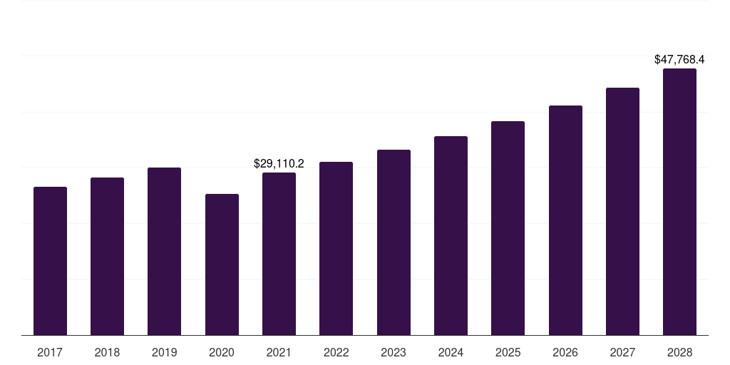
Figure 5: Revenue in India fast food market
(Source: grandviewresearch.com. 2026)
United Kingdom
The UK consumers are very keen on convenience and quality with a big proportion of food being eaten out or ordered electronically (Keeble, Adams and Burgoine, 2022). There is a focus on social trends on health considerations, ethical sourcing, and dietary variety (e.g. plant-based options). KFC can respond by expanding healthier and plant-based menu options (Kumar, Kulkarni and Rathi, 2022). Additionally, emphasising ethical sourcing as well as convenience through digital platforms can strengthen brand loyalty and competitiveness.
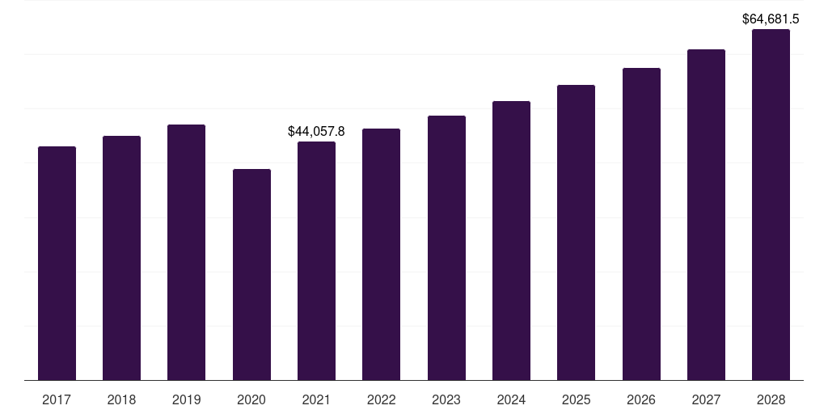
Figure 6: Revenue in UK fast food market
(Source: grandviewresearch.com. 2026)
Comparative Evaluation
Social distinctions are also marked: Indian shoppers are very price-sensitive and culturally varied, and it is necessary to localise their menu dramatically. The UK customers are highly focused on convenience, quality and ethical factors, as opposed to price sensitivity, as is the case in India.
Technological Factors
India
The use of technology in the QSR segment of India has been on the rampage with the millions of people placing orders through mobile applications and online services (John, 2023). KFC India pushes its sales using digital menus, mobile payment, and collaboration with food delivery applications.
United Kingdom
The UK QSR sector is very digital, and it has embraced online ordering, online payment features, customer loyalty applications, and artificial intelligence to tailor to customer needs using analytics (Alt, 2021). Multiplexing with different platforms and high-end point of sale systems help overcome effective operations and access to the customers.
Comparative Evaluation
The UK is more integrated in both operational and customer touchpoints compared to the UK, which is actively pursuing technology. India is also fast-paced, notably in online ordering and payments due to intense smartphone penetration and increasing internet penetration.
Environmental Factors
India
Indian consumers are becoming extremely environmentally conscious in the urban centres. It has been driven by the bans on single-use plastics, waste management requirements as well as policies that have compelled KFC India to implement eco-friendly packages along with recycling plans in most of its stores.
United Kingdom
In the UK, brand perception is greatly motivated by environmental sustainability. Consumers also demand recyclable packaging, reduced carbon footprint along with responsible sourcing (Norton et al., 2023).
Comparative Evaluation
In the UK, environmental expectations are deeper rooted and sustainability may have a significant impact on purchasing behaviour. The environmental concern of India is increasing however still it is second to convenience and price among various consumers.
Legal Factors
India
The laws concerning food safety and standards in India demand adherence to the national laws and inspection by the state authorities (Aswal, 2020). Franchise agreements and labour regulations differ, which needs close legal control.
United Kingdom
The UK has strict food safety, employment and labelling laws and adherence is in order and well monitored and violations attract big fines (Evans and Taylor, 2021).
Comparative Evaluation
The legal structure of the UK is more enforced and standardised at the national level whereas in India, legal compliance involves going around both the national and state laws.
Overall Strategic Implications
KFC can take advantage of the political stability and favorable policies towards FDI in both countries and expand operations while complying with the dynamic legal environment in these countries (Norton et al., 2023). Economically, the organization can adopt dynamic pricing strategies to cater to the varying income levels in these countries. Socially, the organization has to align itself with the taste, health, and ethical concerns of the people in these countries (Alt, 2021). Technology-wise, the organization has to invest in technology to increase consumer engagement. In terms of the environment, the organization has to prioritize green packaging and green supply chain practices, as these are becoming the norm. Legally, the organization has to be very careful in complying with food safety and employment regulations.

1.3 A comparative analysis of STP and Marketing Mix

1.3.1 STP Analysis
Segmentation
India
The market segmentation of KFC India is based on demographic, geographic, psychographic as well as behavioural segmentation. Based on demographic segment, KFC focuses on the young consumers between 18 and 35 years old, students, young professionals along with urban families (Batta, 2025). Physically, the distribution of outlets is based on Tier-1 (Mumbai, Delhi, Bangaluru) and Tier-2 cities (Jaipur, Lucknow, Chandigarh), which are urbanised and most exposed to Western foods. KFC divides psychographically consumers who are seeking convenience, affordability, and aspirational international brands. The price and frequency of consumption is used to divide the behaviour of the Indian consumers with a significant number of consumers favouring value meals and discounts.
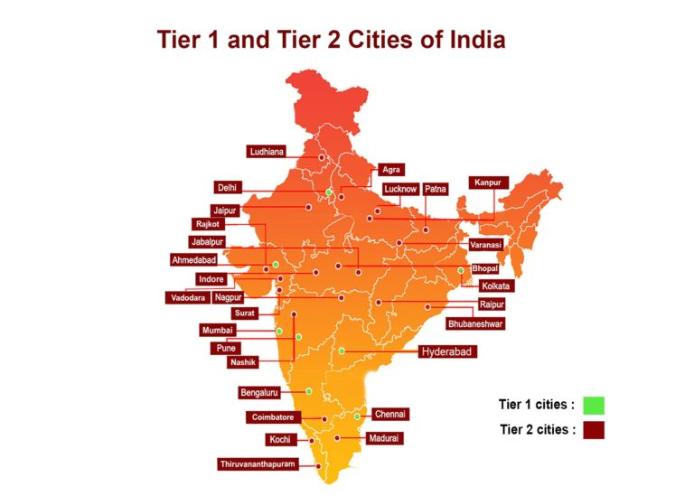
Figure 7: Tier 1 and 23 cities in India
(Source: propertypistol.com. 2024)
United Kingdom
The market in the UK has been segmented by KFC to a large extent based on the lifestyle, income level, and consumption behaviour. The working adults and families between 20 and 45 years are the major demographic segment. KFC operates on a nationwide basis, both in the suburbs and in the high-streets (statista.com. 2025). Psychographic segmentation is centred on consumers who want convenience, indulgence and comfort food which is mostly related to a busy lifestyle.
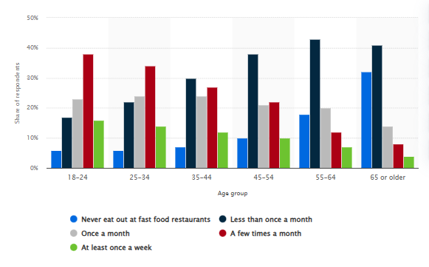
Figure 8: Age group percentage in quick service restaurant in UK
(Source: statista.com. 2025)
Comparative Evaluation
Although both markets are based on multi-variable segmentation, India is more price sensitive and urban youth oriented, where the UK orientation is based on the convenience of lifestyle and the consumption of habit. India is a diverse segment in terms of economic diversity and cultural food habits, whereas the UK is a mature fast-food culture, maintaining constant consumption habits.
Targeting
India
In India, KFC has a selective approach to targeting where it focuses on middle-income and upper-middle-income consumers of the urban population (Bankole et al., 2023). The brand aims to attract young adults and students, who are more inclined to the Western fast food and the advert. KFC also appeals to the families by offering shared buckets at affordable prices to promote consumption by the family units.
United Kingdom
KFC in the UK has a very wide mass-market target strategy, including a large group of consumers, who are spread along income lines. The brand appeals to working professionals, families and the late-night consumers due to the extended working hours. The main focus of KFC targeting strategy is heavy users of the food delivery platform and drive through customers (BATTILANI, 2023).
Comparative Evaluation
In India, the targeting is more selective and narrower as it is influenced by the income differences and cultural receptivity to fast food. KFC, in its turn, has a more inclusive and more focused targeting in the UK, where the average purchasing power is higher, with an already defined consumption pattern of fast foods.
Positioning
India
KFC is placed in India as a dreamy, yet cost effective, global fast-food retailer. The positioning is based on the value of money, bold flavours, and localisation, including vegetarian options and spices inspired by the region. Marketing communication needs to focus the aspect of affordability such as cheap combo meals to appeal to consumers who are budget-conscious (Kumar, Kulkarni and Rathi, 2022).
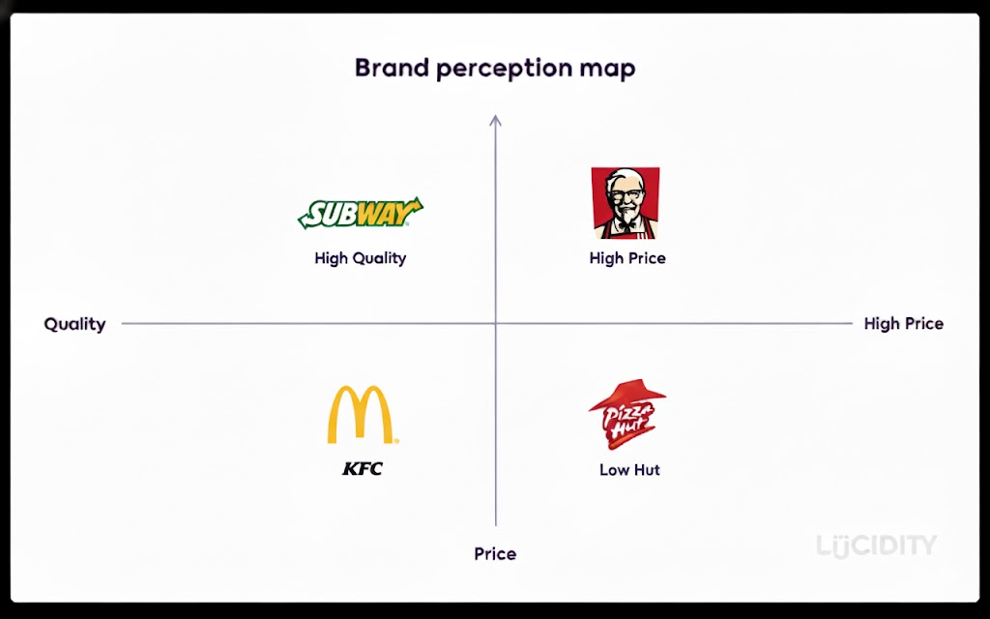
Figure 9: Perceptual map of KFC in India
(Source: self-created)
United Kingdom
KFC is a well-known, reliable brand of comfort food with consistency and convenience in taste in the UK. The brand does not focus on affordability; however, it promotes indulgence, speed as well as reliability.
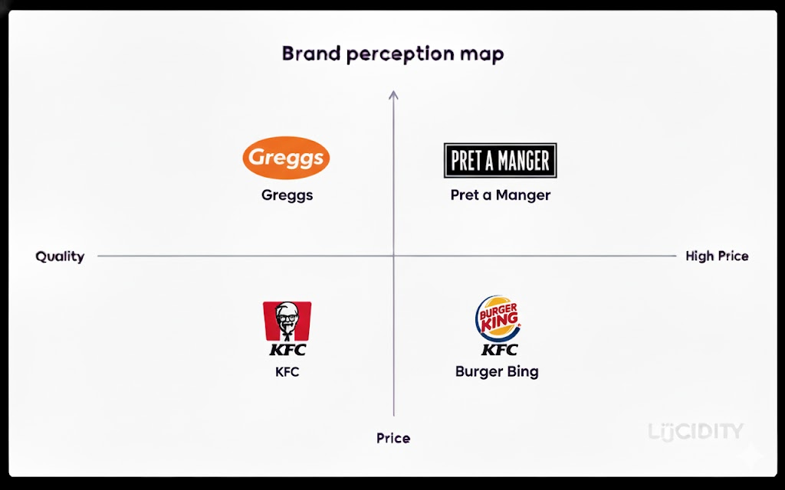
Figure 10: Perceptual map of KFC in the UK
(Source: self-created)
Comparative Evaluation
KFC positioning in India is a balance between the global brand and the local brand, and attractive to aspirational consumers (Sharma, 2025). Positioning in the UK is based on brand heritage, convenience and emotional familiarity.

1.3.2 Marketing Mix (7P)
Product
India
The product strategy adopted by KFC in India is very localised in terms of cultural and dietary practices. With over half the population shunning beef and a substantial number of consumers having a penchant towards vegetarian cuisine, KFC has extended its vegetarian menu, as well as its chicken-only menu (Abdelazim, 2022). Flavour profiles are spicier and taste regional or regional-inspired and meal formats, like rice bowls and wraps, are influenced by local eating habits.
United Kingdom
KFC has a more or less uniform menu in the UK which is based on fried chicken buckets, burgers, and wings. The product innovation is oriented to limited time offers, diversities in portions, and occasional plant-based options instead of profound localisation.
Comparative Evaluation
India requires product adaptation because of the cultural diversity and the UK takes pride in consistency and familiarity in a mature fast-food market (Abdelazim, 2022).
Price
India
In India, KFC is employing a value-based pricing approach in order to attract price-sensitive consumers. Average price of Chicken in India is Rs 200 per Kg and in the UK it is £3.71 per kg and is almost 2 times more expensive in the UK (IBISWorld, 2025). Trial and repeat purchase is encouraged by offering low entry-level products, combo offers and frequent promotions. Perceived value is obtained through family buckets and joint meals and this is vital in a market that has a low average disposable income.
United Kingdom
KFC uses the competitive pricing strategy in the UK, which is in line with the increase in labour and operational costs (Wolniak, Stecuła and Aydın, 2024). Consumers have stronger purchasing power and are less price-elastic so that KFC can set higher average prices without as many aggressive discounts.
Comparative Evaluation
Indian pricing is based on price volume and affordability whilst the UK pricing is based on cost structures and stability of consumer income.
Place
India
The distribution strategy of KFC in India gives preference to the urban areas, specifically malls, commercial centres and places with high pedestrian traffic in the cities. Tier-2 cities expansion promotes growth in the long term (Wolniak, Stecuła and Aydın, 2024).
United Kingdom
The UK has a well-developed and extensive network of KFC outlets, both in high streets, retail parks, drive-throughs, and motorways. Dining, take away and delivery services are all combined, providing a high accessibility in the country.
Comparative Evaluation
The place strategy used by India is selective and growth-oriented whereas the UK has adopted the convenience and national coverage.
Promotion
India
Indian promotional activity is very price-sensitive and digitally intensive. The marketing messages focus on value offers, offers with time limit and affordability. Reaching younger consumers is done through social media, mobile applications and localised ads using regional languages and humour.
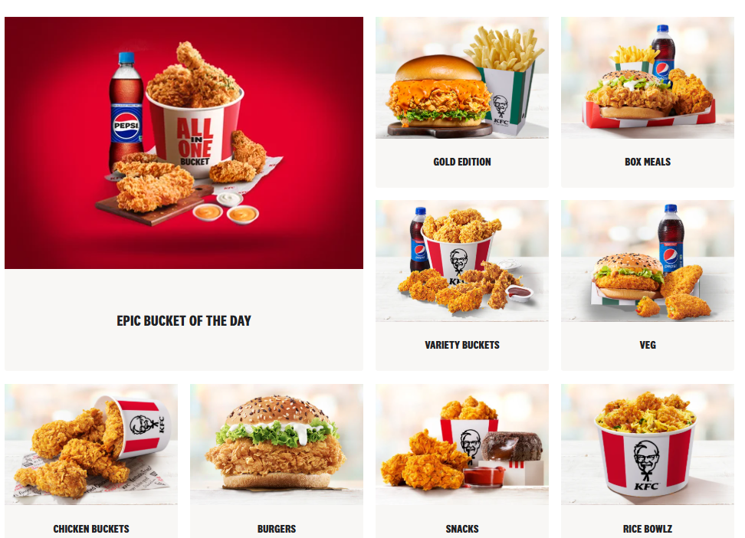
Figure 11: KFC items in India
(Source: KFC, 2026)
United Kingdom
In the UK, brand personality, humour and emotional storytelling are more commonly used in promotion. Taste, indulgence and brand history are being promoted through campaigns, and the ethicalness of sourcing and sustainability are getting more and more attention (Pasaribu and Ellitan, 2025).
Comparative Evaluation
Indian promotional activity has been based on pricing and localisation whereas UK promotional activity has been developed around establishing emotional contact and brand credibility.
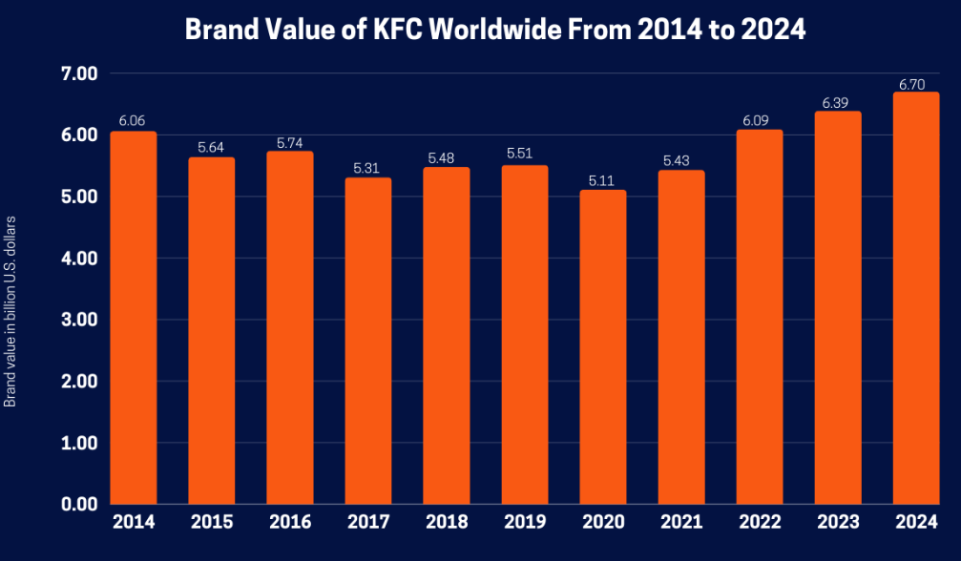
Figure 11: Marketing driven brand value of KFC
(Source: Karthikeyan, 2023)
People
India
Indian staff members are the core of providing quick service in the high traffic stores. The availability of labour enables KFC to have larger teams with the emphasis made on speed, friendliness, and simple service consistency (Zhang, 2024). Training stresses on operational efficiency.
United Kingdom
In the UK, increased labour cost demands high efficiency and level of skill. Training of the staff is geared towards food safety, quality service and adherence to rigid employment rules and regulations.
Comparative Evaluation
Although consistency in services is vital in both markets, staffing models vary as a result of the labour cost as well as regulatory variations (Zhang, 2024).
Process
India
India is equipped with operational processes that are fast, scalable, and have cost control (Fitriani and Supriyaningsih, 2025). Kitchen operations are simplified and combined with well-established collaboration with delivery services to facilitate peak demand.
United Kingdom
The processes in the UK focus on standardisation, hygiene as well as quality assurance. The high-level systems guarantee accuracy of orders, standard food and efficient compliance with regulations in all stores.
Comparative Evaluation
India is more flexible, more volume oriented whereas the UK is more consistent in its operations and is more process oriented.
Physical Evidence
India
Physical evidence entails current store designs, online menu boards, and obvious branding that communicates global quality at low prices. Uncrowded and modern decorations contribute to consumer confidence.
United Kingdom
The UK outlets are in a standardised, contemporary design, focusing on cleanliness and comfort along with sustainability indicators (Francis, 2022). Reliability and brand familiarity is strengthened by packaging and store design.
Comparative Evaluation
Aspirational brand perception in India depends on physical evidence whereas consistency, comfort, and brand credibility in the UK depends on it.

1.4 An analysis of the brand’s directional development strategies in India
KFC strategy of directional development in India is best explained through market penetration which is aimed at maximising sales of existing products in existing markets. The strategy is fitting especially in the Indian context owing to the high population of the country, rising urbanisation, and more people are adopting quick-service restaurants. KFC does not innovate with radically new types of products or choose to enter new markets; rather, the company focuses on reinforcing its position among the existing urban consumers and making them even more frequently consumers. This would enable the brand to expand at a minimum risk in a very competitive and price-sensitive market (Pasaribu and Ellitan, 2025). One of the fundamental elements of KFC market penetration strategy in India is the pricing structure based on the value. The Indian consumers are extremely cautious of price fluctuations and KFC responds by supplying low-end products, combo meals which are discounted, and offers which are time limited. Affordable buckets and shared meals can promote repeat business and eating in groups, especially amongst the students, young professionals and middle-income families. With its affordable price strategy, KFC can grow its transaction levels without the need to change its product line.
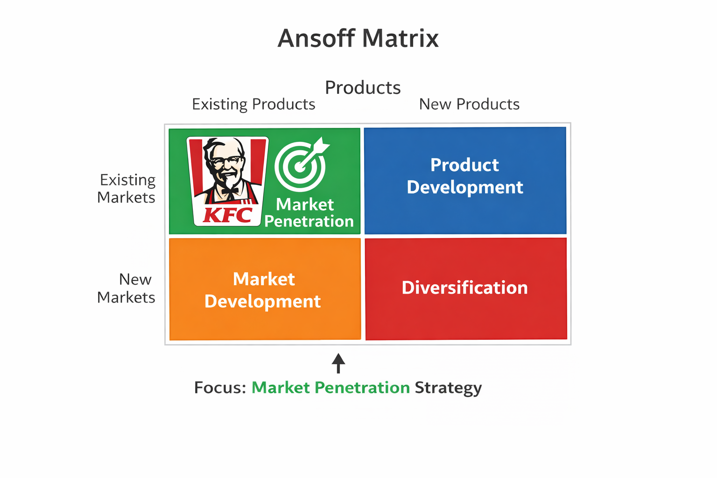
Figure 12: Ansoff Strategy Evaluation
(Source: self-developed)
The other significant market penetration consideration is increasing the accessibility and ease of purchase. KFC has substantially reinforced its ability on food delivery sites where clients can make orders with high frequency without having to pass through physical stores. Online ordering, mobile applications are used to promote offers, and location-based offers, which stimulate repeat use and impulse buying. Such attempts enhance market penetration and habitual consumption habits in the current geographical markets instead of penetrating new geographical markets (Tamang, 2024). The intensive promotional activity is also important in the strategy of penetration that KFC employs. Indian marketing communications emphasizes on low prices, luxurious along with time-saving promotions. The promotions are culturally local, in regional languages, festive themes along with humour that may appeal to the Indian consumers.
Efficiency in operations also facilitates market penetration as it allows KFC to cater to greater volumes on a regular basis. Peak-hour demand is managed by standardised kitchen operations, models of fast service, and linking to logistics of delivery, which enables the brand to be effective in managing its demand during peak hours. Through operation optimisation, KFC will be in a position to maximise throughput without compromising the food quality and speed of service, which is essential to repeat consumption in the quick-service industry (Rodriguez, Reambonanza and Palallos, 2025). In sum, the Ansoff strategy applied at KFC (market penetration) indicates low risk/high-volume growth strategy and is consistent with the economic environment and consumer behaviour in India. KFC maximises its revenue opportunities in the markets that it already operates in by instilling a spirit of affordability, convenience, promotional intensity and operational efficiency.

1.5 Ethical issues related to this brand’s marketing mix in India and the UK
An international marketing mix of KFC in India and the United Kingdom brings up a number of ethical issues, especially on health, consumer protection, cultural sensitivity, labour practise, and environmental sustainability. Although the brand will be adjusting its strategy to align with the local demand of the market, ethical issues in the two countries would differ in their degree because of the difference in regulation, consumer awareness, and social expectations (Malla et al., 2023). One of the ethical concerns is connected with health and nutrition, specifically, the advertisement of high-calorie, high-fat fast food. Fried and rich in energy are the main products of KFC in both India and the UK, which also leads to obesity and related diseases. When promoting value meals and large portion sizes, it is an ethical issue that is brought up, particularly in the UK where fast food is a way of life (Kabadurmus et al., 2023). In India, the use of low pricing offers to attract young consumers and students creates a certain concern of promoting unhealthy dietary habits to a demographic that is highly price conscious due to advertising and price offers. The other ethical question is promotional practices and prices (Anyanwu et al., 2022). The high dependence of discounts and affordability-oriented advertisements in India can be considered to be ethically questionable in case of overconsumption among price sensitive and lower income earners. Although these strategies enhance the aspect of accessibility, they can also take advantage of financial weakness by focusing on quantity instead of the health of consumers. Contrastingly, the UK promotional strategies are not price conscious but brand oriented and engage with the consumer, less ethical issues regarding economic exploitation.
Another ethical aspect is cultural and religious sensitivity, which is especially common in India. KFC has responded to this issue by not selling beef products and providing vegetarian food showing ethical concern and respecting the local culture. Such a lack of adaptation would have created a large-scale ethical backlash. The problem of cultural sensitivity is not so acute in the UK because the country has a greater level of acceptance of poultry-based fast food but the growing need of ethical sourcing and animal welfare has put pressure on the brands based on meat (Malla et al., 2023). Also the two countries differ in ethical issues regarding labour practises. The UK has stringent labour regulations that guarantee minimum wage, employee rights and occupational safety, restraining business ethics. In India, labour is cheaper; however, some ethical issues might be raised concerning the wages, working hours, and safety of employment of the fast-food sector.
Sustainability in the environment is an emerging ethical dilemma in both markets. Large-scale food production causes ethical concerns in packaging waste, single-use plastics, and carbon footprint. The UK consumers are more concerned about environmental responsibility and this puts additional pressure on KFC to implement sustainable packaging and responsible sourcing. The environmental consciousness is on the increase in India, and in most instances, affordability prevails over the sustainability factor (Saraswat, Singh and Vidani, 2024). In general, although KFC shows attempts to confirm ethical issues with localisation, regulatory and sustainability, there are still ethical tensions in the marketing mix. In the UK, the problems are more scrutinised as consumers are more aware and the problem is regulated whereas in India price sensitivity and demographic vulnerability increases ethical risks.

1.6 Recommendations on International Marketing Strategies
1. Enhance Health-Oriented Product Innovation.
KFC needs to increase the number of healthier choices in India and the UK in order to deal with the increased ethical and regulatory pressure associated with nutrition. The introduction of baked or grilled products, smaller portions, and better-described nutrition would enhance brand responsibility without hurting the main products (Kumar, Kulkarni and Rathi, 2022). In India, healthier value meals would attract price-sensitive buyers, whereas in the UK, the strategy would be in sync with increasing health awareness and the role of government regulations toward examining the advertising of fast-food.
2. Balanced Value Pricing and Conscientious Promotion.
As much as affordability is important in India, KFC needs to take advantage of over-reliance on deep discounting which can result in over consumption. Rather, the value propositions are to be oriented to quality, portion control, and bundle nutrition. Promotional strategies need to focus on brand engagement and experience, not insistent pricing in the UK, to reiterate the ethical positioning and long-term brand equity.
3. Localise Improvements without Global Dilutions.
KFC must go on with localising products and promotions to local cultures, especially in India and at the same time with the same global brand standards. Support should be provided to localised tastes, language-based campaigns, and festive promotions with similar quality and service standards throughout the two markets to enhance global brand confidence (Kumar, Kulkarni and Rathi, 2022).
4. Invest to Sustainable and Ethical Practise.
KFC need to focus on environmental sustainability as one of its main pillars of international marketing policy. Consumers are required to be informed about increased use of recyclable packages, responsible sourcing along with initiatives related to decreased waste. It is of particular concern in the UK, where ethical consumption is one of the strongest factors determining the purchase, and quite prominent in urban India.
5. Take advantage of Digital Personalisation and Data Analytics.
KFC can also use data analytics and digital channels to promote personalisation of propositions, customer experience and responsible consumption. Specific online campaigns will allow working more efficiently and minimising the use of mass promotion, which is beneficial both in terms of profitability and the brand image.

1.7 Conclusion
It may be concluded that the success of KFC in India and the UK proves that it is crucial to combine global standardisation with local adaptation. India is in need of value-based pricing, cultural awareness and penetration strategy, whereas the UK is in need of consistency, ethical accountability and convenience. Despite the effective adaptation of KFC marketing mix to the local market conditions, there are still problems of health, sustainability, and ethical promotion. Resolving such issues in advance will enhance long-term competitiveness and brand recognition in these two markets.

Section 2: Reflective Account

2.1 Description
This reflective report reviews the procedure undertaken in conducting research, analysis and writing of the international marketing strategy report of KFC in India and in the United Kingdom. The evaluation necessitated the use of various strategic marketing models, such as PESTEL analysis, Segmentation-Targeting-Positioning (STP), the International Marketing Mix (7Ps), as well as the Ansoff Matrix and the ethical analysis. The assignment was to perform secondary research, integrate the data on the market, and generate the organised comparative analysis. Special focus has been given to the perception of the effects of cultural, economic, and regulatory variations on international marketing strategies. This also needed to be planned carefully to make sure that there was consistency, academic rigour and strict word limits were followed.
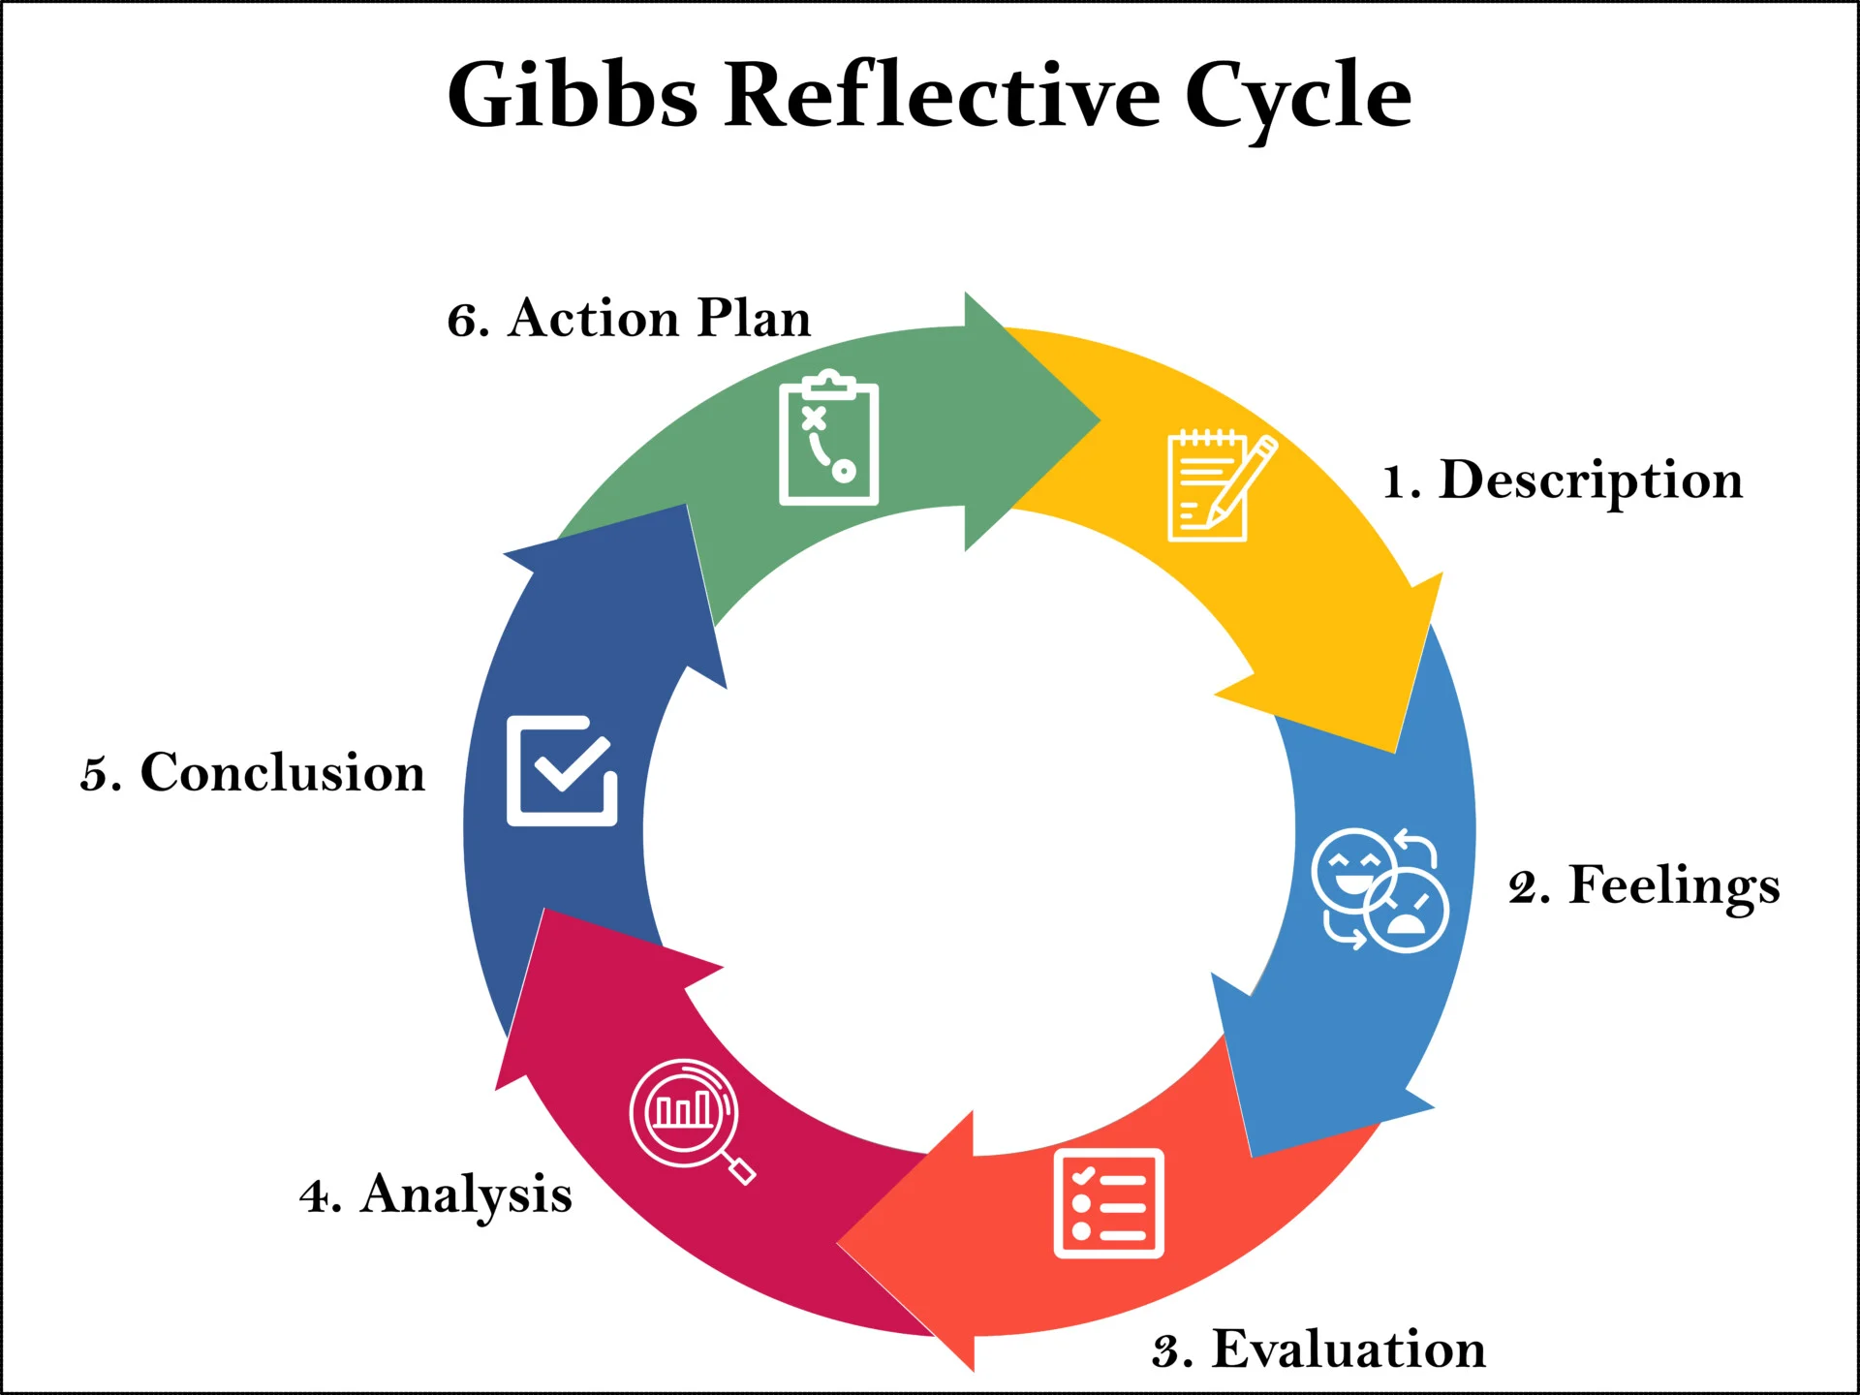
Figure 13: Gibbs Reflective Cycle
(Source: McLeod, 2025)

2.2 Feelings
I was initially confident and insecure. Although familiar with fundamental marketing terminology, I also did not know how effectively I would be able to combine various frameworks in two different countries. I also felt anxious about keeping a critical outlook as opposed to coming up with a purely descriptive report (Ocampo et al., 2025). My confidence developed as the research went on, particularly when the patterns started to emerge between theory and practice. Nevertheless, I felt some frustrations in trying to summarise complicated subjects into short paragraphs and having the same number of words. All in all, the procedure was thought provoking, though it became more and more rewarding as it got clearer.

2.3 Evaluation
A number of elements of the evaluation process worked well. Application of well-recognised frameworks gave a logical framework that directed the research and analysis. The comparative approach between India and UK made me gain more insight into the dynamics of the international market and avoided the one-dimensional analysis. The emphasis on one Ansoff strategy enhanced the depth of analysis and prevented the superficial nature of discussion (Landolsi, Hlaoua and Ben Romdhane, 2023). Nevertheless, there were some difficulties observed. The research period was also time-consuming especially in finding pertinent and valid information. Moreover, the description and evaluation had to be balanced, which meant that it had to be revised over and over again. Time was another constraint because there were parts that needed to be refined than originally expected. In addition, it was difficult to synthesise huge quantities of secondary data on various sources because it needed to be evaluated critically in terms of reliability and relevance. To make the comparisons between India and the UK meaningful and evidence-based work, several cycles of cross-checking and verification were required. Sometimes it was challenging to combine both quantitative and qualitative information without making the paper complicated and monotonous. Although these came with challenges, these challenges helped me to improve my research skills, focus and critical evaluation and interpretation of complex market information in an academic context.

2.4 Analysis
The most useful learning process stage was the analytical one. Using the PESTEL framework also enabled me to appreciate how macro-environmental forces like the economic growth, cultural diversity, and regulatory standards influence the strategic decisions in India and the UK in a different way. The STP framework has helped to point out the impact of the consumer behaviour, level of income and the factors of lifestyles on the segmentation and positioning strategies in the variable analysis of the 7Ps marketing mix affirmed the need to adapt the operations especially on pricing, promotion and localisation of the product. each market. Ethical analysis helped to broaden my thinking past profitability and be critically mindful of issues of health, labour, and environmental responsibility (Gamba, 2025). The step enhanced my capability to connect theoretical frameworks and practical strategic decisions. Moreover, this phase enabled me to determine the interaction between various marketing models and their integration in making strategic decisions. As an example, PESTEL analysis has provided important insights that were used to make the decisions of STP that subsequently informed the marketing mix adjustments. Looking at both ethical implications as well as strategies of operation made it clear that there has to be a balance between profitability and social responsibility. Such a combined analytical style enhanced my critical thinking and strengthened the importance of being able to bridge the gap between theory and the business reality in various foreign markets in a systematic manner.

2.5 Conclusion
In consideration of the entire process, I have learnt a lot about international marketing strategy and academic practice. I also gained a better insight into the localisation and standardisation of global brands. I was also able to think critically, write analytically, and justify strategic decisions with the help of theory which was also a great enhancement of the assessment. I was aware that better initial planning and framework alignment would have minimised subsequent amendments. Notably, I was to find out that when it comes to strategic analysis, it is necessary to not only use models but also evaluate them in respect of their applicability in particular market settings.

2.6 Action Plan
In my future academic assignments, I will be more organised during the planning phase, creating elaborate outlines that are consistent with assessment requirements. I will devote more time to critical analysis instead of descriptive material and incorporate more explicitly the ideas expressed in theory in my writing. By enhancing time management and making early research a priority it will be possible to look into the research more thoroughly and refine it (Holili et al., 2024). Also, I will engage in reflective writing more frequently to increase self-knowledge and improve academic performance and professional decision-making in marketing-related jobs. Moreover, I will also have the formative feedback regarding tutors and peers in earlier stages of the writing process to pinpoint holes in the analysis and enhance the coherence of the argument. I will apply these analytical and research skills to make data-driven decisions, adapt strategies across contexts, and critically evaluate business environments in my future career and everyday problem-solving situations. I will also strive to improve the application of academic resources by using more critically the literature of the journals instead of using mostly descriptive sources. The enhancement of my referencing and synthesis abilities will also facilitate evidence-based reasoning and make my future academic work better in terms of its quality and credibility.

Reference list
Abdelazim, Z., (2022). Global Business Environment-Healthy Eating. Available at SSRN 4453748. https://papers.ssrn.com/sol3/Delivery.cfm?abstractid=4453748
Alt, R., (2021). Digital transformation in the restaurant industry: Current developments and implications. Journal of smart tourism, 1(1), pp.69-74.https://koreascience.kr/article/JAKO202124462476972.pdf
Anyanwu, O.A., Naumova, E.N., Chomitz, V.R., Zhang, F.F., Chui, K., Kartasurya, M.I. and Folta, S.C., (2022). The Socio-Ecological Context of the Nutrition Transition in Indonesia: a qualitative investigation of perspectives from Multi-disciplinary stakeholders. Nutrients, 15(1), p.25. https://www.mdpi.com/2072-6643/15/1/25
Aswal, D.K., (2020). Quality infrastructure of India and its importance for inclusive national growth. Mapan, 35(2), p.139.https://pmc.ncbi.nlm.nih.gov/articles/PMC7261038/pdf/12647_2020_Article_376.pdf
Bankole, E., Harris, N., Rutherford, S. and Wiseman, N., (2023). A systematic review of the adolescent‐directed marketing strategies of transnational fast food companies in low‐and middle‐income countries. Obesity Science & Practice, 9(6), pp.670-680.https://onlinelibrary.wiley.com/doi/pdfdirect/10.1002/osp4.676
Batta, A., (2025). The Economics of Fast Food: Impact on Society, Employment, and Consumption Patterns: A Comprehensive Study Integrating Global and Indian Perspectives. Journal of Economics, Finance and Accounting Studies, 7(7), pp.12-17.https://krishikosh.egranth.ac.in/server/api/core/bitstreams/39a638a4-c6fb-4ac5-9e5e-389eaf6ebee6/content
BATTILANI, F., (2023). The impact of consumer behaviors on business strategies. A KFC Case Study.https://unitesi.unive.it/bitstream/20.500.14247/24509/1/FedericaBattilani_Tesi_PDF-A.pdf
ceicdata.com. (2025). United Kingdom Nominal GDP Growth. CEIC. Available at: https://www.ceicdata.com/en/indicator/united-kingdom/nominal-gdp-growth (Accessed: 31 January 2026).
Evans, E.W. and Taylor, H.R., (2021). Understanding the barriers to food safety scheme certification in the food and drink manufacturing industry in Wales, UK. International Journal of Environmental Health Research, 31(2), pp.225-236.https://www.tandfonline.com/doi/abs/10.1080/09603123.2019.1645307
Fitriani, A. and Supriyaningsih, O., (2025). The Influence of Price Bundling, Physical Evidence, and Store Atmosphere on Consumer Buying Decisions. Research Horizon, 5(3), pp.705-716. http://journal.lifescifi.com/index.php/RH/article/download/558/546
Francis, J.D., (2022). International Marketing. https://spiral.lynn.edu/cgi/viewcontent.cgi?article=1012&context=ludp
Gamba, F.J., (2025). The Marketing Strategies of International Restaurant Chains (IRCs) in Tanzania:: Exploring the Dynamics of 7Ps. Journal of Business and Enterprise Development (JOBED), 13(1). https://journal.ucc.edu.gh/index.php/jobed/article/download/1606/821
Landolsi, M.Y., Hlaoua, L. and Ben Romdhane, L., (2023). Information extraction from electronic medical documents: state of the art and future research directions. Knowledge and Information Systems, 65(2), pp.463-516. https://pmc.ncbi.nlm.nih.gov/articles/PMC9640816/pdf/10115_2022_Article_1779.pdf
grandviewresearch.com. (2026). India Fast Food Market Size & Outlook, 2028. Available at: https://www.grandviewresearch.com/horizon/outlook/fast-food-market/india (Accessed: 30 January 2026).
grandviewresearch.com. (2026). UK Fast Food Market Size & Outlook, 2028. Available at: https://www.grandviewresearch.com/horizon/outlook/fast-food-market/uk (Accessed: 31 January 2026).
Holili, M., Shafa, M.F., Widat, F., Listrianti, F. and Walid, A., (2024). Improving The Quality of Student Learning Through Time Management Training: An Experimental Research. Educazione: Journal of Education and Learning, 1(2), pp.91-101. https://serambi.org/index.php/educazione/article/download/501/443
IBISWorld (2025). Domestic price of chicken - Business Environment Profile. [online] Ibisworld.com. Available at: https://www.ibisworld.com/united-kingdom/bed/domestic-price-of-chicken/44205/? [Accessed 18 Mar. 2026].
John, K.T., (2023). Digital disruption: the hyperlocal delivery and cloud kitchen driven future of food services in post-COVID India. International Hospitality Review, 37(1), pp.161-187.https://www.emerald.com/insight/content/doi/10.1108/IHR-06-2021-0045/full/pdf
Kabadurmus, O., Kayikci, Y., Demir, S. and Koc, B., (2023). A data-driven decision support system with smart packaging in grocery store supply chains during outbreaks. Socio-Economic Planning Sciences, 85, p.101417. https://www.sciencedirect.com/science/article/pii/S003801212200218X
Karthikeyan, A. (2023). KFC’s Marketing Strategy: Recipe for Quality and Creativity. [online] StartupTalky. Available at: https://startuptalky.com/kfc-marketing-strategy/ [Accessed 31 Jan. 2026]
Keeble, M., Adams, J. and Burgoine, T., (2022). Investigating experiences of frequent online food delivery service use: a qualitative study in UK adults. BMC public health, 22(1), p.1365.https://link.springer.com/content/pdf/10.1186/s12889-022-13721-9.pdf
KFC (2026). [online] Kfc.co.in. Available at: https://online.kfc.co.in/ [Accessed 18 Mar. 2026].
Kumar, G.S., Kulkarni, M. and Rathi, N., (2022). Evolving food choices among the urban Indian middle-class: a qualitative study. Frontiers in nutrition, 9, p.844413.https://www.frontiersin.org/journals/nutrition/articles/10.3389/fnut.2022.844413/pdf
Kumar, G.S., Kulkarni, M. and Rathi, N., (2022). Evolving food choices among the urban Indian middle-class: a qualitative study. Frontiers in nutrition, 9, p.844413https://www.frontiersin.org/journals/nutrition/articles/10.3389/fnut.2022.844413/pdf
Kumar, G.S., Kulkarni, M. and Rathi, N., (2022). Evolving food choices among the urban Indian middle-class: a qualitative study. Frontiers in nutrition, 9, p.844413. https://www.frontiersin.org/journals/nutrition/articles/10.3389/fnut.2022.844413/pdf
Malla, I.A., Ayoub, O.B., Rafiqui, A.R., Bhat, I.A., Bhat, J.A. and Altaf, L., (2023). Chapter-9 Fast Food and Beverage Industry: Impact on Human Health and Environment. in Food Technology and Nutrition, 115, p.195. https://www.researchgate.net/profile/Supraja-Thoomati/publication/382918878_2023_book_chapter_Recent_trends_in_Food_technology_Complete_Book-_Chapters/links/66b35115299c327096b60ec9/2023-book-chapter-Recent-trends-in-Food-technology-Complete-Book-Chapters.pdf#page=199
McLeod, S. (2025). Gibbs Reflective Cycle. [online] Simply Psychology. Available at: https://www.simplypsychology.org/gibbs-reflective-cycle.html [Accessed 31 Jan. 2026].
Norton, V., Oloyede, O.O., Lignou, S., Wang, Q.J., Vásquez, G. and Alexi, N., (2023). Understanding consumers' sustainability knowledge and behaviour towards food packaging to develop tailored consumer-centric engagement campaigns: A Greece and the United Kingdom perspective. Journal of Cleaner Production, 408, p.137169.https://www.sciencedirect.com/science/article/pii/S0959652623013276
Ocampo, F.A., McIntyre, B.G., Massey, D. and Saunders, R., (2025). Nursing student reflections on a research internship: A reflective discussion following the Gibbs' reflective cycle. Nurse Education Today, 145, p.106481. https://www.sciencedirect.com/science/article/pii/S0260691724003915
Pasaribu, E.M. and Ellitan, L., (2025). A Review of the Strategic Role of Supply Chain Management for Developing Competitive Advantage. International Journal of Research, 12(1), pp.383-396. https://www.researchgate.net/profile/Lena-Ellitan/publication/388180428_A_Review_of_the_Strategic_Role_of_Supply_Chain_Management_for_Developing_Competitive_Advantage/links/678dbf6d1ec9f9589f51a36a/A-Review-of-the-Strategic-Role-of-Supply-Chain-Management-for-Developing-Competitive-Advantage.pdf
pib.gov.in. (2024). Available at: https://www.pib.gov.in/PressNoteDetails.aspx?NoteId=151915&ModuleId=3&reg=3&lang=2 (Accessed: 31 January 2026).
pib.gov.in. (2025). Available at: https://www.pib.gov.in/PressReleasePage.aspx?PRID=2106921&reg=3&lang=2 (Accessed: 31 January 2026).
propertypistol.com. (2024). What are Tier 1, 2, 3, and 4 Cities in India? - PropertyPistol, Real Estate Sector Latest News, Updates & Insights - PropertyPistol Blog. Available at: https://www.propertypistol.com/blog/what-is-tier-1-2-3-and-4-cities-in-india/ (Accessed: 31 January 2026).
Rodriguez, J.M., Reambonanza, H. and Palallos, L., (2025). Optimizing Operation Processes and Supply Chain Management for Enhanced Service and Product Quality in Quick Service Restaurants. The South East Asian Journal of Management, 19(1), pp.10-7454. https://papers.ssrn.com/sol3/Delivery.cfm?abstractid=5267526
Roe, E., Maye, D., Lambton, S., Mafulul, D., Helwegen, M., Green, S. and Hasnain, S., (2024). Changing agri-chicken for net zero. Findings from an industry workshop.https://eprints.soton.ac.uk/490510/1/ChangingAgri-ChickenReportFINAL.pdf
Saraswat, D., Singh, Y. and Vidani, J., (2024). Consumer awareness and purchasing behaviour of fast-food products in urban and rural stores: A comparison. Journal of Advanced Research in Economics and Business Management, 7(1), pp.31-36. https://www.researchgate.net/profile/Jignesh-Vidani-2/publication/380734369_Consumer_Awareness_and_Purchasing_Behaviour_of_Fast-Food_Products_in_Urban_and_Rural_Stores_A_Comparison/links/664c637422a7f16b4f3ec848/Consumer-Awareness-and-Purchasing-Behaviour-of-Fast-Food-Products-in-Urban-and-Rural-Stores-A-Comparison.pdf
Sharma, V., (2025). Globalization and Brand Management: Balancing Challenges with Strategic Opportunities. Motherhood International Journal of Research & Innovation, 2(01), pp.179-184.https://mhujournal.in/MIJRI/index.php/MIJRI/article/download/97/62
statista.com. (2025). Frequency of visiting fast food restaurants UK, Statista. Available at: https://www.statista.com/statistics/1123873/frequency-of-visiting-fast-food-restaurants-in-the-united-kingdom-by-age-group/ (Accessed: 31 January 2026).
Sureka, A. and Bordoloi, N., (2025) A Comparative Analysis of VAT, Service Tax, and GST: Implications, Challenges, and Transition in the Indian Tax System. Journal of Cases in Management Studies, 1(1).https://journals.dbuniversity.ac.in/ojs/index.php/jcms/article/download/4367/1143
Tamang, S., (2024). Cultural Influnces on Employee Dynamics and Customer Service in Multinational Fast Food Chains. https://www.theseus.fi/bitstream/handle/10024/876646/Tamang_Sharmila..pdf?sequence=2
TheGlobalEconomy.com. (2024). United Kingdom Political stability - data, chart, TheGlobalEconomy.com. Available at: https://www.theglobaleconomy.com/United-Kingdom/wb_political_stability/ (Accessed: 30 January 2026).
Wolniak, R., Stecuła, K. and Aydın, B., (2024). Digital transformation of grocery in-store shopping-scanners, artificial intelligence, augmented reality and beyond: A review. Foods, 13(18), p.2948. https://www.mdpi.com/2304-8158/13/18/2948
Zhang, Y., (2024). The Impact of Sustainable Development Strategies on the Valuation of KFC. Advances in Economics, Management and Political Sciences, 99, pp.33-39. https://aemps.ewapub.com/article/view/15435.pdf

