TITLE
MBA
LEADING AND MANAGING PROJECTS REPORT
for ANTJE COCKRILL

NAME: LIXIANG ZUO
STUDENT ID: 1904075

ACKNOWLEDGEMENTS
I would like to express my gratitude to all those who helped me when I wrote this report. I gratefully acknowledge the help of Antje Cockrill who has offered me valuable suggestions. Without her patient instruction and expert guidance, the completion of this report would not have been possible.

I also owe a special debt of gratitude to all the instructors in the School of Business, from whose enlightening lectures I have benefited a lot and academically prepared for the report.

Finally, I would like to express my gratitude to my friends in Max Gym and my classmates in Wuhan University of Technology as they have collected some important information to support me.

LIST OF CONTENT
TITLE 1
ACKNOWLEDGEMENTS 2
LIST OF CONTENT 3
1. EXECUTIVE SUMMARY 5
2. PROJECT DESCRIPTION WITH BUSINESS CASE 6
3. ENVIRONMENTAL ANALYSIS 10
3.1 PESTLE analysis 10
3.1.1Political factors 10
3.1.2 Economic factors 11
3.1.3 Social factors 12
3.1.4 Technological factors 13
3.1.5 Ecological factors 14
3.1.6 Legal factors 14
3.2 SWOT analysis 15
3.2.1 Strengths 15
3.2.2 Weaknesses 15
3.2.3 Opportunities 16
3.2.4 Threats 16
3.3 Porter’s Five Forces 17
3.4 Stakeholder analysis 20
4. OPERATIONAL REQUIREMENTS 21
5. FINANCIAL PROJECTIONS 24
5.1 Important Assumptions 24
5.2 Financial Plan 24
5.3 Projected Profit 25
6. RECOMMENDATIONS & FINDINGS 26
6.1 Renewing the facilities 26
6.2 Extending gym hours 26
6.3 Improving communication with customers 27
6.4 Training stuff customer service 27
6.5 Establishing a new marketing strategy 27
6.6 Recruit more part-time employees and volunteers 28
APPENDICES 29
REFERENCE LIST 30

EXECUTIVE SUMMARY
This report is to establish a project which will allow Max Gym to have a more competitive advantage in the health and wellbeing industry, which is located in the campus of Wuhan university of technology. It mainly targets the teachers and students of this university. Currently it performs well, however it still has room for improvement based on this research carried out. The objectives of this project that are expected to reach through this project are as follows:
1. To train the teachers and instructors to provide clients with better service;
2. To undertake decoration and renew the facilities;
3. To undertake promotion activities;
4. To increase the number of customers by 20% through this project.

Research will be practically based on the secondary data within the company and university both internally and externally. In the section of project description with business case, the necessity and benefits of carrying out the project were analysed based on some literature and practical data. With regard to environmental analysis, PESTLE analysis, SWOT analysis, Porter’s five forces and stakeholder analysis were carried out. According to the previous research, operational requirements and financial projections were demonstrated to achieve the objectives. Based on all the previous research combined, a range of recommendations and findings are concluded.

PROJECT DESCRIPTION WITH BUSINESS CASE
This project aims to to increase the number of the customers of Max Gym as there are some problems that stop it attracting consumers and increasing profits. The problems were found out by analysing the secondary data gathered from available information, including customer complaints in the gym, a facilities audit, job description and gym records and website, like official college website, the problems are as follows:

Firstly, training classes are offered to the members of a gym by the teachers and instructors, which are a set of intangible activities (Poor, H. M., Poor A. M and Darkhaneh, 2013, p.34). It has a significant impact on clients’ satisfaction and purchase intentions of users for gym teachers and instructors to provide quality of service (Aldana, and Piña, 2017, p.172-197). To provide customers with quality products creates higher competitive advantages such as competitive barriers, increase customer loyalty, supply differentiated products, reduce marketing costs for gyms (Poor, H. M., Poor A. M and Darkhaneh, 2013, p.34).

There is a limited number of fitness facilities for current members as some of them complain that they have to wait for using the facilities on a daily basis according to the complaint and suggestion record in the gym. It is very important to make an investment in updating the exercise equipment as this has many potential benefits which are many folded and long-term (Nagy, and Tobak, 2015, p.47-52). For example, customers can have a wide range of choices to use and have a good customer experience through the customer journey as their touchpoints are paid attention to (Richardson, 2010, p.2-5). It plays a positive role in improving clients’ satisfaction and purchase intentions (Aldana, and Piña, 2017, p.172-197).

In addition, this fitness centre has not established brand image. Brand image is connected to the awareness of customer products and service, feelings, and brand evaluations (Kotler and Pfoertsch, 2006). These factors will reflect the entire information about a brand and the perception of it when customer are purchasing a product, which can motivate consumersn to buy the product or service (Sierra, Heiser and Williams, 2010, p.79-96). For organisations, brand image is used to distinguish various products and services provided by every organisation (Subramaniam, et al., 2014, p.67-73). The gym needs to establish a powerful image and utilize the follow-up brand communication to improve it (Ulusua, 2011, p.3932-3950). Therefore, brand image plays a significant role in developing and maintaining the relationship between the enterprise and customers. The gym establishes its brand image by improving the consumer perceptions of brand image and brand satisfaction, which will promote an increase in customer loyalty (Chao, 2015, p.52-60). Therefor, Max Gym need to enlarge the propaganda in order to improve brand image, allowing more students and teachers in this university to know this gym.

This project aims to enable the gym to gain a high advantage over other gyms in the surrounding area of the university and to benefit the business and its stakeholders in the following aspects.

Firstly, increasing the number of fitness facilities and offering training courses to employees will make the gym more attractive to potential customers and achieve a higher customer satisfaction by improving their fitness experience, which will have a significant influence on the membership renewal rate.

Furthermore, promotion activities, for example, participation in back-to-school season activities, are expected to increase the number of new members, to increase sales and profits and to raise awareness of this gym.
Finally, it enables the firm to reduce labour costs and promote word-of-mouth by
recruiting more qualified part-time employees and volunteers, which mainly consist of students.

All of the above expected outcomes focus on the growth in the sales and profits of the gym, which will allow it to have a greater market competitiveness. Income of the employer and employees will be improved. More students and teachers tend to take exercise more frequently, which will benefit their health and well-being.

ENVIRONMENTAL ANALYSIS
Environment analysis of this project will be made in this section, which demonstrates the external environment of this gym (Posner, 2011).

PESTLE analysis
The PESTEL Framework is used for external analysis of the environmental forces that influence the fitness club. The forces are political, economic, socio-cultural, technological, ecological, and legal, each of which influences the gym in the fitness industry, including Max Gym (Cadle, Paul and Turner, 2014).

3.1.1Political factors
The political forces have an overall effect on the fitness industry. According to China’s laws and regulations, all the organisations in China have to abide by the health and safety regulations to keep in operation. The quality of air, water and lighting must meet the standards. The facility should be clean, including the changing rooms, washing rooms, fitness equipment and regular machine maintenance must be performed. Gyms must make emergency plans for hazardous accidents and undertake regular checks to determine if they meet the standards (Chen, 陈, 2011).

3.1.2 Economic factors
There are also many economic factors that impact the health and wellness industry. In the face of a global slowdown and the long-lasting trade war with the United States, China is experiencing economic slowdown as it has become apparent in recent years that credit's rate of return on overall growth is falling (figure 1).
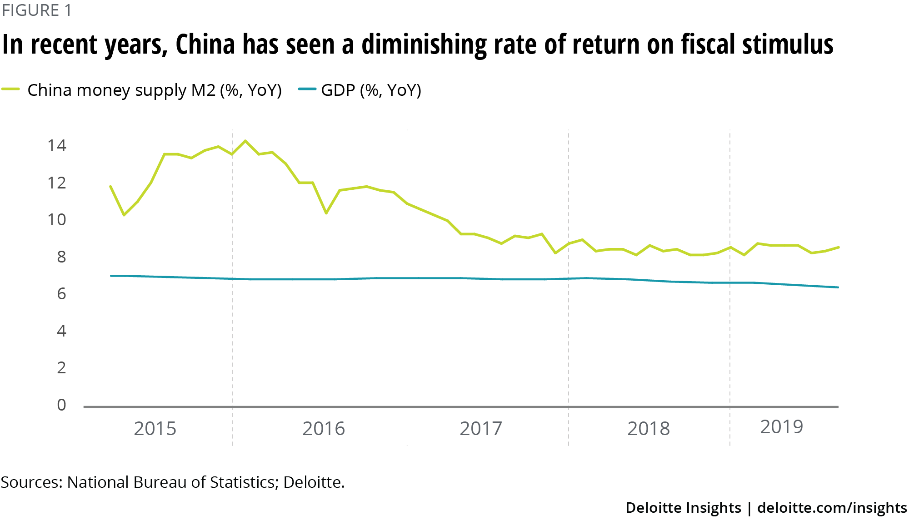
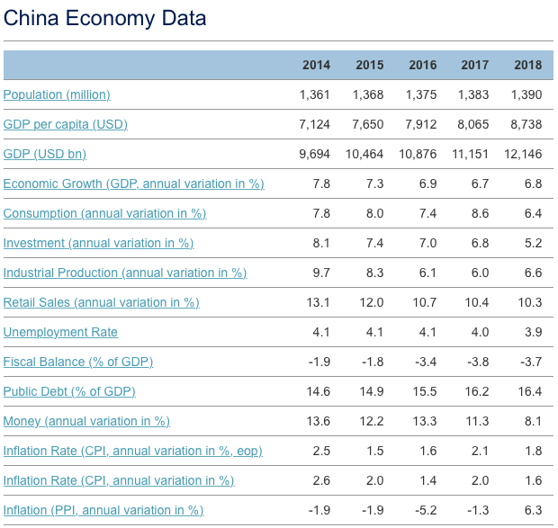
(Source: FocusEconomics, 2019)

Slowndown economy resulted in decreased growth rate, high unemployment rates, and changes in the cost of living and wages. The decreased growth rate had an impact on the industry negatively as it was more difficult for companies to gain profit. The high level of unemployment influences the industry positively, which makes it easier for firms to seek employees needed and job-hopping is less likely to occur (Hall, 2019).

3.1.3 Social factors
The social environment consists of demographics, norms, and values. It is a trend towards working out and keeping healthy and more people would like to have a healthier lifestyle, which has a positive influence on the the health and wellbeing industry. People are more willing to join a fitness club and have a regular membership (Maureen P., et al. 2001, 761-776).

3.1.4 Technological factors
Technological changes can provide business with the opportunities to develop new products and services, explore new markets, and transform society to some extent (Jobber and Ellis-Chadwick, 2016). Technology is rapidly developing in the health and wellness industry. The increasing technology in mobile technology has an impact on businesses as it makes people’s life more convenient. With regard to fitness centre, it makes it possible for people to pay for the membership cards and know their training classes to use a mobile phone. There is also a possibility for fitness facilities to be able to connect to phones so that customers’ fitness data can be kept in track to examine regularly. In addition, mobile technology enables customers to buy food and snacks on the vending machines in gyms (Siau and Shen, 2003, p.3-14). Finally, technology makes it possible for this company to utilize social media marketing which has a positive effect on value equity and brand equity (Ko and Megehee, 2012, p.1395–1398). Through social media this company can continuously interact with its clients and getting feedback and suggestions of its products and services.

3.1.5 Ecological factors
Ecological factor in business is about how a company influences the natural environment. Many companies are more environmentally friendly and tries to decrease carbon emissions, which may have an impact on the operation of the health and wellness industry, for example, saving electricity. More customers are likely to see the environmental-friendly efforts that these companies are making (Pride and Ferrell, 2014, p.75-78).

3.1.6 Legal factors
There are health and safety regulations in the health industry that companies have to abide by, such as regular machine maintenance, keeping facility clean and qualified training that employees must receive(Chen, 陈, 2011). The washing rooms and changing rooms are also required to be clean and fitness equipment needs to be regularly sterilized in case of the possibility that users have illness. It is also very important for staff to have proper training on dealing with the customer relationship as they need to frequently interact with clients, which may play a positive role in avoiding lawsuits from consumers (Brink and Berndt, 2004, p.193-195).

Based on the PESTLE analysis above, the overall external factors of the gym highlighted in the micro-environment has relatively positive impact on this company.

SWOT analysis
The SWOT analysis is used to make an analysis of the internal strengths and weaknesses of the firm, and the external opportunities and threats as well. The analysis examines the gym’s competitive position in the health and wellbeing industry and how it can be improved (Analoui and Karami, 2003, P.93).

3.2.1 Strengths
Max Gym has two important strengths that enable it to compete with its competitors. The first strength of Max Gym is its location in the university campus and this makes it easier for it to attract many students and teachers in this university than other gyms outside the campus because it is more convenient for them to work out. The second strength is their pricing. According to data on the Meituan official website which is one the largest and most popular merchant evaluation life service website, Max Gym is in the medium of the range of fitness prices with annual membership fees. This makes the gym more affordable to the majority of students in this university who have no or little income than other gyms with higher prices (meituan, 2019).

3.2.2 Weaknesses
Although Max Gym is performing well at present, there are some weaknesses.
The first weakness of Max Gym is its customer service. There were some customer complaints about inattentive employees and mistreatment of customers and some clients felt as if they had no choice but to sign up membership because salespeople kept persuading them. Some customers also complained that some instructors and teachers were lacking in patience in the training class. The second weakness is that the obsolete infrastructure in the gym, including workout equipment, changing rooms, and washing rooms. In addition, there is a limited number of fitness facilities as members often have to wait for using the facilities. Finally, it does not have a variety of modern amenities, such as workout equipment and a swimming pool, which is less than the average fitness centre that provides large amount of advanced fitness facilities and various training classes for members (meituan, 2019).

3.2.3 Opportunities
The most significant opportunity for Max Gym to take advantage of is the large number of students in Wuhan University of Technology. According to data updated at 19 November 2019 on the official college website, the total number of students in this university was over 55,700, including more than 36,000 undergraduate students, 18000 doctoral and postgraduate students, and 1,700 overseas students (wuhan ligong daxue, Wuhan University of Technology, 2019). Therefore, there is a large potential for the gym to see an increase in the number of customers in the future.

3.2.4 Threats
The two biggest threats which Max Gym is faxing are the great number of competitors and the high potential for price wars. This industry around the university has 16 large competitors in Jiedaokou Area where the university is located, such as Fitness Club, You Do Fitness and Latte Fitness and much more (meituan, 2019). In addition, these competitors can easily initiate price wars as they are highly profitable. This is a practical threat since better price are attractive to students and they may change gyms to save money, especially as Max Gym is a mid-priced gym (Boone, 2005, P.45-46).

The SWOT analysis examine the internal strengths and weaknesses of Max Gym and identify external opportunities and threats it may face (Jackson and Shaw, 2009).

Porter’s Five Forces
Michael E. Porter identified five forces that influence the competition of businesses at the industry level. These forces include threat of new entrants, the bargaining power of suppliers, the bargaining power of buyers, the threat of substitutes and rivalry amongst existing competitors (Porter, 1989). Analysing the force of each and their influence on the industry will provide idea of the positioning of Max Gym within this industry( See appendix 1).

The first force is high for the health industry. There are some barriers to entry for any industry, while this industry is only impacted by few possibilities. The barriers which may prevent the entry of new businesses are the threats of retaliation, the switching costs of consumers and capital requirements (Porter, 1989). A consumer normally signs agreement for yearly, quarter of or monthly membership and will have penalties if the customer cancels their membership prior to the expiry of the membership card. As a result, there is a small probability that members join a new gym. In addition, there are also essential capital requirements combined with starting and operating a fitness (Boone, 2005, P.45-46).. Finally, there is also the threat of retaliation from existing gyms as they may easily initiate a price war in order to drive the new gyms out of the health and wellbeing industry (Richardson, 2009).

Second, there is the bargaining power of suppliers, which are mainly fitness equipment factories for the industry. The power of this force is medium to low. Suppliers in this industry has the capability of opening their own fitness as their products are differentiated to some extent. However, gyms have many choices of various exercise equipment suppliers and the changing costs is normally not high from present supplier to a new one. In addition, the manufacturers mainly rely on the fitness sales for profit as gyms purchase far more work out facility than the average single user. Generally speaking, manufacturers in the industry rely more on fitness that they supply products than fitness relies on them (Grisso, 2018).
The third force is the bargaining power of buyers. In the health industry, the overall level of the power is high and the fitness centres are the buyers. On the one hand, they make the purchase of a large quantity of work out facilities from each supplier, resulting in the supplier more replying on them, especially as a gym has little switching cost to cooperate with a new supplier (Grisso, 2018). On the other hand, if a fitness centre has a large scale, they will have the ability to start producing their work out equipment.

The fourth force is the threat of substitute products and services and it is neutral to high for this health and wellbeing industry. The practical substitute is students and teachers working out in a campus or at home, for example, running on the playground in the campus. There is no or less switching cost caused by this change, unless there is penalty of the breach of a membership contract. It is also far cheaper than the fitness club. However, not many customers have the desire to to work out by themselves because they are more willing to take advantage of the specific exercise equipment to obtain a better results of workout. It costs a lot for customers to buy the machine to use on their own. In conclusion, the threat of substitute can be judged neutral to high, as customer has an easy substitute to choose while it could not supply as good experience as the gym.

The last force is rivalry among existing competitors. In this industry, the competition level is high as there are many competitors. Each of fitness centres can set its own price, and the barriers to enter this industry are neutral to low as mentioned above. Price is the biggest problem as many gyms are dependent on retaining and increase membership rates to cover the running costs, as well as competing based on price. For example, fitness centres that offer low yearly and monthly membership will attract customers who join a gym club for the first time. The health and wellbeing industry is also developing quite quickly with the increasing social trend towards healthy lifestyle. Gyms also needs to establish a practical marketing plan before entering this industry as it costs great amount of time and capital to start. However, the overall barriers of exit are not high. For example, a gym can sell the equipment it closes.

Stakeholder analysis
A stakeholder is any person or company that have a steak in the performance of the company, often due to the impact it has on the stakeholder in some way, especially financially (Corporate Finance Institute). Max Gym has both internal and external stakeholders. The most important internal stakeholders are stuff members and the board members. Max Gym employs full-time and part-time employees which cause many people to be affected by the performance of this company. The board members are greatly affected due to the stake they have in the gym.

There are some external stakeholders who are influenced by the running of Max Gym, including the community it is located, creditors, and customers. The community is impacted by the jobs that the gym creates as it has a positive impact on the local economy and citizens. Creditors are affected who have investment in the company and this gym creates potential profits and bond income for them after their investment. Finally, consumers are the most important stakeholder as they enable Max Gym to make profits so as to maintain and increase its business.

OPERATIONAL REQUIREMENTS
Creditors is expected to be persuaded to make investment to this project to provide financial support, which is an essential Prerequisites for starting this project.

Work Breakdown Structure (WBS) is utilized to break down the project into smaller parts and identify individual activities (Christensen, 2017) as the chart on next two pages.

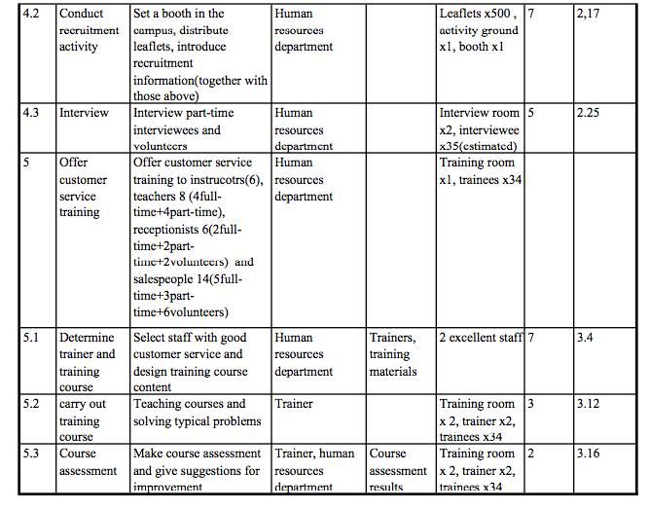

FINANCIAL PROJECTIONS
The costs and projected income are analysed to make the project more realistic and measurable.

Important Assumptions
Three assumptions for Max Gym are:
- A constantly growing economy without any major recession or boom.
- No unpredictable changes in fitness.
- No major significant events that threaten the stability and health of the country and its citizens.

Financial Plan
Cash is needed to purchase equipment and conduct promotional activities and recruitment. Budget is based on a fitness manufacture in China and estimated cost is appropriately more than the manufacture’s offer.

Cost Budget
Name | Definition | Unit Price (RMB) | Quantity | Total Price (RMB) | Total Cost (RMB)
Purchase equipment | Treadmills | 5200.00 | 6 | 31200.00 | 56150.00
Purchase equipment | Spinning | 1100.00 | 2 | 2200.00 | 56150.00
Purchase equipment | Climbing machine | 7200.00 | 2 | 14400.00 | 56150.00
Purchase equipment | Cervix instrument | 7000.00 | 1 | 7000.00 | 56150.00
Conduct promotional activities/Recruitment | Design and print leaflets | 0.50 | 600 | 300.00 | 56150.00
Conduct promotional activities/Recruitment | Rent a booth (7days) | 150.00 | 7 | 1050.00 | 56150.00
(Source: Yancheng ruibaosite jianshen qicai youxian gongsi, 2019)

Projected Profit
220 members are predicted to be on an increase a year at the price of RMB 999.00 yearly membership and 160 current members will continue to sign up membership at the price of RMB 699.00. Sales are predicted to increase with first year annual sales totally to a RMB 331,620.00. Gross margin yearly and gross margin % yearly are also expected to increase accordingly.

Name | 2019 | 2020
Annual sales | 278000.00 | 331,620.00
Gross margin yearly | 247420.00 | 308,406.00
Gross margin % yearly | 89% | 93%

RECOMMENDATIONS & FINDINGS
Based on the previous research, Max Gym currently has a relative competitive advantage in the health and wellness industry. While their performance is good, there is still some room for improvement. Max Gym could make six changes so that it can maintain a competitive advantage and improve the overall company strategy. The changes include renewing the facilities, extending gym hours, improving communication with customers, training stuff customer service, establishing a new marketing strategy, and recruit more part-time employees and volunteers.

Renewing the facilities
Renewing the facilities enable customers to have a various variety of exercise equipment to choose and and improve customers’ satisfaction and purchase intentions. Also, it has a positive impact on the word-of-mouth as most students live in students' dormitory and it is easier for them to speak of gyms. With regard to the variety of exercise equipment, primary data can be collected from survey the competitors in the industry and demand questionnaires of members in this university.

Extending gym hours
Extending gym hours would make Max Gym more comparable to its powerful competitors. It currently opens from 9:30 am to 21:30, while the majority of gyms in this area open until 22:00 or 23:00 (meituan, 2019). Opening longer hours can add the appeal to more customers. More research can be carried to find out the expected time of students, such as the schedule of classes students regularly attend. This data can be collected by face to face or telephone interview to current members.

Improving communication with customers
Proper communication with customers greatly help build loyalty. Max Gym could be more open about some of the operational decisions and how those benefit the gym as well as the customers. Seemingly small issues that customers complain about should be attached great importance to, which could result in a good evaluation on the gym from customers.

Training stuff customer service
Customer service plays a significant role in the business. Salespeople not only aim to sell memberships, but also to help existing members. Pushing customers to buy membership can be effective but it may cause customers to feel antipathy. It would be beneficial to offer employees formal customer service training. Complaints would reduce and therefore customers are willing to speak positively of Max Gym overall.

Establishing a new marketing strategy
The current marketing strategy for Max Gym relies mainly on word-of-mouth. Although it can be effect to some extant, it is limited to increase more customers. Carrying out more advertising, such as promotion for freshers and even a flier campaign, can play a role in reaching more new customers. A more intense marketing campaign will bring in more members and can help increase the market share for the gym.

Recruit more part-time employees and volunteers
My final recommendation for Max Gym would be to hire more qualified part-time employees and recruit volunteers, which mainly consist of students. This would allow the firm to reduce labour costs and promote word-of-mouth.

Overall, Max Gym has an effective business model and appeal to its members across the university and nearby residents. However, these six recommendations could enable the company to become on of the top industry leaders and to have a sustained competitive advantage.

APPENDICES
Appendix 1:
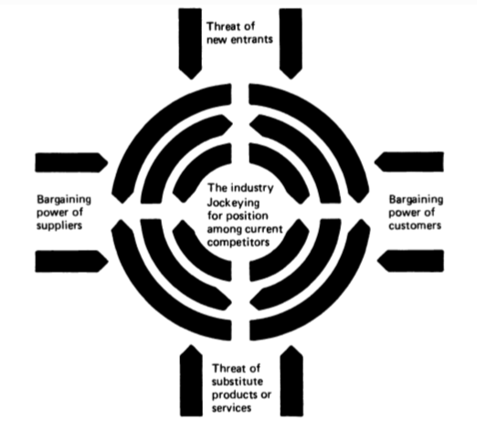
(Source: Porter, 1989)

REFERENCE LIST
Aldana, J., and Piña, J. (2017) ‘Quality of service provided to the client by gym instructors’. Interdisciplinary Arbitrated Review Koinonía, 2(3). Available at: https://www.researchgate.net/publication/321837279_Quality_of_services_in_fitness_centres_Importance_of_physical_support_and_assisting_staff (Accessed: 26 December 2019).
Analoui F. and Karami A. (2003) Strategic management in small and medium enterprises. London: Thomson.
Boone A. (2005) ‘Brokering the Best Deal’. IDEA Fitness Manager. Available at: https://books.google.co.uk/books?id=3LTj-0e-rtMC&pg=PA45&dq=better+price+are+attractive+to+customers+gym&hl=zh-CN&sa=X&ved=0ahUKEwjKyb34hITnAhUGGsAKHWhiCS4Q6AEINDAB#v=onepage&q=better%20price%20are%20attractive%20to%20customers%20gym&f=false (Accessed: 4 January 2019).
Brink A. and Berndt A., (2004) Customer relationship management & customer service. Landsdowne: Juta, 2004.
Cadle, J., Paul, D. and Turner, P. (2014) Business analysis techniques. Chartered Institute for IT.
Chao, R. F. (2015) ‘The impact of experimental marketing on customer loyalty for fitness clubs: Using brand image and satisfaction as the mediating variables’. The journal of international management studies, 10(2). Available at: http://www.jimsjournal.org/6%20Ren-Fang%20Chao.pdf (Accessed: 26 December 2019).
Chen Z. 陈竺 (2011) Gonggong changsuo weisheng guanli tiaoli shishi xize. 公共场所卫生管理条例实施细则 (Detailed Rules for the Implementation of the Health Regulations in Public Places). Available at:
http://www.gov.cn/gongbao/content/2011/content_1955012.htm (Accessed: 26 December 2019).
Christensen E. (2017) How to Create a Work Breakdown Structure and Why You Should. Available at: https://www.lucidchart.com/blog/how-to-create-a-work-breakdown-structure-and-why-you-should (Accessed: 26 November 2019).
Corporate Finance Institute. Stakeholder. Available at: https://corporatefinanceinstitute.com/resources/knowledge/finance/stakeholder/ (Accessed: 29 December 2019).
FocusEconomics (2019) China Economic Outlook. Available at:
https://www.focus-economics.com/countries/china (Accessed: 27 December 2019).
Grisso J. (2018) Individual Case Study: An In Depth Look into LA Fitness. Theses/Capstones/Creative Projects. 23. Available at:
https://digitalcommons.unomaha.edu/university_honors_program/23 (Accessed: 5 January 2019).
Hall M., (2019) Unemployment and Recession—What's the Relation? Available at:
https://www.investopedia.com/ask/answers/032515/why-does-unemployment-tend-rise-during-recession.asp (Accessed: 29 December 2019).
Jackson T. and Shaw D. (2009) Mastering Fashion Marketing. London: Palgrave MacMillan.
Jobber, D. and Ellis-Chadwick, F. (2016) Principles and Practice of Marketing. 7th Ed. Berkshire: McGraw-Hill.
Ko, E. and Megehee, C.M. (2012) ‘Fashion marketing of luxury brands: Recent research issues and contributions’. Journal of Business Research. 65(10). Available at:
https://www.sciencedirect.com/science/article/pii/S0148296311003481 (Accessed: 2 January 2019).
Kotler, P. R. and Pfoertsch, W. (2006). B2B brand management. New York: Springer.
Maureen P., et al. (2001) ‘Demographic influences on environmental value orientations and normative beliefs about national forest management’. Society & Natural Resources, 14(9). Available at: https://www.tandfonline.com/doi/abs/10.1080/089419201753210585 (Accessed: 3 January 2019).
meituan, 美团 (2019) wuhan yundong jianshen zhongxin. 武汉运动健身中心(Wuhan sports and fitness centers). Available at:
https://wh.meituan.com/yundongjianshen/c20253b1007/ (Accessed at 28 December 2019).
Nagy, A., and Tobak, J. (2015) ‘The role of sport infrastructure: use, preferences and needs’. APSTRACT: Applied Studies in Agribusiness and Commerce, 9(1033-2016-84267). Available at: https://ageconsearch.umn.edu/record/210613/ (Accessed: 26 December 2019).
Poor, H. M., Poor A. M. and Darkhaneh A. M. (2013) ‘The Quality of Service and its Importance in Service Organisations’. Arabian Journal of Business and Management Review (OMAN Chapter), 3(3). Available at: https://pdfs.semanticscholar.org/62f2/61ff21384cce85a3d4b1d969fc66ab1ca898.pdf (Accessed: 28 December 2019)
Porter M.E. (1989) How Competitive Forces Shape Strategy. Asch D., Bowman C. (eds) Readings in Strategic Management. Palgrave, London. Available at:
https://link.springer.com/chapter/10.1007/978-1-349-20317-8_10#citeas (Accessed: 3 January 2020)
Posner H. (2011) Marketing Fashion. London: Laurence King Publishing.
Pride W. M and Ferrell O. C. (2014) Foundations of marketing. Stamford: South-Western.
Richardson, A. (2010). ‘Using customer journey maps to improve customer experience’. Harvard business review, 15(1). Available at: http://www.iimagineservicedesign.com/wp-content/uploads/2015/07/Experience-Maps-Using-Customer-Journey-Maps-to-Improve-Customer-Experience.pdf (Accessed: 28 December 2019).
Richardson, M. (2009) How to Start a Gym or Fitness Center? Available at: https://articles.bplans.com/how-to-start-a-gym/ (Accessed: 28 December 2019).
Siau, K., and Shen, Z. (2003) ‘Mobile communications and mobile services’. International Journal of Mobile Communications, 1(1-2). Available at: https://www.researchgate.net/profile/Keng_Siau/publication/220474832_Mobile_Communications_and_Mobile_Services/links/5a94f14c0f7e9ba42970de1b/Mobile-Communications-and-Mobile-Services.pdf (Accessed: 4 January 2020).
Sierra, J. J., Heiser, R. S., and Williams, H. A. (2010). ‘Consumer racial profiling in retail environments: A longitudinal analysis of the impact on brand image’. Journal of Brand Management, 18(1). Available at: https://link.springer.com/article/10.1057/bm.2010.24 (Accessed: 25 December 2019).
Subramaniam, et al. (2014) ‘Effects of brand loyalty, image and quality on brand equity: A study among bank islam consumers in Kelantan, Malaysia’. Asian Social Science, 10(14). Available at: https://www.researchgate.net/publication/263735430_Effects_of_Brand_Loyalty_Image_and_Quality_on_Brand_Equity_A_Study_among_Bank_Islam_Consumers_in_Kelantan_Malaysia (Accessed: 26 December 2019).
Ulusua, Y. (2011) ‘Effects of brand image on brand trust’. Journal of Yasar University, 6(24). Available at:
https://dergipark.org.tr/tr/download/article-file/179335 (Accessed: 27 December 2019).
wuhan ligong daxue, 武汉理工大学 (Wuhan University of Technology) (2019) xuexiao jianjie. 学校简介 (School profile). Available at: http://www.whut.edu.cn/xxgk/ (Accessed: 28 December 2019).
Xu S. (2019) Bracing for a slowdown. Deloitte. Available at:
https://www2.deloitte.com/us/en/insights/economy/asia-pacific/china-economic-outlook.html (Accessed: 26 December 2019).
Yancheng ruibaosite jianshen qicai youxian gongsi,盐城锐宝斯特健身器材有限公司 (Yancheng Ruibaoshi Fitness Equipment Co. LTD) (2019) gongying shangpin. 供应商品(Goods on Offer) Available at:
https://b2b.baidu.com/shop?name=盐城锐宝斯特健身器材有限公司&xzhid=29691731&tpath=prod (Accessed: 8 January 2020)

