COMPONENT 1: REPORT EFFECTIVE TEAM WORKING FOR TEAM SUCCESS
Executive Summary
Effective team management is necessary for achieving common goals. In this report, a brief discussion has been made on how effective team management is useful in the university to remove the cultural barriers and promotion of inclusivity. For effective Team Management, it is necessary to improve the interaction skill and value each other's effort. Cooperation among the team members is the most important element to carry out the activities in the difficult phases. The major aim of producing this report is to state the effective methods of forming a team that can be useful to produce the presentation within the time limit.

Table of Contents
Introduction 4
Methods to develop effective team 4
Impact of effective team working 6
Barriers to effective teamwork 7
Types of roles that are needed for cohesive teamwork 9
Conclusion 10
Reference List 11

.

Introduction
Effective team management is important to improve the productivity and efficiency of team performance. Teamwork is also essential for the improvement of communication and social skills. It teaches the students how to effectively interact with the teachers and provide opinions in a group setting. This report will contain a brief analysis of developing an effective team for university students and its impact on overall productivity. While building an effective team the members can face various challenges regarding diversity in the cultural backgrounds, languages and demographic factors. This report will also highlight the barriers to effective teamwork and roles that need to be performed for cohesive teamwork.

Methods to develop effective team
In the case study, it has been that the team members of University of Wales Trinity Saint David, are facing various challenges to produce a presentation due to conflict among the team members. So various factors are presented below that can be helpful to build an effective team within the university.
- Before forming any team, it is important for team leaders to define the purpose of forming a team to each of the members clearly. The reason for creating the team, overall expectation from the team members, inspiring vision can help the members by providing a direction at the challenging time (Trivedy et al., 2020).
- The next stage is the determination of the team goals. Once the team is established and united it is necessary to formulate smaller manageable goals and tasks. It is also necessary to outline every task and schedule all the activities with agreed deadlines. The role of each team member needs to be properly decided and communicated. For the accomplishment of the goals, it is necessary to provide adequate resources and enough time and support to all the team members.
- After setting the goal for the formation of the team in the next stage it is important to clarify the expectation from each member of the team. It is the responsibility of the team leaders, to be honest, and transparent with every team member. In order to motivate the team members, it is important to properly clear the standards. Each member of the team needs to respect the feedback and modify the activities according to that (Peters and Stamp, 2021).
- The team leader must regularly review the performance of the group and need to provide effective feedback for continuous progress. The monitoring and review process is helpful for adjustment and improvement that need to be incorporated along the way.
- The team leader must be careful to regularly value and recognise the effective performance of the team members. It will help to build the morale of the team members. Positive feedback can inspire the other team members to work hard and make an effective contribution to the achievement of the common goal.
- Communication is another factor for effective team performance. For effective communication, it is important to follow a transactional model of communication. According to this model, simultaneous communication between both parties is necessary for proper clarification of the message. Proper communication can also improve social interaction skills. In this way, it will be possible to reduce the barriers of language and cultural diversity among the team members (Graham et al., 2020).
- Effective team performance, team leaders can also apply a Belbin team performance model for the proper division of the work among each member of the team. For effective performance from all the team members, the most important thing is motivation. Highly motivated students are important for producing presentations within the deadline.
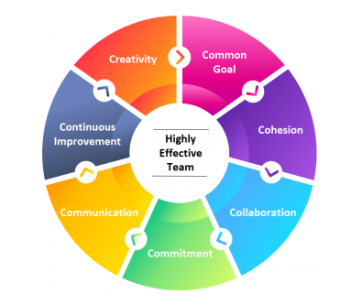
Figure 1: Effective team management
(Source: Vanbuel and Van den Branden, 2021)

Impact of effective team working
Team working helps in building strong bonds between colleges. Building strong relationships between team members can help them in changing their determined goal and also become a self-confident determined task. Teamwork is essential for every student and it leads to academic success (Grzimek et al., 2021). It was necessary to understand the importance of teamwork where proper communication of skills and Social skills get developed. Students from different diverse backgrounds message difficulty to cope up with the learning environment. It is important for every student to recognise the importance of education and how it can provide major benefits in enhancing a Good career. Teamwork also teaches students how to respect and value other team members while accomplishing the task easily. Another benefit of teamwork is to reduce the effect of bullying from students and also share respect with each other. Bullying is considered one of the major problems that are faced by students of different backgrounds. The impact of bullying is relatively high which can impact the mind-set of those students. The benefit of teamwork can be easily translated into success outside the classroom. The teacher is responsible for introducing students to the collaborative environment for improving their self-confidence and also making them productive (Simkins et al., 2021).
The benefits of teamwork are:
- The student contributes to helping a team produce effective results. It can enhance the productivity of the team member and also remain motivated. It was the determined goal.
- Deadline is considered one of the primary objectives for every student. It is essential for students to meet deadlines in a given period of time and working in a team can help to increase productivity. Students completing the task single-handedly face a heavy workload and it becomes difficult for managing the task. Working in a team can help in achieving the task easily (Berksonet al., 2020).
- Students working in a team can easily solve problems with their ideas and experience. It will also help in increasing the decision-making ability of individuals and let them find solutions easily.
- Working in a team sparks the creativity of other team members. For example, a single student message is difficult to make a PowerPoint presentation creative. On the other hand, team members can incorporate new ideas and make the PowerPoint more productive and innovative in comparison to single-handed students.
- Working in a team leads to lowering conflict in the classroom and resulting in wrong relationships. It helps in building good bonding between students of different backgrounds and finding the best possible way to resolve the disagreement for the benefit of team members.
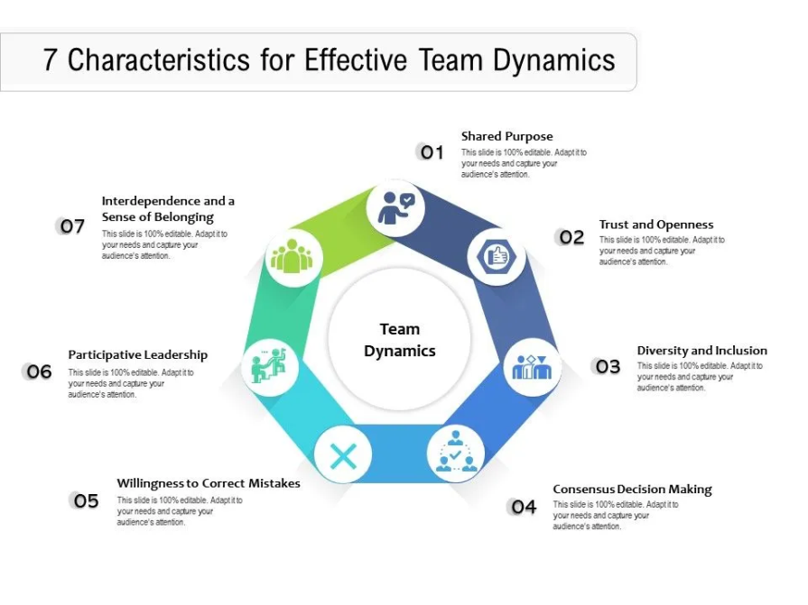
Figure 2: Characteristic of effective team dynamics
(Source: Maher and King, 2020)

Barriers to effective teamwork
Teamwork is considered one of the fostering ways by which students can take effective decisions in completing the task. A solid team can easily improve the working progress and also increase collaboration. Trust is considered one of the primary objectives where every objective relies and every team member must build trust towards each other. Every student must understand the rising issue of four communications which may hamper the success rate. Lack of communication can create a toxic working environment and it may lead to turnover of team members. To understand the barrier and overcome the barrier every team member is required to improve their communication skill and build trust while working upon the determined task (Pesout, O., and Nietfeld, 2021). At first, it is necessary to understand the primary reason for the barrier while completing a task in a team.
Group size: More groups of people in a team with different schedules for accommodating the task and result in delay upon the task. Different opinions of different team members can lead to missing the deadline.
Task Independence: While working in a team every team member divides the task accordingly. It is considered one of the primary objectives for every student to focus upon their determined objective and implement the strategies for accomplishing the task. The negative consequences arrive when the coordination cost gets higher and the task is allowed to students and not divided as per the cost.
Heterogeneity: Heterogeneity of the group member may result in rising coordination costs and facing language barriers. The rising issue of a cultural language barrier may result in missing deadlines and increasing challenges in meeting deadlines.
Barriers:
- Lack of trust is considered one of the primary reasons for lowering the confidence of team members while accomplishing the task.
- Rising conflict due to miscommunication can affect the working progress of the team member and result in missing deadlines.
- Lack of skill is considered one of the major problems and the Limited ability of team members may result in rising conflict and delay in completing the task.
- Too many group numbers result in too many decisions. It can also give rise to complexity and miscommunication.
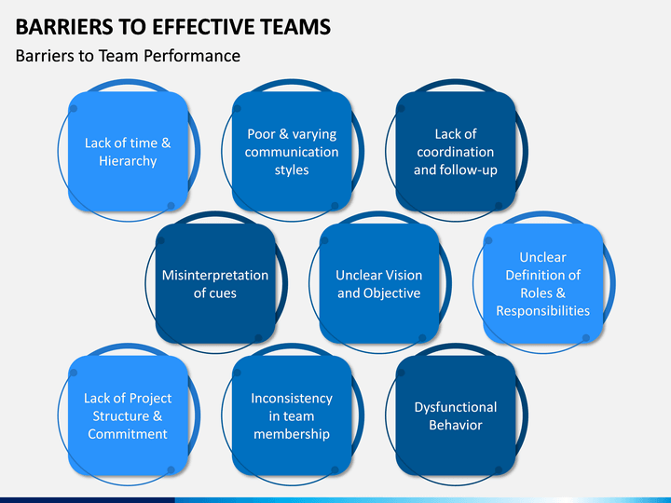
Figure: Barriers of effective team
(Source: Jerome, 2020)

Types of roles that are needed for cohesive teamwork
Creating an effective team and performing various activities as a team requires a number of intellectual properties as well as skills that will allow the team to ensure better work performance. University students have a greater ability to perform various levels of tasks with a significant standard of difficulty. To improve the cohesive teamwork as well as support other team members on the way of achieving success can include a number of individual approaches and potential. The features which might be beneficial for a team are described within the below table.
Roles | Individual benefits | Usefulness for team collaboration
Better time management abilities | Appropriate time management skills will significantly help individual students to perform different tasks and fulfil objectives within the time period. | The team will effectively perform different activities with appropriate time management skills and better utilisation of time effective issues. Creating a presentation or any curriculum assignment requires appropriate time management and utilisation of available force potential. Gaining better time management skills for a team member can significantly improve the work potential along with improved work efficiency (Selvarajah et al., 2021).
Improve ability to resolve various problems and conflict | Problem resolution skills will help any individual student to avoid unnecessary issues and maintain a positive approach for others' collaboration. | For any team, problem resolution skills will significantly help the team to avoid unnecessary conflict and issues. Management of conflict is very necessary as it will allow different students from unique backgrounds and cultural groups to cooperate on a specific task.
Appropriate decision-making abilities | Proper decision-making abilities along with appropriate leadership skills are very crucial to lead an individual performance tour to achievement. | For any team, it is very crucial to have a team member which can effectively lead the whole team along with making decisions in crucial situations. Apart from leading the team, appropriate decision-making ability will also allow the team to effectively perform various tasks depending upon the work potential of each team member.
Creative and innovative thinking | Creativity and innovation can significantly help individual students to use available resources at study materials effectively to gain better academic success. | Creative and innovative approaches in different team activities will significantly allow the whole team to perform comparatively more effectively. Innovative thinking and creativity are also significantly beneficial for a team to include different abilities of team members and utilise other aspects of individual abilities.
Note: The roles and abilities mentioned in the table have a significant influence on team working and collaboration. Though to improve the relationship and bond between the team members, the team has to include different motivational aspects and moral values to engage the individual workforce in a team. The appropriate meaning and awareness about the collaboration along with respectful views to others approaches will allow the team members to perform more effectively. It is also very crucial to include issues and inconveniences of every team member to support and fulfil the gap within the individual performance.

Conclusion
The study describes various aspects of team working and the potential influence of team working increasing the ability of every individual student. Student life can be considered as a crucial moment where every individual can learn various ethical and moral aspects for cooperating with other individuals and improving interaction. The study elaborates different barriers and limitations which are mostly faced by teams to perform different tasks as a singular entity. The study also includes a description of the impact of the team working and how efficiently it can affect the performance of every individual student included within a team.

Reference List
Berkson, R., Richter, U. M., Veerabhatla, S., and Zasiekina, L. (2020). Experiences of Students with Communication Related Disabilities in the TBL classroom. East European Journal of Psycholinguistics, 7(1).
ELLIS, P. (2020). Team working (part 1): creating a team. Wounds UK, 16(1).
Graham, J., Hayes, C., and Pendry, K. (2020). Can Team-Based Learning (TBL) Be Used to Deliver Postgraduate Education in Transfusion Medicine for UK Physicians?. Medical Science Educator, 30(1), 631-642.
Grzimek, V., Kinnamon, E., and Marks, M. B. (2020). Attitudes about classroom group work: How are they impacted by students’ past experiences and major?. Journal of Education for Business, 95(7), 439-450.
Jerome, L. (2020). Making sense of the impact agenda in UK higher education: a case study of preventing violent extremism policy in schools. Journal of Social Science Education, 19(2), 8-23.
Maher, K., and King, J. (2020). Observing Anxiety in the Foreign Language Classroom: Student Silence and Nonverbal Cues. JOURNAL FOR THE PSYCHOLOGY OF LANGUAGE LEARNING, 2(1), 116-141.
Pesout, O., and Nietfeld, J. (2021). The Impact of Cooperation and Competition on Metacognitive Monitoring in Classroom Context. The Journal of Experimental Education, 89(2), 237-258.
Peters, T. D., and Stamp, P. L. (2021). The virtual workplace: The impact of embedding business simulations into classroom culture. Journal of Education for Business, 96(6), 373-380.
Selvarajah, K., Zadeh, P. M., Kobti, Z., Palanichamy, Y., and Kargar, M. (2021). A unified framework for effective team formation in social networks. Expert Systems with Applications, 177, 114886.
Simkins, S. P., Maier, M. H., and Ruder, P. (2021). Team-Based Learning (TBL): Putting learning sciences research to work in the economics classroom. The Journal of Economic Education, 1-10.
Trivedy, C., Mills, I., and Dhanoya, O. (2020). The impact of the risk of COVID-19 on Black, Asian and Minority Ethnic (BAME) members of the UK dental profession. British dental journal, 228(12), 919-922.
Vanbuel, M., and Van den Branden, K. (2021). Promoting primary school pupils’ language achievement: investigating the impact of school-based language policies. School Effectiveness and School Improvement, 32(2), 218-240.

