Executive Summary

This report will give an explanation of the circular economy and how it can underpin responsible business. The example chosen for the research is a local business in Pembrokeshire called FRAME. It up cycle’s furniture for local communities and now has two shops. Frame adheres to principles of the circular economy and to the ethos of sustainability. This report will highlight the challenges it faces and how it will overcome them in the future.

Introduction
Firstly, this report will consider how the principles of circular economy support responsible businesses to be accountable by being sustainable. It will then be looking at a local business as a case study to provide primary evidence to show how it reflects the circular economy. It will also consider what challenges this business faces in being responsible and suggest how those challenges could be met in the short, medium, and long term. Frame supports local employment and is a life-changing charity.
Frame will involve commercial operations in reuse by reducing waste and collecting furniture and other household goods to be used to upcycle, resell, and deliver their products. Although Frame started in a bungalow in Merlin's Bridge in 1994, Frame now has two reused furniture showrooms in Pembroke Dock. Frame also has The Green Shed, a community reuse center, The Community Fridge in Haverfordwest and three social enterprises, including One of A Kind, Frame furniture surgery and Blue Sky, a gardening project Frame (2022).
The five common obstacles in implementing the circular economy.
1. The horror or disrupting consumer's convenience. One of the many common cases will be the use of disposable plastic, as there are so many different types of plastic to be had, where most of us have now grown accustomed to its simplicity, as it is lightweight and flexible. A producer of bottled water wants to change its packaging to make it more environmentally friendly. They thought of making it into paper cartons to be still lightweight, but this could be easily broken when it comes into contact with water.
2. Local regulations versus the circular economy concept, after the circular economy concept was introduced in 2009, it has only just hit the Indonesian market in 2018, with it needing ten years to reach the local waste management, where several ideas have been discussed, that prohibit producers from filling up their waste within the landfill. With this new requirement of an environmentally friendly business model, most companies will require support from their government.
3, Lack of infrastructure for waste treatment, with regulations being just words and ideas, but without the facilities and human resources to run it, with talks about money, energy and the time it takes to prepare the necessities when the regulations have been made. China is now the 1st world's plastic producer, and with there not being enough plastic waste treatment facilities around so that the plastic can be reused within the industry, what will happen? Plastic waste will be accumulated within landfill or dumped at sea.
4. Lack of recycling technology, there are many materials that do need to have higher technology, like textiles and beverage cartons that are used to contain juice and milk, there could be limited materials, maybe only use natural cotton for the fashion industry, metal or glass packaging to be used in exchange for beverage cartons, but then for the circular economy implementation to work there is a need to make sure the technologies that are needed to recycle their materials would be enough to cover all industries requirements- regarding numbers and quality.
5. Poor business model plan, with some of the previous problems that have been talked about, while maintaining consumers expectation, and government regulations, and with the lack of waste treatment facilities, and recycling technologies this will all come to one conclusion, we need to have a better business plan, one that will implement the circular economy concept. When a business plan is excellent when created from the beginning and fixing the existing business model challenges it faces.

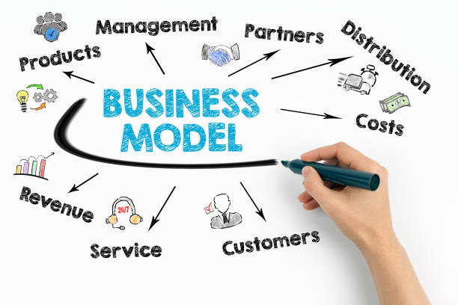
Figure 1.

What is a Circular Economy?
The world in the 21st century is far more conscious of human’s impact on the planet, and this, in turn, has an impact on what customers are looking for when they buy something. Businesses, therefore, need to make sure they remodel their business plans so they can introduce the three principles of a circular economy- reduce, reuse, and recycle- into their supply chain. This will allow a business to get the most out of a product by recovering and reusing it instead of discarding it when no longer in use (DS Smith2022).

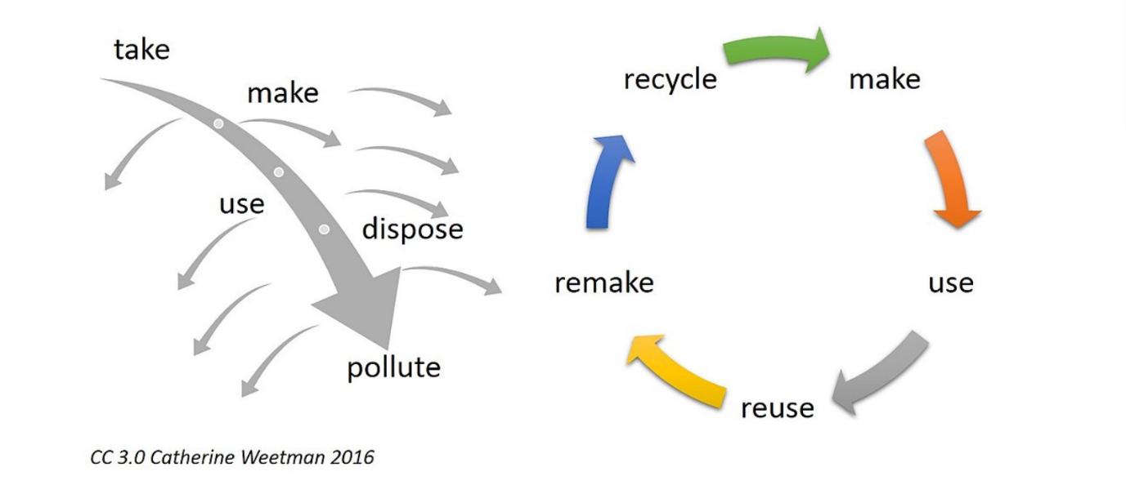
Figure 2. Linear Economy Circle Economy

A circular economy is fundamentally different from a linear economy. To put it simply, in a linear economy, we mine raw materials that we process into a product that is thrown away after use. In a circular economy, we close the cycles of all these raw materials. Within the circular economy, most manufacturers will design a product to be reusable, like electrical products that will be designed to be easier to repair, and the recycling of plastic into pellets will be used for making new products, this will prevent litter on our streets and in the natural environment by using the circular economy Government (2017).
What is the difference between Circular Economy and Sustainability?
“In circumstance, sustainability will aim to benefit the environment, the economy, and society at large … with the main beneficiaries of the Circular Economy will appear to the economic actors that implement the system.”Collectivegreen(2022).
“With The Circular Economy …willstates mostly to individual economic benefits through input reduction, efficiency gains, and waste avoidance with relatively immediate results compared to sustainability.”.Wincent and Parida(2018).
The circular economy is based on three principles,
- Circulate products and materials.
- Eliminate waste and pollution.
- Regenerate nature.
To summarise this, the existing Circular Economy model is an intentionally designed human construct, grounded in the Technosphere with a clear emphasis on governments and companies.
Sustainability, then again, aims at benefiting the environment, the economy, and society at large; responsibilities are shared by everybody but are not well-defined Macarthur (2021).
With over 100 definitions of the circular economy used in literature, with the concept applied by different groups of researchers, with the diversity of definitions this also makes it more difficult to make circularity measurable.
Theses definitions would often focus on the usage of raw materials or a system.
- REDUCE (with minimum usage of raw materials)
- REUSE (reuse of products and components)
- RECYCLE (to reuse a high quality of raw materials).
Three elements
Closed cycles: there is no waste because every residual stream will be used to make a new product.
Renewable Energy: energy will also last as long as possible within the circular economy, by feeding renewable energy.
Systems Thinking: this is where people come together (company, person, organism) this will form a network so that one player will influence other players
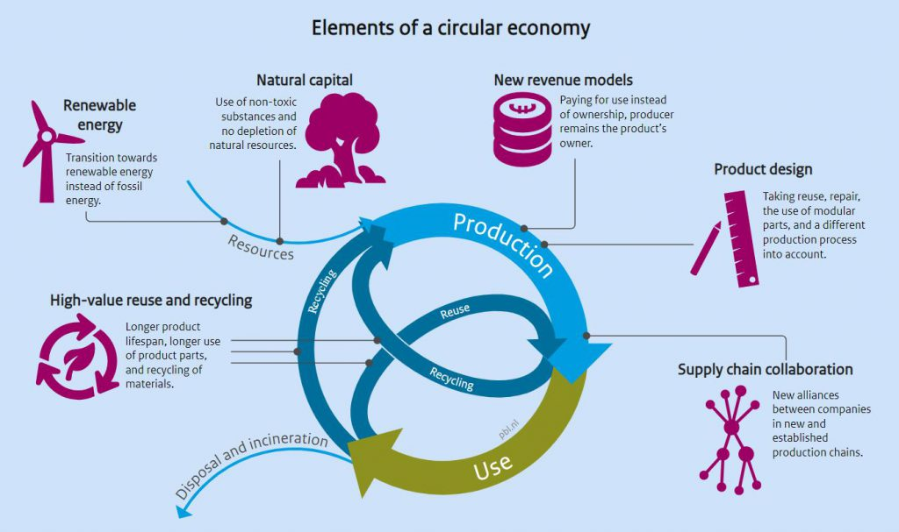
Figure 3. Elements of a circular economy.

Case Study
FRAME started in 1994 as a very small company reselling used furniture to the local community, especially to those who were disadvantaged socially or economically. It has now grown into two furniture showrooms in Merlin's Bridge and Pembroke Dock. It is still involved in community projects and has opened the Green Shed as a community reuse centre. It has developed links to Pembrokeshire County Council and carries out waste-reducing activities for them throughout the year. Their whole business model involves being commercial in reusing and reducing waste of unwanted furniture by mending and repairing and selling these goods. This is done in order to sustain their charity programmes which involve delivering social value whilst helping the environment and fighting climate change.
Background to the Company
Frame is a company based in Pembroke, Merlin's bridge, but also have two units in Pembroke Dock, and Goodwick where they are continually expanding the opportunities for the placements who attend to try various tasks from upcycling to warehousing. They initially opened for those on benefits only and clients with mental health issues. Anyone can buy &volunteer, with 60% of their workforce having problems, but the company is there to help people who struggle to find employment elsewhere. Recycling has become a part of our everyday life. With inflation on the rise, we understand that most everyday items may not be affordable to many people. But this was not the case when Frame started nearly 30 years ago. The general lack of income means that charity shops are flourishing, but Frame provides furniture free of charge to people who are referred for this reason. Frame is also council-funded as a drop-in centre for people coping with mental ill-health
Frame’s goal is to be self-sufficient. Frame is a non-profit charity and a business; the two are not always easy. Participants take priority. Frame is reliant on funding/grants, which are awarded because of the people that Frame supports with many issues and because they recycle. The referring agencies change, and Social Workers, Support Workers etc. and so Frame keeps the public informed and up to date. One of the Frame outlets is called One of a Kind, and this team will be involved in upcycling furniture by preparing and re-painting and transforming them into something new. The second is called the Furniture Surgery, which is a reuse project by re-upholstering furniture to reduce waste. The Community Fridge is another project to help participants that want to be involved in food preparation, baking and cooking, and with the opportunity to assist in the community fridge known as the Green Shed Café. This project was only made possible with the support from WCVA and the landfill tax community fund after they donated £43,600 for the setup costs.
With contracts to Pembrokeshire County Council for bulky waste items, this means the team from Frame can collect bulky household waste, from house to garden, bicycles, rug and electrical appliances, such as white goods.
Challenges
One of the challenges that Frame must face is funding. Funding is and will always be a concern, as everyone is after the same funding pots. Frame has to try and be inventive with what they offer to secure the funding. While winning a contract with PCC to collect bulky waste was a big boom for Frame. With the need for valued occupation and real work, volunteering opportunities will always be needed. The partnerships Frame has with the council will hopefully continue and help keep them solvent.
Encourages social inclusion for the participants and volunteers.
- Provides education and training for participants and volunteers
- Encourages social inclusion for the participants and volunteers
- Develops self-worth and personal well-being for participants and volunteers
- Relives the effects of poverty and social deprivation
- Provides opportunities for the employment of disabled staff
Other challenges that Frame face is the will to expand, to be able to go green, supporting solar panels, moving more people into employment, and reaching out to more people through marketing, and with petrol prices on the up frame would like to go to all electric vehicles.
Conclusion
In summary Frame has been illustrated to be a business that tries to embrace the principles of the circular economy. In recycling and up cycling furniture it prevents extraction from the earth of any new raw materials. In creating a business based on recycling and reusing it manages to reduce the consumption of fossil fuels that create global warming. Frame in mending and repairing the furniture extends the useful life of these products. This creates a huge decrease in waste and landfill. It is educating a whole local community that you do not have to buy new to have good furniture. Frame is enabling from a grass root level true innovation in the world of home furniture and at the same time has created new local jobs. Frame in supporting the local community with new skills has helped those in society who are more challenged both in terms of mental health and well-being. It continues to grow to meet any changes in consumption habits by adding value to the shopping experience with cafe and workshop. Its long-term goal is to have furniture shops around the whole of Pembrokeshire negating the fact that new furniture has to be bought but can be obtained by recycling and up cycling that furniture that is already in existence

References
Pembrokeshire Frame, supporting local people (2020). Available at
https://www.pembrokeshire-Frame.org.uk/ (Accessed on 7th March 2022)
Collectivegreen(2022). What’s the difference between circular economy and sustainability? Available at
What’s the difference between Circular Economy and Sustainability? – COLLECTIVE GREEN (Accessed on 8th March 2022)
Ellen Macarthur foundation (2021). What is a circular economy? Available at
What is a circular economy? | Ellen MacArthur Foundation (Accessed on 7th March 2022)
pembrokeshire-Frame.org.uk/our-vision-mission. Available at
https://www.pembrokeshire-Frame.org.uk/pembroke-dock-creative-reuse-centre/conculsion (Accessed on 7th March 2022).
Smith DS (2022). How to bring your business in to the circular economy. Available at
https://www.dssmith.com/sustainability/circular-economy/your-business-the-circular-economy/how-to-bring-your-business-in-to-the-circular-economy ( Accessed on 8th March).
Pembrokeshire Frame supporting local people (2022). Available at
Who We Are - Pembrokeshire Frame (pembrokeshire-Frame.org.uk) (Accessed on 9th March 2022).
Government of the Neverlands. (2017). The Government-wide programme for a circular economy entitled’ A Circular Economy in the Neverlands by 2050. Available at
From a linear to a circular economy | Circular economy | Government.nl. (Accessed on 9th March 2022)
Lahti, Wincent and Parida (2018) define the circular economy as an environmental change in response to the global need for an ecological economy, which requires human economic activities that are consistent with the three Rs principles: Reduce, reuse, and recycle.
Businesses that recycle goods into resources that can be reused will reduce waste and cut down on using raw materials. Available at
https://ellenmacarthurfoundation.org/topics/circular-economy-introduction/overview (Accessed on 9th March 2022)
A Definition and Theoretical Review of the Circular Economy, Value Creation, and Sustainable Business Models: Where Are We Now and Where Should Research Move in the future? Tom Lahti 1 , Joakim Wincent 2,3,4 and Vinit Parida 3,5,* Available at
https://ellenmacarthurfoundation.org/topics/circular-economy-introduction/overview (Accessed on 9th March 2022).
Waste 4 change (2021). The 5 common obstacles in implementing circular economy. Available at
The 5 Common Obstacles in Implementing Circular Economy - Waste4Change
( Accessed on 10th March 2022)

