University of Wales Trinity Saint David
Wales Institute of Science & Art

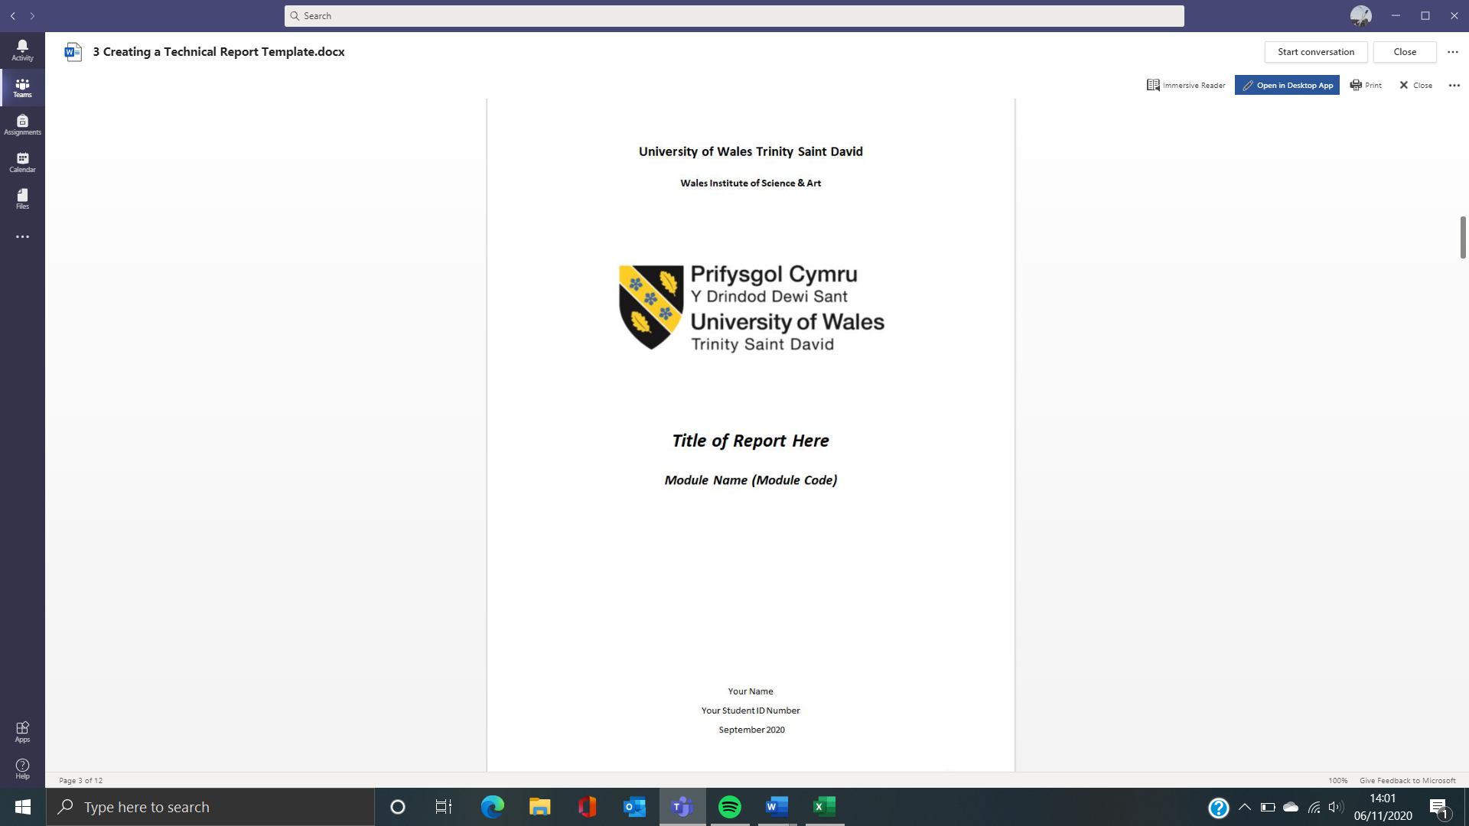

Risk Assessment & Technical Report
Workshop & Practise ACHA4011

Daniel Pewsey
1901754
March 2021

Contents page

1.Introduction
1.1 Aims and objectives
2.Research Review
3.FMEA Risk Assessment
3.1. Initial FMEA
3.2. Post Mitigation FMEA
4.Conclusion
5.References

Risk Assessment & Technical Report

1.Introduction
The aim for my investigation is to assess an assembly lines processes and establish potential risks and hazards in the workplace, the importance of analysing the safety of a working environment is paramount especially when that environment features heavy machinery and large objects such as a production line for a car manufacturer, These risks need to be managed by use of mitigative actions and need to be understood by all engineers as its crucial to their safety and vital in their role and duty as an engineer.

  - Aims and objectives: -

My first aim is to establish potential risks and hazards in the workplace and organise them in terms of how prevalent and dangerous that risk is. My objectives are:

- To analyse the workspace and find potential hazards and risks to make the engineering workers aware of the risks.
- To input these hazards and risks into a spreadsheet so they can be ranked and analysed in terms of the likelihood of occurrence, the severity, and the likelihood of detection.
- To use the resultant analysed values to rank the hazards and risks in terms of a priority number system, this ensures that the most prevalent risks will be prioritised to raise awareness and therefore improve safety.
- To then create mitigating actions for the workspace using the priority number to improve safety and lower the risk where the engineers require it the most.

My second aim is to implement mitigating actions to reduce risk and improve safety in the workspace for the engineers. My objectives are:

- To implement mitigating actions to lower the priority numbers of the risks and hazards on the assembly line.
- To research modern features of production lines that reduce risk and improve safety for the workers.

My third aim is to re-assess the previous risks and hazards to establish whether the preventative mitigating actions have had a significant effect on the safety aspect of the workspace. My objectives are:

- To reconduct the previous analysis after implementing the mitigative actions to evaluate any changes to health and safety.
- To re-order the risks in terms of their new priority.
- To identify whether there are and more potential risks of failure.

My fourth aim is to refer to official code of conduct and legislation to further improve my mitigating actions and ensure that they are realistic and effective. My objectives are:

- To refer to the Institute of Mechanical Engineers and adhere to their standards to improve safety in the workspace.
- To adhere to the governments H&S legislation to make sure that the production line is safe, and the risks and hazards are managed.

2.Research Review
The Importance of Risk Management in transport
The transportation industry is a very prominent figure when it comes to the forefront of production line-based manufacturing, cars have been made on these production lines for over 100 years and companies are advancing their technologies in this department at an ever-increasing rate.
The requirement for risk management in the transportation manufacturing sector is vital so the engineers need to keep to a standard or code of conduct such as the IMECHE code of conduct, the risk management is vital because it will protect the engineers from endangering their own health through means of whether that would be through lack of competence or other reasons. The code of conduct will enforce this and ensure that the engineer is responsible and honest with their stance, for example if a heavy object needs lifting then you need to be responsible and ask for assistance or you could potentially endanger your own health or the health of others around you, this specific scenario is mentioned in the IMECHE code of conduct where “if aware or on becoming aware of relevant limitations in, or in any respect unsure of, their competence to undertake professional work they shall disclose that fact to their employer or the client of the work” which would refer to them being honest to their employer or client about undertaking the task with their level of competence. A situation like this would be commonplace on a production line of a transportation manufacturer as in those environments there will be large machinery and many heavy-duty tools which could potentially cause serious harm if not handled with a level of competence.
Another issue is that some companies will try to cut corners when it comes to enforcing health and safety to try and save costs, therefore the government has to enforce a legislation that makes sure that the health and safety in all workplaces has a low risk level so that a standard is achieved, and people are safe in their workplace. The HSE legislation gives a guide for businesses for what general duties they have toward their workers and toward any others involved in their product. They also give advice on risk assessment such as FMEA risk assessments.
The FMEA risk assessment is a very useful tool for mitigating risks in the workplace and ensuring that workers are safe and your duty of care as an employer or client in intact. The FMEA is a clear set out risk assessment which will assist in organising and managing the risks in the workplace, this will make the mitigating actions easier to enforce and will therefore lower risk.
When I analyse the risks in this project, I will be using FMEA to help structure the mitigations and review the progress after implementing them.

3.FMEA Risk Assessments
3.1 Initial FMEA

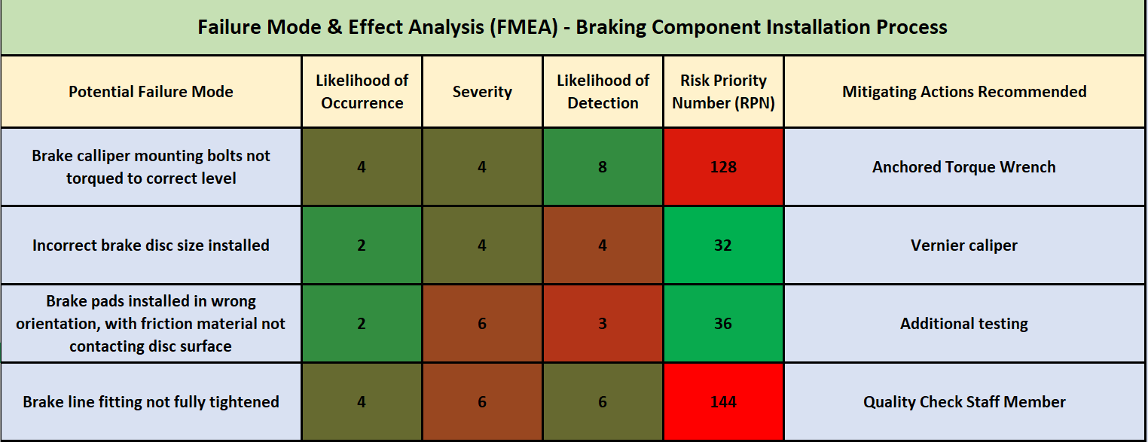

Failure 1
The hub of the wheel which the calliper is attached to is often subjected to a large amount of bumps and vibrations due to it being unsprung, if the mounting bolts are not torqued correctly it could either shear the bolt and get stuck into the thread or could alternatively shake itself loose, the consequences of this could potentially be very severe as it could cause damage and a loss of pressure of the braking system therefore potentially causing a loss of brakes, this would have a high chance of causing a potentially fatal incident. This would also cost the business a considerable amount of compensation and would decrease the brand popularity and overall safety image.
Mitigating actions
After looking into some methods used by big manufacturers such as BMW, I have found that to mitigate these sorts of risks they use anchored tools, this is basically where the tools are a part of the actual production line and are electronically set through the production line, this therefore removes the possibility of a human error when torquing the calliper bolts and reduces the risk of not torquing to the correct level by a large margin. Systems like this also reduce risk when the production lines use is changed, for example making a different part which requires a different torque setting than the previous part, it will remove the need for a human to go and change the settings.

Failure 2
The brake disc is seated on the hub of the wheel with the brake calliper and brake pads clamping onto it in a braking situation, if the disc is the incorrect size then the brake pad will not make full contact with the disc, this could potentially cause a few scenarios where the brake pad becomes unseated or the disc wears unevenly causing a vibration under braking, this could result in a loss of brakes and therefore potentially a fatal car accident.
Mitigating actions
A good way of reducing the chances of this risk occurring is to have the worker check that the diameter of the disc is to the correct specification, this can be done using a tool such as an electric vernier calliper to check the diameter is correct before it is assembled as this would add an extra layer of protection against a risk occurring.

Failure 3
The brake pads are seated in the brake caliper in between the brake piston and the brake disc, as the pressure increases in the braking system the piston pushes out and clamps the brake pad onto the disc slowing the vehicle down. If the brake pad is installed in the wrong orientation where the friction material is not contacting the disc this can causing a multitude of problems. The car will not be able to slow down sufficiently causing a great risk to the passengers of the car, this could result in a potentially fatal accident which would cause many problems for the brand image and in terms of cost. Even if the car does stop using the brakes it could cause the added risk of chattering from the brakes and would also potentially damage and warp the disc.
Mitigating actions
To reduce the risk of these scenarios occurring the production line could perform brake tests to reduce the chances of that happening, for example, a system could be attached to the caliper and could pressuring the system individually, this would move the pistons and therefore the brake pads into the braking position. After a small inspection from a technician to see whether contact is made with the disc on the friction material or not it would be determined whether there is any risk of the brake pads being in the incorrect orientation therefore mitigating the risk.

Failure 4
The brakes of the vehicle on the production line use a hydraulic system where fluid pressurizes the system and pushes the brake caliper pistons and slows the car using discs and pads to cause a frictional opposing force, this works using a series of brake lines which are subject to a high pressure. When attaching these brake lines there is a possible risk that they may not be attached correctly potentially causing a leak in the system which could waste brake fluid and could cause a hazard on the production line due to it being a harmful chemical and also potentially a slip hazard, another issue is that if the brake line isn’t loose but is also not tight enough then the pressure could work it loose over time meaning that the customer could be driving the car, the car would then have a complete loss of brake pressure and therefore there is a large risk that the car would go out of control causing a potentially fatal incident. This would have a severe effect on the manufacturers safety image and would cost a significant amount of money.
Mitigating actions
A method of countering this risk would be to add an additional quality check engineer to the production line therefore significantly reducing the chances of the initial workers error making it through the production phase. Another aspect would be to add hazard mitigations such as keeping an absorbent material nearby in case of a spill such as a brake fluid leak.

3.2 Post Mitigation FMEA

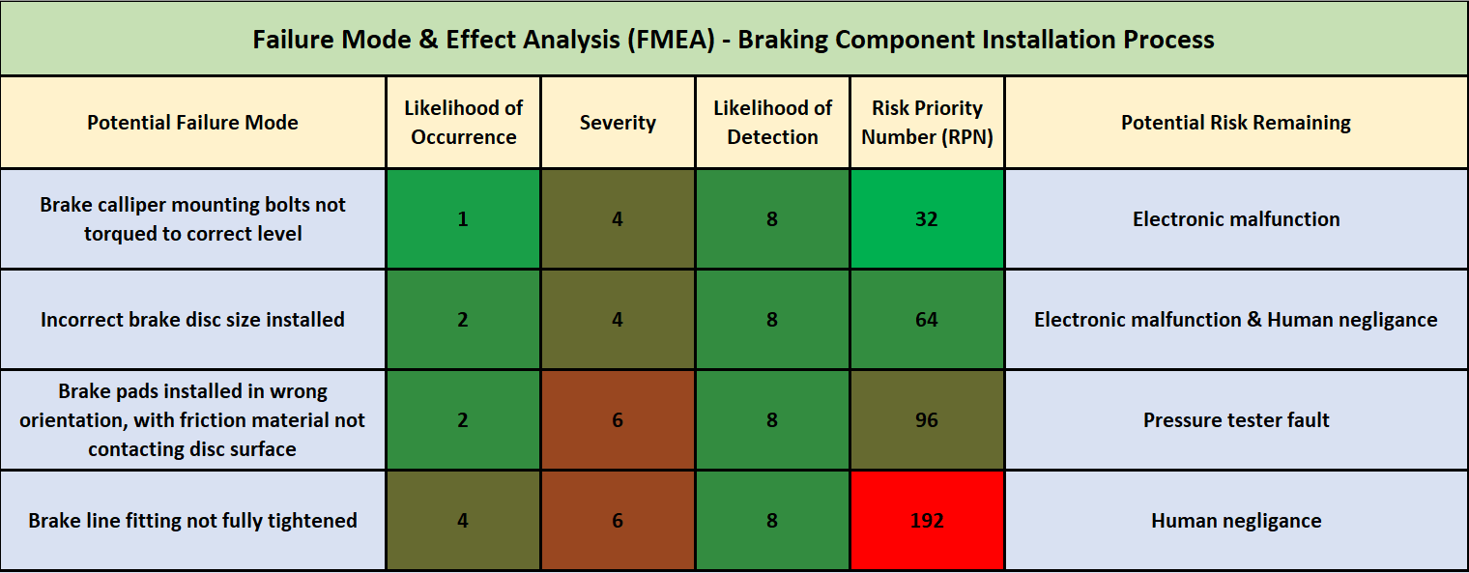
Failure 1
The mitigative action for the first risk greatly reduces the likelihood of the risk occurring and if the failure were to occur the tool would notify the user.
Systems such as the Anchored torque wrench can electronically malfunction due to an electrical surge which could therefore damage circuitry and computer systems which control the module therefore potentially causing the torque setting to be incorrect, this however has a very low chance of happening as long at the systems are checked by trained professionals at maintenance intervals which are set by the manufacturer.

Failure 2
A vernier calliper greatly increases the chance of the detection of this risk
The action taken to prevent this risk are very simple and effective, the likelihood of an electronic failure on such a small device is very unlikely and as long as the workers keep logs of what size the part needs to be, then their own responsibility and competence as a worker is the only potential risk remaining that has a significant possibility.

Failure 3
The pressure testing system would greatly increase the likelihood of detection of a misfitted brake pad as it would be clear to the visual inspection.
This mitigative action does require more complex machinery and therefore there is a possibility that the machinery could fail, however, it has a very low likelihood as long as the machines are maintained correctly by a professional.

Failure 4
The addition of a quality check engineer to check the fittings would greatly increase the likelihood of detection and therefore reduces the likelihood of occurrence greatly.
Any other potential risk of this scenario occurring would occur through lack of competence of the engineer, this was referenced in my research and is one of your duties as an engineer that follows code of conduct.

4.Conclusion
Conclusion of FMEA
To conclude my FMEA the risks presented were mitigated effectively using methods that greatly decreased the likelihood of occurrence and/or the likelihood of detection, I believe this has reduced overall risk significantly and uses some new researched technologies as methods of reducing risk. The remainder of risk greatly depends on the competence of the engineers as they have sufficient mitigation methods to assist them with the smaller more plausible mistakes such as not tightening a bolt correctly.
FMEA is a vital tool in all aspects of any industry as it helps risk assessment staff organise and improve on theirs and their colleague’s workspace safety, it is a very effective tool overall and should be used wherever possible in the workplace and as an engineer as a whole.
In terms of achieving my aims I feel that I have used my objectives well to give a balanced overview and provide a good assessment of risk.

5.References
BMW Motorrad Assembly line 2011 BMW AG
https://www.youtube.com/watch?v=WNSGhcc4NSQ&ab_channel=CarsGarage
This video was analysed by me and hence I learnt about the existence of the anchored tools which are attached to the assembly line.

Institute of Mechanical Engineers 05/12/2018
The code of conduct was used in the research section of my project to find out the responsibilities that an engineer has in the workplace and why it is vital to adhere to a code of conduct for risk mitigation reasons.

Health and Safety Executive 2005 (Last Main Update)
This was used in my research section to establish the governments enforcement of health and safety in a workplace.

