

Module Name: Digital Skills for Personal and Professional Growth
Module Code: BMSW4008
Assignment Name: Evidence of Learning (E-Portfolio)
Student Name: Tudor-Florin Vass
Student Number: 2436754
Lecturer: Gareth Hughes
AI Acknowledgement
I confirm that no AI-generated content has been submitted as my work. I also confirm that I have all the drafts, notes, and resources used to prepare this assignment and can provide them if needed.
Table of Contents
Task 1 – Market Research and Website Development Project 4
1. Introduction 4
2. Market Research Methodology 4
3. Key Findings from Survey 4
4. Website Design Based on Research Insights 7
5. SEO and Marketing Strategy 9
6. Conclusion 10
References 11
Task 2 12
Part A: Excel Spreadsheet – Financial Projection 12
Part B: Essay – Importance of Excel in the Digital Era 13
Reference 16
Task 3: 17
Title Slide 17
Slide 1 17
Slide 2 18
Task-4 19
Slide 1-Title Slide 19
Slide 2 – Project Overview 19
Slide 3 – Market Research Design 20
Slide 4 – Data Analysis Process 21
Slide 5 – Key Findings from Market Research 22
Slide 6: Website Development 23
Slide 7 – Marketing Materials Design 24
Slide 8 -Video Advertisement Campaign 25
Slide 9 Reflections and Learning 26
Slide 10: References 27

Task 1 – Market Research and Website Development Project
Website link: https://thecampusbrewuk.wixsite.com/the-campus-brew-uk
Survey link: https://docs.google.com/forms/d/e/1FAIpQLSd3Fo6xkpDqi4i04xerE9S1v1wL1AxkSfIVZxTrdse4wSNj-A/viewform?usp=header

1. Introduction
This project examines the creation of Campus Brew UK, a proposed mobile coffee cart venture that will aim to provide campus students with convenient and affordable coffee services at the university. Online questionnaire was used in carrying out market research to learn about coffee consumption habits, preferences, and purchasing behaviour of students. The information obtained in the survey was very insightful in terms of demand of coffee services that are personal, affordable, and accessible. The findings were later applied to develop the business idea, site layout and marketing plans, such that the projected service addresses the needs and expectations of the target student market.

2. Market Research Methodology
Primary data collection was conducted through a Google Forms questionnaire as part of the market research of Campus Brew UK (Mondal et al., 2019). Online surveys are also popular in business research because they enable the researcher to effectively collect opinions and behavioural data about the respondent (Regmi et al., 2016). The survey had 10 statements in a five-point Likert scale, Strongly Agree to Strongly Disagree, to allow the respondents to express their perceptions regarding coffee use, cost, and convenience on campus. Likert scales are applied in the survey research to determine the perceptions and behavioural intentions (Bhandari and Nikolopoulou, 2020). The questionnaire was emailed to the students in the university, who are the key target market of the Campus Brew UK, and 10 students were reached. The information collected was used to determine trends which influenced the business idea, pricing strategy, web development and marketing strategy.

3. Key Findings from Survey
The survey findings present a number of key trends connected to the coffee drinking patterns of students, their price sensitivity, and their desire to use the Campus Brew UK idea.

Figure 1: Finding 1 Chart from Q1
(Source: MS Excel)
Firstly, the answers to Question 1 imply that coffee drinking is widespread among students. Among the 10 respondents, 4 were strongly in agreement and 3 in agreement that they drink coffee or other caffeinated beverages throughout their day. Neutral was only chosen by 1 respondent and 2 disagreed. It indicates that 70% of the respondents take coffee regularly, meaning that coffee dominates the day-to-day activities of the students and that coffee services are in high demand on campus.

Figure 2: Finding 2 Chart from Q2
(Source: MS Excel)
Secondly, Question 2 examined the issue of cheap coffee on or around campus. The findings indicate that 5 respondents said yes and 2 said strongly yes, affordable access to coffee is important to them. In the meantime, 1 respondent was neutral, 1 disagreed, and 1 strongly disagreed. 70% of respondents shared positive impressions regarding cheap coffee, which means that price is one of the most important criteria to consider when making buying decisions. This favours the concept of selling coffee between the prices of £2 and £3 so as to attract student budgets.

Figure 3: Finding 3 Chart from Q4
(Source: MS Excel)
Question 4 also tested the interest of students to buy coffee in a mobile coffee cart that is situated on campus. The findings indicate that 3 respondents firmly agreed and 4 agreed, and 3 respondents were neutral. Interestingly, none of the respondents chose disagree or strongly disagree. This represents that 70% of the respondents expressed evident interest in an on-campus mobile coffee cart, which indicates that there is a high potential of Campus Brew UK business model.

Figure 4: Finding 4 Chart from Q9
(Source: MS Excel)
Lastly, Question 9 explored the effect of the promotions and discounts on students on the purchasing behaviour. The outcomes demonstrate that 3 of the respondents strongly agreed and 4 agreed, 2 of them had neutral, and 1 disagreed. It also implies that 70% of the surveyed individuals feel that promotions would motivate them to buy coffee at Campus Brew UK, which proves the value of student-oriented discounts and marketing tactics in customer attraction.

4. Website Design Based on Research Insights
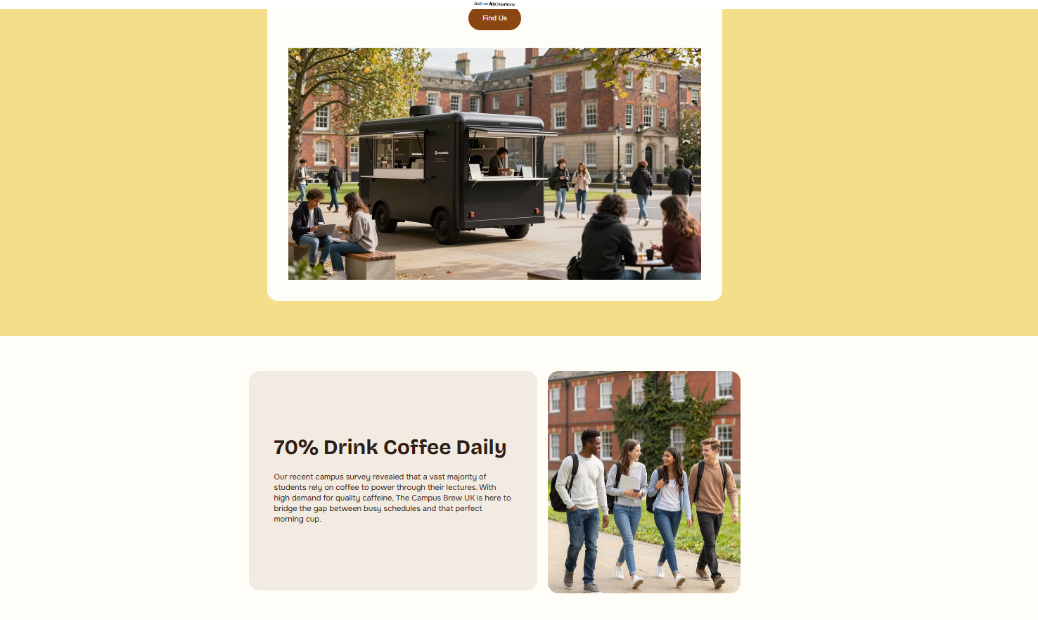
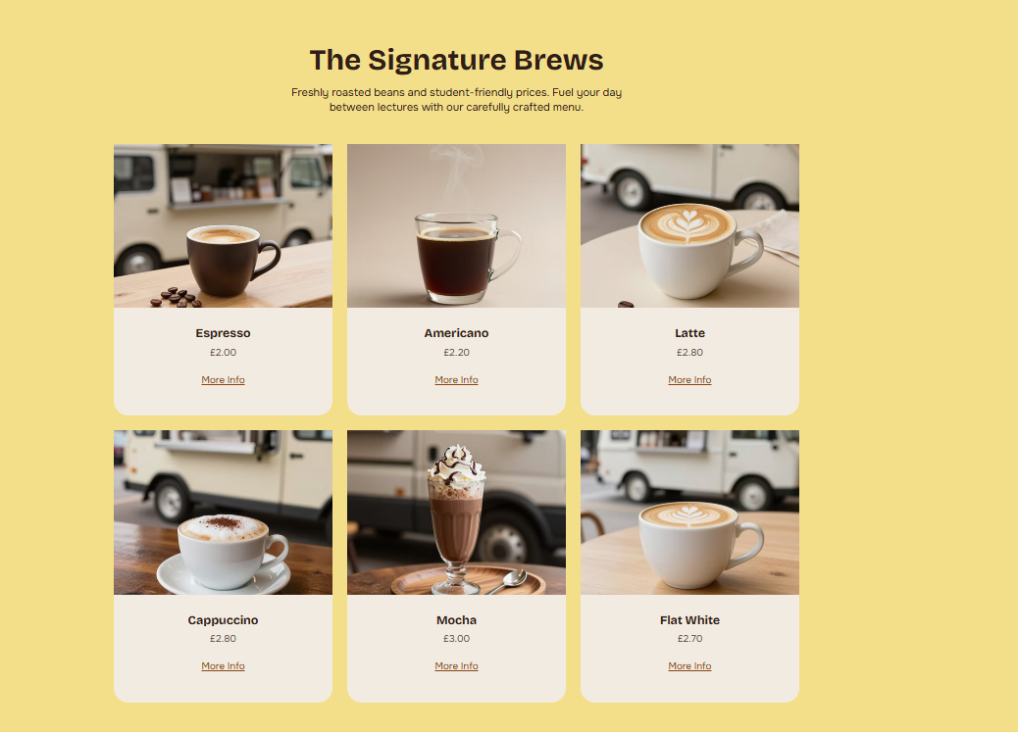
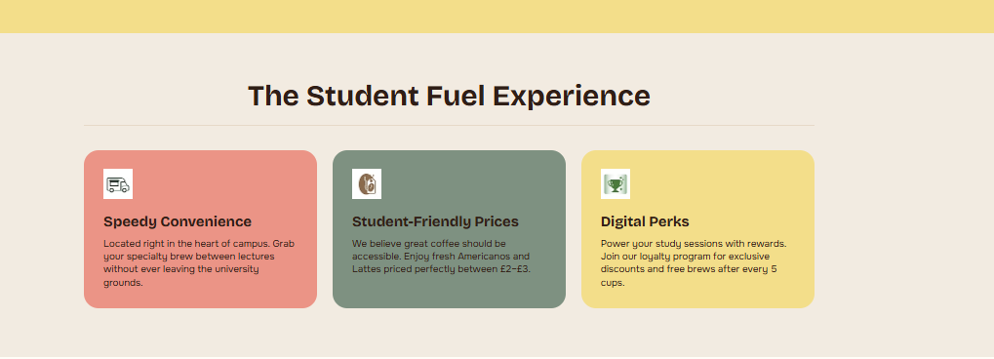
Figure 5-7: Website Design
(Self-created)
The Campus Brew UK site was designed based on the results of the survey directly and with the purpose of representing needs and preferences of university students. Because the survey shows that 70% of the surveyed people drink coffee regularly and treasure affordable prices, the site features student-friendly pricing by prominently featuring sections like Quality Shouldn’t Break the Bank and showing menu items between £2 and £3. This strategy consolidates the value proposition of the brand which promises low-cost coffee to students (Corporate Finance Institute, 2022). Also, as a significant number of respondents were interested in convenient on-campus coffee services, the site is divided into such sections like: On-Campus Convenience for Busy Students and Fast Grab-and-Go Service, as they are focused on the accessibility and speed between the lectures. The visual messages, including the image of campus surroundings, a coffee cart in a hand, and images of student lifestyle were also used to provide the target audience with relevance and relatability (Traboco et al., 2022). The webpage design is enhanced to be plain and easy to navigate so that visitors can simply scroll information on the concept, menu and benefits. To enhance user engagement and digital marketing strategy, it is critical to match the design of websites with their preferences (Chaffey and Ellis-Chadwick, 2019).

5. SEO and Marketing Strategy
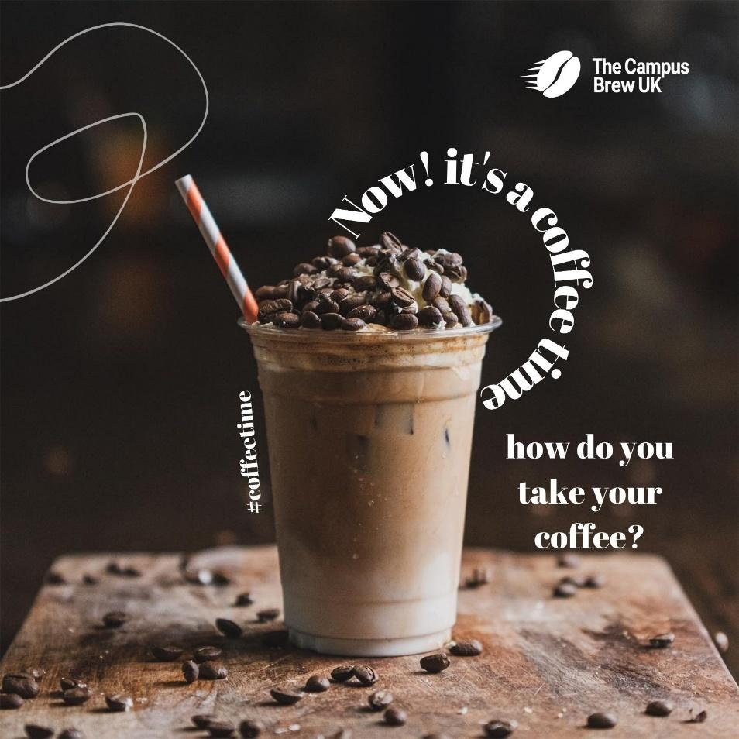
Figure 8: Marketing Material 1
(Created on Canva)

Figure 9: Marketing Material 2
(Created on Canva)
The digital marketing and mobile search of Campus Brew UK aims at enhancing operation and visibility of the business online and attracting student clientele via specific online platforms (Usmany et al., 2024). The website has relevant keywords including student coffee, campus coffee cart and cheap coffee to ensure students which will enhance the ranking of the site in search engines. Instagram and TikTok should also be suggested as the possible social media to promote the offers and to connect with students (Ashraf et al., 2021) (Mishnick and Wise, 2024). Moreover, the brand awareness and retention may be enhanced with the help of student offers and customer loyalty (Bariha, 2021).

6. Conclusion
The survey results show that students have high demand of convenient and affordable coffee at the campus. These pieces of knowledge informed the Campus Brew UK business idea, web design and marketing plan, as to make the suggested coffee cart meet the needs and preferences of the university students successfully.

References
Ashraf, M.A. (2021). Social Media Improves Students’ Academic Performance: Exploring the Role of Social Media Adoption in the Open Learning Environment among International Medical Students in China. Healthcare, 9(10), p.1272.
Bariha, P.P. (2021). Customer Loyalty Program and Retention Relationship. Psychology and Education Journal, 58(1), pp.5069–5074.
Bhandari, P. and Nikolopoulou, K. (2020). What is a likert scale? | guide & examples. [online] Scribbr. Available at: https://www.scribbr.com/methodology/likert-scale/ [Accessed 8 Mar. 2026].
Chaffey, D. and Ellis-Chadwick, F. (2019). Digital marketing. Pearson uk.
Corporate Finance Institute (2022). Value Proposition. [online] Corporate Finance Institute. Available at: https://corporatefinanceinstitute.com/resources/management/value-proposition/ [Accessed 9 Mar. 2026].
Mishnick, N. and Wise, D. (2024). Social Media Engagement: An Analysis of the Impact of Social Media Campaigns on Facebook, Instagram, and LinkedIn. International journal of technology in education, 7(3), pp.535–549.
Mondal, H., Mondal, S., Ghosal, T. and Mondal, S. (2019). Using Google Forms for Medical Survey: A Technical Note. International Journal of Clinical and Experimental Physiology, 5(4), pp.216–218.
Regmi, P.R., Waithaka, E., Paudyal, A., Simkhada, P. and Van Teijlingen, E. (2016). Guide to the Design and Application of Online Questionnaire Surveys. Nepal Journal of Epidemiology, 6(4), pp.640–644.
Traboco, L., Pandian, H., Nikiphorou, E. and Gupta, L. (2022). Designing Infographics: Visual Representations for Enhancing Education, Communication, and Scientific Research. Journal of Korean Medical Science, 37(27).
Usmany, P., Rachmawati, R., Rembe, E., Sopacua, F., Santosa, T.A., Arifin, A.H., Fitria, A. and Suhardi, S. (2024). The Effectiveness Of Search Engine Optimization (SEO) In Marketing: A Meta-Anlysis Study. Journal of Economic, Bussines and Accounting (COSTING), 7(5), pp.807–811.

Task 2

Part A: Excel Spreadsheet – Financial Projection
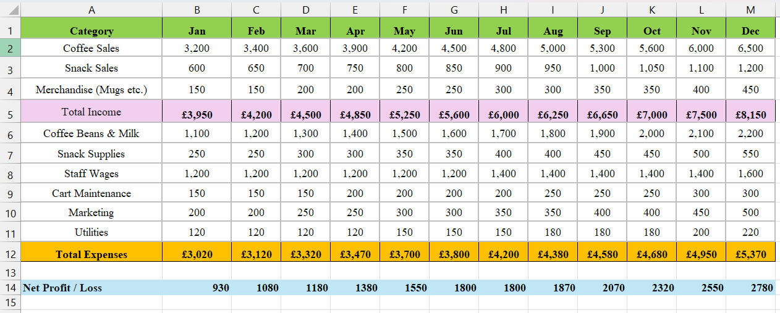
Figure 10: Financial Projection for year 1 [Calculated View]
(Source: MS Excel)
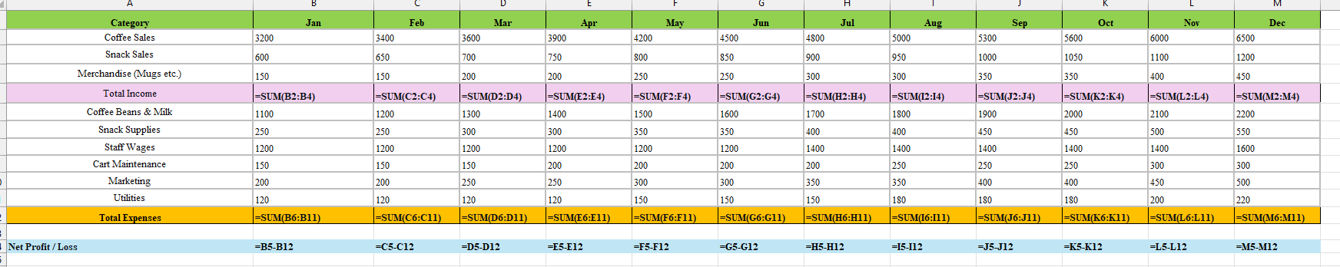
Figure 11: Financial Projection for year 1 [Formula View]
(Source: MS Excel)

Figure 12: Comparison chart of Total income vs Total Expenses
(Source: MS Excel)

Part B: Essay – Importance of Excel in the Digital Era
Introduction
In the contemporary digital economy, companies are strongly dependent on information and data analytics to facilitate decision making and financial forecasting (Tiwari, 2024). Microsoft Excel is a spreadsheet programme that is commonly utilised in the organisation, analysis, and presentation of business data (Charlesworth, 2024). It enables organisations to do calculations, monitor financial data, and visualise the trends in form of charts and tables. These features render Excel a vital instrument to entrepreneurs and managers to analyse the performance of a business and predict outcomes in the future (Microsoft, 2023). The Campus Brew UK project provides an example of how digital tools can facilitate planning and informed decision-making in small businesses by creating a financial projection of the first year of operation in Excel.
Main Body
Role of Excel in Business Financial Planning
Excel is very important in business financial planning of all organisations. Spreadsheets are often applied to monitor revenue, expenditure and profitability in time at the companies. Excel is flexible which means that organisations can design their own budgeting and forecasting models depending on the needs of their businesses (Harrison, 2024). As an example, the sources of income and costs of operations can be structured into monthly spreadsheets which will assist the managers to know the financial performance and future investments. Spreadsheet also assists businesses in analysing the cash flow patterns and also detecting possible financial risks. As Adisa (2025) demonstrates, numerous organisations are still experiencing budgeting and financial planning on Excel because it is flexible, available and affordable to use than specialised financial software. This renders Excel very convenient to start-ups and small companies that need effective financial management tools.
Data Analysis and Decision Making
The most valuable benefit of Excel is that it can be used in data analysis and decision-making. Companies are able to store huge amounts of information, use formulas and create charts, which can identify trends and patterns (Raubenheimer, 2017). Excel transforms raw data into valuable information that can be used to make strategic choices through such tools as pivot tables, graphs, and conditional formatting (Microsoft, 2023). As an example, the data concerning the income and expenses may be analysed to assist managers in assessing the profitability and identifying whether a business model is sustainable. The owners of the business can also compare the financial performance at different months using visual representations like bar charts (Raubenheimer, 2017). Excel can assist organisations to make evidence-based and informed decision by providing data in a format that is easy to understand and thus enhances operational efficiency and performance.
Efficiency and Automation in Excel
Excel is also efficient in organising an organisation by automating and performing calculations using formulas. The SUM, AVERAGE, and other financial formulas can also be used by the user to carry out complex calculations automatically, which minimises the likelihood of mistakes that could have occurred during manual calculation (Corporate Finance Institute, 2024). Automation features such as macros and templates also help save time by automating repetitive work on behalf of business professionals. Excel has also been used in financial management to compute total income, expenses, and profit margins automatically through inputted data, which business can quickly assess their financial health (Bailey, 2024). These automated functions are more productive and help organisations to work with massive data in an easy way. This makes Excel still a key to financial modelling, budgeting and operational planning in most industries.
Excel in the Digital Business Environment
Decision-making in the digital business world has become more critical today due to the use of data (Tiwari, 2024). Excel helps in this process because it allows organisations to gather, arrange and examine business data. The software combines the data analysis tools, charts, and dashboards that enable managers to monitor business performance on real-time basis (Microsoft, 2023). Moreover, Excel facilitates forecasting, and trend analysis which helps companies in making predictions about the future of their financial performance and strategize on how to approach the future. The use of spreadsheets is still a trend among many companies in the digital transformation strategies due to its flexibility and integration with other business software solutions (School of Coding & AI, 2025). Consequently, Excel is still useful to small start-ups as well as large organisations that are in the digital economy.
Conclusion
Overall, Microsoft Excel remains an effective solution in the digital age of financial data management, business performance analysis, and strategic decision-making. Its flexibility, analytical analysis and automation features specifics make it quite beneficial to start-ups and small businesses. In the Campus Brew UK project, the Excel software allowed developing a financial forecast that allowed assessing the profitability and sustainability of the business. Financial planning and analysis of data in spreadsheets can help entrepreneurs make better decisions and increase their probability of successful businesses in the long term.

Reference
Adisa, Z. (2025). The Impact of Excel on Decision-Making in Financial Institutions. [online] DEV Community. Available at: https://dev.to/zeeintech/the-impact-of-excel-on-decision-making-in-financial-institutions-301a [Accessed 10 Mar. 2026].
Bailey, K. (2024). What-If Analysis. [online] Corporate Finance Institute. Available at: https://corporatefinanceinstitute.com/resources/financial-modeling/what-if-analysis/ [Accessed 9 Mar. 2026].
Charlesworth, L. (2024). What is microsoft excel used for and is it still relevant? [online] Kaplan.co.uk. Available at: https://kaplan.co.uk/blog/features/is-microsoft-excel-still-relevant [Accessed 9 Mar. 2026].
Corporate Finance Institute (2024). Basic Excel Formulas. [online] Corporate Finance Institute. Available at: https://corporatefinanceinstitute.com/resources/excel/basic-excel-formulas-beginners/ [Accessed 6 Mar. 2026].
Harrison, L. (2024). Excel spreadsheets vs web-based budgeting apps - which is better? [online] Phocassoftware.com. Available at: https://www.phocassoftware.com/resources/blog/budgeting-software-vs-excel [Accessed 7 Mar. 2026].
Microsoft (2023). Spreadsheet Programs | Microsoft 365. [online] Microsoft.com. Available at: https://www.microsoft.com/en-us/microsoft-365/excel/spreadsheets [Accessed 10 Mar. 2026].
Raubenheimer, J. (2017). Excel-lence in Data Visualization? Data Visualization and Statistical Literacy for Open and Big Data, pp.153–193.
School of Coding & AI (2025). Importance of Microsoft Excel in Business: 10 Reasons. [online] School of Coding & AI. Available at: https://schoolofcodinguk.com/blog/importance-of-microsoft-excel-in-business/ [Accessed 10 Mar. 2026].
Tiwari, V. (2024). Role of Data Analytics in Business Decision Making. Knowledgeable Research A Multidisciplinary Journal, 3(01), pp.18–27.

Task-4

Slide 1-Title Slide
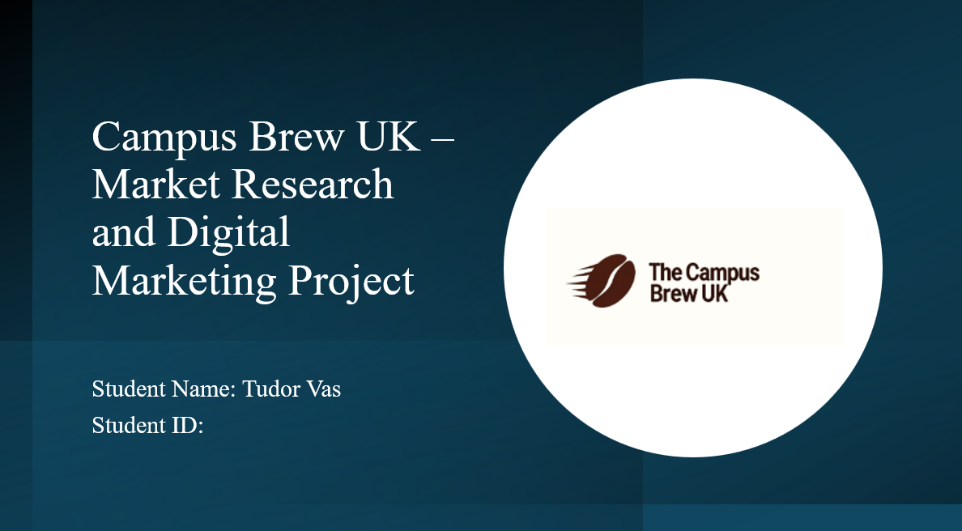

Slide 2 – Project Overview
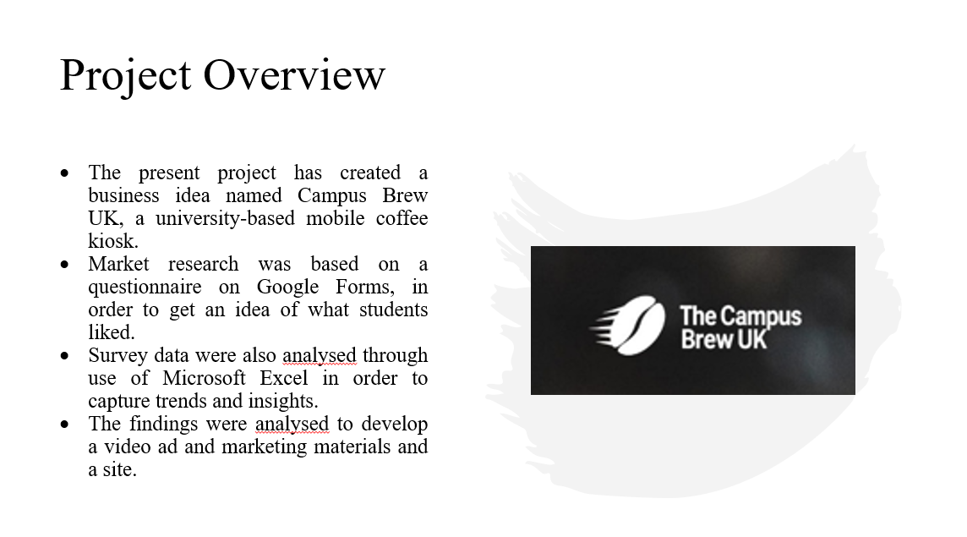
The current project was aimed at developing a business idea, which is a mobile coffee stand that targets university students and is named Campus Brew UK. This was to be done to find out the student coffee consumption patterns and what prospects an affordable coffee service on campus had. In order to do that, primary market research was conducted through Google Forms questionnaire. The data collected through the survey was analysed in Microsoft Excel in order to establish patterns and insights. According to these results, a Web site, advertising materials and a video advertisement have been developed as means of spreading the idea of Campus Brew UK and conveying the brand message.

Slide 3 – Market Research Design
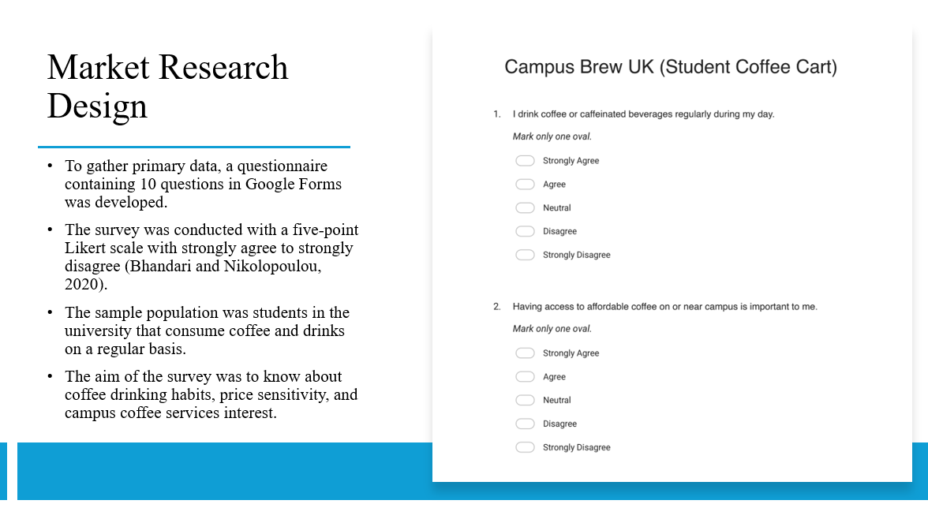
The questionnaire that was developed via Google Forms was used to carry out the market research in this project. The questionnaire contained ten formatted questions that were aimed at knowing the coffee consumption habits and preferences of the students. The Likert scale was five points, whereby the respondents were allowed to respond on a scale of strongly agree to strongly disagree. The respondents of interest were the university students as they are the major customers of Campus Brew UK. This survey was to be carried out in order to obtain information concerning the demand of coffee by students, their sensitivity to price and the interest of having convenient coffee services that are within the campus.

Slide 4 – Data Analysis Process

The survey results were obtained and then the data was exported to Microsoft Excel to be analysed. The responses were organised and percentages calculated using Excel and visual charts were created which aided in determining the trends in the data. With the help of these charts, it became convenient to comprehend the attitude of students to coffee use, affordability, and offers. The analysis was done with an aim of coming up with the most crucial questions that made pertinent contributions to the business concept. Through Excel, the data was interpretable making the findings to be used as a guide to make significant decisions regarding pricing, marketing strategies and the general structure of the Campus Brew UK site.

Slide 5 – Key Findings from Market Research
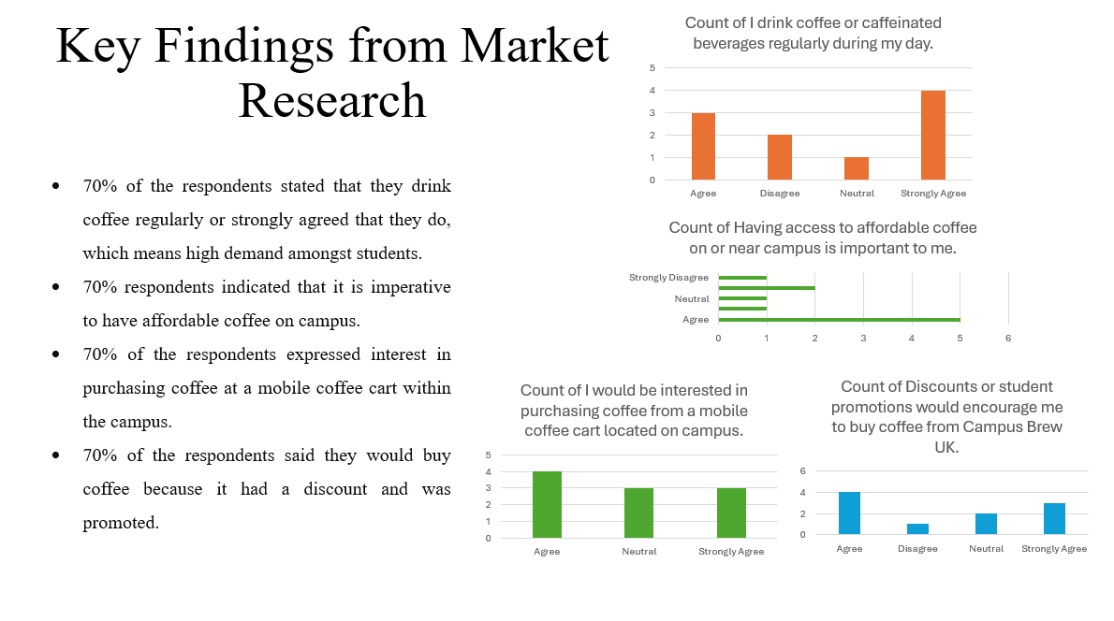
The survey analysis brought about interesting results concerning the behaviour of students. To begin with, approximately seventy percent of the respondents either approved or highly approved that they consume coffee or caffeinated drinks on a regular daytime basis. This validates the claim that coffee is an aspect of the daily lives of students. Secondly, seventy percent of the respondents revealed that it is important to them that affordable coffee is available on campus. Also, a majority of the respondents had indicated that they were interested in buying coffee in a mobile coffee cart that could be found in campus. Lastly, offers and student discounts were also determined to have a great impact on buying behaviour and marketing effort ought to be concentrated on promotions and incentives.

Slide 6: Website Development
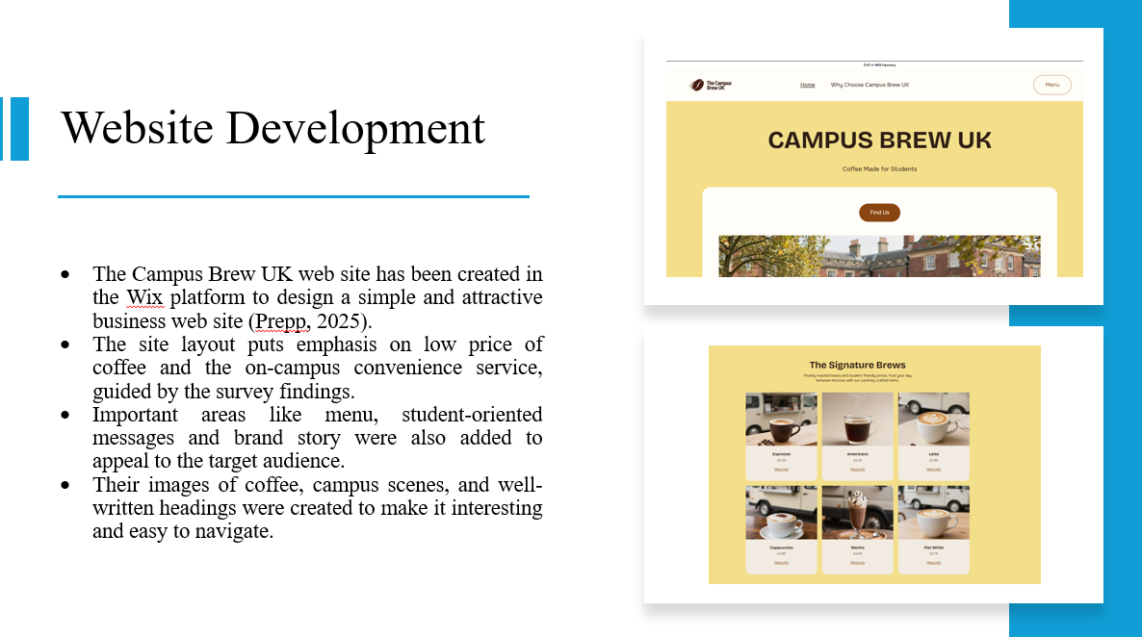
The Campus Brew UK web-site is created on the basis of the Wix platform to introduce the business idea in a clear and interesting manner. The web site was developed based on the findings of the survey. The site has focused on affordability and speed since students pointed out that these are key factors that they would use to decide on the choice of coffee at the campus. The menu, brand story and convenience message sections were added to appeal to the target audience. The use of images of coffee, and campus themes was also a visual feature that enhanced a pleasant and recognisable experience to students.

Slide 7 – Marketing Materials Design
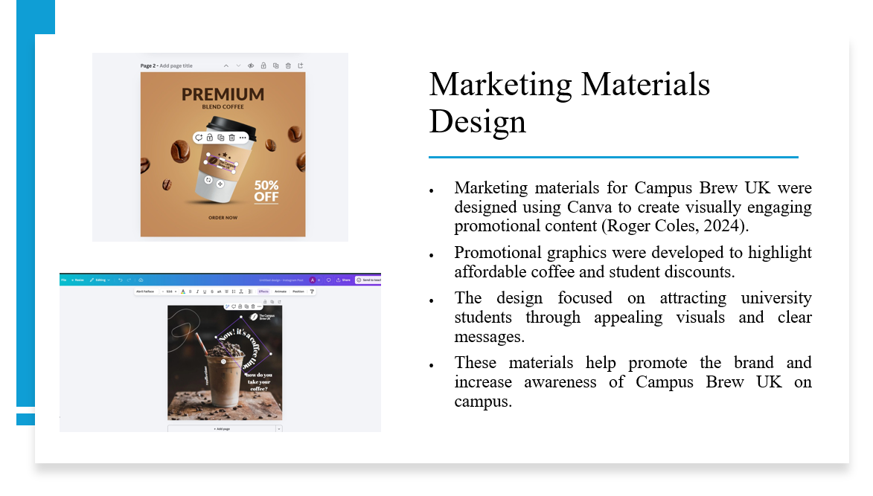
The marketing assets of Campus Brew UK were designed on the Canva design platform. Canva led to the creation of appealing promotional posters and graphics that brings to the fore the message of the brand. These were materials based on advertising cheap coffee, student discount and conveniently having access to coffee within the campus. The designs were bold in text, attractive colours and images related with coffee to attract the attention of the students. The marketing materials contribute to raising the brand awareness and motivate students to use the Campus Brew UK coffee service by designing promotional visuals that are appropriate on social media and digital platforms.

Slide 8 -Video Advertisement Campaign
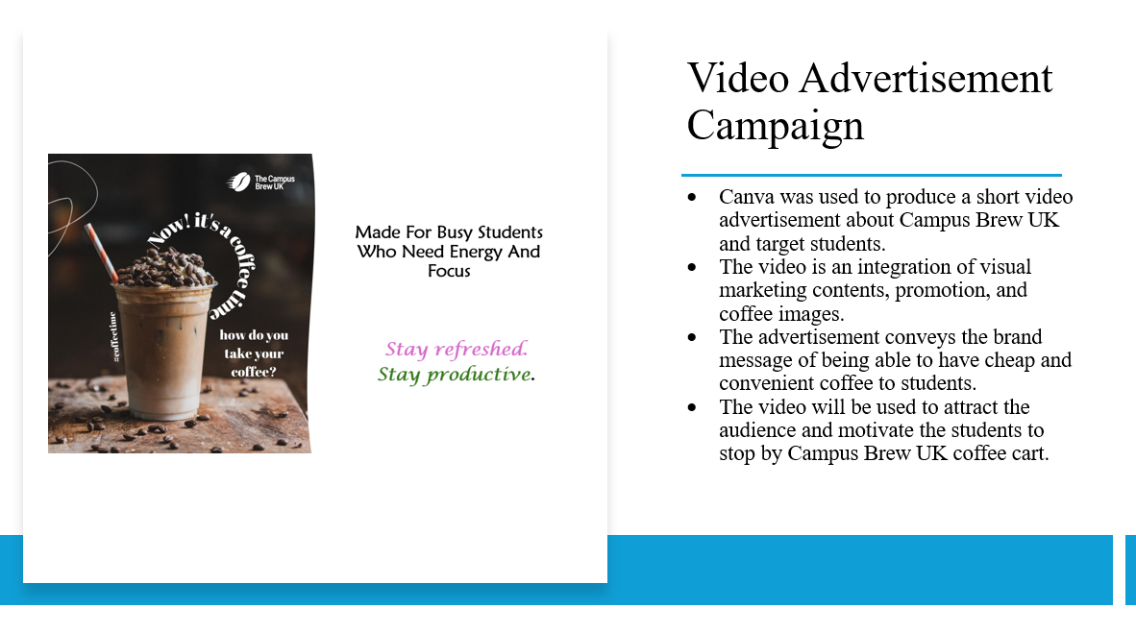
Canva was used to create a short video commercial to market the Campus Brew UK brand. The video is an amalgamation of visuals in the marketing materials, and plain promotional messages relaying the value proposition of the brand. The advert emphasises the ease of having a mobile coffee cart at college and the cost-effectiveness of the coffee sold to the students. Through the attractive images and concise communication, the video will capture the interest of the student audience, and the video will motivate them to seek out the coffee cart. Digital marketing using social media that is promoted in the video as well.

Slide 9 Reflections and Learning
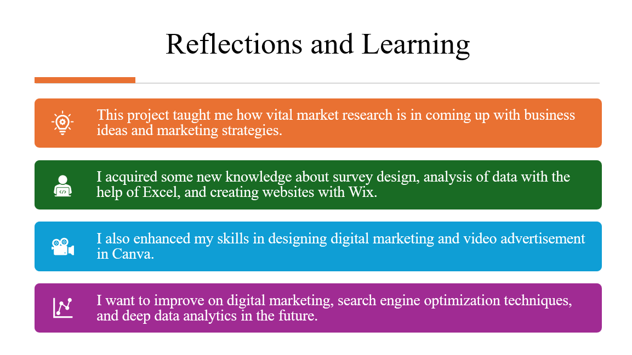
This project was a good learning experience in research and digital marketing. I was taught how market research can assist business to comprehend the customer needs and make strategic decisions. The skills that I acquired through this project were the ability to design questionnaires, data analysis with the help of excel, designing websites with the assistance of Wix, and marketing material design with Canva. Another area that I acquired experience in was to make a short video promotion. Additionally, I would like to enhance my knowledge in digital marketing, search engine optimisation, and advanced data analysis in the future to enhance business decision-making.

Slide 10: References
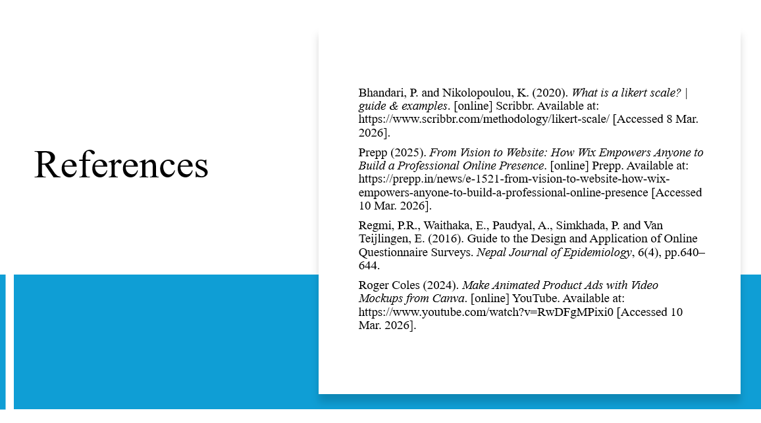
Bhandari, P. and Nikolopoulou, K. (2020). What is a likert scale? | guide & examples. [online] Scribbr. Available at: https://www.scribbr.com/methodology/likert-scale/ [Accessed 8 Mar. 2026].
Prepp (2025). From Vision to Website: How Wix Empowers Anyone to Build a Professional Online Presence. [online] Prepp. Available at: https://prepp.in/news/e-1521-from-vision-to-website-how-wix-empowers-anyone-to-build-a-professional-online-presence [Accessed 10 Mar. 2026].
Regmi, P.R., Waithaka, E., Paudyal, A., Simkhada, P. and Van Teijlingen, E. (2016). Guide to the Design and Application of Online Questionnaire Surveys. Nepal Journal of Epidemiology, 6(4), pp.640–644.
Roger Coles (2024). Make Animated Product Ads with Video Mockups from Canva. [online] YouTube. Available at: https://www.youtube.com/watch?v=RwDFgMPixi0 [Accessed 10 Mar. 2026].

