Assignment 1 – Reflective Review of Learning Journey

Professional career development skills are important in all industries of work. The purpose of this report is to demonstrate my understanding of the skills and knowledge which contribute towards working effectively, my willingness for employment, an understanding or my strengths and areas that I can develop further, as well as establishing my employment goals. It will highlight what I have learned whilst undertaking this module.

SMART Objective

Setting personal goals is an important part of my learning journey and one of the ways of doing this is by having SMART objective.

The SMART objective is an effective process for setting and achieving goals. A SMART goal must be Specific, Measurable, Achievable, Realistic and Time-Bound and usually includes an end – goal (Spacey, 2018).

Specific - Your goal should be well defined and identified. The more specific the description, the better chance you’ll have of reaching your goal.

Measurable – This is when you break down your goal into measurable parts. It can go a long way when refining exactly what you want to achieve.

Achievable – You should investigate whether your goal is reachable. Weigh in the effort, time and costs your goal will take against the other obligations and priorities in your life.

Realistic - Showing a sensible and practical idea of what can be achieved or expected can help you to reach your goal. If you’re missing certain skills, then you can plan training and if you’re missing certain recourses then you can look for ways to get them.

Time Bound – A time frame helps you to keep goals and objectives in mind. How long will It be until the goal is reached? Is it time realistic? Incorporate specific dates, milestones and times frames.

My Goal:

My goal is to be the manager of the bar that I work in.

SMART Goal - In order to reach my goal of becoming the manager in Bar Red by summer 2022, I will undertake the necessary courses and strengthen my skills. I will take time to understand the business and continue my studies in university.

SWOT ANALYSIS

SWOT stand for Strengths, Weaknesses, Opportunities and Threats. A SWOT analysis will help you to recognize your strengths, but it is also helpful to understand weaknesses and threats that can be improved and turned into opportunities (Parson, 2018).
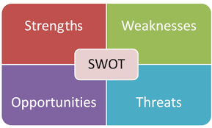

I will conduct a SWOT analysis on myself and show how my strengths, weaknesses, opportunities and threats play a part in my current job role as a bartender at Bar Red and help me achieve my goal of becoming the bar manager within the next 3 years.

My Strengths
- Time keeping
- Hard working
- Very tidy and organized
- Sympathetic towards others
- Independent but I also work well within a team
- Good computer skills
- Committed

My Weaknesses
- Public Speaking
- Self-critical
- Presenting to large groups
- Being too sensitive
- Taking on too many things at once and then panicking about accomplishing all of them
- Too much of a perfectionist
- Working too many hours

My Opportunities
- Introduce card payments and contactless payments
- Set up a company Facebook and Instagram page
- Use less plastic. For example, use paper straws instead of plastic – this will make the company more environmentally friendly and attract more customers.
- Future opportunities for event planning
- Introducing more drink options
- Opportunities to photograph football matches and events at the bar and manage the company website

My Threats
- Lack of future growth
- Not much work when the football season is over
- Competing with other bars/pubs in the area
- Noise complaints from local residents
- `Complaints about not having on-site parking

The TOWS Matrix

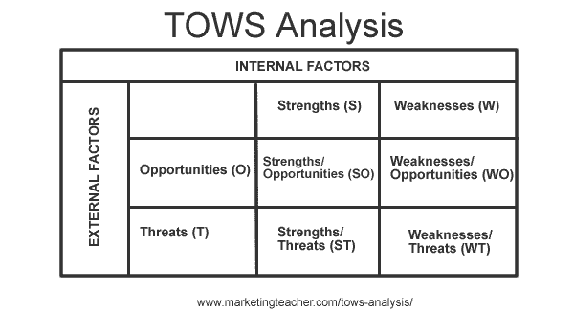
A TOWS, analysis will match aspects to help you recognize relevant options that you could pursue. It can help you see how to benefit from opportunities, minimize threats, overcome weaknesses and benefit from strengths (Oxford College of Marketing).

Strengths and weaknesses are internal factors and opportunities and threats are external factors. There are four TOWS strategies which are - Strength/Opportunity (SO), Weakness/Opportunity (WO), Strength/Threat (ST) and Weakness/Threat (WT), as shown below.
(https://www.marketingteacher.com/tows-analysis/ )

Strength/Opportunity (SO) – Using your strengths to manipulate your opportunities.
- By looking at my SWOT analysis, I would use my good computer skills to put into action an opportunity to manage the company website and use it to inform customers of upcoming events, etc.
Weakness/Opportunity (WO) –Looking at options to overcome weaknesses and take advantage of opportunities. Lessening weaknesses to manipulate opportunities.

- One of my weaknesses is being a perfectionist, sometimes this might not be seen as a weakness, but for me, being a perfectionist means I spend too much time on one thing. If I could exploit this weakness and use it to plan ore events at the bar, I could make sure that they were planned properly and efficiently. I would be overcoming the weakness by using it towards an opportunity.

Strengths/Threat (ST) – Manipulating strengths to overcome any potential threats.
- Another of my strengths is being able to sympathize with others. One of the threats for the bar is local residents complaining about the noise when we have live music, parties etc. I would sympathize with the residents and be able to overcome the threat of complaints by making sure that all music is turned off by a certain time.

Weakness/Threat (WT) – Attempting to minimise any weaknesses to avoid potential threats.

- In order to avoid a potential threat of competing with other bars in the area, I would try to minimise my weakness of public speaking by organizing a quiz night, which I know none of the other bars currently have. Being the only person working in the bar sometimes. I would also need to face my fear of public speaking by asking the questions for the quiz on the microphone.
Learning styles

There are many different methods of learning. What works best for you depends on the task, the context and your personality. To be a more efficient learner, it would be wise to know the range of different learning methods, how to apply them and what works best for you (Roswell, J. The Open University).

Honey & Mumford
Peter Honey and Alan Mumford believe that different learning activities are better suited to different styles of learning. Knowing your preferred learning style will help you assess if a certain activity is helpful to you.

The four different types of learners are:

Activists- Activists are people who learn by experiencing. They like to get involved and “throw themselves in the deep end”. These are people who like to work with others in problem solving and games and are able to lead a group.

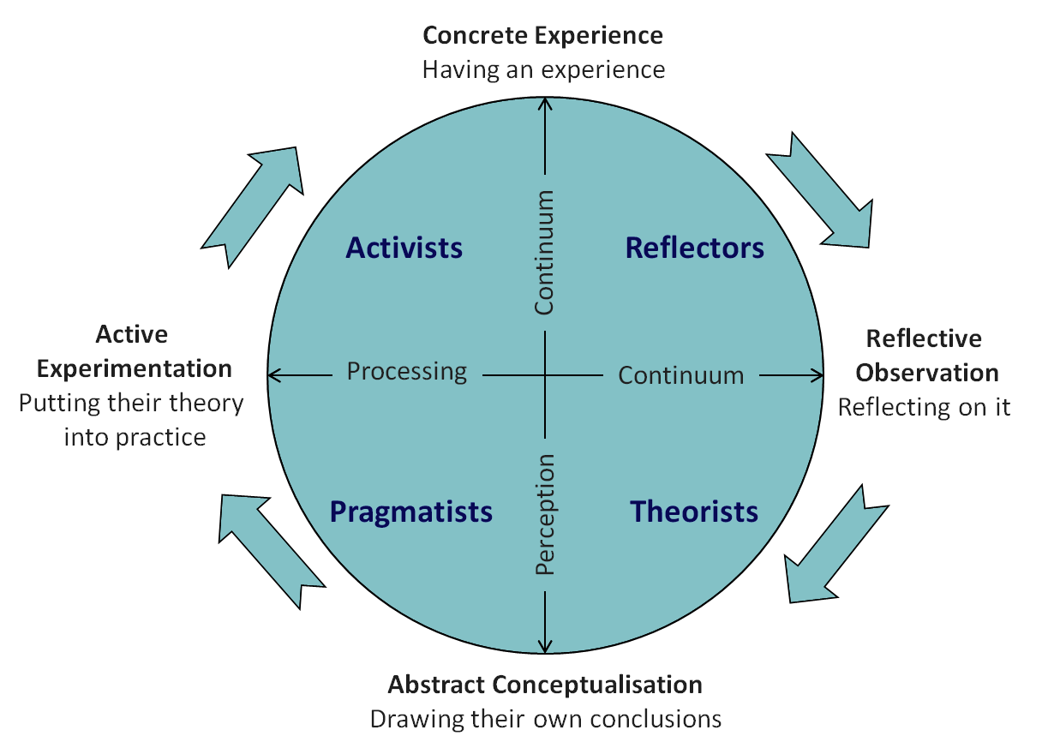
Reflectors – Reflectors learn by observing. They consider all angles before making a decision. They listen and observe and can be more cautious than others. They learn best when having time to think and investigate first and have an opportunity to review.

Theorists – Theorists like to understand the theory behind everything. They learn best when given a chance to question and probe. They like to have facts in order to understand a situation.

Pragmatists – Pragmatists look for new ideas that can be applied. They tend to be inpatient and like to get on with things. They are practical and down – to - earth people that learn best when they can try things out with feedback from a lecture.

As part of my learning journey I completed a Honey and Mumford learning style questionnaire and my results indicated that my preferred learning style is a ‘reflector’. I agree with my results because I like to stand back observe what is happening and am very cautious so will look at other angles before coming to a decision. I like to be given time to think before commenting on a situation.

VARK

VARK stands for Visual, Aural, Read/Write and Kinaesthetic. It is a learning styles assessment tool that consists of multiple-choice questions. Your results will indicate your preferred way of learning.

Visual – Visual learners are people who observe rather than act or talk. They find verbal instruction difficult and would learn better by looking at graphs, maps and charts etc. This type of learning does not include pictures or videos but rather patterns, shapes and other visual aids.

Aural – Aural learners enjoy talking and listening to others. They have difficulty with written instructions and don’t like noisy environments because they can get easily distracted.

Read/Write – People who learn best from reading or writing like to see things in lists, notes or texts. They learn best when reading books or internet pages.

Kinaesthetic – Kinaesthetic leaners like practical exercises and taking part. They like to try new things and like physical activities. They often fidget and use their hands whilst talking.

I completed the VARK questionnaire and my results indicated that my preferred learning style is mostly ‘Visual’. My score was 16 for Visual and 4 for Kinaesthetic. I agree with these results and believe that I really do learn best and take in information easier by using charts, maps and diagrams etc. I find that using images is the best way to explain my idea. I do sometimes like to get involved and learn by practical exercises.

GO MAD

The GO MAD Thinking Model System Was developed by Andy Gilbert and Ian Chakrvorty in 1999. It is an efficient and effective framework for thinking and achieving success. The GO MAD Thinking model helps you to identify where you are starting from. It is about making a difference and what you’re doing to achieve your goals (https://www.gomadthinking.com/about/our-approach/).

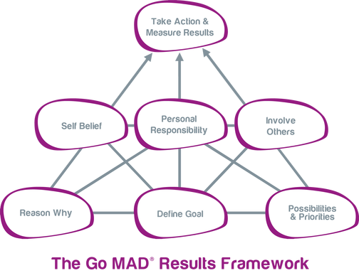

To achieve my goal, I am going to use the GO MAD framework to help me achieve success and make a difference.

My goal is to be the manager of Bar Red by summer 2022. The reason why I want to achieve my goal is to make more money to help me save up to buy my first home. In order to reach my goal, I will need to strengthen my skills which I have already taken a step towards by doing this course. I prioritise work over a lot of things by taking extra hours to show that I am committed. I believe in myself and show willingness to reach my goal. It is important that I take personal responsibility for my actions. I have involved my family and close friends because they help to motivate me. When I am having an off day, they remind of where I want to be in life and help me to pick myself back up again. If I do not complete this course and get good grades, then I won’t have an advantage over the other employees who want the same position as me.

Development needs

Personal Development Plan
Personal development plans are intended to develop skills and are important for working life. Planning for anything if often about finding a gap between where you are and where you want to be or need to be (Morgan, P. P.27-28).

One of my learning objectives is to gain more confidence to do presentations and public speaking. One of the things that gets in my way being more confident is how anxious and nervous I get. I would need to find a way of settling my nerves, I would do this by thinking positively and doing breathing exercises before I have to do a presentation or speak in front of a group of people. I will know when I have achieved this goal when I stop feeling anxious about having to stand up and speak to an entire room of people.

Conclusion

In conclusion, I believe that I have identified the specific actions I am going to take to bring about the changes and developments I need to achieve my goal of being the manager of Bar Red. I have made my goal SMART by making sure that my goal is specific and well defined, I have used dates in a way to be clear of when I want to reach my goal, made sure that my goal is attainable so that I don’t set myself up for disappointment, ensured that any actions that I plan are relevant and set up a time scale for the completion of my goal.

References

Author Unknown. Personal SWOT Analysis. Available at: https://www.skillsyouneed.com/ps/personal-swot-analysis.html
(Accessed 31st May 2019)

Author Unknown. TOWS Analysis: A Step by Step Guide. Available at: https://blog.oxfordcollegeofmarketing.com/2016/06/07/tows-analysis-guide/
(Accesses 28th May 2019).

Author Unknown. TOWS Analysis. Available at: https://www.marketingteacher.com/tows-analysis/
(Accessed 31st May 2019)

Author Unknown. Personal SWOT Analysis. Available at: https://www.mindtools.com/pages/article/newTMC_05.htm
(Accessed 31st May 2019).

Bush, T (2016). SWOT Analysis Threats: Definition and Examples. Available at: https://pestleanalysis.com/swot-analysis-strengths-definition-examples/
(Accessed 28th May 2019).

Doyle, A (2019). List of Weaknesses with Examples. Available at: https://www.thebalancesmb.com/smart-goal-examples-2951827
(Accessed 31st May 2019).

Grant, M (2019). Strengths, Weakness, Opportunity and Threat (SWOT) Analysis. Available at: https://www.investopedia.com/terms/s/swot.asp
(Accessed 31t May 2019).

Haughey, D. Smart Goals. Available at: https://www.projectsmart.co.uk/smart-goals.php
(Accessed 31st May 2019).

Jackson, T. A Detailed SWOT Analysis Example. Available at: https://www.clearpointstrategy.com/swot-analysis-examples/
(Accessed 28th May 2019).
Parson, N. (2018) What is SWOT Analysis, and How to Do IT Right. Available at: https://www.liveplan.com/blog/what-is-a-swot-analysis-and-how-to-do-it-right-with-examples/ (Accessed 31st May 2019)

Rosewell, J. Learning Styles. Available at: https://www.open.edu/openlearn/ocw/pluginfile.php/629607/mod_resource/content/1/t175_4_3.pdf
( Accessed 2nd June 2019)

Tjan, A.K. (2015), 5 Ways to Become More Self-Aware. Available at: https://hbr.org/2015/02/5-ways-to-become-more-self-aware
(Accessed 2nd June 2019).

VARK Questionnaire:
http://vark-learn.com/the-vark-questionnaire/

Results for Honey & Mumford Questionnaire:



