Comparison of Shangri-La Hotels and Travelodge Hotels.

Student name: Alexandru Badea.
Student ID: 2208275.
Module name: Financial Management for the Hotel Industry
Module code: BMIH5007, BMIH5002.
Lecturer: Ernest Wavei.

Executive Summary
This report provides a comparative analysis of Shangri-La and Travelodge Hotels within the UK’S hospitality industry. The study evaluates revenue, market growth, financial commitment to Corporate Social Responsibility (CSR), and strategic prospects. Shangri-La's focus on customer satisfaction and 24-hour service has led to an increase in occupancy rates and Revenue per Available Room (RevPAR), reaching $56 USD post-pandemic (Shangri-La Group, 2020). Travelodge, known for its affordability and quality service, has seen a revenue rise to £52.59 GBP and an Occupancy rate of 81.8% during the same period (Travelodge Corporate Website, 2023). Recommendations include Shangri-La's continued focus on branding and Travelodge's priority on optimal pricing strategies for sustained growth. Overall, both brands show stable growth potential and a commitment to CSR. Additionally, strategic frameworks like Ansoff’s Matrix and Bowman’s Strategy Clock are applied to further evaluate the businesses' growth strategies.

Table of Contents
Introduction 4
Background of report 4
Aim of report 4
Discussions 4
General details of operation for both businesses 4
Comparative analysis in the prospective business revenue for both businesses 5
Comparative analysis of market growth for both hospitality businesses 6
Evaluate the overall growth potential for both business operations 8
Identification of financial commitment towards corporate social responsibility 10
Applied engagement of Bowman’s Strategy Clock for both Business 11
Recommendation 12
Conclusions 12
References 13
Appendix 15

Introduction
Background of report
The conceptual element of benchmarking is identified as a technique with some positive mechanism that is adopted in a business with the intention of continuous improvement. It is also defined as a process applied in a business to evaluate the position and performance with a comparative approach with the other internal or external to the firm for a strategic prospect (Drury, 2021). Since the period of 1980, the overall demand for the hospitality business has influenced significantly and the competitive market environment reformulated the overall operating structure in most of the business operation strategies. During the period of the pandemic, due to some significant social consequences, the overall performance of most businesses was negatively impacted and in the current position of pre-covid situation, most of the businesses are focused on their strategies including both the financial and non-financial to reformulate business operating capability properly.
Aim of report
The purpose of this report is to evaluate the performance of Shangri-La and Travelodge Hotels in the UK hospitality industry while providing strategic recommendations for each brand. I will achieve this by analysing financial data, market trends, and other strategic initiatives. Furthermore, I will examine revenue figures, market growth rates, and CSR, to gain a better understanding of their positions in the current market. Additionally, I will apply strategic frameworks such as Ansoff’s Matrix and Bowman’s Strategy Clock to further evaluate their growth strategies and competitive positioning.
Discussions

General details of operation for both businesses
The primary operating performances of and incorporation indicate Shangri-La Hotel is a Chinese hospitality organisation that operates in the United Kingdom. As per the performance and operating level, an immense number of customer presence is generally noticed in this business based on its branding and popularity. Applicability of the strategic approach including the incremental initiative related to the satisfaction of customers is one of the primary strategic initiatives for this business (Seal, 2019). The involvement of 24-hour customer service reformulated operating performances along with providing focused on customer-centric attributes mainly enhancing the position of business revenue. At the present position, the primary level of the Occupancy rate of this business indicates a level of 62% which is expanded from the standard of 37% earlier and represents a contemporary development initiative structure in this business. In the present situation after the pandemic, the primary level of RevPAR volume of the business has expanded to the level of $56 (in USD) representing the optimised opportunities of the business under the current competitive position (Shangri-La Group, 2020).
The operating position of Travelodge (Competitive business), which is also recognised as a hospitality business incorporated in the United Kingdom represents progressive operating stability and marketing-attributable support. This organisation was established in 1985 and its main operating area is spread in the United Kingdom, Ireland and some parts of Spain. Importance of the affordability with a standard quality service engagement is one of the primary USP of this particular business which influence the structural growth including the revenue positioning level in a different order. After the pandemic, to initiate a proper operating stability approach, the management of this business mainly focused on the branding reformation structure and promotional attribute simultaneously so that standard operating quality and competitive advantages could be initiated for this business. With the support of 600 hotels and more than 45.000 bedrooms, this business is used to represent a strong portfolio structure which is accountable and also represents a quality market approach. As per the identification the current RevPAR level of the business is around $52.59 (in USD) representing a contemporary positioning approach for market stability (Travelodge Corporate Website, 2023).

Comparative analysis in the prospective business revenue for both businesses
The concept of revenue generally represents one type of determination metric related to the competitive gaining opportunity for a business concerning the competitive market. In the case of a competitive market, the Volume of revenue is applied to represent the performance structure of the business and also the competitive advantages approach that ultimately provides an opportunity for business furtherance support. The concept of revenue projection depending on the anticipated Occupancy, average daily rate and the revenue per available room is used to structure the performance capability for the hospitality business (Walker, 2021).
The primary identified measurements related to the market structure of Shangri-La Hotel indicate the beneficial approach of branding formulation that ultimately expanded the level of RevPAR in this business up to $56 (USD). With the generally identified positioning, the present consolidated income statement of the business indicates the general volume of business revenue has expanded from the level of 1049.4 million to 1261.9 million in 2022, which indicates a positive growth of 20.2% in the business income from hotel properties (Shangri-la, 2022). Compared to the previous stage of the pandemic, the current promotional strategies and the revised USP formulate the overall revenue positioning structure of the business from the level of 1241.0 million to 1462.1 million with an average progress of 17.8% in the present period. The primary approach of this expansion includes the investment property revenue of up to 6.3% growth, and gross revenue volume of up to 11.9% growth support (Consolidated revenue details in appendix).
Following the same measurement principle, a progressive revenue initiative is also noticed in the business operation of Travelodge during the present accounting period. A proper importance of the value-based operating support and customer-centric approach expanded the contemporary value positioning structure of the business revenue on a systematic progress basis (Guilding, 2014). The primary measurement related to the present revenue details of the business indicates a positive response in the form of an expanded RevPAR level in the business up to £52.59 from the previous level of £33.04 (in 2021) (Travelodge, 2022). The present Occupancy rate of the business has expanded to 81.8% with the level of revenue expansion up to 910.8 million from the level of 566.7 million in standard. The current volume of adjusted level of EBITDA expansion is up to 212.9 million in the present period of 2022 (Consolidated revenue details in appendix). Additionally, the present formulated strategic initiative of branding formulation and initiative of a next-generation room facility with some advanced innovation processing brings a progressive level of revenue formulation strategy to this business (The Caterer, 2023).

Comparative analysis of market growth for both hospitality businesses
To identify the market positioning structure, the present operating initiative of Shangri-La Hotel’s elite-class approach needs to be evaluated as it is applied to recognise the market position and performance values. Along with progressive market stabilities support the present strategic approach of 24-hour customer service initiative allows a quality positioning structure related to business branding bringing are significant volume of goodwill development initiatives.
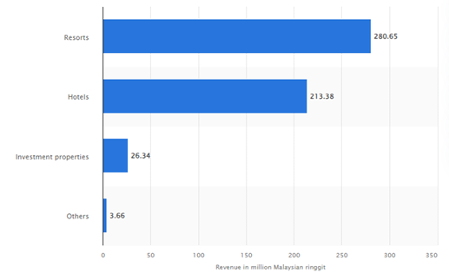
Figure 1: Revenue position of Shangri-La Hotel
(Statista, 2022)
The present market capital level of this business indicates $2.51 Billion around 2.09% expansions compared to the earlier value (Companiesmarketcap, 2024). The primary operation of the business is in China, however as per the identifications the Current Occupancy rate of the business is around 79% in the United Kingdom which indicates a progressive opportunity for the business to maintain the market capital development initiative (Lun, 2023).
In the present situation, the present operating structure and the market performances of Travelodge indicate a comparatively optimised market position with some potential competitors' existence. The applicability of the flat Occupancy rate level of 81.8% is generally initiated it is business in the present year along with an average room rate level of expansion up to 12.5%s which indicates a business market stability approach.
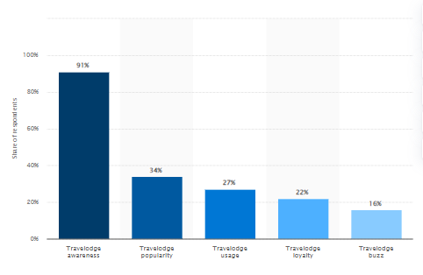
Figure 2: Revenue position of Travelodge
(Statista, 2022)
The primary operating support, including the basic statistical position of the business, indicates that around 90% of Goodwill development, including the branding approach mainly formulate a proper volume of business contemporary growth positioning support which ultimately initiates the stability development. During 2020, the organisation mainly used to “offer 1 million rooms for £25 or less a night” which initiated a new form of branding initiative for the business and structured the overall competitive level differently (McGuinness, R. 2022). After the pandemic period to expand the business opportunity and market reformulation the organisation initiated its sixth Spanish hotel in Madrid and for such purpose the business contributed around €1 million, including the refurbishing charges also (Hospitality Net, 2023). Associated with the same approach, the market initiative structure, including the overall capitalised approach of the business also presents statutory positioning support, which ultimately brings the progressive value positioning approach.

Evaluate the overall growth potential for both business operations
The primary initiative and the compatibilities structure related to providing a proper volume of business operating approach, including accounting formulation, are initiated to stability formulation support, which provides an opportunity for competitive market gain (Atrill and McLaney, 2021). Regarding the present operating structure and performance initiative, the application of Ansoff’s matrix is initiated mainly for the evaluation of the present operating position of both businesses.
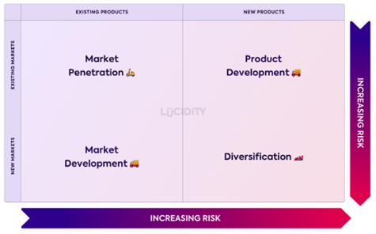
Figure 3: Ansoff’s matrix for both hotels
(Learner, 2022)
About the present operating position and performance of Shangri-La Hotel Group, the organisation provides a significant level of importance over the branding initiative including the approach of market penetration process to maintain a proper volume of business development approach. Additionally, the current commitment towards the “Pioneers of Asian Hospitality” indicates a proper volume of branding initiative approach that ultimately indicates systematically formulate the market development processing. Applied Iconic Global Projects initiated the diversification approach for this business which ultimately formulated the statutory development including the market stability approach (Shangri-la, 2020). Additionally, the identified approach of Holistic Programmes for the Modern Urbanite with the formulation of which a new service development brings progressive growth support.
Associated with the same processing over the business of Travelodge, the identified unique market proposition initiates a proper volume of market development approach systematically. Prioritising the best locations and operations along with customer satisfaction brings operating growth and optimised market positioning support to the business operating system on a formulated basis (Travelodge Corporate Website, 2022). Associated with the basic approach to providing a proper volume of market penetration support and service development initiative, the business focuses on “Medallia to power its new voice of the Customer Programme” which brings a contemporary operating development approach (Businesswire, 2022).

Identification of financial commitment towards corporate social responsibility
With providing a primary significance to the ESG structure the managerial department of Shangri-La Hotel Group provides an equivalent approach to the Sustainability initiative which provides significant importance to the implementation of the green building standard approach. In the present situation, the organisation provides a significant level of commitment towards establishing 39 green building certifications and also 44th properties along with an environment and managerial approach that brings compatibility and environmental-friendly initiative.
Additionally, for the development of environmental progress, the organisation also initiated a commitment to eliminating the 100% use of plastic usage so that proper statutory growth can be initiated. Even for maintenance and accountability development the business also focuses on a 74% diversion rate for food waste that ultimately structures the operating position of this business on an effective basis.
Associated with the same processing the current CSR engagement for the business of Travelodge represents a proper volume of focus on employee and customer engagement that brings a progressive approach for stable growth development. As per the primary engagement at the present situation for the reason of maintaining a proper charitable approach, the organisation provides a significant level of importance to the processing of human trafficking and child abuse prevention commitment (Better Future, 2022).
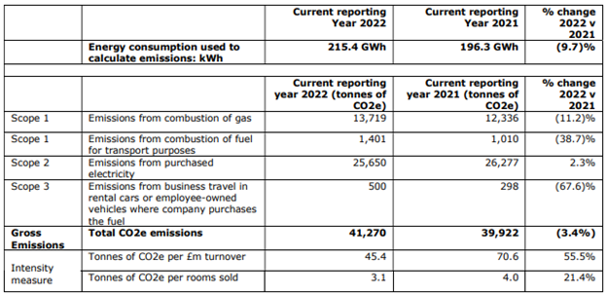
Figure 4: Sustainability commitment in Travelodge
(Better Future, 2022)
The present operating approach, including the operating contribution, initiates a progressive opportunity for the business which is controlling the carbonization level up to 11.2% in the present year.

Applied engagement of Bowman’s Strategy Clock for both Businesses
Bowman's Strategic Clock is a framework developed by academic Cliff Bowman. It is used in strategic management to analyse and understand competitive positions in a market (Bennett, 2023).
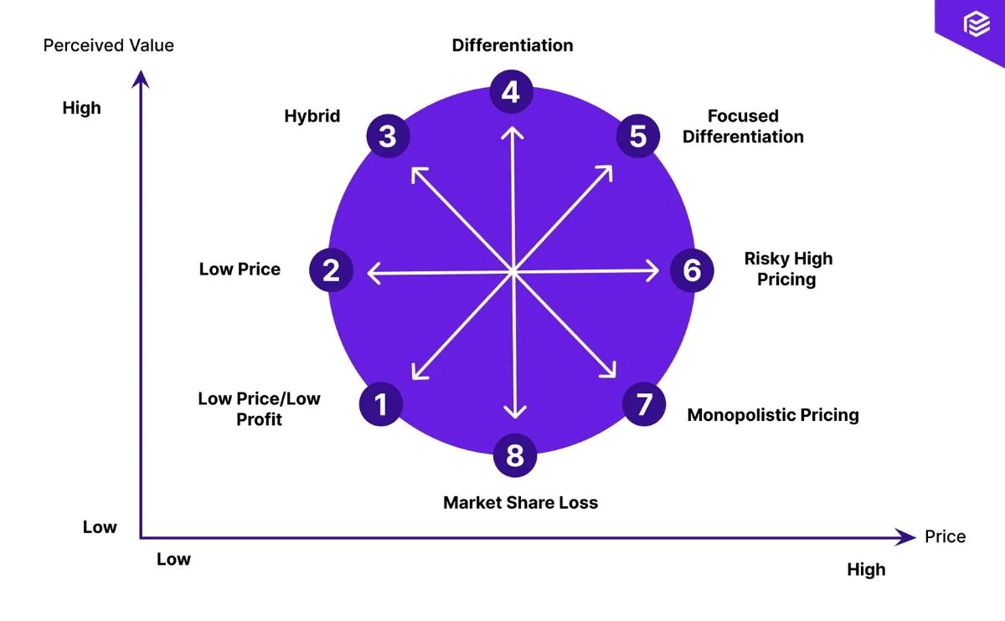
Figure 5: Bowman’s Strategy Clock
(Bennett, 2023)
Based on the above analysis and present strategic formulations like Iconic Global Projects, Innovative Dining Concepts, and Holistic Programmes for the Modern Urbanite, Shangri-La appears to alight with the high price quadrant. The exceptional service, premium experiences, higher room rates, positive customer reviews, justify its higher price and reinforce the brand’s positioning (Shangri-la, 2020). On the other hand, Travelodge seems to fit into the low-price quadrant. This is clear because of its focus on affordability and standard quality service without extensive luxury amenities.

Recommendation
At the present position the management of Shangri-La needs to provide significance to their Pioneers of Asian Hospitality strategy in a formulated basis with the optimised branding support so that the general level of operating growth can be initiated. Even the management of the business is also needed to formulate the operating structure in a proper basis so that the level of revenue development can be formulated.
On the other hand, for the business of Travelodge, current commitment towards the optimised pricing structure with prioritising the best locations and operations and well-priced quality positioning approach is needed to be initiated for the upcoming period including the initiative of low pricing strategy to manage the operating value in the upcoming period.

Conclusions
Overall, the present operating structure and financial positioning approach for both business indicates stable growth and optimised operating initiative support that brings the compatibility development initiative. Even the present operating level at the strategic position in the structure of the business also indicates and optimised development related to the market potentiality and financial stability approach which is accountable for managing the competitive market positioning gain support.

References
Atrill P., and McLaney E (2021). Management Accounting for Decision Makers, FT Prentice Hall
Bennett, T. (2023). Bowmans Strategic Clock Model: Choosing a Price Strategy. Priceva. [Online] Available at: https://priceva.com/blog/bowmans-strategic-clock-model-choosing-price-strategy [Accessed on 29 Apr. 2024].
Better Future. (2022). Available at: https://www.travelodgesustainability.co.uk/wp-content/uploads/sites/2/2023/05/Better-Future-Report-2023.pdf [Accessed 30 Apr. 2024].
Businesswire (2022). Travelodge (UK) Selects Medallia to Power its New Voice of the Customer Programme. [online] Available at: https://www.businesswire.com/news/home/20220616005140/en/Travelodge-UK-Selects-Medallia-to-Power-its-New-Voice-of-the-Customer-Programme [Accessed 30 Apr. 2024].
Companiesmarketcap (2024). Shangri-La (0069.HK) - Market capitalization. [online] Available at: https://companiesmarketcap.com/shangri-la/marketcap/ [Accessed 30 Apr. 2024].
Drury C (2021) (11th Ed) Management and Cost Accounting, London, Prentice Hall
Guilding, C. (2014) (3rd Edition) Accounting Essentials for Hospitality Managers, London, Routledge
Hospitality Net. (2023). Travelodge officially opens its sixth Spanish hotel in Madrid. [online] Available at: https://www.hospitalitynet.org/announcement/41010183.html [Accessed 30 Apr. 2024].
Lun, T.N. (2023). Shangri-La Asia posts H1 net profit of $177m on recovery of hotel business. The Straits Times. [online] 30 Aug. Available at: https://www.straitstimes.com/business/companies-markets/shangri-la-asia-posts-h1-net-profit-of-us1314-million-on-recovery-of-hotel-business [Accessed 29 Apr. 2024].
Seal W (2019) (6th Ed) Management Accounting, London, McGraw Hill
Shangri-La Group (2020). About Shangri-La. [online] Shangri-la.com. Available at: https://www.shangri-la.com/group/our-story/about-shangri-la [Accessed 30 Apr. 2024].
Shangri-la (2022). Cover Photos: 1. JEN Shenzhen Qianhai by Shangri-La 2. Kerry Hotel. [online] Available at: https://sitecore-cd.shangri-la.com/-/media/Project/Shangri-La-Group/Investor/Files/Public-Disclosures/Latest-Top-Publications/e0069_230418_AR.pdf [Accessed 29 Apr. 2024].
Shangri-la (2020). business operating strategies. [online] Available at: https://www.shangri-la.com/group/our-businesses/ [Accessed 30 Apr. 2024].
Statista. (2022). Shangri-La Malaysia: revenue by business segment. [online] Available at: https://www.statista.com/statistics/1199674/shangri-la-malaysia-revenue-by-business-segment/ [Accessed 6 May 2024].
Statista. (2022). Travelodge UK revenue 2020. [online] Available at: https://www.statista.com/statistics/429089/travelodge-total-revenue-united-kingdom-uk/ [Accessed 6 May 2024].
The Caterer. (2023). Travelodge reports ‘record’ results for... [online] Available at: https://www.thecaterer.com/news/travelodge-record-2022-financial-results-encouraging-start-2023 [Accessed 29 Apr. 2024].
Travelodge Corporate Website. (2022). Business Model & Strategy. [online] Available at: https://travelodge.co.uk/our-business/about-us/business-model-and-strategy/ [Accessed 30 Apr. 2024].
Travelodge Corporate Website. (2023). About Us. [online] Available at: https://travelodge.co.uk/our-business/about-us/#:~:text=visitors%20each%20year.- [Accessed 30 Apr. 2024].
Travelodge (2022). Travelodge Investor Site. [online] www.travelodge.co.uk. Available at: https://www.travelodge.co.uk/investors/home [Accessed 30 Apr. 2024].
McGuinness R. (2022). Travelodge responds to coronavirus by offering 1 million rooms for £25 or less a night. [online] Available at: https://uk.finance.yahoo.com/news/travelodge-coronavirus-million-rooms-night-134153116.html [Accessed 30 Apr. 2024].
Walker J (2021) Introduction to Hospitality, Harlow, Pearson

Appendix
Revenue for Shangri-La Hotel Group
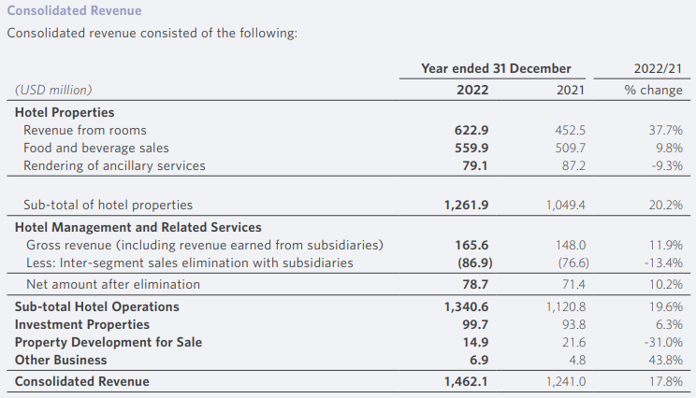

Revenue for Travelodge


