MSc in Public health- Leadership

Tutor Notes

Group Work: Personality types & Exploring workplace interactions

This debrief/group work is to allow you to apply the knowledge from the lecture entitled “Personality types: How we learn, think, and communicate” to situations and scenarios you may find yourself in professionally.

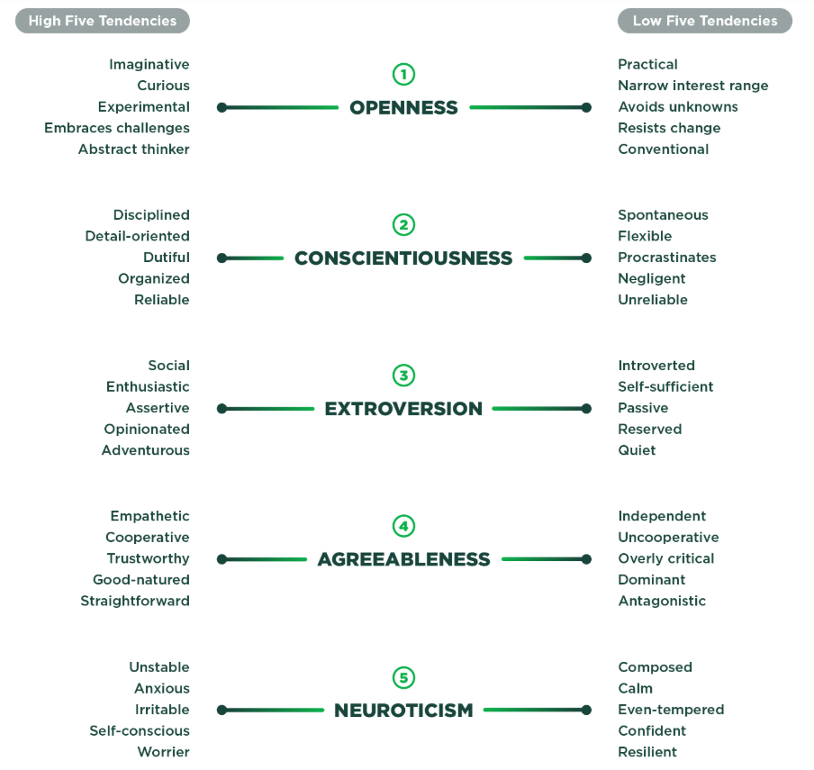

Figure 1. ‘OCEAN’ five-factor model of personality with each dimension displayed as a continuum.

Task 1: What does the typical personality of a university student look like? (5 Mins)

Think about the OCEAN five-factor personality framework. In groups, think about what the ‘typical’ university student personality might be. Which personality traits might be more beneficial vs less?

Task 2: Introspection, your own personality type and personal professional development (25 Mins)

Introspection is defined as ‘the examination of one's own conscious thoughts and feelings’ and may form part of reflective practice as a part of your personal professional development.

Task 2A (5 Mins)
Take 5 minutes to take an introspective stance to think about your own personality type. For each of the personality dimensions above (Figure 1) rate yourself from 0-100 (0 being low in the trait i.e. practical and narrow range of interest for the dimension of openness; whilst 100 being high in the trait i.e. imaginative and curious for the dimension of openness).

Task 2B (10 Mins)
Think about your strength and weaknesses. Identify and share with the group;

- One strength your personality may have on your career as a healthcare professionals/ any job
- One potential area of difficulty your personality may have on your career as a healthcare professionals/ any job

Task 2C (10 Mins)
Your underlying personality is likely stable and consistent, however it is also contextually malleable – you can change how you might usually act in a given scenario, BUT ONLY IF YOU ARE SELF-AWARE! That is one of the main reasons why we might engage in reflective practice as individuals. Think about a potential PPD goal which may help you overcome the difficulty your personality poses as identified in Task 2Bii.

For example, if I reflect upon my own personality and role, I believe I am more introverted than extraverted. This might lead me to be less assertive and more passive in my role as a lecturer, this might lead to me not inspiring confidence in you all as my students in my expertise as a lecturer. Therefore I might identify a potential PPD goal as trying to be more confident in a given situation.

Task 3: Personality types in the workplace, working in a team and patient safety.

you may have learnt about the topic of patient safety. In your groups, please evaluate which personality types is important i.e:

- Extremely high agreeableness
- Extremely low agreeableness
- Extremely low extraversion
- Extremely high conscientiousness
- Extremely low conscientiousness

Task 3A (15 Mins)
Imagine as a healthcare professional with your given personality type. This healthcare professional is working in resus within a busy A&E department. Consider how that healthcare professional personality type may lead to potential medical error and subsequent patient harm?

Task 3B (15 Mins)
Imagine you are the leader of a healthcare team. Specifically this is a surgical team including a specialist surgeon, two foundation doctors, an anaesthetist, and multiple nurses. You identify that the anaesthetist has a personality type based upon the one your group has been assigned.

In the lecture, you were presented with ideas around how different personality types could influence team dynamics. In your group think about how this team member may negatively affect teamwork during the surgery. As the leader of the healthcare team think about what you might do to improve team dynamics in the presence of this team member.

There are no right or wrong answers to these questions, but the important skills that this lecture has focussed upon has been the ideas of self-awareness, introspection and metacognition, that will allow you as doctors to be more mindful of these factors – hopefully to the benefit of yourselves and the people around you.

