  - Levelling Computation
  - ACBA4002

Prepared for Jamiu Dauda

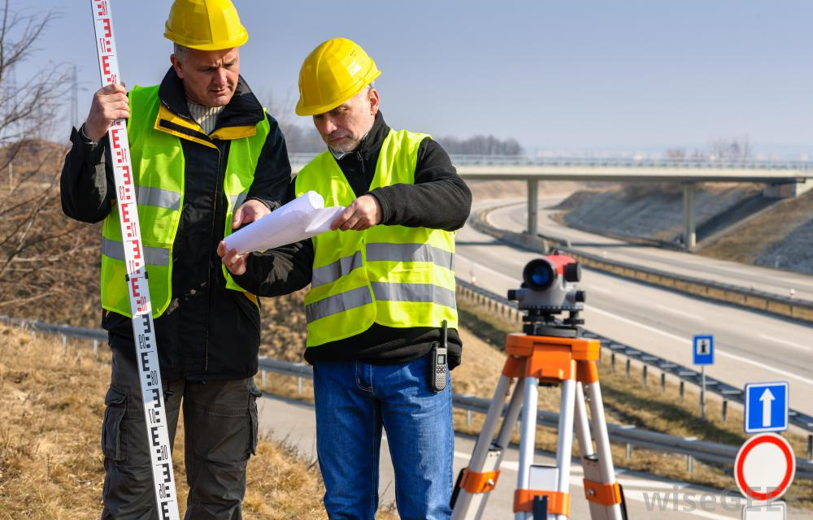

Created by Jonathan Langstone

Date Completed:
14th May 2021

Contents
1.0 Executive Summary 2
2.0 Terms of Reference 2
3.0 Procedure 2
4.0 Findings 3
4.1 Introduction 3
4.2 Levelling Surveying 4
4.3 Equipment used for Levelling. 6
4.4 Leveling Procedure 8
4.5 Computation and plotting of level. 9

Executive Summary
This report will aim to explain the step-by-step approach to carrying out a levelling exercise, which will highlight the equipment in use and the data collected from the intended survey. From this, an estimate of the volume of the earthwork involved will be found, and comments will be given on the information from the levels plotted in the survey showed.

Terms of Reference

2.1 The Principle Focus.

2.1.1 To give an overview of levelling surveying.
2.1.2 To explain what types of equipment are used when levelling and to explain the levelling procedure.
2.1.3 To correctly calculate a given set of data using computation and plotting level.

2.2 The document was constrained by the information given and researched and the need to complete it by the 14th of May 2021.

3.0 Procedure
This section identifies the research sources used.

3.1 The research includes secondary sources about Levelling, General Surveying equipment, and how to calculate using computation and plotting levels.

  - University notes, lecture material and calculation methods also provided background to the research.

4.0 Findings

4.1 Introduction
This Report is aimed at explaining the method for levelling computation by finding ‘level’ on a planned new route, which will be situated between Llandarcy and Neath (South Wales, United Kingdom). The Swansea city council are planning to construct a new route between the two locations. This report will explain the step-by-step method involved in carrying out the levelling exercise and highlighting which equipment would be used to complete the survey and the definitions used to explain Levelling to allow the reader to understand it fully. The data that will be collected from the survey will be analyzed via the appropriate techniques.
“It is often important to know whether the ground is level or, if not, to what extent it varies in level” (Clancy, 1991). The term ‘Levelling’ can be used for setting out and measuring the levels of pre-existing or built structures, setting construction elements to their reduced level, and establishing vertical control points. This levelling is found using levelling equipment that creates horizontal lines of sight through a telescope or laser. Another piece of equipment named a ‘staff’ is used vertically to give a certain height measurement that will be taken as a reading. Essentially the instruments work together to calculate the height of the line of sight relative to a known control point.
These control points might be established by using:
• Laser Levels.
• Digital levels.
• Precise Levels.
• Traditional levels (E.g., Water levels).
The Main Reasons for Levelling
Many levelling procedures are undertaken because a person or team of people would like to determine the difference in height between two or more points on the surface of the earth. A Surveyor may also want to find the altitude of a specific location or set out a level horizontal surface on a construction project. In the case of this report, the reason is to find a level plan from one of the lands to another. (Arthur Bannister, 1998).

4.2 Levelling Surveying
Before describing the methods and techniques used for a levelling survey, a few definitions must be described:
Definitions
Terms used when carrying out a ‘levelling traverse’ survey method are as follows:
- Benchmark – Is a permanent reference point on the ground in which the reduced level is known. A Temporary benchmark (TBM) may be used from time to time, and then destroyed after completion of a project/survey. The figure below shows the symbol for the ordinance survey benchmark used across the country:
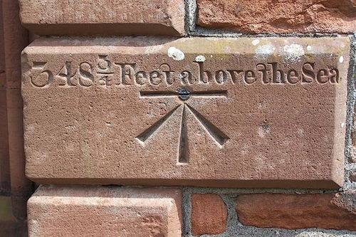
Figure 1 Ordnance Survey Benchmark (Cowie, n.d.)

- Datum – This is a horizontal plane of reference at a chosen reduced level.
- AOD – Refers to an ‘above ordinance datum’ which refers to the height of mean sea level in the United Kingdom.
- Back Sight (BS) – is the first reading taken to a point of known or assumed reduced level once the level has been set up. Typically, this will be set up at the entrance to a construction site or place which will be undisturbed from further construction or excavation activity.
- Level Line - A line that is at a constant height relative to mean Sea Level.
- Intermediate Sight (IS) – A reading that is not a backsight or foresight, but reading to a point being measured or the required staff reading to a point being set out.
- ForeSight – This is the final reading that comes after a (BS) and an (IS), from a setup position. It can be to a point of the known reduced level, so it can be checked for the closing errors of a survey.
- Reduced Level – Is an elevation in height or altitude found in relation to a datum point. It is the vertical distance found from the Datum.
- Line of Collimation – This is the line of sight that is meant to be horizontal across the whole area of the survey, so readings can be taken from it.
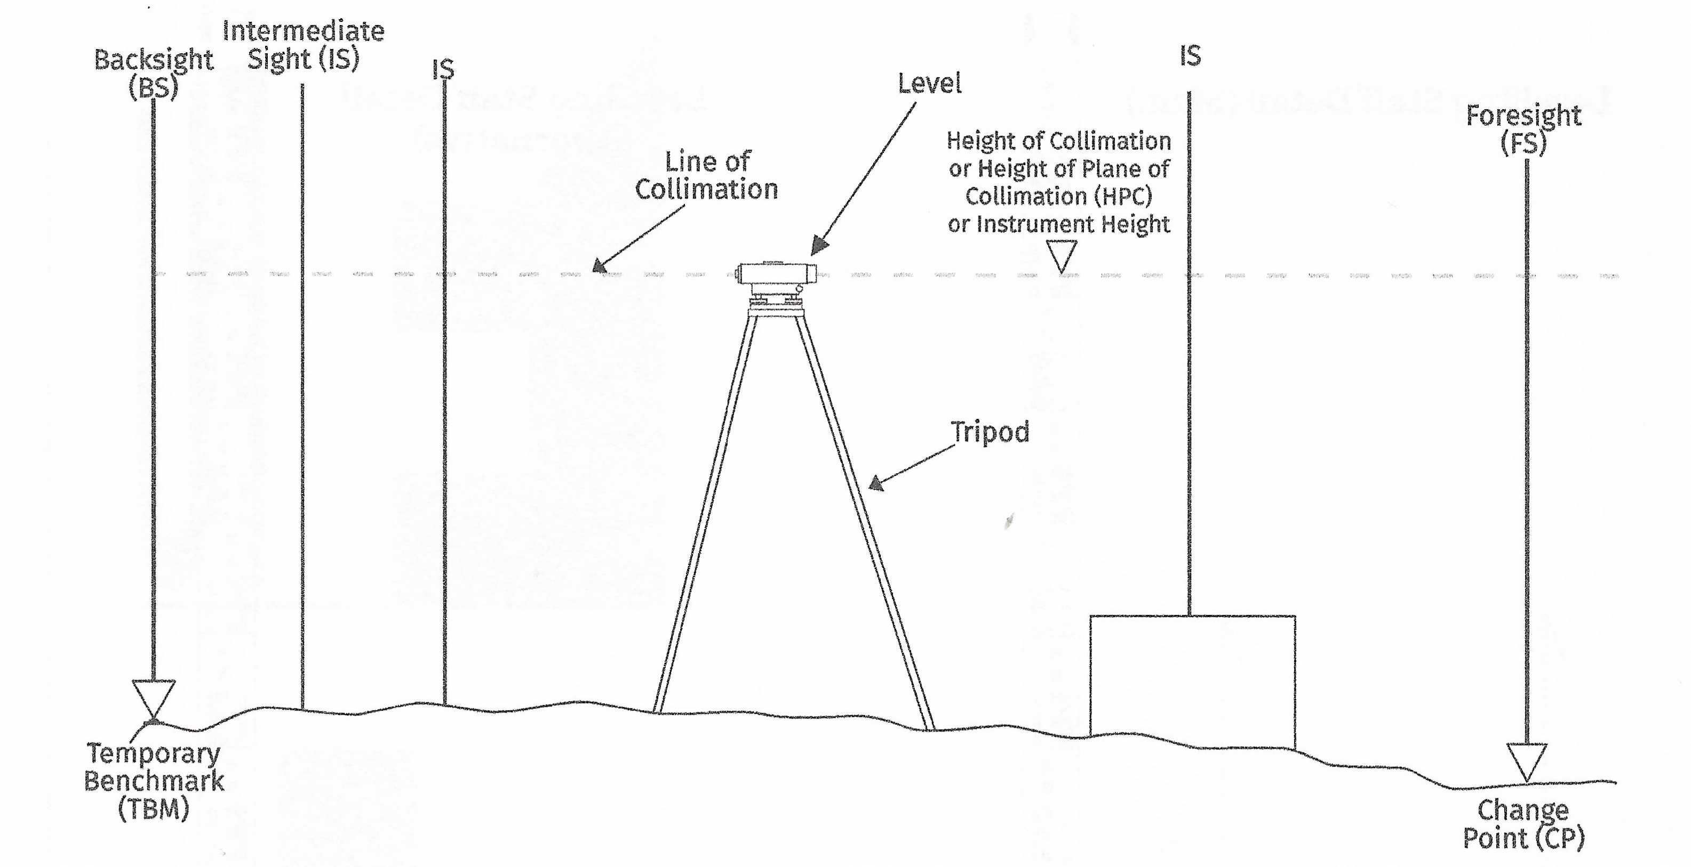
The Figure below highlights some of the terms given above, and where they appear in a typical levelling survey:
Figure 2 Levelling terminology Diagram (Grant, 2020).
The Levelling Survey
When carrying out a levelling survey, it is important to find the most accurate equipment available to obtain the most accurate data possible. In the case of most levelling surveys, either a dumpy level, an automatic level or digital levels would be used, which is accompanied by a staff or a receiver to accurately record measurements for the survey data.
The surveyors that look at the new route between Llandarcy and Neath, that the Swansea City Council are planning, and have determined that they must use the technique of ‘Level Traversing’ to identify the correct levels and volume of earthwork needed to be removed or added to build the new route. A quote taken from ‘lssltd.net’ has been taken to best describe the Traverse levelling technique:
“The levelling traverse is a series of measurements taken that are taken in the field that may either start and finish at the same known point or start and finish in two different known points”.
(lssltd.net, n.d.)

4.3 Equipment used for Levelling.
It is very important to respect the equipment used to find Level. Great care must be taken as any minor damage or simply dropping an item may cause the equipment to produce false readings and develop errors in recorded any data for a survey.
The common types of equipment and instruments are as follows:
Levels - The level is essentially a telescope that uses the line of sight and is attached to a levelling device and placed on a level tripod. This will allow the telescope to rotate horizontally at 360 degrees. The levelling device on the tripod would have a bubble found at the top to allow the user to find level by eye. The level will allow the user to find the line of collimation and read an accurate reading displayed on a staff, found at given points on a survey. The two main types of levels used in a levelling survey are the dumpy level and the automatic level. The Automatic level is much like the dumpy level, but more modern in design. The dumpy level requires more skill to use compared to the modern automatic version. Below is a figure showing a typical automatic level and a tripod on which it is mounted upon:
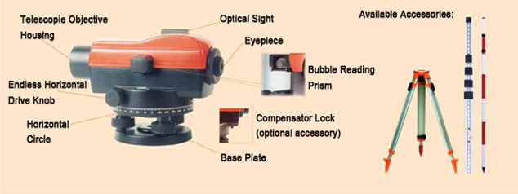
Figure 3 Automatic Level (Wild, n.d.)
The Staff – The staff is used to take precise measurements at given locations on a survey. A typical staff would be split into 1m sections (a total of 3 to 5metres in length), alternating between a red and black symbol. The E’’ shape found on the front of a staff represents a block of 5 blocks which are 10mm each. This will allow the user to take an accurate reading through the automatic level’s lens. “staffs used for ordinary levelling work are sectional and are assembled either telescopically or by slotting onto one another vertically” (Arthur Bannister, 1998).
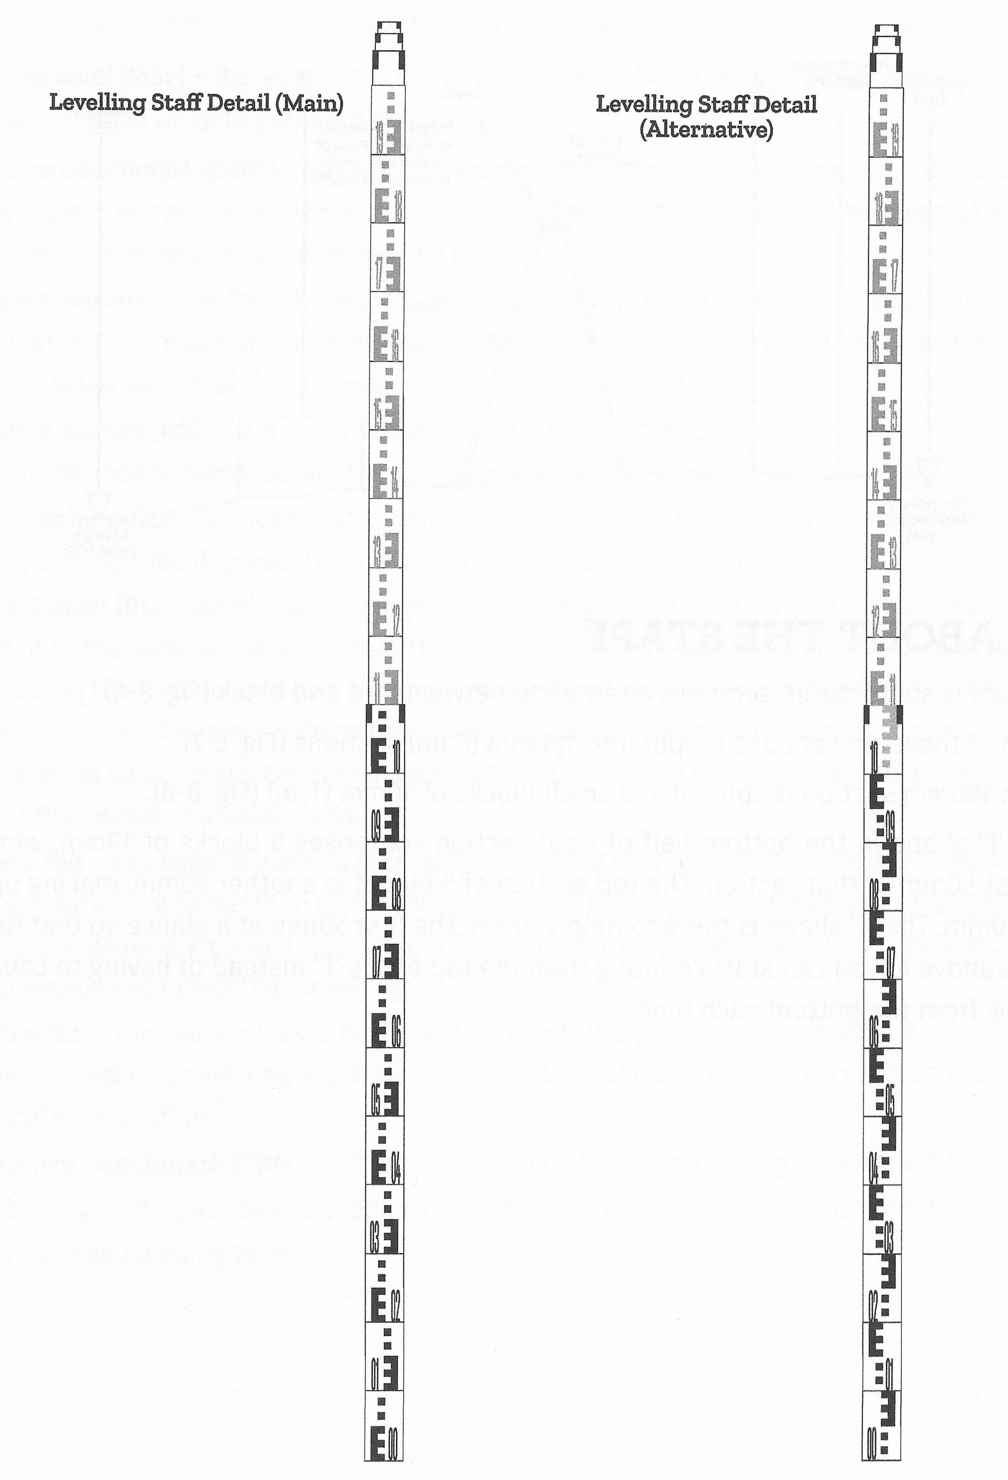
Below is a figure to help the reader visualize the equipment described: Figure 4 Levelling Staves (Grant, 2020)

4.4 Leveling Procedure
When preparing a levelling survey, it is important to make sure the Backsight and foresight distances are approximately equal to avoid any errors along the line of collimation. The distances between the given points must not be so large as it could obscure and make the graduations unreadable. The given points in the survey must be below the level instrument. But they should not be lower than the height of the levelling staff being used.
The step-by-step approach to booking:
1. Set up the level in a good position where it can see all the TBMs.
2. Then calculate the Height of Collimation.
3. Then take intermediate sight points to the next respective temporary benchmarks in the chainage until you reach the next Backsight (BS).
4. Each point in the survey should be recorded in the booking table, by the staff reading in the column labelled for the Intermediate sight.
5. Then after recording, the reduced levels will be found by subtracting the intermediate sight readings from the height of collimation.
6. Finally the Reduced level will be calculated, and it should be within tolerance of around 10mm.
Reducing the levels
When performing a levelling survey, there are two main methods for finding the correct readings from one point to the next. Both of the following methods use a booking table to record the data found in the survey by measuring points to the distance from the line of collimation. These two methods are as follows:
- The Rise and Fall Method.
- The Height of Collimation Method.
The two methods will give the same outcome from the readings put inside the booking table, but how the procedure is calculated is different to one another.
For this report, the ‘rise and fall’ method will be used to carry out the intended levelling survey from the Data that has been collected for the new route for the City and County of Swansea, from Llandarcy to Neath.

4.5 Computation and plotting of level.
To this report, the ‘rise and fall’ method will be used to carry out the intended levelling survey from the Data that has been collected for the new route for the City and County of Swansea, from Llandarcy to Neath.
Booking Table - Using the ‘Rise and Fall’ Method.
Below is the completed booking table calculated from the readings found in the stretch from LLandarcy to neath.
Back Sight | Intermediate Site | Foresight | Rise/Fall | Reduced Level | Chainage | Remarks
1.371 |  |  |  | 738.000 | 0.000 | TBM
 | 2.354 |  | -0.983 | 737.017 | 25.000 | STN. 1
 | 1.222 |  | 1.132 | 738.149 | 50.000 | STN. 2
 | 2.591 |  | -1.369 | 736.780 | 75.000 | STN. 3
1.432 |  | 3.587 | -0.996 | 734.788 | 100.000 | STN.4 Change PT. A
 | 1.872 |  | -0.44 | 733.908 | 125.000 | STN. 5
3.25 |  | 0.573 | 1.299 | 735.207 | 150.000 | STN.6 Change PT. B
 | 1.925 |  | 1.325 | 736.532 | 175.000 | STN.7
3.015 |  | 0.496 | 1.429 | 737.961 | 200.000 | STN.8 / Change PT. C
1.456 |  | 0.499 | 2.516 | 740.477 | 225.000 | STN.9 / Change PT. D
 | 3.853 |  | -2.397 | 735.683 | 250.000 | STN. 10
 | 5.433 |  | -1.58 | 734.103 | 275.000 | STN. 11
 | 5.200 |  | 0.233 | 734.569 | 300.000 | STN. 12
 | 4.000 |  | 1.2 | 735.769 | 325.000 | STN. 13
3.876 |  | 3.067 | 0.933 | 736.702 | 350.000 | STN.14 / Change PT. E
 | 4.533 |  | -0.657 | 735.388 | 375.000 | STN. 15
 | 5.433 |  | -0.900 | 733.588 | 400.000 | STN.16
 | 5.867 |  | -0.434 | 732.72 | 425.000 | STN. 17
 | 5.133 |  | 0.734 | 733.454 | 450.000 | STN. 18
1.734 |  | 3.064 | 2.069 | 735.523 | 475.000 | STN. 19 / Change PT. F
 | 1.280 |  | 0.454 | 736.431 | 500.000 | STN. 20
 | 1.390 |  | -0.110 | 736.321 | 525.000 | STN. 21
3.467 |  | 2.076 | -0.686 | 735.635 | 550.000 | STN. 22 / Change PT. G
 | 4.147 |  | -0.68 | 734.955 | 575.000 | STN. 23
3.371 |  | 1.976 | 2.171 | 739.297 | 600.000 | STN. 24 / Change PT. H
 | 2.395 |  | 0.976 | 740.273 | 625.000 | STN. 25
 | 2.562 |  | -0.167 | 739.939 | 650.000 | STN. 26
 | 2.591 |  | -0.029 | 739.91 | 675.000 | STN. 27
1.432 |  | 3.587 | -0.996 | 738.914 | 700.000 | STN. 28 / Change PT. I
 | 1.872 |  | -0.44 | 738.474 | 725.000 | STN. 29
1.675 |  | 0.573 | 1.299 | 739.773 | 750.000 | STN. 30 / Change PT. J
1.734 |  | 3.064 | -1.389 | 736.995 | 775.000 | STN. 31 / Change PT. K
 | 2.280 |  | -0.546 | 736.449 | 800.000 | STN. 32
 | 2.390 |  | -0.11 | 736.339 | 825.000 | STN. 33
3.467 |  | 3.000 | -0.61 | 735.729 | 850.000 | STN. 34 / Change PT. L
 | 4.147 |  | -0.68 | 735.049 | 875.000 | STN. 35
3.371 |  | 1.976 | 2.171 | 739.391 | 900.000 | STN.36 / Change PT. M
 | 1.395 |  | 1.976 | 741.367 | 925.000 | STN. 37
 | 1.562 |  | -0.167 | 741.033 | 950.000 | STN. 38
 | 1.859 |  | -0.297 | 740.439 | 975.000 | STN. 39
 |  | 2.587 | -0.728 | 739.711 | 1000.000 | STN. 40
BS Total |  | FS Total
34.651 | 34.641 - 30.125 | 30.125 |  | 739.711 - 738.000
 | 4.526 |  |  | 1.711
As you can see in the booking table above, the total Back sight numbers were subtracted from the total Fore sight numbers to give a reading of 4.526. Also the reduced level was only found by firstly finding the points that rise and fall throughout the survey.
From computation and plotting of levels, the estimated volume of earthwork can be found by producing a graph that plots the Chainage against the reduced levels across the booking data found.
Below is the graph:
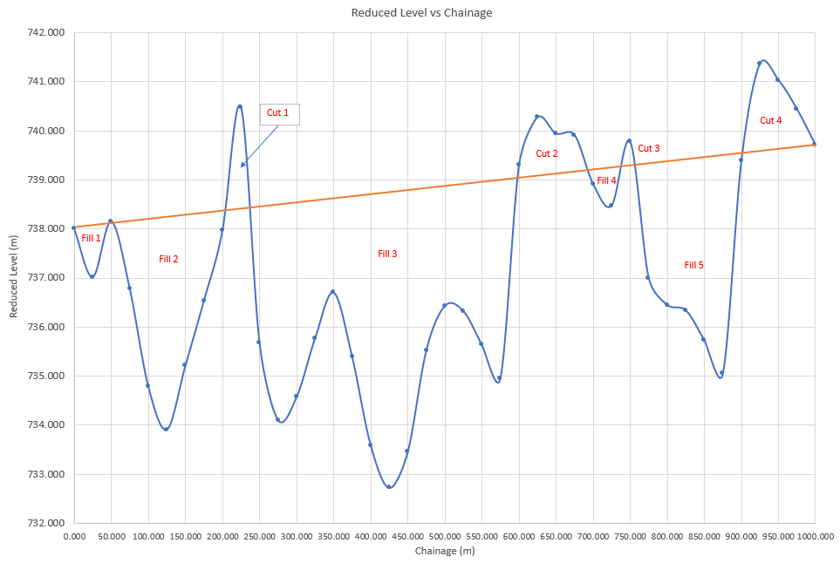
Figure 5 Reduced Level vs Chainage Graph.
From this graph, the volume of earthwork needed to fill can be shown in a table below:

5.0 Conclusion

References
Arthur Bannister, S. R. (1998). Surveying. Longman.
Clancy, J. (1991). Site surveying and levelling. Routledge.
Cowie, A. (n.d.). CRACKING BRITAIN'S KERBSTONE SYMBOL CODE. Retrieved from ashleycowie.com: https://ashleycowie.com/kerbstone-symbols
Grant, S. (2020). Setting out for construction. Costello House publishing.
lssltd.net. (n.d.). How to carry out a levelling traverse or run. The Levelling Procedure. Retrieved from lssltd.net: https://www.lssltd.net/how-to-carry-out-a-levelling-traverse-or-run/#:~:text=What%20is%20a%20levelling%20traverse,in%20two%20different%20known%20points.
Watt, D. (2015). Surveying Historic Buildings. Routledge.
Wild, G. (n.d.). Automatic Level products. Retrieved from www.geowild.com: http://www.geowild.com/product-autolevel.html

