

Programme: Master of Business Administration
Module: International Business Concepts
Module code: LCMB7034
Assignment Title: Report

Student name: Ronak Jerambhai Devani
Student Number: 2531597
Lecturer: Dr.Charles Oham
Word count: 5403
Submission Date: 14th August 2026

Table of Contents
Introduction 1
1.0 Section 1: International Business Analysis 2
1.1 Organisational Classification and Global Strategy 2
1.1.1 Strategic Categorisation 2
1.1.2 Global Configuration 3
1.2 Macro-Environmental Appraisal and Market Attractiveness 4
1.2.1 Host-Country Analysis: Mainland China 4
1.2.2 Market Entry Analysis 11
1.3 Entry-Mode Strategy and Strategic Synthesis 17
1.3 Entry-Mode Strategy and Strategic Synthesis 17
1.3.1 Historical Pattern Recognition 17
1.3.2 Strategic Fit and Justification 18
1.3.3 Conclusion and Recommendations 20
2.0 Section 2: Reflection 22
2.1 Application of Gibbs’ Reflective Cycle 22
Conclusion 26
Reference 27

List of Figures:
Figure 1: Netflix’s Quarterly Financial Performance (Q2 2025–Q2 2026) and Q3 2026 4
Figure 2: Political and Regulatory Pressures Affecting Foreign Technology Firms in China 5
Figure 3: China’s Online Audiovisual User Base Exceeding One Billion 6
Figure 4: Reuters Report on China’s Q2 2026 Economic Slowdown 7
Figure 5: Reuters report on China’s new personal-data export rules 9
Figure 6: Hofstede cultural-dimension profile of China 10
Figure 7: Components of Dunning’s Eclectic Paradigm (OLI Framework) 11
Figure 8: Drivers of Netflix’s Global Brand Index Score, 2026 12
Figure 9: Impact of Market-Access and Regulatory Barriers on European Companies in China, by Industry, 2026 14
Figure 10: Chinese Regulatory Action Against ByteDance and Alibaba over Online-Content Violations, 2025 16
Figure 11: China Expands Restrictions on Foreign Deals and Technology Transfers 19
Figure 12: Gibbs Reflective Model 22

List of Tables:
Table 1: Bartlett and Ghoshal’s (1989) Integration–Responsiveness Framework 2

Introduction
This report discusses the prospects of Netflix entering the mainland China market by examining its globalisation strategy, market potential and entry mode. It analyses the global positioning of Netflix, ownership benefits, environmental issues and strategic choices in the context of applicable international business models to provide a recommended evidence-based market-entry strategy.

1.0 Section 1: International Business Analysis

1.1 Organisational Classification and Global Strategy

1.1.1 Strategic Categorisation
Applying Bartlett and Ghoshal’s Model (1989) to Netflix
 | Low pressure for local responsiveness | High pressure for local responsiveness
High pressure for global integration | Global  • Centralised streaming platform  • Global brand and interface  • Shared recommendation technology  • Worldwide content distribution | Transnational — NETFLIX  •Global platform efficiency  • Local original productions  • Country-specific catalogues  • Local pricing and marketing  • Multilingual dubbing and subtitles
Low pressure for global integration | International  • US-developed streaming capabilities  • Home-market knowledge transferred abroad  • Limited local adaptation• Weak current fit for Netflix | Multidomestic  • Market-specific programming  • Local creative partnerships  • High cultural responsiveness  • Only partial Netflix fit
Table 1: Bartlett and Ghoshal’s (1989) Integration–Responsiveness Framework
Source: (Self-Created)
Using the framework proposed by Bartlett and Ghoshal, Netflix is transnational: the key platform is the recommender and investment control, which combine operations, and local production, catalogues, language and pricing make it responsive (Bartlett and Ghoshal, 1989; Netflix, Inc., 2026a). In the first half of 2026, more than a third of viewing was of non-English content; Korean, Japanese, Spanish and Indian titles represent local production generates global value (Netflix, Inc., 2026b). Jenner (2026), locates Netflix plans local-language programmes to become transnational; Pescatore locates algorithmic mediation and global-local content as the platform mechanisms of Netflix. Therefore, global strategy undermines localisation, multidomestic does not take notice of technology and international is incapable of explaining reciprocal flows of content. Netflix can best be termed transnational and has a digital backbone worldwide. Nevertheless, the 1989 matrix fails to appreciate the strength of algorithms to standardise the discovery and personalise consumption, which makes Netflix a qualified, not pure transnational MNC (Pescatore, 2026).

1.1.2 Global Configuration
Netflix’s Geographic Footprint
Netflix has a presence in over 190 countries and 50 languages with decentralized production and a single digital platform (Netflix, 2026a). However, reach is not even because Netflix is not available in mainland China, or some other territories (Netflix, 2026b). The revenue in Q2 2026 was over 4.0 billion in the EMEA and 1.5 billion in both LATAM and APAC, which is indicative of revenue diversification and non-dependence on North America (Netflix, 2026c).
Competitive Advantage and Value Creation
Netflix transforms scale to cost, differentiation and data benefits. Q2 2026 revenue increased 13 % to 12.6 billion with its 33.4% operating margin indicating that platform standardisation and reusable content turn reach into value capture. Its ten-year production investment with a value of 135 billion said to add above 325 billion to global economy is evidence of value creation in creative clusters but the estimates as reported by the company should be taken with a grain of salt. (Sarandos, 2026) Algorithms discovery decreases search friction and assists in local intellectual property to find transnational niches. The centralised commissioning, on the other hand, can limit the autonomy of producers. (Idiz, 2024) Scale economies are undermined by regulation, currency volatility and being excluded by China. Competitiveness lies then in platform efficiency in combination with embeddedness in the region.
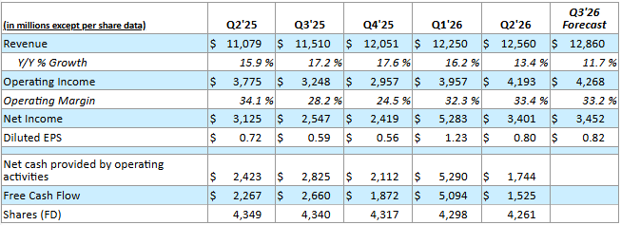
Figure 1: Netflix’s Quarterly Financial Performance (Q2 2025–Q2 2026) and Q3 2026
Source: (Netflix, 2026c)

1.2 Macro-Environmental Appraisal and Market Attractiveness

1.2.1 Host-Country Analysis: Mainland China
Political Factors
The main obstacle to Netflix entering mainland China is political viability since the audiovisual industry of China is a state-controlled media space in which the distribution of content is tightly connected with both national cultural and ideological goals. China is one of the most restrictive media environments in the world, where the government has a wide range of control over online information, regulation of platforms and access to information (Freedom House, 2026). In terms of an international business, this poses systemic political risk since regulatory expectations are institutionalized in the political system and not limited to specific operational problems. In the case of Netflix, it has a direct impact on ownership benefits such as worldwide content freedom, algorithm-driven suggestions and simultaneous releases worldwide. Content screening compliance and algorithmics plus local governmental assent may add to the expenses of monitoring and dilute the Netflix differentiated worldwide platform model (Shen, 2025).
There is also the procedural political risk of Netflix in the form of licensing restrictions, foreign investment restrictions and uncertainty in regard to regulations. The foreign activity in the Chinese entertainment industry typically involves the need to form local joint ventures and adhere to the procedures of governmental approval, which limit the foreign influence of companies on the business (Chambers, 2026). Also, the growing US-China geopolitical tensions add uncertainty since the cultural and technology access may turn into a tool of economic and political rivalry. Such limitations on foreign technology companies show that geopolitics can decrease the access to the market and make the operations riskier (Baptista and Hall, 2026).
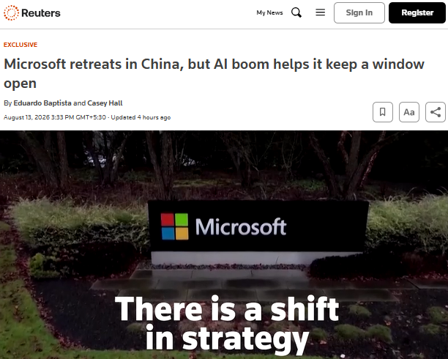
Figure 2: Political and Regulatory Pressures Affecting Foreign Technology Firms in China
Source: (Reuters, 2026b)
Nevertheless, the policy environment in China is not so repressive. When the government supports local cultural industries, it opens up the market to foreign companies that help in producing local content. Thus, Netflix has the chance to enhance political legitimacy by engaging in Mandarin-language content and collaborating with licensed domestic stakeholders. However, excessive localisation leads to a strategic paradox, as, although it enhances acceptance of the regulations, it can diminish the editorial autonomy of Netflix and international brand uniformity. Therefore, the political environment supports an entry mode that is based on controlled partnership and not ownership.
Economic Factors
China has great attention scale, but a challenging conversion economy. According to the 2026 China Online Audiovisual Development Research Report, in 2025, the industry will have 1.099 billion users and a RMB1.29 trillion online audiovisual development, increasing at 5.3, with over 800,000 companies providing the ecosystem (News.cn, 2026). This forms a profound producer base, distribution and advertisement base of Mandarin originals. Nevertheless, the total counts short video, livestreaming and audio, and thus considering it as the addressable SVOD market of Netflix would significantly overestimate revenue potential.
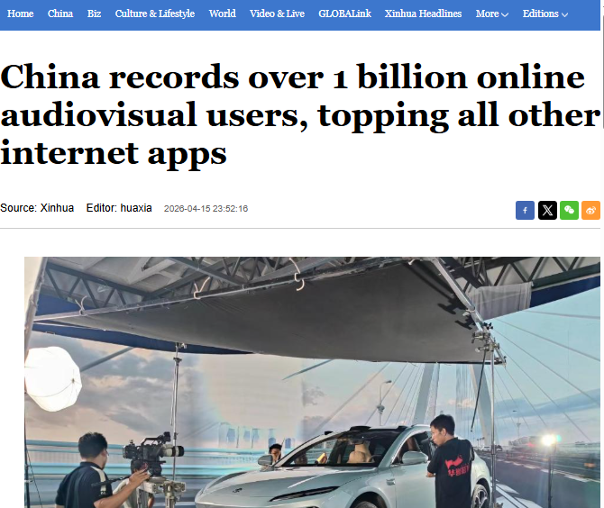
Figure 3: China’s Online Audiovisual User Base Exceeding One Billion
Source: (News.cn, 2026)
Demand is cyclical. The Q2 2026 growth rate of China is 4.3, which is the lowest in three-and-a-half years, and household consumption decreased compared to manufacturing and exports (Gao, Yao and Fu, 2026). Discretionary subscriptions are thus churned and resistant to Netflix-like premium pricing, particularly in non-high-income cities. This attention has changed: micro-dramas have overtaken long-form video in its daily usage, leading to increased competition not only with iQIYI, Tencent Video and Youku but also with mobile-first, low-cost formats (News.cn, 2026).
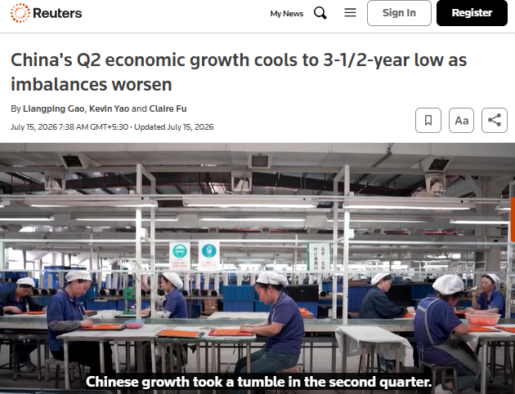
Figure 4: Reuters Report on China’s Q2 2026 Economic Slowdown
Source: (Reuters, 2026a)
Monetisation problem is revealed in incumbent economics. Q1 2026 revenue of iQIYI dropped by 13 % to RMB6.23 billion and membership revenue dropped by 5 % following a reduced content in the program (iQIYI, Inc., 2026). So, even a scaled local operator will still rely on continuous production of hits, increasing the cost of acquisition, talent and marketing at Netflix. A study examining 506-viewers reveals that the perceived value mediates Chinese subscription intention and that attractive alternatives undermine it (Wu et al., 2025). Recent research also indicates that China streaming economy has developed as free with advertisements to hybrid subscriptions, transactions and advertisements instead of Netflix which has a subscription-based global business (Zhao, 2025).
Economically, only when Netflix is not equating reach and willingness to pay, entry is appealing. A partner-led introduction must include a cheaper mobile/ad tier, local payment plans and selectively franchised Chinese sites, and stage investment versus paid conversion, retention and content payback. This trades off margin and control, at the cost of reduced customer-acquisition expense and sunk-content risk, a national rollout based on premium only would annihilate value, instead of creating it.
Legal Factors
China’s legal architecture makes a wholly owned Netflix launch structurally infeasible. The existing Negative List specifically forbids internet audio-visual programme services and programme-production/import enterprises through foreign investment (NDRC, 2024). As a result, a subsidiary or an equity joint venture would not escape the restriction: Netflix would need an arm-length licensing agreement with a Chinese licence-holder. This comes at the cost of control of catalogue, pricing, customer relationships and viewing data- the assets on which its transnational model generates value.
Content law further constrains differentiation. The online dramas and films of subjects to NRTA licensing are also subjected to administrative review and the same standards as offline releases; the 2026 trade-barrier filing submitted by the Motion Picture Association confirms the ongoing censorship and investment barrier to the online audiovisual services (Motion Picture Association, 2025). A shorter, edited and localised Chinese catalogue would undermine simultaneous launches across the globe, franchise spillovers and quality of recommendations, as well as complicate the recovery of content investment.
The regulation of data is in a clash with the algorithmic operating system of Netflix. Beginning 1 January 2026, specified transfers by operators of non-critical-infrastructure are subject to certification, with more risky transfers potentially subject to security assessment (Reuters, 2025b; CMS, 2025). This would require Netflix to have a local mainland data stack with a ring-fenced mainland consent and impact-assessment workflow and possibly local model training rather than free US aggregation. Huang (2026), concludes that the localisation increases the costs of infrastructure and restructuring of foreign firms in disproportion. Opaque experimentation is also limited by algorithm rule mandates of periodic model/data audits and a convenient personalisation opt-out (China Law Translate, 2022). Enforcement is concrete: the amended Cybersecurity Law increased the maximum amount of a fine imposed on the network-operators who violate its provisions to RMB2 million (Library of Congress, 2026).
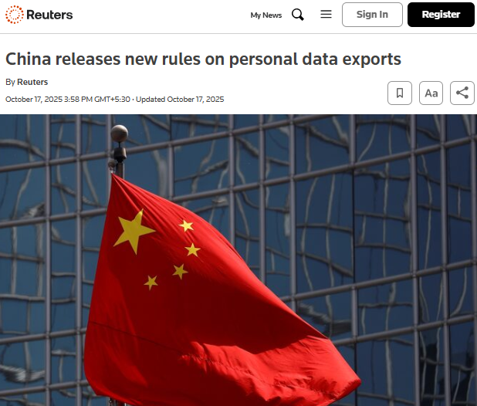
Figure 5: Reuters report on China’s new personal-data export rules
Source: (Reuters, 2025b)
Netflix’s recurring-billing model must also provide prominent auto-renewal notices before acceptance and renewal (Kangxin, 2024). Overall, legal attractiveness is low. A licensed domestic distributor, protected by IP, audit, takedown, data-separation and approval-risk clauses, is defensible; direct platform entry is not.
Cultural Factors
The profile of China shows that it has high power distance (80) and long-term orientation (77), high achievement orientation (66), collectivism (individualism 43), low uncertainty avoidance (30) and restraint (indulgence 24) (The Culture Factor Group, 2025). In the case of Netflix, it does not warrant stereotyping audiences; it offers testable hypotheses that are strategic. Hierarchy and collectivism embrace family responsibility, status and group effects; long-term orientation embraces multi-season multi-character development. Minor uncertainty avoidance allows the introduction of new genres, a difficult localisation.
These implications are narrowed by recent behavioural evidence. In a 2025 mixed-method survey of 1,942 Chinese cinephiles, emotional authenticity, everyday realism and shared family ethics were found to have more impact than cultural proximity alone. It further discovered that 75.03% wanted Chinese subtitles to foreign films as opposed to a mere 2.27% who wanted dubbing (Yaqoub and Gao, 2025). Netflix ought to co-produce Mandarin originals with Chinese showrunners, maintain culturally specific social relationships, and focus on idiomatic subtitles, rather than on uniform dubbing. Marketing needs to employ local credible actors and community discussion, and not American individualist messaging. Instead of considering the national averages of Hofstede as facts about consumers, recommendations ought to be divided by generation, region, city tier and genre. Cultural attractiveness is not absolute: the global production potential of Netflix can only be applied effectively when local producers translate universal themes into the familiar Chinese relationships with caution to avoid the loss of authenticity in the decorative symbolism.
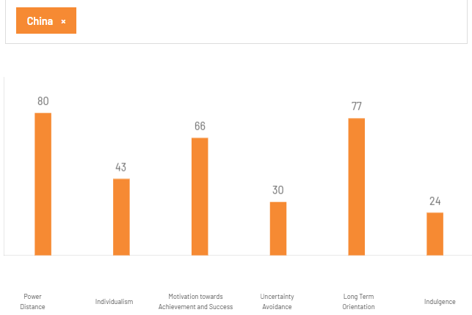
Figure 6: Hofstede cultural-dimension profile of China
Source: (The Culture Factor Group, 2025)

1.2.2 Market Entry Analysis
OLI Framework Synthesis
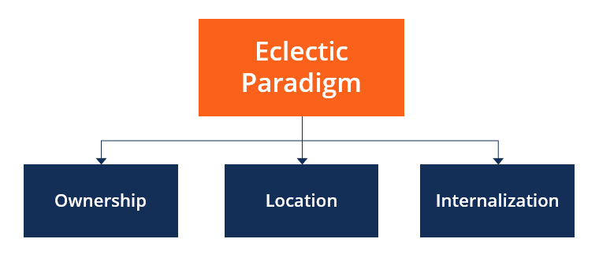
Figure 7: Components of Dunning’s Eclectic Paradigm (OLI Framework)
Source: (CFI, 2022)
The eclectic paradigm by Dunning only favours the foreign direct investment where the advantages of Ownership (O), Location (L) and Internalisation (I) work together better than the alternative options of exporting or licensing (Dunning, 2000). As an interactive decision test, Netflix boasts of good O assets in brand, intellectual property, engineering and global monetisation. The L conditions in China are divided: the creative economy is valuable, yet the institutionally restrictive access to online-video exists. Netflix would typically internalise the data, rights and distribution, but is not legally allowed to own the mainland platform. This imbalance is decisive: great proprietary resources will not be able to balance an place that is obstructive to their favourite form of government.
Studies that have adapted OLI to online platforms have found that local connections and absorbing external knowledge can turn into firm-specific benefits (Surana et al., 2024). A Chinese collaborator should thus establish the market intelligence of Netflix, rather than just give a licence. The overall decision favouring the entry of non-equity contractual entry in its various phases, rather than a wholly owned subsidiary or equity joint venture, is in favour of Netflix safeguarding limited assets and a licensed Chinese operator providing regulated distribution.
Ownership Advantages
The brand makes Netflix less liable to foreignness among the creators and commercial partners: it was ranked as number seven in YouGov (2026) global brand list with a score of 34 on its Index (YouGov, 2026). YouGov (2026) suggests that the highest ownership values at Netflix are Quality net score (40) and Impression score (39) and Recommend (36), Satisfaction (33), Reputation (31) and Value (27). Another O asset of the company is its proprietary personalisation and delivery system. The GenPage experiment at Netflix yielded a statistically significant increase in engagements and a 20-% reduction in end-to-end serving latency compared to its full-fledged recommender (Wang et al., 2026). Its advertising power cuts across markets, too: the ad-supported service has a reach of over 250 million monthly active viewers around the world, with over 80 % of these viewers viewing every week (Netflix, 2026d). It does not have content library but rather starts with its advertising technology that provides partner campaign measurement and premium sponsorship expertise. Together with global distribution, these assets enabled a single mandated Chinese production to produce subscription, advertising, licensing and derivative-rights incomes across regions.
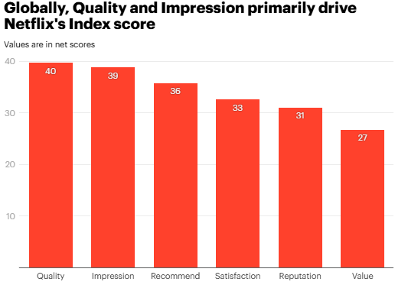
Figure 8: Drivers of Netflix’s Global Brand Index Score, 2026
Source: (YouGov, 2026)
They are however conditional in terms of value. The strength of global brands fails to demonstrate the mainland readiness to pay; their recommendations are weakened in the absence of direct Chinese behavioural information; and uncleared titles cannot be monetised. The ability to transfer source code, models or unrestricted rights may convert Netflix competitive edge into that of partners. Netflix ought to sell some of its titles, production skills and limited knowledge and keep algorithms, masters, global rights and international commissioning power. O benefits reinforce bargaining power but they fail to counteract institutional exclusion.
Location Advantages
China is not an untapped subscriber market, but rather an attractive asset-seeking production and IP location. By the year 2025 it had over 33 million online literary works and had exported over 130,000 works (YANG, 2026). This pool of audience-tested content would provide Mandarin series, animation and micro-dramas to be licensed and released worldwide. Local studios and writers would enhance cultural authenticity and decrease the expensive preference-learning issue at Netflix. The greater risk-adjusted L value can thus be globally reusable Chinese IP as opposed to home subscriptions only.
However, the disadvantages are structural. The present foreign-investment policy of China does not allow foreign involvement in the services of online audiovisual programmes, even free-trade zones (China Briefing News, 2026). Neither a subsidiary nor an equity joint venture of Netflix solves the distribution. Domestic platforms that are already established incorporate content, advertising, payments, customer data and regulatory routines. The partner value brought about by the institutional density also enhances the dependency and bargaining exposure of Netflix. In addition, 54 % of European companies surveyed mentioned that they have lost opportunities due to Chinese market-access or regulatory barriers, indicating that demand does not necessarily turn into a revenue (China Briefing News, 2026b). Therefore, China presents good co-production and content-sourcing opportunities and poor terms in relation to platforms deployed by foreigners. Market attractiveness is based on the distinction of these opportunities rather than the conflation of scale and accessibility.
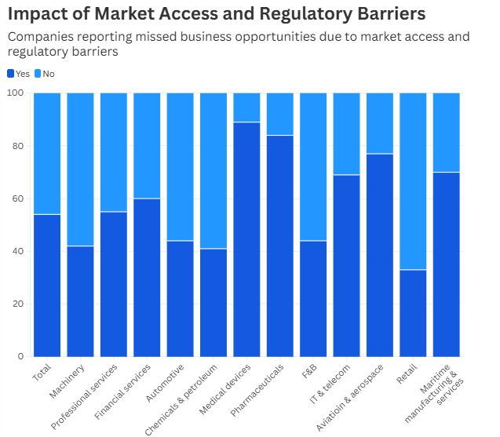
Figure 9: Impact of Market-Access and Regulatory Barriers on European Companies in China, by Industry, 2026
Source: (China Briefing News, 2026b)
Internalisation Advantages
Normally commissioning, production standards, rights, recommendations, billing and audience learning are internalised by Netflix. This integration reduces contracting costs, maintains quality of experience and allows viewing evidence to inform investment. China turns a portion of that reasoning the other way around: domestic licensed organizations are supposed to exercise control over mainland operations, approvals and local information. Complete internalisation is impossible, whereas pure licensing establishes data blindness, royalty-verification risk, brand dilution and format appropriation. A licensee might get to know the Netflix formats, but not the user evidence to enhance it. These issues are not obsolete since China is listed on the US Priority watch list and its rate of intellectual-property protection and enforcement reform was concluded to be slow (USTR, 2026).
Netflix thus requires modular internalization. It must keep international IP rights, funding, production guidelines, international analytics and distribution beyond China; its partner must only do mainland hosting, billing, controlled data, approvals and takedowns. Contracts must be title-specific and time-bound, prohibit unauthorised sublicensing and model training, worldwide reserve, sequel and remake, and should have minimum guarantees with audited revenue sharing. The leakage and opportunism would be limited by watermarked masters, independent usage audits, approval milestones and termination clauses. Netflix does not own the mainland customer interface, but it is able to safeguard property that creates its international edge. High, I (Internalisation) benefit so recognise what should be internalised not a reason to make FDI legally impossible.
Critical Success Factors for Netflix’s Market Entry into China
Netflix must establish success as a China-to-world content feed, monetised under control, with mainland, not direct-to-consumer, and should not copy its direct-to-consumer approach. China registered 293 million active smart-TV sets in March 2026 (Ciw.news, 2026). It ought to select its partners based on audited connected-TV coverage, audiovisual-licence coverage, advertisement sales and title-level reporting - not headline app users. It has been indicated that the entry of transnational programmes in the controlled ecosystem of China occurs via domestic gatekeepers, which facilitate control of the execution of regulatory processes over the highest bidder (Han and Chau, 2025).
Prior to commissioning, content governance has to start. Proper scrutiny of scripts, casting, thumbnails and trailers should be done by a greenlight cell since the action of 2025 CAC against the Bytedance and Alibaba platforms was not only against products hidden in the trending or promotion fronts but the underlying programmes (Baptista, 2025). Every project must have a version of the project that conforms and marketable on the mainland without sacrificing narrative clarity.
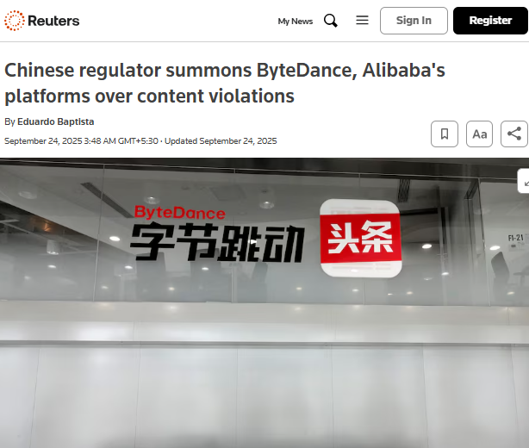
Figure 10: Chinese Regulatory Action Against ByteDance and Alibaba over Online-Content Violations, 2025
Source: (Reuters, 2025c)
Netflix ought to invest in a drama, animation and documentary portfolio that is chosen based on domestic viewer data and foreign analogs. Approval latency, title-attributable conversion, completion, advertising yield and piracy should have release gates that keep track of the same. International travel and mainland performance should be rewarded through producer bonuses so as not to be biased towards domestic-only IP.
Lastly, AI training, synthetic dubbing, performer, adaptation and technical-protection rights should be outlined in rights schedules. In July 2026, a draft of China broadened the scope of implementing rules to 49 articles, and included audiovisual-performer and rights-management-information provisions (Wininger, 2026). Netflix ought to halt scaling until chain-of-title, metadata delivery and remedy on dispute are validated by an independent audit before it goes nationwide.

1.3 Entry-Mode Strategy and Strategic Synthesis

1.3 Entry-Mode Strategy and Strategic Synthesis

1.3.1 Historical Pattern Recognition
Netflix’s Historical International Entry Modes
Direct Digital Export as the Dominant Entry Mode
Netflix’s dominant historical mode is direct digital export of its centrally controlled subscription service, avoiding franchises and country-level equity joint ventures. It combines low host-country assets and rapid rollout with control of the interface, pricing, recommendations and customer relationship. After using Canada as its first foreign learning market in 2010, Netflix progressively entered Latin America, Europe, Australia, New Zealand and Japan and also in 2016 it launched simultaneously in more than 130 additional countries (Kharpal, 2016).
Complementary Distribution and Billing Alliances
Contractual alliances have complemented, not replaced, that control. Netflix’s 2025 Form 10-K identifies device manufacturers, pay-TV distributors, mobile operators and internet providers as marketing partners, but states that Netflix remains principal because it controls service delivery (Netflix, 2026e). Japan illustrates the boundary: SoftBank provided retail enrolment, carrier billing and handset installation, while Netflix retained the product and membership relationship.
Progressive Resource Commitment and Local Production
Commitment deepens only after market learning. Netflix now plans to invest more than €1 billion in Spanish productions during 2025–2028, a decade after entering Spain (Netflix, 2025). The pattern is therefore a commitment ladder: digital export, local distribution alliances, contracted originals, then selective production infrastructure.
China-Specific Licensing Experiment with iQIYI
China produced a different experiment. Netflix licensed a subset of originals to iQIYI in 2017, describing expectations as modest (Netflix, 2024). The arrangement ended by 2024 as iQIYI’s chief executive attributed disappointing results partly to Netflix originals failing local approval (Brzeski, 2024). Licensing delivered speed and minimal capital exposure, but forfeited interface control, audience learning, merchandising and release certainty. Netflix’s history therefore reveals both a scalable default and where that default or a thin licence break.

1.3.2 Strategic Fit and Justification
Suitability of Netflix’s Historical Entry Modes for the Chinese Market
Direct Digital Export: High Control but Regulatory Incompatibility
The direct-export approach of Netflix is strategically appealing but inappropriate to the mainland China. It ensures as much control as possible on brand, sequencing and monetisation of content, but the above analysis indicates that the necessary foreign-controlled audiovisual platform does not exist. The separate technology would be needed in any extraordinary operation that would involve the process of moderation and review, and would concentrate the political, compliance and reputational exposure, and would undermine the scale economies.
Greenfield FDI, Acquisition and Equity-Joint-Venture Risks
Greenfield FDI is most controlling yet committed to sunk capital prior to the quelling of regulatory and demand uncertainty. Acquisition seems quicker as it may purchase licences, talent and distribution, but generates valuation, integration and national-security risk. In 2026, Beijing directed Meta to divest its ownership in Chinese-origin, Manus and established authorities over finalized offshore deals of Chinese technology, data or people (Chen, 2026). Though it is not AI but rather media, the episode shows that post-deal sovereign risk cannot be removed when there is contractual closing. Only an equity joint venture would share finance and offer local knowledge, and cannot overcome an activity-level prohibition, where allowed, a divided control over content, data and reinvestment also can paralysed decisions.
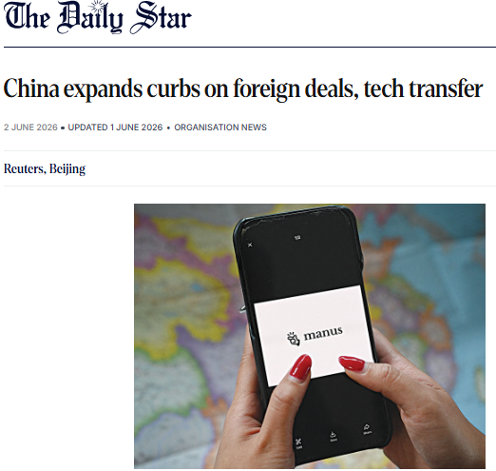
Figure 11: China Expands Restrictions on Foreign Deals and Technology Transfers
Source: (The Daily Star, 2026)
Pure Licensing: Flexibility without Strategic Learning
Pure content licensing is financially elastic, but the result of Netflix iQIYI is revealing its flaws. The licensee has a control over placement, promotion and customer evidence and has the privilege to favour its own productions. Netflix is given royalty and cannot develop its brand-platform flywheel or even be able to distinguish between poor audience fit and poor promotion or regulatory delay. The bigger licensing would replicate information dependency instead of market knowledge generation.
Non-Equity Strategic Alliance: Best Control–Flexibility Balance
A thicker non-equity strategic alliance is superior. The 2026 systematic review by Teplov et al. of 95 studies concludes that digital-platform internationalisation requires ecosystem orchestration, legitimacy building and institutions which co-evolve with firms (Teplov et al., 2026). This applies directly to Netflix: its partner has to establish regulatory legitimacy and has to coordinate local complementors and create verified learning, and not just to be able to carry titles. Licences, submissions of approval, domestic billing, promotion and customer services should be handled by a qualified mainland platform. Netflix ought to share the cost of China productions, use international masters and exploitation and be entitled to title level performance evidence. This puts the political and operational risks in the hands of a party that can handle them most effectively, restricts the financial obligation of Netflix, retains the power to transferable IP and has the flexibility to exit. The weakness is still in partner opportunism, earned exclusivity, auditable performance definitions and formal escalation procedures are thus mandatory.

1.3.3 Conclusion and Recommendations
Synthesis of Key Findings
The historical direct entry of Netflix was successful, in that it was low initial commitment, and high platform control; alliances eliminated the friction of distribution, as Netflix remained the principal. China is the opposite of that formula: With direct control, infeasibility grows, and with conventional licensing, information and IP leverage are lost. Greenfield entry has the overcommitment of resources, acquisition has the sovereign and integration risk, and an equity joint venture does not assure permission and does not solve the control conflict. The analysis is to modularise the controlled-platform logic at Netflix: localise regulated market-facing functions and maintain scalable creative and commercial assets.
Final Recommended Entry Mode for Netflix in China
The approach that Netflix should take is a conditional, milestone based non-equity alliance that entails co-production as well as title-by-title mainland distribution under a single licensed lead platform. The contract ought to cover two periods of commissioning and be non-exclusive in formats. Mainland release rights and performance-based fee would be granted to the partner; Netflix would be left with the international distribution, format-development control and brand-quality criteria. Approval reliability, attributable monetisation, audience completion, export sales and rights integrity should be based on thresholds, and reviewed by a joint steering committee with independent verification. Contingent switching rights allow changing the platform in the event of a decline in performance or compliance.
Until there is a change in regulation and evidence of sustainability in alliances, Netflix should not purchase equity or initiate a mainland-branded direct service. In case the partner is unable to deliver verifiable learning or stop global exploitation, Netflix ought to use its exit entry and limit itself to its purchase of productions to audiences beyond mainland China. This trades off the immediate consumer control but provides the most optimal political-risk containment, limited financial exposure, operational legitimacy, strategic learning and reversible long-term commitment.

2.0 Section 2: Reflection

2.1 Application of Gibbs’ Reflective Cycle
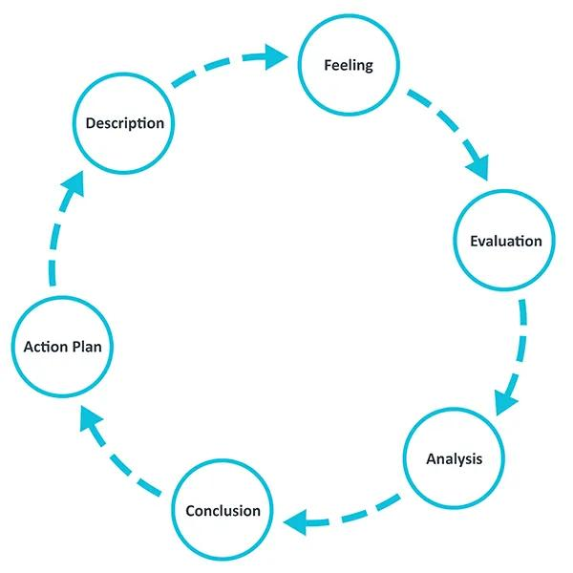
Figure 12: Gibbs Reflective Model
Source: (The University of Edinburgh, 2024)
I chose the Reflective Cycle created by Gibbs as the six phases of the cycle give a pathway between the experience and the improvement. Recent studies, which utilize mixed methods, have shown that when critical reflection is structured, it can enhance understanding, unveil gaps in learning, and enhance engagement (Awidi and Klutsey, 2025).
Description of the Task and Research Process
My assignment was to establish whether and how Netflix ought to enter mainland China. I turned the brief into three interconnected decisions: categorize the international strategy of Netflix; assess industry-specific political, economic, legal and cultural environments with the help of OLI, and choose an entry mode. The first step to avoid the frameworks being disjointed descriptions was to read the assessment criteria and lecture slides.
I also made an evidence ledger that documented all the claims, dates of publication, the type of source, link, relevance and limit and whether its statistic had already been utilized. I laid emphasis on Chinese laws and regulator material, Netflix filings, and peer-reviewed journals, industry reporting and reputable journalism. Triangulation of claims was done between types of sources. Nonetheless, I opened all links, verified the dates of publication, tracked statistics to the sources and made final analytical conclusions.
Feelings and Initial Expectations
In the first place, I felt good as I knew about Netflix and China seemed to present a ready huge market potential. This trust was shaken when I came across unreachable Chinese web pages, broken links in English, paywalls and recent news stories presenting older evidence. I was also upset when AI provided realistic references or dated statements that could not be confirmed. This uneasiness was fruitful: it revealed my supposition that the demand would prevail over institutional restrictions, and it made me less susceptible to convenient evidence.
Evaluation of Research Methods Used
The evidence ledger was my strongest method. It avoided repetitive statistics, maintained references next to substantiated statements and unveiled statements that relied on corporate publicity solely. Triangulation weaknesses of balanced sources: company evidence was authoritative but self-serving; journalism was up-to-date but had the power to reduce the complexity of the law; scholarship explained how things work but might be behind regulatory reform.
General sweeps were not effective. China PESTLE generated generic macroeconomic overviews as opposed to evidence on whether foreign streaming would be granted, regulate data or monetise content. I achieved better scores in decision-led searches that included audiovisual licences, investment limits, content audit, data localisation and incentives to partners.
AI made comparison and redrafting faster, but may flatten disagreement and be over-confident about uncertainty. Language models are capable of being used to support learning and generate bias and inaccuracies that need human intervention. I thus considered AI output as a lead, not evidence.
Analysis of Learning and Key Challenges
The course changed how I interpreted evidence. The model by Bartlett and Ghoshal presented conflict between the efficiency of the central platform of Netflix and the adaptation of its local content; it was not sufficient to call it transnational. The host-country analysis is what caused me to pick the factors that influence streaming instead of occupying all the types of the environmental factors. The OLI framework by Dunning resulted in the key revelation: good ownership assets and a desirable location of content do not warrant internalisation in the face of law limiting foreign control of platforms. It is at this point that entry-mode teaching caused my comparison of risk, commitment, control and flexibility.
This argument reversed my earlier favour of direct digital input. The interface (Netflix), recommendations and customer relationship are safeguarded by its normal mode but these advantages cannot be inherited easily to mainland China. Its previous iQIYI licensing experiment also demonstrated that low commitment inhibits exposure at the expense of approval certainty, audience learning and promotional control. I contrasted direct export, pure licensing, greenfield investment, acquisition, equity joint venture and non-equity alliance with the same considerations. Comparison, rather than description, created a staged co-production and licensing alliance with a qualified domestic platform.
The greatest difficulty was to part evidence and inference. A regulation puts in place a limit, which cannot guarantee a specific partnership to work. I started to indicate sentences as fact, interpretation or recommendation and conditionalized the proposal on staged investment, audit access, title-level learning data, international IP rights and exit triggers. The productivity gains of Generative AI are accompanied by the risks of redundant information, lack of transparency and reliability. My position changed to gathering content to evaluating provenance, relevance and decision value.
Conclusion: What I Learned
I found out that critical research relies upon an accountable lineage, via a valid structure, to an uncertain verdict, not the quantity of facts gathered. I am now able to differentiate market attractiveness and entry feasibility, corporate capability and legally exercisable control. The cycle created by Gibbs also prompted me to question my assumptions, rather than just telling tasks, which is consistent with the evidence that structured reflection bridges theory, learning gaps and problem-solving. The lack of primary evidence of mainland viewers and potential partners is my other weakness.
Action Plan for Future Research
I will also set the decision question and criteria of assessment prior to search next time. I will have a protocol of recency, source hierarchy, triangulation and rejection reasons, and separate registers of used statistics, unresolved claims and counterevidence. AI will assist in query designing, comparison, testing challenges and language refinement; all the factual outputs and citations will be verified with its original publication. My pre-draft mapping will be to map out each claim to evidence, theory, limitation and implication. Lastly, I will check on source validity, analytical balance, Harvard citations and word count. In the absence of primary evidence, I will reveal uncertainty and form conclusions contingent and not as such inferences.

Conclusion
The transnational capabilities of Netflix generate good ownership benefits, and the regulatory, cultural and data restrictions in China mean direct entry is not a good strategic choice. The most appropriate balance of market access, control, organisational learning, flexibility and risk are a staged co-production and licensing collaboration with an established local platform.

Reference
Awidi, I.T. and Klutsey, J.Q. (2025) ‘Using online critical reflection to enhance students’ confidence, motivation, and engagement in higher education’, Technology, Knowledge and Learning, 30, pp. 1499–1534. Available at: https://doi.org/10.1007/s10758-024-09751-4 (Accessed: 3 August 2026).
Baptista, E. (2025). Chinese regulator summons ByteDance, Alibaba’s platforms over content violations. Reuters. [online] 23 Sept. Available at: https://www.reuters.com/technology/chinese-regulator-summons-bytedance-alibabas-platforms-over-content-violations-2025-09-23/ [Accessed 11 Aug. 2026].
Baptista, E. and Hall, C. (2026). EXCLUSIVE: Microsoft retreats in China, but AI boom helps it keep a window open. Reuters. [online] 13 Aug. Available at: https://www.reuters.com/world/china/microsoft-retreats-china-ai-boom-helps-it-keep-window-open-2026-08-13/ [Accessed 14 Aug. 2026].
Bartlett, C.A. and Ghoshal, S. (1989) Managing across borders: The transnational solution. Boston, MA: Harvard Business School Press. Available at: Google Books (Accessed: 10 August 2026).
Brzeski, P. (2024). Filmart: iQiyi’s Tim Gong Yu on Netflix, expanding globally and why the Chinese market is “unpredictable”. [online] The Hollywood Reporter. Available at: https://www.hollywoodreporter.com/news/general-news/iqiyi-ceo-tim-gong-yu-netflix-expanding-globally-why-chinese-market-is-unpredictable-1195599 [Accessed 11 Aug. 2026].
CFI (2022). Eclectic paradigm. [online] Corporate Finance Institute. Available at: https://corporatefinanceinstitute.com/resources/management/eclectic-paradigm/ [Accessed 1 Aug. 2026].
Chambers (2026). Media & Entertainment 2026 - China | Global Practice Guides | Chambers and Partners. [online] Chambers.com. Available at: https://practiceguides.chambers.com/practice-guides/media-entertainment-2026/china [Accessed 13 Aug. 2026].
Chen, L. (2026). China expands curbs on foreign deals, tech transfer after Meta-Manus block. Reuters. [online] 1 June. Available at: https://www.reuters.com/world/asia-pacific/china-toughens-rules-outbound-investment-after-meta-manus-contention-2026-06-01/ [Accessed 2 Aug. 2026].
China Briefing News (2026a). China’s foreign investment negative list - A guide for investors. [online] China Briefing News. Available at: https://www.china-briefing.com/news/chinas-foreign-investment-negative-list-guide [Accessed 5 Aug. 2026].
China Briefing News (2026b). EU chamber China 2026 survey: European business confidence grows. [online] China Briefing News. Available at: https://www.china-briefing.com/news/eu-chamber-china-2026-business-confidence-survey [Accessed 7 Aug. 2026].
China Law Translate (2022) ‘Provisions on the management of algorithmic recommendations in internet information services’, 4 January. Available at: https://www.chinalawtranslate.com/en/algorithms/ (Accessed: 2 August 2026).
Ciw.news (2026). China’s mobile internet insights for q1. [online] Ciw.news. Available at: https://www.ciw.news/p/china-mobile-internet-q1-2026 [Accessed 11 Aug. 2026].
CMS (2025). China issues measures for the certification of the cross-border transfer of personal information. [online] https://x.com/CMS_Law_Tax. Available at: https://cms.law/en/chn/legal-updates/china-issues-measures-for-the-certification-of-the-cross-border-transfer-of-personal-information [Accessed 1 Aug. 2026].
Dunning, J.H. (2000). The eclectic paradigm as an envelope for economic and business theories of MNE activity. International Business Review, [online] 9(2), pp.163–190. doi:https://doi.org/10.1016/S0969-5931(99)00035-9.
Freedom House (2025). China: Freedom in the world 2026 country report | freedom house. [online] Freedom House. Available at: https://freedomhouse.org/country/china/freedom-world/2026 [Accessed 14 Aug. 2026].
Gao, L., Yao, K. and Fu, C. (2026). China’s Q2 economic growth cools to 3-1/2-year low as imbalances worsen. Reuters. [online] 15 July. Available at: https://www.reuters.com/world/china/chinas-q2-gdp-growth-slows-43-yy-misses-market-forecast-2026-07-15/ [Accessed 11 Aug. 2026].
Han, X. and Chau, K.L.-F. (2025). The evolving ecosystem of Chinese children’s television in a regulated environment. Critical Studies in Television: The International Journal of Television Studies, 21(1), pp.114–126. doi:https://doi.org/10.1177/17496020251404935.
Huang, J. (2026). The evolution of sensitive data governance in international investment law: A dual-jurisdictional study. International Journal of Law and Information Technology, [online] 34. Available at: https://academic.oup.com/ijlit/article/doi/10.1093/ijlit/eaaf023/8443256 [Accessed 11 Aug. 2026].
Idiz, D.R. (2024). Local production for global streamers: How netflix shapes European production cultures. International Journal of Communication, [online] 18(0), p.20. Available at: https://ijoc.org/index.php/ijoc/article/view/21881 [Accessed 11 Aug. 2026].
iQIYI, Inc. (2026). iQIYI announces first quarter 2026 financial results | iQIYI, Inc. [online] iQIYI, Inc. Available at: http://ir.iqiyi.com/news-releases/news-release-details/iqiyi-announces-first-quarter-2026-financial-results [Accessed 11 Aug. 2026].
Jenner, M. (2026) ‘Between grammars of transnationalism and hyper-localisation: Strategies of Netflix and Amazon in transnational streaming’, Convergence: The International Journal of Research into New Media Technologies, OnlineFirst, pp. 1–17. Available at: https://doi.org/10.1177/13548565251409847 (Accessed: 11 August 2026).
Kangxin (2024). The “implementing regulation for the law of the people’s Republic of China on the protection of consumer rights and interests” will come into effect on july 1, 2024. – Legal+. [online] Kw-legal.com. Available at: https://www.kw-legal.com/en/2024/05/06/14003en [Accessed 11 Aug. 2026].
Kharpal, A. (2016). Netflix partners with SoftBank for Japan launch. [online] CNBC. Available at: https://www.cnbc.com/2015/08/24/netflix-partners-with-softbank-for-japan-launch.html [Accessed 11 Aug. 2026].
Library of Congress (2026) ‘China: amended Cybersecurity Law takes effect’, Global Legal Monitor, 8 January. Available at: https://www.loc.gov/item/global-legal-monitor/2026-01-08/china-amended-cybersecurity-law-takes-effect/ (Accessed: 3 August 2026).
Motion Picture Association (2025) MPA response to USTR’s request for comments on significant foreign trade barriers for the 2026 National Trade Estimate Report. 3 November. Available at: Motion Picture Association (Accessed: 11 August 2026).
NDRC (2024). Special administrative measures (negative list) for foreign investment access (2024 edition) notes_industrial policies_beijing investment promotion service center. [online] Beijing.gov.cn. Available at: https://invest.beijing.gov.cn/english/Choose/Policies/202410/t20241024_3927463.html [Accessed 11 Aug. 2026].
Netflix (2024). About Netflix - iQIYI and Netflix sign licensing agreement. [online] About Netflix. Available at: https://about.netflix.com/en/news/iqiyi-and-netflix-sign-licensing-agreement [Accessed 11 Aug. 2026].
Netflix (2025). Netflix will invest more than €1 billion in Spain between 2025 and 2028 - about Netflix. [online] About Netflix. Available at: https://about.netflix.com/en/news/netflix-will-invest-more-than-eur1-billion-in-spain-between-2025-and-2028 [Accessed 11 Aug. 2026].
Netflix (2026). Netflix upfront 2026: Get closer - about Netflix. [online] About Netflix. Available at: https://about.netflix.com/en/news/netflix-upfront-2026-get-closer [Accessed 11 Aug. 2026].
Netflix, Inc. (2026a) About Netflix. Available at: https://about.netflix.com/ (Accessed: 11 August 2026).
Netflix, Inc. (2026b) Where is Netflix available? Netflix Help Center. Available at: https://help.netflix.com/en/node/14164 (Accessed: 11 August 2026).
Netflix, Inc. (2026c) Q2 2026 shareholder letter, 16 July. Available at: https://www.sec.gov/Archives/edgar/data/1065280/000106528026000211/ex991_q226.htm (Accessed: 1 August 2026)
Netflix, Inc. (2026e) Annual report for the fiscal year ended 31 December 2025: Form 10-K. Filed 23 January 2026. Available at: U.S. Securities and Exchange Commission (Accessed: 11 August 2026).
News.cn (2026). China records over 1 billion online audiovisual users, topping all other internet apps. [online] News.cn. Available at: https://english.news.cn/20260415/4396df1712a041acba2ab1f94d611cfe/c.html [Accessed 11 Aug. 2026].
Pescatore, G. (2026) ‘Algorithmic neogeneralism in streaming platforms: Recommender systems and content strategy’, Frontiers in Communication, 11, article 1830832. Available at: https://doi.org/10.3389/fcomm.2026.1830832 (Accessed: 05 August 2026).
Reuters (2025a). Beijing bites back at US tariffs by curbing Hollywood film imports. Reuters. [online] 10 Apr.a. Available at: https://www.reuters.com/business/media-telecom/beijing-bites-back-us-tariffs-by-curbing-hollywood-imports-2025-04-10/ [Accessed 11 Aug. 2026].
Reuters (2025b). China releases new rules on personal data exports. Reuters. [online] 17 Oct.b. Available at: https://www.reuters.com/technology/china-releases-new-rules-personal-data-exports-2025-10-17/ [Accessed 11 Aug. 2026].
Reuters (2026a). China’s Q2 economic growth cools to 3-1/2-year low as imbalances worsen. Reuters. [online] 15 July. Available at: https://www.reuters.com/world/china/chinas-q2-gdp-growth-slows-43-yy-misses-market-forecast-2026-07-15/ [Accessed 11 Aug. 2026].
Reuters (2026b). EXCLUSIVE: Microsoft retreats in China, but AI boom helps it keep a window open. Reuters. [online] 13 Aug. Available at: https://www.reuters.com/world/china/microsoft-retreats-china-ai-boom-helps-it-keep-window-open-2026-08-13/ [Accessed 14 Aug. 2026].
Sarandos, T. (2026) ‘The Netflix Effect’, Netflix, 12 May. Available at: https://about.netflix.com/news/the-netflix-effect (Accessed: 7 August 2026).
Shen, F. (2025). Navigating digital borders: Netflix’s inclusion and exclusion in China. Journal of Social Science and Humanities, [online] 7(1), pp.89–92. doi: https://doi.org/10.53469/jssh.2025.7(01).11 .
Surana, A., Chavan, M., Kumar, V. and Chirico, F. (2024). The internationalization of digital platform firms: The platform-OLI (P-OLI) framework. International Marketing Review, 41(5). doi: https://doi.org/10.1108/imr-08-2023-0182 .
Teplov, R., Salihu, D., Väätänen, J. and Settles, A. (2026). What have we learned about the internationalization of digital platform firms? Orchestration, legitimation, and the endogenous role of institutions. International Business Review, [online] 35(4), p.102588. doi: https://doi.org/10.1016/j.ibusrev.2026.102588 .
The Culture Factor Group (2025). Country comparison tool. [online] Available at: https://www.theculturefactor.com/country-comparison-tool?countries=china [Accessed 11 Aug. 2026].
The Daily Star (2026). China expands curbs on foreign deals, tech transfer. [online] The Daily Star. Available at: https://www.thedailystar.net/business/organisation-news/news/china-expands-curbs-foreign-deals-tech-transfer-4188301 [Accessed 11 Aug. 2026].
The University of Edinburgh (2024). Gibbs” reflective cycle. [online] The University of Edinburgh. Available at: https://reflection.ed.ac.uk/reflectors-toolkit/reflecting-on-experience/gibbs-reflective-cycle [Accessed 11 Aug. 2026].
USTR (2026). 2026 Special 301 report. [online] Available at: https://ustr.gov/sites/default/files/files/Press/Releases/2026/2026%20Special%20301%20Report.pdf [Accessed 11 Aug. 2026].
Wang, L., Pan, J. and Baltrunas, L. (2026). GenPage: Towards end-to-end generative homepage construction at Netflix. [online] Medium. Available at: https://netflixtechblog.com/genpage-towards-end-to-end-generative-homepage-construction-at-netflix-77146fba8a08 [Accessed 11 Aug. 2026].
Wininger, A. (2026). China’s national copyright administration releases draft amendments to copyright law implementing regulations. [online] China IP Law Update. Available at: https://www.chinaiplawupdate.com/2026/07/chinas-national-copyright-administration-releases-draft-amendments-to-copyright-law-implementing-regulations [Accessed 11 Aug. 2026].
Wu, T., Jiang, N., Sharif, S.P. and Chen, M. (2025). Explaining subscription intention for video streaming platforms in China: Integrating the UTAUT2 model, perceived value theory, and S-O-R theory. PLoS ONE, 20(5), pp.e0322860-e0322860. doi: https://doi.org/10.1371/journal.pone.0322860 .
YANG, Y. (2026). Online literature expands global reach. [online] ChinaDailyApp. Available at: https://global.chinadaily.com.cn/a/202608/01/WS6a6d2e7fa310986e2b46874a.html [Accessed 5 Aug. 2026].
Yaqoub, M. and Gao, Z. (2025). Cultural exchange through film: Analyzing Chinese audiences’ reception of Japanese and South Korean cinema. SAGE Open, 15(3). doi: https://doi.org/10.1177/21582440251380712 .
Ye, Z., Huang, Q. and Tonny Krijnen (2024). Douyin’s playful platform governance: Platform’s self-regulation and content creators’ participatory surveillance. International journal of cultural studies, 28(1). doi: https://doi.org/10.1177/13678779241247065 .
YouGov (2026). Brand performance: What’s driving Netflix’s global success in 2026? [online] Yougov.com. Available at: https://yougov.com/articles/53967-brand-performance-whats-driving-netflixs-global-success-in-2026 [Accessed 1 Aug. 2026].
Zhao, E.J. (2025). The politics of streaming time: When elastic time meets troubled tiers in the turn to the subscription video-on-demand (SVOD) model. Convergence The International Journal of Research into New Media Technologies. doi: https://doi.org/10.1177/13548565251358948 .

