Name: Joshua Platt
Student Number: 2304399
Module: Contemporary Challenges: Making a Difference
Assessment: Group Presentation

URL of my section of slides and presentation: https://uowtsd-my.sharepoint.com/:v:/g/personal/2304399_student_uwtsd_ac_uk/EYJz8CBs7KZDpqclphHo-gABGGavMMmYwwkU1FqlgktjTQ?nav=eyJyZWZlcnJhbEluZm8iOnsicmVmZXJyYWxBcHAiOiJPbmVEcml2ZUZvckJ1c2luZXNzIiwicmVmZXJyYWxBcHBQbGF0Zm9ybSI6IldlYiIsInJlZmVycmFsTW9kZSI6InZpZXciLCJyZWZlcnJhbFZpZXciOiJNeUZpbGVzTGlua0NvcHkifX0&e=PjlTnk

My slides screenshots: 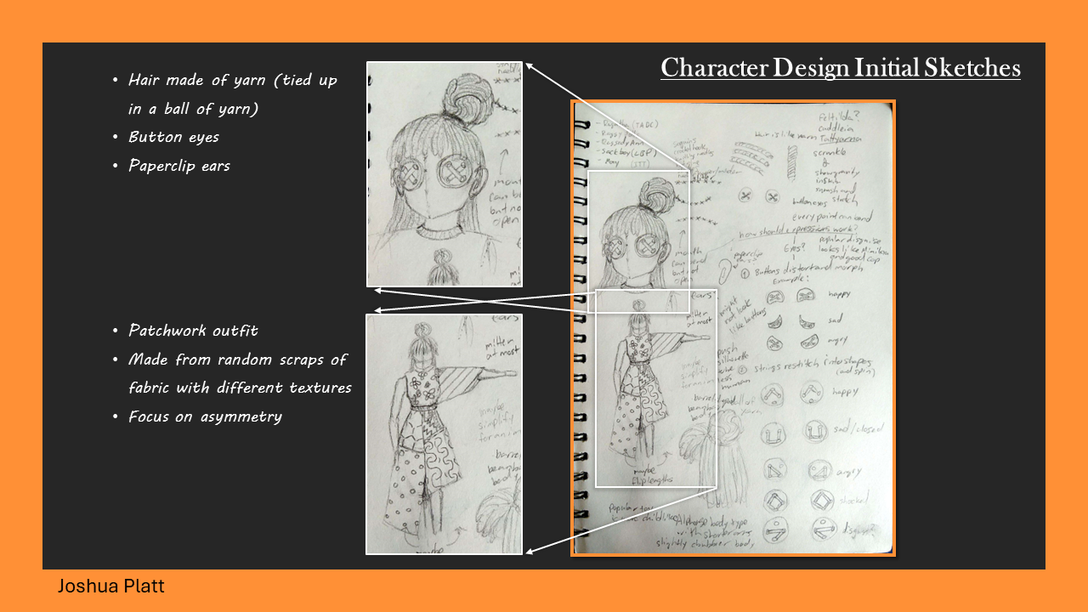
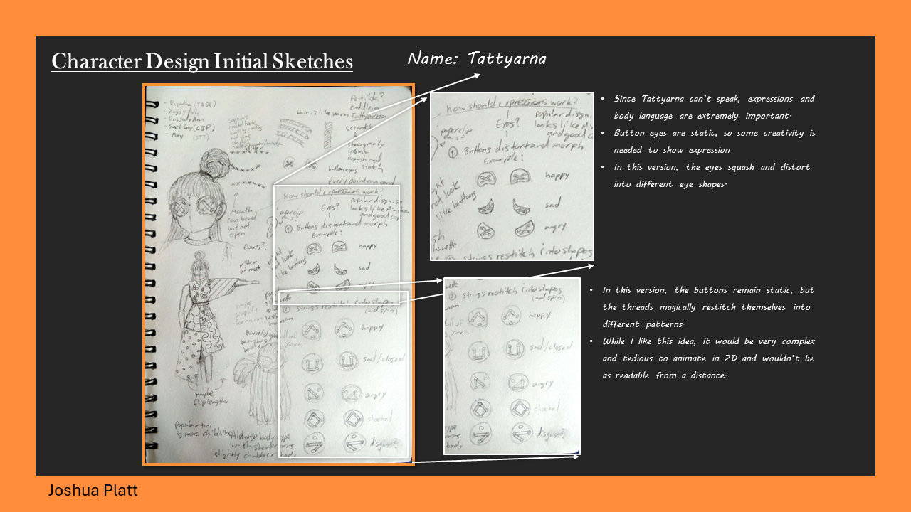
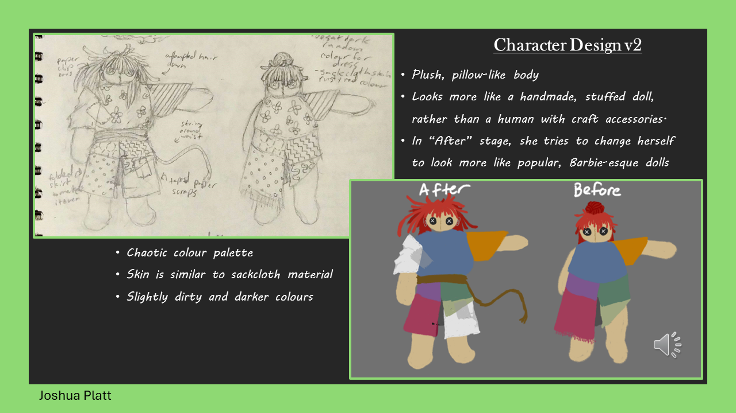
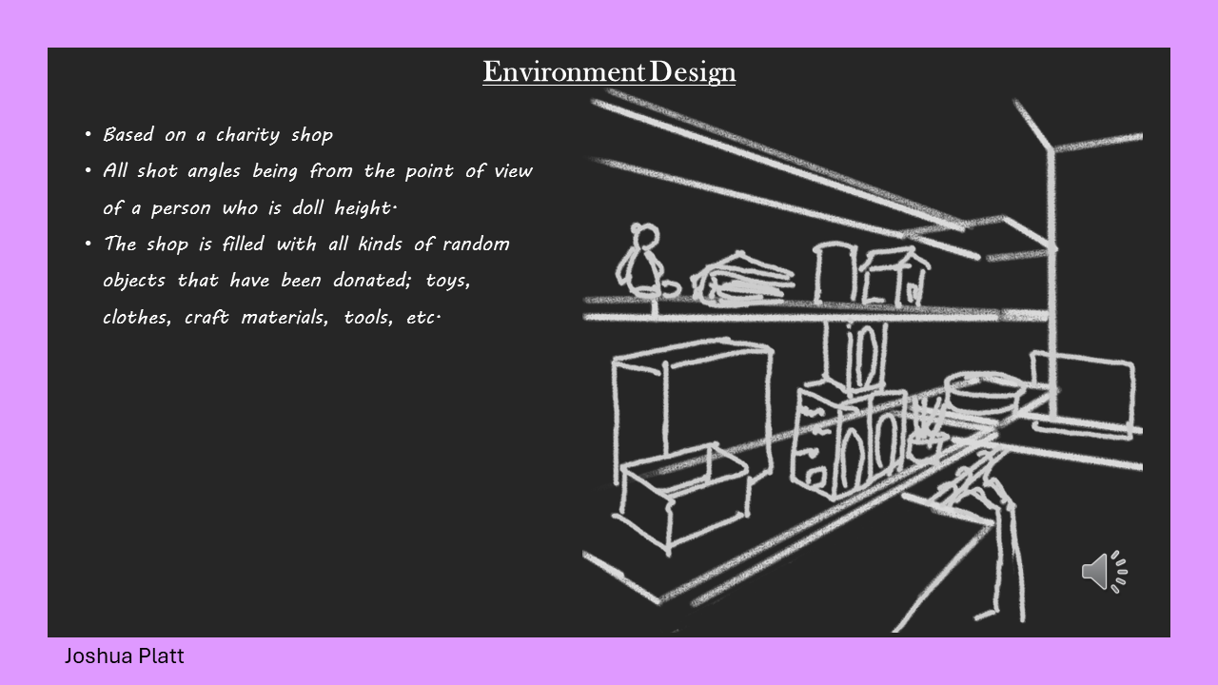

URL full presentation video: https://youtu.be/IEt9w4X5XHA

Bibliography:
[13] M. E. Courtney and A. Dworsky, “Early outcomes for young adults transitioning from out‐of‐home care in the USA,” Child & Family Social Work, vol. 11, no. 3, pp. 209–219, Jul. 2006. doi:10.1111/j.1365-2206.2006.00433.x
[14] “Childhood in care raises risk of entering English youth justice system eightfold,” The Guardian, https://www.theguardian.com/society/2023/sep/21/care-experienced-children-eight-times-more-likely-enter-youth-justice-system-england (accessed Apr. 25, 2024).

