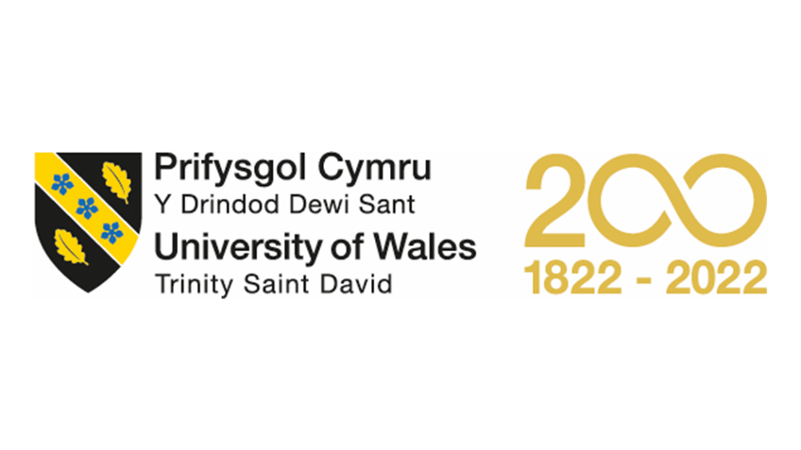

Assignment Title: Personal Development Portfolio
Module Name: Professional Development within Health and Social Care
Module Code: LCHS4005
Program of Study: Certificate of Higher Education Skills for the Workplace (Health & Social Care)
Student Name: Forida Begum
Student ID #: 2127874
Lecturer Name: Ms, Fouziya Farheen

Task 1
Forida Begum
From Birmingham, United Kingdom)
Contact #: 07715612321
Email: forida.begum155@yahoo.com
OBJECTIVES
Seeking a challenging and rewarding career in a dynamic organization that values growth and progress, where I can utilize my experience and qualifications to contribute to the superior relationship management and demonstrate excellent verbal communication skills.
Aspiring to work closely with the management department in a reputable organization, leveraging my time management skills to ensure timely completion of work and maintain the decorum of the organization.
ACADEMIC QUALIFICATION
- Aston Manor School, Secondary Education, 1992-1997
- GCSE:
- Maths: Grade D
- English: Grade B
- Science: Grade C
- Home Economics: Grade C
- Child Development: Grade D
- Geography: Grade D
EXPERIENCE
Internships:
Worked in a newsagent in the Caters news agency
Workshops Conducted:
- Hosted a Mental Awareness Workshop at Birmingham community hall in January 2016.
- Volunteered in a workshop on the rise of digital media at the Birmingham community hall in January 2018
Jobs:
- Aston Mini Market, Cashier, 1997-1998
- Aston mini market 1997-1998
SKILLS & ABILITIES
Demonstrates exceptional leadership skills.
Possesses effective teaching skills.
Hobbies:
- Socializing with friends and family
- Going to the gym
- Watching movies
Personal information
- Date of Birth: 11/5/1981
For further Reference;
Jabeen Rizvi
7756189482
jabeenrizvifatima@gmail.com
Working as an Aston store manager Birmingham.

Task 2
Cover letter
Newsletter editor in News express Birmingham
Dear Hiring Manager,
I am writing to express my interest in the position of Newsletter Editor at your esteemed organization. As an experienced communication specialist with a passion for creating engaging content, I believe that my skills and experience align well with the requirements for this role.
My objective is to join a dynamic and growth-oriented organization where I can apply my extensive experience in relationship management and superior verbal communication skills to deliver high-quality newsletters that drive engagement and growth. As an aspiring candidate, I am confident that my time management skills will ensure that all work is completed on time, and I will maintain the decorum of the organization.
In terms of academic qualifications, I attended the Aston Manor School, where I obtained a Secondary Education degree. My GCSE grades were as follows: Maths (D), English (B), Science (C), Home Economics (C), Child Development (D), and Geography (D). Although my academic qualifications may not directly relate to newsletter editing, I have gained valuable skills and knowledge through my internships, workshops, and jobs.
I worked at a newsagent in Caters news agency as an intern, where I developed a keen interest in the art of storytelling. Moreover, I hosted a Mental Awareness Workshop at the Birmingham Community Hall in January 2016 and volunteered in a workshop on the rise of digital media at the same location in January 2018. These experiences equipped me with exceptional leadership skills, effective teaching skills, and a passion for community involvement.
As for my work experience, I have worked as a cashier at the Aston Mini Market from 1997 to 1998. My responsibilities included handling cash, providing excellent customer service, and maintaining the cleanliness of the store. I have also worked as an Aston Store Manager at Birmingham, where I gained experience in customer relationship management, inventory management, and team leadership.
Aside from my professional experience, I have several hobbies that include socializing with friends and family, going to the gym, and watching movies. I believe that these activities have helped me to develop excellent interpersonal skills, and I enjoy meeting new people and building relationships.
In conclusion, I believe that my passion for storytelling, exceptional leadership skills, and the ability to create engaging content make me an excellent candidate for the role of Newsletter Editor at your esteemed organization. I am excited about the opportunity to bring my skills and experience to your team and would welcome the opportunity to discuss my application with you further.

Thank you for considering my application.

Sincerely,

Forida Begum

Task 3
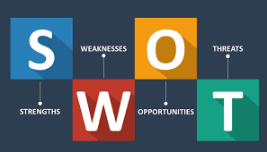
SWOT Analysis:
Strengths:
- Exceptional leadership skills
- Effective teaching skills
- Strong verbal communication skills
- Ability to manage time effectively
- Strong interpersonal skills
- Good organizational skills
- Ability to work in a team
Weaknesses:

- Lack of formal education beyond secondary school
- Limited experience in a professional setting
- Limited technical skills in specific areas
- Limited experience in project management
- Limited experience in budgeting and financial management
Opportunities:

- Pursuing further education or training programs
- Networking with professionals in the field
- Participating in professional organizations
- Taking on new responsibilities or projects at work to gain experience
- Learning new technical skills through courses or certifications
Threats:

- Competition for job opportunities in the field
- Technological advancements that require new skills or knowledge
- Economic downturns or industry changes that affect job prospects
- Limited availability of resources for professional development
- Personal life events that may affect career growth or development
Personal Development Plan:

Goal 1: Complete a professional certification program in project management within the next two years. This will allow me to gain a deeper understanding of project management methodologies and best practices, and enable me to take on more complex projects at work.
Action Steps:

- Research and identify reputable certification programs
- Determine the time commitment and cost of the program
- Schedule study time into my weekly routine
- Identify a mentor or coach to provide guidance and support throughout the process
Goal 2: Attend networking events and professional conferences to expand my professional network and learn about industry trends and best practices. This will allow me to connect with other professionals in the field, gain new insights and ideas, and potentially discover new job opportunities.

Action Steps:

- Research upcoming events and conferences in the industry
- Budget for travel and attendance costs
- Prepare a professional networking plan to make the most of my time at events
- Follow up with new contacts after the events to build relationships and stay connected.

Task 4
Dear Hiring Manager,
I am writing to express my interest in the Newsletter Editor position in your esteemed organization. As an experienced and accomplished individual with a passion for communication and creative content development, I believe that my qualifications and expertise align with the requirements of the position.
My educational background and work experience have provided me with a solid foundation for excelling in the role of a Newsletter Editor. I hold a GCSE in English with a Grade B, which has honed my language skills and proficiency in written communication. I have also completed a series of internships and workshops in the media industry, which have enabled me to acquire valuable experience in content development and editorial processes. During my internship at Caters News Agency, I was responsible for researching and creating content for news articles, while also assisting with proofreading and editing.
One of my greatest strengths is my ability to manage multiple tasks and meet tight deadlines without compromising on quality. I am skilled in managing projects from conception to completion, and I have a keen eye for detail that ensures that all work produced is of the highest standard. As a team player, I work collaboratively with colleagues to ensure that all content is accurate, engaging, and aligned with the organization's goals and values.
In addition to my professional skills, I possess exceptional interpersonal skills that enable me to build strong relationships with clients, colleagues, and stakeholders. I am a natural communicator and listener, with a friendly and approachable personality that helps me to engage with people from diverse backgrounds. These skills have been honed through my experience as a workshop host, where I was responsible for delivering training sessions on mental health awareness and digital media.
I am excited about the opportunity to bring my skills and experience to your organization and make a significant contribution as a Newsletter Editor. I am confident that my skills in written and verbal communication, project management, and stakeholder engagement make me an ideal candidate for the role. I am committed to staying up-to-date with emerging trends and technologies in the media industry and believe that this role will provide me with the platform to achieve my career aspirations.

Thank you for considering my application. I look forward to the opportunity to discuss my qualifications further.

Sincerely,

Forida Begum

Task 5
Personal reflection
The presentation assessment on resume writing, job hunting, and cover letter writing was a valuable learning experience. It provided an opportunity to understand the importance of these skills in the current job market and the importance of presenting oneself in the best possible manner to potential employers.

The presentation highlighted the key components of a well-crafted resume, including relevant work experience, skills, and education. It emphasized the importance of tailoring the resume to the specific job and company, using strong action words, and avoiding spelling and grammatical errors. The presentation also provided helpful tips on job hunting, including leveraging networking opportunities, researching companies, and using online job search engines.

One of the most helpful aspects of the presentation was the discussion on writing an effective cover letter. It highlighted the importance of personalizing the cover letter to the specific job and company, showcasing relevant skills and experiences, and demonstrating enthusiasm for the position.

Overall, the presentation was insightful and provided valuable information on best practices for resume writing, job hunting, and cover letter writing. However, one area for improvement could be to provide more specific examples of resumes and cover letters tailored to different industries and job positions. This would provide students with a more comprehensive understanding of how to apply these skills in real-world scenarios.

In conclusion, the presentation on resume writing, job hunting, and cover letter writing was a beneficial learning experience. It provided useful insights and actionable tips that can be applied to the job search process. Going forward, it is important to continue practicing and refining these skills to present oneself in the best possible manner to potential employers.

