
Skills for the Workplace
Module Assignment Submission
Student Name: | Laura Williams
Student Number: | 1815022
Module No: | BMSK4002
Module Title: | Effective Team Working and Communication  Part 2

Statement of Confirmation of Authenticity
By the act of making this submission, the student declares that this is the work of the student named above. The work has not, in whole or in part, been knowingly presented elsewhere for assessment, or where assessment has been built on a previous assessment, this has been identified. Where materials have been used from other sources it has been properly acknowledged. If this statement is untrue, the student acknowledges that an assessment offence has been committed.
Attention is drawn to the plagiarism and unfair practice policies of both the University and of ILM.

Table of contents
Part 2 Effective Team Working and Communication BMSK4002
Introduction…………………………………………………………………………………………………………………………………...2
1.0 Communication cycles - Shannon and weaver model……………………………………………………………….3
Berlo model……………………………………………………………………………………………….………………………………….4
Schramm model……………………………………………………………………………………………………………….……………4
Blenkensopp 6 step communication cycle ………………………………………………………………………….…………5
- Assessing own communication skills ………………………………………………………………………….………….6,7
Gap analysis…………………………………………………………………………………………………………………….…………….8
Personal Development Plan……………………………………………………………………………………………….………….9
Conclusion……………………………………………………………………………………………………………………………….……10
References ……………………………………………………………………………………………………………………………………11
Appendix 1………………………………………………………………………………………………………………………………….12,13
Appendix 2……………………………………………………………………………………………………………………………………...14

Introduction

This report will be looking further into communication skills and how to be more effective when communicating with others. I will be doing research on various communication models to help me to understand the different styles and completing a preferred communication questionnaire and a communication skills quiz to identify what is my preferred method and how to develop my skills.
Part 2 – Communication
- Communication Cycle

The first linear communication model was first introduced in 1949 by Shannon and Weaver. This model suggests once the message leaves the sender and reaches the receiver, the communication process ends. This model is best known for explaining how messages can get lost or distorted in the process of communication.
“The fundamental problem of communication is that of reproducing a message sent from one point, either exactly or approximately, to another point” (Shannon,1948, p.379)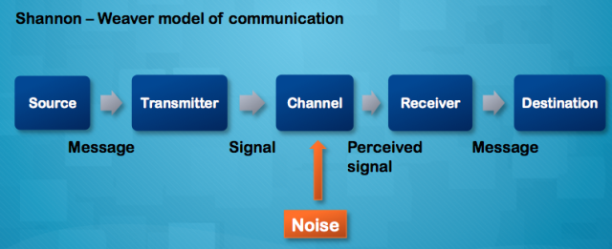

Noise is what interrupts a message while it is in transition from the sender to the receiver. There are two types of noise. Internal noise and external noise.
Internal noise happens if the sender makes a mistake encoding a message or the receiver makes a mistake decoding the message. For example, if the sender misspelt a word in a text message, if the receiver misinterprets a sentence when reading the text message, or someone you are speaking with has a heavy accent or if the sender mumbles when speaking.
External noise happens when something external impedes the message. For example, if you are on the telephone and an ambulance siren comes close, you will not hear the message correctly or you won’t be able to send a message clearly, a poorly tuned radio crackles while you are listening to it or a lost letter in the post. Its important to minimise the cause of noises to improve the quality of the message.
This model also includes three levels, where communication can be interrupted.
Technical Problems – if the encoder, decoder or channel causes the problems. For example, if your mobile phone loses signal while communicating through it
Semantic Problems -when a message is changes before the receiver gets it. For example, the message may be lost or changed in the retelling of the message.
Effectiveness problems – how well the message can cause a reaction from the receiver.
In a recent article, Drew (2020) states the disadvantages to this model. As it’s a linear model it has insufficient regard for feedback. It also doesn’t relate to communication that arises when there is one sender and multiple receivers. A circular model would be used for a more complex analysis of mass communication.

Berlo (1960) created a linear model of communication by referring to Shannon, Weaver (1949) model. His model had 4 components which can be affected by many factors. The elements of his model are:
S- Source. This is the first element in this model. All communication must come from a source. This may include a person, a group of people or a company. This can be done through thinking, writing, drawing and speaking
M – message. This is the information views or thought that are sent by the source using the correct code or language of the message being sent.
C -Channel. The channel is the method used to send the message using the five sense organs, hearing, seeing, touching, smelling and tasting.
R -Receiver. This is the final element in the communication process. This is the audience for the message to be delivered to.
Berlo’s model believes that for effective communication the source and receiver need to be on the same level. This model is criticised as having no room for ‘noise’. Communicating with someone on the same level is rare in everyday life, so requiring people to be on the same level to communicate effectively is not ideal.

Wilbur Schramm is a well-known communication theorist. He developed a circular model of communication in 1954 where he suggested to communicate it is a two-way process, the sender and receiver take their turn to send and receive messages. This model shows that communication requires three elements – the source, the message and the destination. Recently, Janse (2019) states that this model is based on the theory and belief that communication is a two-way street meaning there is at least a sender and receiver being a circular model. Both the sender and receiver must encode and decode the message to interpret the correct message. Shcramm later made changes to his model introducing the commonality of the message. This refers to what is mutually understood between the sender and receiver of a message.
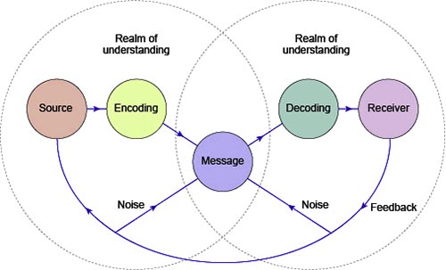
Blenkensopp (2010) said you must communicate clearly, concise and easy to understand. He come up with a six-step communication cycle to help you develop and refine your message. This approach helps you to use feedback you receive to improve your communications in the future. The steps are
Step 1 – Aim. To clarify the aim of the message you want to communicate.
Step 2 – Compose/encode. To start to create the message you are going to give
Step 3 – Transmit/deliver. Communicate your message so the recipient receives it effectively
Step 4 – Receive feedback. This step is key in the communication cycle as without feedback from the receiver you can’t improve the way you communicate you message.
Step 5 – Analyse/decode/learn. By using the feedback from step 4 you can learn and grow. It may be that the message needs to be re write and try again to ensure the message is send correctly.
Step 6 -change/improve
This completes the six-step cycle.
“You cannot help yourself by not committing to learn and change.”
The advantage to this process is in its cyclical nature so the next time you can communicate more effectively by improving from feedback.

2.0

Assessing Own Communication Skills

There are various ways to assess yourself in different areas. Assessing your own communication skills can be identified by completing relevant questionnaires, doing a GAP analysis and creating a Personal Development Plan (PDP) to prepare to develop your skills. Communication styles are set into four different types
Assertive
This tends to be more effective in most situations. Having an assertive communication style helps you express opinions clearly without a negative effect to others as being mindful of your own emotions while taking into consideration someone else’s emotions shows you are empathetic. Behaviours of an assertive communication style include feeling in in control, speaking calmly and clearly by expressing needs appropriately with respect, having a relaxed body posture and good eye contact. Being an active listener by not interrupting and reflecting on what you have heard is a skill that would show you are assertive.
Passive
This style would occur if you don’t express your opinions to others. This may be to protect yourself if you are afraid of confrontation or if you are just laid back and go with the flow. This may assist you having a higher tolerance for other people’s behaviours, but this isn’t always healthy as this could leave you feeling unfulfilled buy letting others have their own way, not speaking up for yourself and ignoring situations that need to be handled.
Passive -aggressive
This style is similar and come across as a passive communication style. However usually are acting out angrily in an indirect way. This could include being sarcastic, mumbling to yourself instead of confronting the situation, giving up on something unexpectantly and having emotional withdrawals. Being passive aggressive is subtle and can go unnoticed which can lead to a vicious cycle of avoidance and conflict.
Aggressive
This communication style can come across as being abusive to others by stating your needs not letting those involved have their say. Being aggressive may mean you struggle to communicate as it could trigger hostility as you may speak loudly and be overbearing, frequently interrupt others and allow things to trigger your temper easily. Being aggressive may make you feel alienated as you may not want to face insecurities and struggle to take responsibility for your own actions. However, you can choose to have an aggressive communication style at times to benefit you if you need to stand up for yourself or make yourself heard. It can be helpful when doing physical activities like being in a race or going to the gym.

Emotions can determine the way you communicate. Feeling frustrated can lead to negative interaction with others if unmanaged. Practicing mindfulness activities can help you gain control of your emotions and have a positive effect when communicating. It is effective to recognise when to appropriately use each of these communication styles. By learning these four communication styles can help you improve your interpersonal skills as you can identify others communication styles and adjust the way you can communicate effectively with them. According to Berne (1953), Interpersonal skills are ways of communicating without talking. He states

“In interpersonal communications, “noise” is of more value than “information”, since in such cases it is of more value to the communicants to know about each other's states than to give “information” to each other. “Noise” carries latent communications from the communicant. Manifest and latent communications arouse latent responses in the receiver which are important to both parties and are of special interest to psychiatrists”

By completing a communication style questionnaire (Appendix 1), it shows my preferred style is being assertive. This reflects on my work and home life and the way I communicate. Having an assertive communication style is beneficial in my current employment as a supervisor. It helps me identify any problems within my team in how they feel and see how they are performing. If there was constant friction or negative communication going on between people you live with can affect the way you perform and communicate in work.
By completing the Mindtools communication quiz (Appendix 2), I scored 51. This interpretation suggests I am a capable communicator but can sometimes experience communication problems. This is a good quiz to take as it goes into detail on how you can develop your communication skills to your advantage. I need to work on paying attention to words and actions, ask questions and watch body language as this will help ensure I say what I mean and hear what is intended for me to hear.

Gap Analysis

Objective | Current Position | Deficiency | Action
What do I want to do? | What can I already do? | What am I lacking? | How do I fix this?
Plan the message I want to give out effectively | Figure out what I want to say | Wasting time conveying information into the message that isn’t necessary | Understand the reason of my message, identify and understand who I am communicating with and what they need to know and seek feedback on how well they received my message
Create a clear message when communicating | Know what I want to say when I have an idea | Considering how I say it and how it will be perceived | Understand what I truly need to say, anticipate the reaction to the receiver and chose the right words and body language
Choose the right channel to communicate effectively | Identify channels available to communicate | Taking time to think before communicating | Consider consequences of how I choose to communicate

PDP

Objectives | Tasks | Success Criteria | Time Frame | Resources
List your Goals | What do you need to do to achieve these goals? | How will you identify your success? | When do they need to be done by? | Who or what do you need to help you?
Improve on my presentations skills | Practice doing a presentation by filming myself or performing to friends or family. | Obtain feedback from the receivers of who I practice my presentation on.  Obtain feedback on evaluation forms of my peers at university from my presentation BMSK4002 | May 2020
Complete my presentation assignment for bmsk4002 | Do research and complete a PowerPoint using relevant information for effect teams  Attend the online classes with my tutor to gain relevant information | Complete an evaluation form asking relevant questions that identify my communication skills  Obtain the tutors feedback and the grade I receive when it is marked. | 17th May 2020 | Husband to occupy the children while I work  Equipment and software to complete my presentation  Tutor and the online classes
Communicate more effectively | Complete questionnaires / quizzes to identify my communication preference. Complete a SWOT analysis to see how my weaknesses can turn to strengths | Feedback form receivers who I am communicating with  Evaluations forms from future presentations | May onwards | Feedback from tutor / friends / family  Self-belief and confidence to develop my communication skills

Conclusion

This report has help me to identify my communication preferences and understand that everyone will have different skills and methods to communicate. When communicating through different methods, i.e. face to face, telephone, messaging via email or text, by considering different approaches will help you communicate effectively.

References

Berlo, D., (1960) The process of communication, Rinehart and Winston, New York

Berne, E., (1953) Concerning the nature of communication. Psychiatric Quarterly 27, 185–198
https://doi.org/10.1007/BF01562485 Accessed 09/05/2020

Blenkinsop, P., (2010) The Communication Cycle. [online]
http://manyana-education.blogspot.com/2010/10/communication-cycle.html Accessed: 18/05/2020

Drew, C., (2020) Shannon- Weaver model of communication- 7key concepts, online
https://helpfulprofessor.com/shannon-weaver-model/ Accessed: 21/05/2020

Janse, B., (2019) Schramm communication model, tools hero
https://www.toolshero.com/communication-skills/schramm-communication-model/ Accessed : 27/04/2020

MindTools (2019) How good are your communication skills? [online] Available at: https://www.mindtools.com/pages/article/newCS_99.htm Accessed: 15/05/2020

Schramm, W., (1954) The process and effects of mass communications, University of Illinois press

Shannon, C. and Weaver, W. (1949) The Mathematical Theory of Communication. Urbana: University of Illinois Press.

Shannon, C., (1948) a mathematical theory of communication, the bell system technical journal.

Skills You Need (2019) Interpersonal Skills Self-Assessment. [online] Available at: https://www.skillsyouneed.com/ls/index.php/343479 Accessed: 15.05.19

Appendix 1

Communication style questionnaire
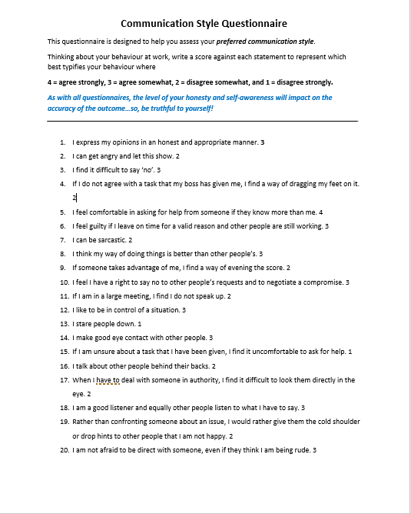
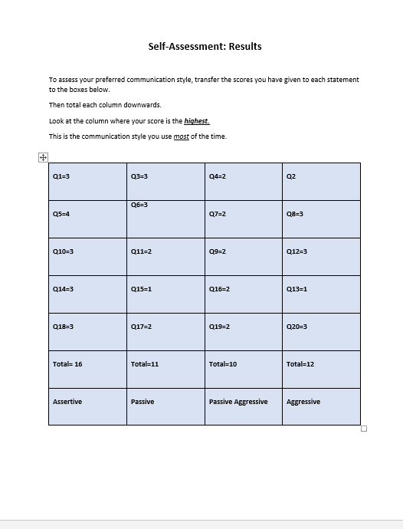

Appendix 2

Mind Tools Communication Quiz



