Process workbook: Creative industries Chris Davies

When starting this module I was excited. I believed there was going to be new insights into the business and development of the industry and gain a better understanding relating to tactics that can be utilised to gain employment that we can use in the future.
In looking at the business angle of theatrical industries, we investigated where creatives get funding for their work. We researched (Arts Council England 2018) and found there were a multitude of grants available to produce shows, workshops and performances of all kinds. The process seemed fairly simple and easy to apply for and the grants ranged in specificity allowing for malleability for what the performer wants to create. A particular grant that took my interest was a new touring scheme that wants to highlight and help touring theatre, dance and music. I believe this would be a great chance to work on a show from beginning to end.
When asked to research specific theatre companies I wanted to look into a company I aspire to work with and one that’s local to where I’m currently based and achievable to work with. Pentabus is a rural based theatre company that aspires to bring high quality theatre to small communities which I especially believe in, being from a rural area and so having limited access to theatre (Pentabus, 2025). I’ve worked with them in the past on a writer’s workshop and have seen how much drive they have for getting young people engaged in theatre. In future, approaching them with a play I’ve written would be something I’d be interested in doing, as pursuing that creative aspect is something I want to hone.
Badwolf is a high-class film company based in Cardiff but internationally recognised working on such shows as (His Dark Materials, 2019) and (Doctor Who, 2005) Badwolf is a company that is screen based and the majority of experience I have is on stage. I think working towards a big screen production like Badwolf is a great goal to have. As an actor, often it’s difficult to find the when you’ve “made it” and having goals, I believe is a great way of directly showing achievements and seeing how far you’ve come (Uta Hagen, 1991).
On the subject of future plans for employment, making a professional development plan(PDP) (see appendix 1) is a great way to track both achievable and long term goals. However, I think the changing landscape of acting makes a PDP a hard thing to keep on top of and to dedicate time to achieve things on a PDP. In my opinion when balancing a part time job as an actor then preparing for multiple auditions, workshops and being an actor; this balance is a hard thing to achieve while also having a stable social, physical and happy life. I think a PDP may be a great thing to keep you accountable for your creative work but lacks short term drive and practicality to achieve success.
Working on personal mental development was something I wasn’t expecting to encounter within this module. Self-analysis is something I’ve always struggled with as a creative. As I have always been critical of my choices in the creative space and often try something before my brain can think about it, making reflection difficult. Using a method called a SWOT analysis (Leigh, D., 2009.) it allows for a balanced reflection on how you see yourself. (see appendix 2). I think this method is useful as it can give many opportunities to pursue specific aims just from your own knowledge. However, when doing this on my own I took more of a negative approach. Phrasing my strengths as “3 Strengths to capitalise on,” effectively turning them into weaknesses. That’s why I think doing this exercise with a friend or peer to disagree or comment on your own opinions, is useful, to keep yourself accountable. I mentioned in my PDP that I wanted to diary more, in order to help with these issues.
I think something I was surprised about when looking at opportunities was the number of resources available for young actors if they’re willing to find them:
-National Youth Theatre Wales
-Open classes
-student peers
-Networking Nights
-City socials
-Fringe Festivals
-Student Films
-Mailing lists
-Amdram
-Mandy casting website
-Linked in, Facebook, TikTok
The industry is huge and there are many different people, organisations and resources available to help and support development of creative projects and share their work. Building that support group of fellow actors is, I think, essential to the success of any actor. Countering this, however, I think having a good mental attitude isn’t necessary to be proactive in the space. It’s stated in Grotowskis “towards a poor theatre” (Jerzy Grotowski, 2012) that “all private affairs cease to be just his own concern”. Grotowski suggests that you should always be ready to develop creative choices in the group and shouldn’t let personal problems affairs effect that. I am obviously an advocate for good mental health, especially in actors where we are constantly being compared too and thinking we’re not good enough in our work (Sørensen et al., 2024). There have been exercises within this module that specifically promote self-belief and I personally feel that drama isn’t a therapeutic place to find your personal expression, which it can be, but if it is consistently used this way by actors in a professional environment then acting to me loses credibility.

A logistical problem for me is I live in the rural West Midlands, my closest city being Birmingham which is a 2-hour drive away so isn’t ideal for work opportunities. As mentioned before Pentabus is a local company and great for me personally but they are a small company and may not have regular work openings. This means travelling for work opportunities and is an unavoidable cost unless I relocate. It could be argued that self-tapes in this modern age make for less travel. Where you are based is a less complex matter but being able to take full advantage of the list of opportunities stated earlier and theatrical workshops, open mics and networking nights makes opportunities come easier and enriches your acting.
When looking at personal branding development and image. The first thing a casting director will receive from you is your CV (see appendix 3) so making it look presentable and interesting is essential. Another key skill practised in this module was self-tapes. I have limited experience of self-tapes but they are a key part of gaining work in the industry (Peter Allen Stone, 2021) Something I found useful during this process is understanding how roles are filled and filling criteria, but then finding the subtleties that make you unique and interesting. I asked my lecturer about what they preferred in performance whether they preferred consistency or nuance in performance. They described this idea. There are lots of good productions but what makes a production great is finding that connection to the character and creating small differences that add character and reality to a story. This is why I believe having good casting and rapport in that cast is essential for theatre to truly make the audience believe in them, laugh with them and love them. This shows the importance of casting directors working hard to find the right people to fit together. But also how self-tapes and to an extent CV’s do not demonstrate who an actor really is. They do not show how an actor works, how they move or conduct themselves in the space which can lead to disastrous casting choices and conflict which can ruin a performance (Catliff and Granville, 2013).
I put down two of my main weaknesses as self-belief (Peters, T.C., 2001) and networking. Self-belief is something a lot of actors struggle with and I think these two weaknesses go hand in hand. Believing that you are worth a company’s time and believing that they want to work with you is a major step towards getting the job and having the confidence needed to perform.
To conclude, throughout this process I have struggled to place myself and stay positive when thinking about the future of my work. Naturally I have a negative outlook due to statistics of the theatrical industry (Simkins, 2019) and often I deem it as out of my control but when thinking about what I can control the options were very limited. I’m a straight, white, man from a middle class environment and that is the opposite to what I want to see on stage I want to see creativity from all backgrounds as I feel the theatre is dominated by this social group and complaining about being in this high minority is completely redundant. However, this module has shown me that the ways of working in the industry are often out of your control, all you can do is go into the audition and present your piece with all the energy and creativity you want to bring to the character. Show you want it and love playing the character and I want to think I did that in our assessment. I always believe there are improvements to be made and nerves got the better of me. I made different creative choices and felt the character in the moment which I feel is what acting is about and whether I did well or not I’m happy with my performance and that’s what counts.

Reference List
Arts Council England (2018). Arts Council England |. [online] Artscouncil.org.uk. Available at: https://www.artscouncil.org.uk.
Catliff, S. and Granville, J., 2013. The casting handbook: for film and theatre makers. Routledge.
Doctor who (2005) BBC one Television, 26 march.
His Dark materials (2019), BBC one Television, 3 November.
Jerzy Grotowski (2012). Towards a Poor Theatre. Routledge.
Leigh, D., 2009. SWOT analysis. Handbook of Improving Performance in the Workplace: Volumes 1‐3, pp.115-140.
Peter Allen Stone (2021). Acting for the Camera: Back to One. Routledge.
Pentabus (2025). Pentabus | Pentabus. [online] Pentabus.co.uk. Available at: https://pentabus.co.uk [Accessed 3 Apr. 2025].
Peters, T.C., 2001. The relationships between acting experience, self-esteem, and self-monitoring. Modern Psychological Studies, 7(1), p.6.
Simkins, M. (2019). Only 2% of actors make a living. How do you become one of them? The Guardian. [online] 5 Jun. Available at: https://www.theguardian.com/film/shortcuts/2019/jun/05/only-2-per-cent-of-actors-make-a-living-how-do-you-become-one-of-them.
Sørensen, K.L., Hald, N., Olsen, R.M. and Ørjasæter, K.B. (2024). ‘Always be relevant’: a phenomenological study of the actor’s workday. Arts & Health, pp.1–14. doi:https://doi.org/10.1080/17533015.2024.2420822.
Uta Hagen (1991). A challenge for the actor. New York: Scribner’s; Toronto.I DID A REALLY FUN SWOT BUT IT WASN’T PROFESIONAL SO DIDN’T PUT IN PW!!
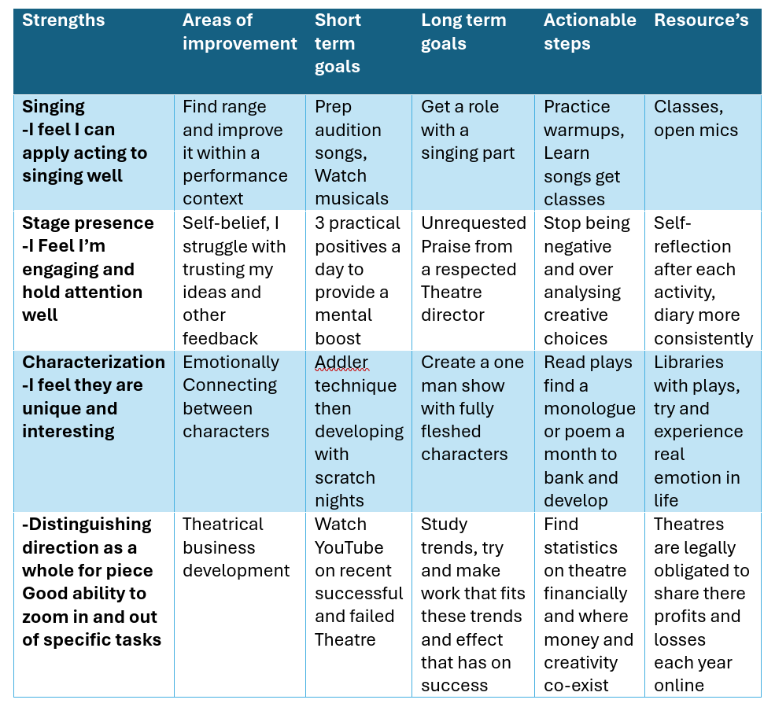
Appendix 1
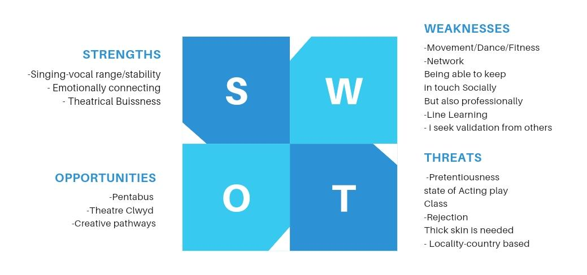
Appendix 2
Business

OPPORTUNITIESS
Business

Appendix 3 Christopher Davies
Email: Christopher.Davies.Creative@outlook.com


Mobile:07393903694
Height:5’10 Age: 20 Eyes: Blue
Hair: Brown Playing age: 19-25 Male

Education:
- LAMDA levels in Acting and Verse and Prose up to Grade 8 Gold
-BA Acting at University of Wales Trinity Saint David’s

Theatre:
-Dragons Breath Apothecary Walk the Plank
-Chaos Butterfly Boy National Theatre Connections
-Agatha Christie’s Butter in a Lordly Dish Sir Luke Enderby Ludlow College
-Jane Eyre Mr Rochester Diana Griffiths Dance and Drama
-Midsummer night’s dream Narrator Diana Griffiths Dance and Drama
Film
-Gods silence Vicar Student short film
-Crossroads Declan Student short film
-Primal urge Supporting Student short film
-Cancer champions promo video Supporting Promotional video
Hobbies: Member of Clun Amateur Dramatics Society, Photography, Bronze D of E award, plays Saxophone, full clean driving licence
Other skills:
-Volunteering: Theatre Clwyd, Sparc Centre, Diana Griffiths school of dance and drama, Ludlow Fringe Festival
-MPYT: Mid Powys Youth Theatre, twenties group
-Pentabus Young Writers

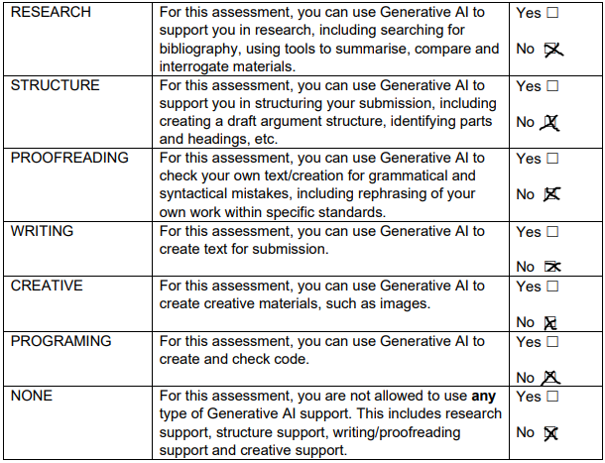
I confirm that I have not used any AI tools in the research and creation of this assignment. I confirm that I have not presented any AI generated materials as my own work. I confirm I have copies of my drafts, notes, and other resources I used, which I may be asked to provide in evidence.

