

Mathew George
2513092

Project Proposal
Engineering and Project Management

University of Wales Trinity St Davids
Bachelor of Engineering: Electrical & Electronic Engineering
Level 4
2025-2026

Supervisor: Jacob Stalin
July 2026

This assignment is submitted in partial fulfilment of the requirements for the degree of HND/Beng Electronic Engineering/Embedded Electronics

Contents
Introduction 1
Aim and Objectives 1
Product description and specifications 2
Project Tasks 3
Task 1: Initial Research and Requirements 4
Task 2: Concept and System Design 4
Task 3: Electronic Circuit Design 4
Task 4: Mechanical and Enclosure Design 4
Task 5: Component Procurement 5
Task 6: Software and Control Programming 5
Task 7: Prototype Construction 5
Task 8: Testing and Evaluation 5
Task 9: Design Improvements 5
Task 10: Final Documentation and Presentation 6
Project timeline 6
Milestones and Deliverables 7
Critical path analysis 9
Risk assessment and Risk Mitigation 11
Cost-Benefit analysis 12
Environmental Impact 13
Societal Impact 14
Ethical considerations 14
Conclusion 15
Prevent Certificate 17
Equality, Diversity and Inclusion Certificate 18
References 19

Table of Figures
Figure 1 - Gantt Chart - created on excel 6
Figure 2 - Key Milestones 9
Figure 3 - Critical path analysis table 10
Figure 4 - Critical path analysis diagram 11

Table 1 - Product specification 2

Introduction
This proposal outlines the design and development of a portable, rechargeable three-speed fan with an integrated digital display, intended to provide personal cooling where mains-powered fans are impractical. The device will be compact, easy to operate and suitable for use in homes, offices, classrooms, public transport and outdoor environments, with the display showing fan speed and battery level.
Alongside defining the product, the proposal places strong emphasis on project management. It sets out a structured plan covering requirement research, electronic and mechanical design, component selection, prototype development, testing and evaluation. The project will be managed using a product-led planning approach supported by milestones, deliverables, scheduling tools and risk-management processes to ensure the prototype is completed efficiently and to specification.

Aim and Objectives
The aim of this project is to design and build a portable three-speed rechargeable fan with an integrated digital display that provides users with convenient, adjustable personal cooling while being safe, energy-efficient and practical to use. The overall aim of this project will be achieved through the successful completion of each of the SMART objectives outlined below. Together, these objectives will provide a structured and measurable framework for the design, construction and evaluation of the portable three-speed fan, ensuring that the final prototype meets the required functional, performance, safety, time and cost requirements.
- To design and construct a working portable fan prototype with three selectable speed settings and an integrated digital display by the end of the project.
- To achieve a minimum battery operating time of 12 hours on the lowest speed setting after a full charge, as verified through prototype testing.
- To ensure that the three fan speed settings, digital display and USB-C charging system operate correctly, with all functions successfully tested before project completion.
- To complete the design and construction of the prototype within the planned project schedule and allocated budget, while meeting the defined safety and performance requirements.

Product description and specifications
The portable, rechargeable fan will offer three speed settings for low, moderate, and high airflow, controlled by electronic buttons and a microcontroller. A digital display will show speed, battery level, and charging status. Powered by a rechargeable battery with USB-C charging, the design focuses on portability, safety, ease of use, and energy efficiency. Table 1 exemplifies the product specification, final specifications, such as battery capacity and motor speed, may be refined after prototype testing.
Table 1 - Product specification
Product Specification
Product Name | Eazybreeze fan
Type | Portable, rechargeable electronic fan
Dimensions | 143 x 90 x 36mm
Power source | Rechargeable lithium-ion battery
Battery Life | 2000mAh – up to 12 hours of use on low speed  USB-C charging
Fan speeds | Low, medium, high
Special features | Digital display, LED battery indicator, protective fan guard grille
Material | Bamboo composite, recycled aluminium
Safety features | Overcurrent protection, battery protection and enclosed moving parts
This fan is intended for convenient personal cooling in a wide range of environments, benefiting users such as students, office workers, commuters, travellers, and people in warm indoor or outdoor conditions. Its compact form, adjustable airflow, and clear digital display make it practical in places with limited access to mains power.

Project Tasks
The project will adopt a product-led planning approach, meaning all activities and decisions are guided by the requirements and performance of the portable fan [1]. Design, component selection, construction and testing will be organised around achieving key product outcomes such as portability, three-speed operation, digital display functionality, at least 12 hours of battery life and user safety. This ensures every decision remains focused on delivering a reliable, effective final product. The work breakdown structure (WBS) has been identified to outline the key project tasks as seen below.

Task 1: Initial Research and Requirements
The first task will involve researching existing portable fan designs and identifying the requirements of the proposed device. This will include investigating suitable motors, batteries, microcontrollers, displays and safety features. The outcome of this task will be a set of defined project requirements and specifications.

Task 2: Concept and System Design
The second task will involve developing the overall concept and system design of the fan. This will include determining the arrangement of the main components, selecting the method of user control and producing an initial system block diagram. This task will establish the overall design direction for the project.

Task 3: Electronic Circuit Design
The electronic system will then be designed to control the fan motor, digital display and user inputs. The microcontroller, battery, charging circuit and motor control system will be selected and integrated into a suitable circuit design. The circuit will be reviewed to ensure that the voltage and current requirements of the components are compatible.

Task 4: Mechanical and Enclosure Design
The mechanical design will focus on creating a compact enclosure capable of housing and protecting the electronic components. Consideration will be given to the positioning of the motor, fan blades, protective grille, battery, display and controls. The enclosure will also be designed to support portability, ventilation and user safety.

Task 5: Component Procurement
Once the electronic and mechanical designs have been established, the required components and materials will be identified and obtained. Components will be selected based on their suitability, compatibility, availability and cost. All components will be checked upon arrival to ensure that they meet the required specifications.

Task 6: Software and Control Programming
The microcontroller will be programmed to control the three fan speed settings and operate the digital display. The software will be developed to respond to user inputs and display relevant information, such as the selected speed and battery status. The program will be tested before being integrated into the complete prototype.

Task 7: Prototype Construction
The prototype will be constructed by assembling the electronic, mechanical and software components. The motor, battery, control system and digital display will be integrated into the enclosure. The prototype will then be checked to ensure that the components are securely assembled and function together correctly.

Task 8: Testing and Evaluation
The completed prototype will undergo testing to evaluate its performance and safety. Testing will include the operation of all three fan speeds, battery life, charging performance, display operation, airflow and potential overheating. The results will be compared with the original project requirements.

Task 9: Design Improvements
Following the testing process, any faults or weaknesses identified will be addressed. Improvements may be made to the electronic system, software, enclosure or overall usability of the device. Further testing will then be conducted to verify that the changes have improved the performance of the prototype.

Task 10: Final Documentation and Presentation
The final task will involve completing the project documentation and presenting the outcomes of the design and development process. This will include the final design, test results, risk assessment, cost-benefit analysis and evaluation of the environmental, societal and ethical impacts of the device.

Project timeline
Gantt charts are project management tools used to represent activities, durations and schedules visually, allowing project progress to be monitored and tasks to be coordinated [2]. The Gantt chart in figure 1, has therefore been developed to show the planned schedule for the design and construction of the portable three-speed fan.
It presents the planned schedule for the design and development of the fan. The project has been divided into ten key tasks. Several activities, such as the electronic circuit design and mechanical enclosure design, will be completed concurrently to improve project efficiency. The schedule has been planned over a 14-week period, with testing and evaluation taking place before final design improvements and completion of the project documentation.
Figure 1 - Gantt Chart - created on excel
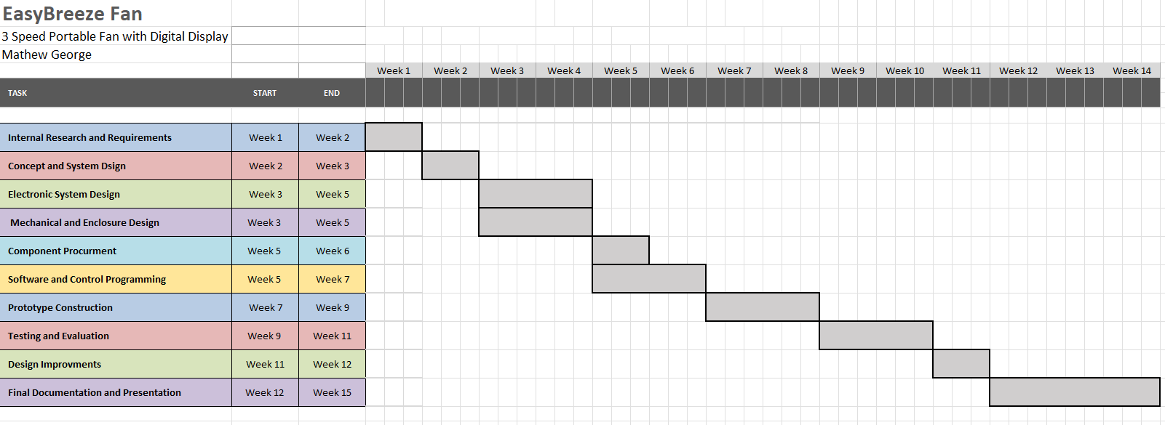

Milestones and Deliverables
Milestones and deliverables are used in project management to divide a project into identifiable stages and provide measurable points for monitoring progress. Milestones represent significant events or achievements within the project, while deliverables are the tangible outputs produced from completed project activities. Together, they provide a method of measuring project progress, confirming that planned activities have been completed and ensuring that the project remains aligned with its objectives and timeline [2] [3].
In this project, milestones, as seen in Figure 2, will be used to monitor the progress of the portable fan's development, while deliverables such as the circuit design, working prototype and test results will provide evidence that each stage has been completed successfully.

Figure 2 - Key Milestones
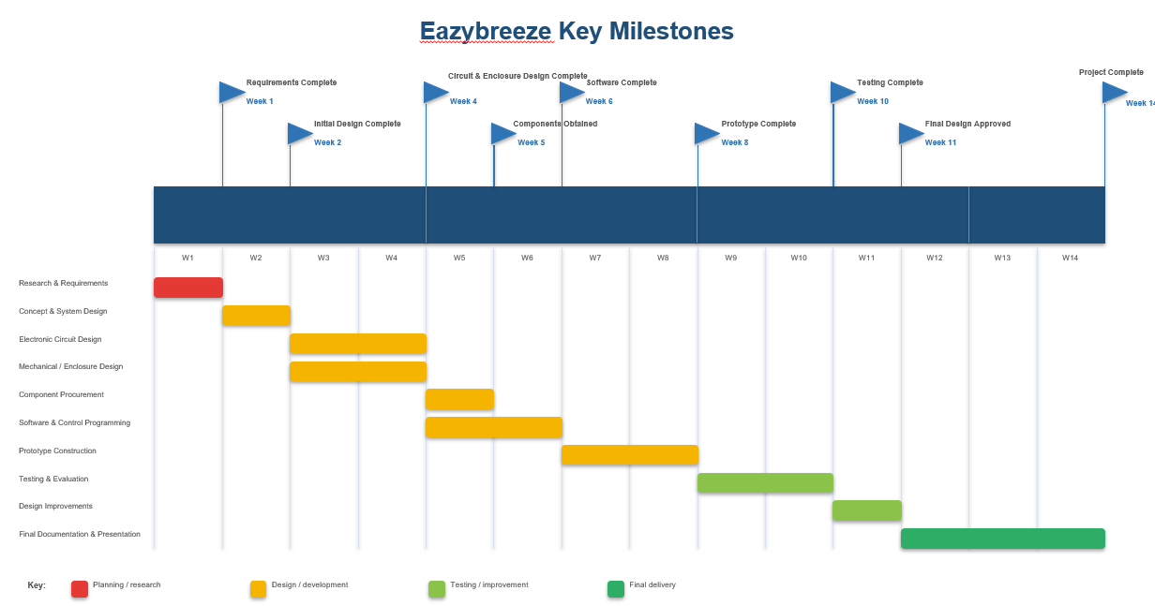
The project milestones begin with defining the requirements, identifying users, key functions and performance targets such as three speed settings, a digital display, USB-C charging and a 12-hour minimum battery life. The deliverables are a formal specification and SMART objectives.
The initial design milestone establishes the fan’s concept, layout and user interaction, with concept sketches as the deliverable.
The electronic and mechanical design milestone finalises the circuit and enclosure, showing the placement and connections of the electrical components. Deliverables include the circuit diagram, component list and enclosure design.
The component sourcing milestone confirms all parts, such as the motor, battery, display and charging circuit are selected and obtained. The deliverable is a complete component set.
The control software milestone produces the programmed microcontroller capable of managing speed control, user inputs and display outputs. The deliverable is a working control program.
Prototype construction follows, assembling all components into a functioning fan capable of three speeds and displaying required information. The deliverable is the first working prototype.
Prototype testing then evaluates speed performance, display accuracy, charging, battery life, airflow and safety, including the 12-hour low-speed target. The deliverable is documented test results and a performance evaluation.
An improvement milestone addresses faults or refinements in software, enclosure, electronics or layout. The deliverable is an improved prototype meeting product specification.
The final milestone completes the project, assessing the prototype against objectives, specifications, cost and performance. Deliverables include the final prototype, project report, test results and presentation.

Critical path analysis
Critical Path Analysis identifies the sequence of activities that determines the minimum time required to complete the project. Any delay to an activity on the critical path may delay the entire project [4]. The first step to a critical path analysis is to establish the WBS, listing all the project tasks and then identify the task dependencies. Once these have been identified a critical path analysis will be used to identify the sequence of activities.
The critical path as shown in figure 4 will begin with researching the project requirements and continue through the initial design, electronic and mechanical design, component procurement, software development, prototype construction, testing, design improvements and final documentation. The electronic and mechanical design stages can be completed concurrently; however, both must be completed before the project can progress to component procurement. Any delay to a critical activity could therefore delay the completion of the final prototype and project deliverables. Monitoring these activities will help reduce the risk of schedule overruns and ensure that the project remains on track.
Figure 3 - Critical path analysis table
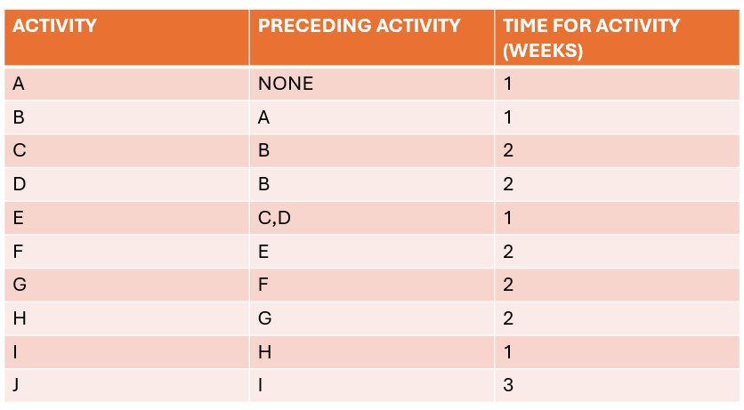

Figure 4 - Critical path analysis diagram
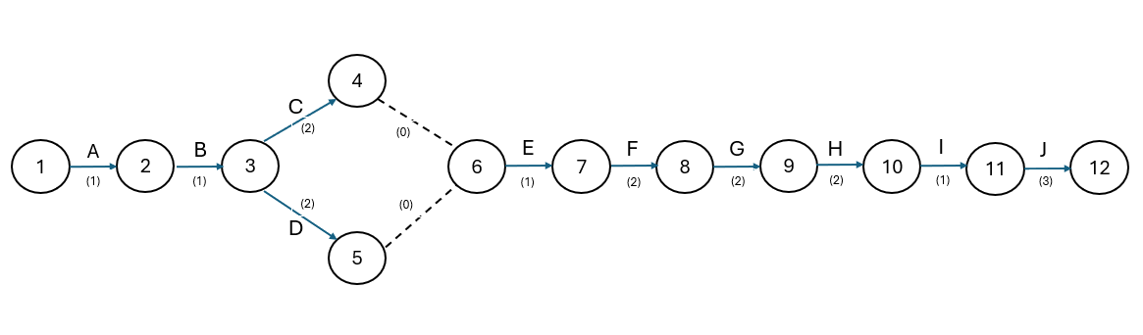

Risk assessment and Risk Mitigation
Risk management is an important part of the project because unexpected events could affect the project's cost, schedule, quality and successful completion. Potential risks associated with the design and construction of the portable three-speed fan have been identified, and appropriate mitigation methods will be used to reduce their likelihood or impact [5] [6]. Risks will be monitored throughout the project and reviewed whenever there are significant changes to the design or project schedule.
The project risks will be managed using the 4 T's approach: tolerate, treat, transfer and terminate. This provides a structured method for selecting an appropriate response to each risk based on its likelihood and potential impact on the project [5] [6].
Low-impact risks may be accepted where mitigation effort outweighs the consequence. Minor delays to non-critical tasks, small scheduling slips, or brief interruptions that do not affect the critical path can be tolerated without action.
Most project risks will be managed through preventative or corrective measures. Electrical risks are treated through careful circuit design, staged testing and proper protection. Battery life risks are treated by selecting an appropriate battery and validating performance early. Critical-path disruptions such as equipment breakdowns, missed deliveries, quality control failures or staff sickness are treated by adding contingency time, maintaining equipment, conducting ongoing quality checks, ordering components early and sharing project knowledge across the team.
Some risks are passed to external suppliers. Using reputable manufacturers transfers part of the responsibility for component quality and defects, though components must still be inspected on arrival. Delivery reliability can also be partially transferred through supplier agreements.
Risks that pose unacceptable safety or reliability issues are removed entirely. This may involve eliminating a problematic component, replacing unsafe design features, or removing activities that introduce unnecessary hazards.
The 4 T's approach will help ensure that risks are not only identified but also assigned an appropriate management strategy. The chosen response will depend on the likelihood and severity of each risk, with priority given to risks that could affect user safety, the critical path or the successful completion of the project.

Cost-Benefit analysis
Cost–Benefit Analysis (CBA) is a structured evaluation method used to assess the expected performance of a proposed action or project by systematically comparing its anticipated costs and benefits. It considers both the positive outcomes that the project is expected to deliver, and the negative factors or expenses associated with its implementation. By quantifying and weighing these elements, the analysis determines the net value of a decision through the calculation of total benefits minus total costs [7] [8].
The cost–benefit analysis will assess whether the resources required to design and construct the portable three-speed fan are justified by the benefits provided by the final product. The main costs will include the electronic components, rechargeable battery, DC motor, microcontroller, digital display, control buttons, USB-C charging circuit, enclosure materials and any additional tools or equipment required for construction and testing. There will also be indirect costs associated with the time required for research, design, programming, construction and testing.
The expected benefits include the development of a working portable fan that provides three adjustable airflow settings, rechargeable operation and useful battery information through a digital display. The project will also provide practical experience in electronics, programming, product design, project management and problem-solving. The use of rechargeable power may reduce the need for disposable batteries and provide a convenient alternative to mains-powered cooling devices. Although the initial development cost may be high, the educational, functional and potential long-term benefits of the project are expected to justify the investment.

Environmental Impact
The device aims to reduce environmental impact by using more sustainable materials, including a bamboo-composite enclosure to reduce reliance on petroleum-based plastics and recycled aluminium to lower demand for newly extracted raw materials. A rechargeable battery further reduces waste from disposable batteries, and the fan’s low-power operation especially at lower speeds helps minimise energy use. However, electronic components, the motor and the battery still require raw materials and energy, meaning the product cannot be entirely impact-free.
Environmental performance will be improved through durability and repairability, with replaceable components such as the battery to avoid full product disposal. At end-of-life, aluminium, electronics and the battery should be recycled, while the sustainability of the bamboo composite will depend on its specific materials and manufacturing processes. Overall, the combination of sustainable materials, rechargeable power and a long-lasting, repairable design is intended to reduce the fan’s environmental footprint.

Societal Impact
The portable fan offers a simple, affordable way for students, office workers and commuters to stay cool, especially in places without easy access to mains power. Its compact design, rechargeable battery and three adjustable speed settings allow users to tailor airflow to their comfort and environment.
The product should remain accessible and easy to operate, with clear controls and a readable digital display. Attention should also be given to minimising noise and ensuring the design is usable for people with varying physical or visual abilities.

Ethical considerations
The portable fan must be designed and produced ethically, with user safety as the main priority. This includes protection against electrical faults, overcharging, overcurrent and accidental contact with moving parts, along with thorough testing and the use of reputable suppliers.
Ethical sourcing and manufacturing should minimise material waste and avoid misleading performance claims, therefore all stated capabilities must be verified through testing. Misuse risks like unsafe modifications or using unsuitable chargers should be addressed through clear instructions and warnings.
Overall, the design should emphasise safety, honest communication, responsible sourcing and reduced environmental harm throughout the product’s life cycle.

Conclusion
The proposal outlines a structured plan for developing a portable, rechargeable three-speed fan with an integrated digital display. The project will combine electronic design, microcontroller programming, mechanical design and prototype construction to produce a device that meets defined technical and user requirements.
A product-led planning approach will guide the project, supported by a Gantt chart, milestones, deliverables and critical-path analysis. Risk assessment and mitigation strategies will address potential disruptions such as equipment failure, delivery delays and technical faults, while cost–benefit analysis will help ensure that the resources required are justified by the expected performance and long-term value.
Environmental, societal and ethical considerations have been incorporated throughout. The use of bamboo composite and recycled aluminium aims to reduce reliance on virgin materials, while the rechargeable battery and low-power operation may lower waste and energy consumption. Environmental impacts from electronic components and battery disposal will still require attention. Safety, responsible sourcing, product reliability and potential misuse will be addressed through careful design, testing and clear user guidance.
Overall, the project is technically feasible within the planned timeframe, provided risks are effectively managed and the work remains aligned with the defined objectives. Successful completion will deliver a tested prototype demonstrating integrated electronic, mechanical and software systems, forming a realistic and well-structured foundation for producing a functional, user-focused and responsibly designed portable fan.

Prevent Certificate
Figure 5 - Prevent certificate


Equality, Diversity and Inclusion Certificate
Figure 6 - Equality, Diversity and Inclusion certificate


References

[1] | G. Nick, Project Management, For Dummies, 2023.
[2] | IPM, Institute Project Management, “Gantt Chart: The Complete Guide,” 12 May 2026. [Online]. Available: https://instituteprojectmanagement.com/blog/gantt-chart-the-complete-guide/. [Accessed July 2026].
[3] | K. Sayer, “Milestones vs Deliverables: Knowing the Difference in Project Management,” Linkedin, 2025.
[4] | B. Day, “Critical Path Method (CPM): The Ultimate Guide,” Forbes, 31 October 2025. [Online]. Available: https://www.forbes.com/advisor/business/critical-path-method/.
[5] | J. R. C. R. a. D. H. M. Loosemore, Risk Management in Projects, Routledge, 2006.
[6] | S. O. O. a. P. K. Dey, Risk Management in Engineering and Construction: Tools and Techniques, Routledge, 2022.
[7] | D. H. G. A. R. V. a. D. L. W. E. Boardman, Cost-Benefit Analysis: Concepts and Practice, Cambridge University Press, 2018.
[8] | M. F. a. C. Pancotti, Applied Welfare Economics: Cost-Benefit Analysis of Projects, Routledge, 2022.

