Accounting Fundamentals

STUDERNT NAME: ELISABETA MARIA POP
MODULE TITLE: ACCOUNTING FUNDAMENTALS
MODULE LECTURTER NAME: REXON NTING
Contents
Introduction: 3
Task one: 4
a. Preparing ledger for Maxim: 4
b. Preparing the list of accounts: 6
c. The statement of profit or loss for the month ended 30 April: 6
Task two: 8
a. The ledger accounts for the transactions: 8
b. The trial balance at 31 January: 11
c. The statement of profit or loss for the month ended 31 January: 12
Task three: 13
a. Presentation of relevant ledger accounts: 13
b. Trial balance: 18
c. The statement of profit and loss: 18
Task four: 20
a. Relevant Ledger accounts: 20
b. The trial balance: 24
Conclusion: 25
References: 26

Introduction:
Cost accounting is the kind of accounting that determines the overall and detailed cost or expense of the manufacturing of products in the supply chain (Laitinen, 2014). In short, cost accounting deals with the fixed and variable aspect of the manufacturing cost of the products. But, to have effective control over the cost of the products, the firm must track each of the transaction that is financially relevant to the entity. Then, identify, record and treat those transactions for the effective tracking of the costs and income.

Task one:

Preparing ledger for Maxim:
Ledger is simply a record of the transactions that occurred in the business over the period. This book summarizes the record of the transactions classified as Debit and Credit as it was in the journal posting (XU, 2017). The ledger accounts of Maxim are given below:
Cash in bank account:
Date | Description | Amount | Date | Description | Amount
5-Apr | Capital account | 300 | 7-Apr | Purchase account | 200
8-Apr | Loan account | 250 | 15-Apr | Motor van account | 150
20-Apr | Revenue account | 350 | 28-Apr | Rent account | 50
 |  |  | 29-Apr | Loan account | 200
 |  |  | 30-Apr | Drawings account | 60
 |  |  | 30-Apr | Balance C/D | 240
 |  | 900 |  |  | 660
1-May | Balance B/D | 240

Capital account:
Date | Description | Amount | Date | Description | Amount
30-Apr | Drawings account | £ 60.00 | 5-Apr | Bank Account | £ 300.00
30-Apr | Balance C/D | £ 440.00 | 30-Apr | Income and Expense account | £ 200.00
 |  | £ 500.00 |  |  | £ 500.00
 |  |  | 1-May | Balance B/D | £ 440.00

Purchase Account:
Date | Description | Amount | Date | Description | Amount
7-Apr | Bank account | £ 200.00 | 30-Apr | Trading account | £ 200.00

Loan account:
Date | Description | Amount | Date | Description | Amount
29-Apr | Bank account | £ 200.00 | 8-Apr | Bank account | £ 250.00
30-Apr | Balance C/D | £ 50.00
 |  | £ 250.00 |  |  | £ 250.00
 |  |  | 1-May | Balance B/D | £ 50.00

Motor van account:
Date | Description | Amount | Date | Description | Amount
15-Apr | Bank account | £ 150.00 | 30-Apr | Balance C/D | £ 150.00
 |  | £ 150.00 |  |  | £ 150.00
1-May | Balance B/D | £ 150.00

Rent account:
Date | Description | Amount | Date | Description | Amount
28-Apr | Bank account | £ 50.00 | 30-Apr | Income statement | £ 50.00

Revenue account:
Date | Description | Amount | Date | Description | Amount
30-Apr | Trading account | £ 350.00 | 20-Apr | Bank account | £ 350.00

Drawings account:
Date | Description | Amount | Date | Description | Amount
30-Apr | Bank account | £ 60.00 | 30-Apr | Capital account | £ 60.00

Preparing the list of accounts:
Trial Balance is a summary of the ending amount of ledger transactions on a specified date that is the first step in the filing of the annual reports. The list of account, also known as the trial balance contains the list of accounts from the ledger that was produced based on the journal posting of the transactions (Benos, 2019).
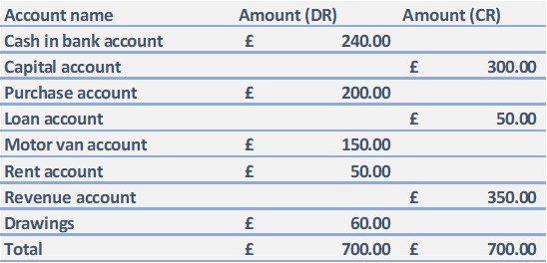

The statement of profit or loss for the month ended 30 April:
The statement of profit and loss statement at 30 April for the entity is given below:
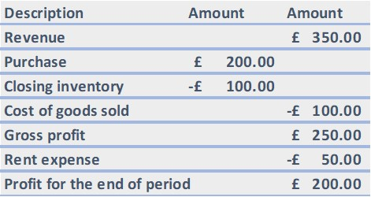

The statement of financial position at 30 April:
The statement of the financial position informs the amount of assets and liability existing in the books of an entity in a given date (Ball, 2012). In other terms, on a given day, it lists a firm's wealth, liabilities, and possession information.
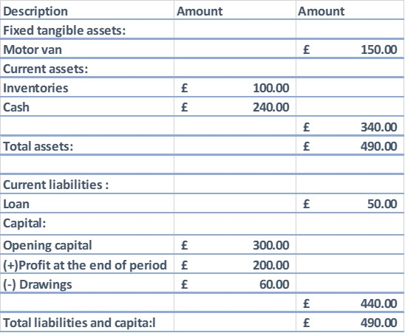

Task two:

The ledger accounts for the transactions:
Cash at bank:
Date | Description | Amount | Date | Description | Amount
1-Jan | Capital account | £ 5,000.00 | 2-Jan | Motor van account | £ 600.00
4-Jan | Loan account | £ 1,000.00 | 3-Jan | Purchase account | £ 1,300.00
13-Jan | Revenue account | £ 300.00 | 10-Jan | Motor expense account | £ 200.00
20-Jan | Revenue account | £ 500.00 | 24-Jan | Storage expense account | £ 150.00
 |  |  | 27-Jan | Loan account | £ 350.00
 |  |  | 30-Jan | Drawings account | £ 175.00
 |  |  | 31-Jan | Balance C/D | £ 4,025.00
 |  | £ 6,800.00 |  |  | £ 6,800.00
1-Feb | Balance B/D | £ 4,025.00

Capital account:
Date | Description | Amount | Date | Description | Amount
31-Jan | Balance C/D | £ 5,000.00 | 1-Jan | Bank account | £ 5,000.00
 |  | £ 5,000.00 |  |  | £ 5,000.00
 |  |  | 1-Feb | balance B/D | £ 5,000.00

Motor van account:
Date | Description | Amount | Date | Description | Amount
2-Jan | Bank account | £ 600.00 | 31-Jan | Balance C/D | £ 600.00
 |  | £ 600.00 |  |  | £ 600.00
1-Feb | Balance B/D | £ 600.00

Purchase account:
Date | Description | Amount | Date | Description | Amount
3-Jan | Bank account | £ 1,300.00 | 31-Jan | Balance C/D | £ 1,300.00
 |  | £ 1,300.00 |  |  | £ 1,300.00
1-Feb | Balance B/D | £ 1,300.00

Loan account:
Date | Description | Amount | Date | Description | Amount
27-Jan | Bank account | £ 350.00 | 4-Jan | Bank account | £ 1,000.00
31-Jan | Balance C/D | £ 650.00
 |  | £ 1,000.00 |  |  | £ 1,000.00
 |  |  | 1-Feb | Balance B/D | £ 650.00

Motor van expense account:
Date | Description | Amount | Date | Description | Amount
10-Jan | Bank account | £ 200.00 | 31-Jan | Balance C/D | £ 200.00
 |  | £ 200.00 |  |  | £ 200.00
1-Feb | Balance B/D | £ 200.00

Revenue account:
Date | Description | Amount | Date | Description | Amount
31-Jan | Balance C/D | £ 800.00 | 13-Jan | Bank account | £ 300.00
 |  |  | 20-Jan | Bank account | £ 500.00
 |  | £ 800.00 |  |  | £ 800.00
 |  |  | 1-Feb | Balance B/D | £ 800.00

Storage expense account:
Date | Description | Amount | Date | Description | Amount
24-Jan | Bank account | £ 150.00 | 31-Jan | Balance C/D | £ 150.00
 |  | £ 150.00 |  |  | £ 150.00
1-Feb | Balance B/D | £ 150.00

Drawings account:
Date | Description | Amount | Date | Description | Amount
30-Jan | Bank account | £ 175.00 | 31-Jan | Balance C/D | £ 175.00
 |  | £ 175.00 |  |  | £ 175.00
1-Feb | Balance B/D | £ 175.00

The trial balance at 31 January:
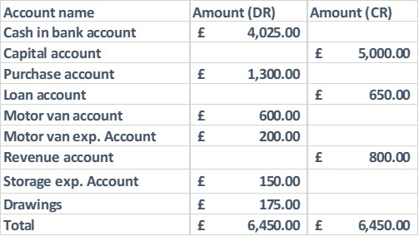

The statement of profit or loss for the month ended 31 January:
A profit and loss (P&L) reporting, or income statement or statement of activity, is a periodic statement that includes a description of the sales, costs and profits / loss of a business for a specific timeframe. The P&L statement proves the capacity of a business to produce revenue, control costs and maximize earnings.
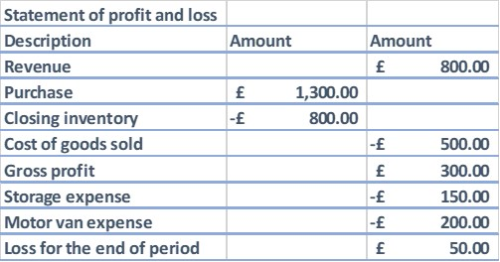
The statement of financial position:
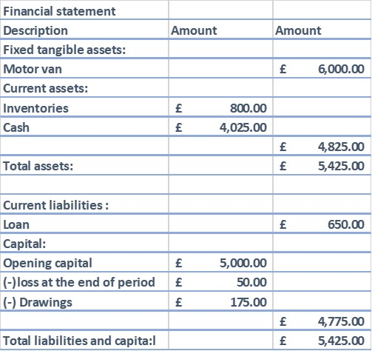

Task three:

Presentation of relevant ledger accounts:
Bank account:
Date | Description | Amount | Date | Description | Amount
1-Jan | Balance B/D | £ 343.00 | 5-Jan | Wages account | £ 14.00
7-Jan | Smith's account | £ 18.00 | 9-Jan | Max's account | £ 21.00
11-Jan | Sales account | £ 64.00 | 14-Jan | Wages account | £ 14.00
21-Jan | Sales account | £ 110.00 | 14-Jan | Purchase account | £ 75.00
23-Jan | Harvey's account | £ 25.00 | 15-Jan | Rich's account | £ 162.00
28-Jan | Sales account | £ 84.00 | 20-Jan | Fixture and fittings account | £ 32.00
31-Jan | Sales account | £ 30.00 | 21-Jan | Wages account | £ 17.00
 |  |  | 23-Jan | Office expense account | £ 3.00
 |  |  | 28-Jan | Wages account | £ 15.00
 |  |  | 31-Jan | Balance C/D | £ 323.00
 |  | £ 674.00 |  |  | £ 674.00
1-Feb | Balance B/D | £ 323.00

Capital account:
Date | Description | Amount | Date | Description | Amount
31-Jan | Balance C/D | £ 1,091.00 | 1-Jan | Balance B/D | £ 1,049.00
 |  |  | 31-Jan | Income and expense account | £ 50.00
 |  | £ 1,091.00 |  |  | £ 1,091.00
 |  |  | 1-Feb | Balance B/D | £ 1,091.00

Fixture and fittings account:
Date | Description | Amount | Date | Description | Amount
1-Jan | Balance B/D | £ 198.00 | 31-Jan | Balance C/D | £ 230.00
20-Jan | Bank account | £ 32.00
 |  | £ 230.00 |  |  | £ 230.00
1-Feb | Balance B/D | £ 230.00

Sales account:
Date | Description | Amount | Date | Description | Amount
31-Jan | Trading account | £ 412.00 | 2-Jan | Harvey's account | £ 124.00
 |  |  | 11-Jan | Bank account | £ 64.00
 |  |  | 21-Jan | Bank account | £ 110.00
 |  |  | 28-Jan | Bank account | £ 84.00
 |  |  | 31-Jan | Bank account | £ 30.00
 |  | £ 412.00 |  |  | £ 421.00

Wages account:
Date | Description | Amount | Date | Description | Amount
5-Jan | Bank account | £ 12.00 | 31-Jan | Income and expense account | £ 58.00
14-Jan | Bank account | £ 14.00
21-Jan | Bank account | £ 17.00
28-Jan | Bank account | £ 15.00
 |  | £ 58.00 |  |  | £ 58.00

Purchases account:
Date | Description | Amount | Date | Description | Amount
5-Jan | Rich's account | £ 150.00 | 31-Jan | Trading account | £ 225.00
14-Jan | Bank account | £ 75.00
 |  | £ 225.00 |  |  | £ 225.00

Office expense account:
Date | Description | Amount | Date | Description | Amount
23-Jan | Bank account | £ 3.00 | 31-Jan | Income and expense account | £ 3.00
 |  | £ 3.00 |  |  | £ 3.00

Receivables account- Smith’s:
Date | Description | Amount | Date | Description | Amount
1-Jan | Balance B/D | £ 18.00 | 7-Jan | Bank account | £ 18.00

Receivables account- Harvey’s:
Date | Description | Amount | Date | Description | Amount
1-Jan | Balance B/D | £ 41.00 | 23-Jan | Bank account | £ 25.00
2-Jan | Sales account | £ 124.00 | 31-Jan | Balance C/D | £ 138.00
 |  | £ 163.00 |  |  | £ 163.00
1-Feb | Balance B/D | £ 138.00

Receivables account- Moon’s:
Date | Description | Amount | Date | Description | Amount
1-Jan | Balance B/D | £ 26.00 | 31-Jan | Balance C/D | £ 26.00
1-Feb | Balance B/D | £ 26.00

Payable account- Rich’s:
Date | Description | Amount | Date | Description | Amount
15-Jan | Bank Account | £ 162.00 | 1-Jan | Balance B/D | £ 12.00
 |  |  | 5-Jan | Purchase account | £ 150.00
 |  | £ 162.00 |  |  | £ 162.00

Payable account- Max’s:
Date | Description | Amount | Date | Description | Amount
9-Jan | Bank account | £ 21.00 | 1-Jan | Balance B/D | £ 21.00

Inventories account:
Date | Description | Amount | Date | Description | Amount
1-Jan | Balance B/D | £ 458.00 | 31-Jan | Trading account | £ 458.00
31-Jan | Trading account | £ 374.00 | 31-Jan | Balance C/D | £ 374.00
1-Feb | Balance B/D | £ 374.00

Trial balance:
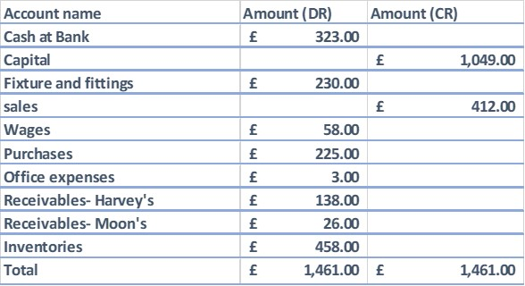

The statement of profit and loss:
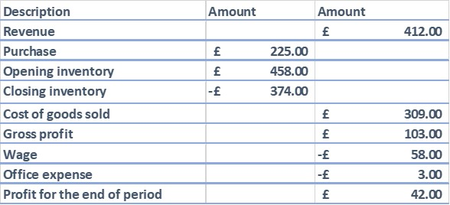

The Statement of financial position:
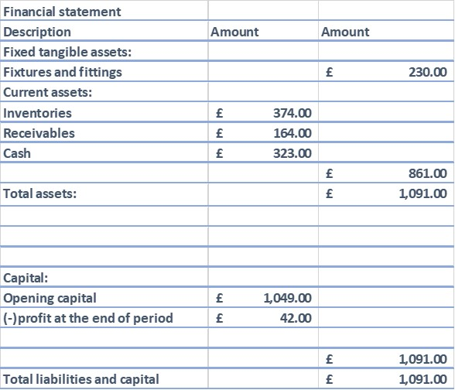

Task four:

Relevant Ledger accounts:
Revenue account:
Date | Description | Amount | Date | Description | Amount
27-Jun | Trading account | £ 28,500.00 | 2-Jun | Claire account | £ 8,500.00
 |  |  | 14-Jun | Hywel account | £ 9,000.00
 |  |  | 20-Jun | Cash account | £ 6,000.00
 |  |  | 24-Jun | Mandy account | £ 5,000.00
 |  | £ 28,500.00 |  |  | £ 28,500.00

Sales return account:
Date | Description | Amount | Date | Description | Amount
22-Jun | Claire account | £ 1,000.00 | 27-Jun | Trading account | £ 1,000.00

Purchases account:
Date | Description | Amount | Date | Description | Amount
13-Jun | Georgina account | £ 12,000.00 | 27-Jun | Trading account | £ 16,500.00
21-Jun | Andrew account | £ 4,500.00
 |  | £ 16,500.00 |  |  | £ 16,500.00

Cash account:
Date | Description | Amount | Date | Description | Amount
20-Jun | Sales account | £ 6,000.00 | 25-Jun | Georgina account | £ 11,160.00
24-Jun | Claire account | £ 7,125.00 | 27-Jun | Andrew account | £ 4,410.00
25-Jun | Hywel account | £ 9,000.00 | 27-Jun | Balance C/D | £ 6,555.00
 |  | £ 22,125.00 |  |  | £ 22,125.00
1-Jul | Balance B/D | £ 6,555.00

Discount allowed account:
Date | Description | Amount | Date | Description | Amount
24-Jun | Claire account | £ 375.00 | 27-Jun | Income and expense account | £ 375.00
 |  | £ 375.00 |  |  | £ 375.00

Discount received account:
Date | Description | Amount | Date | Description | Amount
27-Jun | Income and expense account | £ 930.00 | 25-Jun | Georgina account | £ 840.00
 |  |  | 27-Jun | Andrew account | £ 90.00
 |  | £ 930.00 |  |  | £ 930.00

Account receivable- Claire:
Date | Description | Amount | Date | Description | Amount
2-Jun | Sales account | £ 8,500.00 | 22-Jun | Sales return account | £ 1,000.00
 |  |  | 24-Jun | Cash account | £ 7,125.00
 |  |  | 24-Jun | Discounts allowed | £ 375.00
 |  | £ 8,500.00 |  |  | £ 8,500.00

Account receivable-Hywel:
Date | Description | Amount | Date | Description | Amount
14-Jun | Sales account | £ 9,000.00 | 25-Jun | Cash account | £ 9,000.00

Account receivable- Mandy:
Date | Description | Amount | Date | Description | Amount
24-Jun | Sales account | £ 5,000.00 | 27-Jun | Balance C/D | £ 5,000.00
 |  | £ 5,000.00 |  |  | £ 5,000.00
1-Jul | Balance B/D | £ 5,000.00

Account payable- Georgina:
Date | Description | Amount | Date | Description | Amount
25-Jun | Cash account | £ 11,160.00 | 13-Jun | Purchase account | £ 12,000.00
26-Jun | Discount received account | £ 840.00
 |  | £ 12,000.00 |  |  | £ 12,000.00

Account payable- Andrew:
Date | Description | Amount | Date | Description | Amount
27-Jun | Cash account | £ 4,410.00 | 21-Jun | Purchase account | £ 4,500.00
27-Jun | Discount received | £ 90.00
 |  | £ 4,500.00 |  |  | £ 4,500.00

The trial balance:
Account name | Amount (DR) | Amount (CR)
Cash at Bank | £ 6,555.00
Purchases | £ 16,500.00
Revenue |  | £ 28,500.00
Sales return account | £ 1,000.00
Receivables- Mandy | £ 5,000.00
Discount allowed |  | £ 930.00
Discount received | £ 375.00
Total | £ 29,430.00 | £ 29,430.00

Conclusion:
The accounting cycle or the steps in the cycle must be maintained to report the essential accounting variables of an entity (Argilés and Slof, 2013). Without properly keeping a track of the transactions in the firm, it can not produce any kind of financial statement that will provide information to the relevant stakeholders of the business.

References:
Argilés, J. and Slof, E., 2013. The use of financial accounting information and firm performance: an empirical quantification for farms. Accounting and Business Research, 33(4), pp.251-273.
Ball, R., 2012. The Effect of Mark-to-Market Accounting for Financial Assets and Liabilities on Financial Reporting Transparency and Information Asymmetry in Banks. SSRN Electronic Journal,.
Benos, E., 2019. The Economics of Distributed Ledger Technology for Securities Settlement. Ledger, 4.
Laitinen, E., 2014. Influence of cost accounting change on performance of manufacturing firms. Advances in Accounting, 30(1), pp.230-240.
XU, C., 2017. The Influence Mechanism of Over Investment on Corporate Credit Risk. DEStech Transactions on Economics, Business and Management.

