

Upgrade of pneumatic linear actuator on Dane Encapsulator to Servo driven alternative

By
Christopher James
Supervisor: Gary Jones

Project submitted as part of the requirements for the award of Bachelor of Engineering - Electrical & Electronic Engineering

April 2025

APPENDIX 1: DECLARATION FORM AND FORM OF CONSENT

DECLARATION

I, Christopher James declare that I am the sole author of this Project; that all references cited have been consulted; that I have conducted all work of which this is a record, and that the finished work lies within the prescribed word limits.

This work has not previously been accepted as part of any other degree submission.

Abstract
This project focuses on the upgrading of the Dane encapsulators. The main aim is to replace the horizontal pneumatic driven linear actuator with a servo motor system. This upgrade includes the addition of an electrical drive that will allow for precise motor control compared to the current setup. The system will be integrated into the existing electrical panel, requiring an updated electrical schematics and software configuration.
To ensure full functionality, the new drive was incorporated into the existing safety circuit and then programmed to support both manual and automatic operations. The PLC and HMI were both modified accordingly to provide full control and fault diagnostics.
The complete project demonstrates significant improvements in the performance of the machine, including a 3.5second cycle time reduction per section, allowing for up to 70 extra sections per shift. Enhanced accuracy and precision have also lead to a notable decrease in downtime and scrap sections, resulting in increasing the amount of production time available.
This project has highlighted some of the clear advantages of upgrading machinery compared to a full replacement. This project has shown a cost effective, scalable alternative that allows the company to improve its efficiency and maintain competitiveness without a large costly budget.

Table of Contents

Abstract 3
Table of Contents 4
List of figures 6
1. Introduction 8
1.1 Background 8
1.2 Project location 8
1.3 Issues with the Dane Encaspulator 9
1.4 Proposed solutions 10
2. Literature review 13
2.1 Introduction 13
2.2 Pneumatic actuators 13
2.3 Servo driven actuators 14
2.4 Control using servo processes 15
2.5 Applications in industry 15
2.6 Benefits of upgrading instead of replacing 16
2.7 Brands of electric motor 17
2.8 Summary 17
3. Planning 19
3.1 Methodology 19
3.2. Feasibility studies. 21
3.3 Project design specification 21
3.4 Gantt chart 23
3.5. Project information 24
3.6 Component selection matrix 27
3.7 Costings and budget 30
3.8 FMEA 31
3.9 Health and safety standards 32
4. Design 33
4.1 Electrical drawings 33
4.2 HMI Program 35
4.3. PLC Program 37
4.4. Mexe02 40
4.5. Creating cycle time program 41
4.6. Results 42
5. Installation 42
5.1. Pre-installation 42
5.2. Process 44
5.3. Removal of old pneumatic system 44
5.4. Electrical wiring and configuration 45
5.5. PLC and HMI download 46
5.6. Manual movements 47
5.7. Setting feedback to plc 48
5.8. Testing in automatic 50
5.9. Safety system 51
5.10 Automatic cycle 52
6. Monitoring 52
6.1. Mexe02 improvements 52
7. Conclusion 53
7.1 Monitoring improvements 53
7.2 Project success 57
7.3 Future improvements 57
8. Reflection 57
9. References 59

List of figures
Figure 1 - Current dampeners 10
Figure 2 Current setup. 12
Figure 3 - mind map. 19
Figure 4 Feasibility study. 20
Figure 5 Gantt chart. 23
Figure 6 - Alignment issues 25
Figure 7 - Teardown count. 26
Figure 8 CSM. 26
Figure 9 Linear actuator 28
Figure 10 - AZD-CD Drive unit 28
Figure 11 Costings. 29
Figure 12 FMEA. 30
Figure 13 Pin Assignment 32
Figure 14 Drive wiring. 33
Figure 15 Loading program 35
Figure 16 Laptop connection 35
Figure 17 PanelView tag editor. 35
Figure 18 Horizontal slide page selection 36
Figure 19 Horizontal slide positions. 36
Figure 20 - Sub routine 37
Figure 21 – Jump label 38
Figure 22-Ladder program 38
Figure 23 - Jogging positions 39
Figure 24 Positions. 40
Figure 25 PLC program. 41
Figure 26 Cycle time. 42
Figure 27 - Office setup 43
Figure 28 - Complete servo slide 45
Figure 29 - Allen Bradley SLC 5/04 plc 46
Figure 30 - Manual movements 47
Figure 31 - Setting outputs 48
Figure 32 – monitoring 49
Figure 33 – Jogging 49
Figure 34 - Position tolerances 50
Figure 35 - Error messages 52

1. Introduction

1.1 Background
The battery manufacturing industry has experienced significant growth over the past few decades. This is partly driven by the increased demand for reliable energy storage solutions in various sectors such as renewable energy, electric vehicles, reserve power and defence. While moving towards a more sustainable and efficient system, battery technology continues to evolve, forcing manufacturers to increase efficiency and output to meet the rising demand.
Enersys are continually looking at evolving their production methods. As global leaders in stored energy solutions, Enersys has established a reputation for manufacturing and distributing high performance batteries that are used across the industry worldwide.

1.2 Project location
This project took place within Enersys Cell 2, specifically line 1. This department builds the main components of the battery before being sent off to be filled with acid. The beginning of this process is where this project took place. To build the sections that form the battery, a Dane Encapsulator is used. This machine alternates between picking up negative and positively charged plates and carefully stacks them on top of each other, separated by a sheet of paper each time, forming a section that will go on to be processed into a battery. An image of the Dane Encapsulator can be found in Figure 1.
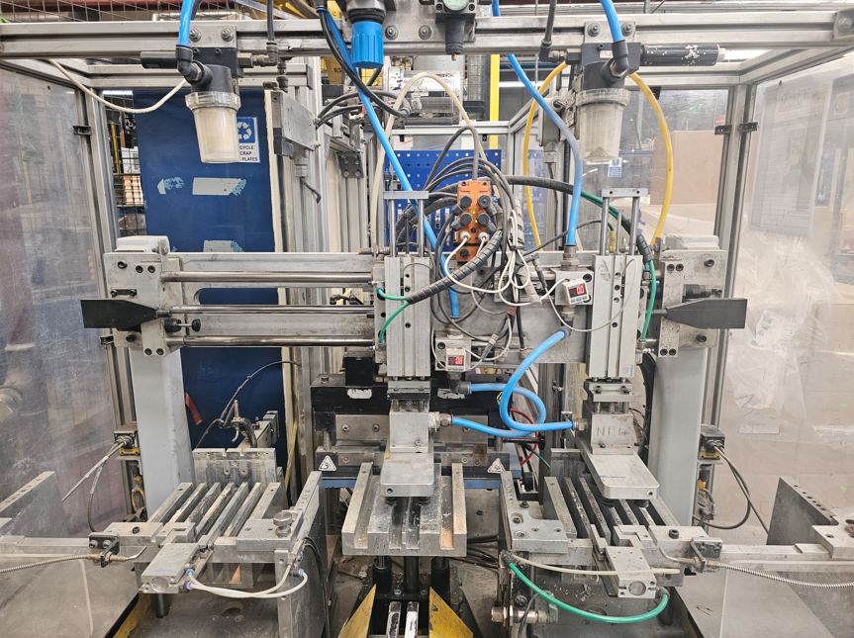
Figure 1. Dane Encapsulator

1.3 Issues with the Dane Encaspulator
The machine is approximately 30 years old; it has had little to no improvements over this time. There is regular maintenance on the horizontal slide, the part of the machinery that moves the plates into position. This is a pneumatically driven component. Over time, the components have worn and become damaged, pipework have become brittle and leak.
As the machine gets older, maintenance have reported more time spent, replacing parts, adjusting valves, and repairing parts such as dampers and sensors.
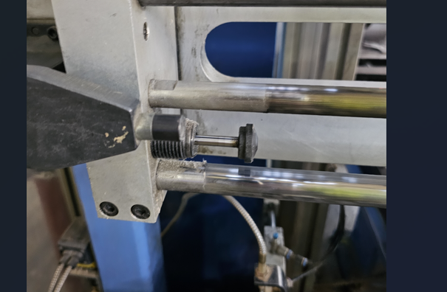
Figure 2. Current dampeners
Figure 2 shows the dampener that is currently used to stop the horizontal slide, with no acceleration or deceleration capabilities, the precision of the process is reliant on the wear and tear of this component. The inability to properly control the movements of the cylinder results in a large amount of money is wasted each year on pneumatic seal kits for the slide.
Due to an increase in orders for this line, we are under pressure to find ways that we can increase the volume of product that can be processed through the line within a shift.
While increasing targets, we are always aiming to improve the quality of the product. Pneumatic cylinders are much less accurate compared to other methods, with them relying heavily on the accuracy of external sensors and dampers to ensure that they stop in the correct location. All to often, seals will leak or become damaged. Over time we have determined that reducing the speed of the process can help to extend the longevity of the seals, however this will also affect production targets.
Issues with the Dane Encapsulator include:
- Downtime due to maintenance
- Costs to replace parts/ purchasing seal replacement kits.
- Scrap/teardowns due to accuracy.
- Speed
1.4 Proposed solutions
In an effort to improve the efficiency, reliability, and precision of this machine, the pneumatic components were replaced with servo driven linear actuator. Although this was quite a large task, it allowed for considerable improvements to the machine, including a reduction in cycle time while improving the quality of the product being produced. It also reduced the amount of downtime on the machine due to less moving parts in the process. The electric linear actuators do not require seal kits so cost were also saved on purchasing these, which can cost up to £200 per seal kit.
To decide on a suitable electric motor and drive, a CSM (component selection matrix) was carried out. This compared multiple different servo motors. The suitable motor offered a solution to all the current issues with the process. Creating and modifying existing drawings allowed updated designs to be viewed easily, making it simpler for future maintenance to be carried out.
The new automatic process was programmed into the plc. This allowed the system to function by itself when the start button is pressed. Including this, an updated HMI program created improved manual functions using the servo motor. This included push buttons to manually move to specified locations and also push buttons to ‘jog’ the linear slide to any position required. An alarm reset button on the HMI will also allow operators or maintenance to reset the motor if there are any faults in the system. All of this was created on the HMI, with the PLC program also modified to allow for the manual functions.
The installation included:
- Assembly of new servo motor and drive
- Wiring of power and control systems to the drive
- Modification of drawings
- Programming of PLC to introduce new features
- Creation of manual functions on HMI
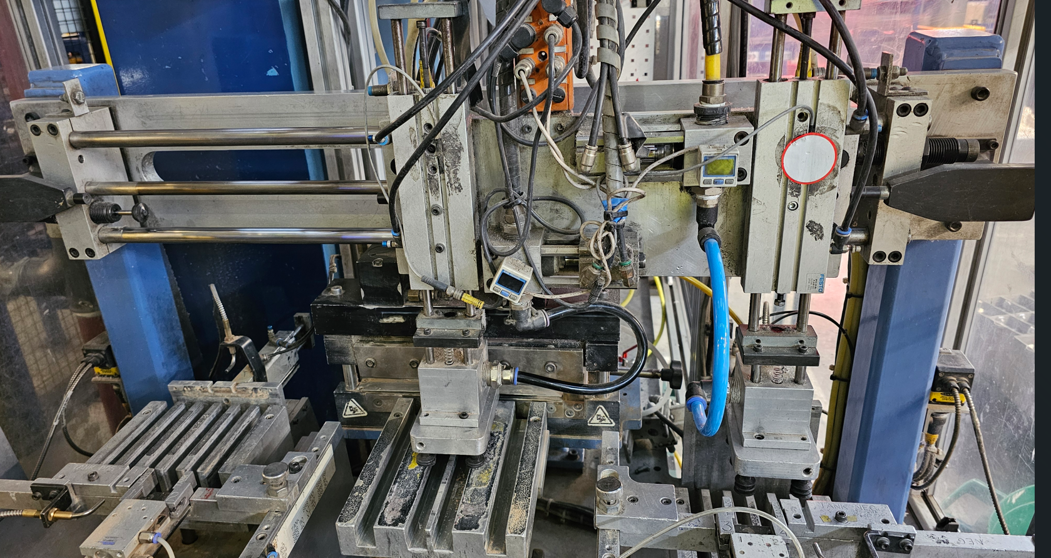
Figure 3 Current setup.
The highlighted image in Figure 3 shows the current pneumatic system that is used to operate the horizontal slide. This was replaced with a servo alternative.

2. Literature review

2.1 Introduction
Industrial automation has increasingly moved towards greater requirements for precise and efficient control methods. In the past, pneumatically driven linear actuators were often used for many linear driven applications. This was mainly due to their low cost and ease of implementation. In modern times, their limitations in precision, control and energy efficiency have become increasingly apparent. This is due to increasing demand for high quality products worldwide. To aid in increasing speed and precision, many companies will now prefer to adopt servo driven linear actuators as an alternative to the pneumatic.
The literature review discusses the advantages of servo actuators, along with the challenges of installation and their applications in industry.

2.2 Pneumatic actuators
A standard pneumatic actuator will use compressed air to generate the required linear movement. In the past, they have been known for their ease of use and low cost to install. They do, however, have multiple drawbacks in today’s modern industry.
These include:
- Precision – Many pneumatic processes use open loop control. This means that it does not use any feedback process to control its positioning. This can cause issues when trying to achieve extremely low tolerances.
- Energy use – A compressed air system will be permanently compressed even when not in use. This means that they are always using energy. In comparison, a servo motor will only use power when it requires it, allowing it to conserve energy when not in use.
- Feedback – Most pneumatic actuators do not allow for real time positional feedback or any other kind of monitoring information that a servo drive may allow.
- Maintenance – Pneumatic systems will require frequent maintenance, whether it is preventative maintenance or breakdowns. This is due to wear and tear of components such as pipework and seals, which cause leaks resulting in inferior performance or failures.
There are multiple studies that highlight these issues. For example, Hazem Ali (2009) [1], mentions that even though pneumatics has many positives, they suffer due to issues such as inconsistency in pressure, which can lead to poor performance of the process. In addition, Airtac et al. [2], talks about issues with pneumatic systems which range from pressure drops, accuracy and even environmental issues. Paul Harris (2014) [3] does however, talk about ways to improve the energy efficiency of pneumatic systems by using a dual pressure approach, which involves implementing an additional pressure regulator.

2.3 Servo driven actuators
A servo driven actuator has a number of advantages, these which include high precision, control, and efficiency. This system uses a servo motor, alongside a method of feedback to an electronic drive, creating a closed loop method of control. A closed loop control will allow the system to correct any error by monitoring the output and adjusting as required.
Advantages include:
- High precision and repeatability – Servo motors will allow an elevated level of precision, allowing for accuracy and repeatability to a very high degree.
- Energy efficient – Motors are only powered when they are required, any other time they are idle, using little to no power.
- Closed loop control – The closed loop control allowed for real time feedback of the system, again, allowing for high levels of accuracy while allowing the user to visually monitor many different aspects of the process.
- Reduced maintenance – Less moving parts and no dependency on external energy control such as compressed air can result in less maintenance requirements. Servo motors are commonly considered to be highly dependable.
Muhammad Baballe [4] considered servo motors to be capable of providing high efficiency, with high torque at high speeds, however can be costly to purchase initially while Marcello Pellicciari [5] considered servo mechanisms to be standard in most modern day manufacturing process.

2.4 Control using servo processes
Servo drives allow for increased levels of control over a process in multiple ways, these include PID control, Monitoring, and accurate sensor feedback.
- PID control – integrated proportional integral derivative control can help to ensure that the motor is controlled in a smooth, accurate process.
- Monitoring – It allows for accurate monitoring of a process, allowing methods to visually monitor and adjust aspects such as acceleration, deceleration, current, position velocity and much more.
- Accurate sensor feedback – The closed loop system allows for an extremely high degree of position monitoring, while also allowing the user to set tolerances to their specified needs.
N.C.Cheung [6]mentions that [7] t a high performing servo system requires optical encoders for position and velocity feedback. By choosing optical encoders with higher resolution, you are able greatly increase the performance and accuracy of servo systems.

2.5 Applications in industry
Servo motors are used throughout industry. They are one of the most popular methods of control due to their high power, accuracy, and speed. Examples of their use include:
Robotics - because of their exceptional power output and accuracy as well as their wide range of size to choose from [8]. Servos are used in the robotic arms as joints, performing tasks such as picking and placing, welding, and painting.
Industrial automation – Used to control movement of many different parts of a manufacturing process. Used to improve quality and volume of product within the process [9].
CNC machines – Their accuracy and precision make them an ideal choice to be used within a CNC. CNC machines such as lathes, and milling machines will both use servo motors within there system as they can conduct difficult tasks such as cutting and drilling.
Aerospace – Within the aviation industry, servo motors are used to control many functions of an aircraft including flaps and rudders. Their precise control allows for stable and effective control.

2.6 Benefits of upgrading instead of replacing
There are multiple benefits to upgrading machinery instead of replacing it altogether. Many improvements can be made with very little cost and have a significant impact on either the volume of product, the safety or quality.
Modern technology is rapidly improving, with the improvements quickly making older technology outdate and obsolete. With standards and expectations from customers continuously increasing, it is vital that we continue to improve our capabilities to continue to stay ahead of competitors [10].
To replace the whole machine with a new, state of the art machine, can potentially cost tens of thousands of pounds, this is often unrealistic. The improvement that it may have on the process may also not justify the spend.
Fixing or replacing a machine is a dilemma that companies will often face. It is reported that companies often use the 50% rule, if the repair or upgrade will cost more than 50% of the value of the machine, then it may be worth replacing [11].
Multiple considerations are made when deciding if an upgrade is worthwhile:
- Reduction in downtime – Will the upgrade result in a reduction in downtime? If so, what will the impact be? A reduction in downtime has multiple benefits, lean manufacturing recognises anything that does not directly impact in the production of a product as a waste. Maintaining a machine is a waste. If the machine sees a reduction in unplanned downtime, then that means that it will be available to produce more product. This makes the machine more valuable to the process. [12]
- Quality – Does the upgrade improve the quality of the product? If an upgrade improves the quality of the product, then that product will be in higher demand. This potentially means that the company can charge a premium for the product, recovering the cost of the upgrade.
- Future proofing – Does the upgrade prepare the machine for future requirements? Upgrading to servo driven technology offers improved scalability and integration with advanced systems. This ensures that the machine remains relevant as production demands change.
Upgrading an existing machine will often require shorter lead times compared to ordering and installing new equipment. Studies such as [13] suggest that retrofitting modern control systems can reduce the downtime by up to 25%.
Upgrading offers numerous benefits; however, it also comes with challenges. Ensuring that all components are compatible is vital in ensuring the success of the upgrade. Downtime during the upgrade, limitations in scalability should be considered. These challenges however can often be removed or minimised through careful planning. [14]
The decision to upgrade compared to replacing manufacturing equipment depends on a variety of factors including budget, demand, quality and environmental. The evidence overwhelmingly shows that upgrading is cost effective and efficient, with the benefits dependant on the size of the upgrade that you wish to undertake.

2.7 Brands of electric motor
There are different companies that produce both types of motors and drive units, each with their own unique designs. Companies such as siemens and Rockwell, have designed their PLC software (TIA portal and Studio 5000) to allow the user to integrate their motors into their programs. This allows for an easier setup and programming sequence.
Examples of the main brands of motor include:
- Siemens
- Mitsubishi
- Fanuc
- Rockwell
- Oriental motor

2.8 Summary
The move from pneumatic to servo driven actuators show a significant advancement within industrial automation. Pneumatic actuators have been used in industry for an exceptionally long time due to their simplicity and affordability. The requirements for precision and speed in modern day industry have led to manufacturing industries to move to servo driven alternatives. Integration of servo actuators allow for improved control, energy efficiency and reduced maintenance requirements. This makes them a suitable choice for modern industrial applications. Even though they have potentially high purchasing costs and more complicated installation, the long-term benefits outweigh the cons. This makes them the preferred choice for industries that are looking for higher productivity and efficiency.

3. Planning

3.1 Methodology
To determine the best method of improving the Dane encapsulators speeds and precision, A mind map was created with 3 potential solutions. The mind map allowed me to visualise the considerations that must be taken into account of each of the potential solutions. This, combined with a feasibility study helped to determine the ideal method of upgrade.
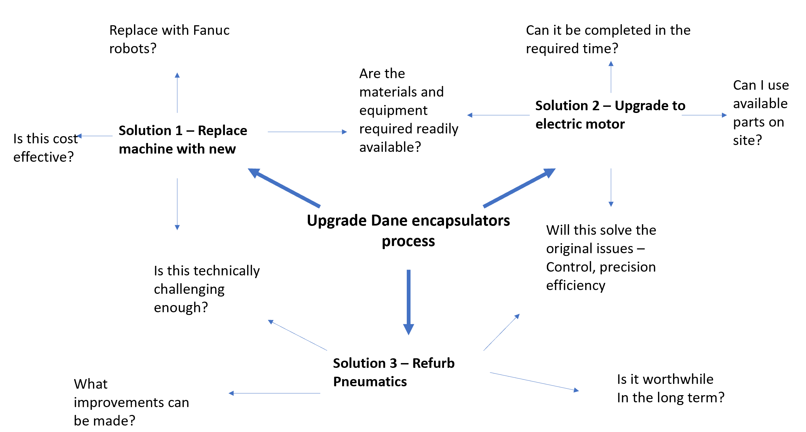
Figure 4 - mind map.

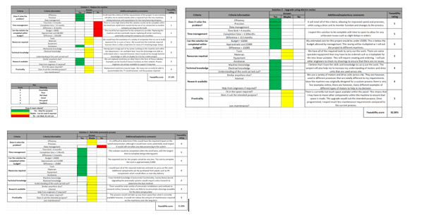
Figure 5 Feasibility study
Solution 1 – Replacing the machine.
Replacing the machine would help to improve all aspects of the process. We would be able to add networking to the process which is currently unavailable with this process. We would be able to set tolerances and expectations of a new process to suit our needs exactly.
The issue with this solution is that the costs, timeframe, and downtime would be unacceptable. We are currently struggling to keep up with demand on this line due to the issues with efficiency. Large amounts of downtime to install machinery would result in missed orders for customers. This then results in charges/fines from the customer due to missed orders, affecting our reputation. A new machine would cost too much money. Using other lines as examples, replacements of a machine has cost over £100,000 by upgrading to FANUC machinery. Since we are looking at working to a much lower budget, this would not be accepted by finance and the CEO’s.
Solution 2 – Upgrade with electric motor
Upgrading with an electric motor will allow us to improve the process as a whole. With the potential of electric motors to increase speed and precision, it would meet the 2 main goals of the project. I would also be able to complete this within the timeframe required. A drive unit would allow feedback to monitor the process which would help with maintenance, engineering, and quality work.
Solution 3 – Upgrade the pneumatic system.
Upgrading the pneumatic system would be the simplest option of all the tasks. Improving the pipework and upgrading the valves may offer a slight improvement with the process. This will also be the least expensive of all the options. This option would be complete quickly, once parts are ordered it could be installed.
This option may not be technical enough to create a project out of. There would be no original upgrades, and it would be difficult to anticipate the number of improvements that it would have on the process. Over time, the pipes would once again begin to leak, with connections failing, causing leaks resulting in low performance.

3.2. Feasibility studies.
When conducting a feasibility study of all the options, option 2 – upgrade with electric motor, scored the highest with 82% whereas replacing the machinery scored just 57%. This is due to the length of time to carry out the work and the cost.
Refurbishing the pneumatics scored quite high (71%) however it suffered due to its overall impact.

3.3 Project design specification
The project was to upgrade the current pneumatic linear slide with a servo alternative. The original process was no longer capable of meeting the increased demand on the machinery for volume and precision. The new system was implemented to increase the speed and precision of the process while allowing a method to monitor data whenever required.
The completed installation was designed to meet the following criteria:
- Performance – The new system must:
  - Be capable of improving the process by a minimum of 2 seconds per section.
  - Be capable of performing repetitive tasks over long periods of time.
  - Have a method for engineering to increase speed/acceleration/deceleration when required.
  - Operate safely with a method of stopping the process when required.

- Precision
  - Must have a low error rate.
  - Be capable of stopping in the same place each time within a very low tolerance.
- Cost
  - Fall within the given budget.
  - Parts purchased from companies we have accounts with
  - Spare parts made available in case of future issues.
- Safety
  - Completed work to be checked by the relevant departments to ensure the safety of the new process.
  - Work carried out to meet the relevant regulations.
  - Safety processes created to ensure safety (Such as mcbs etc).
- Feedback –
  - Integrate a method of data monitoring that will allow the engineer to connect and monitor the process in case of any maintenance requirements in future.
To ensure a smooth installation and a high focus on quality and safety I liaised with all relevant departments such as health and safety, quality, maintenance, and production before beginning any work. This included performing a risk assessment of the area that was being working in. Because of the environment, PPE such as overalls, masks, gloves, and ear protection were worn at all times.
Longevity
Installed, the new system is capable of performing to a high standard for a long time. It must manage a large volume of product so ideally fewer moving parts are preferred to minimise wear and tear. All parts have been made a stock item to ensure that there are spares in case of any issues.
Expected issues.
Due to a limited amount of room within the panel, components were moved as required to ensure that there was space to carry out the installation. A portion could be conducted within the panel while the machine is running however, great care was taken, considering the safety aspects of this. A risk assessment and company procedure determined that it was safe to work inside the panel while the machine is running.

3.4 Gantt chart
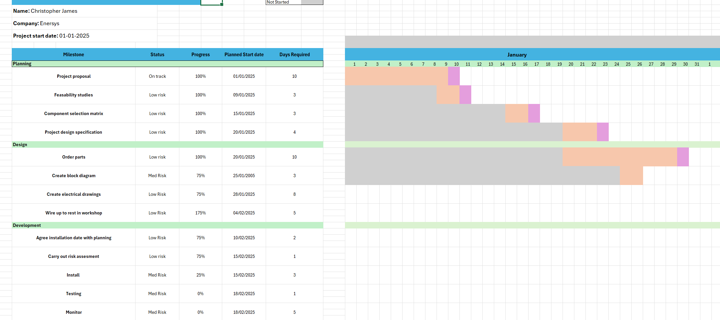
Figure 6 Gantt chart.
A Gantt chart ensured total management of a project, allowing the user to determine which parts of the project were delayed and for what reason. The Gantt chart was divided into specific sections. Each of these sections contained sub-tasks and milestones. The Gantt chart allowed a visualisation of the progress of the project, Highlighting the next deadlines, allocating resources correctly and to identify any delays before they become critical issues.
The Gantt chart was structured into key phases, these include planning, design, development, improvements, and evaluation. Each of these tasks could then be broken down into further sub tasks, which created a more methodical approach to the project.
- Planning – This section is about defining the project objectives, showing any current research carried out and gathering all the necessary resources required for the project. Information such as Costings, critical path, FMEA, initial research, project design and work breakdown structure can be found here.
- Design – This section will contain such information as electrical drawings, PLC changes, HMI changes.
- Development – This phase of the project will contain the implementation of the project. This includes the installation of equipment, integrating with current system and programming of HMI and PLC.
- Improvements – Once the installation is complete, it will require testing, monitoring, and optimising. All the information found here will detail the testing and improvement phase.
- Evaluation – This is the final stage. This will contain an assessment of the overall project, with information regarding the success/failure of the project, all feedback and information showing the impact of the upgrade.
- This structured approach, will help to ensure that each phase is completed systematically., minimising risk and helping to improve the overall efficiency of the project.

3.5. Project information
The success of the project was determined based on 2 key aspects, efficiency, and precision. To determine these, I required a method of measuring both. Cycle times can help to determine the efficiency of the process before and after the upgrade. The increased precision of the system after the upgrade was monitored by using the section ‘jigs’ to measure the sections and to obtain information for up to a week after the upgrade.
- Cycle time – The cycle time of the Dane Encapsulator can vary depending on the product being run at the time. To determine an accurate value of before and after the upgrade, I would require a ‘datum’ value.
I can run the machine on a ‘dry cycle.’ In this cycle, the machine will create a section without using any product. It will mimic all the movements of the pneumatic linear actuator without picking up any product. In this method, I can also set the number of plates in the system. This means I can use the same program with the same values before and after the upgrade to accurately determine the success of an improved cycle time.
When measuring an accurate cycle time that can be used, I placed the machine into dry cycle and ran it through multiple cycles to determine what the average cycle time was. Over 10 cycles, it averaged at 33.78 seconds per 15 plate section. This is the value that the project will aim to improve.
- Precision – The main motivation for improving the efficiency of the process is to reduce the number of teardowns that are required throughout the day. A teardown is when a section that has been built is deemed unsuitable, mainly because it does not fit inside the jig that is available to check the precision of the build. Instead of scrapping a failed section, it is taken apart, with any sections that are successfully taken apart without damage can then be re-used. The issue with this process is that it takes time, increasing downtime, and it makes traceability difficult as reworked plates have now been used in multiple sections.
Management reported that there was up to 8% product teardowns in the process, however they were not able to show any sort of research to determine this. I carried out my own research to attempt to determine a more accurate value. My research involves asking the operators to fill in a sheet showing how many teardowns they were having per hour. I found that the teardown rate was closer to 5-6%. I believe that this will be improved with the introduction of a servo linear actuator.

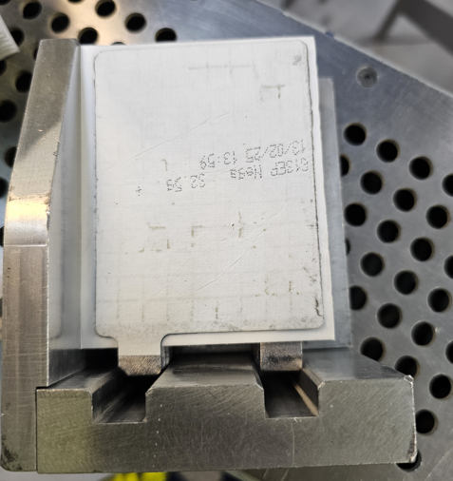
Figure 7 - Alignment issues
Figure 7 shows an example of alignment issues from a section produced from the Dane Encapsulator. Because the section does not fit accurately within the jig, it must be torn down and reworked. This is time consuming and results in machine downtime while the operator carries out adjustments.
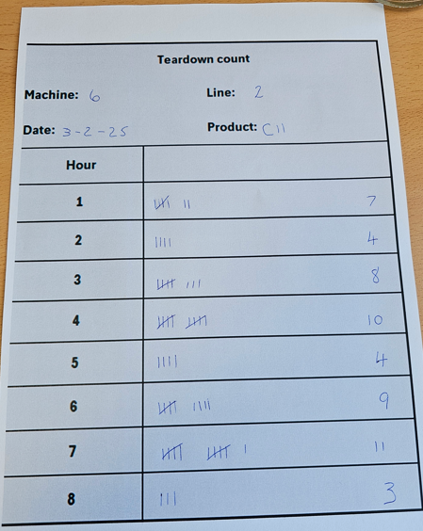
I created a sheet and asked the operators to keep track of how many teardowns that they would carry out during a shift. The feedback showed an average of 7% teardown rate. The majority of these were due to the sections being slightly out of line in the jig.

Figure 8 - Teardown count.

Figure 8 - Teardown shows an example of the data collected from the operators regarding the number of teardowns that they were performing per shift. This sheet shows the potential to improve the process by reducing the number of teardowns per hour

3.6 Component selection matrix
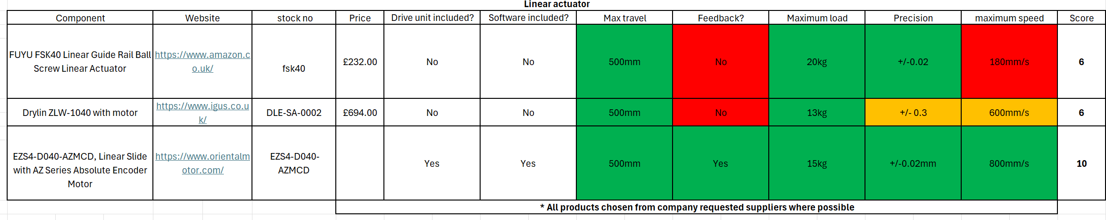
Figure 9 CSM.

Figure 6 CSM shows my component selection matrix that helped me to determine a suitable linear actuator, the oriental motor EZS4 emerged as the ideal choice. Not only did it score the highest overall, but it was the only one that met all the project requirements.
Although slightly more expensive than some of the other options, the oriental motor still ensures that it falls within budget while allowing for multiple advantages over the alternatives. The FUYU linear guide was considered however, the requirement to purchase a separate drive unit that required multiple compatibility checks negatively impacted its overall score. The oriental motor will offer a range of drive units that are all compatible with the linear slide.
The oriental motor is a closed loop system that allows instant feedback. This feedback will allow it to automatically monitor and correct any error within its movement and positioning, ensuring high accuracy. The Software required for programming is offered as a free download, making it easily accessible.
With a maximum travel range of 500mm, the actuator is more than capable of meeting the project requirements. The precision of +/-0.02mm and maximum speed of 800mm/s will significantly improve the current system performance. The total load, including the pick heads that it will hold in a vertical position, totals 4.5kg which sits comfortable under the carrying capacity.
In line with the linear actuator, the AZD-CD drive unit was chosen. This is compact enough to fit within the existing control panel, which is already limited in space. The included software allows real time data monitoring and storage, providing valuable information for both maintenance and quality requirements.
Another servo motor was originally considered, the Drylin ZLW, however, this was ultimately ruled out due to its lower precision, which could have no impact, or even a negative impact on the quality of the product. Additionally, since the company already has an account with oriental motor, due to ordering from them in the past, obtaining equipment should be seamless, ensuring prompt delivery and allowing the installation to begin as soon as possible.

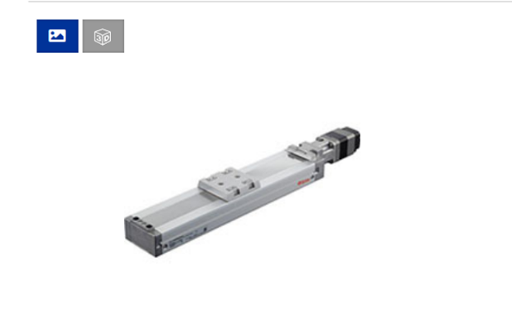
Chosen components and specifications:
Figure 10 Linear actuator
    - Linear actuator – EZS4-D040-AZMCD:
      - Electromagnetic brake – yes
      - Max speed – 800mm/s
      - Power – Single or three phase.
      - Accuracy - +/- 0.02mm

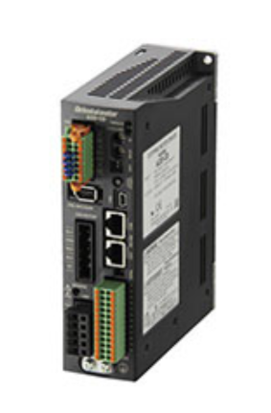
Figure 11 - AZD-CD Drive unit
    - Drive unit – Oriental motor AZD-CD
      - Power – Single phase or three phase.
      - Control – 24v
      - Type – Absolute, Closed loop.
      - Up to 10 digital inputs
      - 6 digital outputs
      - Ethernet compatibility.

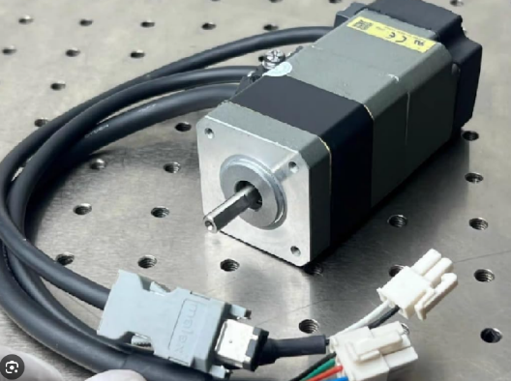
      - Motor – AZM46MC oriental motor
Figure 12. Motor AZM46MC
      - Power – Single phase
      - Brake – 24vdc
      - Type – Hybrid servo
      - Absolute positioning
      - Closed loop control

Azd-CD drive.
Figure 8 - AZD-CD Drive unit allows for a choice of either 3 phase or single-phase input and output, offering a greater degree of flexibility compared to other drive units. There are multiple oriental motor drives available, however this one allows for a greater degree of flexibility with digital inputs within the software. Other drives such as the AZD-CEP has a strong focus on ethernet compatibility. Since I am connecting to a slc5/04 which does not have ethernet capabilities, I decided that this would be an unrequired feature that would result in unnecessary added expense.
The drive requires an input current of up to 3.9a. A 5A breaker will be sufficient in protecting the drive from any unexpected or high current. Visual features of the drive unit such as LED’s will help with fault finding when there is an error on the drive.
The drive unit has numerous beneficial features:
- Closed loop – absolute control, operating in a closed loop system, ensuring accurate and precise positioning my continuously monitoring the drives position.
- Power supply compatibility – Capabilities of both single and 3 phases will offer a greater degree of flexibility.
- Communication – multiple communication options such as digital I/o, rs-485 and ethernet capabilities offers a large degree of communicational flexibility.
- Reduced heat – The drive is designed to reduce heat generation from the motor, improving efficiency and longevity.

3.7 Costings and budget

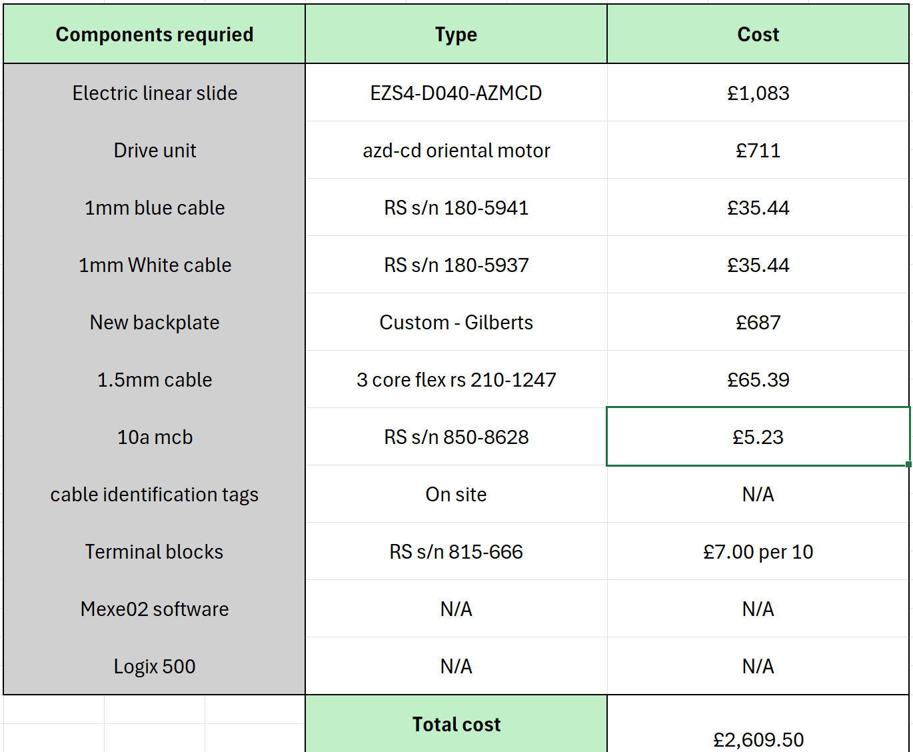
Figure 13 Costings.
Figure 11 shows the total cost of my project to be £2609.50. This covers all the necessary components for the project. The most significant parts of the installation Include the linear actuator, the drive and the backplate. The backplate will be custom built to accommodate our new equipment, ensuring a precise and secure fit allowing for optimal performance and structural integrity. Additional costs include wiring and connectors. Since we already have the majority of software available to us on site, I will not require adding these to the budget.
Enersys have allowed me a budget of £3000. My cost estimations remain well within this limit, allowing for a financial buffer to allow for any unforeseen expenses or adjustments that may arise during installation. This budgeting allows me more flexibility, minimising the risk of going overbudget. Any remaining budget can potentially be used on further improvements in the future or additional testing or safety to ensure the success of the project. Careful financial planning and monitoring of the expenses will be vital to ensure that I do not go overbudget with the project.

3.8 FMEA
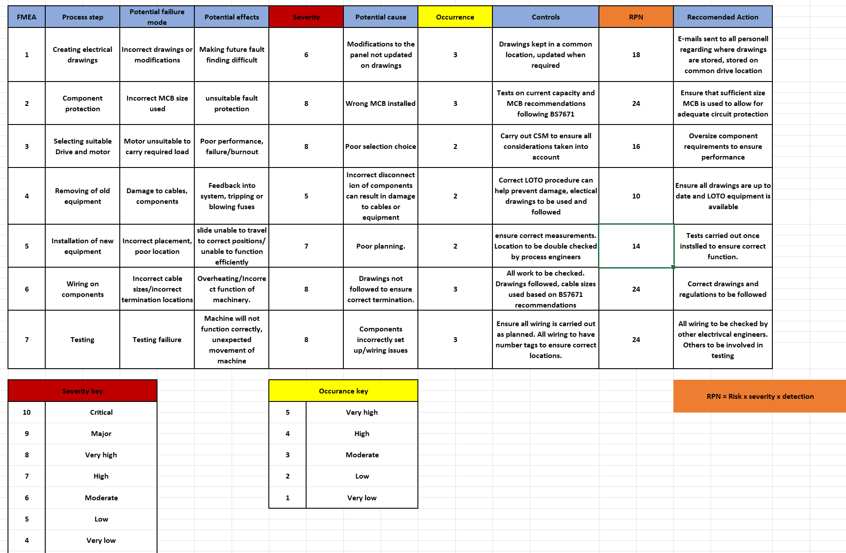
Figure 14 FMEA.
Carrying out a failure modes and effects analysis (Figure 10 FMEA) allows for multiple benefits, allowing for the identification and mitigation of potential failure points before they cause any disruptions to the install. With this approach, I can prioritise risks based on their severity and likelihood. This will enable me to address the most critical issues first to improve the overall safety and effectiveness of the project.
The FMEA has highlighted several potential risks within my project. One main concern is incorrect wiring, which could potentially result in unexpected movement of machinery. To prevent this, I will ensure that my wiring diagrams are correctly designed, reviewed, and followed correctly. As an added precaution, I will seek verification from another engineer to cross check my work. Before reinitialising power to the machine.
To further improve safety, I will implement strict access control measures, which includes cordoning off the work area, to prevent unauthorised access to a work area. These steps will help me to mitigate risks and ensure a structured safety conscious approach to the project completion.

3.9 Health and safety standards.
Throughout the project, I will adhere to all the correct health and safety standards, industry, and company policies to always ensure a safe working environment. Key regulations such as LOLER (lifting operations and lifting equipment regulations) will be followed as well as EWR (electricity at work regulations) and the BS 7671 (IET wiring regulations). All of this will help to ensure safe working practices, especially when working within the control panel.
Company policies including LOTO (lock out tag out) will be strictly followed to ensure that the electrical panel is fully isolated before beginning any work. This procedure aligns with the HASAWA (Health and safety at work act) to ensure that all work is deenergised before maintenance or modifications are conducted. By following these protocols, I will ensure that I minimise the risk of accidents to ensure compliance with company and industry standards.
One of the main hazards that are associated with this project is the risk of electric shock and potential entrapment or physical injury from the linear actuator. To mitigate these risks, a risk assessment will be conducted before work commences, identifying any potential hazards and rectifying them before commencement of any work.
During testing, I will ensure that the area is secured and that all personnel within the department are aware of the installation. Yellow/black tape will be used to cordon off the machine preventing any unauthorised access.
Due to the high level of lead in the environment within Cell 2, strict PPE (personal protective equipment) must be worn at all times. This includes mask, gloves, overalls, ear protection and safety boots. This will help to meet the PPE at work regulations and CLAW (control of lead at work regulations). Following this will help to ensure my personal safety whilst working within the area.

4. Design

4.1 Electrical drawings
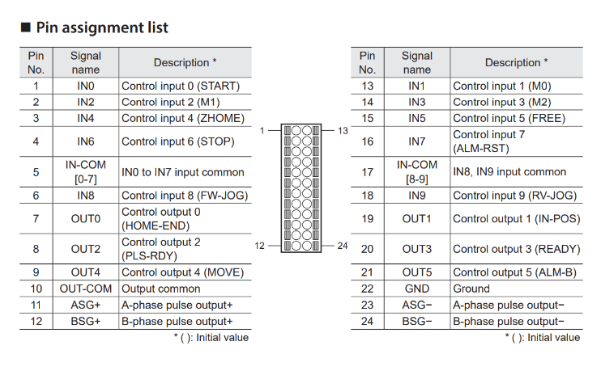
Figure 15 Pin Assignment
To ensure that the motor and drive perform as required, I created a wiring diagram to show the required terminations to integrate the drive to the current plc system. The pin assignment list found on the oriental motor website allowed me to identify where the inputs and outputs were located. These pins are default, with the option to change their use within the MEXE02 software.
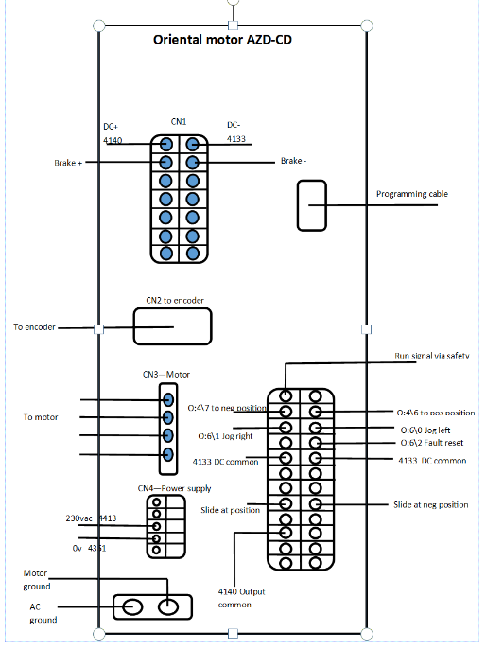
Figure 16 Drive wiring.

I created an electrical design using publisher. To assign PLC inputs, I would have to find spare ports within the program by cross referencing to find which inputs and outputs are not being used. The plc outputs that I assigned were:

O:4\7 – Horizontal slide to neg position
O:4\6 - Horizontal slide to positive position
O:6\0 – Jog slide left
O:6\1 – Jog slide right
O:6\2 – Fault reset
I:2\7 – Slide at positive position
I:2\8 – Slide at neg position
I was able to reuse the 2 inputs from the pneumatic sensors for the slide at positions.

4.2 HMI Program
Modifying the HMI program involves creating the following additional features:
- Manual movement to positive position
- Manual movement to neg position
- Jog Left
- Jog Right
- Drive fault reset.
The HMI is a PanelView 550. This is connected to an Allen Bradley SLC 5/04 using an RS232 cable. There is no ethernet functionality between the PLC and HMI.
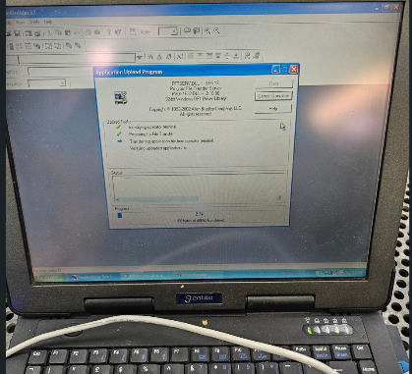
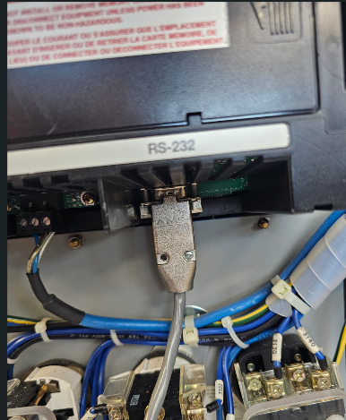
Figure 17 Loading program
Figure 18 Laptop connection

Before I could make any modifications, I would have to upload the program from the HMI. This was achieved using an RS232 cable and a usb adaptor. With the project successfully uploaded, I saved a master copy and then began to make modifications to the program.
Within the PLC program, B:15 is reserved for PanelView communication. By cross referencing this, I was able to determine what bits were available to be used. I assigned the following internal tags to the HMI/PLC communication:
- Go to neg position – B:15\24
- Go to positive position – B:15\23
- Jog Slide left – B:15\52
- Jog slide right – B:15\53
- Reset fault on drive – B:15\56
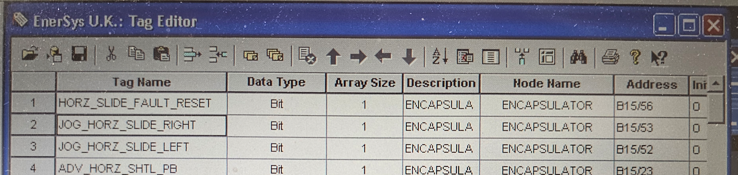
Figure 19 PanelView tag editor.

These tags must first be created within the tag editor, they can then be assigned to push buttons created in the HMI program.
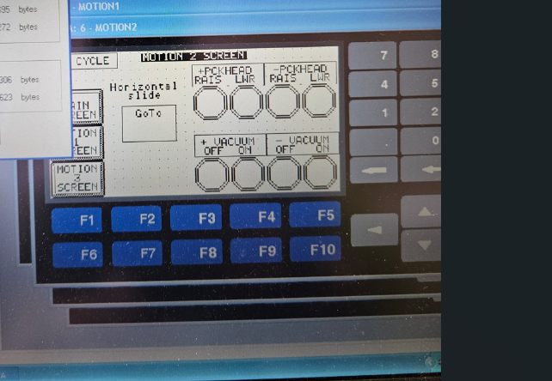
Figure 20 Horizontal slide page selection

I created a new page for the horizontal slide. A ‘go to’ button was created to allow the user to navigate to this page.

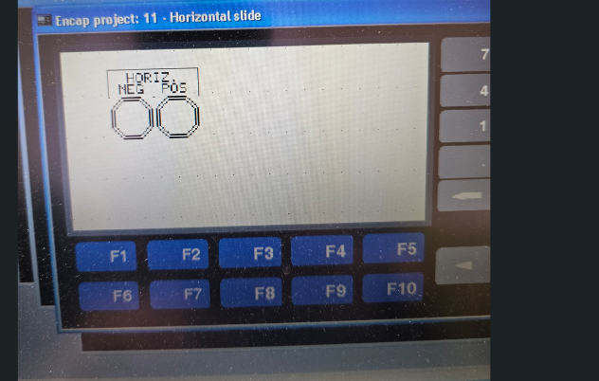
Figure 21 Horizontal slide positions.

The horizontal slide movements can then be placed within this page. Each created push button can be assigned its internal bit value by right clicking on the button and pressing ‘edit tag’.

4.3. PLC Program
The manual functions should only be used under the following conditions:
When the machine is:
- In manual mode
- Step 0
- HMI Push button has been pressed.
- Safety ok
By programming this into the PLC, I can ensure that there will be no unexpected movements of the machine, ensuring safety of the process. If the safety system is tripped, manual movements must not be allowed.
A ‘home’ button already exists on the HMI. When this is activated, the linear slide will move to the neg position. A manual button to move to neg position should be programmed in parallel with this to ensure that the functionality of the home button still works.
To ensure that the servo slide performed correctly, I would have to modify the current SLC5/04 program. This includes creating new outputs for the positions, feedback and jogging. This was created using logix 500 software.
To make the program more readable, I created a subroutine (Figure 19 - Sub routine) within the program would be dedicated to the servo slide.
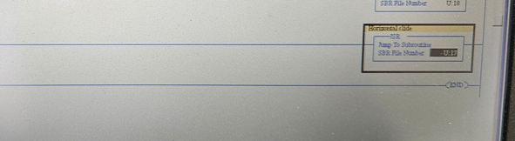
Figure 22 - Sub routine

A jump label was created within the main program (Figure 20 – Jump label) that so that it would load the subroutine as soon as the power was switched on.
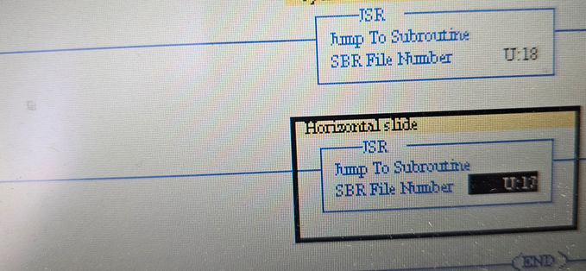
Figure 23 – Jump label

The program was created within this subroutine. For the correct output to be called, specific conditions must be made. For example, to move the horizontal slide to the positive position, the machine must be in auto, step 3, plate picked signal received and all safety conditions met. Once these conditions are ok, the program will now send a signal to the oriental motor drive to move the motor to the correct postion.
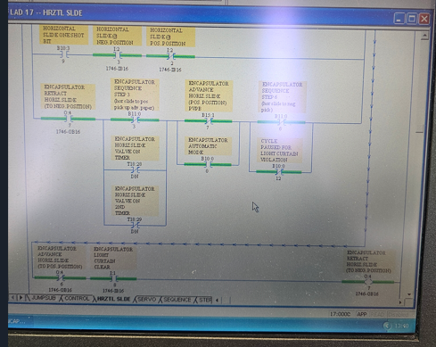
Figure 24-Ladder program
The program within the drive will then determine the postion of the slide. To manually send a signal to the drive to move to desired postions, when in manual functions, I am now able to press the allocated button on the Panelview 550 HMI.
Jogging left to right can only be achieved in manual mode. Pressing the dedicated buttons on the HMI (B15:2/14 and B15:2/15), I can incrementally move the horizontal slide to any position within the 2 limits.
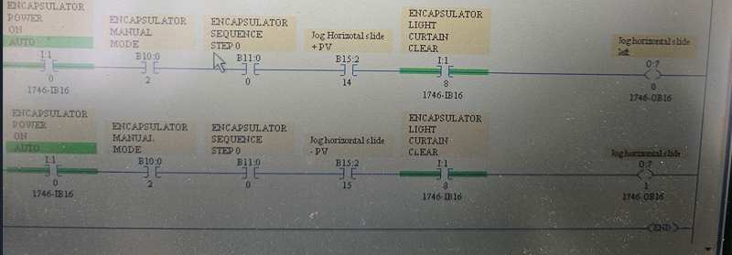
Figure 25 - Jogging positions

4.4. Mexe02
Once the drive and other components have been wired in and ready for setup, I will use the oriental motor software Mexe02 to program the drive and motor. This software will allow me to create many different positions (up to 256) using digital inputs.
The software allows me to make manual movements of the process, as well as change the inputs to carry out different tasks as required.
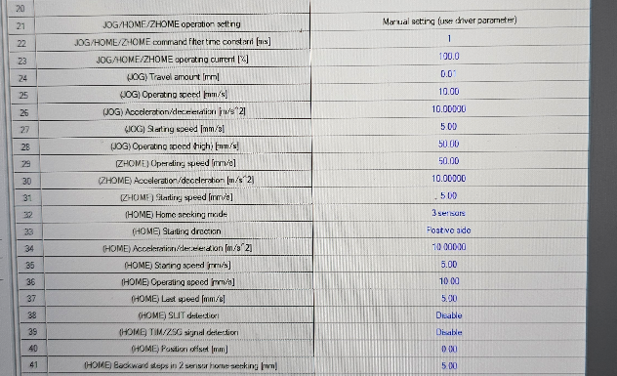
Figure 26 Positions.

The software will allow me to assign ports to jog movements, while deciding suitable acceleration, deceleration, and velocity settings for each. I can choose my own tolerances for the output signals for each position. These can be set to the nearest 0.01mm.
I measured the cycle time of a section by using a stopwatch. Originally this was the only method possible as there was no automatic method of counting the cycle time within the program.
To determine an accurate cycle time, I would have to create a program that would allow me to automatically measure the amount of time that is required to build a section.

4.5. Creating cycle time program
I created the cycle time counter using RSlogix 500. Creating it within its own subroutine allowed me to keep it separate from all other subroutines within the program, allowing for easier readability within the program.
Creating the cycle timer involved creating an internal flag to determine when the cycle time would begin (assigned B3:50\0) and a new timer (assigned T4:40\0) that would count the length of time taken to complete the cycle. The time is stored within an integer file assigned as N50:0
I decided that the cycle time would run from when it picks up the first plate from the first section until it picks up the first plate from the next section. This would give me an accurate reading of the time that it takes to create a section.
Using internal flags that determined when the center stepper was in its home position (something that only happens at the start of the cycle) and when the internal flag for the encapsulator picking up its first plate was active, I would begin the timer.
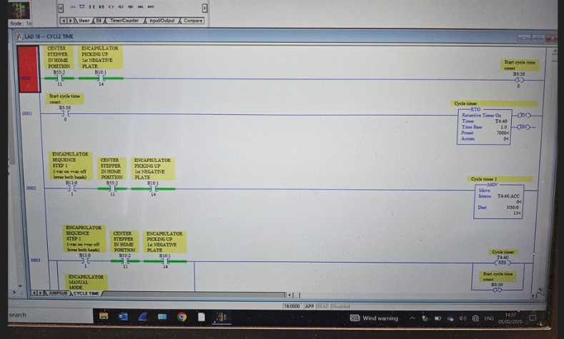
Figure 27 PLC program.

This timer would continue until it reached the same conditions. At this point it will move the current time within T4:40.acc to a new internal bit – N50:0. This is where the cycle time is now stored. Each time a cycle is complete, it will overwrite the value within this integer.
Certain conditions will reset the counter, these include instances where the machine has been placed into manual mode or power has been removed (e.g. door open). These are times where the timer does not require counting.

4.6. Results
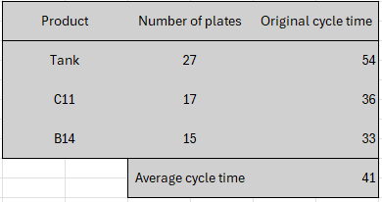
Figure 28 Cycle time.

I measured the cycle time of the 3 most popular products that are run on this machine. Each one performs the same process, with a different number of plates. Running in dry cycle they produced a consistent cycle time for each product. The average cycle time across all 3 products combined was 41 seconds. Can use this value to compare against once the upgrade is complete to help to determine the success of the project in terms of efficiency.

5. Installation

5.1. Pre-installation
Before beginning any installation, I wired up and tested the horizontal slide in the office. This allowed me to gain a better understanding of how the equipment worked and how it would be programmed. Even though I could only create a ‘dummy’ program, I was able to learn the correct wiring to allow it to function, ensure the correct input locations and how to modify inputs and outputs within the program, Doing this will have saved a large amount of time carrying out the actual installation on the machinery.cos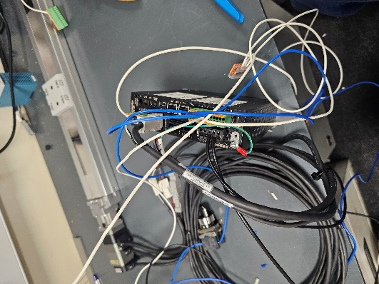
Figure 29 - Office setup
Figure 26 shows how I was able to set the equipment up in the office to ensure functionality. Wagos and a power supply were used as a temporary supply to power the drive. To ensure safety, I limited the movement of the actuator to just 50mm/s.
Ensuring the highest level of preparation before beginning the installation helped to ensure that the installation would run as smoothly as possible. Since there was a strict timeslot for me to conduct the work, anything that could be carried out beforehand would help to maximise efficiency of the installation.
Before mounting the linear slide, I screwed it to the backplate. This would allow me to ensure that there were no issues with alignment between the backplate and the linear slide. It would also allow me to connect the whole unit to the Encapsulator in one piece, saving time on the actual installation.
When attempting to bolt the linear slide to the backplate, I found that 2 of the securing bolt holes have been manufactured incorrectly. Approximately 3mm out of position. To rectify this, it was required to create a slot in the backplate and secure the linear slide with nyloc nuts. Carrying out this part of the installation in advance allowed me to rectify this issue before installation. This may have caused a large delay in the installation, preventing it from being completed within the timeframe allotted.

5.2. Process
Before commencement of any work, I ensured that the panel was correctly isolated by using my own personal lock out/tag out (LOTO) device. This precaution will ensure that myself and others are protected from accidental startup whilst I am performing my modifications. This lock remained in place until I was fully satisfied that the work was completed safely.

5.3. Removal of old pneumatic system
I began by removing the old pneumatic systems. The cylinder and back plate we removed using and Allen key and hex bolts. These will be kept in the storage area. If there are any issues with the install, then they can be re-attached to the machine. Alternatively, they can be used as spares for other machinery on site. The sensor block that is located on the back of the pneumatic back plate is still required as it is used for other sensors in the area (the positive and negative pick heads). This block will be re-secured back onto the new backplate when the installation is complete.
With the pneumatics removed, I was then able to attach the new servo linear actuator and backplate. This back plate was heavy, to safely install I asked for assistance lifting and holding it in place while it was secured. The backplate was carefully aligned to match the existing configuration and secured in place to allow for a stable foundation for the new components.
Once secured, I routed the required cables to their designated locations, ensuring proper cable management. These cables were then labelled for clarity and neatly routed through the electrical panel to allow for an organised and accessible system.
The new oriental motor servo drive was secured to the panel, with a 230v supply wired from the power supply, with a 6A MCB integrated into the system to provide adequate circuit protection.
Using the Manufacturers recommendations for the motor and drive, I determined that a 6a mcb and 1mm cable would be sufficient for power requirements as the motor would pull a maximum of 3.7a with a full load.
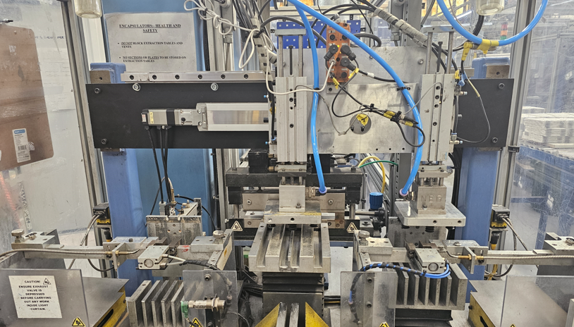
Figure 30 - Complete servo slide

5.4. Electrical wiring and configuration
The servo drive was wired in accordance with my updated electrical schematics and verified pin terminations. By labelling each cable accordingly (shown in Figure 31), it prevents any misconnection and will simplify future maintenance tasks. All numbering of cables also aligned with the electrical drawings to ensure continuity of processes.
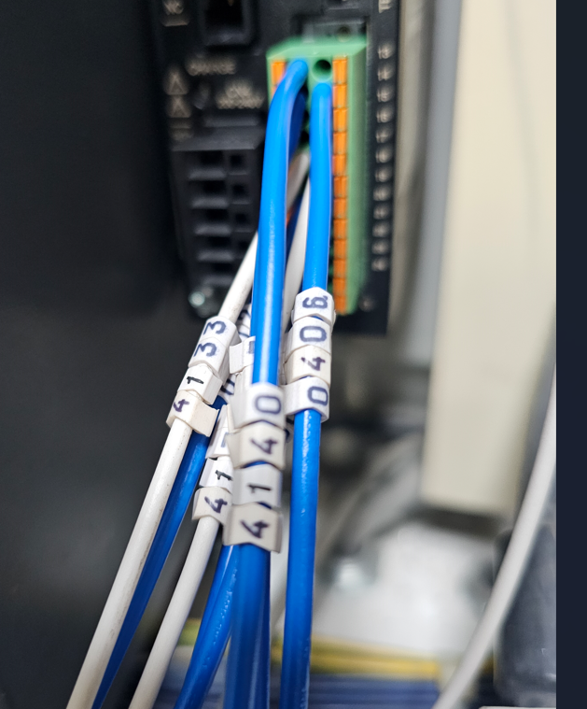
Figure 31. Cable labels
The start signal of the drive was wired through the safety system, this would ensure that the drive will cut out immediately if any safety protocol is activated.
The outputs were taken from the SLC 5/04 plc. This is an outdated/obsolete plc so connecting and maintaining it has proved troublesome in the past however since I had a working program with updated tags, I was able to identify which inputs and outputs were required for connection to the drive. The updated tag configuration allows me to easily identify the correct inputs and outputs required from the plc program.
With the drive correctly wired, I was able to plug in the connections to the servo motor. At this point I tidied up the cables so that they would not interfere with the testing, I permanently secured them once all the testing was complete. The wiring was the longest part of the installation, it was important to ensure that this was done correctly as improper wiring may have resulted in improper functionality.
Once the installation was complete, I was able to begin manual testing of the movement. I removed my LOTO lock and switched on the power. To ensure that there are no unexpected movements, I left the machine in manual mode, this would allow me full control over the process. Using the oriental motor software MEXE02, I connected my laptop to the drive using a USB cable.
By connecting the USB cable to the laptop and the drive I can read the data on the drive by selecting the correct USB port and pressing the ‘data reading’ button. Once reading is complete it will show all the drive information on the screen. With the original drive there is no current positions set, with all settings at default.
Using MEXE02, I can view information such as positive and negative limits, starting speeds, default acceleration and deceleration. All of these can be modified for each set position.
The monitor page allows me to view a real time monitor of the process, ensuring that all components stay within their limits such as current, temperature and speed. This information can be saved and used for future reference. This is ideal for diagnosis and machine improvements.

5.5. PLC and HMI download
To download my new, modified PLC program, I required the specific cable. Since there are no ethernet capabilities in the slc5/04, I used a 1784-U2DHP Allen Bradley cable.
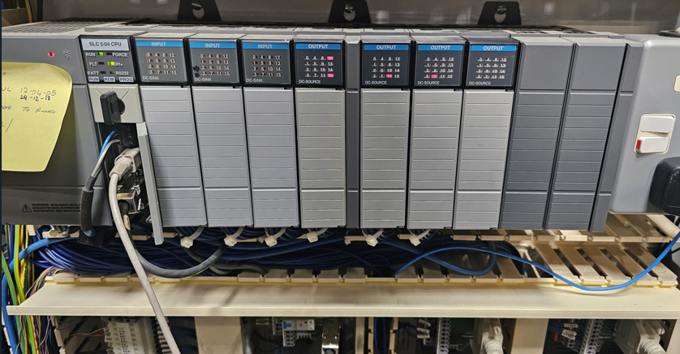
Figure 32 - Allen Bradley SLC 5/04 plc
Figure 29 shows the SLC 5/04 PLC that I required connecting to.
Once connection was established, I saved a copy of the current program as a backup before downloading my new program. This version successfully downloaded with minimal issues. I followed a similar procedure when downloading the new HMI program, with a copy of the original file kept as a backup. Since older PLC’s and HMI’s require separate software, Logix 500 was used for the PLC, and Panelbuilder32 was used for the HMI.

5.6. Manual movements
To manually test the movements of the slide, I use the teaching mode within the software. This allows me to move in both directions at a predetermined speed to ensure that it moves smoothly. I can slowly increase the speed until it moved at a speed that would suit the process. The linear slide moved smoothly in both directions, indicating that the wiring to the power signals was correct.
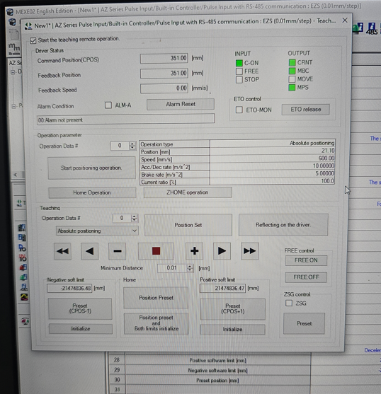
Figure 33 - Manual movements
Figure 22 - Manual movements shows how I was able to set my positions, I used the teaching page to move the servo to the correct positions, once in the correct location, I can set this position to one of the values within the program. This can then be called from the plc whenever required. To determine the correct positions, I aligned the positive and negative positions with the centre of each positive and negative stepper. This would ensure that no matter what product is run, it would pick the plate up centrally each time.
The software allows for 3 methods of calling positions, by digital inputs, rs485 or by ethernet/IP. Since I am using an outdated plc that does not support ethernet, I chose to use digital inputs. Via digital input, the oriental motor allows you to call up to 512 different positions using different variations of the 9 digital inputs.

5.7. Setting feedback to plc
Instead of using external sensors to send a signal back to the plc when the linear slide has reached its correct position, I am using internal feedback from the drive. This will have a quicker response time and be much more accurate than an external sensor. The drive allows me to decide my own tolerance of the positions, allowing set points of +/- 0.01mm. If the motor were to drive the slide out of these positions, then it would not send the ‘at position’ input to the PLC, preventing the machine from continuing. This would help to ensure the precision of the process.
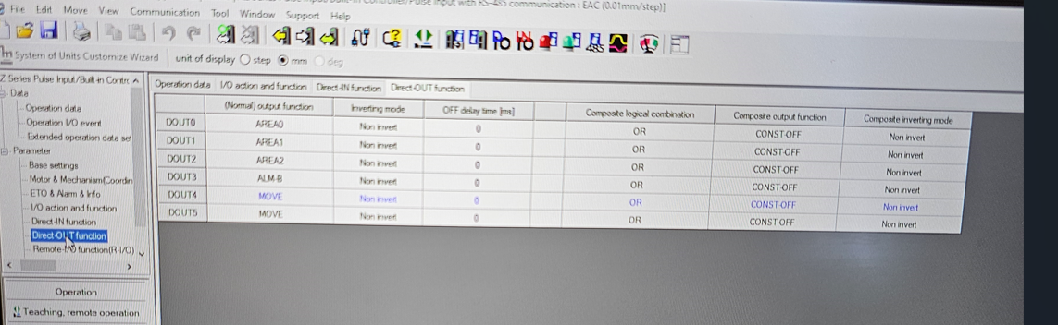
Figure 34 - Setting outputs
To achieve this, it required that I program the outputs via the Mexe02 software. Figure 29 shows the setting out outputs within the software, this allowed the drive to send a signal to the PLC once is has reached specific positions, allowing the PLC to continue with its cycle. This allowed me to assign a digital output for each position. Once it reached its desired position, it would send a 24v signal to the PLC. Using the software, I was able to monitor the outputs, ensuring that the correct outputs were activated when it reached each position. Once this was correctly calibrated, I was then able to test the functions in auto mode.
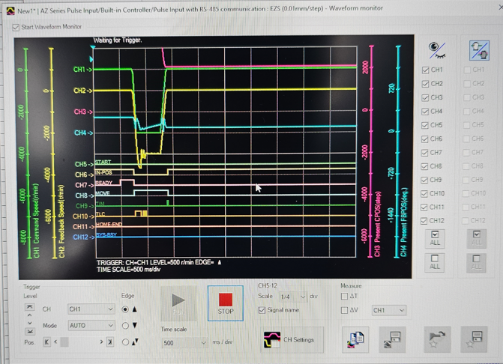
Figure 35 – monitoring
Figure 23 – monitoring shows how the software now allows the ability to monitor the movements of the servo slide. When preset positions have been activated, they will appear on the chart as a waveform. This type of monitoring can be recorded and stored in future to help to improve our quality and traceability of the product.
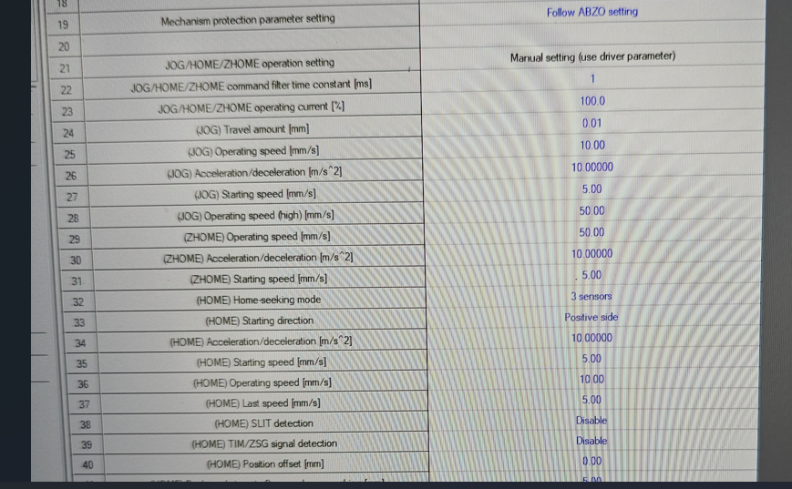
Figure 36 – Jogging
Figure 24 – Jogging displays my settings to carry out the jog function. This allowed me to set all the positions for jogging the linear slide. These include, jog speed, acceleration, and deceleration. The ability to jog the linear slide to any position allows the user more control over the process.

5.8. Testing in automatic
Before moving into engineering, I worked as an operator, specifically on the Dane Encapsulator. I learned how to competently run the machine without any assistance. This meant I was able to safely operate the machine without the need for operators. This was a benefit as I was able to also test all the safety aspects of the machine myself without endangering anyone.
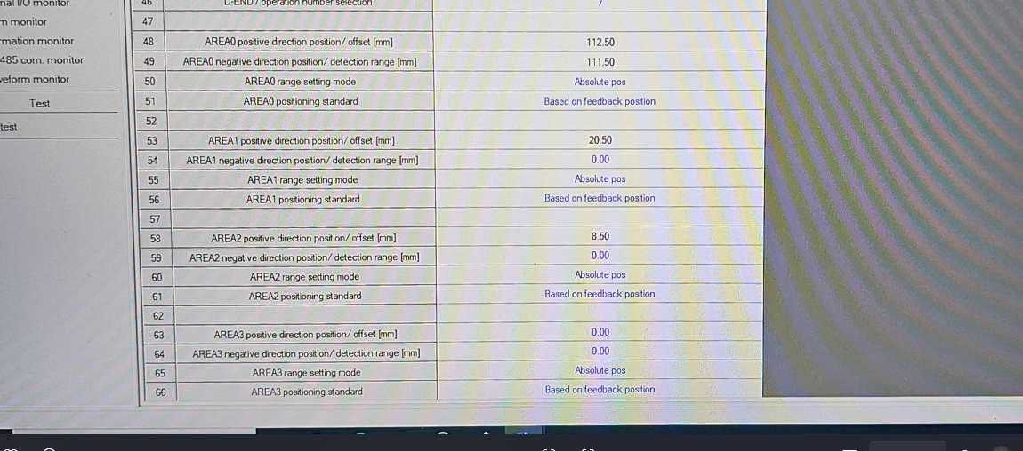
Figure 37 - Position tolerances
Figure 32 shows how I was able to set the tolerances within the program. Reducing the tolerances slowly through testing allowed me to find a setting that would allow the machine to continue running without any issues while improving the accuracy of the output.
When I was confident that the positions in the program were set correctly, I used the download function within the software to download everything to the drive. With the parameters set. I started up the machine in dry cycle. This means that the program will run the linear slide without picking up any product. This was a suitable test to ensure the safety and effectiveness of the upgrade.
Originally, I set all the speeds to 200mm/s. This allowed me to run the machine slowly to ensure that it functioned correctly. I used a permanent marker to mark both the backplate and the linear slide in the same position. This would allow me to see any movement/play in the motor. At 200mm/s, the motor performed as expected. This allowed me to increment the speeds slowly by 100mm/s.
The motor is capable of running at 700mm/s however, when I tried at this speed, I found that the motor would stall regularly when trying to slow down. This may be because of the short distance that it is moving, potentially not being able to generate enough acceleration before it needed to decelerate again. Eventually, I found that 600mm/s was an optimum speed, this was still much faster than the original pneumatic cylinder driven equipment. On a dry cycle I ran this for approximately 20 minutes continuously, monitoring the current and temperature on the software to ensure that it didn’t exceed any limits.
By increasing the deceleration value within the software, it will allow the motor to stop quicker. For the safety of the operator, it is important that the motor stops immediately when the light guard is broken. If the deceleration value is raised too high however, then it may put unnecessary stress on the motor, causing damage, failure, or unexpectedly high current. Assessing the process to ensure that a suitable value was identified was vital to ensuring both safety of the operator and longevity of the components.

5.9. Safety system
The safety system within the Dane Encapsulator operates via a contactor within the electrical panel. When either the light guard, door or e-stop is activated, it will shut off the contactor and remove all power from the equipment, preventing it from moving, with all components stopping immediately. This contactor is shown in Figure 37.
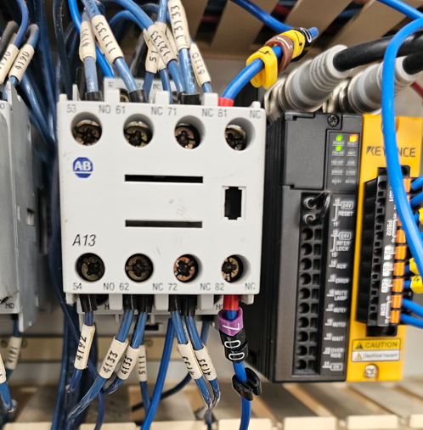
Figure 38. Safety circuit
To ensure that the motor functioned as required when the safety system was activated, I broke the light guard multiple times. Originally when I did this, the motor disengaged but the linear slide continued to move slowly under its own momentum, coming to a slow stop. This was unacceptable as safety systems should ensure that all components come to an immediate stop. To rectify this, I had to re-trace my wiring. Eventually I found a fault in the wiring which meant that the input signal to the drive was dropping out as expected, however the braked were not engaging. This means that the motor was stopping but the brake was not allowing the motor to stop immediately. Once I corrected the wiring, I tested the process again and it stopped as it should. As extra checks, I check the process when pressing both the e-stop and opening the door, I was satisfied that the linear slide was functioning correctly.
To ensure that I have not missed anything, multiple other people carried out checks on the safety system. These included maintenance, health and safety and process engineer.

5.10 Automatic cycle
With the system tested to ensure safety, and the speeds and precision functioning correctly, I began to evaluate the process by building product. When running in automatic, I found that the pick heads were picking up plates slightly off-centre. To rectify this, I moved the positions slightly using manual functions within the software and reset the new positions. This was done multiple times until I was satisfied with the pickup positions While watching this process, I could already see a marked improvement in the speed. I ran this for approximately 1 hour myself before passing onto an operator to continue to test. I continued to monitor it for the remainder of the day to ensure that there were no issues. The machine ran well, with no issues related to the new installation.

6. Monitoring

6.1. Mexe02 improvements
Programming the mexe02 software allows for multiple performance monitoring improvements. Using the software, we are now able to monitor large portions of the process. If there are any faults, then the software will make us aware of the fault and offer us multiple solutions to rectify any issues.
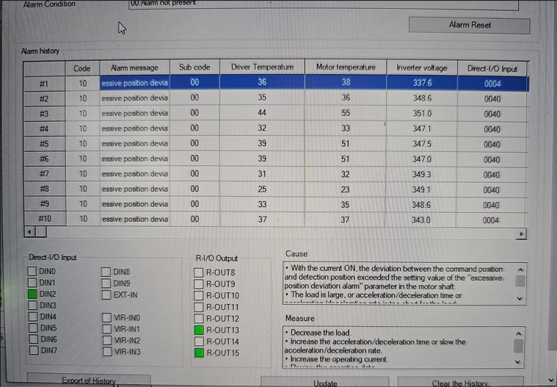
Figure 39 - Error messages
Figure 24 - Error messages shows an example of an error message. When I manually jogged the linear slide past its tolerance, it showed up as a deviation alarm. The software informs me of the alarm and also offers measures to rectify the issue.

7. Conclusion

7.1 Monitoring improvements
I originally determined that the success of the project would be decided based on the following criteria:
- Performance
- Precision
- Cost
- Safety
- Feedback from operators
Performance -The supervisors monitor the numbers produced from each machine at an hourly rate. Depending on the product being built operators can be expected to produce up to 100 sections per hour. Over the next week, this machine has comfortably built an average of 110 blocks per hour, this means that over a 7-hour period (1 shift after breaks), the machine is now producing an average of 70 more sections per shift.
Using these values to calculate savings, with the product ‘C11’ as an example, the Dane Encapsulator were originally expected to produce a section every 36seconds (this considers such stoppages as paper change, material changes etc), With the new changes, the machine is now averaging a section build every 32.5 seconds, this shows an average improvement of 3.5 seconds per section.
On a production scale, this means that with 6 sections per battery, the company can now produce an extra 10 batteries per shift just off this machine alone, with an average battery cost of £200, this is a significant improvement.
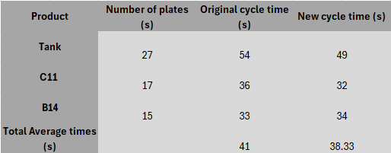
Figure 40. New cycle times
On average across the 3 main products, the cycle time per section is now 38.33seconds (Figure 39). This is a significant saving, showing the success of the installation, allowing the company to produce greater volumes of product in a shorter space of time.
Precision - Using the same data sheets, the operators continued to monitor the number of teardowns conducted throughout the shifts. The feedback showed that there was a significant reduction in the amount of scrap due to alignment issues in the jigs. The example shown in Figure 5 - Teardown count reports 56 scrap due to alignment. The new data shows that this is now as few as just 3-4 per shift. This information shows a marked success in improving the precision of the process.
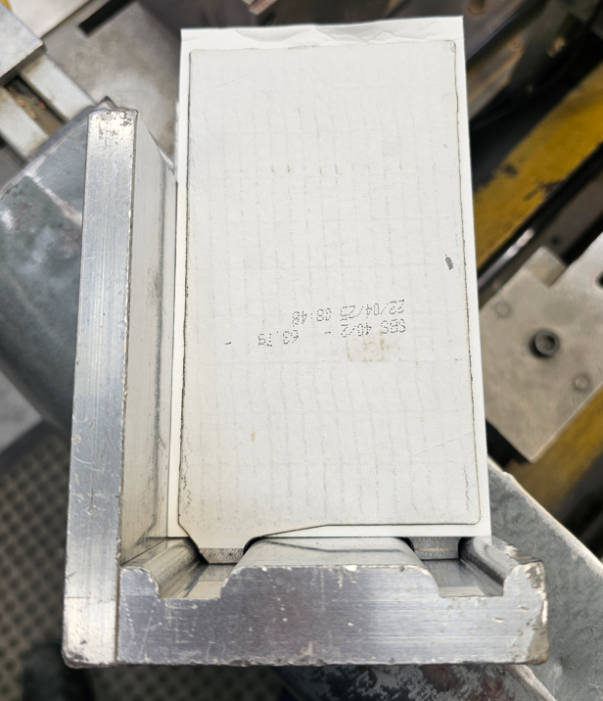
Figure 41. Complete section
Figure 38 shows the complete section. The section fits perfectly into the jig, showing a good section to be processed. The tabs sit in their grooves and the plate is central to the paper. The ability to repeat this positioning for each plate and section shows an improvement in the precision and repeatability of the process
With a significant increase in efficiency of production, along with the reduction in scrap/teardowns, I have met the main criteria of my project.
Cost -The overall cost of the project was comfortable under the budget of £3000. This was important as management are keen to roll out the improvements to other machinery within the department in the near future.
Safety - The wiring was kept in line with the current safety protocols within the machine. When any of the safety doors or light guard were activated, the brake would engage, and the drive would also lose its run signal. This ensured that the motor would not move unless under controlled circumstances. I tested this to ensure that’s it worked correctly, also health and safety and maintenance personnel also tested this as a precaution.
Feedback – The feedback from operators has been largely positive. The ability to produce a larger volume in a shorter space of time allows them greater flexibility with their jobs. If there are no other issues across the department, then they are capable of producing a larger number of blocs per shift, however, even with issues, they are now able to catch up and minimise disruption to overall targets.
Management have also seen the benefits to the installation. With the obvious improvements to speed and reduction in scrap, they are now requesting that I continue these improvements across other machinery.

7.2 Project success
The overall project was a considerable success, offering multiple improvements to the machine, while also replacing old technology with newer, more familiar equipment. Visually, the improvements to the machine are easy to see for management and operators, with the data feedback also showing a physical display of the improvements.
By using methods that I have learnt, such as creating Gantt charts, FMEA and project design specifications, I have been able to ensure that I stayed in control of the project at all times, with the Gantt charts ensuring that I never fell behind with any part of the project.

7.3 Future improvements
There are multiple improvements that I will look at carrying out to the machine in the future that can continue to improve the safety, precision, and efficiency of it. As mentioned, I will look at incorporating an improved safety system. Even though the current setup is suitable, improving the system will ensure the continued safety of the operators and the process.
Other areas of the process that can improve the efficiency of the machine is on the stepper drives. The drives that are currently in use are over 30 years old and use obsolete drives and software. Upgrading these to use oriental motor and drives will not only improve the speed of the process, but standardise the drives across the whole machine, allowing for easier maintenance. This will also help to improve the monitoring process of the machine.

8. Reflection
What would I have done differently.
Upon reflection, there are multiple areas that could have been improved upon. The current safety system within the machine is based on standard contactors, I would like to improve this to incorporate safety relays. This will offer a much greater amount of safety across the machine, not just with my improvements.
I would have preferred to have more time to perform the installation. Although the installation was complete within the agreed timescale, I felt ‘rushed’ at certain times to ensure that there would be no delay to production. Ideally, an extra shift to conduct final work and testing would have been beneficial.

9. References

[1] | H. Ali, “A review of pneumatic actuators,” 01 2009. [Online]. Available: Researchgate.net/publication/223260423_A_Review_of_Pneumatic_Actuators_Modeling_and_Control.
[2] | Airtac, “6 Common Problems in Pneumatic Systems,” 07 2022. [Online]. Available: https://www.linkedin.com/pulse/6-common-problems-pneumatic-systems-how-fix-them-.
[3] | P. Harris, “Energy optimisation of pneumatic actuator systems in manufacturing,” 06 2014. [Online]. Available: https://www.sciencedirect.com/science/article/abs/pii/S0959652614002327.
[4] | M. A. Baballe, “Different Types of Servo Motors and Their Applications,” 05 2022. [Online]. Available: https://d1wqtxts1xzle7.cloudfront.net/86342857/SERVO-libre.pdf?1653302483=&response-content-disposition=inline%3B+filename%3DDifferent_Types_of_Servo_Motors_and_Thei.pdf&Expires=1738353577&Signature=dorF7LYPzN4R8~tdTVbI-REcxsl5~oQbsML~HCn5OIN3j5SN-3R2~Qi5.
[5] | M. Pellicciari, “Increasing position accuracy and energy efficiency of servo-actuated mechanisms,” 08 2015. [Online]. Available: https://ieeexplore.ieee.org/abstract/document/7294284.
[6] | N. Cheung, “An innovative method to increase the resolution of optical encoders in motion servo systems,” 07 2002. [Online]. Available: https://ieeexplore.ieee.org/abstract/document/792808.
[7] | Rise, “Controls upgrade vs new machinery,” 2024. [Online]. Available: https://www.riseautomation.co.uk/post/machine-upgrade-vs-controls-upgrade.
[8] | M. Keefe, “Introduction to Servo Motors for Industrial Applications,” 09 2023. [Online]. Available: https://www.kebamerica.com/blog/introduction-to-servo-motors-for-industrial-applications/.
[9] | S. Autsou, “Principles and Methods of Servomotor Control: Comparative Analysis and Applications,” 03 2024. [Online]. Available: https://www.mdpi.com/2076-3417/14/6/2579.
[10] | Rise, “Controls Upgrade vs New Machinery,” 12 2024. [Online]. Available: https://www.riseautomation.co.uk/post/machine-upgrade-vs-controls-upgrade.
[11] | C. Beck, “Fixing a machine vs buying a new one,” 04 2020. [Online]. Available: https://www.manufacturingmanagement.co.uk/content/features/fixing-a-machine-vs-buying-a-new-one/.
[12] | D. Jaspert, “Smart retrofitting in manufacturing: A systematic review,” 08 2021. [Online]. Available: https://www.sciencedirect.com/science/article/abs/pii/S095965262101773X.
[13] | R. Jagarajan, “Green retrofitting – A review of current status, implementations and challenges,” 2017. [Online]. Available: https://www.sciencedirect.com/topics/engineering/retrofitting-action.
[14] | D. St-Onge, “When to Upgrade, Migrate, or Replace,” 2014. [Online]. Available: https://www.controleng.com/when-to-upgrade-migrate-or-replace/.
[15] | M. A. Baballe, “Different Types of Servo Motors and Their Applications,” 05 2022. [Online]. Available: https://www.researchgate.net/publication/360781666_Different_Types_of_Servo_Motors_and_Their_Applications.

