STUDENT NAME: Halema Khatun
STUDENT NUMBER: 1808827
MODULE CODE: BMSW6102
MODULE NAME: Developing Innovation and Creativity for Business Advantage

INNOVATIVE PRODUCT PLAN
ONE-CLICK ASSISTANCE

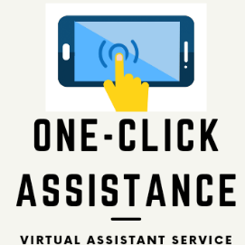

LECTURER: Dr Md Nazmul Hasan
Contents
1. DESCRIPTION OF THE INNOVATION SERVICE OFFERED 3
1.2 TARGET CLIENTS 4
1.3 LOCATION 4
1.4 COMPANY NAME 5
1.5 SUSTAIN INNOVATIVE PROCESS 5
1.5 COMPETITORS 6
2. E-COMMERCE 6
2.1 AIMS AND OBJECTIVES OF WEBSITE 6
2.1 PAYMENT METHODS 6
2.2 GDPR 8
3. MARKETING STRATEGY 8
3.1 GOOGLE ADS AND FACEBOOK 8
3.2 EMAIL 9
3.3 LINKEDIN 9
APPENDIX ONE – SWOT ANALYSIS 10
APPENDIX TWO – WEBSITE HOMEPAGE 11
REFERENCE LIST 12

DESCRIPTION OF THE INNOVATION SERVICE OFFERED
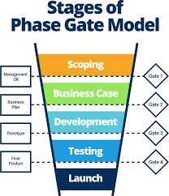
With a global pandemic causing many employees to switch to remote working, firms were forced to send their staff home, which meant a lot of work was done online. As a result, there was a potential market gap for a service innovation that is an online assistant to provide a wide range of support services to businesses, such as administrative tasks, social media management, project management, and a variety of other tasks that may be required, all of which can be done remotely. This is where the concept was developed and using the Stage- Gate model the idea was then investigated to see if it would pass each stage to be developed into a business model. It is a project management technique, in which an initiative or project takes place, divided over several stages. The stages technique breaks new product development projects into five phases – scoping, business case creation, development, testing and validation, launch phase. These stages are separated by so-called gates. The decision points for whether to proceed to the next stage. (Gronlund, 2010).
Source: Smartsheet (Eby, 2019).
A Virtual Assistant (VA) is an independent contractor who provides professional services from a remote location which is an e-commerce business, e-commerce is the platform upon which new methods to sell and to distribute innovative products and services electronically (Reynolds, 2004). As a virtual assistant company, we will be offering a remote service for clients who will provide administrative services as well as specialist support to those who require this such as small businesses or entrepreneurs. The services offered will include data entry, scheduling, book management, transcription and typing, social media management and document production, the services will be monitored and dependant on the use and requirement other services will be added. The aim is to save small businesses time and money on outsourcing jobs that would otherwise need permanent staff to carry out without having to recruit new staff, so you only pay for the time that you use. This will enable executives to free up time and delegate mundane tasks to the VA and therefore will free up time to get on with other tasks and will allow extra time for leisure.
This service allows businesses to hire a virtual assistant on an as-needed basis rather than committing to a long-term contract, which would require employers to provide benefits such as holiday and sick pay, which are not required when hiring a virtual assistant. Ultimately, this saves the organisation money and time by eliminating the need to go through recruitment processes, which can be costly and time-consuming if done externally.

1.2 TARGET CLIENTS
Almost any industry these days are using virtual assistants as a lot of work is being done online from doctors to lawyers are all using VA assistance to make work life easier to ease the workload and reach those targets or deadlines ultimately increasing their profit margins. Knowing your target customers helps as a company to identify where best to promote and advertise to offer our services. To better understand the market and identify those potential customers a SWOT analysis (appendix one) was done to analyse the micro and macro environment that will affect the business. Analysing your strengths, weaknesses, opportunities, and threats (SWOT analysis) is simple, yet powerful, and will help you develop your goals and marketing strategies (Sarsby, 2016).

1.3 LOCATION
The service will be offered online only and will be done remotely from the home office using a laptop or even smart phone depending on the task at hand. This is what is the best thing about being a virtual assistant is the capability of working from home or anywhere you have a good internet connection. Remote working saves time and money as you do not need to travel to work and allows you to set your own schedule. The percentage of workers permanently working from home is expected to double in 2021, according to a survey from Enterprise Technology Research (ETR). “The productivity metric is proving that remote work is working,” said Erik Bradley, chief engagement strategist at ETR (Castrillon, 2020).

1.4 COMPANY NAME
As a company we want to stand out from the rest with a simple yet catchy name which can easily point out what the company is about and stands for. After a lot of debate and brainstorming to find the right name for the company, One-Click Assistance stood out as this is what our company is about with one click you will find help and assistance with whatever job you need help with. The idea is that this will become a brand and be well known for when anyone needs a virtual assistant, they will look up One-Click Assistance and will not need to go anywhere else, as we develop, we will offer all specialist virtual services possible.

1.5 SUSTAIN INNOVATIVE PROCESS
Sustainability business strategy is the integration of economic, environmental, and social aims into a company’s goals, activities, and planning, with the aim of creating long-term value for the firm, its stakeholders and wider society (Long, 2020). Creating a sustainable business strategy will give the company a competitive advantage and potentially the company will grow and be successful in the long term if the sustainable practices are put in place. As an online business less paper will be used, no packaging which means less waste so this will have a good impact on the environment, no offices are required so less energy is being used compared to having a big building to work from.
As an ecommerce business creating an online ethos that reflects how important sustainability is for us will attract clients to us as they will want to work with a company that is concerned about the environment, stakeholders, and community as well as the economy because of course the company must also think of their own viability and profit to stay in business. To sustain the business, we will be using the SCAMPER model to improve and develop the services that are offered as the business grows or even remove aspects that are not working. The SCAMPER technique, for one, uses a set of directed, idea-spurring questions to suggest some addition to, or modification of, something that already exists, (Serrat, 2017). The changes that SCAMPER stands for are:
- S—Substitute (e.g., components, materials, people)
- C—Combine (e.g., mix, combine with other assemblies or services, integrate)
- A—Adapt (e.g., alter, change function, use part of another element)
- M—Magnify/Modify (e.g., increase or reduce in scale, change shape, modify attributes)
- P—Put to other uses.
- E—Eliminate (e.g., remove elements, simplify, reduce to core functionality)
- R—Rearrange/Reverse (e.g., turn inside out or upside down)

1.5 COMPETITORS
According to Research and Markets (2021) the publisher has been monitoring the virtual assistant market and it is poised to grow by $4.12 billion during 2021-2025, progressing at a CAGR of almost 12% during the forecast period. It is important to market our company to stand out from the competition. It is important to create a competitive advantage to survive in the market and to do this we will need to offer services that others are not providing for example we will be offering specialists services such as virtual assistants who can take on tasks like software developing or experts in managing projects using software like Trello or Agile. We will also be offering a service that will be available 24/7 so clients can access a virtual assistant anytime they need one and we will aim to provide a quick response to any enquiries. Providing this kind of support efficiently will show how professional the company is and will outperform the competitors and help clients to reach their goals. Knowing who your competitors are, which market segment/audience they are targeting, and their marketing activities allow you to learn from them (Cleaver, 2020). This research will give us the advantage of knowing what the competitors are offering and what we can do different to gain the competitive edge.

E-COMMERCE

2.1 AIMS AND OBJECTIVES OF WEBSITE
Our service will be provided online on the website that has been created for the company and options will be available for our clients to choose what they require. The website has been created on Wix which is a free website builder which is great for a start-up as it saves money in the first instance and as we progress and make a good turnover, we can investigate using professional websites. On the homepage (appendix two) the services that are offered will be displayed and clients can navigate their way through and click on the options that they require. They can choose whether they need an expert with a specific skill or just someone to do administrative tasks and will have many options to contact us through email, phone, chatbot and we will aim to give an instant reply. Clients will have the option to have a free trial to try out an VA and of course if they meet their needs this will lead on to permanent contracts. The aim of the website is to make it user friendly, easy to navigate round and allow users to make quick selections without getting confused.

2.1 PAYMENT METHODS
There will be the option for clients to pay online using a debit card, credit card or can pay through PayPal, these options will give the clients peace of mind that they can make secure online transactions. They will be given the confidence that there card numbers and email addresses for PayPal are stored correctly using highly advanced online security and we will do this by ensuring that we have implemented SSL protocol on our website which will encrypt sensitive information that goes through the website such as credit cards numbers. Additionally, the lock symbol obvious within the URL bar that leads to the web address which starts with https tells clients that the site is secured and secure to utilise. This develops the company’s online notoriety, moves forward brand mindfulness and builds the organisations credibility (Dodson, 2016).
As we will be accepting payments on our website, we shall also need to be PCI DSS compliance as this is a set of regulations which has been set by the major credit card brands which require organisations to comply with twelve general data security data requirements which Chuvakin & Williams (2011) suggest as the following: -
- Protect your system with firewalls.
- Configure passwords and settings.
- Protect stored cardholder data.
- Encrypt transmission of cardholder data across open, public networks.
- Use and regularly update anti-virus software.
- Regularly update and patch systems
- Restrict access to cardholder data to business need to know.
- Assign a unique ID to each person with computer access.
- Restrict physical access to workplace and cardholder data.
- Implement logging and log management.
- Conduct vulnerability scans and penetration tests
- Documentation and risk assessments
As a service provider our website will store, process, and transmits card holder data it is important for the company to abide by these regulations to gain the confidence of clients and show that the company is trustworthy.

GDPR

The GDPR expands the scope of data protection so that anyone or any organisation that collects and processes information related to EU citizens must comply with it, no matter where they are based or where the data is stored (tankard, 2016). We will need to comply with the GDPR requirements as a company, hence we will take steps to become GDPR compliant and ensure that our platform aids GDPR compliance by ensuring that we have the appropriate level of security. GDPR requirements will be at the front of mind in the collection, processing and storing of confidential data. We recognise that as a data controller, we have several responsibilities under GDPR, and we must undertake full responsibility for ensuring that the company follows GDPR guidelines. As a result, we will implement GDPR-compliant privacy policies, notices, and terms and conditions, as well as GDPR training for our employees.

MARKETING STRATEGY
To be visible to potential clients it is crucial to promote the business and get it out there to reach those potential customers and for the survival of the business. Therefore, it is necessary to have a clear marketing plan so that you can identify the target market, attract potential clients, and retain these as paying clients. When describing the basics of marketing strategy Drummond et al. (2001) identifies the concept of marketing as being inherently simple – business success through a process of understanding and meeting customer needs.

3.1 GOOGLE ADS AND FACEBOOK
The marketing strategy that we will use firstly is the website and make it available on Google Ads so when people search for virtual assistants our company is one of the first to flag up. Secondly, we will have a Facebook business page which is totally free to set up and can potentially reach thousands of people. By creating an ad campaign and advertising our services on the page can have the potential to reach potential customers, we can also boost the campaigns by paying Facebook to reach even more customers. However, this can also be done for free by adding friends or other business pages and sharing the page and staying active and posting regular updates about the services on offer will increase the customer reach and raise awareness.

3.2 EMAIL
As an e-commerce business it is important to have a good customer relationship to hold on to customers, effective relationship development can lead to positive word of mouth recommendations and business referrals (Wood, 2006). It is essential that clients should be able to contact the company when they have any enquiries through email and these details will be stored on to the database. Consequently, we can use client email addresses to send out advertisements for any current specials or special offers to attract more consumers to hire virtual assistants.

3.3 LINKEDIN
As we are offering a professional service we will sign up to LinkedIn as it is the hub of professionals, and we can showcase what we offer here to other professionals as it is a social network that focuses on professional networking. After creating an individual or a company profile page with a structure similar to a CV/resume, LinkedIn members can use the network services for connecting with colleagues, professional networking, job searching, recruiting and job posting, providing company information to prospective employees, and joining groups of users who share common professional interests and educational backgrounds (Kostov, 2020). The business can potentially reach millions of people who are our target market such as other entrepreneurs and small businesses who maybe looking for virtual assistants. This will be a fantastic opportunity for the company to get new clients and grow and develop the company to profit financially and create the brand awareness.

APPENDIX ONE – SWOT ANALYSIS
STRENTGHS | OPPORTUNITIES
Specialist skills in I.T, software such as Microsoft Office and Cloud systems  Personal Assistant experience  Knowledge of quality processes such BA and ISO standards  Time management  Professionalism  Reliability  Competitive pricing  Home office | A developing market  Potential to expand and offer services globally.  Team building  Job opportunities  Networking  Developing technology
WEAKNESSES | THREATS
Web development  Lack of marketing expertise  Social media marketing  Lack of technical skills  Lack of physical presence with clients | Outpriced by competitors.  Reputation  Too many virtual assistants

APPENDIX TWO – WEBSITE HOMEPAGE
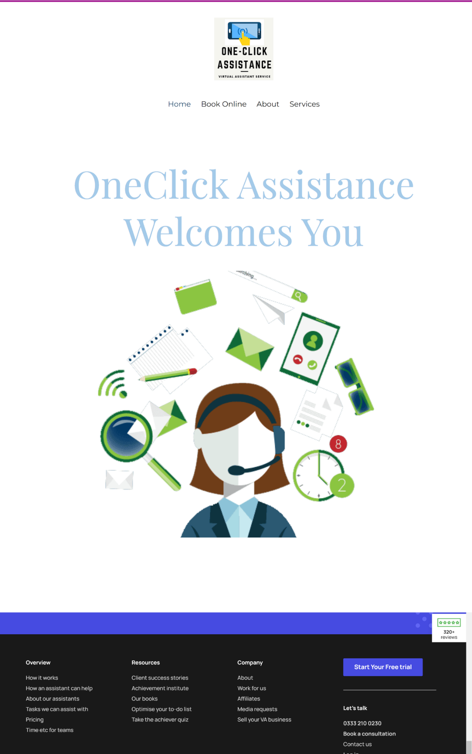

REFERENCE LIST

Castrillon, C., 2020. This Is the Future of Remote Work In 2021. [online] Forbes. Available at: <https://www.forbes.com/sites/carolinecastrillon/2021/12/27/this-is-the-future-of-remote-work-in-2021/?sh=6304176f1e1d> [Accessed 20 July 2021].
Cleaver, A., 2021. Virtual marketing assistants and outperforming competition. [online] AVirtual. Available at: <https://avirtual.co.uk/beating-your-competition-by-using-a-virtual-marketing-assistant/> [Accessed 10 July 2021].
Dodoson, I, 2016. Art of Digital Marketing: The Definitive Guide to Creating Strategic, Targeted and Measurable Online. Hoboken: John Wiley.
Drummond, G., Ensor, J. and Ashford, R., 2001. Strategic Marketing: Planning and Control. 3rd ed. Oxford: Elsevier.
Eby, K., 2019. Ultimate Guide to the Phase Gate Process | Smartsheet. [online] Smartsheet. Available at: <https://www.smartsheet.com/phase-gate-process> [Accessed 10 July 2021].
Grönlund, J., Sjödin, D. and Frishammar, J., 2010. Open Innovation and the Stage-Gate Process: A Revised Model for New Product Development. California Management Review, [online] 52(3), pp.106-131. Available at: <https://journals.sagepub.com/doi/pdf/10.1525/cmr.2010.52.3.106?casa_token=ut_NAQ2w_yoAAAAA:Mb1E9rkZlD47U677m9-srQUMnBZ4NmGpG1_N5ogjRz9SdZ7lIHfC4KtUU6gsIkZ_0HC7ic_PHJk> [Accessed 5 July 2021].
Kostov, C. 2020. LinkedIn. In: Debra L. Merskin Editor, 2020. The SAGE International Encyclopaedia of Mass Media and Society, Thousand Oaks, CA: SAGE Publications, Inc. pp. 961-962 Available at: <http://www.doi.org.ezproxy.uwtsd.ac.uk/10.4135/9781483375519.n370> [Accessed 19 Jul 2021]
Long, T., 2020. Sustainable Business Strategy. [online] Available at: <https://www.researchgate.net/publication/332414437_Sustainable_Business_Strategy> [Accessed 14 July 2021].
Markets, R., 2021. Global Virtual Assistant Market (2021 to 2025) - Featuring Alphabet, Amazon and Apple Among Others. [online] GlobeNewswire Newsroom. Available at: <https://www.globenewswire.com/en/news-release/2021/04/23/2215996/28124/en/Global-Virtual-Assistant-Market-2021-to-2025-Featuring-Alphabet-Amazon-and-Apple-Among-Others.html> [Accessed 17 July 2021].
Reynolds, J., 2004. The Complete E-Commerce Book. 2nd ed. CRC Press, p.141.
Sarsby, A., 2016. SWOT analysis. Spectaris Limited.
Serrat, O., 2017. The SCAMPER Technique. Knowledge Solutions, [online] pp.311-314. Available at: <https://link.springer.com/chapter/10.1007/978-981-10-0983-9_33#citeas> [Accessed 15 July 2021].
Tankard, C., 2016. What the GDPR means for businesses. Network Security, [online] 2016(6), pp.5-8. Available at: <https://www.sciencedirect.com/science/article/abs/pii/S1353485816300563?casa_token=7wqEJxmewJUAAAAA:QVz8AAjxe9mESbUOOBshFrlK5HHkwjDZoUgJk9LASNNd6zWCC8DwhtHqTVKur-XRAz-sqqJaPg> [Accessed 23 July 2021].
Williams, B. and Chuvakin, A., 2011. PCI compliance. Ukraine: Elsevier Science.
Wood, G., 2006. CIM Professional Diploma in Marketing. Butterworth-Heinemann, p.45.

