Digital Skills and Research Methods
Assessment 2
Name: Violeta Ivanova Vasileva
Student number: 2113478
Lecturer’s name: Asim Satti
Individual Report

Word count: 2,052

Table of Contents

1.0 Introduction 3
2.0 Project Report 4
2.1 Methodology 4
2.2 Results 5
2.2.1 Secondary Research Results 5
2.2.2 Primary Research Results 6
2.3 Discussion 99
3.0 Conclusion 10
4.0 References 11
Appendix 1: Questionnaire 12

1.0 Introduction
This report is focused on the importance of using digital learning, specifically by looking at the use of a Virtual Learning Environment (VLE) at the university level. A VLE is defined in simple terms as a platform used by educational institutions to allow students to get their educational content online, whether they are using desktop computers or mobile devices like mobile phones or tablets (Evans, 2020). A VLE is useful for both the teachers and the students since it is a space that facilitates both teaching and learning (Firefly, 2021). In this report, the focus is on the benefits of using a VLE from the learning perspective, specifically since the key aim of using a VLE is to improve existing educational practices (Firefly, 2021). For example, by providing a single place in which educational information and resources are aggregated, the VLE is an extended space for learning over and above the physical learning environment (Evans, 2020). This benefits students when they are studying because it gives them access to the necessary materials in one place and thus it is argued that VLEs can improve student outcomes (Evans, 2020).
This report aims to examine the impact of having a VLE, specifically Moodle, on students' learning experience at the University. To achieve this aim, there are three objectives of the research:
- To discuss the methodology used for collecting and analysing the data
- To use the secondary and primary data collected to address the research aim
- To discuss these results to determine the impact of having a VLE on students’ learning experience at the University.
The rest of the report is divided into two main sections to address these objectives, beginning with the discussion of the methodology and then the presentation and discussion of the research results. The report ends with a brief conclusion.

2.0 Project Report

2.1 Methodology
For this research, both primary and secondary data were collected and analysed. Secondary data collection is about using research that has already been published for other purposes to shed light on the current research aim (Saunders, Lewis and Thornhill, 2019). For this research, the secondary data was collected from published material on the impact of VLE on students' learning experience in general. Academic articles were used to obtain high-quality data, especially because one of the disadvantages of using secondary data is that the researcher does not have the full information on the quality of the original data included (Saunders, Lewis and Thornhill, 2019). Using articles that are previously reviewed increases the trust in the quality of the data. For this research, five articles published from 2011 to 2021 were found by searching EBSCOHOST, specifically identifying articles that dealt directly with the impact of VLE on students' learning experience in the United Kingdom (UK) and especially using the Moodle platform.
Primary data collection is about collecting data directly, rather than relying on previously published data (Saunders, Lewis and Thornhill, 2019). The primary data collection aims to help examine the impact of having a VLE, specifically Moodle, on students' learning experience at the University). For this research, a questionnaire was used to collect the data by conducting a survey face-to-face of students in University A (the questionnaire is in Appendix 1). A total of 10 short multiple-choice questionnaires were distributed and 7 were returned. The students were all from the Business Management Department, 5 of them were male and 2 were female, and all were in the age range from 25 to 30 years. The survey results are presented in the next section using Microsoft Excel to generate graphs.
Finally, when conducting the research, ethics had to be considered. Before the participants completed the questionnaire, the research gave them a full explanation of the aim and purpose of the research, as well as will be done with their data and how confidentiality will be ensured so that they could give their informed consent and participate willingly (Saunders, Lewis and Thornhill, 2019). To protect the privacy of research participants, the standards of confidentiality and anonymity had to be applied and all of the participants in this research had their identities protected by not naming any of them willingly (Saunders, Lewis and Thornhill, 2019). Therefore, neither the name of the university nor the name of the participants is used in this report.

2.2 Results

2.2.1 Secondary Research Results
In this section, the research of published material on the impact of VLE on students' learning experience, in general, is presented. Five articles were identified that were published in the last 10 years on this topic, specifically focusing on UK data and the use of Moodle. The first article is by Barker and Gossman (2013) based on a large survey of higher education students in the UK, in which they surveyed almost 250 students about their use of VLE (Moodle). Specifically, as it relates to their experience and learning, the students said that using Moodle helped to increase their motivation to learn and their actual learning at school. In terms of how this happened, they found that using the VLE helped the students to do more independent learning because having the information there means that they can access and use this information at any time and place that they wanted and at their own learning pace. This would be good for helping the students to do the coursework when it was best for them, so this highlighted the flexibility that the VLE gave to the students in terms of their learning.
Very similar results are reported by Reis et al. (2015) even though they had a much smaller group of students, which was 40 medical students that were in their fourth year of university. Rather than looking at only the use of the VLE, this study was good and added to Barker and Gossman (2013) because Reis et al. (2015) exposed the students to two different learning/teaching methods over a total of eight weeks: lectures and using Moodle for student-centred discussions. Reis et al. (2015) reported that 86% of the students preferred the approach in which they used the VLE based on a range of benefits they received, including high student involvement in the course, higher grades, and more frequent interaction between the students and the teacher. Overall, this led them to conclude that the VLE helped the students to be more immersed in learning and it helped them to learn at their own pace (as found by Barker and Gossman (2013). It also allowed the students to focus on their strengths and weaknesses, which they called personalised learning. The VLE approach gave the students real-time feedback and there was a lot of peer-assisted learning, but this is a benefit that arose from the specific way in which the Moodle approach was used for these students. Importantly, more universities use Moodle and other VLEs to supplement classroom teaching (blended approach) or for fully online teaching, as studied in Barker and Gossman (2013), rather than using the VLE to replace lecture with student-centred group discussion, as studied in Reis et al. (2015).
Lyndon and Hale (2014) examined the impact of the blended approach (VLE and classroom learning) using Moodle in a UK university. In addition to the questionnaires used by the previous researchers, they also used reports from Moodle and student assessment grades to make their conclusion. They report that the students like the online forums and they identified two benefits consistent with Barker and Gossman (2013): greater flexibility and improved higher learning skills. These students also said they had a better sense of community with other students.
Similarly, Chung and Ackerman (2015) looked at student perceptions of the benefits of using Moodle using a survey of 125 marketing students at two universities in the United States. These students used more than one VLE, including Moodle, Blackboard, and WebCT. The most valuable thing that students found about Moodle is the level of control that it provided to them, depending on how the VLE is implemented by the teacher. Where students have greater flexibility over when work is done and the amount of work done each time, then this flexibility can be empowering for them. Additionally, the VLE supported better communication between students and teachers and between students and their peers, both consistent with Reis et al. (2015).
Finally, Cassidy (2016) also used a questionnaire to examine the experience of 128 university students in using a VLE and adds to the previous articles examined because they surveyed the students both completed before and after the introduction of the VLE. Most of the students were satisfied with the VLE as much more of them said they were 'extremely satisfied' or 'very satisfied' with their course after using the VLE compared to those who made these same ratings before they had a VLE. Like Chung and Ackerman (2015), these results also showed that students saw communication as being improved with the introduction of the VLE and they also reported that a greater range of teaching methods was used when the VLE was introduced.

2.2.2 Primary Research Results
First, 5 out of 7 students said they spent between 1-3 hours on average on distance education and 2 said they spent 3-5 on average on distance education (Figure 1). Most of them used their laptops (6) but one person also used his/her smartphone (Figure 2). Most of them used Zoom (5) for online learning (Figure 3). These students had positive feelings about distance learning as only one person said they had poor feelings about it (Figure 4). The situation was similar when it came to online education, as only one person said they had bad feelings about it (Figure 5). Most of the students (5) also thought that online learning was comparable to classroom learning (Figure 6). At the same time, 6 of the students said that online learning did not negatively affect their motivation (Figure 7). Finally, they mostly (6) said that the university helped them in using online learning (Figure 8).
Figure 1: Number of hours on average spent on distance education
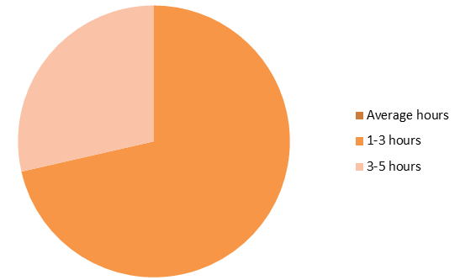
Figure 2: Devices used for online learning
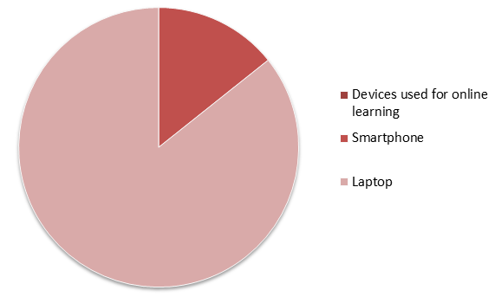
Figure 3: Applications used for online learning
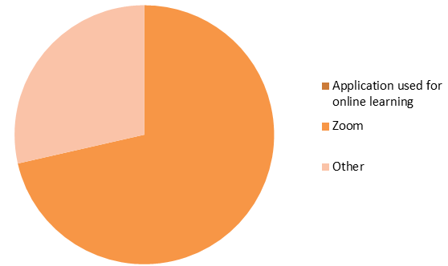

Figure 4: Feelings about distance learning
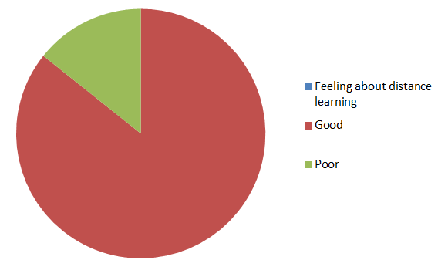
Figure 5: Feelings about online education
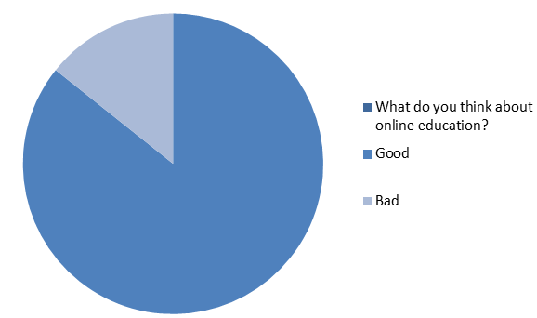
Figure 6: Comparing online learning and classroom learning
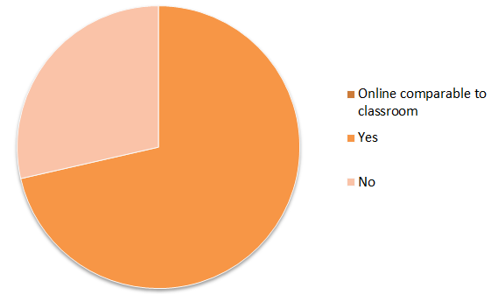

Figure 7: Online learning and motivation
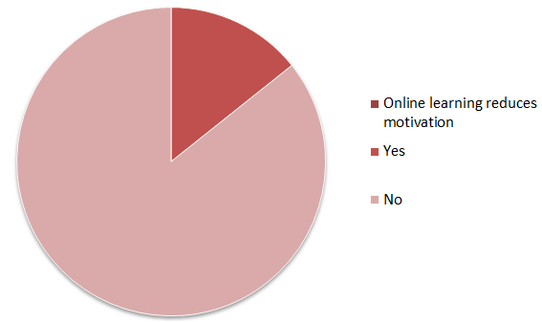
Figure 8: University helpfulness with online learning
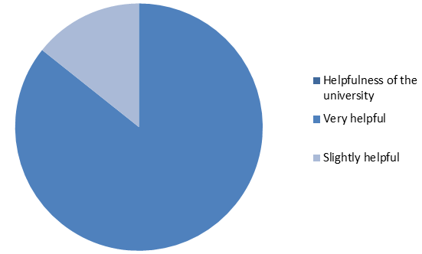

2.3 Discussion
The results from the primary data were limited because only 7 people completed the questionnaire, so it was good that the research also had secondary research. The results from the survey done for this research were similar to what was shown in the secondary research. First, students used a lot of different technologies for learning, including Moodle and Zoom. Second, students can access the VLEs from different kinds of devices, depending on what they have, and this helps with flexibility. Third, students have good feelings about distance learning and online learning, and this may be because they see online learning as comparable to classroom learning and they are just as motivated in either class. However, the articles show that students are usually more motivated with VLE.

3.0 Conclusion
It is argued that a VLE can improve existing educational practices and the students' learning experience (Firefly, 2021). To examine this issue, this research aimed to study the impact of a VLE, specifically Moodle, on students' learning experience at the University. To reach this aim, data was collected from published journal articles to see what others had found out about the impact of having a VLE on students' learning experience in general. Then primary data was collected from a survey of students at the University to see how their experience matches those found in the secondary data. The secondary research has shown that there are a lot of good experiences that students have when using a VLE, specifically Moodle, such as flexible learning (Barker and Gossman, 2013; Chung and Ackerman, 2015; Lyndon and Hale, 2014), better communication and more independent learning (Barker and Gossman, 2013; Reis et al., 2015), as well as more satisfaction with the course (Chung and Ackerman, 2015). The students at the University seem to be more satisfied with their course when using a VLE and had positive feelings about distance learning and online learning. Overall, it seems like the two sets of data are consistent with each other.

4.0 References
Barker, J. and Gossman, P. (2013) ‘The learning impact of a virtual learning environment: students’ views’, Teacher Education Advancement Network Journal (TEAN), 5(2), pp. 19-38.
Cassidy, S. (2016) ‘Virtual Learning Environments as mediating factors in student satisfaction with teaching and learning in Higher Education’, Journal of Curriculum and Teaching, 5(1), pp. 113-123.
Chung, C. and Ackerman, D. (2015) ‘Student reactions to classroom management technology: Learning styles and attitudes toward Moodle’, Journal of Education for Business, 90(4), pp. 217-223.
Evans, M. (2020) ‘What is a VLE (Virtual Learning Environment)? 2021 Guide’ [Online] Available at: https://www.learningladders.info/news/what-is-a-vle/ (Accessed: 26 December 2021).
Firefly (2021) ‘What is a Virtual Learning Environment (VLE)?’ [Online]. Available at: https://fireflylearning.com/what-is-a-virtual-learning-environment-vle (Accessed: 30 November 2021).
Lyndon, S. and Hale, B. (2014) ‘Evaluation of how the blended use of a virtual learning environment (VLE) can impact on learning and teaching in a specific module’, Enhancing Learning in the Social Sciences, 6(1), pp. 56-65.
Reis, L., Ikari, O., Taha-Neto, K., Gugliotta, A. and Denardi, F. (2015) ‘Delivery of a urology online course using Moodle versus didactic lectures methods’, International Journal of Medical Informatics, 84(2), pp. 149-154.
Saunders, M., Lewis, P., and Thornhill, A. (2019) Research methods for business students. Harlow, England: Prentice Hall.

Appendix 1: Questionnaire
Ouestion 1: What do you think about Online Education?

- Good
- Very good
- Very bad
- Bad
Ouestion 2: How helpful your university has been in offering you the resources to learn from home?

- Not at all helpful
- Very helpful
- Extremely helpful
- Slightly helpful
Ouestion 3: Can you conduct your lectures in online education as in a regular classroom?

Question 4: Does online education reduce student motivation?

- Yes
- Of course
- No
- Not really
Question 5: What device do you use for online education?

- Smartphone
- Tablet
- Desktop
- Laptop

Question 6: How much time do you spend each day on an average on distance education?

- 1-3 hours
- 3-5 hours
- 5-7 hours
- 7+ hours

Question 7: How do you feel overall about distance education?

- Poor
- Good
- Average
- Excellent

Question 8: What technology-based applications have you uesd for online education?

- Social Medya
- Zoom
- Google
- Other

Question 9: What do you think about the online courses?

- Good
- Perfect
- Bad
- Not so helpful

Answers:

Good ( 6 people )
Bad ( 1 person )

Very helpful (6 people )
Slightly helpful (1 person l

3.
Yes ( 5 people )
No ( 1 person )

4.
Not really ( 6 people )
Yes ( 1 person )

5.
Laptop ( 6 people )
Smartphone ( 1 person )

6.
1-3 hours ( 5 people )
3-5 hours ( 2 people )

7.
Good ( 6 people )
Poor ( 1 person )

8.
Zoom ( 5 people )
Other ( 2 people )

9. Good ( 6 people )
Bad ( 1 person )

