Student Name: Kouadio Affoue Denise
Student ID: 2412968

Module Code: BMHP5015
Module Title: BSc (Hons) Health and Social Care

Changemakers: Building Your Brand for Sustainable Employment
Academic Year: 2025

Assignment Title: COMPONENT 1: Online
Portfolio of Set OF 7 Exercises

Table of Contents
Task 1: Personal Brand 3
Task 2: Network Map and Rationale 4
Part 1: Network Map 4
Part 2: Rationale 4
Task 3: Blog 6
Introduction 6
Body 6
Conclusion 7
Task 4: Equality, Diversity and Inclusion 8
Task 5: Letter to myself 10
Task 6: Gantt Chart 11
Tasks 12
Dependencies 13
Visualisation 13
Task 7: Making Changes Report 14
Introduction and Background 14
Change Applied: Lewin’s Change Management Model 14
Developmental Expectations 14
Conclusion 14
References 16

Task 1: Personal Brand
Introduction
Building a personal brand is key to showing off what you're all about and helps you stick out. I have developed good communication, teamwork, and problem-solving skills through my studies and work experience.
Body
Currently, people see me as reliable and organised, the type of person who dives into tasks and is always there to assist others. This trait is particularly beneficial in health and social care, making job hu nting easier and pushing me towards my long-term career objectives (Audrew and Herdiansyah, 2024). It enables effective collaboration with various groups and drives great outcomes. Besides, I emphasise respect, empathy, and responsibility as core qualities in health and social care. These traits are precisely what employers seek in rising stars in the field (Harisandi et al., 2025).
There are still some things I want to improve. Increasing my own leadership and interaction skills, improving my relationships and being better at online stuff are at the top of the list. So, I will be going to some workshops, getting better at LinkedIn and working on some health and social care volunteer placements. Learning and reflection are very important elements, and I'll continue to do this as well.
Conclusion
It is to be concluded that having a natural crop will give me confidence and will certainly assist me in handling situations better in different working and related positions. I will continue to develop myself as a personal brand, and hopefully, this will help me develop more job opportunities.

Task 2: Network Map and Rationale

Part 1: Network Map
My network's got family, close buddies, classmates, coworkers, health pros, LinkedIn folk, and community crew. They give me personal support, chances to learn, career tips, and professional guidance too (Kitsios et al., 2022).
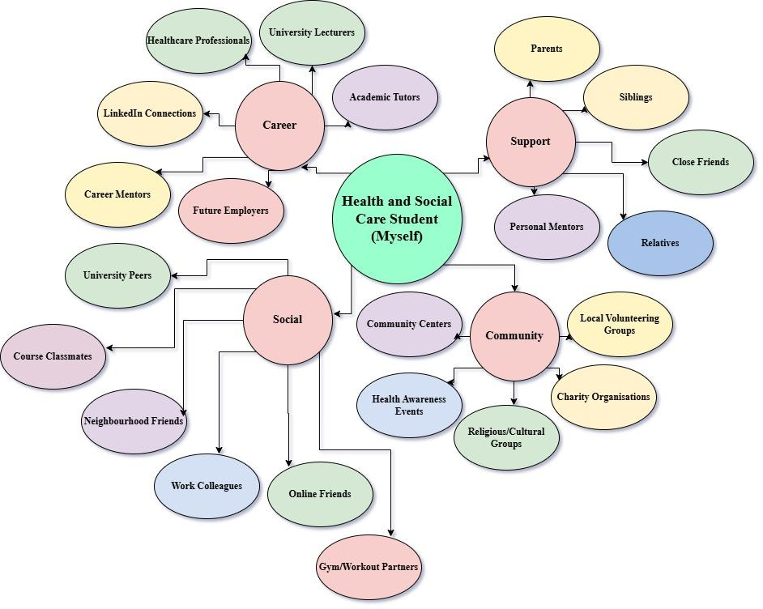
Figure: Network Map
(Source: Author)

Part 2: Rationale
Type of Network
My network is a selective network with elements of a closed network. Most of the people I have contact with regularly are my family, friends, classmates and colleagues who give emotional support and useful tips and tricks. Meanwhile, I make a few connections to lecturers, health care professionals, and industry contacts that can help me grow my professional network. This kind of network equals mutually dependable relationships and access to expert knowledge (Dalege et al., 2025).
Areas of Weakness
Though there are some strengths in my bonding social capital, there are some weaknesses in my bridging and linking social capital. Right now, I don't have a very large contact list within Health and Social Care. I know a few senior managers and decision makers from here. That's been helpful, but it certainly hampers my opportunities on some career paths, mentor opportunities, and when it comes to getting the inside scoop on the industry. Studies show that having a wider range of professional connections boosts employability and career advancement (Hanson and Theis, 2024).
Improvement Plan
I'll be attending a couple more professional events and connecting with others on LinkedIn health and social care discussion boards to expand my network. Volunteering might be an alternative, too. The stronger my relationship with these people becomes, the deeper I will understand them, the more eyes I will have as to new career avenues and opportunities to improve my position.

Task 3: Blog
Tackling the Underutilisation of Mental Health Services: The Role of NHS Talking Therapies in Supporting Young Adults with Anxiety

Introduction
There are plenty of young adults who suffer from anxiety but don't ask for professional help. Many people do not seek help because of stigma, lack of knowledge of services available, and not seeing their symptoms as a serious problem. It's important because it keeps people from taking care of their education, work, relationships, and well-being due to untreated anxiety. The NHS has launched their national campaign towards encouraging people to seek support called NHS Talking Therapies in recognition of these issues.

Body
Mental health conditions are becoming increasingly common across England. NHS data estimates that the following areas are primarily applicable for the detection of the issue
- A common mental health condition affects 9.4 million adults (England-2026).
- Close to half (49.4%) of all people put off going to seek help due to the feeling that it is not warranted.
- 21% do not seek help at all (NHS, 2026).
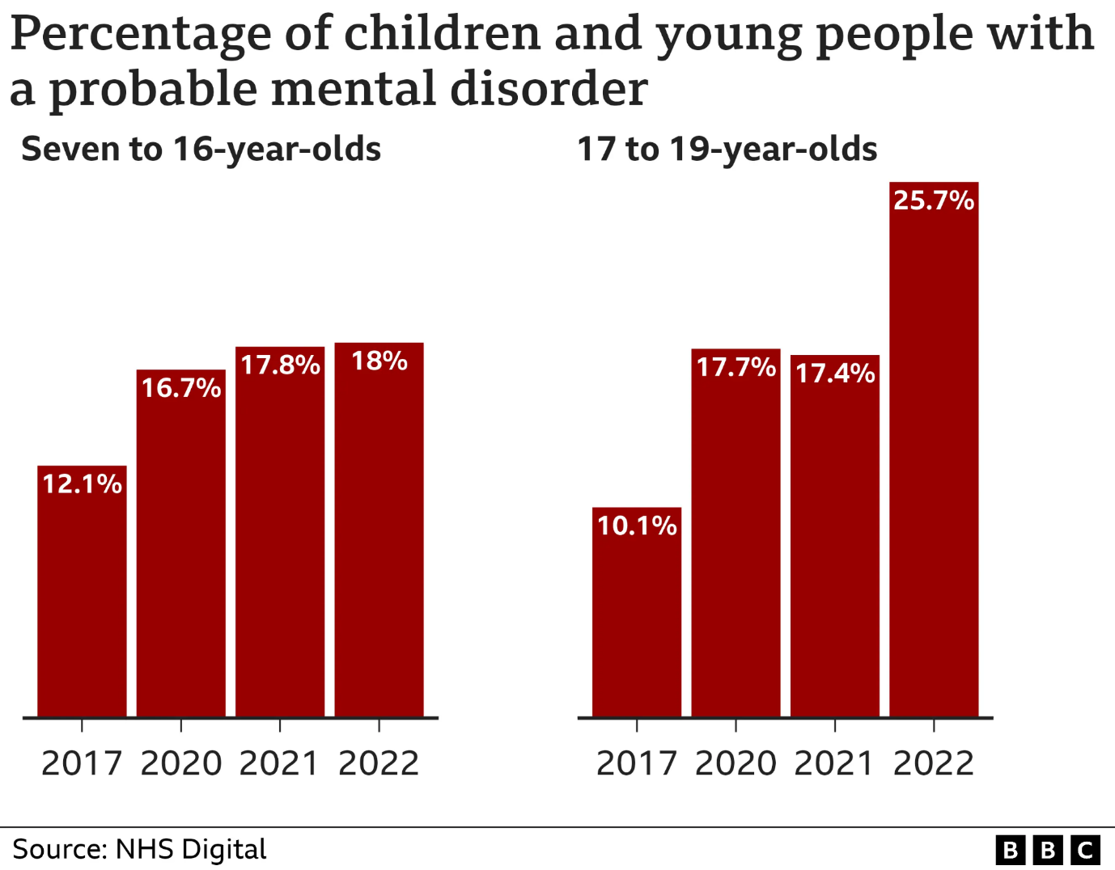
(Source: BBC, 2022)
NSHSTT's solution is to offer evidence-based therapy for anxiety, depression, PTSD, OCD and other accompanying conditions. Over 670,000 families started treatment in the service last year. Furthermore, 91.6% of all service users received help within six weeks, and 50.5% progressed to recovery (NHS, 2026) during the course of the 2024-25 period.

Conclusion
Even though resource recovery is common, an unmet need for mental health services continues to be a pervasive issue among young people with anxiety. By offering accessible, effective treatment, NHS Talking Therapies is helping to ease access to services that help.

Task 4: Equality, Diversity and Inclusion
1. What is the primary goal of the NHS Equality, Diversity, and Inclusion Improvement Plan?
To help raise standards for all NHS employees that promote equality, diversity, inclusion and g2ood feelings in the workplace and help to minimise discrimination and unfair treatment (Wolbring and Nguyen, 2023).
2. How does the NHS EDI Improvement Plan propose to tackle the gender pay gap?
The plan calls on NHS organisations to break down their pay-gaps information and put measures in place to bring down gender and other pay disparities across their workforce.
3. What is meant by the term ‘intersectionality’ as used in the NHS EDI Improvement Plan?
Intersectionality is the term used to describe the intersection of various individual attributes such as age, gender, ethnicity, disability and others that can lead to multiple disadvantage/discount or disadvantage/discount (Williamson and Kizilcec, 2022).
4. Why is it important for the NHS to create a psychologically safe work environment?
A psychologically safe culture frees up employees, enables them to discuss issues, voice concerns, and speak freely, fostering wellbeing and better patient care.
5. How does the NHS EDI Improvement Plan suggest improving the experience of internationally recruited staff?
The plan suggests good communications, robust induction programmes, cultural support, career development and supportive working environments (Burkhard et al., 2022).
6. What role does leadership play in advancing EDI objectives according to the NHS Improvement Plan?
Leaders have a responsibility to establish inclusive cultures, set measurable goals for excellence in EDI and then be held accountable for excellence in equality and staff experiences.
7. Identify one way the NHS EDI Improvement Plan aims to reduce health inequalities within the workforce.
The plan includes the promotion of ongoing wellbeing discussions with managers and staff, to determine what health needs exist and how to support those needs.
8. Why does the NHS EDI Improvement Plan emphasise the importance of collecting and analysing data on protected characteristics?
Data informs organisations about inequalities, aids tracking progress and promotes fairer and more inclusive actions based on evidence (Ng et al., 2025).
9. Explain how flexible working policies can contribute to equality and inclusion in the NHS workforce.
Flexible working is about a staff member balancing work and personal responsibilities, which in turn makes it easier and more inclusive to access employment for various groups of staff.
10. What is one strategy mentioned in the NHS EDI Improvement Plan to combat bullying and harassment in the workplace?
A strategy can be to develop a culture of the workplace in which employees feel free to report bullying/ harassment when they experience it and feel supported and safe to do so.

Task 5: Letter to myself
Dear younger me,
I am writing this letter to allow myself to consider a difficult time in my life when I was feeling stressed, uncertain about my future and stressed myself out. Often at that time, I was deliberately concentrating on my failures and despairing at my setbacks, instead of delights and successes. Now, I realise that emotional intelligence and resilience would have played significant roles in things I have taken on at that time to help me overcome those difficult situations better.
Self-awareness is one of the crucial factors that comprise emotional intelligence. Knowing what I was feeling, I would have realised that stress and frustration were expected in times of stress, and in no way a reflection of failure. Emotional intelligence would have enabled me to deal with my emotions more constructively and be able to express my concerns to others in a more suitable manner, rather than coping on my own.
It was also imperative that they were resilient. In tough times, I sometimes saw failure as an end goal, instead of a chance to gain knowledge and understanding and to learn and become better. If I were more resilient, I would have been able to deal with difficult situations more encouragingly, would have stayed motivated and easily bounced back after setbacks. I never believed that failure was something to be feared; rather, it was something to learn from in being better.
The one thing that I will say here is, of course, be patient with yourself. What makes you fall doesn't make you incapable or unfit. Feel, seek help, and learn that sometimes growth is found in overcoming and tackling challenges. You will learn to tackle challenges with confidence and tenacity thanks to cultivating emotional intelligence and resilience.
Good luck, just keep going through what you are going through.
---------------Your Future Self

Task 6: Gantt Chart
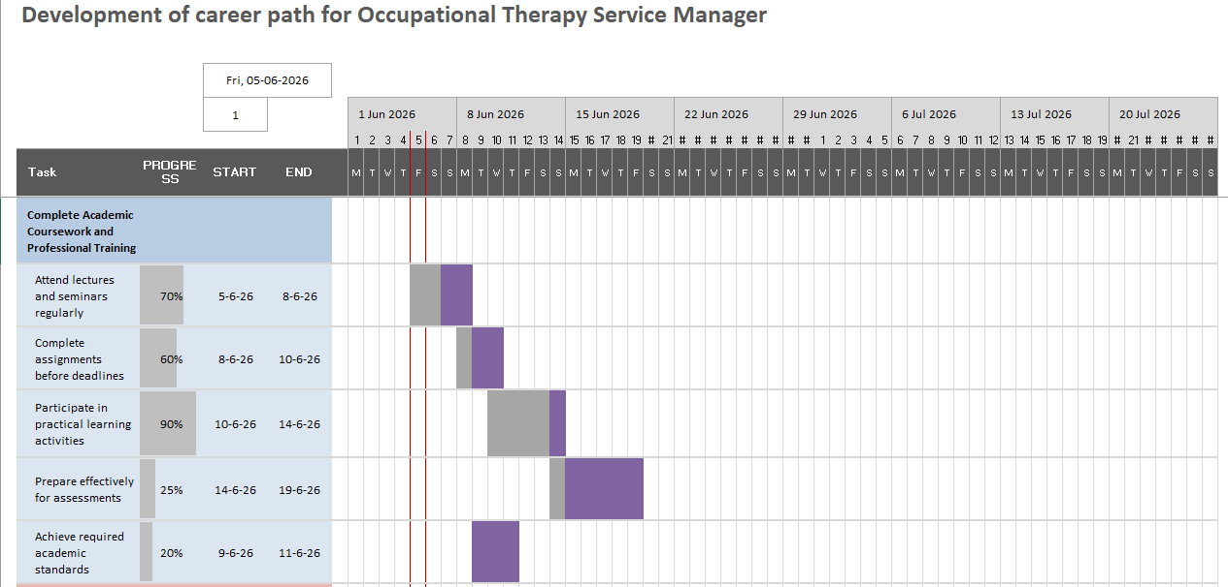

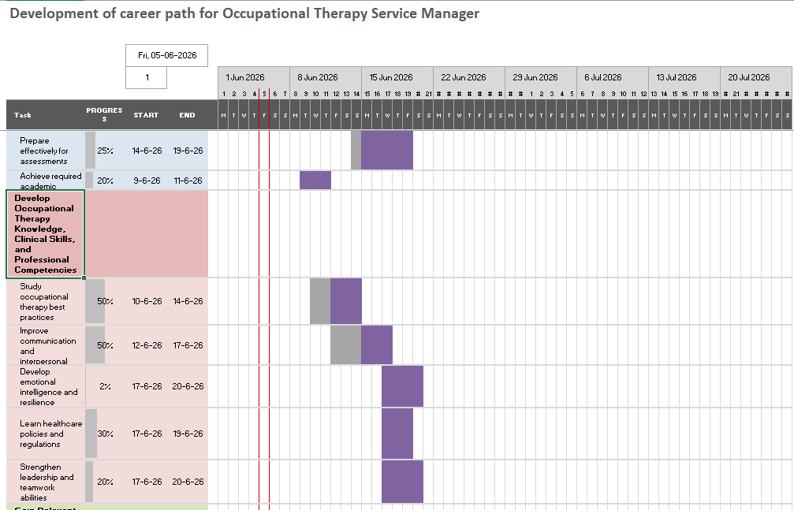
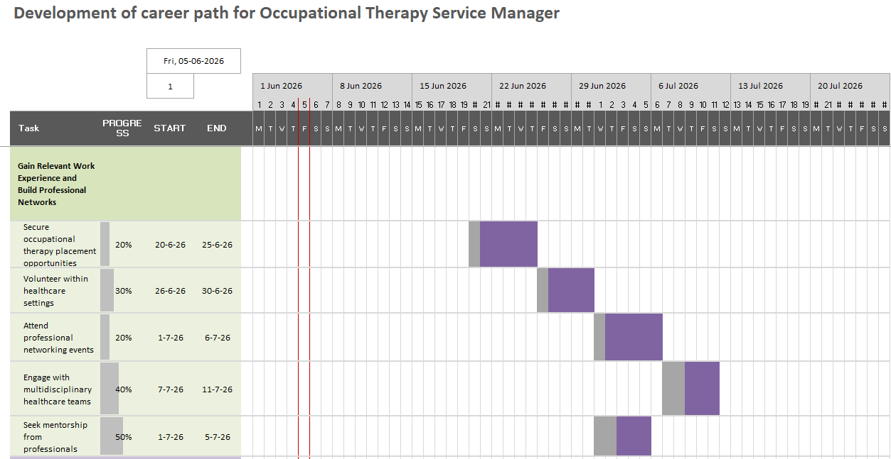
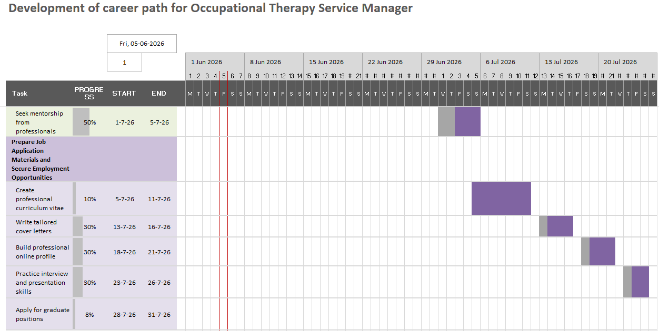
Goal: To gain academic qualifications, professional skills and knowledge and gain leadership experience in the NHS to become an Occupational Therapy Service Manager.

Tasks
- Completion of all the academic coursework and professional training.
- Build Occupational Therapy Knowledge, Skills and Competencies.
- Pursue work experience that is relevant and develop professional connections.
- Create job preparation materials and qualify for jobs

Dependencies
Professional qualifications can only be achieved after academic courses. Learners' knowledge and competencies help them to be successful in the workplace. Applications and interview performance are enhanced by work experience, and this results in employment opportunities.

Visualisation
There is a clear and structured progression to the career goal along a pathway. Challenges may arise from the balance between studying and finding placements that are relevant to the program, and limited clinical placement opportunities in a competitive health care setting.

Task 7: Making Changes Report

Introduction and Background
Ridgeway Court Care Home is a residential care/home for elderly people in Dudley, including those with dementia. The overall CQC rating for the service is Good with good comments made about safety, effectiveness, caring and responsiveness (CQC, 2026). The CQC did, however, make several recommendations about the areas for improvement, focusing on the leadership and quality monitoring systems.

Change Applied: Lewin’s Change Management Model
In the first phase of the Change Model (Unfreeze), the importance of person-centred care to staff, with an explanation of the benefits of person-centred care, and gaps in resident involvement will be identified. Staff resistance and not enough time for substantive conversations (Sunjaya et al., 2025) seem to be potential barriers.
All staff to be trained on Change in active listening, empathy, communication and collaborative decision making. Regular meetings of the individuals that live in the home, care planning discussions and feedback sessions will be added to foster participation (Lynch et al., 2022).
This will be built into ongoing Program protocols, and supervisory and program review during this Refreeze phase. Success will be facilitated through the feedback from the residents, auditing care plans, observation and evaluation by staff (Deussom et al., 2022).

Developmental Expectations
The project will be designed to increase residents' involvement; improve their dignity and independence in the care and health they receive and improve their satisfaction with the regard given to them by the project. The achievement of the staff resident relationship and the communication enhancement can be promoted through the application of the enhanced staff resident relationship and proper communication (Gurung and Chaudhury, 2025).

Conclusion
At Ridgeway Court Care Home, joining in with the person at hand and listening are opportunities to enhance the quality of care. Joining in with what the person is thinking and actively listening can help to reinforce care quality through shared decision-making.

References
Audrew, E. and Herdiansyah, H. (2024). The impact of self-esteem and media literacy on personal branding strategies on Instagram among Generation Z. ETTISAL: Journal of Communication, 9(2), pp.35-54. Available at: https://ettisal.journal.unida.gontor.ac.id/index.php/ettisal/article/view/57 [Accessed on: 5th June 2026]
BBC (2022) ‘Quarter of 17-19-year-olds have probable mental disorder - study’, BBC News, 29 November. Available at: https://www.bbc.com/news/health-63784751 (Accessed: 5 June 2026).
Burkhard, M.J., Dawkins, S., Knoblaugh, S.E., El-Khoury, C., Coble, D., Malbrue, R.A., Read, E.K., Greenhill, L.M. and Moore, R.M. (2022). Supporting diversity, equity, inclusion, and belonging to strengthen and position the veterinary profession for service, sustainability, excellence, and impact. Journal of the American Veterinary Medical Association, 260(11), pp.1283-1290. Available at: https://avmajournals.avma.org/view/journals/javma/260/11/javma.21.11.0477.xml [Accessed on: 5th June 2026]
CQC (2026) Ridgeway Court Care Home HTML report ‘Responsive’ for assessment AP22164 - Care Quality Commission, Cqc.org.uk. Available at: https://www.cqc.org.uk/location/1-19430569821/reports/AP22164/overall/responsive (Accessed: 5 June 2026).
Dalege, J., Galesic, M. and Olsson, H. (2025). Networks of beliefs: An integrative theory of individual-and social-level belief dynamics. Psychological Review, 132(2), pp.253. Available at: https://psycnet.apa.org/record/2025-24581-001 [Accessed on: 5th June 2026]
Deussom, R., Mwarey, D., Bayu, M., Abdullah, S.S. and Marcus, R. (2022) ‘Systematic review of performance-enhancing health worker supervision approaches in low- and middle-income countries’, Human Resources for Health, 20(1). Available at: https://doi.org/10.1186/s12960-021-00692-y.
England, N. (2026). NHS England» ‘NHS talking therapies completely changed my life’: NHS launches major campaign to support millions more people with anxiety, England.nhs.uk. Available at: https://www.england.nhs.uk/2026/02/nhs-talking-therapies-completely-changed-my-life-nhs-launches-major-campaign-to-support-millions-more-people-with-anxiety/ (Accessed: 5 June 2026).
Gurung, S. and Chaudhury, H. (2025) 'Relationship-Centred Care for Older Adults in Long-Term Care Homes: A Scoping Review', Journal of applied gerontology: the official journal of the Southern Gerontological Society, p. 7334648241309761. Available at: https://doi.org/10.1177/07334648241309761.
Hanson, K.R. and Theis, N. (2024). Networked participants, networked meanings: Using networks to visualise ethnographic data. Sociological Methodology, 54(1), pp.142-156. Available at: https://journals.sagepub.com/doi/abs/10.1177/00811750231195338 [Accessed on: 5th June 2026]
Harisandi, P., Hurriyati, R., Gaffar, V., Wibowo, L.A., Yanti, P., Yusriani, S. and Purwanto, P. (2025). Personal branding of lecturers and word of mouth: Effective education strategy in increasing the attractiveness of the entrepreneurship study program and reputation of Pelita Bangsa University. IJORER: International Journal of Recent Educational Research, 6(3), pp.758-774. Available at: https://www.researchgate.net/profile/Sri-Yusriani/publication/ [Accessed on: 5th June 2026]
Kitsios, F., Mitsopoulou, E., Moustaka, E. and Kamariotou, M. (2022). User-Generated Content behaviour and digital tourism services: A SEM-neural network model for information trust in social networking sites. International Journal of Information Management Data Insights, 2(1), pp.100056. Available at: https://www.sciencedirect.com/science/article/pii/S2667096821000495 [Accessed on: 5th June 2026]
Lynch, B., Ryan, A.A., O’Neill, M. and Penney, S. (2022) ‘The Factors That Influence Care Home Residents’ and Families’ Engagement with decision-making about Their Care and support: an Integrative Review of the Literature’, BMC Geriatrics, 22(1). Available at: https://doi.org/10.1186/s12877-022-03503-8.
Ng, E., Fitzsimmons, T., Kulkarni, M., Ozturk, M.B., April, K., Banerjee, R. and Muhr, S.L. (2025). The anti-DEI agenda: navigating the impact of Trump’s second term on diversity, equity and inclusion. Equality, Diversity and Inclusion: An International Journal, 44(2), pp.137-150. Available at: https://www.emerald.com/edi/article-abstract/44/2/137/1274210 [Accessed on: 5th June 2026]
NHS (2026) NHS Talking Therapies, for anxiety and depression, Annual reports, 2024-25, NHS. Available at: https://digital.nhs.uk/data-and-information/publications/statistical/nhs-talking-therapies-for-anxiety-and-depression-annual-reports/2024-25 (Accessed: 5 June 2026).
Sunjaya, A.M., Schreiber, T., Kantilal, K., Davies, N. and Griffiths, S. (2025) ‘Communication strategies for delivering personalised dementia care and support: a mixed-methods systematic review and narrative synthesis’, Age and Ageing, 54(5). Available at: https://doi.org/10.1093/ageing/afaf120.
Williamson, K. and Kizilcec, R. (2022, March). A review of learning analytics dashboard research in higher education: Implications for justice, equity, diversity, and inclusion. In LAK22: 12th international learning analytics and knowledge conference (pp. 260-270). Available at: https://dl.acm.org/doi/abs/10.1145/3506860.3506900 [Accessed on: 5th June 2026]
Wolbring, G. and Nguyen, A. (2023). Equity/equality, diversity and inclusion, and other EDI phrases and EDI policy frameworks: A scoping review. Trends in Higher Education, 2(1), pp.168-237. Available at: https://www.mdpi.com/2813-4346/2/1/11 [Accessed on: 5th June 2026]

