
BSc Applied Computing

Research, build, and deploy a Virtualised Enterprise network

Module Name: Network Operating Systems and Services
Module Code: ACCA5023
Student Name: Mariana Silva Martins
Student ID: 22319931
Lecturer Name: Md Abrar Jahin Almazi Bipon

Submission date: 03/07/2026

1.1 Hypervisor
The technology of virtualisation has been adopted in modern networks due to its capacity to support the execution of several operating systems at once on one computer physically. Through virtualisation, the use of hardware resources can be optimised through cost reduction and increased flexibility in testing various network scenarios. There exist two main types of hypervisors: Type 1 and Type 2. As depicted in Figure 1, a Type 1 hypervisor operates directly on the hardware without the involvement of an intermediate host operating system; hence, its performance, scalability and isolation are more effective than those of Type 2. The latter operates on a host operating system, and hence it is easy to deploy, configure and manage it [1], [2].
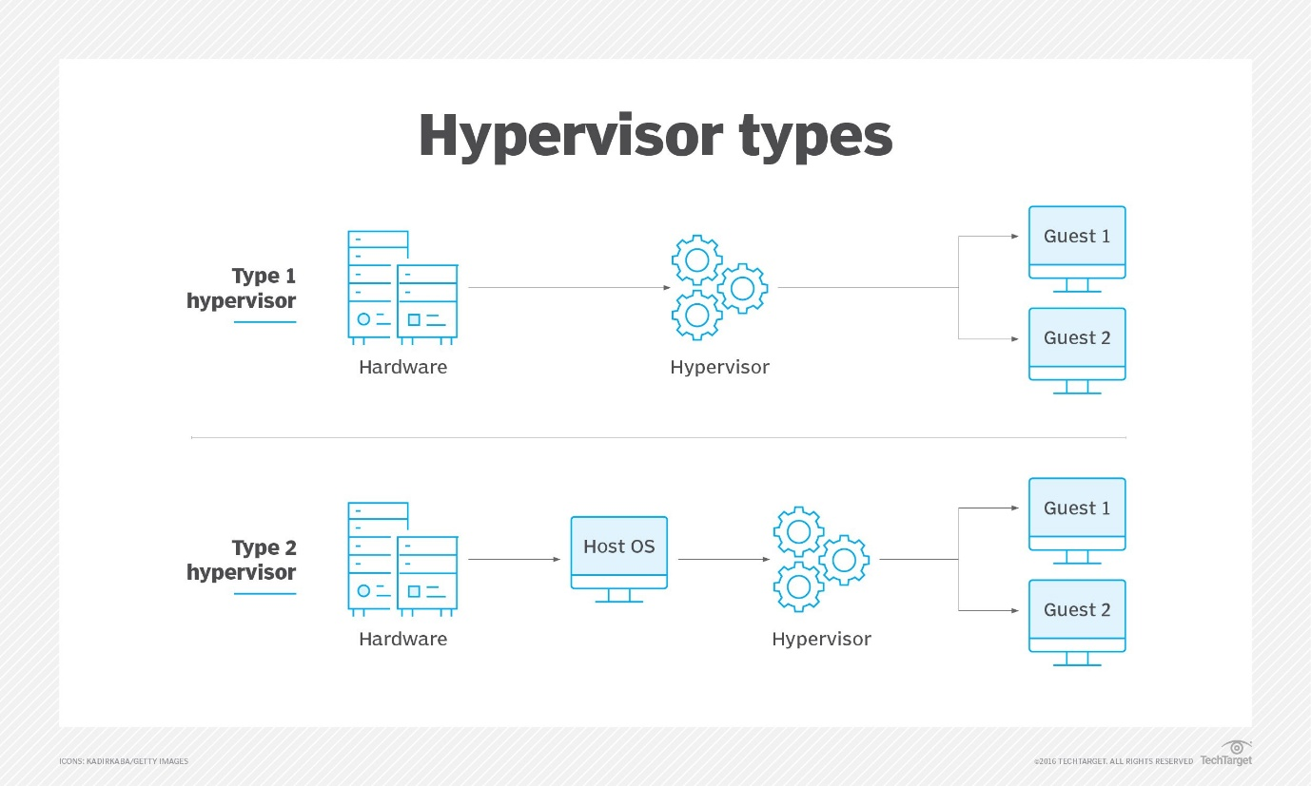
Figure 1. Type 1 and Type 2 Hypervisor Architecture.
Source: TechTarget [2].
In light of the analysis of both architectures, I have identified that there are some advantages to be seen in each architecture based on the environment in which it is supposed to work. Type 1 hypervisors are usually favored in an enterprise data center environment because of their better performance with regard to security and scalability. But Type 1 hypervisors normally need specific hardware and more knowledge about administration. Type 2 hypervisors can perform sufficiently well with good compatibility and no special hardware.
As part of this coursework, Oracle VirtualBox was chosen because of its ability to allow Windows Server 2022, Debian Server (CLI), Windows 10 and Debian Client VMs to run on a single computer as host. Taking into consideration the theoretical review conducted and practical use of these technologies, I have concluded that VirtualBox was the best choice to build and test the suggested virtual network topology [1], [3].

1.2 IP Addressing
IP addressing is vital for any network because it identifies unique devices and helps to deliver the information between various networks. If the information needs to be delivered, then the switch delivers the data inside the local network based on MAC addresses, and the router analyses the IP address to find the best way for packet delivery across various networks [4].
IPv4 and IPv6 provide the required logical addressing for communication in networks. However, there are some differences in their structure and capacity. The first one contains the 32-bit address written in dotted-decimal form, while the second protocol has the 128-bit hexadecimal address. It is clear that the address space is much larger and can handle the growing number of connections [5], [6]. Despite the advantages of IPv6, IPv4 is more popular because of its compatibility with current enterprise networks and applications [4].
Subnetting is an essential process of network addressing because of the benefits such as better address allocation, lower number of broadcast traffic and easier administration of the network [5]. During the coursework, the two subnets of the IPv4 network were used to allocate devices in the Birmingham (172.16.1.0/24) and London (172.16.2.0/24) networks, while the 10.0.0.0/30 network was used for the connection of both servers.
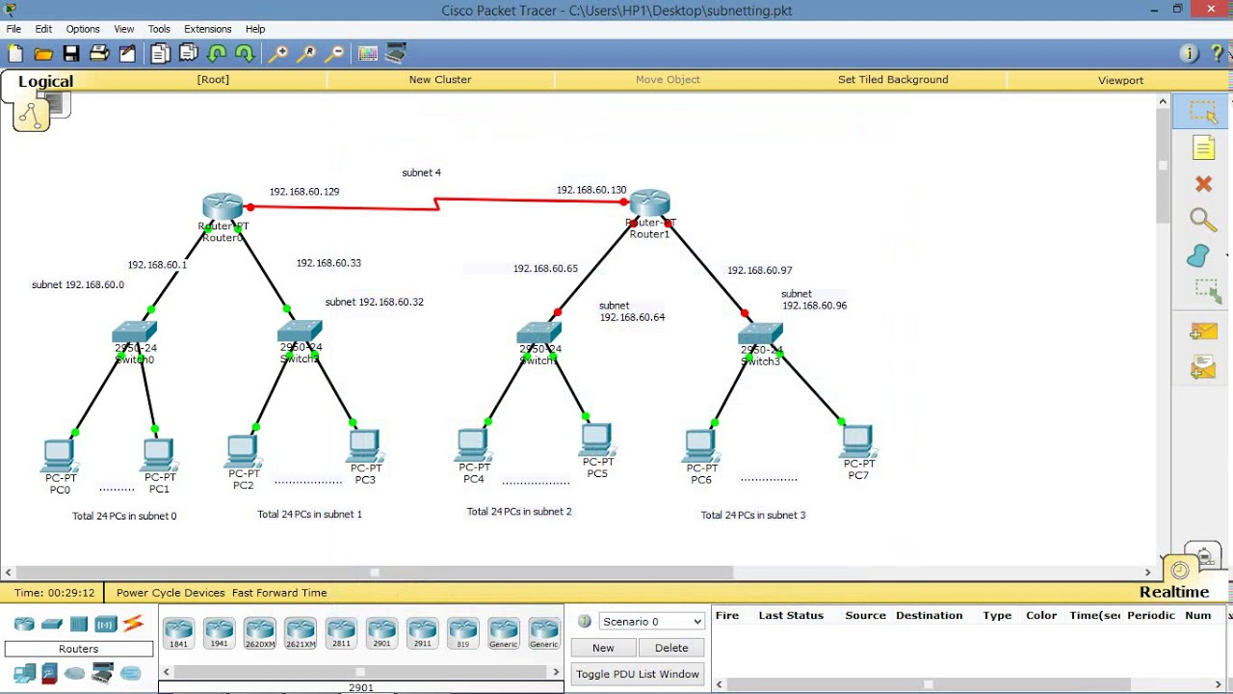

Figure 2. IPv4 subnetting example illustrating multiple logical subnets created from a larger network.
Source: Adapted from Tech Acad, "Subnetting – Cisco Packet Tracer," YouTube [7].

1.3 Routing
Routing is a mechanism used to send data packets from one network to another. It allows communicating the devices located on the different subnets of networks in an efficient way. Routing differs from switching because switching is used for frames sending inside the same local network. Routing includes analyzing destination IP-addresses and using routing information for choosing the best way for sending the packets [8], [4].
The routing process can be done by using either static or dynamic techniques. Using static routing, network administrators have to manually configure all the routes. It works well in small and unchanged topologies of networks. Dynamic routing uses special routing protocols that allow exchanging routing information between routers. Thus, network can change dynamically according to its topology [5]. The disadvantage of the dynamic routing is its greater complexity.
I think that static routing will be the best choice for the proposed topology because the network includes only two locations that are connected by a point-to-point link. Small number of networks allows configuring the routes easily. However, when enterprise network will expand greatly, the dynamic routing will be the better choice.
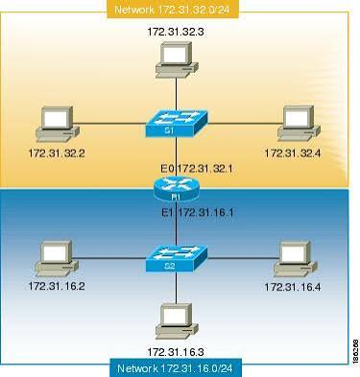
Figure 3. Example of packet forwarding between networks using routing tables.
Source: Cisco Systems [8].

1.4 Network Services
The functioning of enterprise networks requires coordination of several network services to ensure the secure interaction, centralized administration and resource availability. Contrary to independent operation of Virtual Private Networks (VPNs), Dynamic Host Configuration Protocol (DHCP), Active Directory Domain Services (AD DS) and Certificate Authorities (CAs), their combined operation allows improving performance and enhancing network security [9], [10].
The use of Virtual Private Network (VPN) technology makes it possible to extend remote secure access to organizational resources through encryption of transmitted information, making it impossible for unauthorized parties to read it [9]. In the same way, DHCP makes automatic distribution of IP addresses available to clients. It is regarded as the best practice because it ensures scalability of a network and minimizes administrative efforts, especially in enterprise networks [10], [12].
Active Directory Domain Services (AD DS) allows centralizing user, computer and shared resource authentication and management and thus applying security policies consistently across the organization. Certificate Authorities (CAs) add to this approach by providing the issuance and management of digital certificates and thus allowing systems to be authenticated and trusted communication to be secured [9], [11].
According to the results of literature review, it can be concluded that implementation of all these services as a whole network infrastructure, and not as separate parts, is the most efficient solution. Application of best practices, such as secure authentication, automated address management and certificate-based trust, allows organizations to create networks which are reliable, scalable and easy to manage and at the same time sufficiently secured [9] – [12].

Task 2 – Technical Documentation
2.1 Choose your Hypervisor
Oracle VirtualBox was chosen as the platform to implement hypervisor for the current course works considering the analysis provided in Task 1 and the compatibility with the specified enterprise network topology. Despite the fact that Oracle VirtualBox had been installed in the host computer, the decision to use this platform was also driven by the opportunity to operate multiple operating systems in the same virtual environment, such as Windows Server 2022, Windows 11 and Debian Linux.
The Oracle VirtualBox software allows using the following characteristics that were needed for implementation of the course works. It is possible to create multiple virtual network adapters that would allow connecting each virtual machine at the same time to NAT, Internal Networks and WAN segments. The software also allows creating virtual hardware, configuring network connections, taking snapshots and providing efficient use of resources. Thus, the Oracle VirtualBox is a very appropriate tool not only for the current implementation but also for the additional enterprise services to be implemented in Coursework 2 [13].
One more crucial aspect is that Oracle VirtualBox allows creating isolated virtual networks without adding new hardware. It is possible to build separate Birmingham and London local area networks and create a dedicated WAN connection between two sites in a fully virtualized environment. The variety of networking tools in Oracle VirtualBox allows building a small enterprise network for further testing and troubleshooting [13], [14].

Figure 5. Oracle VirtualBox Manager displaying the four virtual machines deployed for the enterprise network infrastructure.
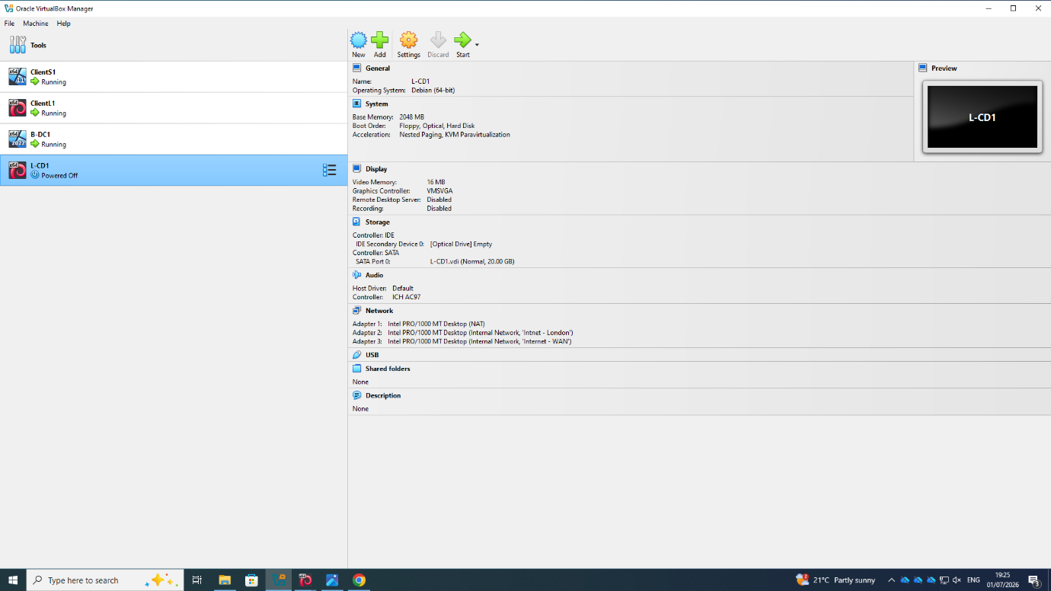
After selecting Oracle VirtualBox as the hypervisor platform, all virtual machines required for the enterprise network were created and organised within VirtualBox Manager. The environment includes two servers (B-DC1 and L-CD1) and two client workstations (ClientS1 and ClientL1), representing the Birmingham and London sites. The completed virtual infrastructure was ready for configuration and testing.

Figure 6. Selecting the Windows Server 2022 Edition
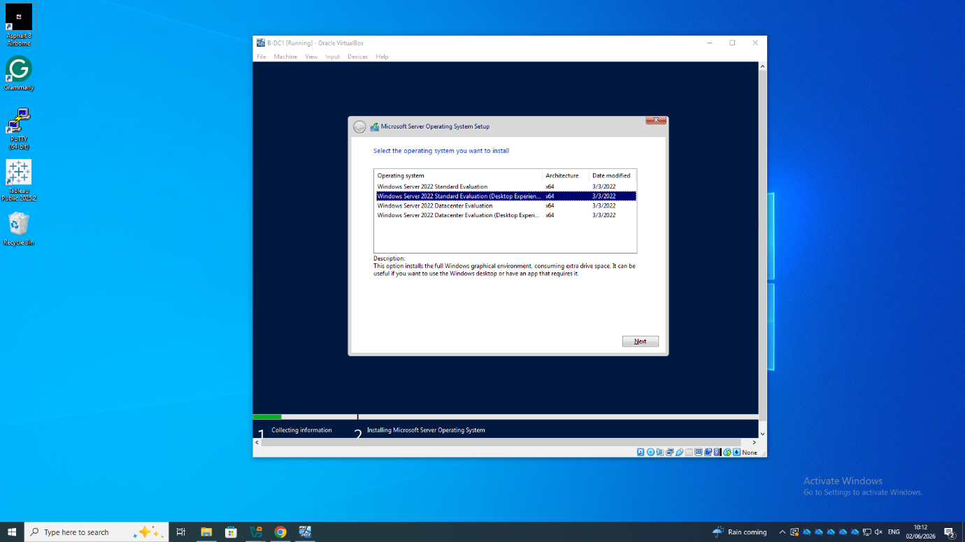
The Windows Server 2022 Standard Evaluation (Desktop Experience) edition was selected to provide a graphical administration environment.

Figure 7. Accepting the Windows Server Licence Agreement
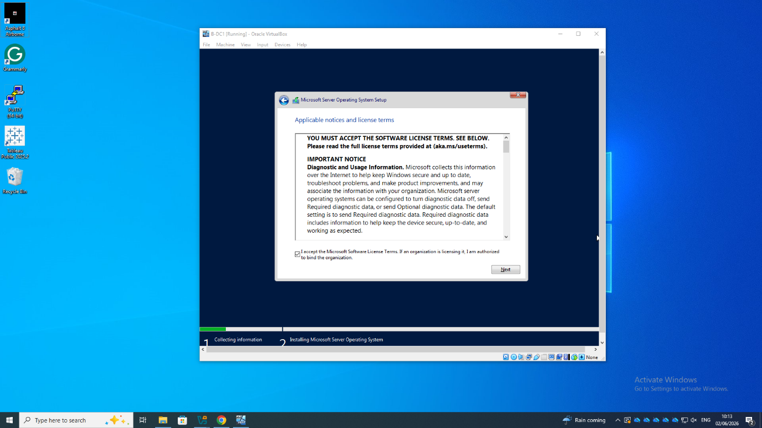

The Microsoft licence agreement was accepted before continuing with the installation process, ensuring that the operating system installation followed the standard deployment procedure.
Figure 8. Selecting the Virtual Installation Drive
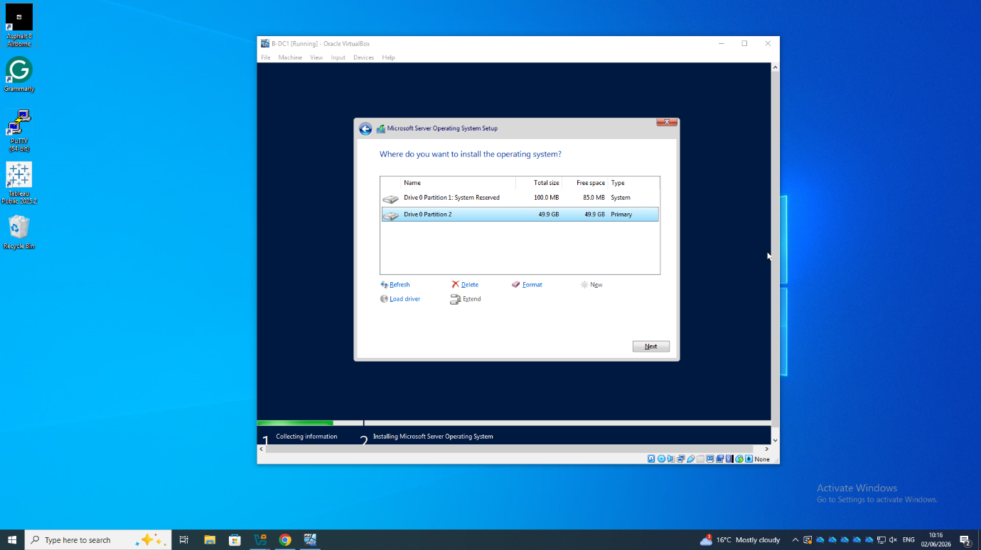
The virtual hard disk was selected as the installation destination for Windows Server 2022.

Figure 9. Installing Windows Server 2022
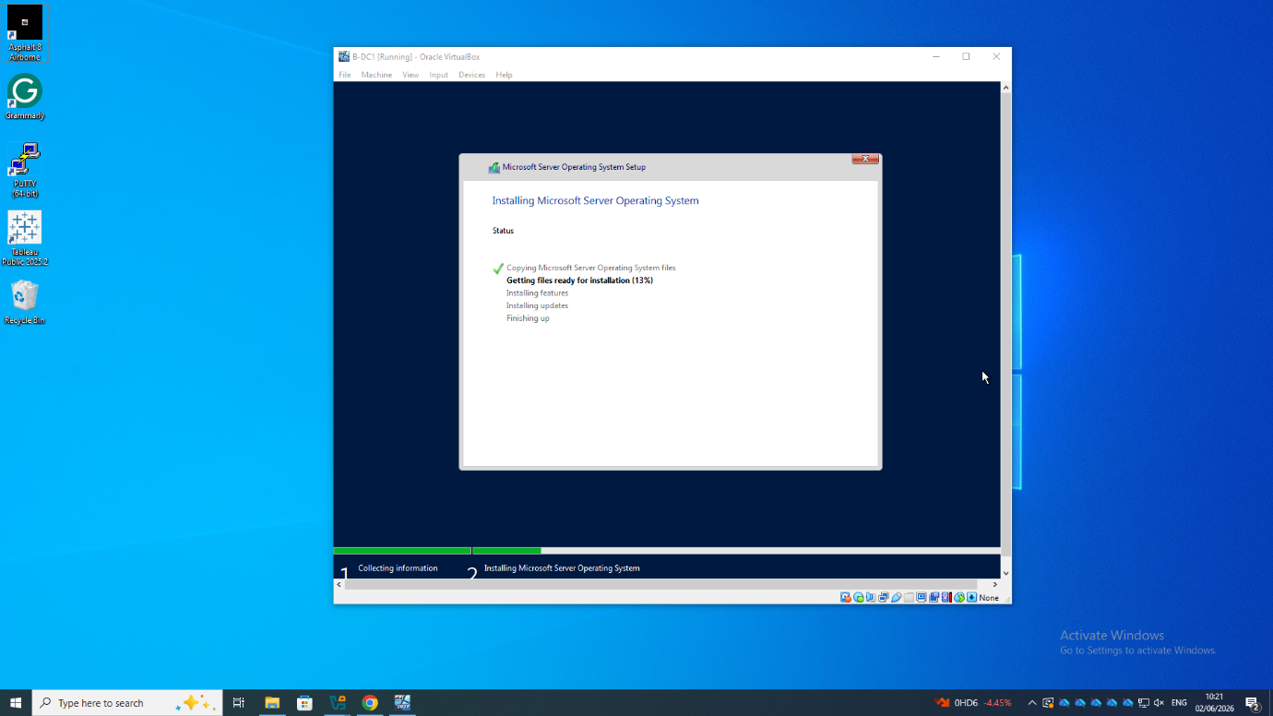
Windows Server installation files were copied and configured automatically. This stage prepared the operating system for its initial startup and subsequent network configuration.

Figure 10. Windows Server 2022 Successfully Installed
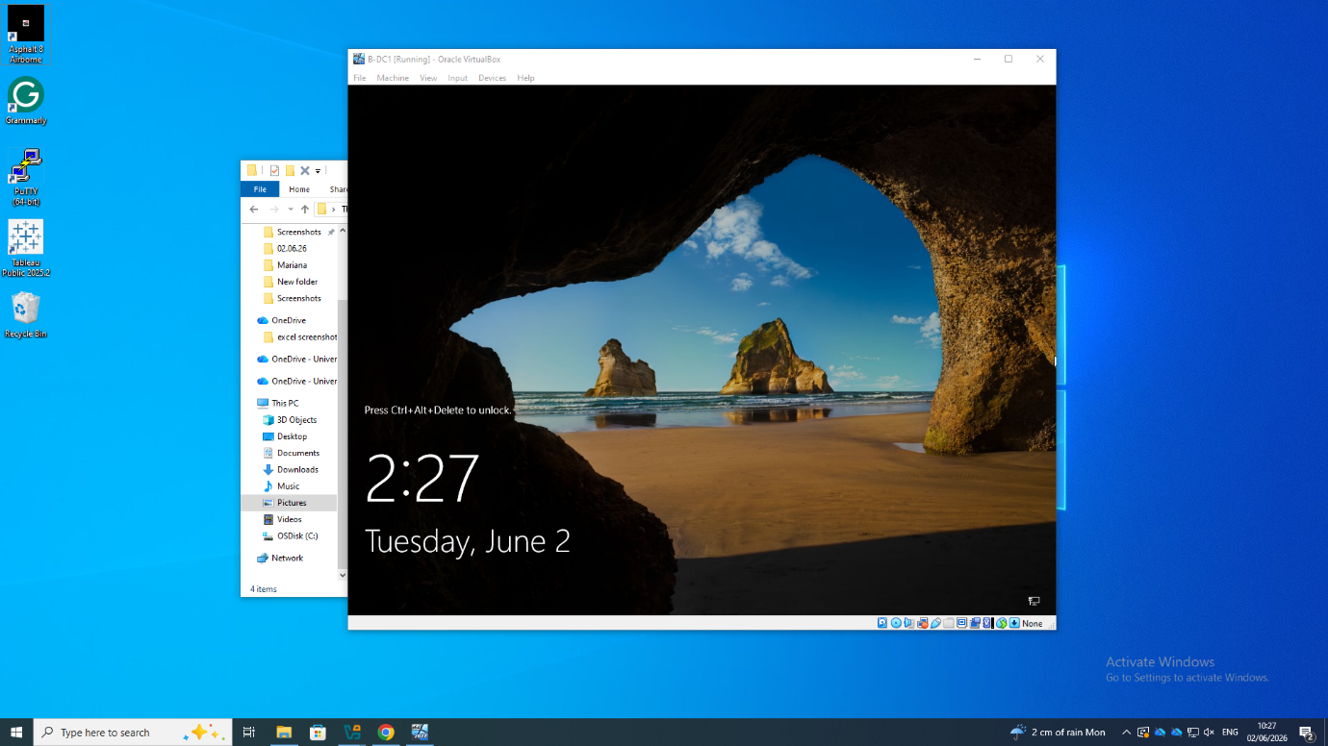
The successful completion of the installation was confirmed when the operating system reached the Windows login screen, indicating that the server was ready for post-installation configuration.

Figure 11. Windows Server Initial Administrative Environment
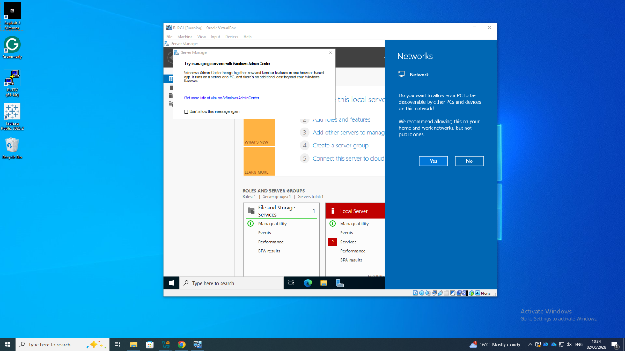
Once the first login was completed, the Server Manager started automatically, which confirmed that the deployment of the Windows Server 2022 was successful. It was then ready to be configured with network interfaces and IP configuration, together with server roles.

Once the Windows Server was successfully deployed, it was time to configure it with IP.
2.3 Configure IP Addressing
Static IPv4 addressing was assigned to all VMs according to the enterprise layout. Static IP addresses have been chosen since it is going to be used for future services, including AD DS, DNS and DHCP.
Figure 15. Static IPv4 Configuration of the Birmingham Domain Controller (B-DC1)
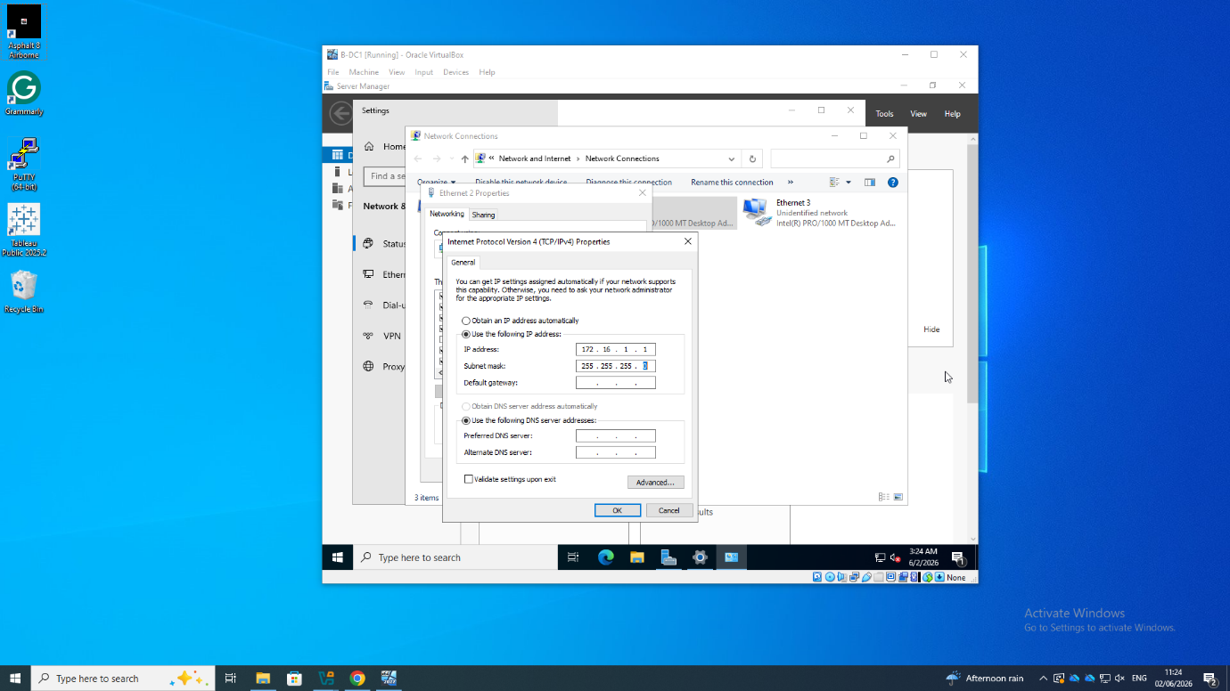
The main network interface card on the B-DC1 domain controller in the Birmingham city is assigned an IPv4 address which is statically configured within the 172.16.1.0/24 IP block. The main interface offers connections to the devices connected to the local area network in Birmingham.

Figure 16. Point-to-Point Network Interface Configuration
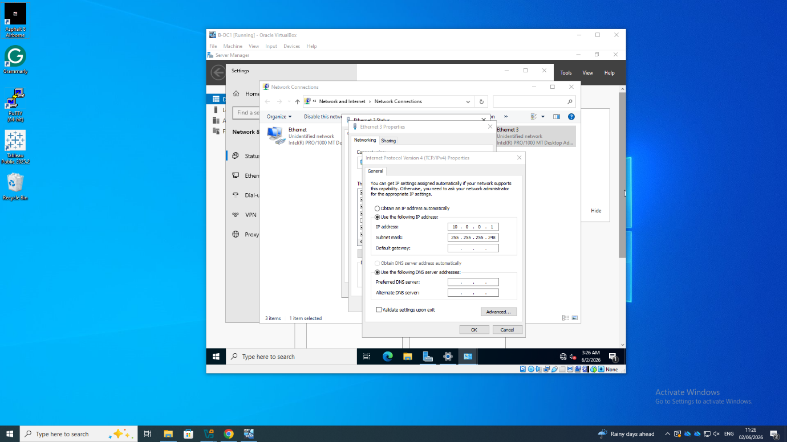
The second network card was configured using the point-to-point network connection that is available between the two servers at Birmingham and London. The network card serves as an alternative channel of communication between the two locations but is kept logically separated from the local area network.
Figure 17. Static IPv4 Configuration of ClientS1
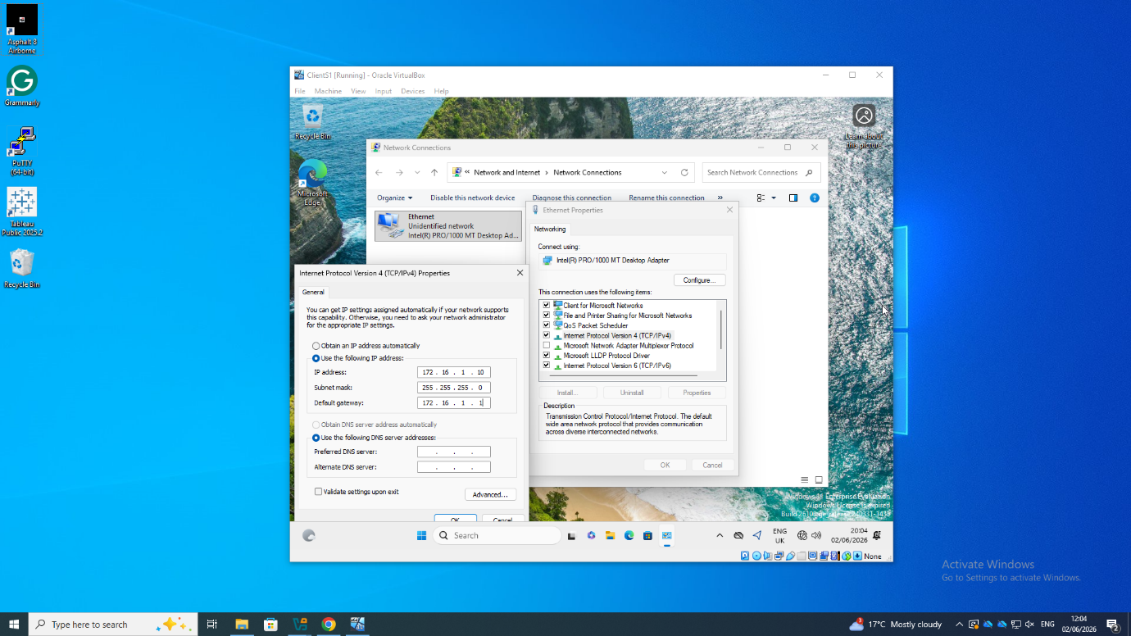
IP Configuration for Windows Client (ClientS1)
The Windows client (ClientS1) was configured manually by providing it with an IP address, subnet mask and default gateway to enable communication within the Birmingham network. This configuration made sure that the client was able to communicate effectively with the local server without any inconsistencies in the addressing scheme of the network.
Completed IP Configuration
With the completion of IP configuration for both the server and the client, a logical communication channel has been set up within the virtual enterprise network. This will help us to test the connectivity and deploy more services within the network in the coming stages of the coursework.

2.3.2 Debian Systems
After the Linux virtual machines were set up, the Debian server’s network interface was then configured through the NetworkManager Text User Interface (nmtui). Manual assignment of static IPv4 addressing enabled reliable connectivity with the other devices on the enterprise structure. This setup made sure that the Linux operating system had the same addressing scheme as the Windows environment.
Figure 18. Accessing the Debian Network Configuration Utility
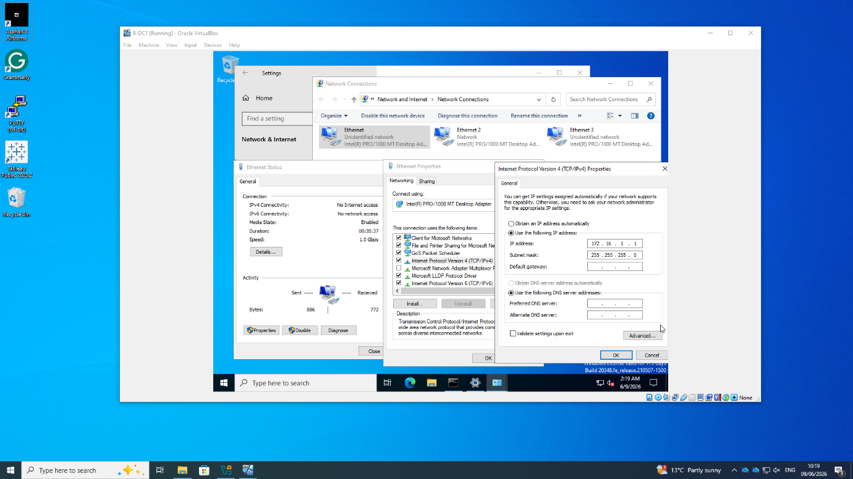
The Debian server network interface was configured using the NetworkManager text-based configuration utility (nmtui), providing a straightforward method for managing network parameters within the command-line environment.

Figure 19. Assigning Static IPv4 Addressing
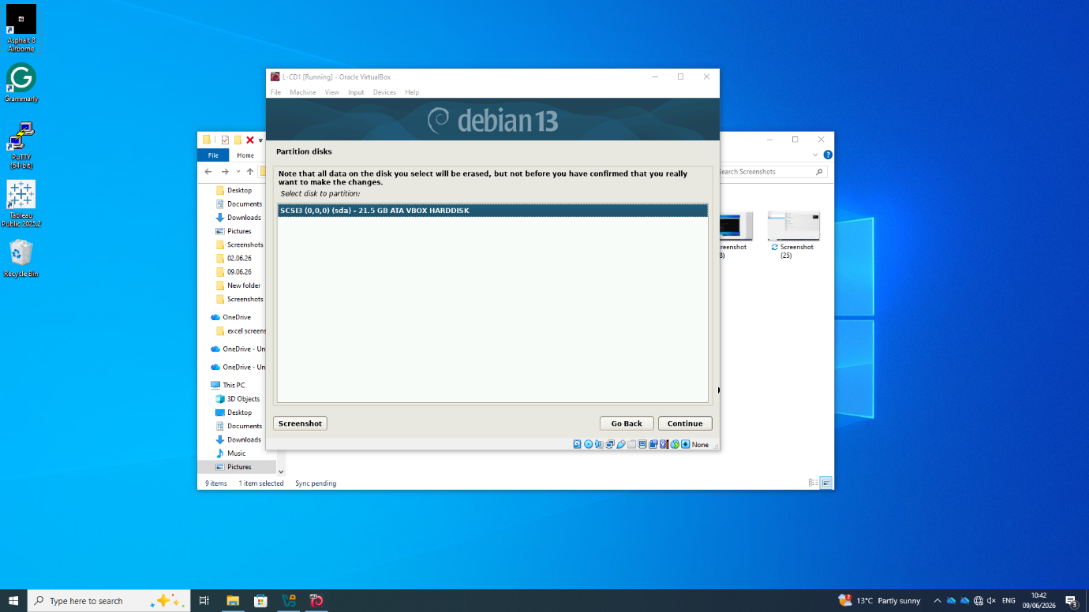
The IPv4 address, subnet mask and gateway information were entered manually to ensure that the Debian server could communicate reliably with the remaining devices in the enterprise network.

Figure 20. Applying the Network Configuration
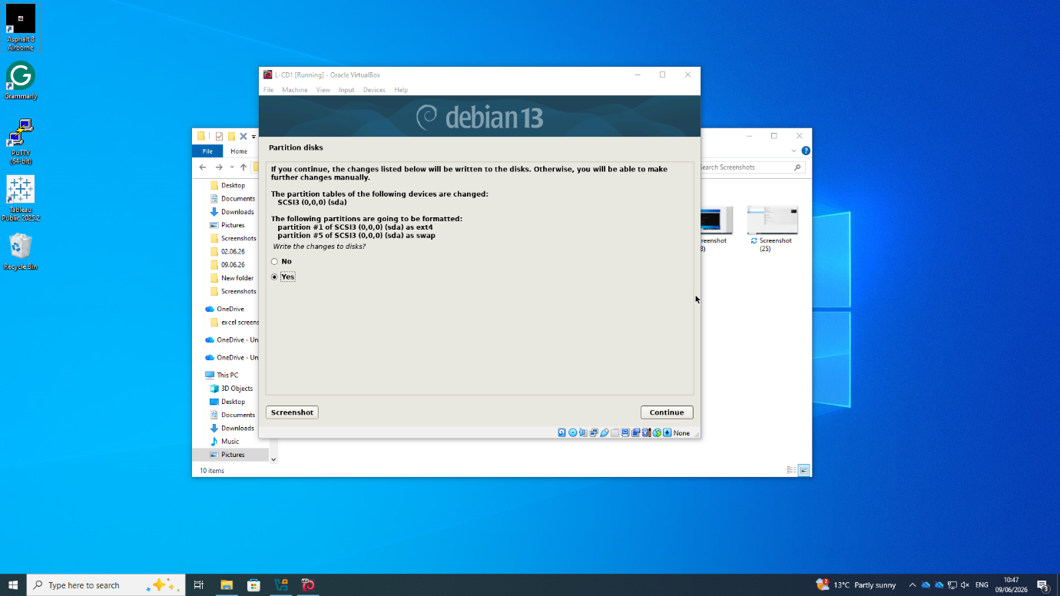
After completing the configuration, the network settings were applied, updating the active network interface with the newly assigned addressing information.

Figure 21. Verifying the Network Configuration
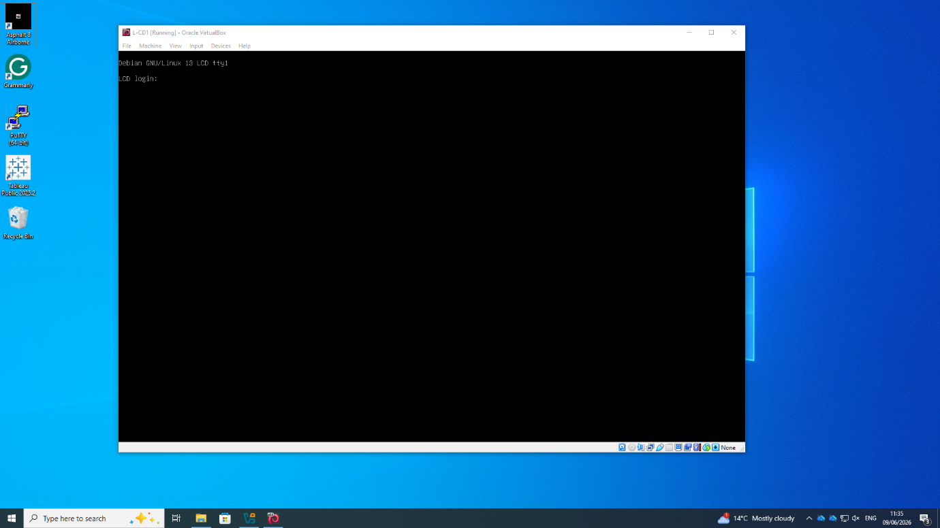
A command prompt was used to confirm that the configuration had been applied and that the interface was functioning as expected based on the required parameters.

As both Windows and Debian computers were configured, all virtual machines had been working with fixed IPv4 addresses according to the corporate address range. This ensured the stability for further testing and troubleshooting processes, which are discussed in the following section.
2.4 Test and Troubleshoot
After configuring all virtual machines, connectivity tests were performed to validate the IPv4 configuration, VirtualBox network adapters and communication between devices on the same subnet.

Figure 23. Verification of the Windows Server Network Configuration
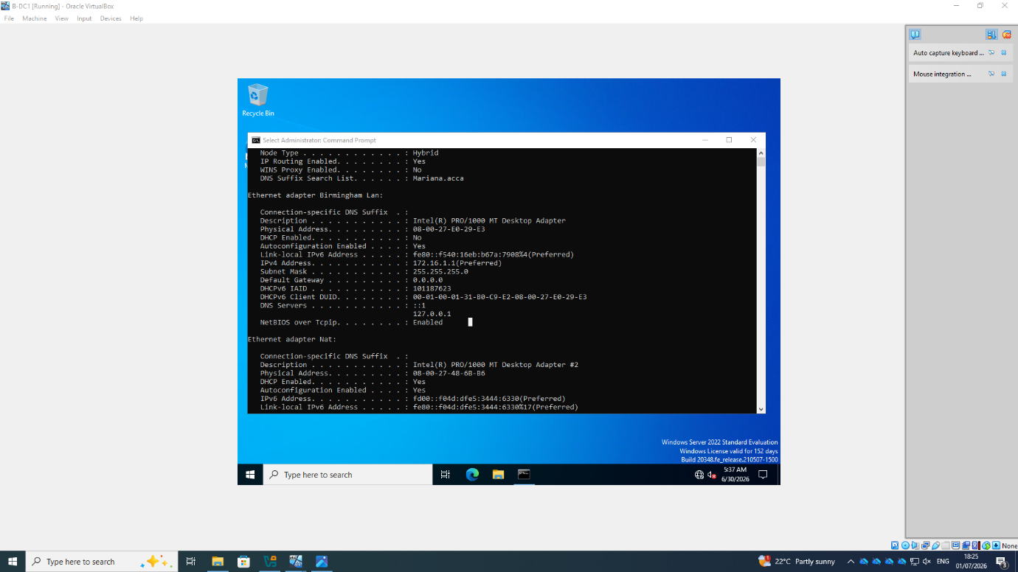 The Windows Server network interfaces were verified before testing to confirm that each adapter was connected to the correct network.
Figure 24. Validation of the Windows Server IPv4 Configuration
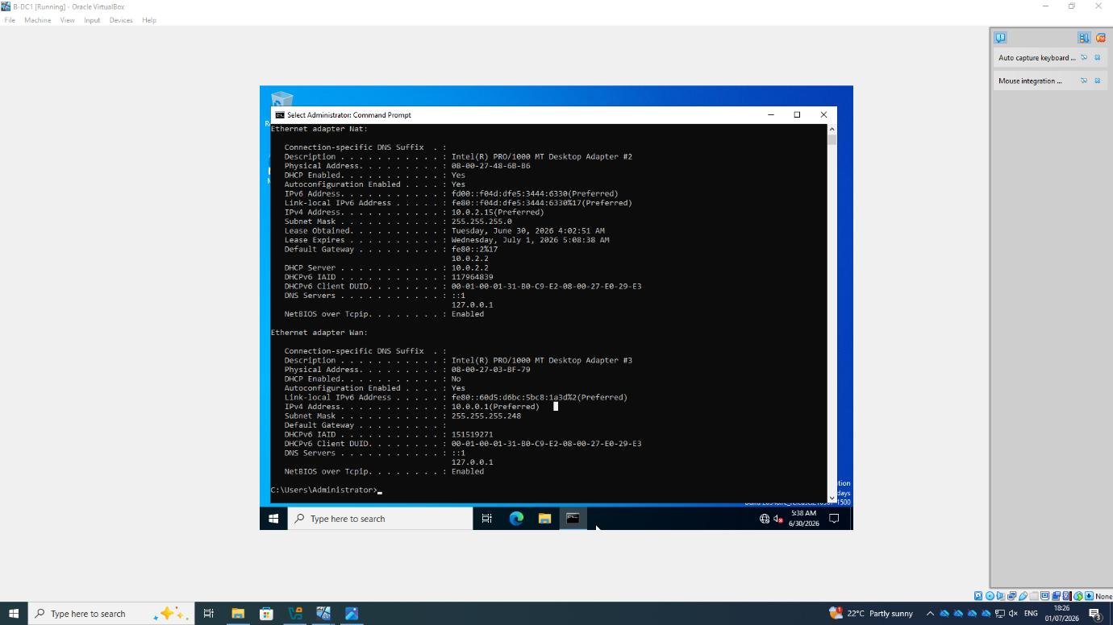
The IPv4 configuration was reviewed to confirm the correct IP addresses, subnet masks and DNS settings.

Figure 25. Successful Connectivity Test within the Birmingham Network
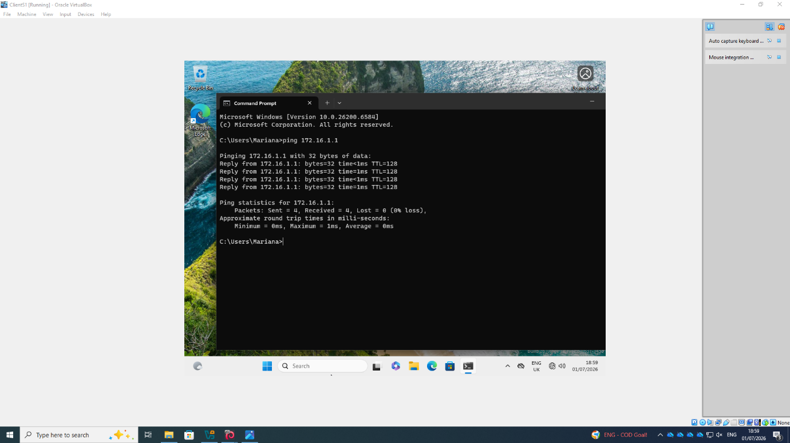
Ping tests confirmed successful communication between ClientS1 and B-DC1 with no packet loss, validating the Birmingham network configuration.
Figure 26. Successful Connectivity Test within the London Network
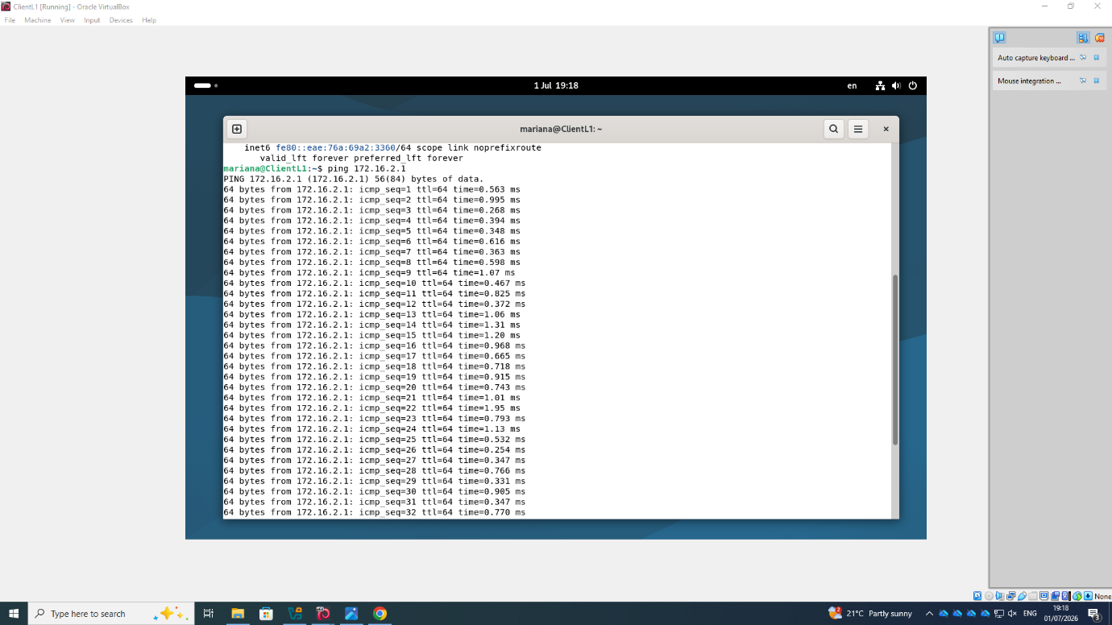
Ping results between ClientL1 and L-CD1 showed the successful operation of communication inside the London Network.
Configuration of the VirtualBox Network Adapters was examined to ensure each virtual machine is attached to the right network segment.

Figure 27. Verification of the VirtualBox Network Adapter Configuration
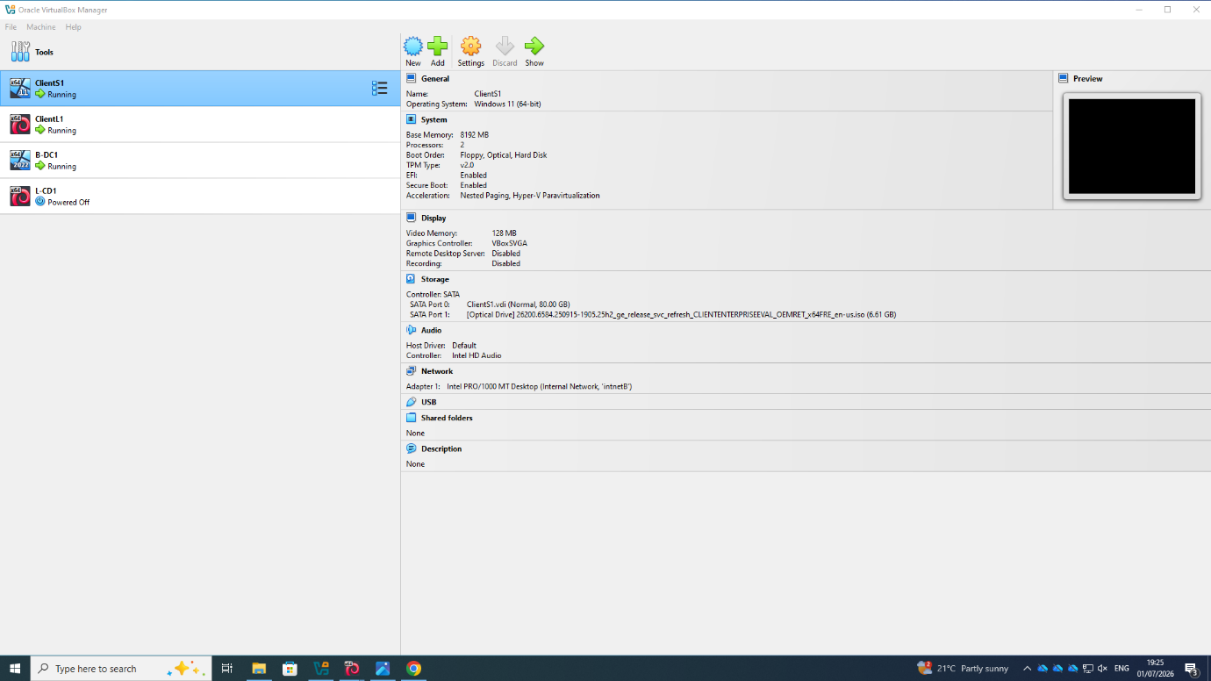
The VirtualBox adapter configuration matched the enterprise network topology.
Figure 28. Final Validation of the Virtual Network Deployment
Final testing showed that all virtual machines were properly configured for future network services.
Tests carried out proved that the deployed virtual network functioned correctly. Proper connectivity in both local area networks showed that IPv4 configuration and network settings in VirtualBox worked fine.

Task 3 – Personal & Technical Reflection
Conducting this assignment increased my knowledge of network deployment and virtualization for the enterprise. Setting up Windows Server 2022 and Debian within Oracle VirtualBox gave me hands-on experience in virtual networking, use of static IPv4 addresses in multilayered networks. Moreover, the process helped me build proficiency in setting up network interfaces and testing the configuration to ensure connectivity. Documenting the entire procedure, including taking relevant screenshots, helped me appreciate the significance of keeping proper documentation of the implemented setup.

Lista de referências (IEEE)
[1] P. Barham et al., "Xen and the Art of Virtualization," Proceedings of the 19th ACM Symposium on Operating Systems Principles (SOSP), Bolton Landing, NY, USA, 2003, pp. 164–177.
[2] TechTarget, "What's the difference between Type 1 vs. Type 2 hypervisor?" Available: https://www.techtarget.com/searchitoperations/tip/Whats-the-difference-between-Type-1-vs-Type-2-hypervisor. Accessed: Jul. 9, 2026.
[3] Oracle Corporation, Oracle VM VirtualBox User Manual. Available: https://www.virtualbox.org/manual/. Accessed: Jul. 9, 2026.
[4] J. F. Kurose and K. W. Ross, Computer Networking: A Top-Down Approach, 8th ed. Hoboken, NJ, USA: Pearson, 2021.
[5] W. Stallings, Data and Computer Communications, 11th ed. Harlow, U.K.: Pearson, 2020.
[6] Internet Engineering Task Force (IETF), RFC 8200: Internet Protocol, Version 6 (IPv6) Specification, Jul. 2017. Available: https://www.rfc-editor.org/rfc/rfc8200
[7] Tech Acad, Subnetting – Cisco Packet Tracer. YouTube video. Available: https://www.youtube.com/watch?v=fvFr7K5SRlM. Accessed: Jul. 9, 2026.
[8] Oracle Corporation, Oracle VM VirtualBox User Manual, 2025. [Online]. Available: https://www.virtualbox.org/manual/. [Accessed: 9-Jul-2026].
[9] W. Stallings, Network Security Essentials: Applications and Standards, 7th ed. Harlow, U.K.: Pearson, 2020.
[10] J. F. Kurose and K. W. Ross, Computer Networking: A Top-Down Approach, 8th ed. Hoboken, NJ, USA: Pearson, 2021.
[11] Microsoft, Active Directory Domain Services Overview. Available: https://learn.microsoft.com/windows-server/identity/ad-ds/get-started/virtual-dc/active-directory-domain-services-overview. Accessed: Jul. 9, 2026.
[12] Microsoft, DHCP Overview. Available: https://learn.microsoft.com/windows-server/networking/technologies/dhcp/dhcp-top. Accessed: Jul. 9, 2026.
[13] Oracle Corporation, Oracle VM VirtualBox User Manual, Version 7.x. Available: https://www.virtualbox.org/manual/. Accessed: Jul. 9, 2026.
[14] Oracle Corporation, Oracle VM VirtualBox – Technical Documentation. Available: https://www.virtualbox.org/. Accessed: Jul. 9, 2026.

