Name: Simona Elena Cotofan
Student nr. 2313525
Module name: Principles of Human Resource Management
Module code: LCBB5012

Environmental Factors' Impact on HR Manager Performance
A PESTLE Analysis of Unilever PLC

Table of Contents
1.) Introduction 2
1.1) Important HR Functions' Role 2
1.2) Report Structure 3
2.) Internal and External Environment 4
2.1) Business Environment Model- PESTEL Analysis 4
3.) Organisation Application- Unilever 5
4.) Using PESTLE in Unilever's Human Resources Procedures 7
4.1) Political Factors 7
4.2) Economic Factors 7
4.3) Social factors 8
4.4) Technological factors 8
4.5) Environmental factors 8
4.6) Legal Factors 9
5.) Conclusion 10
Bibliography 11

Environmental Factors’ Impact on HR Manager Performance

A PESTLE Analysis of Unilever Plc


Source: https://kpu.pressbooks.pub/hrcommunication/chapter/legal-principles-for-policies/

1.) Introduction

1.1) Important HR Functions' Role

Because they oversee the processes that attract, cultivate, inspire, and retain the people needed to implement strategy, human resource (HR) managers are crucial to an organisation’s success. Four roles are particularly significant. Organisational competence is directly shaped by recruitment and selection, which ensures that the firm recruits and selects individuals with the skills, values, and potential needed for current and future responsibilities. Training and development enhance employee competence and flexibility, which are vital for companies facing rapid technological or regulatory change (Price, 2023).
Performance management integrates individual goals with corporate goals, using appraisal, feedback, and incentives to support productivity and engagement. Employee relations manage the interaction between employer and employee, including communication, conflict resolution, and compliance with labour laws, thereby ensuring organisational stability and legitimacy. Together, these activities enable a company to establish a qualified and motivated workforce, in accordance with the law (Kenton , 2026).

1.2) Report Structure

This paper examines the effectiveness of human resource managers in international companies in relation to internal and external environmental factors. Organisational culture, leadership style, structure, resources, technology, and employee expectations are examples of internal factors that interact with the PESTLE analysis of external pressures, including political, economic, social, technological, legal, and environmental influences. These factors become more complex in global contexts because human resource managers must navigate diverse national cultures, labour regulations, economic conditions, and social norms. Using PESTLE, the report begins by describing the internal and external business environment and assessing its benefits and drawbacks. It then links the PESTLE elements to the core human resource functions, using a case study of the multinational consumer goods corporation Unilever, and examines how these elements affect Unilever’s human resource practices.

2.) Internal and External Environment

2.1) Business Environment Model- PESTEL Analysis
PESTLE is a helpful paradigm for assessing the external business environment. The six macroenvironmental variables PESTLE examines are political, economic, social, technical, legal, and environmental. The CIPD claims that PESTLE analysis aids businesses and human resources professionals in comprehending outside factors and applying this knowledge to strategic decision-making (CIPD, 2025). Because changes in government policy, labour markets, employee expectations, technology, employment legislation and sustainability demands significantly impact workforce decisions, this is pertinent for HR managers.
Government stability, trade policy, immigration laws, and employment policy are among the ways the political climate influences HR. For instance, a global corporation's ability to hire foreign talent may be impacted by modifications to visa regulations. Wage levels, labour supply, inflation, cost pressures, and employee financial well-being are all impacted by the state of the economy. HR managers may be under pressure to keep labour costs under control while maintaining employee motivation during periods of high inflation or slow economic growth. According to the International Labour Organisation, gender inequality, youth unemployment, and a delayed economic recovery have affected global labour markets, demonstrating how economic conditions directly influence workforce planning (International Labour Organization (ILO), 2026).
Cultural standards, employee values, work-life balance demands, diversity, and demographic shifts are examples of social influences. These elements affect employee relations, recruiting, inclusion, and employer branding. Automation, artificial intelligence, people analytics, digital hiring platforms, and remote work systems are examples of technological elements. These can increase HR efficiency but also need reskilling and ethical oversight. Employment contracts, minimum wage regulations, health and safety, discrimination laws, data protection, and collective labour rights are examples of legal considerations. Environmental factors are increasingly important because organisations are expected to operate sustainably, and HR managers must support green skills, a responsible culture and employee engagement with sustainability goals (Talent Management Institute, 2024).
PESTLE's primary benefit is that it provides HR managers with an organised method for examining the outside world. It helps them spot risks and opportunities before they become significant issues. For instance, HR managers can amend contracts, policies, and training if a nation enacts more stringent labour laws. HR can develop reskilling initiatives if technology alters work responsibilities. Because HR choices are linked to broader company concerns, PESTLE also aids strategic alignment (Pritula , 2024).
PESTLE analysis has two main drawbacks: it finds external elements without prioritising their significance, and it oversimplifies relationships. For instance technological advancements might have simultaneous consequences for the law, society, and the economy. Additionally, it ignores internal strengths and weaknesses in favour of simply focusing on the external environment; thus, combining it with SWOT, workforce analytics, or stakeholder analysis provides a more complete view. Combined internal-external awareness is crucial for HR managers because PESTLE is closely related to HR practice: hiring responds to labour markets, immigration policy, and digital platforms; training responds to technology and sustainability needs; performance management reflects culture and legal fairness; and employee relations depend on labour law, unions, and diversity expectations (CIPD, 2025).

3.) Organisation Application- Unilever

Unilever is a multinational consumer products corporation with operations in several nations. It has well-known brands in ice cream, personal care, nutrition, home care, and beauty and wellness. Unilever claims that its teams and employees work in almost 190 countries, demonstrating the breadth of its global reach. Unilever's HR managers must oversee employees in a variety of cultural, legal, and economic situations due to the company's global reach (The Editors of Encyclopaedia Britannica, 2026).
Talent, learning, inclusiveness, reward, wellbeing, and people analytics are all highly valued in Unilever's HR procedures. Talent, Equity, Diversity and Inclusion, Reward, Pensions and Benefits, Learning, Organisation Development, People Analytics, Employer Brand, and Global Health and Wellbeing are among the topics covered by its HR function's centres of excellence. This suggests that Unilever has a structured global HR approach in which specialised HR teams create policies and assist with their local implementation.
Employer branding, early-career programs, and international careers platforms are used to manage recruitment. For instance, Unilever supports graduate and apprenticeship programs in the UK and Ireland, such as the Unilever Future Leaders Programme, which helps graduates grow via training, mentorship, and placements. Because Unilever requires workers who can adapt to shifting customer tastes, sustainability standards, and digital change, training and development are crucial. Employee development, leadership, and corporate success are all related to performance management. Because Unilever works across nations with varying labour rights, employee voice systems, and cultural norms, employee relations are also important. Due diligence and governance procedures, which are crucial for controlling labour standards across international businesses and supply chains, form the foundation of its human rights policy (Unilever , 2025/2026).

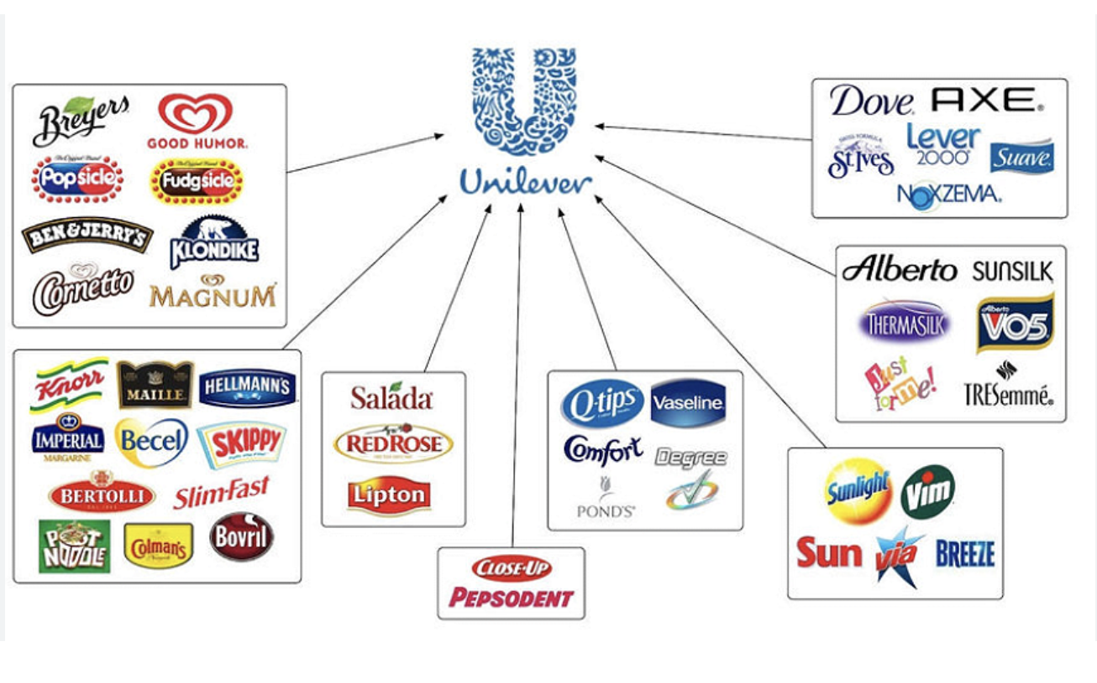
Source:https://strategicmanagementinsight.com/swot-analyses/unilever-swot-analysis/

4.) Using PESTLE in Unilever's Human Resources Procedures

PESTLE helps explain how environmental variables affect the efficacy of Unilever's HR managers. HR managers must strike a balance between local adaptability and global consistency, as Unilever is an international corporation. Common standards may be provided by a global HR strategy, but local employment legislation, culture, skill availability, and economic realities must all be considered while implementing it.

4.1) Political Factors
According to The Strategy Story,( 2026) Unilever's HR effectiveness is significantly affected by political issues. Because Unilever operates in about 190 countries, its HR managers are subject to a variety of government policies, such as trade restrictions, sanctions, and geopolitical instability. For instance, in 2026, as the Middle East conflict escalated, Unilever temporarily halted global hiring while it evaluated the operational impact of regional instability (Bhaimiya, 2026). HR managers must carefully plan workforce mobility in response to changing political conditions since political choices in specific markets, such as modifications to foreign investment requirements or work-permit rules, can affect how readily Unilever may transfer people across operating firms.

4.2) Economic Factors

Given Unilever's vulnerability to inflation, currency fluctuations, and consumer purchasing trends in both developed and developing economies, economic conditions have a significant impact on the company's HR strategy. Recent announcements of cost-cutting initiatives, such as the reduction of office-based positions as part of a larger efficiency drive, show how economic pressure can directly result in workforce reorganisation, redundancy management, and updated recruitment strategies, all which HR managers must carefully implement while preserving employee engagement. Local pay benchmarking and benefit affordability in comparison to more developed Western markets are also impacted by economic situations in developing economies, where Unilever makes a significant portion of its sales (Smithson, 2024).

4.3) Social factors
Shifting customer and employee expectations about well-being, diversity, and purpose-driven work are examples of social factors. These are particularly important for a consumer-facing firm like Unilever, whose employer brand is strongly linked to its public sustainability promises. Instead of using a single worldwide template for people policy, HR managers must adapt to a varied, multigenerational global workforce that spans widely disparate societal norms on gender roles, working hours, and family responsibilities (CIPD, 2016) (Unilever, 2026).

4.4) Technological factors
Through automation, learning platforms, digital hiring, and people analytics, technology impacts HR. People analytics, which implies that data is utilised to support worker choices, is part of Unilever's HR system.
By accelerating hiring, identifying talent shortages, and supporting performance management, technology may enhance HR effectiveness. But it also poses hazards. If algorithmic recruiting technologies are not adequately supervised, prejudice may result. Concerns about privacy and data security are also brought up by digital technologies. Automation can also alter work responsibilities and require reskilling. Therefore, HR managers need to make sure that workers are trained for new technology and that digital HR systems are used in an ethical manner ( Chapman, 2025).

4.5) Environmental factors
Because business strategy now includes sustainability, environmental considerations are increasingly impacting HR.
Environmental standards affect Unilever's culture, capabilities, and employee engagement. HR managers might have to hire workers knowledgeable about sustainability, educate employees about their environmental obligations, and align performance goals with sustainability objectives. Employer branding may also be impacted by environmental challenges. Many workers, particularly younger workers, favour companies that exhibit environmental and social responsibility. Thus, the capacity to facilitate long-term organisational transformation is just as important to HR performance as traditional people management (The Strategy Story, 2026).

4.6) Legal Factors
HR managers in multinational corporations are greatly impacted by legal considerations. Countries have very different employment laws. For instance, different jurisdictions have different laws governing working hours, termination, maternity rights, collective bargaining, minimum pay, data protection, and trade union rights. This implies that without local legal assessment, HR managers cannot simply implement a single worldwide policy. Because Unilever claims that its strategy is based on human rights due diligence and governance procedures, the company's human rights approach is pertinent in this case. Legal knowledge is crucial for HR managers to prevent conflicts, safeguard workers, and preserve the company's brand. HR managers risk legal repercussions, harm to the organization's reputation, and disgruntled employees if they disregard local legislation (The Strategy Story, 2026) (Unilever, 2026).

In summary, PESTLE demonstrates that the effectiveness of HR managers at Unilever is contingent on their ability to understand environmental forces and translate them into actionable HR policies. Political, economic, social, technical, legal, and environmental factors all influence hiring, training, performance management, and employee relations. The most successful HR managers are more than just administrators; they are strategic collaborators who support the company in adjusting to shifting external circumstances while safeguarding employee welfare and organisational effectiveness.

5.) Conclusion

The impact of environmental variables on HR managers' effectiveness in a worldwide organisation has been assessed in this paper. HR tasks, including hiring, training and development, performance management, and employee relations, are crucial because they guarantee that businesses draw in, nurture, manage, and keep the personnel required to meet their goals. Nonetheless, HR managers must work in both internal and external contexts, which can either increase or decrease their efficacy.
Because it offers a methodical approach to analysing political, economic, social, technical, legal, and environmental aspects, the PESTLE model is helpful. It assists HR managers in identifying opportunities and hazards that impact HR strategy and workforce planning. However, because PESTLE is wide, primarily external, and does not automatically prioritise the most relevant aspects, it also has drawbacks. It should thus be utilised in conjunction with HR data and internal analysis.
The application to Unilever demonstrates the need for consistency and adaptability in global HR management. Recruitment, learning, diversity and inclusion, reward, wellbeing, and people analytics are all part of Unilever's HR procedures. However, because cultures, labour laws, economic realities, and employee expectations vary among nations, these methods need to be modified. Labour relations and compliance are impacted by political and legal issues. Pay, retention, and talent availability are all impacted by economic considerations. Inclusion, employee expectations, and reskilling are influenced by social and technical variables. HR managers must also promote sustainability-related culture and competencies due to environmental concerns.
HR managers in multinational corporations will require improved strategic, digital, legal, and cultural competencies in the future. Artificial intelligence, unpredictability in the labour market, demands from sustainability, and changing employee expectations will all continue to alter the corporate environment. As a result, HR managers need to develop into strategic partners and proactive environmental scanners in addition to operational administrators. Building strong, moral, and successful international organisations will continue to need an understanding of environmental elements.

Bibliography
Chapman, T., 2025. Tech and Talent Help Unilever Transform Manufacturing. [Online]
Available at: https://manufacturingdigital.com/news/unilever-talent-tech-boosts-productivity
[Accessed 15 07 2026].
Bhaimiya, S., 2026. Unilever enforces global hiring pause due to ‘significant challenges’ amid Middle East conflict. [Online]
Available at: https://www.cnbc.com/2026/03/31/unilever-global-hiring-pause-us-iran-war-challenges-.html
[Accessed 13 07 2026].
CIPD, 2016. Valuing your talent: Unilever. [Online]
Available at: https://www.cipd.org/uk/knowledge/case-studies/value-talent-unilever/
[Accessed 14 07 2026].
CIPD, 2025. PESTLE analysis. [Online]
Available at: https://www.cipd.org/en/knowledge/factsheets/pestle-analysis-factsheet/
[Accessed 07 07 2026].
International Labour Organization (ILO), 2026. About the ILO. [Online]
Available at: https://www.ilo.org/about-ilo
[Accessed 07 07 2026].
Kenton , W., 2026. Roles and Responsibilities in Business. [Online]
Available at: https://www.investopedia.com/terms/h/humanresources.asp
[Accessed 03 07 2026].
Price, J., 2023. Why HR Is Key To Executive Success: How The Human Resources Function Impacts Business Growth. [Online]
Available at: https://www.forbes.com/councils/forbeshumanresourcescouncil/2023/02/08/why-hr-is-key-to-executive-success-how-the-human-resources-function-impacts-business-growth/
[Accessed 03 07 2026].
Pritula , M., 2024. PESTLE Analysis Templates and Actionable Guide. [Online]
Available at: https://us.pritula.academy/blog/tsy8sxb1r1-pestle-analysis-templates-and-actionable
[Accessed 09 07 2026].
Smithson, N., 2024. Unilever PESTEL/PESTLE Analysis & Recommendations. [Online]
Available at: https://panmore.com/unilever-pestel-pestle-analysis-recommendations
[Accessed 13 07 2026].
Talent Management Institute, 2024. Performing a PESTLE Analysis for Strategic HR Planning. [Online]
Available at: https://www.tmi.org/blogs/performing-a-pestle-analysis-for-strategic-hr-planning
[Accessed 09 07 2026].
The Editors of Encyclopaedia Britannica, 2026. Unilever. [Online]
Available at: https://www.britannica.com/money/Unilever#ref477530
[Accessed 10 07 2026].
The Strategy Story, 2026. Unilever PESTEL Analysis. [Online]
Available at: https://thestrategystory.com/blog/unilever-pestel-analysis/
[Accessed 13 07 2026].
Unilever , 2025/2026. Unilever Future Careers. [Online]
Available at: https://tbcdn.talentbrew.com/company/34155/gst_v1/lib/unilever-ec-brochure-uk-2025.pdf
[Accessed 10 07 2026].
Unilever, 2026. A beacon of diversity and inclusion. [Online]
Available at: https://www.unilever.com/sustainability/equity-diversity-and-inclusion/a-beacon-of-diversity-and-inclusion/
[Accessed 14 07 2026].
Unilever, 2026. Human Rights in our own operations. [Online]
Available at: https://www.unilever.com/sustainability/respect-human-rights/human-rights-in-our-own-operations/
[Accessed 15 07 2026].

