BA (Hons) Leadership and Management Skills for the Workplace
UNIVERSITY OF WALES TRINITY SAINT DAVID

Emergent Leadership Skills for the Workplace
(BMDSW6101)
Part 1 Report
Student name: Roman Kadlubiec
Student Id: 1916730
Lecturer: Charles Nwaogwugwu

EXECUTIVE SUMMARY
This report analyses the critical role of effective leadership in creating a healthy workplace and driving success in ABC.inc. The report highlights the role of several leadership styles, like autocratic, transformational, democratic leadership and situational, in the creation of a positive environment in a workplace.
The report further discusses the usual barriers to effective leadership, for examples poor communication, lack of self-awareness, resistance to change, fear of failure, and emotional intelligence related problems. For an organization like ABC.inc. To be able to overcome such challenges, it needs to make some investments in leadership development, promotion of an innovative culture, and employee empowerment.
In addition, this report highlights the importance of ethical leadership in trust building, encouraging a positive culture in the organization, and minimizing the risks. In a positive work environment, an ethical leader prioritizes fairness, integrity, as well as honesty, inspiring their employees.
Addressing the leadership crisis at ABC Inc., requires them to prioritize the CEO’s selection by focusing on a person with a clear vision, strong leadership qualities, and a committed to ethical behaviors.

TABLE OF CONTENTS

1.INTRODUCTION…………………………………………………………………………………..3
2.IMPORTANCE OF EFFECTIVE LEADERSHIP SKILLS AND ITS CONTRIBUTION TO A HEALTHY WORKPLACE………………………………………………………………………….3,4
3.IMPORTANCE OF EFFECTIVE LEADERSHIP STYLES AND ITS CONTRIBUTION TO HEALTHY WORKPLACE………………………………………………………………………….5,6
4. HOW CAN MANAGEMENT TACKLE THE BARRIERS TO EFFECTIVE LEADERSHIP IN THE WORKPLACE………………………………………………………………………………..6,7
5.THE IMPORTANCE OF ETHICAL LEADERSHIP IN THE WORKPLACE SUCH AS ABC INC 8
6.RECOMMENDATION FOR A STRATEGIC APPROACH TO SELECTING ABC INC……9,10
7.CONCLUSION 10
8. REFERENCES……………………………………………………………………………….10,11

1.INTRODUCTION
The technological landscape is rapidly evolving today, all industries are undergoing huge transformations. With AI-powered solutions emerging as effective tools in improving client’s outcomes are streamlining organization’s operations. Many IT companies stand out as the drivers of this revolution, by developing innovative AI-driven solutions that address critical challenges in the various industries.
On the other hand, when a company like ABC.inc rapidly scales up, it begins to face many challenges, like acquisition and retention of the best talent, maintenance of the quality of their products, as well as making sure that their customers remain satisfied. Overcoming such and sustaining ABC.inc’s growth trajectory required the company to recognize the main importance of having a strong leadership. An investment in a good leadership development program enables the company to develop a robust leadership pipeline, empowering emerging leaders, and fostering the culture of innovation and excellence.

1.1 Emergent leadership

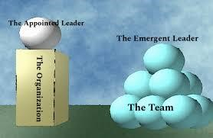
Joshua (2019)

Emergent leadership is referred to as the natural emergence of an individual as a leader from within a group, contrary to the normal formal appointment into a leadership position. This tends to happen organically based on that person’s influence, actions, as well as capacity to meet the needs of the group (Garcia, 2015). Emergent leaders often have certain aspects that make them emergent in nature, such as the following characteristics below.

These leaders can naturally influence the group using their behaviors and respect earned from peers. They tend to be flexible and adaptable and can easily step up to lead group when needed. Emergent leaders have high competence levels as well as relevant skills in meeting the group’s goals. Their unique ability to understand as well as effective management of the group dynamics, encouraging cooperation as well as cohesion. And can be recognised and accepted by their peers as their leader (Hanna etal., 2021).

2.IMPORTANCE OF EFFECTIVE LEADERSHIP SKILLS AND ITS CONTRIBUTION TO A HEALTHY WORKPLACE.

Effective leadership is key to the success of any organization. It is the key to motivating innovation in the workplace, driving productivity, and encouraging a positive work environment. With a strong leader employees are inspired and motivated, which builds cohesiveness among team members, and the navigation of complex workplace challenges. The world today is full of rapidly changing business landscapes and industries. This means that the importance of effective leadership is very critical in today’s workplace and world. However, being a strong leader is not enough if the person does not have a special blend of skills and qualities to assist them in inspiring and guiding their teams (Koinig and Diehl, 2021).

Such skills include the following set of skills below (Duttweiler and Hord, 1987).

a) Visionary Leadership
An effective leader should have the ability to clearly explain the company’s compelling vision for the future and they do this by inspiring team members to work towards the shared common goal and vision.

b) Strategic Thinking
An effective leader should be capable of analyzing very complex situations, and should be good at identifying opportunities, as well as developing effective strategies for the company.

c) Effective Communication
An effective leader should have the skill of explaining ideas clearly and concisely, in written format and verbally, as a way of building trust and fostering collaboration.

d) Emotional Intelligence
An effective leader should have the ability to understand and manage their own emotions and those of their teammates, which leads to a very strong interpersonal relationship with their team mates as well as resolve conflicts effectively.

e) Decision-Making Skills
An effective leader should have the ability to make informed decisions on time no matter how ambiguous the situation they in.

f) Adaptability and Resilience
An effective leader should have the capability to adapt to change and bounce back from any setbacks.

g) Team Building and Collaboration
An effective leader should have the skill of building teamwork, encouraging collaboration, and a positive work environment.

2.1 The contributions of effective leadership in a healthy workplace
Effective leadership can make many positive contributions to a positive workplace. Some of these contributions include increased employee morale, enhanced job satisfaction, reducing employee turnover, better and stronger organization culture, improving company financial performance and increased innovation and creativity in the workplace (Levinson, and Sperry, 2013).

Effective leaders provide inspiration and motivation to their employees, which increases their sense of purpose, belonging and employee morale. On the other hand, this improves the Productivity levels in a workplace as a positive work environment that has been created provides clarity in terms of expectations, leads to effective communication, and the proper employee recognition on top of this will improve work efficiency (Bazigos etal., 2016).

Effective leadership contributes to Job Satisfaction as the employees feel more valued, respected. This in turn reduces the employee turnover levels through the creation of a more positive work culture which provides employees with opportunities for growth and development. The stronger the positive workplace culture, the stronger the organizational culture of that workplace gets. This is very important when the company is trying to encourage the organization’s desired behaviors (Conger, 1990).

Effective leadership contributes to an increase innovation as well as levels of creativity. This is so because effective leadership encourages employees in creative thinking and coming up with innovative solutions. In the end this can improve the financial performance of the company by driving business growth, increasing profitability, and enhancing the company’s’ shareholder value (Nanjundeswaraswamy, and Swamy, 2014).

3.IMPORTANCE OF EFFECTIVE LEADERSHIP STYLES AND ITS CONTRIBUTION TO HEALTHY WORKPLACE

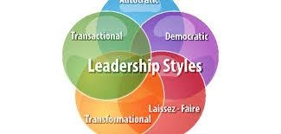
Sethuraman and Suresh (2014).

Effective leadership is a concept with many faces encompassing several leadership styles, each having strengths as well as weaknesses. The leadership style selected by a leader has a huge impact on the health as well as productivity of the company. A healthy workplace tends to have very high employee morale, strong teamworking, as well as a positive organizational culture. Having effective leadership in a company contributes greatly to the creation of a positive environment (Sethuraman and Suresh, 2014).

TRANSFORMATIONAL LEADERSHIP STYLE
The first effective leadership styles referred to as the transformational leadership style. In this style of leadership, the leader inspires and motivates the teams through setting a clear vision, effective communication, as well as demonstration of high ethical standards. This way employees are empowered, creativity encouraged, and a culture of innovation is built. Transformational leaders use charisma most of the time, stimulating intellect, as well as personalized consideration as a way of motivating and inspiring their followers (Veliu etal., 2017).

SERVANT LEADERSHIP
The second leadership style is referred to as servant leadership. In this style, a servant leader prioritizes the needs of the team members over their personal needs. The leader focuses on building relationships, empowering others, and in so doing, they create a positive work environment. A servant leader exhibits empathy, has strong listening skills, as well as the strong desire to help others (Veliu etal., 2017).

SITUATIONAL LEADERSHIP
The third leadership style is called the situational leadership style. This approach puts more emphasis on the adaptation of their leadership style to one that enables them to meet the needs of the team in a particular situation as well as those of the people involved. Such as style acknowledges the fact that each unique situation requires a different leadership approach (Veliu etal., 2017).

DEMOCRATIC LEADERSHIP
The fourth leadership style is a democratic leadership style where the members on the team are involved in the decision-making processes of the company. This style creates a sense of ownership as well as empowers employees, which leads to an increase job satisfaction as well as productivity (Veliu etal., 2017).

LAISSEZ-FAIRE LEADERSHIP
The fifth leadership style is referred to as the Laissez-faire leadership style. This is used as a hands-off approach by providing very limited guidance and direction. Such style can be effective situations, but on the other hand it tends to demotivate the team due to the lack of direction it offers (Agarwal, 2020).

However, the choice of leadership style has a significant impact on the health as well as productivity of the company. An effective leader needs to be flexible enough adapting their style to situation and people involved. Understanding the strengths as well as the weaknesses of these leadership styles helps leaders in the creation of a positive work environment, fostering creativity, innovation, and employee satisfaction.

4. HOW CAN MANAGEMENT TACKLE THE BARRIERS TO EFFECTIVE LEADERSHIP IN THE WORKPLACE.

Having effective leadership is an important factor in the success of any company. However, there are many barriers hindering the leaders’ ability to achieve the set goals. Proper identification as well as addressing the barriers, organizations can create a positive work environment improving the general performance of the company (Bassi and Shinde, 2024).

4.1 Barriers to Effective Leadership
Some of the common barriers to effective leadership include the following:

Firstly, the lack of self-awareness which limits the leader's capacity to understand their weaknesses and strengths, which in the end leads to poor decision-making and negatively affects interpersonal relationships. This is followed by poor communication skills leading to misunderstandings, which decreases morale, and reduces productivity (Newton, 2002).

Secondly the fear of failure tends to stifle innovation preventing leaders from taking the necessary risks to ensure company success. Is there any form of resistance to changing progress as well as the implementation of any new initiatives that may be hindered (Barnwell Jr, 2015.).

Thirdly, the lack of emotional intelligence, an important factor in the building of strong work relationships as well as effective conflict resolution. On top of this micromanagement is another barrier that tends to stifle creativity, reducing employee morale, and hindering productivity. In such cases there is also a problem of lack of delegation as the leaders fail to delegate tasks certain tasks, they may get overloaded with work which limits their team members’ development (Barnwell Jr, 2015).

4.2. Strategies to overcome barriers to effective leadership

For any organization to run a successful operation, they need to be able to address the barriers to effective leadership. The organization needs to implement the following strategies to address these barriers.

The company should conduct self-awareness as well as personal development sessions from time to time to encourage its leaders in the practice of engaging in self-reflection and seeking feedback from others. During this process, the company provides the leaders with

opportunities for leadership development, like mentoring, coaching, and training programs (Wright, 2022).

Effective communication training should be conducted on a regular basis with the organization making huge investments in communication training programs which enhance their leaders' capacity in articulating the company’s vision, providing clear instructions, as well as active listening to their team (Wright, 2022).

The company needs to cultivate a culture of innovation, encouraging the idea of taking risks and experimentation through the celebration of the subsequent successes while learning from the consequent failures. On top of this, the company should be able to provide resources and support to employees with innovative ideas (Wright, 2022).

Change Management Strategies are to become the norm of the organization with clear and effective communication regarding the reasons for change as well as the benefits brought about by the change. Employees need to be involved in the change-making process as this increases the employee buy-in and reduces resistance. Constant provision of training and support encourages employees’ adaptation to the change (Wright, 2022).

Promotion and provision of emotional intelligence training programs to enable leaders in the development of emotional intelligence skills, like self-awareness, empathy, self-regulation, as well as social skills. Moreover, other approaches such as delegation and empowerment are essential in strengthening trust among team members, when it comes to taking ownership of tasks and making decisions. In a way, clear expectations and support should also be provided to empower employees.

Lastly mentorship and coaching are key in overcoming barriers to effective leadership. The company can do this by establishing mentorship programs connecting experienced leaders with emerging talent. The provision of coaching opportunities helps leaders in the development of their leadership skills and overcome challenges. Properly addressing these barriers as well as implementing effective strategies, enables companies to cultivate a strong leadership culture, driving success and fostering a positive work environment according to Smith, (2022).

5.THE IMPORTANCE OF ETHICAL LEADERSHIP IN THE WORKPLACE SUCH AS ABC INC.

Ethical leadership is the foundation upon which any company is built. Leadership sets the tone for the entire company’s operations, as it influences the behavior’s as well as the decisions of all employees. As for ABC Inc., a company struggling because of its leadership challenges, having ethical leadership is key in restoring employee trust, rebuilding employee morale, as well as providing the company with long-term sustainability.

Having ethical leaders leads to prioritization of fairness, integrity, and honesty in all the company dealings. Ethical leaders embody such values in their actions as well as decisions, which sets a positive example for their followers. When a leader acts ethically, they can build trust with customers, employees, as well as other stakeholders. Such trust is important in the creation of a positive work environment to achieve company goals according to Chughtai (2015).

Ethical leaders also play an important role in the promotion of a strong organizational culture, where ethics and integrity significantly affect morale and productivity, as well as the overall job satisfaction of the employee. Upon seeing their leaders acting ethically, employees have high chances of following suit. This leads to a positive as well as supportive work environment, with employees feeling more valued and respected.

Moreover, ethical leadership is vital in managing risks. Adhering to such ethical principles, it helps companies like ABC Inc to avoid possible legal as well as reputational risks. Ethical leaders can identify any potential ethical dilemmas as well as take more proactive steps in addressing them. This helps in the prevention of lawsuits, scandals, as well as other consequences of a negative nature.

As per the case of ABC Inc., ethical leadership will be vital in helping in the restoration of the company's reputation as well as rebuilding trust with stakeholders. With a demonstration of transparency, integrity, and fairness, the new leadership will be able to inspire confidence as well as motivation of employees. A strong ethical foundation helps in attracting and retaining the top talent, because employees become more drawn to an organization that prioritizes ethical behaviors.

6.RECOMMENDATION FOR A STRATEGIC APPROACH TO SELECTING ABC INC.

The unexpected quick turnover of CEOs at ABC Inc. is affecting morale, productivity, as well as the general performance of the organization. Addressing such a leadership crisis as well as securing a stable future is a priority for the company’s Board of Directors. The Board of Directors need to apply a more rigorous as well as strategic approach in selecting the next CEO.
For a successful CEO selection, several considerations as indicated below should be made during the hiring and selection process.

Clarity of vision as well as strategic alignment
ABC Inc.’s board of directors should define the role by clearly articulating the key expectations, responsibilities, as well as performance metrics of this CEO position. In addition, an assessment of the cultural fit must be done through the identification of a candidate aligning with the company's culture, values, and long-term vision. Strategic acumen is a key consideration and thus, priority should be given to candidates with a track record of strategic thinking, problem-solving and innovation as suggested by Ritchie-Dunham and Puente (2008).

Strong Leadership Qualities
ABC’s newly selected CEO should have effective communication skills. Seeking a leader with a clear articulation of the company’s vision as well as effective communication with employees, and other stakeholders, is very important. Moreover, prioritization of candidates with strong emotional intelligence capable of building relationships, resolving conflicts, and inspiring trust is very important. The company should hire a candidate capable of making sound decisions, especially under pressure, and can operate comfortably with ambiguity (Krasnoff etal., 2015).

Crisis Management and Resilience
Because of the company's recent leadership struggles history, the board of ABC Inc. should select a leader with experience in the navigation of the most challenging situations as well as effectively managing crises. The board needs to conduct an assessment on the new CEO’s ability to remain calm under high pressure as well as making rational decisions according to Tait, (1996).

Ethical Leadership
The management should mainly focus on those candidates who have a very strong ethical compass as well as their commitment to integrity. As such the board needs to select capable of encouraging a culture of good ethics as well as compliance. The moreover the new CEO should have a long-term perspective in terms of the vision for the company maintaining their commitment to sustainable growth.

The Selection Process
The Board of ABC Inc must set up a very strong selection committee. By establishing a diverse selection committee made up of senior executives, board members as well as external experts. The roles and responsibilities of the committee should be clearly defined. This will include comprehensive candidate profiling where a very detailed profile outlining the most suitable candidate's experience, skills, as well as qualifications is made into consideration of ABC Inc’s specific needs as well as the challenges (Tait, 1996).

The Board should make use of a rigorous selection process by conducting thorough background checks as well as reference checks, using several assessment tools like cognitive ability tests, personality tests and situational judgment tests. Furthermore, they should conduct multiple rounds of interviews, including case-based interviews as well as behavioral based interviews.

Engage with Key Stakeholders
By seeking input from customers, employees, and other stakeholders to get some insight into the type of qualities desired by the next CEO. The company can make use of employee surveys and focus groups.
If followed by ABC Inc, these recommendations can increase the company’s chances of selecting the most suitable next CEO, capable of restoring stability, driving growth, and ensuring the long-term success of the company.

7.CONCLUSION
In conclusion, ethical leadership is a very important part of an organization like ABC inc’s success. Therefore, promoting fairness, integrity, and honesty, would enable emergent leaders in the creation of a positive work environment, building strong relationships with stakeholders, and enhancing the organization’s long-term sustainability. ABC Inc. ABC would need to prioritize ethical emergent leadership to be able to overcome the challenges the company is currently facing and emerge as a stronger, as well as more sustainable company.

8.REFERENCES

Agarwal, S., (2020). Leadership Style and Performance of Employees. International Research Journal of Business Studies, 13(1).
Barnwell Jr, D.J. (2015.) Strategies to overcome barriers to a more effective leadership style. Walden University.
Bassi, D. and Shinde, A., (2024). Barriers to successful change management. Management in Healthcare, 8(3), pp.271-283.
Bazigos, M., Gagnon, C. and Schaninger, B. (2016). Leadership in context. McKinsey Quarterly, 1, pp.72-79.
Chughtai, A.A. (2015). Creating safer workplaces: The role of ethical leadership. Safety Science, 73, pp.92-98.
Conger, J.A., (1990). The dark side of leadership. Organizational dynamics, 19(2), pp.44-55.
Duttweiler, P.C. and Hord, S.M., 1(987). Dimensions of Effective Leadership.
Garcia, I. (2015). Emergent leadership: Is e-leadership importance in the quality of virtual education?. RIED-Revista Iberoamericana de Educación a Distancia, 18(1), pp.25-44.
Hanna, A.A., Smith, T.A., Kirkman, B.L. and Griffin, R.W. (2021). The emergence of emergent leadership: A comprehensive framework and directions for future research. Journal of Management, 47(1), pp.76-104.
Koinig, I. and Diehl, S. (2021). Healthy leadership and workplace health promotion as a prerequisite for organizational health. International Journal of Environmental Research and Public Health, 18(17), p.9260.
Krasnoff, B., Leong, M. and Siebersma, M. (2015). Leadership qualities of effective principals. Education Northwest, 4, pp.1-10.
Levinson, H. and Sperry, L. (2013). Effective leadership: Strategies for maximizing executive productivity and health. Routledge.
Nanjundeswaraswamy, T.S. and Swamy, D.R. (2014). Leadership styles. Advances in management, 7(2), p.57.
Newton, J. (2002). Barriers to effective quality management and leadership: Case study of two academic departments. Higher education, 44, pp.185-212.
Ritchie-Dunham, J.L. and Puente, L.M., (2008). Strategic clarity: actions for identifying and correcting gaps in mental models. Long Range Planning, 41(5), pp.509-529.
Sethuraman, K. and Suresh, J. (2014). Effective leadership styles. International Business Research, 7(9), p.165.
Smith, W.T. (2022.) Effective Leadership Strategies to Engage Employees. Walden
University.
Tait, R., (1996). The attributes of leadership. Leadership & Organization Development Journal, 17(1), pp.27-31.
Veliu, L., Manxhari, M., Demiri, V. and Jahaj, L., (2017). The influence of leadership styles on employee's performance. Management (16487974), 31(2).
Wright, S., (2022). Leadership strategies for improving employee engagement (Doctoral dissertation, Walden University).

BA (Hons) Leadership and Management Skills for the
Workplace
UNIVERSITY OF WALES TRINITY SAINT DAVID

Emergent Leadership Skills for the Workplace
(BMSW6101)
Part 2 Reflective Essay
Student name: Roman Kadlubiec
Student Id: 1916730
Lecturer: Charles Nwaogwugwu

TABLE OF CONTENTS
1. INTRODUCTION 13
1.1Individual reflection on my emergent leadership 13
Description 15
Feelings 15
Evaluation 15
Analysis 16
Conclusion 16
Action Plan 16
Analysis 16
2.IMPACT ON PERSONAL GROWTH 16
2.2. How can I apply this in Professional Settings 16 ,17
3.CONCLUSION 17
4.REFERENCES 17
Appendix Class Activity Questionnaires………………………………………………………17-20

1. INTRODUCTION

1.1Individual reflection on my emergent leadership.
My personal reflection on emergent leadership is my position as an emergent health and fitness leader at my workplace. I apply Gibbs reflective cycle to examine my personal experiences as well as learn from them. As suggested by Gibbs (1977), the reflection follows six stages. These include, description, feelings, evaluation, analysis, conclusion, and an action Plan. As indicated below I applied Gibbs' Reflective Cycle in exploring my emergent leadership.
Figure.1
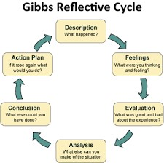
Gibbs (1977)

Figure 2. self- Assessment exercise
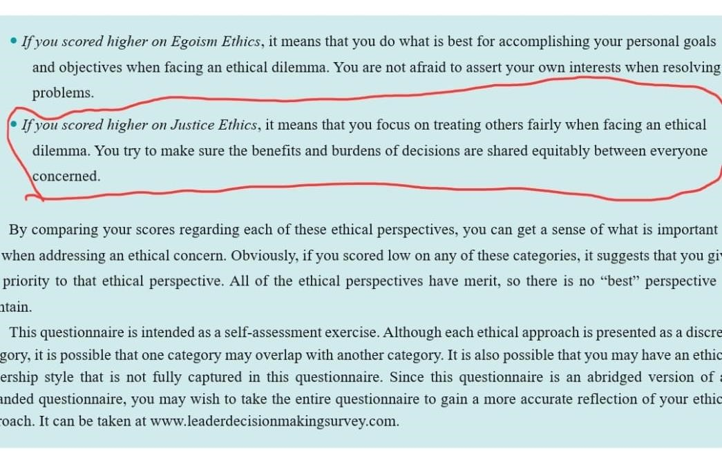
Source: Author

Description
Emergent leadership is referred to as the natural emergence of an individual as a leader from within a group, contrary to the normal formal appointment into a leadership position. This tends to happen organically based on that person’s influence, actions, as well as capacity to meet the needs of the group (Garcia, 2015).

This reflective essay focuses on my experience within a group of people where my emergent leadership played an important role. The task involved a team of workmates tasked with developing a health fitness program at my workplace. In the beginning no official leader had been selected to lead the team, and the group had to go through all the dynamics of group formation to achieve the health fitness goals.

Feelings
At the beginning of the task, not having a formal leader brought about a sense of uncertainty as well as hesitation among members of the team. I felt anxious regarding the management of coordination as well as decision-making due to lack of a clear direction. But, as the task progressed, the group dynamics started shifting. I found myself consistently providing valuable insights as well as facilitating discussions. My calmness and active listening skills made me a central figure in all team interactions. This created relief and admiration for the team members. They were happy to have someone naturally guiding the team, although deep within me, I kept wondering whether my leadership would not be challenged by any member as suggested by Nanjundeswaraswamy and Swamy (2014).

Evaluation
My emergent leadership has both negative and positive aspects. On the positive side, my leadership style proved inclusive and collaborative. As indicated in the self-assessment exercise in figure.2 above. I encouraged freedom of speech, creating a diverse range of ideas. My influence created a sense of unity and commitment in the health and fitness team. But, initially, some team members tried to resist acknowledging me as their leader because I had not formally been appointed leading to occasional friction slowing down the decision making process as suggested by Yoo and Alavi (2004).
Figure 3.
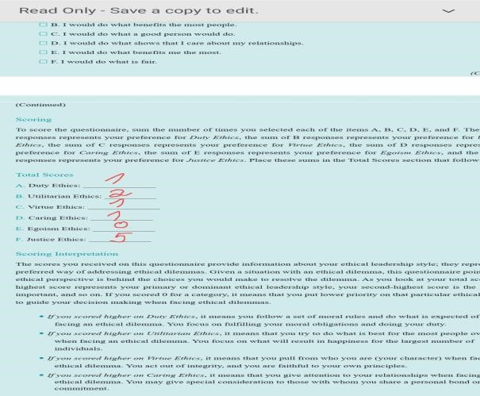
Source: Author

Analysis
The emergent leadership, I demonstrated, shades some light on several principles. Below.
- Effective leaders emerge naturally based on their actions and contributions and not their titles.
- My clear communication, active listening skills, and provision of constructive feedback demonstrated that I am a natural leader.
- An emergent leader must be highly adaptive. Hence, my approach kept evolving to meet the team's needs, which showed my flexibility and responsiveness aligning with the situational leadership theory (Veliu etal., 2017).
- I earned the respect of my teammates because of my competence and integrity, which are critical components of effective leadership meaning that influence and respect are important in emergent leadership as indicate din figure .3.

Conclusion
In conclusion, emergent leadership significantly impacts the team dynamics and success. My natural leadership emerged via my consistent contributions as well as my ability to connect with my team members emotionally. This experience has taught me that leadership is not only achieved through formal titles but can also come organically from individuals demonstrating the qualities of an effective leader. This experience made me realize that being open and supportive is very important for emergent leaders.

Action Plan
My plan for emergent leadership in future tasks is the adoption of several strategies. Such as actively encouraging open communication and collaboration among team members giving potential leaders a chance to emerge naturally. I intend to observe all the team dynamics and contributions, ensuring recognition and support of the ones demonstrating leadership qualities. Enhancing leadership skills, such as emotional intelligence, effective communication, as well as ability to adapt, and preparation for a leadership role when needed.

Analysis
This reflection on emergent leadership using Gibbs' Reflective Cycle has further increased my understanding of the development of leadership in a team. Clearly emergent leadership is not only about taking control but also about building a work environment where employees are empowered (Smith, 2022).

2.IMPACT ON PERSONAL GROWTH
This experience has made a big contribution to my personal growth. Through observing and supporting my leadership, I've learned what it means to be hamble as well as what it means to lead by example. And that leadership is about supporting others and guiding them. Such a perspective shapes my approach to team dynamics as well as future leadership opportunities.

2.2. How can I apply this in Professional Settings
When it comes to a professional setting, recognition and nurturing of emergent leadership leads to the creation of a dynamic as well as resilient team. An organization benefits from the creation of cultures valuing the members’ contributions, which allows natural leaders to lead when needed.

3.CONCLUSION
In conclusion, emergent leadership remains a powerful phenomenon in enhancing team performance as well as cohesion. My reflection on the experience using Gibbs' Reflective Cycle, has given me valuable insights into the development of emergent leadership and its role in effective teamworking (Sun etal., 2018). When emergent leaders are supported and recognized the teams become more adaptive and collaborative, making a huge contribution to the success of any set task.
My reflection on this experience has placed more emphasis on the relevance of building an inclusive as well as supportive environment allowing leadership to emerge naturally. It reminds me that leadership is not tied to titles but can also demonstrated using actions and the capacity to inspire as well as motivation of others.

4.REFERENCES
Gibbs, J. (1977). Kohlberg's stages of moral judgment: A constructive critique. Harvard educational review, 47(1), pp.43-61.
Nanjundeswaraswamy, T.S. and Swamy, D.R. (2014). Leadership styles. Advances in management, 7(2), p.57.
Smith, W.T. (2022) Effective Leadership Strategies to Engage Employees. Walden University Sun, J., Datu, E., Warchola, G.A. and Anderson, R.C. (2018). Emergent leadership and its influence on collaborative and individual reasoning. International Society of the Learning Sciences, Inc.ISLS.
Veliu, L., Manxhari, M., Demiri, V. and Jahaj, L., (2017). The influence of leadership styles on employee's performance. Management (16487974), 31(2).
Yoo, Y. and Alavi, M. (2004). Emergent leadership in virtual teams: what do emergent leaders do?. Information and organization, 14(1), pp.27-58.

Appendix Class activity Questionnaires



