

LEVEL 5

SEMESTER 2

MODULE CODE: SHSS5093

MoDule Title: Biomechanics of sport and Exercise
aSSESSMENT TYPE: Experimental Research
Assessment/Component: 2

COMPONENT WEIGHTING: 50 %

WORD COUNT: 2000

MODULE TUTOR: David Gardner

SUBMISSION DETAILS: by 3.00 pm through Turnitin

Kinematic Analysis

Conduct a complete kinematic analysis of a sporting action on two athletes of different abilities, or one athlete in at least two contexts in order to full describe the movement and highlighting training advice for the athlete or coach.

Write a 2000 words article (Journal of Sport science format) describing the data and justifying training advice.

Tasks

Using video and or other relevant biomechanical assessment techniques record a sporting performance that occurs primarily in 2 dimension.

Conduct and compare an identical second analysis on the athlete within a different context (fatigue, higher resistance, different equipment) or compare to a high performing athlete.

Describe the observed sporting action potentially in terms of;

Phases,

Joint angles,

Linear displacement, velocity and accelerations.

Angular displacement, velocity and accelerations.

Joint and muscle forces (if appropriate)

Additional biomechanical assessments as appropriate

Based on the information observed, collected and deduced justify training and performance recommendations.

Complete a 2000 work journal (in the format of the Journal of Sport Sciences) based report describing

Assessment Criteria

Further details relating to the specific requirements of levels grading and format for the article will be provided during lectures and tutorials.

School of Sport, Health & Outdoor Education

Assessment Feedback Sheet

Student No./Name: 1809629 Steve Richardson

Module Code: SHSS5093
Module: Biomechanics of sport and Exercise

Personal Evaluation – to support your academic progress please complete the section below BEFORE submitting your work.
What do you consider to be the best aspects of this work?
Which aspects do you consider could have been improved in this piece of work?
What have you found most satisfying whilst undertaking this submission?
ASSESSMENT CRITERIA | Learning  Outcomes |  | GRADE
ASSESSMENT CRITERIA |  |  | Poor  < 20% | Weak  20-29% | Unsatisfactory  30-39% |  | Satisfactory  40 – 49% | Good  50 – 59% | Very Good  60 – 69% | Excellent  70 – 84% |  | Exceptional  85– 100% | %
Abstract | 1,2 |  |  |  |  |  |  |  |  |  |  |  | 5
Introduction | 1,2 |  |  |  |  |  |  |  |  |  |  |  | 15
Method | 1,2 |  |  |  |  |  |  |  |  |  |  |  | 10
Results | 1,2 |  |  |  |  |  |  |  |  |  |  |  | 25
Discussion | 1,2 |  |  |  |  |  |  |  |  |  |  |  | 25
Conclusion | 1,2 |  |  |  |  |  |  |  |  |  |  |  | 5
References | 1,2 |  |  |  |  |  |  |  |  |  |  |  | 5
Article format | 1,2 |  |  |  |  |  |  |  |  |  |  |  | 10
It is expected that students will present work that is proof read, correctly referenced and adheres to the Assessment Checklist. Therefore a range of 0 – 10 marks will be deducted for non-completion of any of the points on the checklist below.
TUTOR COMMENTS:
Submission date:  via Turnitin |  | Return date:  (at least within 4 weeks) |  |  |  | Tutor: |  |  |  |  | Mark:

Assignment Checklist

- Please complete the Personal Evaluation section of the Assessment Feedback sheet, add your name and details, and paste the whole of this assignment document into the front of your assignment

- Submission is a single word file, clearly labelled with your name and module code
- Font style - Times New Roman, size -12 for text and 14 for headings
- Ink colour – black only
- Line spacing – 1.5 line spacing and 2cm- 2.5cm page margins
- Quotations more than three lines to be indented 1 line spacing
- One line space between paragraphs, paragraphs must be left aligned
- Pagination (your assignment should have page numbers)
- All tables and figures are internally referenced and have a title
- Word count checked and written at end of text (before references and any appendix)
- Assignment is within 10% of the word limit (excluding references and any appendices)
- All references in the text are included in the reference list
- Correct referencing following the Harvard style, as described in the Palgrave study skills book ‘Cite them Right’.
- Correct spelling using UK English
- Correct use of punctuation
- Grammar and syntax correct- double check anything that has a green line under it
- I have read my assignment out loud to myself and it makes sense and is easy to read
- Somebody else has read my work and it makes sense to him or her!
- I have checked and I have not plagiarised
Failure to follow these guidelines will cost you marks!

Biomechanical assessment on different type and branded shoes
A biomechanical assessment of two different kinds and brands of shoes was carried out to see the differences in force and friction that occur during use between the two different shoe. Both shoes were of good condition with good tread on the soles, both sets were around the same age. One brand was a running shoe, (Image 1) made by Asics, weighing 288g, made with a rubber sole and synthetic upper, the second shoe was a walking shoe, made by Karrimor, (Image 2) this shoe weighed almost double what the running shoe weighed at 538g and had a rubber sole with synthetic and leather upper. The Asics shoe is described as fitted with Impact Guidance System technology a construction technique that allows the shoe to respond to your natural gait. TRUSSTIC SYSTEM technology provides added stability. (Asics.com, 2020). The Karrimor walking boot carries the following information on their website, The Karrimor Jaguar Walking Boots benefit from a waterproof and breathable Weathertite Xtreme (WTX) lining with integrated D30 cushioning technology delivering the ultimate in response and comfort. (Karrimor.com, 2020). Both shoes have a different tread pattern for their different uses, but both have a force of friction to stop slipping when being used. Friction is caused by two surfaces sliding across each other and causing a resistant force, (Kragelsky, Dobychin and Kombalov, 1982), the tread groove and depth play a big part in any sole of a shoe to prevent slipping and to propel the wearer forward as they walk on various surfaces and through contaminants that maybe on the floor (Li, Wu and Lin, 2006). For this test both shoes are a U.K size 8. As shoes are worn, they will wear out, this is because part of the sole is left behind on the surface it has been in contact with, this in turn causes the friction to lessen which could cause the wearer to slip depending on the surface they are on. (Tanveer Singh, 2018). Friction is also determined by load, depending on the surface the more load the better the friction, resulting on a better grip. (Sakai, 1996). To tests the shoes, two tests were performed, the first test was to measure the frictional force in the soles of the shoes, this was done by using a board that had a rough coating over the top to provide friction between the soles and the surface of the board. The differences between the running shoe and walking boot would be compared, being as both shoes were intended for different uses. Using a shoe friction experiment both tests were carried out by putting a weight of 25kg into each shoe, each shoe was then placed on the friction board, the board would then be slowly raised until the shoe began to slide down the board. When the shoe began to move the angle would be measured. This was done by videoing the action and then measuring the angles using the huddle technique program. The test was carried out for both sets of shoes in an environment with the same ambient temperature so that surface friction of the testing platform would be the same for both shoes. As temperature can affect friction, it was important that it should be the same for both tests. (Laux et al., 2016). Between the two tests the walking shoe was raised to 48 degrees this is higher than the running shoe which was 23 degrees before it began to slide down the board, this is most likely due to the design and purpose of the walking boot for climbing and walking on a rougher terrain, having a tread pattern to best act under such circumstances, the walking shoe is also made from heavier materials to offer a greater support to the wearer on a rough terrain, than the running shoes design which is for faster travel and impact absorbency, which is a lot lighter than the walking shoe and has a tread pattern more suited to flat ground rather than rough terrain. The second part of the test involved using a force platform to test the ground reaction force to each shoe. To begin the test the force platform was recalibrated to zero before the test began so a true reading would be given, each shoe was then dropped from a height of 38cms onto the platform and the measurement was taken at the moment of impact (graph 1).
Graph1
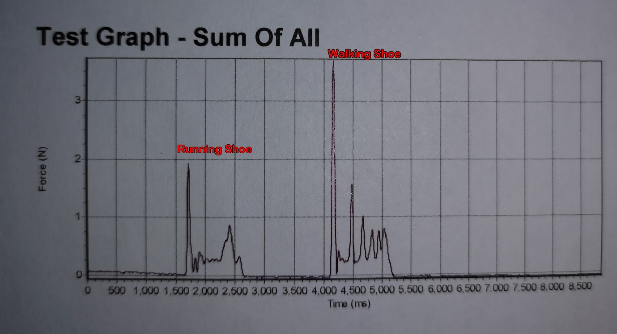
The running shoe had a ground force score of 1.7 newtons, which are the standard measurement used across physics (Hawkin Dynamics, 2018) and with a force max sum of 0.15 kg where as the walking shoe had a ground force score of 3.73 newtons and a force max sum of 0.38 kg. As can be seen in the graph, the running shoe absorbs impact better than the walking shoe. This is likely because running shoes are designed to absorb impact as a person runs in them to help make them perform better during the running phase. (Baltich, Maurer and Nigg, 2015) In comparison walking shoes are designed with stability as the core function, the design is to offer support and grip during the walking activity on uneven surfaces (Lee and Choi, 2006), at a slow pace so impact absorption isn’t as needed as it is in a running shoe. When comparing the two different shoes, there is a definite difference between the two, not surprisingly as they are both designed for two different activities, the running shoe is designed to be light and to absorb impact as the foot strikes the ground while running or jogging, as this particular running shoe is designed for road running the sole is designed with a flatter tread pattern with grooves that flex for smoother pacing on pavements or roads as well as a toe box to allow spreading and protection of the toes as they move (Runners World 2019). The walking shoes design also depends on its use, walking shoes, walking boots or backpacking boots, in the case of this analysis we used a walking shoe, walking shoes are low cut and flexible, the soles in comparison to the running shoe, have lugs made of rubber for a better grip on the surface of the terrain they come into contact with, hiking shoes are made from a heavier material than running shoes as they need to offer protection from the elements that they come into contact with. (rei.com, 2020)
1080 words

References
‘How Your Running Shoes Work’ (2019) Runner’s World, 54(2), pp. 76–81. Available at: https://search-ebscohost-com.ezproxy.uwtsd.ac.uk/login.aspx?direct=true&db=s3h&AN=134878299&site=ehost-live (Accessed: 13 February 2020)
Asics.com. (2020). Men's GEL-NIMBUS™ 21 | BLACK/BLACK | Running Shoes | ASICS. (online) Available at: https://www.asics.com/gb/en-gb/gel-nimbus%E2%84%A2-21/p/1011A169-004.html (Accessed 4 Feb. 2020).
Baltich, J., Maurer, C. and Nigg, B. (2015). Increased Vertical Impact Forces and Altered Running Mechanics with Softer Midsole Shoes. PLOS ONE, 10(4), p.e0125196.
Hawknin Dynamics (2018) So what exactly is a force plate? Available at: https://www.hawkindynamics.com/blog/what-is-a-force-plate (Accessed: 12 February 2020).
Karrimor.com. (2020). Karrimor | Karrimor KSB Jaguar Mens Walking Boots | Mens Walking Boots | Karrimor. [online] Available at: https://www.karrimor.com/karrimor-ksb-jaguar-wtx-mens-walking-boots-182762#colcode=18276203 (Accessed 4 Feb. 2020).
Kragelsky, I., Dobychin, M. and Kombalov, V. (1982). Friction and wear. Oxford: Pergamon Press, pp.1-44.
Laux, K., Jean-Fulcrand, A., Sue, H., Bremner, T. and Wong, J. (2016). The influence of surface properties on sliding contact temperature and friction for polyetheretherketone (PEEK). Polymer, 103, pp.397-404.
Lee, K. and Choi, C. (2006). Effect of Independent Suspension Function of Hiking Boots on the Stability and Load of Foot. Journal of the Ergonomics Society of Korea, 25(4), pp.115-119.
Li, K., Wu, H. and Lin, Y. (2006). The effect of shoe sole tread groove depth on the friction coefficient with different tread groove widths, floors and contaminants. Applied Ergonomics, 37(6), pp.743-748.
rei.com, (2020). How to Choose Hiking Boots. (online) Available at: https://www.rei.com/learn/expert-advice/hiking-boots.html (Accessed 13 Feb. 2020).
Sakai, H. (1996). Friction and Wear of Tire Tread Rubber. Tire Science and Technology, 24(3), pp.252-275.
Tranveer Singh (2018) Why do the sole of your shoes and the tyres of cars wear out gradually? Available at: https://www.quora.com/Why-do-the-sole-of-your-shoes-and-tyres-of-cars-wear-out-gradually (Accessed: 4 February 2020).

Appendices
Image 1
Image 2

