Professional Career Development in Health and Social Care (LCHS 4009)

ASSIGNMENT 2

Name of Student: Ufuoma Peace Adjuya

I.D. Number: 2511147

Name of Tutor: Odette Jack

Acknowledgement of AI use: I confirm that I have used AI to complete my work. I used Quillbot to proofread and improve grammar in this assignment.

Table of Contents
Task 1: Professional CV 1
Personal Profile 1
Education 1
Employment Experience 2
Key Skills 2
Interests and Hobbies 2
References 3
To be submitted upon request 3
Task 2: Personal Statement 4
Application for Care Assistant at Fairlie Healthcare Group 4
Task 3a: SWOT Analysis 5
Task 3b: Personal Development Plan 5
Two-Year Development Timeline 6
Task 4: Critical Reflection on Component 1 Presentation Using Gibbs' Reflective Cycle 7
Description 7
Feelings 7
Evaluation 7
Analysis 7
Conclusion 8
Action Plan 8
References ……………………………………………………………………………………………8

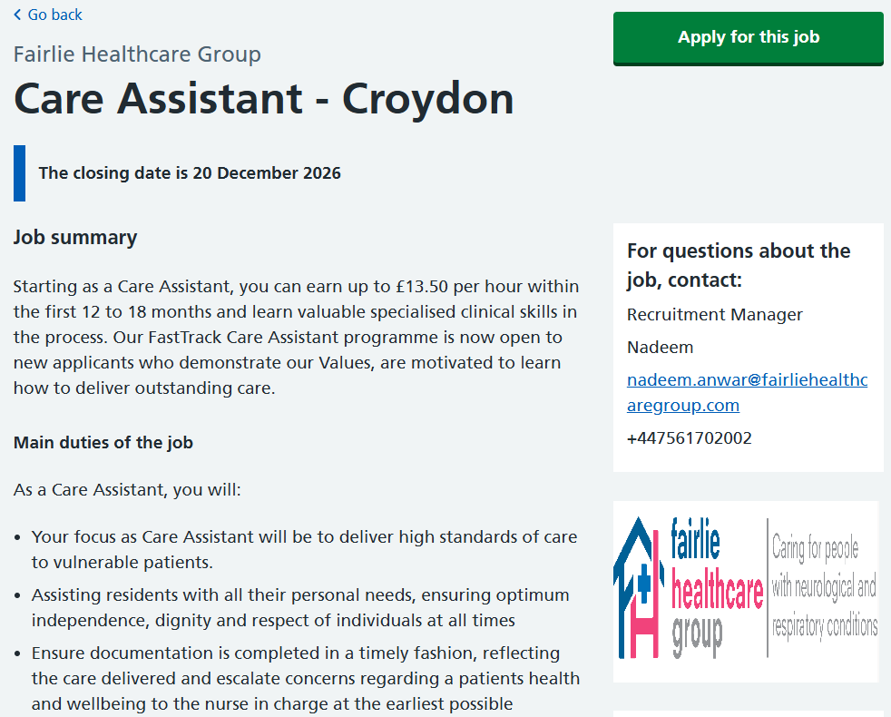

Practical Portfolio
Introduction:
This portfolio is a practical demonstration of my educational learning, professional skills and personal development in readiness for a career in health and social care. It contains my professional CV, personal statement, SWOT analysis, personal development plan and critical reflection on my presentation. Taken together, the components expose my current strengths, point out areas for development and set realistic goals for growth. The portfolio also demonstrates how my education, volunteering and reflective practice have prepared me for the role of Care Assistant at Fairlie Healthcare Group.

What is a Portfolio?
Portfolio is defined as a systematic collection of documents and evidence that demonstrates the individual’s skills, knowledge, achievements, experiences and professional development (Alkaabi and Abdallah, 2024). This may include a CV, personal statement, reflective piece, development plans and evidence of learning within health and social care. It is useful for people to measure progress, identify areas for growth and organise upcoming professional development activities (Beka and Kulinxha, 2021).

Task 1: Professional CV

Ufuoma Peace Adjuya
Address: 26 Sandbach Place, SE18 7EX
Telephone: 07897593802
Email: peaceishonuored@yahoo.com

Personal Profile
Compassionate Health and Social Care student with care and voluntary experience, strong communication and teamwork skills, and a commitment to person-centred, dignified and safe care. Seeking to develop specialist skills through Fairlie Healthcare’s FastTrack programme.

Education
Certificate of Higher Education Skills for the Workplace (Health & Social Care)
South Wales-based Higher Education Provider | 2025–Present
Relevant areas of study include:
- Professional development in health and social care
- Communication and interpersonal skills
- Reflective practice
- Employability and personal development
- Safeguarding and person-centred approaches
Level 3 Greenwich Community College
London | 2023–2025
GCSEs including English and Mathematics
Dom Domingons College | 1984-1990

Employment Experience
Care Support Volunteer – Oakfield Community Care Centre, Croydon
January 2025–Present
- Supported older adults during recreational and social activities.
- Communicated respectfully with service users and listened to their individual preferences.
- Assisted staff with non-clinical activities while maintaining appropriate confidentiality.
- Encouraged service users to participate independently rather than completing tasks unnecessarily for them.
- Reported concerns or changes in wellbeing to supervising staff.
Customer Service Assistant – Greenway Supermarket, Croydon
June 2023–December 2024
- Communicated with customers from diverse backgrounds.
- Responded professionally to complaints and enquiries.
- Worked effectively as part of a busy team.
- Prioritised tasks during busy periods.
- Followed workplace procedures and instructions accurately.
- Developed reliability, time management and problem-solving skills.

Key Skills
- Person-centred communication
- Compassion and empathy
- Teamworking
- Active listening
- Respect for dignity and privacy
- Safeguarding awareness
- Confidentiality
- Accurate record keeping
- Reliability and punctuality
- Ability to follow instructions
- Adaptability and flexibility
- Willingness to learn
- Basic digital skills

Interests and Hobbies
I enjoy volunteering within my local community, reading about health and wellbeing and participating in football and recreational activities. I also enjoy developing my communication and professional skills through online learning.

References

To be submitted upon request

Task 2: Personal Statement

Application for Care Assistant at Fairlie Healthcare Group
I am applying for the Care Assistant position within Fairlie Healthcare Group's FastTrack Programme because I want to develop a long-term career in health and social care while making a positive difference to the lives of people who require support. I am currently studying for a Certificate of Higher Education Skills for the Workplace in Health and Social Care and previously completed a Level 3 Diploma in Health and Social Care. My education has developed my understanding of person-centred care, communication, safeguarding, professional responsibility and reflective practice.
Working as a volunteer at Oakfield Community Care Centre has deepened my understanding of the need to see individuals as people with their own needs rather than just providers of care. I help adults to participate in social activities and have realized that being an effective caregiver is not just about doing things. It is also about hearing what people have to say, knowing their wishes and preferences, and assisting them to stay as independent as possible. This relates very closely to Fairlie Healthcare’s approach to providing care that promotes independence and dignity. CQC guidelines state that a person's care must be individualized and the person is to be treated with dignity (Care Quality Commission, 2025).
I believe that one of my strengths is my communication and interpersonal skills. My experience in customer services has taught me the need for effective communication skills in dealing with individuals from different backgrounds and listening to their concerns. I know that communication in health and social care also includes written documentation and escalation of concerns. These requirements match the requirements of communication and handling-information standards (Skills for Care, 2025).
Moreover, I am dependable, courteous and eager to receive and implement professional direction. I accept the fact that the Care Assistant operates in an extended multidisciplinary team and is therefore expected to be aware of their own limits (Fee, 2020). Hence, I would seek the advice of more experienced colleagues any time I was faced with uncertainty instead of simply making assumptions. This is especially important where complex clinical situations are concerned (Singh et al., 2025).
I am drawn to the FastTrack Programme among other reasons due to its promise of professional advancement. While I have laid the groundwork for my career through my studies and volunteering experience, I realize that I still need to gain more practical experience. The Care Certificate is crucial for the beginners in the health and social care sectors as it deals with such matters as responsibility and duties in the job, the person-centred approach, communication competencies, protection of vulnerable groups, and health and safety (Skills for Care, 2025).
My long-term aim is to become a competent and trusted health and social care professional who can advance in a leading care position. I take a keen interest in acquiring expertise in difficult care issues. I believe I can prove valuable at Fairlie Healthcare due to my compassion, eagerness to learn, ability to communicate effectively and the desire to treat everyone with respect.

Task 3a: SWOT Analysis
The SWOT analysis assesses my suitability for the Care Assistant role by identifying internal strengths and weaknesses and external opportunities and threats, supporting targeted development actions.
Strengths | Weaknesses
Excellent spoken and written communication skills. | Limited experience of complex clinical care.
Compassionate and patient approach to supporting adults. | Not having any prior experience of assisting patients with tracheostomy or on a ventilator
Experience of volunteering in a healthcare environment. | Low self-confidence in dealing with unfamiliar clinical conditions.
Strong teamwork and ability to follow instructions. | Lack of ability to do formal clinical documentation.
Strong commitment to dignity, privacy and independence. | Need to learn more about different diseases affecting nervous system.
Responsible, flexible and ready to learn. | Need further practical experience of safeguarding procedures.
Opportunities | Threats
Fairlie Healthcare provides structured induction and training. | Competition from applicants with greater practical care experience.
Opportunity to achieve the Care Certificate. | Emotional demands associated with supporting vulnerable adults.
Development of specialist clinical skills. | Potential anxiety when initially working with complex needs.
Opportunities for career progression. | Balancing employment, study and professional development.
Access to experienced colleagues and workplace supervision. | Changes in employer expectations and health/social care requirements.
My key strengths are communication, interpersonal skills, reliability and willingness to learn and these are aligned with the knowledge, skills and behaviours expected of new care workers (Skills for Care, 2022). My limited experience of complex neurological and respiratory care shows that supervised experience and further training are needed, as poor preparation can leave care workers feeling underprepared for complex needs (Skills for Care, 2025). Protection is a further issue of importance, protecting the health, well-being and human rights of individuals from harm, abuse and neglect (CQC, 2026). It is therefore important that I develop my capacity to recognise and report concerns for safe practice.

Task 3b: Personal Development Plan
My PDP uses the weaknesses identified through the SWOT analysis in order to create specific and measurable objectives for my development. This is important as the Care Certificate constitutes the baseline for new care workers and helps to facilitate their further professional development. The Care Certificate has 16 standards which cover communication, person-centred care, dignity, safeguarding, basic life support, information handling and prevention of infections.
Goal | Actions | Timescale (Months) | Success Measure | Monitoring/Evaluation
1. Obtain the Care Certificate and enhance basic care skills. | Finish onboarding, participate in training programs, maintain a learning log and complete required assessments. | 1–6 | Care Certificate completed successfully. | Review progress monthly with supervisor and record completed standards.
2. Develop knowledge and confidence in complex care. | Attend training arranged by the employer and observe experienced staff providing assistance to people with neurological disorders. | 6–18 | Improvement in confidence and positive feedback from the supervisor. | Quarterly supervision meetings and reflective learning records.
3. Improve safeguarding skills and professional communication. | Complete courses on safeguarding and practice the reporting/escalation of concerns through supervised scenarios and workplace experience. | 1–12 | Courses completed and the ability to explain the proper reporting procedures | Monitoring through supervision and reflections
4. Prepare for progression into a senior care role. | Take on more responsibilities, ask for feedback, enroll in relevant educational programs and learn about the requirements for promotion | 12–24 | Evidence of increased responsibility and readiness for progression. | Review in 6 months in relation to career objectives.

Two-Year Development Timeline
Year 1: Establish a robust professional basis through obtaining the Care Certificate, training in communication and safeguarding, caring for others responsibly under supervision, engaging in learning reflection and receiving ongoing evaluation.
Year 2: Gain knowledge about extensive care and diseases of the nervous system, be given more responsibility according to one’s competencies, and revise the PDP every half a year.
This corresponds with the guidelines of Skills for Care, which underline that training must be based on the applicable law and regulations, standards and recommendations (Skills for Care, 2025c).

Task 4: Critical Reflection on Component 1 Presentation Using Gibbs' Reflective Cycle

Description
In Component 1, I presented a five-minute presentation regarding the importance of problem-solving in healthcare as a professional skill. In my presentation, I defined problem-solving as a professional skill that involves understanding, analysing and resolving issues through the proper selection of decisions as well as the evaluation of outcomes (Cottrell, 2023). Moreover, I explained the significance of the skill in ensuring patients’ safety, quality of care delivered to patients and the effectiveness of teamwork and introduced the Ishikawa or Fishbone framework to determine root causes of issues. Additionally, I applied the framework to a scenario of a vulnerable person suffering from cognitive impairment that refused to take cardiac medication consistently.

Feelings
Prior to making the presentation, I felt uneasy because of my worries about speaking confidently and describing the content accurately within the time limit. I was particularly aware that the presentation included technical concepts such as the Fishbone model and patient safety. However, my research has kept my worries under control. I felt much more self-assured while discussing the topics I did thorough research about, such as the medication refusal case. I felt quite motivated too because the presentation made it possible for me to prove that resolving problems is not merely finding quick responses but uncovering the root causes and contemplating the right measures.

Evaluation
The strength of my presentation lies in its structure itself. I defined the concept of problem-solving, explained its significance, presented the Fishbone method, and applied it in a real-world setting of a refusal of medication treatment. This showed that I had followed the assessment requirement, which is to define the issue, support its importance, and provide the practical example of it. I also provided examples of how problem-solving can help to make sure that the safety of the patients is secured and the clinical errors decreased (Ibrahim et al., 2025; Kakemam et al., 2025). Nevertheless, the presentation has shown me possible improvements that I need to make in my work. Although I understood the topic well, I saw that I could have delivered several key points in more confident and concise manner. Sometimes, the great volume of information makes it difficult to bring out the main message in time. I also need to be more systematic while explaining the process of applying theoretical frameworks in practical care.

Analysis
Gibbs' Reflective Cycle systematically explores experiences through description, feelings, evaluation, analysis, conclusion and action planning (Gibbs, 1988). Reflecting on my presentation helped me recognise that, although problem-solving is a strength, I need to approach it more systematically rather than relying mainly on instinct. The Fishbone framework demonstrated the importance of examining factors such as people, methods, environment and resources before selecting an appropriate solution (Kumah et al., 2024).
Lecturer feedback also showed that my main weakness was not subject knowledge but confidence in communicating information spontaneously. I focused on preparing accurate content but paid less attention to delivery. This is relevant to my intended Care Assistant role because effective problem-solving requires clear and respectful communication with patients and colleagues. CQC guidance emphasises person-centred care, dignity and respect, requiring professionals to recognise individual needs and preferences (CQC, 2024a; CQC, 2024b).
The medication-refusal scenario further demonstrated the importance of combining systematic problem-solving with person-centred care. Rather than assuming refusal was non-compliance, I considered possible causes, including pain, swallowing difficulties and side effects. As a Care Assistant, I would need to communicate concerns appropriately and collaborate with nurses while respecting patient autonomy. Improving my problem-solving and communication confidence will therefore support safer, person-centred care.

Conclusion
The presentation furthered my knowledge of problem-solving as a viable professional skill, showing its importance regarding patient safety from the perspective of the Fishbone model. Nevertheless, I realised that I must work on my confidence, organisational skills, and the ability to spontaneously use systematic approaches.

Action Plan
To achieve self-improvement, I plan to practice applying the Fishbone model and Gibbs’ cycle in real situations, ask for feedback from tutors and experienced colleagues, as well as take part in relevant training and simulation activities. These methods correspond to those mentioned previously in my presentation. I will assess my improvement during the next two years with reflective records and supervision.

Reference list
Alkaabi, A.M. and Abdallah, A.K. (2024) ‘Portfolio practices in the principal evaluation process: A qualitative case study’, Heliyon, 10(21), pp. e39467-e39467. Available at: https://doi.org/10.1016/j.heliyon.2024.e39467.
Beka, A. and Kulinxha, G. (2021) ‘Portfolio as a tool for self- reflection and professional development for pre-service teachers’, International Journal of Learning, Teaching and Educational Research, 20(2), pp. 22–35. Available at: https://doi.org/10.26803/ijlter.20.2.2.
Care Quality Commission (2024a) Regulations for service providers and managers, Cqc.org.uk. Available at: https://www.cqc.org.uk/guidance-regulation/providers/regulations-service-providers-and-managers/health-social-care-act/regulation-9 (Accessed: 10 August 2026).
Care Quality Commission (2024b) The fundamental standards , Cqc.org.uk. Available at: https://www.cqc.org.uk/about-us/fundamental-standards? (Accessed: 10 August 2026).
Care Quality Commission (2025) Regulation 10: Dignity and respect - care quality commission, Cqc.org.uk. Available at: https://www.cqc.org.uk/guidance-regulation/providers/regulations-service-providers-and-managers/health-social-care-act/regulation-10? (Accessed: 10 August 2026).
Care Quality Commission (2026) Safeguarding people , Cqc.org.uk. Available at: https://www.cqc.org.uk/about-us/how-we-do-our-job/safeguarding-people? (Accessed: 10 August 2026).
Fairlie Healthcare Group (2026) Care Assistant – Croydon. Available at: https://www.jobs.nhs.uk/candidate/jobadvert/E0429-26-0008?searchFormType=main&keyword=visa%20sponsorship%20jobs&language=en&page= (Accessed: 10 August 2026).
Fee, A., Muldrew, D., Slater, P., Payne, S., McIlfatrick, S., McConnell, T., Finlay, D.-A. and Hasson, F. (2020) ‘The roles, responsibilities and practices of healthcare assistants in out-of-hours community palliative care: A systematic scoping review’, Palliative Medicine, 34(8), pp. 976–988.
Gibbs, G. (1988) Learning by Doing: A Guide to Teaching and Learning Methods. Oxford: Further Education Unit, Oxford Polytechnic.
Singh, S., Degeling, C., Caputi, P., Raftery, D., Montgomery, A., Drury, P. and Deane, F.P. (2025) ‘How do healthcare professionals manage uncertainty in making decisions? Applying theory to nurses” experiences of uncertainty regarding antibiotics in residential aged-care facilities’, Health, Risk &amp; Society, pp. 1–19. Available at: https://doi.org/10.1080/13698575.2025.2492147.
Skills for Care (2022) Minimum standards, Skillsforcare.org.uk. Available at: https://www.skillsforcare.org.uk/Developing-your-workforce/Guide-to-developing-your-staff/Minimum-standards.aspx? (Accessed: 10 August 2026).
Skills for Care (2025a) Care certificate standards, Skillsforcare.org.uk. Available at: https://www.skillsforcare.org.uk/resources/documents/Developing-your-workforce/Care-Certificate/Care-Certificate-Standards/Care-Certificate-standards-March-2025.pdf? (Accessed: 10 August 2026).
Skills for Care (2025b) Closing the skills gap in adult social care, skillsforcare. Available at: https://www.skillsforcare.org.uk/news-and-events/blogs/closing-the-skills-gap-in-adult-social-care? (Accessed: 10 August 2026).
Skills for Care (2025c) ‘Statutory and mandatory training guide for adult social care employers’. Available at: https://www.skillsforcare.org.uk/resources/documents/Developing-your-workforce/Guide-to-developing-your-staff/Statutory-and-mandatory-training-guide-December-2025.pdf (Accessed: 10 August 2026).

