Cover page:

Topic: Comparison between Hilton Worldwide Int. and Marriot International Inc. their approach to financial Management.

Name of Student: Musa Farhana Shikder Uddin
Student ID number: 2109302
The module title: Financial Management for the Hotel Industry (BMIH5007)
Lecturer’s name: Dale Clarke
Table of Contents
Cover page: 1
Executive Summary: 3
Introduction: 3
Total Revenue: 4
Net Revenue: 5
Gross Revenue: 5
Market position: 7
Financial Commitment to CSR 11
Conclusion: 12
Recommendation: 12
Reference: 13

Executive Summary:

Finance is a core foundation of all kinds of economic activities in a business. And managing all these activities is financial management (Bhat, 2008). This report compared the financial management, potential growth, and financial commitments to CSR of hotel Hilton Worldwide Int. and Marriott international Inc. Where it been discussed about the total revenue of last three years for respective hotels. During covid 19 hotel lost a margin level of revenue. Comparing the net income of $886 million of 2019, Hilton losses $710 million during 2020 (Fox, 2021). whereas, In April Marriott undergone record break worldwide decline of revenue. They had a 90% decrease year-on-year (Sanders, 2021).
To produce high revenue and overcome pandemic loses Hilton and Marriott both enhanced their luxury brand ranges in many countries and they also developed many programs such as loyalty points and Marriott partnered with American Express. Furthermore, each hotel has many activities planned for the financial commitments to CSR.
They opened luxury brands many places in the world to establish their brand name and set the position in the market. They have many prices and product strategy for the market positioning and CSR.

Introduction:
Finance is the core foundation of all kinds of economic activities in modern era. Business needs money to make money and this is only happened when its properly managed (Bhat, 2008). Business Finance is an activity to gain and preserve of capital funds to meet financial needs and aims of the business (Bhat, 2008). Financial Management of a business is to deal with the financial features such as promotion, administration, accountings, and financial adjustments (Bhat, 2008).
The purpose of this report is to compare the Financial Management of one of the largest hotel chain Hilton Worldwide Inc. and Marriott international Int. Where it will discuss several areas of financial management such as, Total Revenue, Market Position, Growth Potential and Financial Commitment to CSR.
Hilton Hotel is one of the largest and fast-growing company which has 19 brands in 123 countries all over the globe. Conrad Hilton opened first hotel in Texas in 1925 and from then its brands are continued to grow (Hilton,2023). Thus, they set up new brands like Motto, a hostel-style micro-hotel, Signia and Tempo. Which is a lifestyle-first luxury hotel. At present all around the globe there are 923,000 hotel rooms. Out of 100 hospitality companies they are the number one in the US on Forbes (Hotel Tech Report, 2022).
Whereas Marriot international, Inc. is a one of the leading companies, has most powerful portfolios in the industry with 30 brands. It is based in Bethesda, Maryland, USA, and has 8000+ properties with approximately 1,423,044 rooms, all over the 139 countries and among them 2,149 are controlled by Marriott. Furthermore, 5,493 rooms are controlled by other franchise agreements (Marriot Hotel, 2023). J. Willard and Alice Marriott is the founder of Marriott hotels, and they established it in 1927. Therefore, it run by their family leadership and principles. All around the world Marriott manages and franchises hotels and licenses vacation ownership resorts. Marriot Bonvoy is highly awarded company which has 141 million members around the world (Marriott International, 2023).

Total Revenue:
Total revenue is the whole amount of income of the company which they get from sale of good or services in a certain period (Indeed, 2022). For a hotel business KPI (Key Performance Indicators) is a measure which shows the amount of income a hotel generates for all sold rooms in that period. It is an essential implementation metric for analysing the (RevPAR Revenue per Room) and GOPPAR (Gibson, 2021). There are the tables below is comparing Hilton Worldwide holding Inc. and Marriott International, Inc financial from year 2019 to 2021.

Net Revenue:
The amount what left after deducting all the expenses from the total revenue is called Net Revenue.

Gross Revenue:
The total amount of income before deducting the expense is the Gross Revenue. Gross Revenue and total revenue are not same as gross revenue is the sales of the products or services, whereas total revenue is company’s total income from all prospects.

Hilton worldwide Holding Inc. | 2021 | 2020 | 2019
Total Revenue | 5788000 | 4307000 | 9452000
Total Operating Expenses | 638000 | 702000 | 859000
Operating Income loss | 1017000 | -119000 | 1576000
Net Income | 410000 | -715000 | 881000
(Yahoo finance, 2023).

Marriott International, Inc. | 2021 | 2020 | 2019
Total Revenue | 13857000 | 10571000 | 2097200
Total Operating Expenses | 1043000 | 1108000 | 1279000
Operating Income loss | 1758000 | 351000 | 1938000
Net Income | 1099000 | -267000 | 1273000
(Yahoo finance, 2023).
Covid 19 changed the form of global travel for both leisure and business travellers in 2020. There was a low demand for hotel rooms, conventions, and conferences (sanders, 2021). It affected both hotel Hilton and Marriott.
Chris Nassetta, president, and CEO of the global chain of Hilton said, 2020’s pandemic and tightening of travel restriction interfered the positive momentum of the company (Fox, 2021). Comparing the net income of $886 million of 2019, Hilton losses $710 million during 2020. In Europe, it dropped 53% year-on-year because of the occupancies. Nassetta said in webcast that the decline of the demand has never been seen in Hilton’s 101-year history (Fox, 2021).
In year 2021 Hilton had 97% of their hotels open, and despite the ongoing impact of the pandemic they sold their one million room milestone, moreover, their net growth increased by 5% for the year. Within a week there was a 70% of booking made by the consumer which help to recover the loss of second half of 2021. Therefore, in 2022 and 2021 Hilton Worldwide Holding has an increase of their revenue respectively of $8.165 billion which is 68.63% and $5.788 billion which is a 34.39% year-over-year (Macrotrends, 2023).
Nevertheless, Marriott’s group president of consumer operation, technology and emerging business, Stephanie Linnertz, mentioned that covid 19 pandemic in 2020 slowed down the travel of consumer and that affected their occupancy and revenue per available room (RevPAR). And in April they undergone record break worldwide decline of revenue. They had a 90% decrease year-on-year (Sanders, 2021).
Marriott International losses $234 million or 72% a share which is compared to a profit $232 million in 2019. The losses were 64% a share while revenue fell 72.4% to $1.46 billion (Heller, 2020).
Despite the low revenue performance 2020, Marriott’s portfolio grew by 3.1% in net room and end of the year it was 2,882 properties and 498,000 rooms. Therefore, in 2021 and 2022 Marriott international has an increase of their revenue respectively of $13.857 billion which is 31.09% and $19,296 billion which is a 66.59% year-over-year (Macrotrends, 2023).
Total revenue is important to analysing the organisation performance. Because any business must bring in money to turn a profit. When there is a less revenue, then businesses make less money (Kennon,2022).

Market position:
The ability of influencing the customers view to consider a brand or product comparative to the opponent is called Market positioning. Its objective is to establish the image and identity of a brand or product to its consumer (CFI, 2022). It is the brands unique selling proposition that how they convince consumer to stay in their hotel over the competitor. Brand image of the hotel, reputation and unique selling point is the key elements of market positioning (BEON, 2022).
Hilton Worldwide has many strategies for their market positioning. They expand their umbrella according to the locality, and by the demand and preferences of service they are offering. Hilton Hotels & Resorts is the leading brand which accounted for 29% of the total rooms. And the other brands such as Hampton, DoubleTree, and Hilton Garden Inn are accounting respectively for 28%, 14%, 12% of total rooms (Cederholm, 2020). There is a wonderful selection of Hilton brands that expanded into several tiers, such as luxury, upper upscale, upscale, upper midscale, midscale, and timeshare (Au, 2023). Their price range or average room rates under each brand influences the average daily rates which is one of the important revenue drivers of the hotel (Cederholm, 2020).
Here is a Perceptual Map in Market Positioning of some hotels along with Marriot and Hilton.

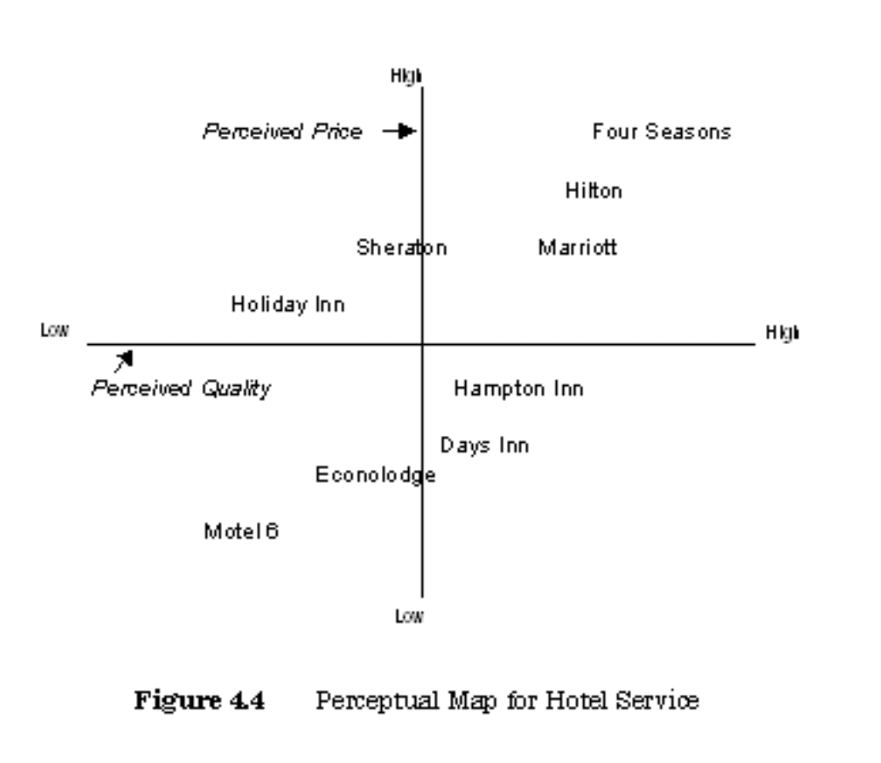
(SlidePlayer, 2010)
On the other hand, the classification of Marriott brands are Collections and Soft Brands, Marriott Luxury Brands, Marriott Upper-Upscale, Marriott Upscale Brands. (Hotel Tech Report, 2022).
Main purpose of Marriott is to offer the greatest product to their customer at the right price and with a finest service. Their price depends on their excellence basis, and it is design to maximise their revenue without losing brand name (Hotel Tech Report, 2022). It also varies according to customer demand and the cost of the promotion and maintenance. Moreover, the price modifies according to the change of situation and competitors’ behaviour.

Growth Potential:
The future ability of a company to produce higher revenues, develop its workforce and expansion of the manufacture is called Growth Potential (Lebeaux, 2012). It can evaluate their strategic programme into new markets, the improvement of latest product, the more effective marketing techniques, and method.
Growth potential for hotel Hilton and Marriott are compared below:
In 2020, Hilton enhanced their luxury range in many countries and cities, such as they opened Conrad properties in Nashville, Sardinia, Los Angeles, and California, then Waldorf Astoria in Sydney and Kuala Lumpur (Zacks, 2022). Conversion of the hotels which has been delayed for pandemic, they are now focusing on them. Such hotels are in Galapagos Islands, San Sebastian, Spain, Maui and Sonoma County, and California. They signed a contact with Curio and Tapestry to cover those destinations (Zacks, 2022). They are expanding Double Tree with new conversion in France, Germany and Netherlands (Zacks, 2022).
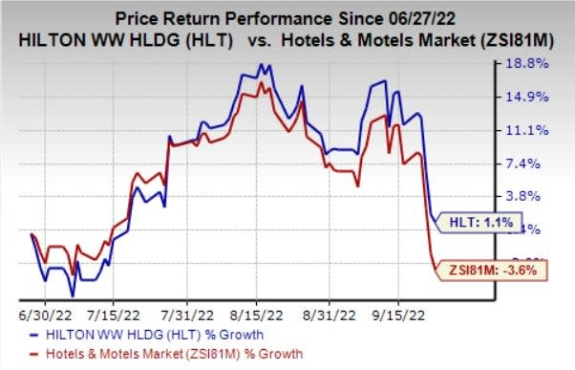
Zacks (2022)

Hilton Honors is a largest loyalty programs, and its app created an enormous asset to its growth. This program got more than 139 million members which increase 17% on year-over-year. Enhanced partnerships and point redemption offer constantly giving opportunities to engage new member. Hilton focusing on latest prospects to drive consumer commitment to get stages like before pandemic.
Whereas Marriott using their social media and latest technology and mobile app to attract modern traveller. Marriot Bonvoy and loyalty program is their supporting marketing strategy (Zacks,2021). They also partnered with American Express and Chase credit cards and promoting offers in shopping. They also affiliated with uber. Its demands in countries like Africa, Maldives, Australia, Canada, and Mexico are increasing (Zacks,2021).
Meanwhile, Marriott is constantly expanding their hotel in international Market and their plans to expand their Luxury and lifestyle brands. Their development pipeline will help them toward their room growth in the range of 3-3.5% (Zacks,2021).

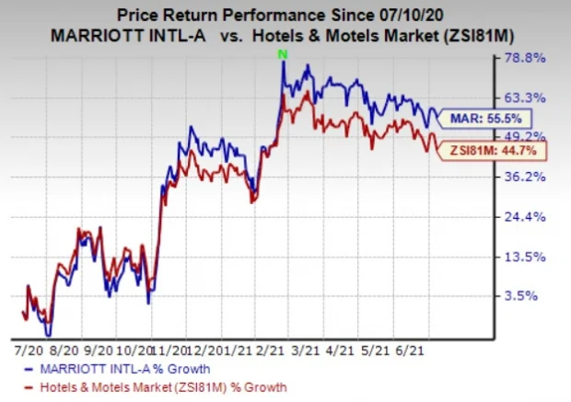
(Zacks,2021).

Financial Commitment to CSR

A company who is communally responsible to itself, its investors, and public by a self-acting corporate modal called Corporate social Responsibilities (CSR). It helps to process the business while taking care of their social, economic, and environmental impact (Amyx, 2020). Hotel Hilton’ ‘travel with purpose’ is its ESG strategy to develop climate science and more sustainable operations. Hilton’s goal is to reduce their hotels emissions by 75% and franchised emission by 56% by 2030 (Fernando, 2022).
To reduce carbon emission, they joined with other businesses and industry leaders. And their mission is to be below two degrees Celsius for its franchised properties.In addition, to invest in software, renewable energy, energy storage, smart building, and carbon sequestration technologies, Hilton bind with Fifth Wall’s Climate Tech Fund to decarbonise the $10.5 trillion real estate industry (Fernando, 2022). To support their team member and communities they have 5 million learning and career growth opportunities for underrepresented groups by 2030. It has a social foundation called Hilton Global Foundation. which is awarded over $5 million to 70 non-governmental organizations (Fernando, 2022).
Hilton’s team members begin to contribute $1 USD per night in a fund called Team Member Assistance Fund and Hilton Global foundation, which is started in August in 2022. These funds will support programs for team members (Hilton, 2022).

On the other hand, Marriott’s sustainability goal 360 Report toward environmental, social and governance set by 2025. They set a target of zero emission greenhouse gas by 2050. They want to reach a gender equality in executive positions by 2023 and 25% colour equality by 2025.
Marriot-Sorenson Center for hospitality Leadership is a system to help inspiring Black students to enter the hospitality industry. they also created a human trafficking awareness training. They are supporting historically underrepresented groups in North America with $50 million. its Marriott’s Bridging the Gap is a new program to support the company’s goal of achieving 3000 diverse-owned hotels by the end of 2025 (Hertzfeld, 2022).

Conclusion:

This report compared the financial management, potential growth, and financial commitments to CSR of hotel Hilton Worldwide Int. and Marriott international Inc. Where it been discussed about the total revenue of last three years. As shown in the total revenue section that during the covid 19 both the hotels revenue had been reduced. To produce high revenue and overcome pandemic loses Hilton and Marriott both enhanced their luxury brand ranges in many countries and they also developed many programs such as loyalty points and Marriott partnered with American Express. Furthermore, each hotel has many activities planned for the financial commitments to CSR.

Recommendation:
- To increase their revenue Hilton should introduce three-star hotels in the developing countries, because there is a huge economic class consumer to target who will appreciate it as it will be affordable to them. Whereas, to increase the revenue Marriott can partnered with several sector like catering, real estate.
- Hilton and Marriot both can outsource High Speed internet service and IT management, as everything has been more IT depended,

Reference:

Au, S (2023) ‘19 Hilton Hotel Brands: Lifestyle, Midscale, Upscale, Luxury & More’ Home. Available at: https://upgradedpoints.com/travel/hotels/hilton-hotel-brands/ (Accessed: 3rd February 2023)
Amyx, S (2020) ‘To CSR Improves the Bottom Line’, Forbes. Available at: https://www.forbes.com/sites/forbesbusinesscouncil/2020/04/14/how-commitment-to-csr-improves-the-bottom-line/?sh=642ba8342944 (Accesses: 2nd February 2023)
BEON (2022) ‘What is hotel market positioning’, The Importance of Hotel Market Positioning and How To Benefit From It. Available at: https://www.beonx.com/the-importance-of-hotel-market-positioning-and-how-to-benefit-from-it/ (Accessed: 5th February 2023)

Bhat, S. (2008). Financial Management: Principles and Practice. India: Excel Books. Available at: https://www.google.co.uk/books/edition/_/UAflULA1DkIC?hl=en&gbpv=0 (Accessed: 5th February 2023)

Cederholm, T. (2020) ‘Hilton’s hotel room composition by brand and chain scale’, Market Realist. Available at: https://marketrealist.com/2014/10/hiltons-hotel-room-composition-by-brand-and-chain-scale/ (Accessed: 9th February 2023)
CFI (2022) ‘Market Positioning’, CFI. Available at: https://corporatefinanceinstitute.com/resources/management/market-positioning/ (Accessed: 5th February 2023)

Fernando, J. (2022) ‘Corporate Social Responsibility (CSR) Explained with Examples’, Investopedia. Available at: https://www.investopedia.com/terms/c/corp-social-responsibility.asp (Accessed: 14th February 2023)

Fox, L. (2021) ‘Hilton posts big losses for 2020 yet forging ahead with new properties’, PhocusWire. Available at: https://www.phocuswire.com/Hilton-q4-FY-2020 (Accessed: 5th February 2023)

Gibson, A. (2021) ‘Hotel Revenue Management Formulas: KPIs, Calculations & Use Cases’, Upstay. Available at: https://www.upstay.tech/hotel-revenue-management-formulas-kpis-calculations-use-cases/ (Accessed: 6th February 2023)

Heller, M. (2020) ‘Marriott Posts Big Loss, Sees Recovery Signs’, Financial Performance. [CFO] Available at: https://www.cfo.com/accounting-tax/2020/08/marriott-posts-big-loss-sees-recovery-signs-5849/ (Accessed: 5th February 2023)

Hertzfeld, E. (2022) ‘Marriott report highlights ESG successes’, Hotel Management. Available at: https://www.hotelmanagement.net/own/marriott-publishes-esg-report (Accessed: 3rd February 2023)

Hilton (2023) About us. Available at: https://www.hilton.com/en/corporate/. (Accessed: 4th February 2023)

Hilton (2022) ‘Hilton Enhances ESG Targets to Drive Climate Action and Social Impact’, Environment & Sustainability. Available at: https://www.hospitalitynet.org/news/4111731.html (Accessed: 23rd February 2023)

Indeed (2022) ‘A Complete guide on how to calculate total revenue’, career-development. Available at: https://uk.indeed.com/career-advice/career-development/how-to-calculate-total-revenue (Accessed: 10th February 2023)

Kennon, J. (2022) ‘Analysing Revenue and Sales on Your Income Statement’, Investing. Available at: https://www.thebalancemoney.com/total-revenue-or-total-sales-357593 (Accessed: 5th February 2023)

Lebeaux, R. (2012) ‘growth potential’, CIO Strategy. Available at: https://www.techtarget.com/searchcio/definition/growth-potential (Accesed: 10th February 2023)

Macrotrends (2023) Marriott Revenue 2021-2022| MAR’, Revenue & Profit. Available at: https://www.macrotrends.net/stocks/charts/MAR/marriott/revenue (Accessed: 5th of February 2023)

Marriott Hotel (2023) [Facebook]. Available at: https://www.facebook.com/Marriott/?locale=en_GB (Accessed: 2nd February 2023)

Macrotrends (2023) Hilton Worldwide Holding Revenue 2021-2022|HLT MAR’, Revenue & Profit. Available at: https://www.macrotrends.net/stocks/charts/HLT/hilton-worldwide-holdings/revenue (Accessed: 5th of February 2023)

SlidePlayer (2010) Perceptual Map for Hotel Service. Available at: https://slideplayer.com/slide/8474529/ (Accessed: 10th February 2023)

Yahoo finance (2023) Marriott International, Inc. Available at: https://uk.finance.yahoo.com/quote/MAR?p=MAR&.tsrc=fin-srch (Accessed: 4th February 2023)

Yahoo finance (2023) Hilton worldwide Holding Inc. Available at: https://uk.finance.yahoo.com/quote/HLT?p=HLT&.tsrc=fin-srch (Accessed: 4th February 2023)

Zacks (2021) ‘Here's Why You Should Retain Marriott (MAR) Stock for Now’, News and Insights. Available at: https://www.nasdaq.com/articles/heres-why-you-should-retain-marriott-mar-stock-for-now-2021-07-09-0 (Accessed: 8th February 2023)

Zacks (2022) ‘Here's Why You Should Retain Hilton (HLT) Stock for Now’, Zacks Equity Research. Available at: https://uk.style.yahoo.com/heres-why-retain-hilton-hlt-163504673.html (Accessed: 7th February 2023)

