START-UP BUSINESS PLAN DEVELOPMENT
ESTABLISH A FOOD OUTLET
Executive Summary
This study explores the market viability and the potentiality of growth of a proposed business start-up idea. Galland is a suggested business which will engaged to sell Indian cuisine in the UK marketplace. Addressing the market demand in the UK for Indian authentic dishes has seen a strong market position that can be gained for this business. Followed by SWOT, 4P marketing-mix and PSETLE analysis highlights in which perspective it can gain opportunity and from which aspect it may encounter threats. A cash flow forecast for 12 months depicts the financial viability of this company idea.

Table of Contents
Introduction 4
Overview of the Business Idea 4
Legal format of the startup company 5
Management of the company 5
Usage of strategic framework tools within the business plan 7
SWOT analysis 7
4P marketing mix 8
PESTLE analysis 9
A cash flow forecast for the first 12 months 10
Conclusion 11
Reference List 12

Introduction
A defined purpose, transparent way of conduction, efficient financial insight and in-depth market understanding are the key pillars of successful start-up business planning. This study is going to illustrate a business plan for developing a food outlet in the UK, namely Galland. The plan is designed the captivate stakeholders and investors. Before starting a business, some concerns need to be managed carefully under a strong leadership pattern, including legal formats of the business, management hierarchy of the organisation, a detailed vision of the market trends and potentiality along with a financial market forecast to support long-term growth of the start-up. Considering this, here by using the SWOT, 4P and PESTLE analysis will explore the market demand for such a food outlet.

Overview of the Business Idea
The purpose of the proposed business plan is to develop a distinctive food outlet in the United Kingdom business portfolio, that will specialise in Indian cuisine along with promoting sustainable packaging. Global market research has illustrated that the UK and India are two effective trade partners for a long period. Specifically in the case of food and drinks products, India's trading with the UK was US$ 475.30M favourable in 2019. India's overall food trade in the UK has significantly increased from 2009, US$ 479.97M to 2019 US$ 873.72M, as depicted in the following image (Paarlberg, 2019). This has signified a strong market potential for Indian food products in the UK. This is a favourable trend for growing this start-up. In addition, the ethnic cuisine sector in the UK is expanding significantly due to evolving customer preferences and changes in demographics. The planned food outlet, Galland, will have an excellent opportunity to take part in this growing industry due to the attractiveness of Indian tastes, fragrances, and spices.
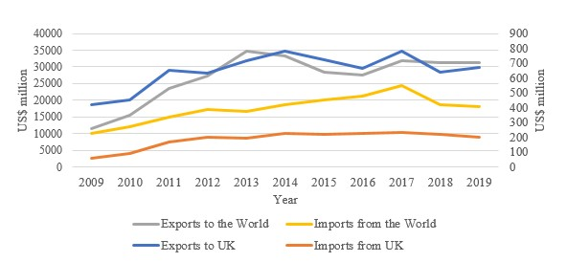
Figure 1: Increased food trading between India and the UK
(Source: Paarlberg, 2019)
On the other hand, this business idea will be offering eco-packaging, one of the strong “unique selling propositions” (USP) of the business, in terms of strengthening its competitive edge. Eco-conscious customer segments are becoming increasingly attracted to goods and services that share those values. By providing eco-packaging, the Galland will satisfy customer demands while simultaneously supporting sustainable development initiatives. As per the report by “The Department for Environment, Food & Rural Affairs”, the UK government's attempts to lessen the use of plastic and encourage sustainable activities offer a legal framework that is favourable for companies adopting environmentally suitable replacements (Stewart et al., 2021). Sustainable solutions are direly demanded, as single-use plastic containers contribute significantly to the UK's landfills.

Legal format of the startup company
Starting a business concerns several legal formalities and business structure. In terms of managing such a small-scale business idea, it will be followed by “sole proprietorship” as the legal format of Galland. This is the simplest business structural framework that signifies the entire operational performance will be managed solely by a single one. In this business development context, a sole proprietorship will depict some potential advantages. Primarily it can be stated that having single ownership gives the proprietor complete authority over corporate choices and strategic decision-making, which promotes operational flexibility and independence (Januarita, 2021). Additionally, this framework has few legalities and administrative processes, which lowers the associated expenses and regulatory hurdles. This is especially advantageous for small-scale businesses like these food stores. Additionally, in the case of taxation and other legal management, establishing sole ownership in the UK merely requires registration with the relevant local governments. A study by Oats and de Widt, (2019), has illustrated an instance of “HM Revenue & Customs” (HMRC), as the local authority of the UK specifically authorised regulation for taxation in small-scale businesses. It makes a comparatively simple governing process through sole ownership. Due to this simple governing structure company will get more time to focus on resource management which surely speeds up the business formation process significantly. Accomplishing this simple legal format, culinary enthusiasts can potentially show their expertise in the targeted marketplace without any complexity.

Management of the company
Entire business management is considered a well-structured management team. Business entrepreneurs along with the distribution of internal and external stakeholders, employees are the core of the management structure (Chams and García-Blandón, 2019). Here, as this business idea is considered a unique management plan, it needs to dictate a structure of management. Primarily this business will be developed with approximately 15 to 20 employees.
Stakeholders | Department | Number of employees
Owner or CEO of the business | Management | 1
Accountant | Financial | 1
Human Resource Manager | HR | 2
Chef | Kitchen management | 2
Marketing Manager | Marketing | 1
SCM Officer | Logistic and procurement | 1
Sustainability Officer | Organisational Sustainability | 2
Servers | Front-of-House | 3
Sales Coordinator | Sales | 1
Maintenance Crew | Facilities Enhancement | 1
Table 1: Proposed management structure for Galland
(Source: Created by the author)
Here illustrate a proposed structure of the management team for the primary implementation of this suggested business. Basically, to accomplish this business goal, employees are recruited and focusing on a “customer-centric approach”. In terms of managing training and development, recruitment, and employee satisfaction 2 HR professionals are recruited. On the other hand for promoting unique Indian cuisine, 2 chefs will be recruited. The sustainability officer looks upon the locally sourced ingredients, quality of the foods, and sustainable packaging. In the case of serving dishes, it has been planned that there will be mostly 3 employees. Active engagement of the employee lessens the waiting time of customers which further boosts the customer's satisfaction for the company. Since the food market in the UK is enormously grown, in such extensive competition, the business should look to innovative strategic adaptation. In that case, a management crew will also be planned to recruit, who will mainly be responsible for the overall management and promoting innovative initiatives to support business distinctiveness. The primary challenge for a start-up business is fund collection, and collaboration with potential market investors. In that case under the supervision of the CEO, the account will take part in this responsibility actively.

Usage of strategic framework tools within the business plan

SWOT analysis
Strength | - It promotes its business uniqueness by its offerings and services, of selling Indian cuisine dishes.  - The extensive Indian food market size in the UK of about £3.6 billion.  - An initiative of eco-friendly packaging promotes its competitive edge along supports the UK government's commitment to organisational sustainable development.
Weakness | - As it will adopt a sole ownership approach, there will be the possibility of threats in the case of decision-making and overall management.  - Primarily it has less initial capital
Opportunity | - Successively increased demand for Indian food in the UK market.  - About 60% of UK customers are becoming more prone to sustainable preference to lessen food wastage.
Threats | - Highly competitive food market in the UK.  - Increased economic market fluctuation in the UK, can affect the food price.
Table 2: SWOT analysis
(Source: Created by the author)
The above illustration has demonstrated the internal market strength, opportunities, threats and weaknesses of Galland through SWOT model analysis. Research by Naylor et al., (2021), has acknowledged that successively the market demand for Indian cuisine in the UK market has grown by about 54%. This emphasises the strong potentiality of successfully implementing this start-up. On the other hand, intense competition and adaptation of sole proprietorship of this planning may create barriers to further growth. It enhances the need to adopt innovative market strategic choices.

4P marketing mix
The 4P marketing mix which signifies four pillars including Product, Price, Place, and Promotion, is essential to the present study since it offers an organised framework for creating marketing plans that are successful and specifically adapted to the requirements of Indian cuisine. In order to maximise market share and consumer engagement, it serves to establish coordination between product offers, price strategies, distribution networks, and marketing efforts (Thanseer et al., 2022). This model analysis is a part of market research before implementing this startup in the targeted marketplace of the UK.
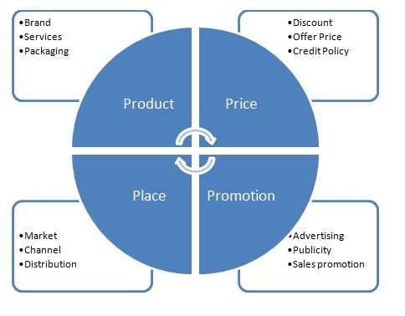
Figure 2: 4P market analysis
(Source: Thanseer et al., 2022)
Product
Galland will be committed to offering distinctive and diverse varieties of Indian food items. Different ethnic Indian platters and authentic dishes will be served here. Traditional Indian food like samosas, biriyani butter chicken and others will be included in the platter item of this food outlet (Reddy and van Dam, 2020). Additionally, accomplishing the UK demand for Indian food types and spices will also be added. Considering its business value, the UK customer's expansive palate will be catered for authentic Indian meals that are made with expertise and genuineness.
Price
Pricing strategic choice ought to take into consideration the product's value offering along with the market environment. Pricing is competitive when compared to other ethnic cuisine establishments ensuring affordability without sacrificing profitability. Price-conscious customers may be drawn in by discounted lunch combo food, while those with more money to spend may benefit from expensive alternatives for special occasions or food service providers (Lopez, 2020). Therefore, it will follow a competitive and “value-based pricing strategy” to successfully progress the business.
Place
In the case of selecting a targeted place, it should be focused on maintaining high accessibility and visibility to the customers (Naylor et al., 2021). United Kingdom’s city area which is usually a densely populated urban region or ethnically diversified communities with a strong ethnic food market will be the best suited to the targeted place.
Promotion
In order to increase brand recognition and consumer base, promotional activities need to use an array of conventional and digital advertising platforms. Chatter and engagement can be generated through utilizing influencer relationships, social networking platforms, and targeted marketing initiatives (Kittipanya-Ngam and Tan, 2020). Special advertisements, like cooking classes or themed events, may boost foot traffic and encourage community involvement.

PESTLE analysis
Political | - Considering the political background of the UK, it has been noted a strong emphasis on organic and standard quality food protection.  - “The Food Safety Act of 1990” was enacted in the UK to promote a standard living of for community health (Garcia-Garcia et al., 2019).
Economic | - Increased Inflation rate in the UK peaked in 2022 by about 11.1% affecting the cost of living (Singh et al., 2019).  - Economic downturns and fluctuations in food prices significantly decreased customer spending.
Social | - The increasing demand for Indian meals and other ethnic foods is driven by an increasing interest in a variety of gastronomic sensations.  - Preferences for organically and regionally produced ingredients may be influenced by growing environmental and health consciousness.
Technological | - Increased acceptance of digital marketing tools, automated management practices, and online food ordering facilitates the growth potentiality of this type of business (Rejeb et al., 2020).
Legal | - The UK government mandates the Workplace Safety Act, of 1974 to protect employee safety, wages and protective workforce.
Environmental | - As inferred by Aschemann-Witzel et al., (2021), increased customers trend and preferences towards sustainable packaging supports the UK sustainable commitment.
Table 3: PESTLE analysis
(Source: Created by the author)

A cash flow forecast for the first 12 months
This start-up business planning is started with an initial investment of about £25,000. In terms of evaluating the market's financial viability of this proposed planning, here mentioned a cash flow forecast with a limited £25,000. This forecast is effective in determining the potentiality of success of a planned project within a year (Bondina et al., 2021). For commencement the following budget is prepared:
Proprietor’s Investment:
Commencement cost, permits, and license- £8,000
Kitchen equipment and furniture- £5,000
Working capital- £12,000
Fixed Cost per month:
Rent- £2,500
Electricity- £700
Salaries- £4,000
Insurance- £350
Marketing- £1,000
Miscellaneous cost- £1,000
Variable Cost per meal:
Ingredients- £12
Packaging cost- £3
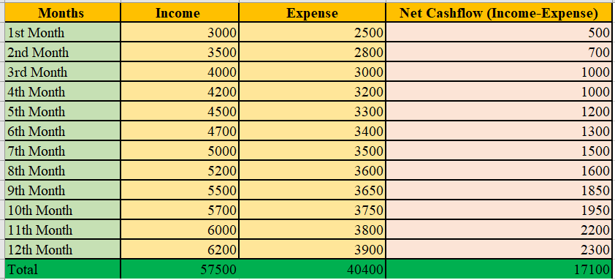
Figure 3: Cash flow forecast for the first one year
(Source: Created by the author)

Conclusion
This study develops a significant exploration of a start-up business idea of developing a food outlet in the UK. Indian cuisine and sustainable packaging are its USP. Accomplishing budget planning and the UK business environment here proposed cashflow forecast and market analysis by using the suitable framework.

Reference List
Aschemann-Witzel, J., Gantriis, R.F., Fraga, P. and Perez-Cueto, F.J., 2021. Plant-based food and protein trend from a business perspective: Markets, consumers, and the challenges and opportunities in the future. Critical Reviews in Food Science and Nutrition, 61(18), pp.3119-3128.
Bondina, N., Bondin, I. and Pavlova, I., 2021. Methodological justification and analytical support for cash flow forecasting. Management, Economic Engineering in Agriculture and Rural Development, 21(2), pp.111-17.
Chams, N. and García-Blandón, J., 2019. On the importance of sustainable human resource management for the adoption of sustainable development goals. Resources, Conservation and Recycling, 141, pp.109-122.
Garcia-Garcia, G., Stone, J. and Rahimifard, S., 2019. Opportunities for waste valorisation in the food industry–A case study with four UK food manufacturers. Journal of Cleaner Production, 211, pp.1339-1356.
Januarita, R., 2021. The Newly Sole Proprietorship as Limited Liability Company in Recent Indonesian Company Law. Jurnal Sosial dan Pembangunan, 37(1).
Kittipanya-Ngam, P. and Tan, K.H., 2020. A framework for food supply chain digitalization: lessons from Thailand. Production Planning & Control, 31(2-3), pp.158-172.
Lopez, S., 2020. Value-based marketing strategy: pricing and costs for relationship marketing. Vernon Press.
Naylor, R.L., Kishore, A., Sumaila, U.R., Issifu, I., Hunter, B.P., Belton, B., Bush, S.R., Cao, L., Gelcich, S., Gephart, J.A. and Golden, C.D., 2021. Blue food demand across geographic and temporal scales. Nature communications, 12(1), p.5413.
Oats, L. and de Widt, D., 2019. Co-operative compliance: The UK Case–playing the long game.
Paarlberg, R.L., 2019. Food trade and foreign policy: India, the Soviet Union, and the United States. Cornell University Press.
Reddy, G. and van Dam, R.M., 2020. Food, culture, and identity in multicultural societies: Insights from Singapore. Appetite, 149, p.104633.
Rejeb, A., Keogh, J.G., Zailani, S., Treiblmaier, H. and Rejeb, K., 2020. Blockchain technology in the food industry: A review of potentials, challenges and future research directions. Logistics, 4(4), p.27.
Singh, R.K., Luthra, S., Mangla, S.K. and Uniyal, S., 2019. Applications of information and communication technology for sustainable growth of SMEs in India food industry. Resources, Conservation and Recycling, 147, pp.10-18.
Stewart, C., Piernas, C., Cook, B. and Jebb, S.A., 2021. Trends in UK meat consumption: analysis of data from years 1–11 (2008–09 to 2018–19) of the National Diet and Nutrition Survey rolling programme. The Lancet Planetary Health, 5(10), pp.e699-e708.
Thanseer, M.A., Riyas, M.M., Mariappan, M.J. and Edassery, M.J.R., 2022. Importance Of Marketing Mix In Successful Positioning Of Products And Their Services On The Market. Journal of Positive School Psychology, 6(8), pp.7711-7721.

