A critical evaluation and the identification of next teaching and learning steps focusing on a case study of an individual learner or a group of learners, based on an observed critical incident.
Introduction (250 words)
Khem Joshi (2018), refers to a critical incident (CI) as something that does not occur routinely, though something that is often personal to individuals within an educational setting. The idea and concept of a CI may vary between individuals and the observation they may have to reflect upon. In addition to this, Tripp (2011), describes a CI as an interpretation of the importance of an event, where the incident is made critical through the judgements that are seen to be attached to that specific event. Although, it is important to note that whilst a CI may sound like something negative, not all CIs are negative incidents, they are often seen as straight forward observations that can also be positive. The analysis and judgement that an individual makes of an observation is what makes it critical (Tripp, 2011). According to McGarr and McCormack (2016), it is stated that observing critical incidents within the classroom is important due to the test and thinking it brings upon teachers and student teachers. Focusing on these incidents allows room for in depth thought on the incident, creating suitable opportunities for the incident to be explored whilst challenging actions of the incident in relation to the intended outcome. In addition to this, it is also noted that these incidents are a good way of engaging teachers with reflective writing, encouraging them to think about the scenario and to think about the teacher’s role within the classroom (McGarr and McCormack, 2016).
Throughout this assignment the role of critical reflection is being explored, putting emphasis on why reflecting on CI’s is important. Furthermore, an observation of the school will be discussed, looking at the statistics of the school, and how these statistics may affect the CI observed, throughout the body of this assignment, the school discussed will be referred to as ‘School X’. Moreover, an in-depth discussion based around the CI will be given, explaining what happened and why this was important. Several areas of literature will be explored around the observed CI, which then allows me to evaluate and identify the next teaching and learning steps from this.

The Role of Critical Reflection
White, Fook & Gardner (2006) state that critical reflection is the process of reflecting whilst incorporating the analysis of an individual’s thinking, specifically focusing on the importance of socially dominant thinking. Throughout the process of critical reflection, critical theory plays an important role where the material that is being reflected upon, is filtered through an analysis based on that of critical theory. Schön is an individual who made massive developments in individuals understanding of learning and critical reflection, encouraging learners to critically reflect upon their own work in order to develop and improve their practice (Aubrey and Riley, 2019, p. 182). Similarly, to this, according to Schön (1991) cited in Le Cornu (2016), although reflection is something individuals do all the time, it is often done without thought where no label is put on the process of reflection throughout the ongoing learning of professionals.
There are several cycles of reflection within education, allowing individuals to learn from their experiences through reflecting whilst being critical of themselves, which allows the opportunity to learn from these experiences (Cardiff Met, no date). Gibbs’ Reflective Cycle, which was developed by Graham Gibbs in 1988 provides structure to an individual’s learning, based on their past experiences where an understanding of what went well and what could go better next time is developed (The University of Edinburgh, 2021). Gibbs’ Reflective Cycle covers 6 areas in total, where each gives emphasis on the experience and these areas are: Description, Feelings, Evaluation, Analysis, Conclusion and Action Plan. Each of these areas allow the situation to be described, evaluated and reflected upon through a beneficial reflective cycle (The University of Edinburgh, 2021). It has been suggested that this model is an easy model to understand, where a more balanced and accurate judgement can be made due to the fact that learning can happen over a certain period in relation to an individual’s experiences, altering and adapting to each experience (Wilding, 2008). Although, some of the issues emerging from this reflective model include the aspect of some individuals feeling uncomfortable in sharing their thoughts and feelings whilst questioning their own practice, possible resulting in negative consequences (Forrester, 2020).
In addition to this, critical reflection plays an important role in relation to teaching standards. Reflecting on teaching methods and standards set within the classroom allows teachers to challenge their thinking, thinking about what they are teaching, what materials and resources are used and reflecting upon their reasoning for doing the activities/lessons they do. Whilst it is noted that whilst teachers do not often make adequate time for reflection, the importance of meeting teaching standards should enable teachers to question what they are doing and why they are doing it, therefore forcing reflection upon them, thus realising the importance of reflection (Stearns-Pfeiffer, 2011). The professional standards for teaching and leadership in Wales also puts significance on the role of reflection within teaching, where the standard for professional learning states that teachers should understand how reflection and openness on challenge can inform their professional learning, hence allowing them to develop pedagogy progressively (Welsh Government, 2018). As well as this, teachers can use the Professional Learning Passport (PLP), to influence their critical reflection, allowing them to grow and develop within the profession (Craban, 2019). Furthermore, according to Cambridge International Education (2014), it is noted that reflection is an important process in teaching, allowing teachers to make links from previous experiences to future ones, therefore making sure that students achieve the maximum progress possible. Reflection allows teachers to solve problems using a wide range of skills to identify how their students learn, therefore allowing them to know how to teach them, removing any barriers to learning that may hinder a child’s educational experiences (Cambridge International Education, 2014).
Observation
In accordance with the British Educational Research Association (BERA) Guidelines, “the confidential and anonymous treatment of participants’ data is considered the norm for the conduct of research. Researchers should recognise the entitlement of both institutions and individual participants to privacy and should accord them their rights to confidentiality and anonymity (BERA, 2018), it is therefore important to ensure that the school, staff and pupils observed continue to remain anonymous throughout.
The Observation took place in an English Medium Secondary School (School X) based in the north-west of Cardiff, where the school accommodates individuals aged 11 to 18. There are more than 1300 students attending, that including 300 sixth formers. School X welcomes individuals of both faith and no faith, creating a positive environment where everyone is respected and treated equally. Estyn (2018), states that diversity within the school environment is celebrated, creating ethical, well-informed citizens of Wales and the world. Within school X, it is identified that under 16% of individuals have additional learning needs, which currently falls below the national average. 5% of pupils at the school have statements of special educational needs and the school also has additional teaching facilities and provisions for individuals with autism. It is prominent that under 9% of pupils at the school are eligible for free school meals (FSM), which appears to be a lot lower than that of the national average which is around 17% (Estyn, 2018). The attitudes towards learning within the school creates a sense of resilience and ambition within the learners, allowing them to develop their skills in subject areas that interest them most, therefore enabling them to reach their full potential (Estyn, 2018).
Critical Incident
During a recent observation that took place at School X, there were many opportunities for CIs to be seen and analysed. The CI that stood out to me occurred in a Design & Technology (DT) lesson for a Year 7 class which occurred the session before lunch, where the class was made up of mixed gender and mixed abilities (appendix 1). Although the class had only been in school X for around two to three weeks, it was already apparent that pupils were finding their feet and were starting to commit to the standards that are expected of them. Upon students entering the classroom they were commended on the amount of time it took them to get from one lesson to another and were told that this is something that is expected of them from there on. In addition to this, when students were seated and writing learning objectives (LO’s) that were displayed on the board, there were three different options to work towards, where children were expected to reach at least one of the objectives, whilst striving to possibly reach the further objectives if they could.
During this lesson, pupils were focusing on a graph they had created, which was made up from results of a survey that they had conducted in a previous session therefore allowing them to build on their previous knowledge. Students were encouraged to discuss their results amongst their peers, and whilst collaborating their ideas, the teacher, who I will refer to as ‘Teacher A’, told the pupils to get their phones out, take a photo of their piece of work and then put their phones away. Upon discussing the reasoning for the photo with teacher A, it was apparent that pupils were taking photos of their work to upload as evidence to their digital learning passport. The digital passport appeared to be a ‘pupil friendly’ version of the digital competency framework (DCF) which allowed pupils to upload pictures of their work, evidencing what they are capable of and leaving blank pieces that they need to complete. An important note to make here is that some individuals were absent from the previous lesson so did not have a graph to analyse, whilst others did not have mobile phones so could not take part in collecting evidence. This aspect of the observation particularly stood out to me as a CI as I believe it reflects upon the importance of being digitally competent within the school. The importance of digital competency is further supported through that of Artacho et al, (2020) where it is stated that the skill of digital competence has become one of the most fundamental skills that every individual must develop before the end of their necessary education.
In addition to this, Professor Graham Donaldson’s, Successful Futures Review (2015) also reflects the importance of digital technology in young people in Wales. Donaldson’s four purposes of the curriculum aim to develop the lives of children and young people, allowing them to reach their potential of the curriculum purposes. According to one of the four purposes, the aim is that all children and young people in Wales will be ‘ambitious, capable learners who are ready to learn throughout their lives’. Within this purpose, learners are encouraged so set themselves high standards whilst seeking and enjoying challenge, thinks links nicely with that of the standards set for pupils in school X, where pupils are challenged to keep up the high level of standards that are expected of them. Moreover, this purpose also aims for children to use digital technologies to communicate and to find and analyse information (Donaldson, 2015, p. 29). This is evident in the case of School X, where pupils use phones and computers to analyse data, create graphs and upload evidence of their work.
Literature Review (1,500 words)
Introduction
The purpose of this assignment aims to evaluate and identify the next steps in teaching and learning, based on a case study of a group of learners, whilst focusing on an observed critical incident. In addition to this, this assignment will focus on the aspects of the DCF and look at why the DCF is important in schools and education today, whilst using theorists and their theories in relation to the observed critical incident. As stated by the Welsh Government (2018) in the Digital Competence Framework guidance, digital competence is the skills and attitudes individuals have towards technology, as well as the knowledge that enables them to be creative and critical when using technology and the systems around technology. In addition to this, it is noted that digital competence is one of three cross-curricula ideas within the curriculum, where the focus is solely upon developing lifelong digital skills which can be transferred into real life situations and scenarios. Tasks that take place within the classroom prepare individuals for this, where the ideas used allow skills to develop in ways that are natural and meaningful (Welsh Government, 2018).
Digital Technology and Inclusion
The DCF is a framework within the new curriculum for Wales and it is set out to create confident and creative individuals when using technology, preparing them for the wider world and wider technologies (Twinkl, 2021). The DCF is made up of four strands, with each strand including elements that can be implemented into the classroom, using specific elements to create successful tasks and lessons. These strands are Citizenship, Interacting and Collaborating, Producing & Data and Computational thinking. Within these strands, children and young people are encouraged to develop their skills, collaborate with technology, exercise numerical data and understand the role of data, all of which prepare these individuals for their futures (Twinkl, 2021). During the 21st century, the use of digital competence and skills in using digital technology such as computers and iPads has evolved massively, especially in the younger generation (Ilomäki, Kantosalo and Lakkala, 2011). This is especially portrayed throughout the use of technology during the COVID-19 pandemic, where there has been a huge growth in individuals’ abilities to live, stay connected with one another and learn, all through using technology (Goldschmidt, 2020). However, whilst online learning becomes the norm for individuals around the world, many individuals do not have the access to computers, or several families may share a computer which makes online learning difficult and inaccessible for some students (Goldschmidt, 2020). According to these data, we can infer that whilst the use of technology is vastly important in such times, especially in developing individuals’ skills to prepare them for the wider world. Although, the limit on human contact and the pupil reactions towards online learning can often suggest different where some individuals may become disengaged from the tasks they have been set as they lose interest along the way, this can often result in the difficulties outweighing the successes of technology (Muste, 2020).
The Centre for Studies on Inclusive Education (2018) confirms that the law prohibits against discrimination in education, whilst supporting the right to provide inclusive education for all children. A classroom that is seen as inclusive is one where all students, regardless of their academic level, educational needs, gender and sexuality should have the same opportunity to be included within the classroom as well as general classroom activities (Corbett, 2014). Whilst inclusion requires that people should feel confident about joining in with classroom activities, as well as having the right to take part, it is also important that their voice in choosing to take part/not to take part is heard (Brodie and Savage, 2015). However, it is imperative to note that it can sometimes be difficult to measure the amount in which an individual is either included or excluded. This is seen throughout the observed CI where individuals are required to take photos of their work, one individual said she did not have her phone so could not take part. Whilst exclusion may not be intentional here, this could make some individuals feel excluded as they may feel embarrassed due to not having a phone or they may not have the latest phone that their peers have. Riva and Eck (2016), state that the influences of an individual’s peers within the classroom can either promote an individual’s learning and well-being, or it could have a detrimental effect, depending on the situation and the way they are treated. In order to ensure that learning is inclusive for all, iPads could be implemented within the classroom, which enables teachers to enhance student learning through implementing pedagogies which will benefit students positively (Geer et al., 2017). However, the findings of the current study do not support that of previous research, as it is noted by Kennedy et al. (2008), that although iPads are beneficial tools within the classroom, students do not take sufficient time in learning how to navigate the tools, therefore do not use them effectively for their own learning.
Collaboration in Education
Collaboration among students ensures a collaborative learning approach where pupils are encouraged to work together on tasks and activities, in groups that are small enough so that everyone gets the fair chance and choice to participate on the task. Individuals can work on separate tasks, collaborating each to achieve a common overall outcome (Education Endowment Foundation, 2021). In addition to this, collaboration also appears to be one of the four strands of the DCF, where individuals are encouraged to understand how data should be stored, and how sharing data should be done in an appropriate way that is safe and successful (Welsh Government, 2018). This represents the importance of collaborative working and highlights how collaboration is one of the key elements in working with those around them. According to a recent study conducted by Ainscow (2016), collaboration is thought to be an important element in promoting equity in several schools around the world. This implies that collaborating both those with high academic achievement and low academic achievement allows these individuals to achieve a good standard of work in their collaborated overall outcome. However, Le, Janssen and Wubbels (2018) argue that whilst collaborative learning may be seen as beneficial to some, there is often the aspect of unequal participation from individuals included in the groups, some participants may lack more communication and collaboration skills than that of others, thus implying that collaborative learning may not always be ‘fair’.
Collaboration is seen within the observed CI through individuals formulating ideas together when analysing graphs from previous sessions. A student who was absent from the session previously worked collaboratively with his peers to ensure he was at the same stage of learning as them. One individual allowed this student to photocopy her graph, therefore allowing him to achieve the same level of learning as his peers. In this instance, this child could be seen as the ‘more knowledgeable other’ (MKO) based on the Vygotskian perspective. Vygotsky claims that individuals learn better in the presence of others, who may have a better knowledge and capability than the person they are facilitating (Abtahi, 2017). In addition to this, Vygotsky puts focus on the Zone of Proximal Development (ZPD), which allows the students educational potential to be measured where the idea is to look at the distance between an individual’s development and problem solving, whilst looking at their problem solving in collaboration with peers who may be more capable (Abtahi, 2017). While the ZPD is a time-dependent aspect within an individual’s education, the focus is also based upon the competence that a learner already retains in order to effectively complete the task, though they need the support and guidance of an individual who is more competent that allows them to fully succeed in the task set (Barohny, 2019).
Collaboration plays an important role within the ZPD, where the learner is given the opportunity to imitate the MKO, therefore allowing them to reach a point where they are able to learn independently, thus resulting in the zone of their proximal development decreasing as they become more able (Shabani, Khatib & Ebadi, 2010). Whilst it is essential to note that individuals may in fact advantage from the collaboration and support of their peers within their education, it is also important to acknowledge that the ZPD may not be beneficial for everyone. Whilst Barohny (2019) suggests that an individual’s own knowledge and the guidance and support of others allows them to achieve great outcomes, the ZPD should not stop here. Shabani, Khatib and Ebadi’s (2010) study of the ZPD implies implications where there is limited focus on the individual’s future. Whilst observing what an individual was previously capable of doing only allows scope for a small picture of their success, considering their future and what they are capable of achieving at that time allows the full picture to emerge. As suggested by Vygotsky where he said teachers must base a child’s work “not on yesterday’s development in the child but on tomorrow’s” (p.244). This supports what was previously suggested by that of Shabani, Khatib and Ebadi where the focus should be present on the future, not just the now.
Reflection & Next Steps
In order to reflect and evaluate the next teaching steps based on this critical incident, I have decided to focus on Kolb’s reflective model which is a cycle that signifies learning from an individual’s own experiences in life (Leeds Beckett University, 2019). The role of critical reflection has been vital throughout this process allowing me to analyse and reflect upon the situation observed. Upon physically experiencing observing a CI, I was able to describe what had happened during the incident, make judgements on the observation which therefore allowed me to make the incident critical through my thoughts and reflection. This area therefore fulfils the experience and reflect aspect of Kolb’s reflective cycle.
In addition to this, reviewing several areas of literature that link to the CI has allowed me to conclude my thoughts, based around the areas of research that I have picked out from my CI. It has been interesting to see the varying viewpoints on both technology and collaboration within the classroom, which is not something I had thought about previously to this. Many researchers and critiques have conducted studies around the areas that I had chosen, which allowed me to develop my understanding of views that were different to my own. An important note to take from this is regarding the inclusion seen in schools, I believe that the observed critical incident will have consequences regarding my next teaching and learning steps as I aim to ensure that the classroom is an inclusive environment for all. Whilst I believe that teacher A used some excellent approaches within the classroom, including setting standards and allowing students to know what is expected of them, I would suggest ensuring every child has some form of access to technology within the classroom before they are told to use it to evidence their work.
However, something I believe I will take from this CI is allowing individuals to work collaboratively within the classroom, where they communicate effectively together to achieve an overall outcome. I believe the teacher allowed this to happen in a manner where individuals were independent, working together to discover answers, as well as working collaboratively in ensuring the absent student had a copy of a graph, therefore allowing him to work at the same level and pace as his peers. Upon researching strategies regarding collaboration, it is evident that this is one of the best strategies to be used within the classroom, it benefits pupils massively where individuals of all abilities can work together, not only this, but it also works in a way that promotes equity in schools (Ainscow, 2016). Reviewing literature and pointing out benefits and suggestions regarding the CI, this fulfils the conceptualise aspect of Kolb’s Reflective Cycle.
Upon conducting this assignment, the importance of reflection and the benefits of doing so has stood out to me massively. As stated previously by Craban (2019), reflection is vital in continuing my professional learning and so therefore, in moving forward with my own development I will use my PLP to influence the criticality of my reflection, consequently allowing me to grow and develop on my journey of entering the teaching profession.

Conclusion
This assignment set out to identify and evaluate my next steps within teaching after looking at a case study, based on an observed critical incident in school X. Before observing this critical incident and conducting this assignment, the importance of technology never really occurred to me until I had a first-hand experience within school X. It is now very much apparent that schools rely heavily on technology to ensure lessons are successful, as well as ensuring that children receive the best possible outcomes from their lessons. In addition to this, I had never noticed how well collaboration works within schools between peers, but upon researching around both areas of technology and collaboration, I can now see why these aspects work so well in schools.
My approach taken for this assignment was to discuss the role of reflection, research and analyse the areas I had chosen which allowed me to develop a better understanding of these aspects. Upon researching, I was able to reflect on my experiences, noting what went well and what could have been done different next time. Ensuring I understood what had gone well and suggestions for next time has enabled me to reflect upon my understanding of the CI and therefore allowed me to acknowledge my next teaching and learning steps within the reflection section of this assignment. Using the professional standards for teaching and leadership in Wales has guided me and informed me on the importance of reflection throughout this assignment, allowing me to improve my ideas as I reflect upon them.

References
Abtahi, Y. (2017) ‘The ‘More Knowledgeable Other”: A Necessity in the Zone of Proximal Development?’ For the Learning of Mathematics, 37(1), pp. 36 – 39. Available at: https://www.researchgate.net/profile/Yasmine-Abtahi/publication/318780971_The_'More_Knowledgeable_Other'_A_Necessity_in_the_Zone_of_Proximal_Development/links/5c08668b299bf139c741be60/The-More-Knowledgeable-Other-A-Necessity-in-the-Zone-of-Proximal-Development.pdf. (Accessed: 16 October 2021).
Ainscow, M. (2016) ‘Collaboration as a strategy for promoting equity in education: possibilities and barriers’ Journal of Professional Capital and Community, 1(2), pp. 1 – 15. Available at https://www.cscjes-cronfa.co.uk/api/storage/2a6d51d2-92c2-45e3-97a8-2567619e7fb6/Ainscow-paper-for-JPCC-February-2016.pdf (Accessed: 17 October 2021).
Artacho, E. (2020) ‘Teacher Training in Lifelong Learning – The Importance of Digital Competence in the Encouragement of Teaching Innovation’ Sustainability, 12(7). Available at: https://www.mdpi.com/2071-1050/12/7/2852
Aubrey, K., Alison, R. (2019) UNDERSTANDING AND USING EDUCATIONAL THEORIES. 2nd ed. LA, London, New Delhi, Singapore, Washington DC and Melbourne: SAGE PUBLICATIONS, p.182.
Bangor University. (2019) Professional Teaching and Leadership Standards Assessment Handbook. Available at: https://caban.ac.uk/dogfennau-documents/H2%20PSTL%20Assessment%20Handbook.pdf. (Accessed: 21 October 2021).
Barohny, E. (2019) ‘The zone of proximal development as an overarching concept: A framework for synthesising Vygotsky’s theories’. Educational Philosophy & Theory, 51(1), pp. 18 – 30. Available at: https://web-s-ebscohost-com.ezproxy.uwtsd.ac.uk/ehost/detail/detail?vid=0&sid=b46f36f7-1a71-490b-a0b6-4f78b594c7a8%40redis&bdata=JnNpdGU9ZWhvc3QtbGl2ZQ%3d%3d#AN=134609549&db=eue (Accessed: 17 October 2021).
British Educational Research Association [BERA] (2018) Ethical Guidelines for Educational Research, fourth edition, London. Available at: https://study.sagepub.com/sites/default/files/bera_ethical_guidelines_2018_4th_ed.pdf (Accessed: 01 October 2021)
Brodie, K., and Savage, K. (2015) Inclusion and Early Years Practice. London; Routledge
Cambridge International Education. (2014) Getting started with Reflective Practice. Available at: https://www.cambridge-community.org.uk/professional-development/gswrp/index.html (Accessed: 05 October 2021).
Cardiff Metropolitan University (no date) Reflective writing: applying Kolb’s (1984) learning cycle. Available at: https://study.cardiffmet.ac.uk/AcSkills/Documents/Guides/AS_Guide_Reflective_writing_Kolb.pdf (Accessed: 03 October 2021).
Centre for Studies on Inclusive Education. (2018) Inclusive education and the law in the UK. Available at: http://www.csie.org.uk/inclusion/legislation.shtml (Accessed: 07 October 2021).
Corbett, T. (2014) ‘Teachers’ Desk Reference: Practical Information for Pennsylvania’s Teachers’ Bureau of Special Education, 1(6), pp 1-6. Available at: http://www.charterarts.org/wp-content/uploads/2014/09/Inclusive-Practices.pdf (Accessed: 07 October 2021).
Donaldson, G. (2015) Successful Futures. p.29. Available at: <https://gov.wales/sites/default/files/publications/2018-03/successful-futures.pdf> (Accessed 2 October 2021).
Education Endowment Foundation. (2021) Collaborative learning approaches. Available at: https://educationendowmentfoundation.org.uk/education-evidence/teaching-learning-toolkit/collaborative-learning-approaches (Accessed: 16 October 2021).
Estyn (2018) A report on The Bishop Of Llandaff C.I.W High School, Rookwood Close, Llandaff, CF5 2NR. Available at: https://www.estyn.gov.wales/system/files/2020-08/The%2520Bishop%2520of%2520Llandaff%2520C.I.W.%2520High%2520School_1.pdf
Forrester, M (2020) Reflection and Reflective Writing. Clinical Educator Programme. Available at: https://www.clinicaleducator.org/en-gb/resource/735 (Accessed: 03 October 2021).
Geer, R. et al. (2017) ‘Emerging pedagogies for the use of iPads in schools’ British Journal of Educational Technology, 48(2), pp. 490 – 498. doi:10.1111/bjet.12381
Goldschmidt, K. (2020) ‘The COVID-19 Pandemic: Technology use to support the wellbeing of children’, Journal of paediatric nursing, 53, p.88. Available at: https://www.ncbi.nlm.nih.gov/pmc/articles/pmc7161478/ (Accessed: 07 October 2021).
Ilomäki, L., Kantosalo, A, and Lakkala, M. (2011) What is digital competence? Available at: https://core.ac.uk/download/pdf/33734457.pdf (Accessed: 05 October 2021).
Joshi, K. (2018) ‘Critical Incidents for Teacher’s Professional Development’, Journal of NELTA Surkhet, 5, pp. 82-88. doi: https://doi.org/10.3126/jns.v5i0.19493 (Accessed: 28 September 2021).
Kennedy, G. et al. (2008) ‘First year students’ experiences with technology: Are they really digital natives?’ Australasian Journal of Educational Technology, 24(1), pp. 108 – 122. Available at: https://ajet.org.au/index.php/AJET/article/view/1233 (Accessed: 16 October 2021).
Le Cornu, A. (2009) ‘Meaning, Internalization, and Externalization. Toward a Fuller Understanding of the Process of Reflection and Its Role in the Construction of the Self’, Adult Education Quarterly, 59(4), pp. 279-297. Available at: https://citeseerx.ist.psu.edu/viewdoc/download?doi=10.1.1.890.4842&rep=rep1&type=pdf (Accessed: 05 October 2021).
Le, H., Janssen, J., & Wubbels, T. (2018) ‘Collaborative learning practices: teacher and student perceived obstacles to effective student collaboration’. Cambridge Journal of Education, 48(1), pp. 103 – 122. DOI: 10.1080/0305764X.2016.1259389
Leeds Beckett University. (2019) Kolb’s Reflective Cycle. Available at: https://libguides.leedsbeckett.ac.uk/skills-for-learning/ (Accessed: 20 October 2021).
McGarr, O., and McCormack, O. (2016) ‘Counter-factual thought mutation of critical classroom incidents: implications for reflective practice in initial teacher education’ European Journal of Teacher Education, 39(1), pp. 36 – 52. Available at: https://ulir.ul.ie/bitstream/handle/10344/5076/McGarr_2016_counter.pdf?sequence=1 (Accessed: 27 September 2021).
Muste, D. (2020) ‘Opinions of primary education teachers on the advantages and disadvantages of on-line teaching’ Educatia 21 Journal, 19(18), pp. 144 – 147. doi: 10.24193/ed21.2020.19.18
Riva, P., & Eck, J. (2016) Social Exclusion Psychological Approaches to Understanding and Reducing Its Impact (1st ed. 2016.). Springer International Publishing. https://doi.org/10.1007/978-3-319-33033-4
Shabani, K., Khatib, M., & Ebadi, S. (2010) ‘Vygotsky’s Zone of Proximal Development: Instructional Implications and Teachers’ Professional Development.’ English Language Teaching, 3(4), pp. 237 – 248. Available at: https://files.eric.ed.gov/fulltext/EJ1081990.pdf (Accessed: 18 October 2021).
Stearns-Pfeiffer, A. (2011) ‘Using Standards as an Opportunity for Teacher Reflection Revisiting the “Best Practices” Debate ‘Language Arts Journal of Michigan, 27(1), pp. 13 – 15. Available at: https://scholarworks.gvsu.edu/cgi/viewcontent.cgi?article=1828&context=lajm (Accessed: 04 October 2021).
The University of Edinburgh (2021) Gibbs’ Reflective Cycle. Available at: https://www.ed.ac.uk/reflection/reflectors-toolkit/reflecting-on-experience/gibbs-reflective-cycle (Accessed: 01 October 2021).
Tripp, D. (2011) ‘Critical Incidents in Teaching (Classic Edition): Developing professional judgement. (1st ed.). Available at: https://www.taylorfrancis.com/books/mono/10.4324/9780203802014/critical-incidents-teaching-classic-edition-david-tripp (Accessed: 27 September 2021).
Twinkl. (2021) What is the DCF Wales? Available at: https://www.twinkl.co.uk/teaching-wiki/dcf-wales (Accessed: 07 October 2021).
Welsh Government. (2018) An introduction to the professional standards for teaching and leadership. Available at: https://hwb.gov.wales/api/storage/932d8940-56f5-4660-aa85-afb4e87560a9/an-introduction-to-the-professional-standards-for-teaching-and-leadership.pdf (Accessed: 07 October 2021).
Welsh Government. (2018) Digital Competence Framework guidance. Available at: https://hwb.gov.wales/api/storage/337437b8-cfe3-4305-ae32-f47ad82f3e76/digital-competence-framework-guidance-2018.pdf. (Accessed: 06 October 2021).
White, S., Fook, J., and Gardner, F. (2006) Critical Reflection in Health and Social Care. United Kingdom: McGraw-Hill Education.
Wilding, P. (2008) ‘Reflective Practice: a learning tool for student nurses’. British Journal of Nursing, 17(11), pp. 720 – 724. Available at: https://www.nurse2nurse.ie/Upload/NA5151article.pdf (Accessed: 04 October 2021).

Appendix
Appendix 1
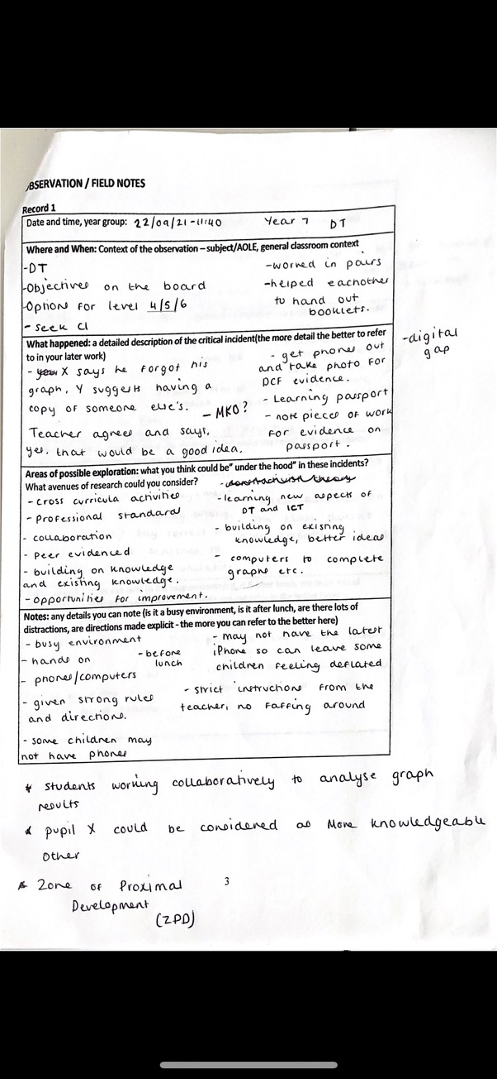
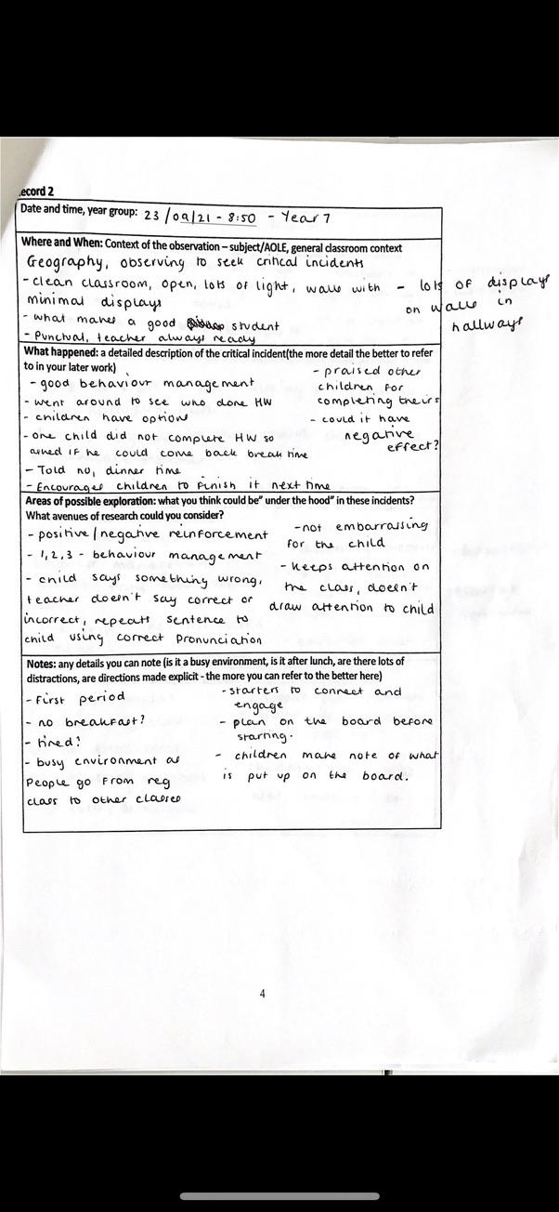
Appendix 2

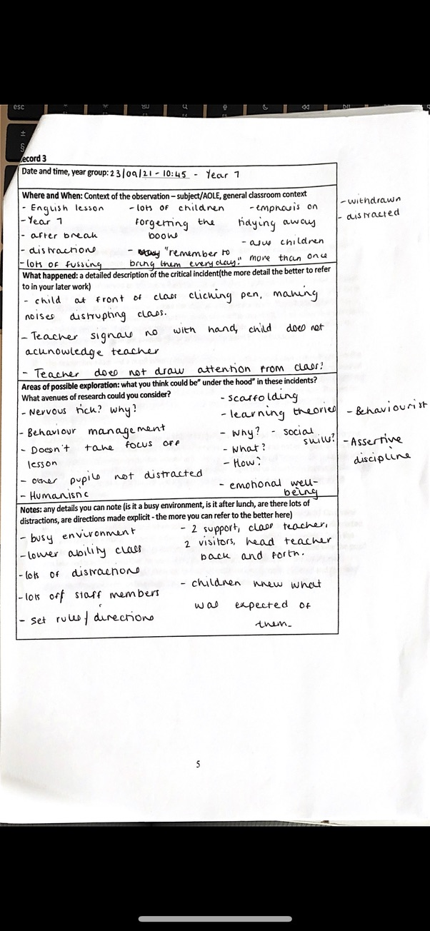
Appendix 3

