Student Name: Vackaar Hussain
Student ID: 2209946
Module: Advanced Statistical Programming
Module Code: ACCA7022
Comp 2: Data Analysis Task 2
Lecturer: Dr Aliyu Sambo

Task 2 – Reflective Summary

Visualisations and Exploratory Data Analysis
A structured visualisation approach was adopted to support both exploratory and explanatory analysis, grounded in the principles of John Tukey’s Exploratory Data Analysis (EDA), which emphasises graphical techniques for uncovering patterns, identifying anomalies, and informing statistical decision-making. The selection of visualisations was guided by the dual objectives of effective data exploration and clear communication of key patterns within the Air Quality dataset. Each visual was carefully aligned with the nature of the variables and the specific analytical questions addressed. To ensure reproducibility and analytical transparency, all visualisations were generated through a structured supplementary section of the R script, enabling consistent regeneration and maintaining a clear link between computational processes and interpretative insights.

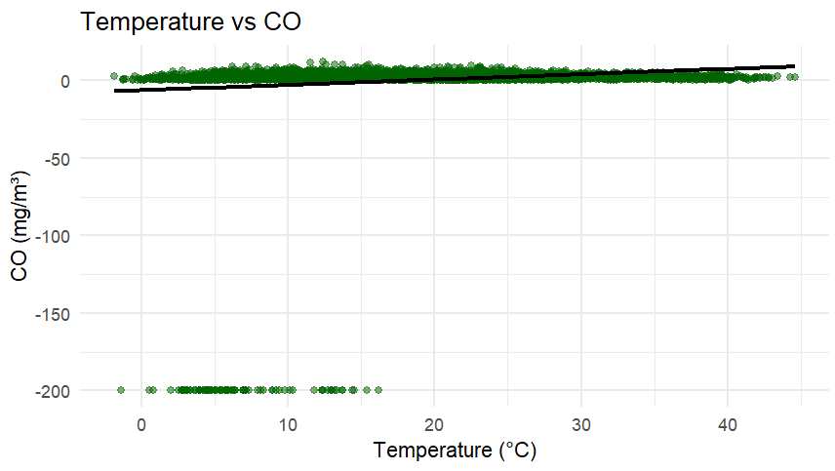

The scatterplot of Temperature vs CO concentration was employed to examine potential relationships between environmental conditions and pollutant levels. Scatterplots are particularly effective for identifying correlations, trends, and outliers in continuous variables. This visual enabled the detection of any linear or non-linear association, supporting hypothesis generation regarding temperature-driven pollution dynamics.

R Code Snippet for Scatter Plot

scatter_CO <- ggplot(AirQuality, aes(x=T, y=CO.GT.)) +
geom_point(alpha=0.5, color="darkgreen") +
geom_smooth(method="lm", se=FALSE, color="black") +
labs(title="Temperature vs CO",
x="Temperature (°C)",
y="CO (mg/m³)") +
theme_minimal()

print(scatter_CO)

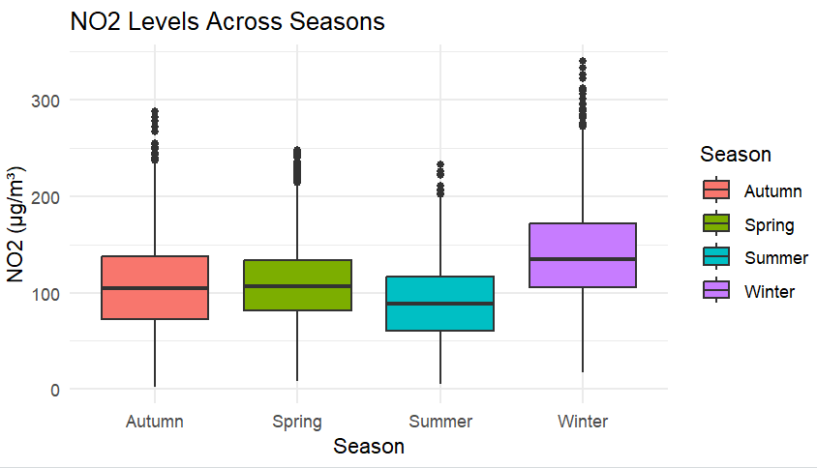

The boxplot of NO₂ levels across seasons provided a robust summary of distributional differences between categorical groups. Boxplots were selected for their ability to highlight medians, interquartile ranges, and outliers. This allowed for clear seasonal comparisons, revealing variability and potential seasonal pollution effects that may not be evident through summary statistics alone.

R Code Snippet for Boxplot

box_NO2 <- ggplot(AirQuality, aes(x=Season, y=NO2.GT., fill=Season)) +
geom_boxplot() +
labs(title="NO2 Levels Across Seasons",
x="Season",
y="NO2 (µg/m³)") +
theme_minimal()

print(box_NO2)

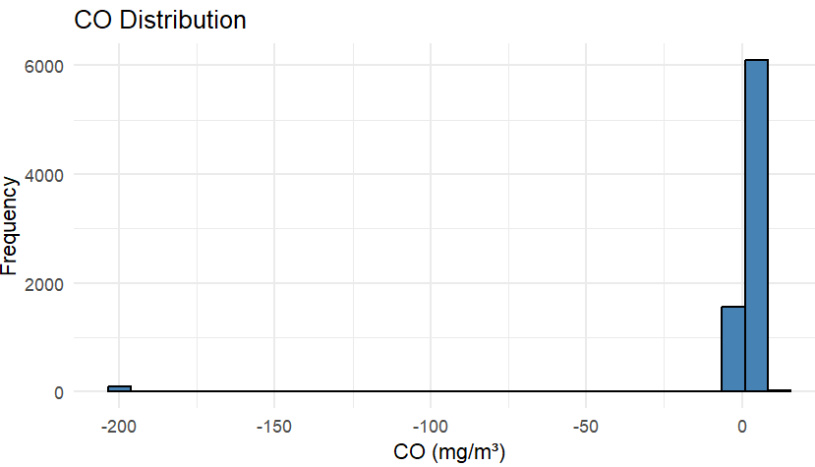

The histogram of CO concentration was used to assess the underlying distribution of the data. Understanding skewness and normality is critical for subsequent statistical modelling. The histogram revealed whether transformations or non-parametric approaches were necessary.

R Code Snippet for Histogram

hist_CO <- ggplot(AirQuality, aes(x=CO.GT.)) +
geom_histogram(bins=30, fill="steelblue", color="black") +
labs(title="CO Distribution",
x="CO (mg/m³)",
y="Frequency") +
theme_minimal()

print(hist_CO)

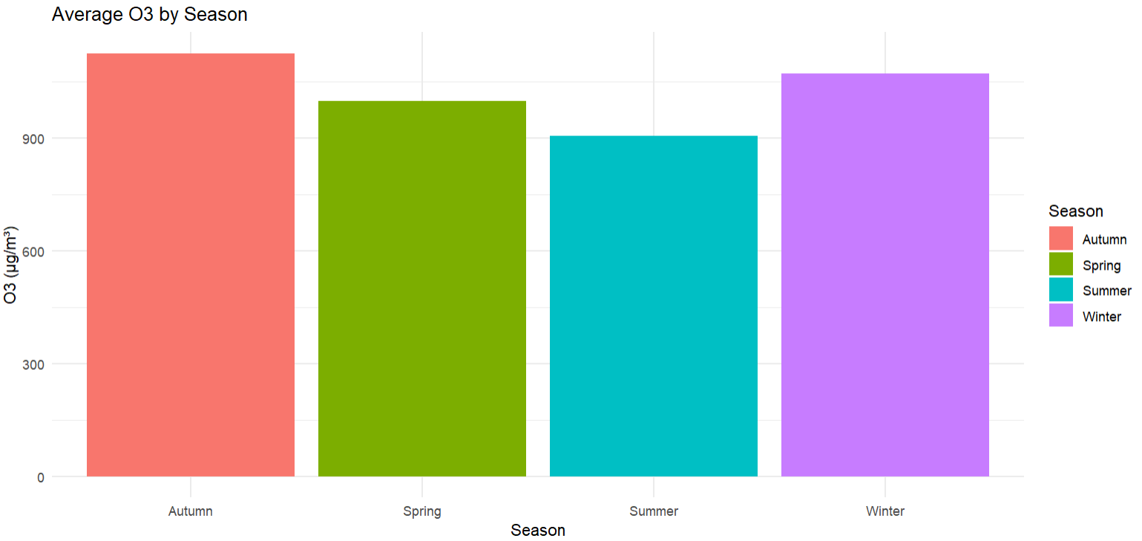

A bar chart summarising mean O₃ by season was chosen to communicate aggregated trends clearly. Bar charts are intuitive for comparing central tendencies across discrete groups, making seasonal differences immediately interpretable for non-technical stakeholders.

R Code Snippet for Bar Chart

library(dplyr)
library(ggplot2)

# Summarise mean O3 by Season
O3_season <- AirQuality %>%
group_by(Season) %>%
summarise(mean_O3 = mean(`PT08.S5.O3.`, na.rm = TRUE)) # use the correct column name

# Create bar plot
bar_O3 <- ggplot(O3_season, aes(x = Season, y = mean_O3, fill = Season)) +
geom_bar(stat = "identity") +
labs(title = "Average O3 by Season",
x = "Season",
y = "O3 (µg/m³)") +
theme_minimal()

print(bar_O3)

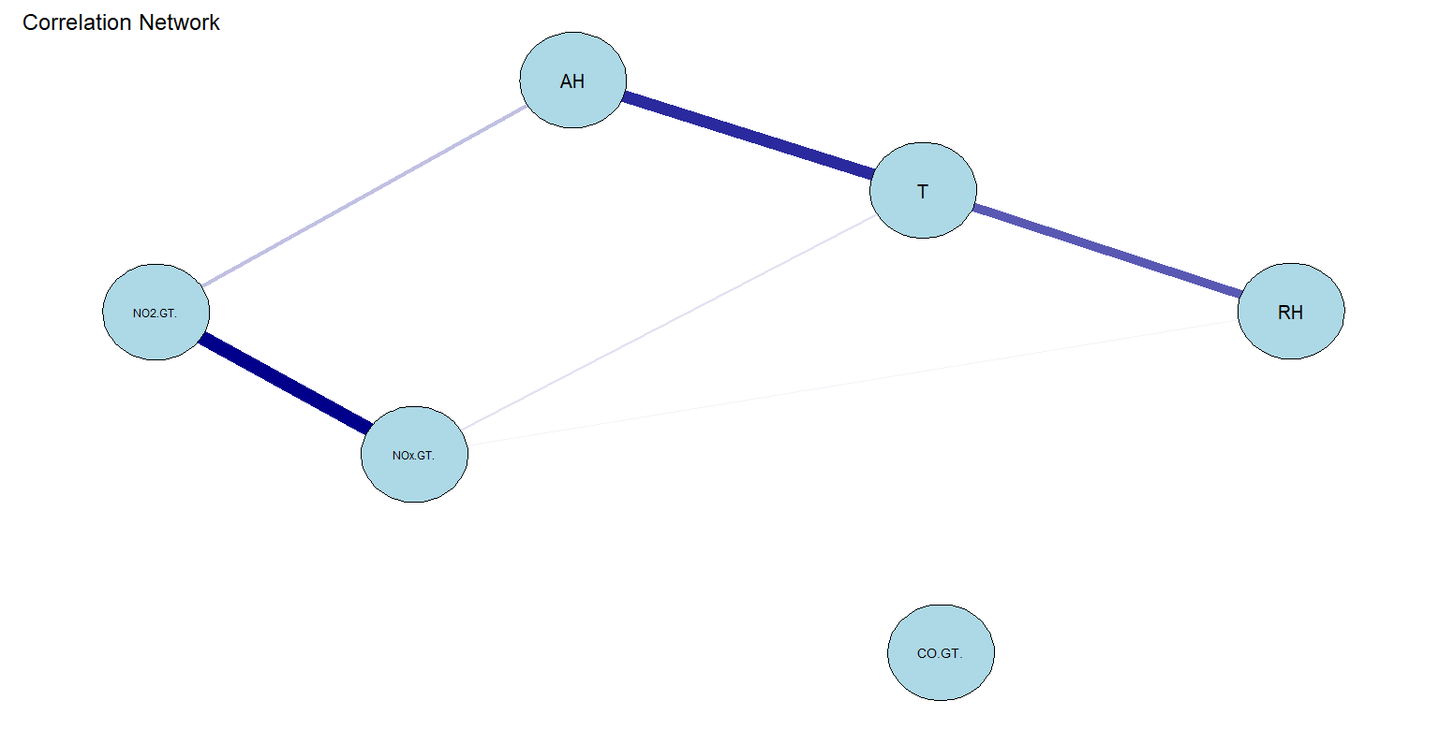

Finally, the correlation network visualisation provided a holistic view of inter-variable relationships. Unlike traditional correlation matrices, network graphs enhance interpretability by visually emphasising strength and direction of associations, supporting feature selection and multicollinearity assessment.
Collectively, these visualisations enabled both granular and holistic insights, enhancing interpretability and supporting data-driven conclusions.

R Code Snippet for Correlation Network

# Install qgraph if not already installed
if (!require(qgraph)) install.packages("qgraph")
library(dplyr)
library(qgraph)

# -----------------------------
# Select variables for correlation
# -----------------------------
cor_vars <- AirQuality %>%
select(`CO.GT.`, `NO2.GT.`, `NOx.GT.`, T, RH, AH) %>% # backticks for columns with dots
na.omit()

# -----------------------------
# Compute correlation matrix
# -----------------------------
cor_matrix <- cor(cor_vars)
print("Correlation matrix:")
print(cor_matrix)

# -----------------------------
# Generate and display correlation network
# -----------------------------
corr_plot <- qgraph(cor_matrix,
layout = "spring",
labels = colnames(cor_matrix),
color = "lightblue",
edge.color = "darkblue",
minimum = 0.2,
title = "Correlation Network")

Challenges and Things Learned
A key challenge in this analysis was managing data quality, particularly the handling of placeholder values (-200). Converting these to NA improved analytical validity but introduced potential bias through listwise deletion, reducing representativeness.
Ensuring correct data types was also critical, as initial conversion errors led to misleading outputs, highlighting the importance of validating data structures. A major learning outcome was the application of multivariate techniques such as PCA and clustering, revealing complex relationships between environmental variables.
The analysis also demonstrated the value of integrating visual, statistical, and machine learning approaches to enhance interpretation, ultimately strengthening my ability to develop a robust and structured analytical pipeline.

Improvements for Future Work
Based on this analysis, several extensions could enhance the utility and industrial relevance of the project:

Predictive Modelling
Incorporating machine learning algorithms (e.g., Random Forest, Gradient Boosting, LSTM networks) could enable air quality forecasting, aiding meteorologists and environmental agencies in planning and public health interventions.

Real-Time Sensor Integration
Modifying pipelines to ingest streaming IoT sensor data would allow dynamic monitoring, visualisation, and early warnings for pollution spikes.

Spatio-Temporal Modelling
Integrating GIS data could allow pollution mapping by location and time, guiding urban planning and targeted environmental interventions.

Satellite Data Integration
Combining ground measurements with high-resolution satellite sensors would support regional pollution monitoring and climate interaction analysis, representing a step toward next-generation environmental intelligence.

Health Risk Early Warning
Coupling pollutant predictions with public health data could enable automated early warnings, supporting mitigation strategies for vulnerable populations.

AI-Enhanced Decision Support
Combining this analysis with AI systems could automatically recommend policy or industrial interventions, turning environmental data into actionable solutions—a potential future achievement in environmental technology.

Code Modularisation and Automation
Creating reusable, interactive pipelines (e.g., via R Shiny) could allow easy integration of new datasets and visualisations, supporting real-world operational decision-making.

Parametric vs Non-Parametric Models

Model Type | Example Methods | Key Features & Use Cases
Parametric | t-test, ANOVA, Linear Regression | Assume a specific data distribution (e.g., normal). Efficient if assumptions hold; used for hypothesis testing and regression modelling
Non-Parametric | Wilcoxon test, Kruskal-Wallis test, Spearman correlation | Do not assume specific data distributions. Useful for skewed data, small sample sizes, or ordinal variables. Provides robust alternatives to parametric tests.

These methods were applied in this analysis to test hypotheses on pollutant concentrations under different conditions. Parametric tests were selected when assumptions of normality and homogeneity of variance were met, while non-parametric tests offered robust alternatives where assumptions were violated.

Use of Generative AI
Generative AI tools, including ChatGPT, were used to assist with code structuring, error troubleshooting, and identifying potential analysis enhancements. All outputs were critically evaluated and adapted to ensure accuracy. The final analysis, visualisation, and reflections reflect my understanding and were independently verified.

