Ioan Davies
2115169
Written Assessment
Computational Methods
2d dIFFUSION EQUATION MODEL USING THE EXPLICIT FINITE DIFFERENCE METHOD
ACMA6012

Table of Contents
Introduction 2
The Constitutive Equation of The Problem 3
Explicit finite difference form of the constative equation 4
The Initial and Boundary Conditions Implemented 9
Analytical Solution 10
Codes’ details and explanations 11
Validation of the code 16
Sensitivity analysis of the code 18
Main models limitations 21
Suggested improvements and future developments. 23
Conclusion 24
Bibliography 25
Appendix 26

Introduction

This report follows the process of developing a Matlab code for the 2D diffusion equation model using the Explicit Finite Difference Method. The main aims and objectives of the report are as follows:

Numerical Implementation and Validation – Demonstrate the Implementation of the Explicit Element Finite method for solving a 2D heat diffusion model in MATLAB. Validating the numerical results with an analytical method.

Sensitivity and Limitations Analysis – Determine the impact of grid spacing, time step and thermal equilibrium tolerance on the model’s outcome. Identify the limitations associated with the numerical method.

Propose Future enhancements – Discuss and propose alternative numerical methods and improvements that enhance the model.

The report commences with an overview of the heat diffusion equation, discussing its relevance and importance in this problem, including its mathematical definition for a 2D geometry with no heat source. This is followed by a full explanation of the chosen numerical method and describing the full discretisation procedure of the constitutive equation. Including concepts such as Fourier’s number and stability criteria. The next section specifies the initial and boundary conditions to be considered and introduces the analytical solution which is essential for validating the numerical code.

Illustrative snapshots of each section of the code have been incorporated into the report with explanations to enhance explanation. A sensitivity analysis follows, exploring the impacts of grid spacing, time steps and thermal equilibrium tolerance on the model. The following discussion clearly explains limitations of the chosen numerical method. The report then discusses proposed enhancements to the model, exploring numerical alternatives that improve accuracy, overcome stability issues, handle complex geometry and robust methods of modelling thermal equilibrium. The conclusion provides an overview of the key findings, revisiting originally established aims and objectives.

The Constitutive Equation of The Problem

As stated by (Narasimhan, 1999) The process of heat conduction described by a partial differential equation was first formulated by Jean Baptiste Joseph Fourier and published in 1822 as the ‘Analytical Theory of Heat’. (Fourier, 2009) explains that the transient heat diffusion equation relates to conductive transfer and storage of heat in a solid body. Fourier’s differential equation mathematically describes the rate of temperature change at any location in a solid body as a function of time. With the knowledge that a body of a given shape and size will exchange heat with its surroundings across its boundary and that heat can be measured accurately as temperature

The heat equation is significantly important in the areas of applied mathematics, physics, and engineering that models the temporal evolution of temperature distributions within a given domain (Wang & Solomon, 2019). With the primary purpose of combining the principles of heat transfer, to demonstrate the dynamic behaviour of heat propagation through materials. In mechanical engineering the heat equation is instrumental in thermal design and analysis. This is supported by (Kiharanjogu, 2009) in which explains engineers use the heat equation to predict temperature distributions in various components, ensuring that materials can withstand thermal stresses. The heat equation is also fundamental in the areas of energy systems and fluid dynamics. In which engineers apply the heat equation to model heat transfer and optimise the efficiency of systems.

The mathematical definition of the heat equation for a 2D geometry with no heat source term is as follows (Croft & Lilley, 1977):

$$\frac{∂^{2}T}{∂x^{2}}+\frac{∂^{2}T}{∂y^{2}}=\frac{ρ∙c_{p}}{k}∙\frac{∂T}{∂t}$$

$$α=k/{(ρ.c)}$$

$∇^{2}T=\frac{1}{α}.\frac{∂T}{∂t}$

$∴\frac{∂^{2}T}{∂x^{2}}+\frac{∂^{2}T}{∂y^{2}}=\frac{1}{α}∙\frac{∂T}{∂t}$ (1)

$∇^{2}$ is the Laplacian defined by $∇^{2}=\frac{∂^{2}}{∂x^{2}}+\frac{∂^{2}}{∂y^{2}}$ in two dimensions.
t = Time
T = Temperature
$α=k/{(ρ.c)}$ is the thermal diffusivity [m².s⁻¹]
k = Thermal conductivity [W.m⁻¹.K⁻¹]
$ρ$ = The density [kg.m⁻³]
$c$ = The specific heat [J.kg⁻¹.K⁻¹]

Explicit finite difference form of the constative equation

The idea of the finite difference technique is the substitution of the derivatives in the differential thermal diffusion equation by forward, backward, and central differences according to the Taylor series expansion (Recktenwald, 2004). The discretisation of the governing heat equation begins with the application of Taylor Series expansion to generate difference approximations for the first and second derivatives. The Taylor series converts the heat equation into a system of discrete algebraic equations suitable for use in numerical simulations. If a function $f\left(x\right)$ centred at point $x_{0}$ is considered using Taylor series to build a polynomial, the following is written (Abramowitz & Stegun, 1970):

$$f\left(x\right)=f\left(x_{0}\right)+\left(x-x_{0}\right)\frac{f^{'}\left(x_{0}\right)}{1!}+{(x-x_{0})}^{2}\frac{f''(x_{0})}{2!}+{+(x-x_{0})}^{3}\frac{f'''(x_{0})}{3!}+ . . .$$

We can then rewrite the equation to the form:

$f\left(x\right)=f\left(x_{0}\right)+ f^{'}\left(x_{0}\right)∙\frac{{\left(x-x_{0}\right)}^{1}}{1!}+f^{''}\left(x_{0}\right)∙\frac{{\left(x-x_{0}\right)}^{2}}{2!}+{f^{''}}^{'\left(x_{0}\right)}∙\frac{{\left(x-x_{0}\right)}^{3}}{3!}+ . . .$ (2)

By replacing $x$ with $x_{0}+h$ the equation can be written as follows:

$$f\left(x_{0}+h\right)=f\left(x_{0}\right)+f^{'}\left(x_{0}\right)∙\frac{h^{1}}{1!}+f''\left(x_{0}\right)∙\frac{h^{2}}{2!}+f'''(x_{0})∙\frac{h^{3}}{3!}+ . . .$$

Forward difference approximation to the first derivative $f^{'}$ can be generated by making $f^{'}\left(x_{0}\right)$ the subject. Firstly, transpose $f\left(x_{0}\right)$ to the opposite side of the equation:

$$f\left(x_{0}+h\right)-f\left(x_{0}\right)=f^{'}\left(x_{0}\right)∙h+f^{''}\left(x_{0}\right)∙\frac{h^{2}}{2!}+f^{'''}\left(x_{0}\right)∙\frac{h^{3}}{3!}+. . .$$

To cancel out the $h$ term divide both sides of the equation by $h$:

$$\frac{f\left(x_{0}+h\right)-f(x_{0})}{h}=f^{'}\left(x_{0}\right)+f^{''}\left(x_{0}\right)∙\frac{h^{2}}{2!}+f^{'''}\left(x_{0}\right)∙\frac{h^{2}}{3!}+f^{4}\left(x_{0}\right)∙\frac{h^{3}}{4!}+. . .$$

Neglecting the higher order terms and rearrange, to give the Forward difference approximation to the first derivative:

$f^{'}\left(x_{0}\right)≈ \frac{f\left(x_{0}+h\right)-f\left(x_{0}\right)}{h}$ (3)

Backward difference Approximation to the first derivative $f^{'}$ can be generated by replacing $x$ with $x_{0}-h$ in equation 2 as follows:

$$f\left(x_{0}-h\right)=f\left(x_{0}\right)-f^{'}\left(x_{0}\right)∙\frac{h^{1}}{1!}+f^{''}\left(x_{0}\right)∙\frac{h^{2}}{2!}-f'''(x_{0})∙\frac{h^{3}}{3!}+ . . .$$

Then make $f^{'}\left(x_{0}\right)$ the subject. Firstly, transpose $f\left(x_{0}\right)$ to the opposite side of the equation:
$$f\left(x_{0}-h\right)-f\left(x_{0}\right)=f^{'}\left(x_{0}\right)∙h+f^{''}\left(x_{0}\right)∙\frac{h^{2}}{2!}-f^{'''}\left(x_{0}\right)∙\frac{h^{3}}{3!}+. . .$$

To cancel out the $h$ term divide both sides of the equation by $h$:

$$\frac{f\left(x_{0}-h\right)-f(x_{0})}{h}={-f}^{'}\left(x_{0}\right)+f^{''}\left(x_{0}\right)∙\frac{h}{2!}-f^{'''}\left(x_{0}\right)∙\frac{h^{2}}{3!}+. . .$$

Neglecting the higher order terms and rearrange, to give the Backward difference approximation to the first derivative:

$f^{'}\left(x_{0}\right)=\frac{f\left(x_{0}\right)-f(x_{0}-h)}{h}$ (4)
Central difference Approximation to the first derivative $f^{'}$ can be generated by subtracting Equation 3 from Equation 2 as follows:

$$f\left(x_{0}+h\right)-f\left(x_{0}-h\right)=2f^{'}\left(x_{0}\right)∙h+2f^{'''}\left(x_{0}\right)∙\frac{h^{3}}{3!}+2f^{(5)}\left(x_{0}\right)∙\frac{h^{5}}{5!}+ . . .$$

To cancel out the $2h$ term divide both sides of the equation by $2h$:

$$\frac{f\left(x_{0}+h\right)-f(x_{0}-h)}{2h}={-f}^{'}\left(x_{0}\right)+f^{''}\left(x_{0}\right)∙\frac{h^{2}}{3!}+f^{(5)}\left(x_{0}\right)∙\frac{h^{4}}{5!}+. .$$

Neglecting the higher order terms and rearrange, to give the Central difference approximation to the first derivative:

$f^{'}\left(x_{0}\right)=\frac{f\left(x_{0}+h\right)-f(x_{0}-h)}{2h}$ (5)

Central difference Approximation to the second derivative $f^{'}'$ can be generated by adding Equation 3 to Equation 2 as follows:

$$f\left(x_{0}+h\right)+f\left(x_{0}-h\right)=2f\left(x_{0}\right)+2f^{''}\left(x_{0}\right)∙\frac{h^{2}}{2!}+2f^{(4)}\left(x_{0}\right)∙\frac{h^{4}}{4!}+ . . .$$

Transpose $2f\left(x_{0}\right)$ to the opposite side of the equation:

$$f\left(x_{0}+h\right)-2f\left(x_{0}\right)+f\left(x_{0}-h\right)=f^{''}\left(x_{0}\right)h^{2}+2f^{\left(4\right)}\left(x_{0}\right)∙\frac{h^{4}}{4!}+ . . .$$

To cancel out the $h^{2}$ term divide both sides of the equation by $h^{2}$:

$$\frac{\left(x_{0}+h\right)-2f\left(x_{0}\right)+f\left(x_{0}-h\right)}{h^{2}}=f^{''}\left(x_{0}\right)+2f^{\left(4\right)}\left(x_{0}\right)∙\frac{h^{2}}{4!}+ . . .$$

Neglecting the higher order terms and rearrange, to give the Central difference approximation to the second derivative:

$f^{''}\left(x_{0}\right)≈\frac{f\left(x_{0}+h\right)-2∙f\left(x_{0}\right)+f\left(x_{0}-h\right)}{h^{2}}$ (6)

Now the spatial second derivative in the constitutive equation can be replaced by the central difference approximation Equation 6 with respect to $x$ and $y$ respectively.

For this we will use the cardinal direction notation to replace the term $x_{0}$ with point $P$ and $h$ with a direction as shown in Figure 1 to denote the location around point $P$:

P

Figure 1.01: Cardinal direction notation to denote location around point $P$.

Replacing the terms and derive with respect to $x$ and $y$ respectively to give:

$$\frac{∂^{2}T_{P}}{∂x^{2}}=\frac{T_{E}-2T_{P}+T_{W}}{h^{2}}$$

$$\frac{∂^{2}T_{P}}{∂y^{2}}=\frac{T_{N}-2T_{P}+T_{S}}{h^{2}}$$

The temporal first derivative in the constitutive equation can replaced by the forward difference approximation Equation 3, with respect to time:

$$\frac{{∂T}_{P}}{∂t}=\frac{T_{P}^{t+∆t}-T_{P}^{t}}{∆t}$$

$∆t$ = Difference in time between two successive plates.

Resulting transformation of the constitutive equation with no derivative terms can now be written as:

$$\frac{T_{E}^{t}-2T_{P}^{t}+T_{W}^{t}}{h^{2}}+\frac{T_{N}^{t}-2T_{P}^{t}+T_{S}^{t}}{h^{2}}=\frac{1}{α}∙\frac{T_{P}^{t+∆t}-T_{P}^{t}}{∆t}$$

To make $T_{P}^{t+∆t}$the subject. Firstly, factorise the left-hand side of the equation by $h^{2}$:

$$\frac{1}{h^{2}}\left(T_{E}^{t}+T_{W}^{t}+T_{N}^{t}+T_{S}^{t}-{4T}_{P}^{t}\right)=\frac{T_{P}^{t+∆t}-T_{P}^{t}}{α∆t}$$

Transpose $α×∆t$ to the opposite side of the equation:

$$\frac{α∆t}{h^{2}}\left(T_{E}^{t}+T_{W}^{t}+T_{N}^{t}+T_{S}^{t}-{4T}_{P}^{t}\right)=T_{P}^{t+∆t}-T_{P}^{t}$$

Transpose $\frac{α∆t}{h^{2}}$ to the opposite side of the equation which can be defined as the Fourier number $F_{o}$ (Croft & Lilley, 1977):

$$F_{o}=\frac{α∆t}{h^{2}}$$

$$∴F_{o}\left(T_{E}^{t}+T_{W}^{t}+T_{N}^{t}+T_{S}^{t}-{4T}_{P}^{t}\right)+T_{P}^{t}=T_{P}^{t+∆t}$$

Combine the two terms on the left hand-side of the equation by implementing common factor of $F_{0}$:

$$F_{o}\left(T_{E}^{t}+T_{W}^{t}+T_{N}^{t}+T_{S}^{t}-{4T}_{P}^{t}\right)+\frac{F_{o}T_{P}^{t}}{F_{o}}=T_{P}^{t+∆t}$$

Then factorise by $F_{0}$:

$$F_{o}\left(T_{E}^{t}+T_{W}^{t}+T_{N}^{t}+T_{S}^{t}-{4T}_{P}^{t}+\frac{T_{P}^{t}}{F_{0}}\right)=T_{P}^{t+∆t}$$

Factorise by $T_{p}$ to simplify equation and give:

$$F_{o}\left(T_{E}^{t}+T_{W}^{t}+T_{N}^{t}+T_{S}^{t}-T_{P}(-\frac{1}{F_{0}}+4)\right)=T_{P}^{t+∆t}$$

Gives discretised form of the heat equation using the Explicit finite difference method:
$$T_{P}^{t+∆t}=F_{o}\left(T_{E}^{t}+T_{W}^{t}+T_{N}^{t}+T_{S}^{t}-T_{P}^{t}(4-\frac{1}{F_{o}})\right)$$

Rearrange to give final discretised form of the heat equation using the Explicit finite difference method:

$T_{P}^{t+∆t}=F_{o}\left(T_{E}^{t}+T_{W}^{t}+T_{N}^{t}+T_{S}^{t}-(4-\frac{1}{F_{o}}){∙T}_{P}^{t}\right)$ (7)

The stability criterion for a 2D geometry using the explicit finite difference method can be defined as (Croft & Lilley, 1977):

$0<F_{o}≤\frac{1}{4}$ (8)

$$∴0<\frac{α∆t}{h^{2}}≤\frac{1}{4}$$

We can then rearrange to calculate the maximum time step:

$0<∆t≤\frac{h^{2}}{4α}$ (9)

h = Grid spacing
α = Thermal diffusivity
$∆t$ = Time step

The Initial and Boundary Conditions Implemented

The geometry to be considered is a square 2D plate with the dimensions 6 x 6 subject to the initial domain conditions from the assignment brief as follows:

$$T\left(x,y,0\right)=0 0<x<6 0<y<6$$

The initial condition $T\left(x,y,0\right)=0$ means that at the beginning of the simulation when time, $t=0$ the temperature $T$at any point across the ($x,y)$ axis in the spatial domain is set at zero. The initial condition $0<x<6$ is applied for values in the $x$ values in a range from 0 to 6 with the condition for $T$ valid for any point within the plate along the $x$ axis. Similarly, the initial condition is also applied for the $y$ values in a range from 0 to 6 with the condition for $T$ valid for any point within the plate along the $x$ axis.

In addition to the initial condition’s boundary conditions are also applied. These conditions describe the behaviour of the solution at the boundaries of the spatial domain or in this scenario the plate. The boundary condition type used for this simulation is also called a Dirichlet boundary condition. This type of boundary condition in which the values, in this case temperature, are specified at the boundary of the spatial domain. The Dirichlet boundary condition for the simulation are as follows:

$$\begin{matrix}T\left(0,y,t\right)=0 \\ T\left(6,y,t\right)=0\end{matrix} for 0≤y≤6 and 0≤t≤thermal equilibrium$$

This condition sets the temperature along the left edge of the plate $x=0$ remain constant and equal to zero, regardless of the term $y$ and time $t$. Similarly, this condition sets the temperature along the right edge of the plate $x=6$ remain constant and equal to zero, regardless of the term $y$ and time $t$.

$$\begin{matrix}T\left(x,0,t\right)=0 \\ T\left(x,6,t\right)=0\end{matrix} for 0≤x≤6 and 0≤t≤thermal equilibrium$$

Where,

$$f\left(x\right)=\left\{\begin{matrix}12.5x & if 0≤x≤(\frac{2}{3}×6) \\ -25x+150 & if (\frac{2}{3}×6)<x≤6\end{matrix}\right.$$

This condition specifies the temperature along the top edge of the plate $y=0$ at any given time, $t$. The temperature value is given by the function $f(x)$ that depends on the spatial variable $x$. Therefore, all values for $x$ greater than zero and less than or equal to four will be calculated using $12.5x$ . If the value for $x$ is greater than four and less than or equal to six, then it will be calculated using $-25x+150$. This condition also sets the temperature along the bottom edge of the plate $y=6$ to remain constant and equal to zero, regardless of the term $x$ and time $t$.

Analytical Solution

The code will be tested against the following analytical solution of temperature and thermal equilibrium (Daileda, 2012):

$T\left(x,y\right)=\frac{450}{π^{2}}∙\sum_{n=1}^{∞}{\left(\frac{\sin\left(\frac{2∙n∙π}{3}\right)}{n^{2}∙\sinh\left(n∙π\right)}∙\sin\left(\frac{n∙π∙x}{6}\right)∙\sinh\left(\frac{n∙π∙y}{6}\right)\right)}$ (10)

This equation provides an analytical solution to calculating the temperature distribution within the 2D plate through time.

Codes’ details and explanations

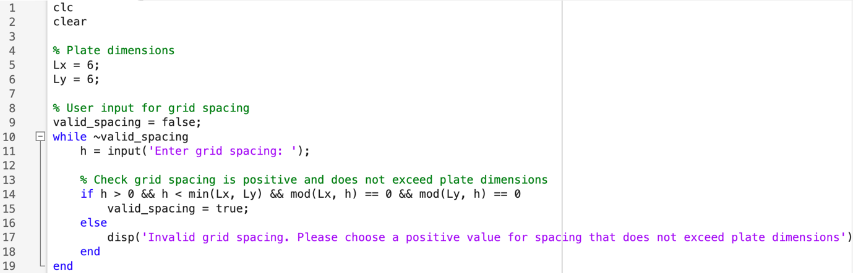

Figure 1.02: Screenshot of MATLAB code, lines one to nineteen.

The section of code shown in Figure 1.02 starts by defining the plate dimensions as a 6 by 6 square. The code then prompts the user to input a grid spacing, ensuring that the grid spacing is positive, generates and even grid spacing and does not exceed the plate dimensions. If the conditions are not met, then an error message is displayed to the user to choose another value using a while loop function until a valid input is provided.

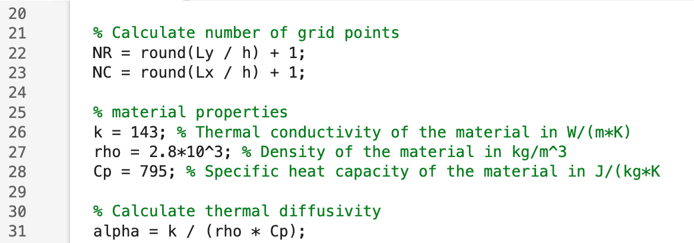

Figure 1.03: Screenshot of MATLAB code, lines twenty to thirty-one.

The next section of code shown in Figure 1.03 starts by calculating the number of grid points in the y-direction NR (number of rows) and x-direction NC (number of columns), to discretise the spatial domain. Which is determined by dividing the plate dimensions by grid spacing and adding one, using the round function to ensure the result is an integer. Then next few lines of code determine the material properties of the plate. Thermal diffusivity is then calculated using the material properties and using formula for thermal diffusivity from Equation 1.

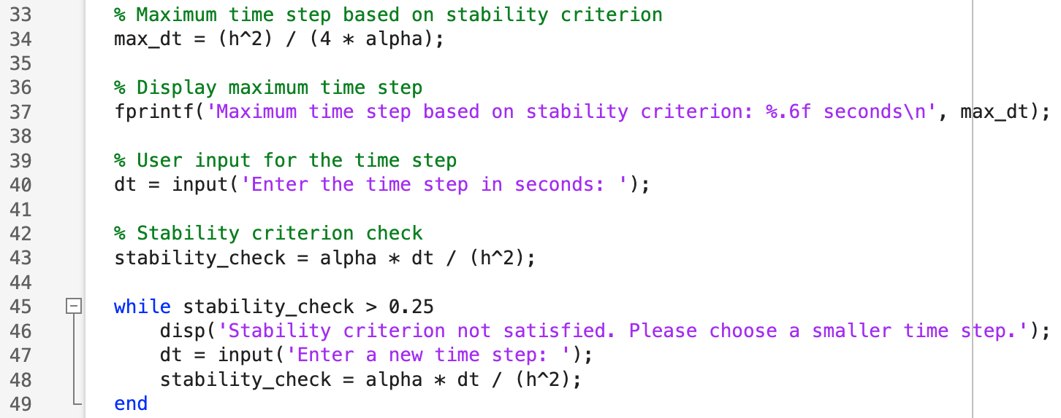

Figure 1.04: Screenshot of MATLAB code, lines thirty-three to forty-nine.

The section of code shown in Figure 1.04 starts by calculating the maximum allowable time step based on the stability criterion, using Equation 9. The maximum time step is then displayed to the user before the user is prompted to input a time step in seconds. A stability check is carried out on the user provided time step. A while loop is used to check the parameter does not exceed 0.25, If the time step does not meet the stability criterion the code requests a new time step to be entered until stability is achieved.

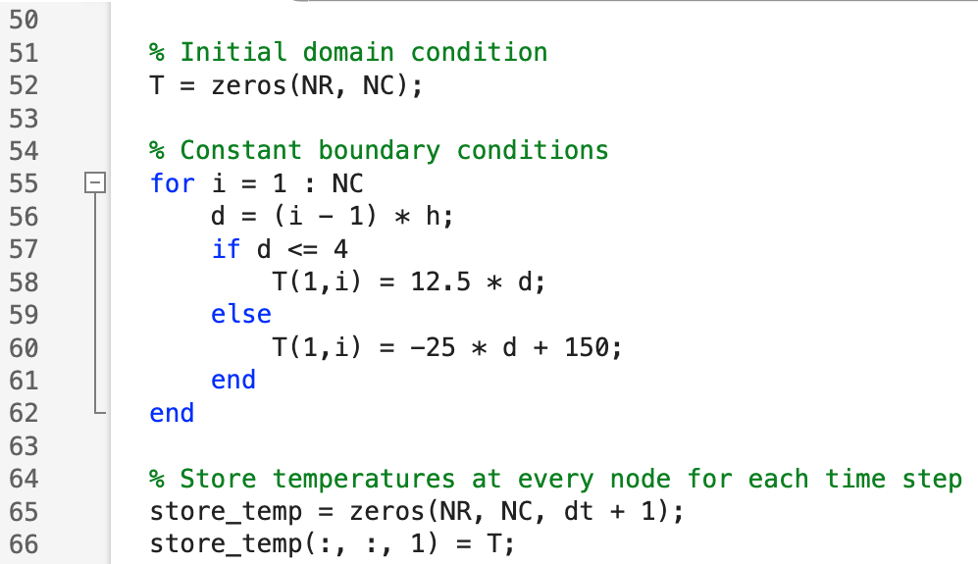

Figure 1.5: Screenshot of MATLAB code, lines fifty to sixty-six.

The initial and boundary conditions are then determined in the section of code shown in Figure 1.05. Firstly, the code sets the initial temperature of the matrix to zero, using the function ‘zeros’. The code then sets the constant boundary conditions along the top edge of the plate based on the conditional statement, which is applied to every node. If the distance ‘d’ along the x-axis is less than or equal to four, the temperature will use condition 12.5 x d. Otherwise, the temperature will use condition -25 x d + 150. The temperature is then stored at each node for each time step, with the initial temperature T being at the first time step.

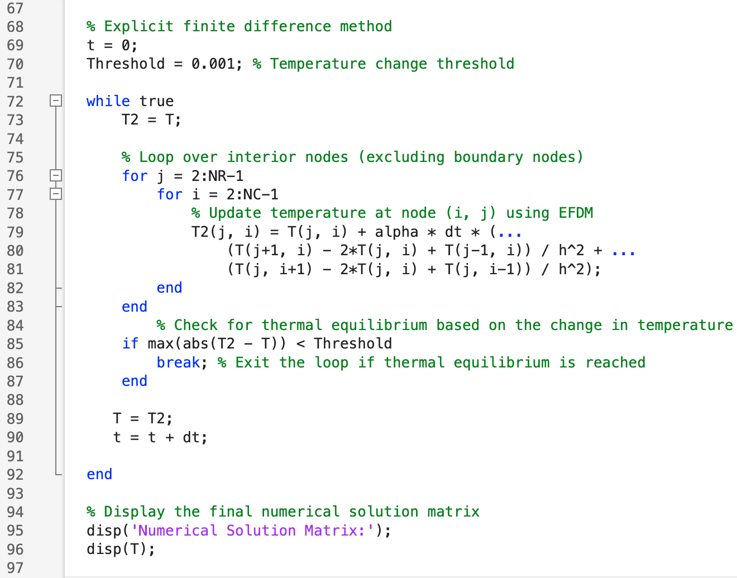

Figure 1.06: Screenshot of MATLAB code, lines sixty-seven to ninety-seven.

The next section of code shown in Figure 1.06 implements the explicit finite difference method to numerically solve the heat conduction problem of the 2D plate. This section of code starts by initialising the time variable ‘t’ to zero and sets a threshold value of 0.001 to determine with thermal equilibrium is reached. An infinite loop is then started to iterate over time steps until thermal equilibrium is reached, creating a temporary matrix T2 which stores the updated temperature at each node. All interior nodes are then updated using the Explicit finite difference method excluding the boundary nodes. To reach thermal equilibrium a check is carried out between consecutive time steps until maximum change in temperature reaches threshold value (tolerance). Finally, the numerical matrix solution is then displayed in the command window.

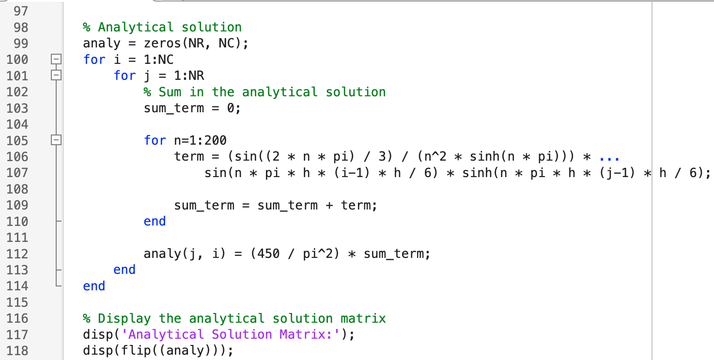
Figure 1.07: Screenshot of MATLAB code, lines ninety-eight to one hundred eighteen.

The section of code shown in Figure 1.07 starts by creating a temporary matrix ‘analy’ which stores the analytical solution of the temperature at each node. A nested loop is then used to iterate over each node in the grid and calculates the temperature value using the analytical equation for each node. The final analytical solution matrix is then displayed and flipped using ‘flip’ function to correctly orient the matrix.

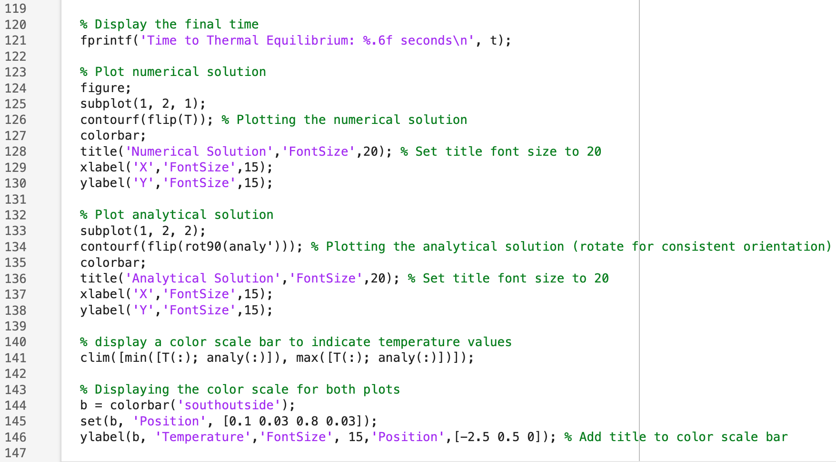

Figure 1.08: Screenshot of MATLAB code, lines one hundred nineteen to one hundred forty-seven.

The final section of code shown in Figure 1.08 starts by displaying the time to thermal equilibrium based on the explicit finite difference method. The code then generates a visual representation of the temperature distribution of the 2D plate for both the numerical and analytical solution in the same plot window. The ‘contourf’ function was used to plot the temperature distribution for both solutions. In addition to the plot titles a colour scale bar was also added below the subplots to aid the readability of the plots.

Validation of the code

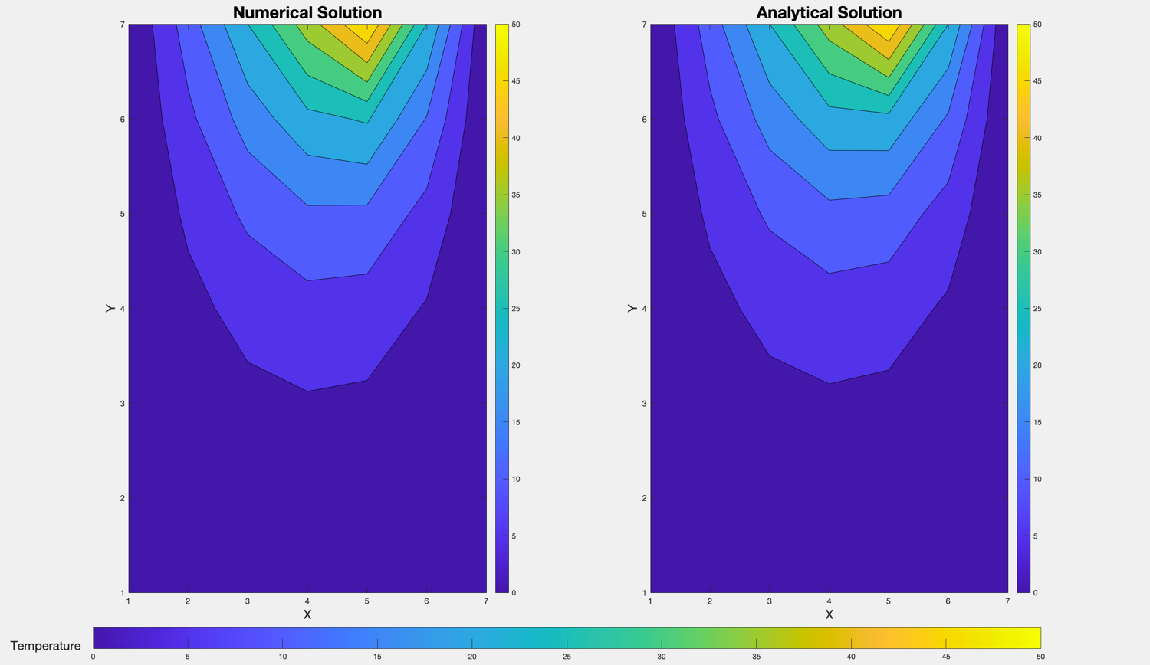

Figure 1.09: resulting temperature map at thermal equilibrium for the numerical and analytical solution.

The resulting temperature map generated at thermal equilibrium using the explicit finite difference method (numerical) and the analytical solution are shown in Figure 1.09. A grid spacing of one and a time step of 3600 seconds was used to generate these values. By comparing both temperature maps the qualitative results appear to be very similar with only slight discrepancies in temperature display. Therefore, this indicates the numerical solution is accurate and valid.

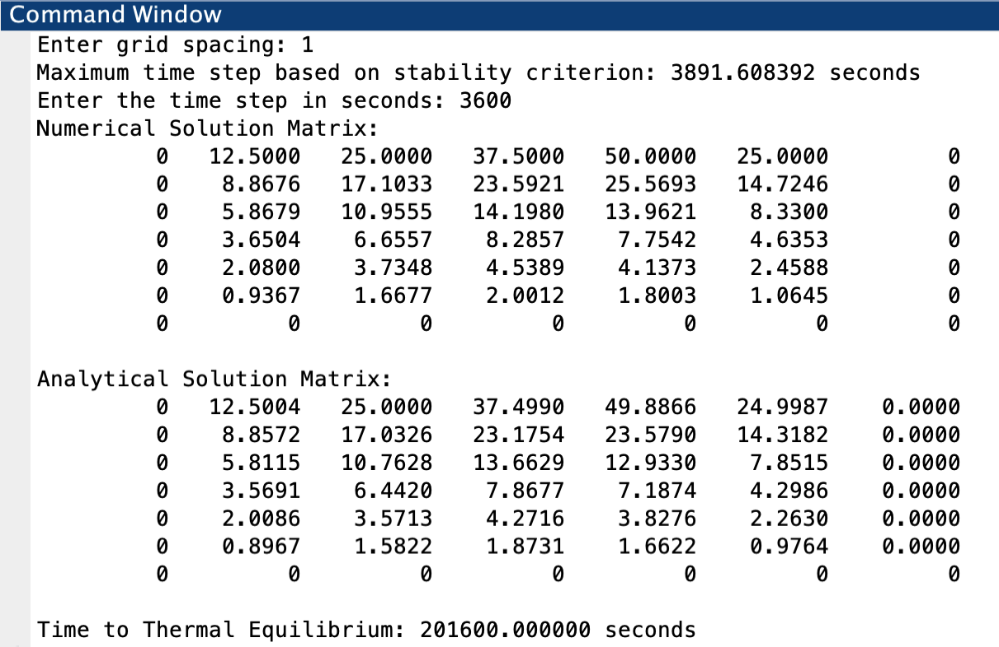

Figure 1.1: Resulting matrix for both the numerical and analytical solution using a grid spacing of one and time step of 3600 seconds.

The solution temperature matrix shown in Figure 1.1 for both the numerical and analytical methods result in values that are very similar. These values were generated using the same grid spacing value of one and time step of 3600 seconds. Using this quantitative method for comparison it is also indicates that the numerical solution is accurate and valid. With none of the values at any given node in the numerical solution varying by more than 0.5 degrees Celsius when compared to the analytical solution.

Sensitivity analysis of the code

Figure 2.1: Influence of the grid spacing on time to reach thermal equilibrium.

By analysing the results in Figure 2.1 a smaller grid spacing results in a more refined (reduced) time to thermal equilibrium. The results were generated by running the code with varying grid spacing values and fixed values for the time step (150 seconds) and tolerance (0.001). As the value of the grid spacing $h$ increases, the error of the approximation derived from Taylor series also increases. Therefore, as the grid spacing reduces the accuracy of the final solution and time to thermal equilibrium result will also increase due to a reduced error term.

During the discretisation of the Constitutive equation using Taylor series an error is introduced when approximating the derivatives, which is known as the truncation or discretization error. (Mazumder, 2016) explains that the truncation error is proportional to the power $n$ of the grid spacing term, with the error reducing as the order term increase ensuring power $n$ is greater than zero. Therefore, smaller grid spacing will result in higher order accuracy and lead to a faster convergence for the numerical solution.

Figure 2.2: Influence of the tolerance condition on time to reach thermal equilibrium.

The influence of the tolerance condition on the time to reach thermal equilibrium is shown in Figure 2.2, whereby a test was conducted on the code in which the tolerance condition was varied with a fixed grid spacing (one) and time step (500). By analysing the graph, as the tolerance condition has increased, the time to thermal equilibrium decreased. The methodology implemented in the code to model thermal equilibrium is based on the concept of convergence criterion. The convergence criterion used in this code checks the maximum temperature difference between successive time steps does not exceed the pre-determined threshold or tolerance value. An infinite loop iterates over each time step until the tolerance has been reached and which determines the time taken to reach thermal equilibrium. Therefore, by increasing the tolerance condition the time required to reach thermal equilibrium will be reduced and decreasing the tolerance condition will increase the time to thermal equilibrium.

Figure 2.3: Influence of the time step on time to reach thermal equilibrium.

By analysing the results in Figure 2.3 a smaller time step results in a reduced time to thermal equilibrium. The results were generated by running the code with varying time step values and maintaining fixed values for the grid spacing (0.75) and tolerance (0.0001). These results align with the principles of the Explicit finite difference method where the time step value in the MATLAB code affects the trade-off between accuracy and computational efficiency. A suitable time step is required to ensure that the simulation remains stable, and results are accurate. This is highlighted by (Trefethen, 1994) as the Explicit finite difference method is highly sensitive to the time step. A smaller time step allows for a more accurate representation of the model’s behaviour and allows the simulation to converge to thermal equilibrium in a faster time (Wenjie Cui, 2019).

Main models limitations

The Explicit finite difference method is widely used for thermal process simulations due to its simplicity and computational efficiency. However, it is important to acknowledge and understand its limitations to ensure accurate and reliable results. One primary limitation of the explicit finite difference method is round-off error. Which occurs when fewer digits are used to represent a number than required (Andrili & Hecker, 2010). EFDM involves carrying out mathematical operations in iterations and as a result small numerical errors can accumulate over time. As explained by (Pacheco, 2022) these errors are commonly introduced due to the finite precision of digital computers and their limited memory, when calculating and representing real numbers. Therefore, round-off errors can lead to a loss of accuracy of the results, particularly in simulations with many iterations and large values which can significantly accumulate over the course of the simulation.

Another significant limitation of the Explicit finite difference method is Truncation error. This errors occurs due to the approximation of derivatives using Taylor series during the discretization process of the constative equation. As defined by (Neill & Reza, 2018) truncation error is the difference between the analytical derivative of a function and the derivative obtained by numerical approximation. During the process of replacing the derivatives with their discrete alternatives a level of approximation must be implemented. The explicit finite difference method in the code approximates the spatial and temporal derivatives of the temperature matrix and therefore, their results at each grid point will deviate from the analytical solution of the partial differential equation (Mazumder, 2016). The accuracy of the simulation is highly dependent on the spatial and temporal discretization and therefore, smaller grid spacing, and time steps will lead to reduced truncation error.

The explicit finite difference method also faces limitations when dealing with complex geometry. The cause of this limitation arises from the use of a grid structure method, in which the domain is discretised into a grid of nodes. (Lomax, et al., 2001) explains that when the number of discrete elements in specific region of the domain increases as in complex shapes FDM methods become too difficult to implement. Therefore, when running simulations in systems with complex geometry such as irregular shapes or intricate boundaries the explicit finite difference method may struggle to represent the geometry and accurately capture the thermal behaviour.

Another primary concern and limitation when using the Explicit finite difference method is stability. The Explicit finite difference method is governed by a stability criterion condition as defined in Equation 8, which restricts the relationship between the time step, spatial discretization, and physical properties. The John Von Neumann stability analysis is used to establish a relationship between stability and convergence and identify valid stability criteria (Trefethen, 1994). If the stability criterion is not satisfied, then simulation may become unstable. The stability of this numerical method is highly sensitive to the time step and therefore a very small-time step may be required in dynamic systems to maintain stability which can lead to more computational power to reach a thermal equilibrium time.

Beyond the mathematical and numerical limitations of the explicit finite difference method there may also be limitations arising from coding method. Defining thermal equilibrium based on a minimum difference value between successive temperature maps although practical, may not always represent the physical process accurately. Thermal equilibrium in a system occurs when temperature distribution becomes constant in time and therefore, relying on a minimum difference value between two successive temperature maps oversimplifies the dynamics of the system and may miss important behaviours, reducing accuracy of the results (Dixon, 2019). The convergence criteria of the numerical simulation also rely on the tolerance value on achieving thermal equilibrium between two successive temperature maps. Therefore, as the tolerance value increases the simulation will prematurely stop before the system has fully reached thermal equilibrium, reducing accuracy of the result.

Suggested improvements and future developments.

Although there are limitations to the Explicit finite difference method there are potential areas for improvement and future developments that will enhance the numerical method, improving accuracy of results and efficiency in running thermal simulations. One alternative numerical method that could be used to improve stability is the Alternating direction implicit (ADI) method. ADI provides much improved stability to the numerical method, allowing larger time steps compared to the explicit finite difference method (Garrett Birkhoff, 2008). This is because unlike the Explicit finite difference method the ADI method does not require CFL conditions for convergence and instead exhibit unconditional stability. This means that it can use larger time steps and will always remain stable regardless of the time step chosen.

Numerical method alternatives to the Finite difference method (FDM) such as the Finite element Method (FEM), Finite volume method (FVM) and Boundary element method (BEM) offer improvements when handling complex geometries. In FEM geometry is discretised into nodes and elements, with elements being geometric shapes such as triangles that connect the nodes to create a mesh (AltairUniversity, 2023). This allows unstructured meshes to be used instead of regular grid patterns as nodes and elements can be placed and shaped as needed to accurately represent the geometry. This makes this method much more suitable for complex geometries. FVM is another alternative to FDM which is well suited for dealing with complex geometries. This method divides the domain into nodes of control volume, the differential equations are then integrated over the volumes (Rapp, 2017). This allows for more flexibility when adapting to complex geometries.

As previously discussed, defining thermal equilibrium based on a minimum difference value between successive temperature maps is not very robust. There are many more robust approaches that model thermal equilibrium such as implementing a multi-criteria convergence. This involves monitoring multiple parameters to ensure the numerical solution converges accurately. For example, a multi-criteria convergence could be determined by implementing checks on difference in temperature, the use of material properties such as thermal conductivity and flux imbalances (L. Evangelisti, 2023). The additional checks would check convergence with respect to material properties such as thermal conductivity and monitor imbalances in heat flux at boundaries or interfaces to ensure heat is properly transferred throughout the domain. A tolerance would be set for each criteria and the simulation would then only converge once all convergence criteria have been met. Therefore, improving accuracy of the thermal equilibrium model.

Another more robust method of modelling thermal equilibrium would be to implement energy balance checks. This will monitor the total energy entering and leaving the domain and ensure that they are equal. A tolerance could also be applied to the model. This method ensures that the simulation captures all relevant heat transfer behaviours and reaches a true thermal equilibrium.

Conclusion

This report has discussed in detail the process of developing a MATLAB code for solving 2D diffusion equation model using the Explicit finite difference method. All primary aims and objectives have been effectively addressed throughout the report. The first objective which focused on numerical implementation and validation was achieved by demonstrating the discretisation of the governing heat equation and the use of Taylor series. The discretised constative equation was then implemented into MATLAB code. The numerical results were then validated by comparison to the analytical method to confirm the accuracy and reliability of the method. The results show that the numerical method is very similar to the analytical method both qualitatively and quantitively and provides and accurate model of the heat diffusion across a 2D metal plate.

The second objective sensitivity and limitations analysis were also achieved by understanding the impact of grid spacing, time step and thermal equilibrium tolerance on the time to reach thermal equilibrium. From the report’s findings we can conclude that as the grid spacing, and tolerance condition values increase the time to thermal equilibrium decreases but may reduce accuracy of the results. Additionally, as the time step decreases the time to thermal equilibrium will also decrease. This provided valuable understanding on the behaviour of the model under varying conditions and identified limitations to the numerical method used. The limitations for the Explicit finite difference method include round-off error, truncation error, stability, and the inability of the method to deal with complex geometry. These limitations highlight the considerations to be made when analysing the results of the numerical method.

By addressing the third objective the report proposed future improvements to the numerical method and alternative numerical methods. Alternative methods such as Finite element Method (FEM) and Finite volume method (FVM) were discussed for potential improvements to the model’s accuracy and performance. The report also proposed the implementation of multi-criteria convergence methods to improve the accuracy of the thermal equilibrium modelling, such as material properties, thermal conductivity, and heat flux imbalances at the boundary.

In summary, this report has successfully addressed the aims and objectives set out. The MATLAB code was successfully validated against the results of the analytical solution and therefore, provides a robust solution to modelling the 2D diffusion equation. The sensitivity analysis and limitations identified helps to understand the behaviours of the model and the Explicit finite difference method used in heat diffusion modelling.

Bibliography
Abramowitz, M. & Stegun, I. A., 1970. Handbook of Mathematical Functions: with Formulas, Graphs, and Mathematical Tables. Washington D.C.: National Bureau of Standards.

AltairUniversity, 2023. Introduction to Meshing. [Online]
Available at: https://altairuniversity.com/wp-content/uploads/2014/02/meshing.pdf
[Accessed 23 January 2024].

Andrili, S. & Hecker, D., 2010. Elementary Linear Algebra (Fourth Edition). In: S. Andrili & D. Hecker, eds. Chapter 9 - Numerical Methods. Philadelphia: Academic Press, pp. 587-643.
Anon., n.d. In: s.l.:s.n.

Croft, D. R. & Lilley, D. G., 1977. Heat Transfer Calculations Using Finite Difference Equations. Michigan: Applied Science.

Daileda, R. C., 2012. The Two Dimensional Heat Equation. [Online]
Available at: http://ramanujan.math.trinity.edu/rdaileda/teach/s12/m3357/lectures/lecture_3_6_short.pdf
[Accessed 17 January 2024].

Dixon, A., 2019. Chapter 8 - The “control diagram” method. In: A. Dixon, ed. Modern Aspects of Power System Frequency Stability and Control. s.l.:Academic Press, pp. 191-209.

Fourier, J. B. J., 2009. The Analytical Theory of Heat. Cambridge: Cambridge University Press.

Garrett Birkhoff, R. S. V. D. Y., 2008. Alternating Direction Implicit Methods. In: Advances in Computers. s.l.:Elsevier, pp. 189-273.

Kiharanjogu, S., 2009. Heat Equations and Their Applications, Nairobi: University of Nairobi.
L. Evangelisti, C. G. E. D. L. V. F. A., 2023. Convergence criteria analysis for thermal conductance measurements of building walls: A case study. Case Studies in Thermal Engineering, Volume 49, pp. 1-10.

Lomax, H., Pulliam, T. H. & Zingg, D., 2001. Fundamentals of Computational Fluid Dynamics. s.l.:ResearchGate.

Mazumder, S., 2016. Chapter 2 - The Finite Difference Method. In: S. Mazumda, ed. Numerical Methods for Partial Differential Equations. Ohio: Academic Press, pp. 51-101.

Narasimhan, T. N., 1999. Fourier’s heat conduction equation: History, influence, and connections. Proceedings of the Indian Academy of Sciences - Earth and Planetary Sciences, Volume 108, pp. 117-148.

Neill, S. P. & Reza, M. H., 2018. Chapter 8 - Ocean Modelling for Resource Characterization. In: S. P. Neill & M. H. Reza, eds. Fundamentals of Ocean Renewable Energy. s.l.:Academic Press, pp. 193-235.
Pacheco, D. R. Q., 2022. Rounding errors in numerical differentiation, s.l.: Norwegian Univeristy of Science and Technology.

Rapp, B. E., 2017. Microfluidics: Modeling, Mechanics and Mathematics. s.l.:Elsevier.

Recktenwald, G., 2004. Finite-Difference Approximations to the Heat Equation. Mechanical Engineering, Volume 10.

Trefethen, L. N., 1994. Chapter 4 - Accuracy, Stability and Convergence. In: L. N. Trefethen, ed. Finite Difference and Spectral Methods for Ordinary and Partial Differential Equations. Oxford: University of Oxford, pp. 146-185.

Wang, Y. & Solomon, J., 2019. Chapter 2 - Intrinsic and extrinsic operators for shape analysis. In: R. Kimmel & X. Tai, eds. Handbook of Numerical Analysis. Cambridge, MA: Elsevier, pp. 41-115.

Wenjie Cui, K. A. G. D. M. T. D. M. P. L. Z., 2019. Time-step constraints for finite element analysis of two-dimensional transient heat diffusion. Computers and Geotechnics, Volume 108, pp. 1-6.

Appendix

MATLAB code:

clc
clear

% Plate dimensions
Lx = 6;
Ly = 6;

% User input for grid spacing
valid_spacing = false;
while ~valid_spacing
h = input('Enter grid spacing: ');

% Check grid spacing is positive and does not exceed plate dimensions
if h > 0 && h < min(Lx, Ly) && mod(Lx, h) == 0 && mod(Ly, h) == 0
valid_spacing = true;
else
disp('Invalid grid spacing. Please choose a positive value for spacing that does not exceed plate dimensions')
end
end

% Calculate number of grid points
NR = round(Ly / h) + 1;
NC = round(Lx / h) + 1;

% material properties
k = 143; % Thermal conductivity of the material in W/(m*K)
rho = 2.8*10^3; % Density of the material in kg/m^3
Cp = 795; % Specific heat capacity of the material in J/(kg*K

% Calculate thermal diffusivity
alpha = k / (rho * Cp);

% Maximum time step based on stability criterion
max_dt = (h^2) / (4 * alpha);

% Display maximum time step
fprintf('Maximum time step based on stability criterion: %.6f seconds\n', max_dt);

% User input for the time step
dt = input('Enter the time step in seconds: ');

% Stability criterion check
stability_check = alpha * dt / (h^2);

while stability_check > 0.25
disp('Stability criterion not satisfied. Please choose a smaller time step.');
dt = input('Enter a new time step: ');
stability_check = alpha * dt / (h^2);
end

% Initial domain condition
T = zeros(NR, NC);

% Constant boundary conditions
for i = 1 : NC
d = (i - 1) * h;
if d <= 4
T(1,i) = 12.5 * d;
else
T(1,i) = -25 * d + 150;
end
end

% Store temperatures at every node for each time step
store_temp = zeros(NR, NC, dt + 1);
store_temp(:, :, 1) = T;

% Explicit finite difference method
t = 0;
Threshold = 0.001; % Temperature change threshold

while true
T2 = T;

% Loop over interior nodes (excluding boundary nodes)
for j = 2:NR-1
for i = 2:NC-1
% Update temperature at node (i, j) using EFDM
T2(j, i) = T(j, i) + alpha * dt * (...
(T(j+1, i) - 2*T(j, i) + T(j-1, i)) / h^2 + ...
(T(j, i+1) - 2*T(j, i) + T(j, i-1)) / h^2);
end
end
% Check for thermal equilibrium based on the change in temperature
if max(abs(T2 - T)) < Threshold
break; % Exit the loop if thermal equilibrium is reached
end

T = T2;
t = t + dt;

end

% Display the final numerical solution matrix
disp('Numerical Solution Matrix:');
disp(T);

% Analytical solution
analy = zeros(NR, NC);
for i = 1:NC
for j = 1:NR
% Sum in the analytical solution
sum_term = 0;

for n=1:200
term = (sin((2 * n * pi) / 3) / (n^2 * sinh(n * pi))) * ...
sin(n * pi * h * (i-1) * h / 6) * sinh(n * pi * h * (j-1) * h / 6);

sum_term = sum_term + term;
end

analy(j, i) = (450 / pi^2) * sum_term;
end
end

% Display the analytical solution matrix
disp('Analytical Solution Matrix:');
disp(flip((analy)));

% Display the final time
fprintf('Time to Thermal Equilibrium: %.6f seconds\n', t);

% Plot numerical solution
figure;
subplot(1, 2, 1);
contourf(flip(T)); % Plotting the numerical solution
colorbar;
title('Numerical Solution','FontSize',20); % Set title font size to 20
xlabel('X','FontSize',15);
ylabel('Y','FontSize',15);

% Plot analytical solution
subplot(1, 2, 2);
contourf(flip(rot90(analy'))); % Plotting the analytical solution (rotate for consistent orientation)
colorbar;
title('Analytical Solution','FontSize',20); % Set title font size to 20
xlabel('X','FontSize',15);
ylabel('Y','FontSize',15);

% display a color scale bar to indicate temperature values
clim([min([T(:); analy(:)]), max([T(:); analy(:)])]);

% Displaying the color scale for both plots
b = colorbar('southoutside');
set(b, 'Position', [0.1 0.03 0.8 0.03]);
ylabel(b, 'Temperature','FontSize', 15,'Position',[-2.5 0.5 0]); % Add title to color scale bar

