Module: Network Operating Systems and Services

Module Code: ACCA5023

Date: 17th February 2024

ASSESSMeNT 1
Kristian Crawford (1919795)

2024
Table Of Contents

Front Cover Page 1

Table of Contents Page 2

Abstract Page 3

Introduction Page 4

Main Report Page 5-13

Conclusion Page 14

References Page 15-17
Abstract
The purpose of this report is to document the planning and implication of a networking solution containing two servers and two host PC’s. With the design goal required to look at all aspects of the design and justify the choices of all parts of the final system from Operating systems to hosting systems, everything that is required to link the four parts of this system and obtain a working communications system.
The final section will look at the required testing and troubleshooting required to achieve full communication between the various devices within their own specified domains.

Introduction
Since the earliest days of the modern computer era there has been a vision to enable people across the world to access not only data, but services across a web of interconnected digital devices. This vision was first brought to light in theory, in 1961[1] Leonard Kleinrock, in his paper "Information Flow in Large Communication Nets", described the development of Advanced Research Projects Agency Network(ARPNET). The following year in 1962[2] J.C.R. Licklider developed his “Galactic Network”, which outlined his vision for everyone to have the ability to access information and software through a network of interconnected computers.
Over the intervening years much progress has been made to see these visions come to fruition, one of the biggest steps towards this goal must be in the work of Tim Berners-Lee, who whilst working at the European Organisation for Nuclear Research(CERN) in 1989 developed the modern day internet, which was released to the public as the World Wide Web(WWW)[1, 3] in 1991.With the development of the internet and the associated speeds of data transfer we have grown closer the original dream of J.C.R. Licklider[2], considered pivotal in the development of the concepts behind modern cloud computing[4]. These ideas were then taken forward by first John McCarthy[4] and later by Douglas Parkhill in his book “The challenge of Computer Utility”[4], the term “cloud” was originally a telecommunications term used to describe the practice of balancing traffic across the whole network, allowing the more efficient utilization of the available resources and lowering of costs.
Cloud computing entered the general publics consciousness after the launch of Amazons AWS service in 2006[4, 5]. Along with this service the development and deployment of Virtual Machines(VM) was introduced to streamline the efficiency of the new systems.

What is a Hypervisor
A hypervisor is a software layer that enables the running of multiple virtual machines simultaneously on a single piece of hosting hardware[6], which allows for the for the more efficient utilization of the available hardware, as a single operating system running on a single piece of hardware usually, unless the processes being run are hardware intensive, only use a small part of the available resources. A hypervisor by contrast is able to more fully utilize the hardware resources of each piece of hardware by running multiple VM’s on a single machine, reducing overall hardware costs, and improving efficiency.
Hypervisors come in two main varieties Type 1(bare metal) and Type 2(hosted)[7], it is worth noting that whilst they both have different advantages and disadvantages, and both achieve the same end results by different means, both types have individual circumstances where each is more appropriate than the other, making the choice of hypervisor type very important depending on the requirement of the task at hand.
Advantages and Disadvantages
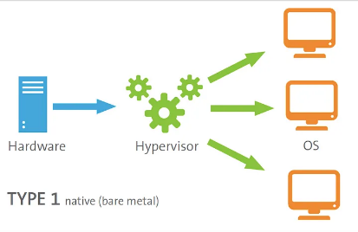
The main advantages of type 1 hypervisors, as the bare bones alias implies, is that they are installed directly to the hardware without the need for a dedicated operating system to interact with the underlying hardware. The hypervisor software acts as the operating system, and is able to natively run multiple VM’s as required[8]. While most Type 1 Hypervisors do not allow other applications to run natively on them other than the VM’s, there are a few that do, these are sometimes referred to as type 1.5, or hybrid and include Hyper-V and KVM. Bare bone hypervisors are also not designed for direct access, but rather are managed via an embedded web interface.
[1]Figure 1: Type 1 Hypervisor
Advantages[8]
Better performance.
Higher security.
Higher stability.
More dedicated features.
Ability to manage the system from any web browser.
[Grab your reader’s attention with a great quote from the document or use this space to emphasize a key point. To place this text box anywhere on the page, just drag it.]

Disadvantages[8]
More complicated to deploy and manage.
Compatibility issues.
Lack of direct management.
Only 1 hypervisor can be deployed on one piece of hardware at a time.
[2]Figure 2: Type 2 Hypervisor
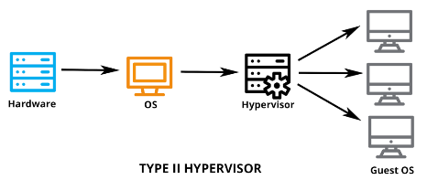
Whereas type 2 hypervisors run on top of a supported operating system and uses the systems drivers to communicate with the system hardware. Ideally designed to run on single machines such as desktops and workstations[8], they lack some of the high end support and tools available with type 1 hypervisors, and are more susceptible to security and stability issues caused by the host operating system,
Advantages[8]
Hardware agnostic.
Easier to install and maintain.
Can run other applications, and type 2 hypervisors in parallel
Disadvantages[8]
Lower performance.
Lower stability and security.
Less additional functionality and features
This chart sums up the main points of each.

Hypervisor Type 1 vs. Type 2 in Tabular Form[9]
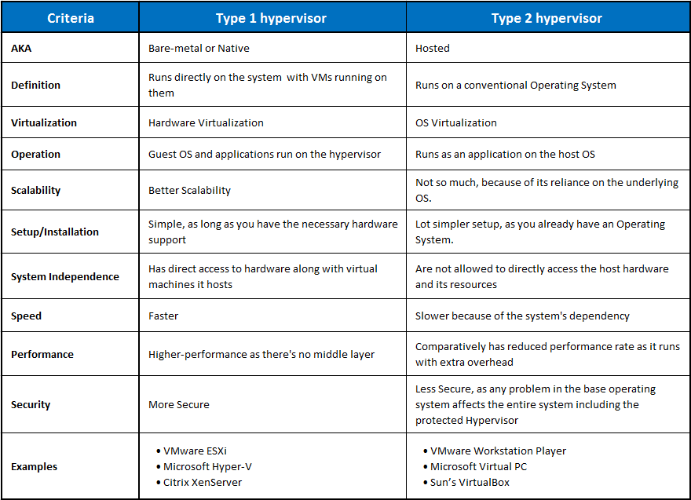
[Grab your reader’s attention with a great quote from the document or use this space to emphasize a key point. To place this text box anywhere on the page, just drag it.]

Hypervisors on the market
The following are a list of the top 5 rated type 1 hypervisors as rated by actualtech media[9].
VMware vSphere / ESXi
Microsoft Windows Server 2012 Hyper-V
Xen / Citrix XenServer
Red Hat Enterprise Virtualization
KVM (Kernel-Based Virtual Machine)
Whilst they all have varying levels of features they are classed as enterprise level type 1 hypervisors.
For type 2 hypervisors the following list from techtarget[10] provides an idea of the offerings available on the market
VMWare Fusion
Oracle Virtual Box
Parallels Desktop
VMWare Workstation / Pro
Whilst many of these options provide paid versions for professional use there are also trial and free versions of some of the software available for home or educational use.
Which Hypervisor to use
When deciding which of the many hypervisor options will be best suited for this project the first decision has to be whether to use a type 1, or type 2 hypervisor. The lack of availability of dedicated hardware is the main obstacle to using a type 1 hypervisor, despite the clear advantages. Cost would be another, as all of the up to date type 1 hypervisors are enterprise editions,. With all this in mind there is only one real choice and that is to use a type 2 hypervisor, which will enable the use of an existing hardware and software setup without the risk of compromising the usability of that setup around the project base.
When considering the various available type 2 hypervisors there are two main contenders, as VMWare Fusion[10], and Parallels Desktop[11] are both designed as virtualization tools for running operating systems other than Mac OS on a Mac system. Which leaves us with Oracle Virtual Box[12] and VMWare Workstation / Pro[13,14].
When considering these options it is worth noting that the free VMWare Workstation is unable to virtualize multiple machines simultaneously, for that the Pro version which is required, which either needs to be paid for or there is a 30 day trial which would be insufficient for the current project.
Which leaves Oracles VirtualBox which is able to support multiple VM’s whilst being free to use for home or educational purposes. VirtualBox is the best option as it meets all the needs outlined for the project.

How do computers communicate
The use of the earlies variants of the Transport Control Protocol / Internet Protocol(TCP/IP) protocols for computer communication was first introduced in 1965[1] when scientists at the Michigan Institute of Technology used packet switching technology to connect two PC’s, this the lead to the development of the TCP/IP protocol suite. This collection of protocols are now used as internet standards issued by the Internet Activities Board[15]. These protocols set out a the basic rules to enable the communication between one device and another, whether they are on the same network or on distant parts of the wider world wide web. As these protocols are the guiding principles they enable any user to operate any network connected device, whether that be a computer, smartphone, tablet or any of the plethora of devices classified as the Internet of Things(IOT) straight out of the box without issue as all network connected devices connect using the same suite of protocols[16].
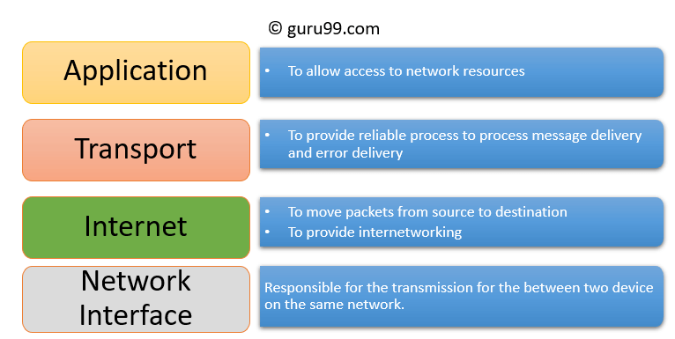
In order to simplify the structure of the protocols, the TCP/IP protocols are divided into subcategories called layers, which help to group together protocols based on their function. The TCP/IP uses four of these layers as displayed in figure 1 opposite. These four layers are Application, Transport, Internet, and Network Interface. All information transported over a network must pass through the four layers before it can be passed along the wired or wireless medium of the network, where the data is broken down into the most basic digital building blocks, “bits”, which can then be transmitted using electrical waves or pulses of light representing the 1’s and 0’s of the data, before being received and rebuilt at the receiving device, before the reconstructed data can be passed through the TCP/IP protocols in reverse.
[3] Figure 3 TCP/IP model
If larger amounts of data are required to be sent then the TCP/IP protocols allow for the data to be broken up into smaller chunks called packets using a system known as fragmentation, this has the advantage of allowing the data to be transferred more efficiently as any intermediary notes do not have to wait for the entire data package to arrive before retransmitting it[17], additionally if any of the data packets are lost or corrupted during transmission then only that packet will need to be resent, and not the entire data set.
IP Addresses
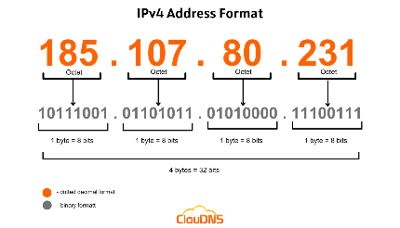
Enabling the network to identify the intended destination of the data is the role of the Internet Protocol(IP) Address. The IP Address is to all network enabled devices, akin what a home address is with regards to sending mail from one address to another. To this end all IP addresses need to be unique. The current standards for IP addresses are IPv4 and IPv6, IPv4 was first introduced in 1980 before being updated by the Internet Engineering Task Force(IETF) in 1981[18], and was structured as a 32 bit numerical address, arranged into 4 octets of eight bits, normally displayed in a dotted decimal notation for simplicity, an example of which is 192.168.10.1[19]. These addresses are made up of two sections, the network section and the host section, with either a slash notation at the end of the number when written out or a subnet mask, used when programming, to identify the two sections to the systems involved.
[4]Figure 4: IP Addressing
Since its inception IPv4 has and can only have a maximum of 4,294,967,296[20] total addresses, and with the growing world population currently standing at just under 8.1 billion, the total number of IPv4 addresses would never be enough, especially since many people now own multiple network enabled devices, with many of those able to access the internet. In order to extend the lifespan of IPv4 two now technologies were introduced, Network Address Translation(NAT), and Port Address Translation(PAT).
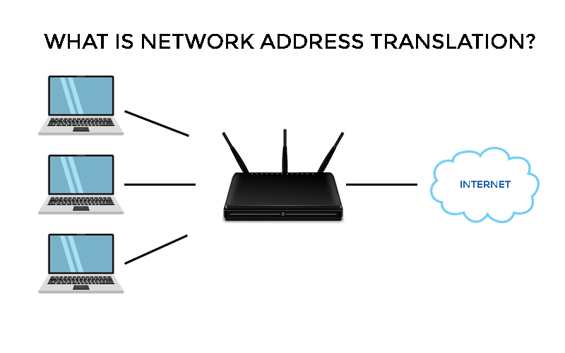
NAT provides a way of addressing private IP addresses on a local network into public IP addresses that can be used on the internet. As a means of extending the number of addresses available through IPv4 Private and Public IP address ranges were specified, with each of the classes of public IP addresses having corresponding cluster of private addresses which cannot be routed over the internet. This allows for a router with only one public facing port to allow access to the internet to multiple devices which are all assigned private IP addresses, with NAT providing the translation point from private to public addresses but usually one a one-to-one basis.
[5] Figure 5: NAT
PAT[22] works as an extension of NAT, but by mapping the individual network attached devices ports rather than their private addresses it is able to map multiple ports and therefore multiple devices to a single public IP address without causing any additional issues.
IPv6 began development in 1994 by IETF[18], though the specification was not published until 1998. IPv6 uses 128 bit addresses based on 16 pairs of hexadecimal digits divided into 8 groups of four colon separated digits. This structure provides for a maximum of 340 undecillion[23] or 340,282,366,920,938,463,463,374,607,431,768,211,456[24] IP addresses. In order to simplify IPv6 addresses any leading 0’s in any of the quartets of hexadecimal digits can be omitted, and any long string of 0’s can also be admitted but only once per address[24]. This should be enough to provide more than enough IP addresses going forward for quite some time, but also provides these other benefits[25].
No more NAT (Network Address Translation).
Auto-configuration.
No more private address collisions.
Better multicast routing.
Simpler header format.
Simplified, more efficient routing.
True quality of service (QoS), also called "flow labelling".
Built-in authentication and privacy support.
Flexible options and extensions.
Easier administration (no more DHCP).
Whilst these are the main IP addressing standards currently in use there are always more being developed just like the failed IPv5[25] which was intended as a Stream Protocol, which failed even before it could be announced. To meet the needs of the ever growing complexity of the global networks including the requirements to have variable IP addresses, to improve connectivity with the IOT and other adaptable network structures, NEW IP[26] is currently being developed to help reduce the overall efficiency of network communications by reducing the amount and type of information required in the packet header.
Switches and Routers
These two network devices form an integral part of all networks, without which networks, and more importantly the internet would not work.
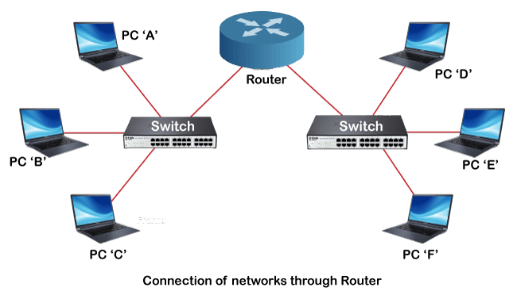
Switches allow for all the devices on a local network to connect and interact with each other[27], whether these are computers printers, or servers, without switches it would only be possible to connect devices via a peer to peer direct cable link, limiting the potential network to just two devices. Switches use the Media Access Control(MAC) address to identify individual hosts on the same network.
[6]Figure 6: Switches and Routers
Routers whilst in some ways are similar to switches, they actually play a far greater roll by being able to connect multiple switches and their connected networks to form larger and more dispersed networks, the largest of which is the internet. Routers have been described as dispatchers[27], and air traffic controllers[28], but in essence the are responsible for receiving data packets from attached networks, analysing the packet, selecting the best route to the destination host using the IP address and subnet mask, and then forwarding the packets[29]. All of this allows routers which are network addressable to link all of the various available switched networks, where the switches are not internet routable, creating the network of networks that we know as the internet.
Practical Project
The first requirement of the practical part of the assignment has been to choose the hypervisor to be used and for the practical reasons stated earlier in this report the decision was made to go with VirtualBox.
The next decision is what operating systems to use for the various machines, the two servers and the two PC’s. For the servers I the decision was made to opt for Microsoft Windows Server 2019(Server 19) one of the main reasons was that as many Industries may not have opted to upgrade to Microsoft Windows Server 2022(Server 22) due to the increased hardware requirements of the newer operating system, and the tried and tested nature of the system having been in service for more than five years. The real detriments of this approach would be the lack of extra functionality and the possibility of security issues. The answer to these issues is that Server 2019 has sufficient functionality, and any security issues will be nullified by the systems being run within a hypervisor.
For the PC operating systems a similar thought process was used, with the selection of Microsoft Windows 10 over its newer rival Windows 11, due to hardware requirements not justifying the extra functionality or security, and many organisations including the NHS still using predominantly Windows 10 based systems.
The Next big decision to be made is over the choice of IP addresses, and subnetting to use to achieve a secure and successful network configuration, whilst allowing for future growth. With this in mind retaining the internal Network configuration of the class a addressing system allows for the greatest adaptability in subnetting for the various departments of this large company, AWS[30] recommends the use of pools of /24 or larger giving a minimum of 254 hosts per pool, while Cisco[31] also use this same configuration at its San Jose to administer to the needs of 12,00 users so this would obviously work of both internal networks. For the link between networks Cisco[31] recommends a /30 subnet for router to router connections and as the servers are technically connected in a similar setup this would seem to be appropriate especially on a public IP address as it would limit the connection to these two servers internally whilst a different setup would be justified if a greater number of servers were to be added.
Testing and Troubleshooting the Network
Using the ping command is the primary tool for testing connectivity on a basic network setup[32], so in order to test the new network I have pinged each of the devices to each other over the Swansea and London domains as shown below.
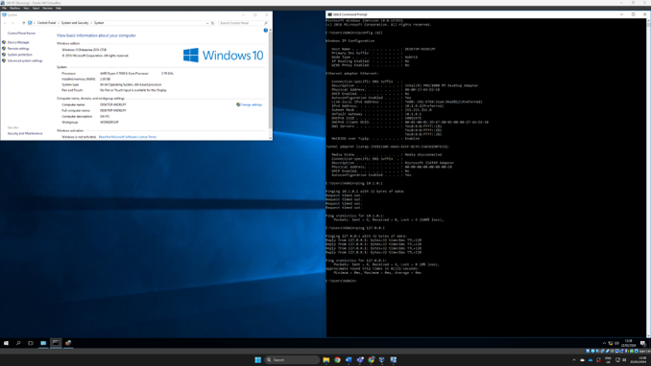
As can be seen from the above screenshot the Swansea PC was unable to ping the Swansea Server, though use of the loopback address proved that the TCP/IP stack was functioning correctly.
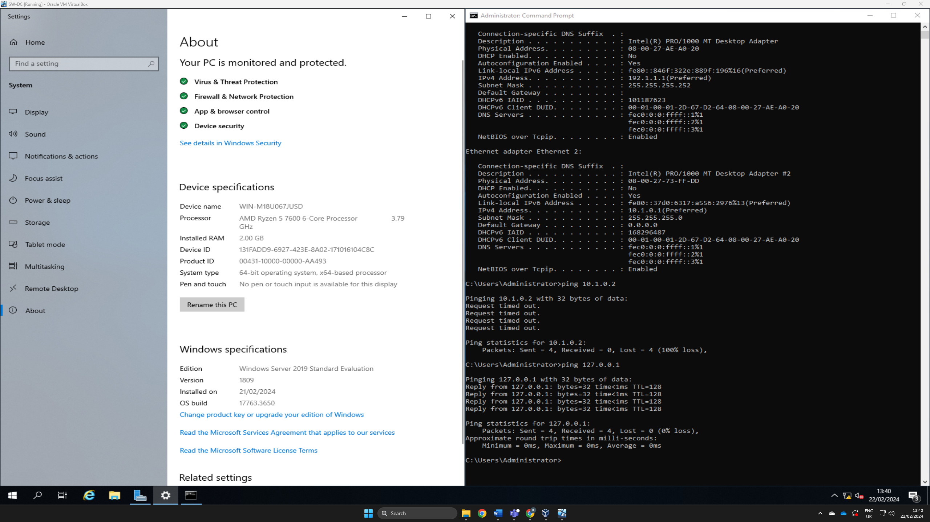
Again the same response from the Swansea Server to the Swansea PC.

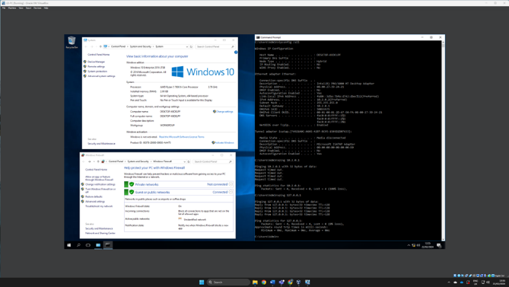
Both London systems reacted the same.
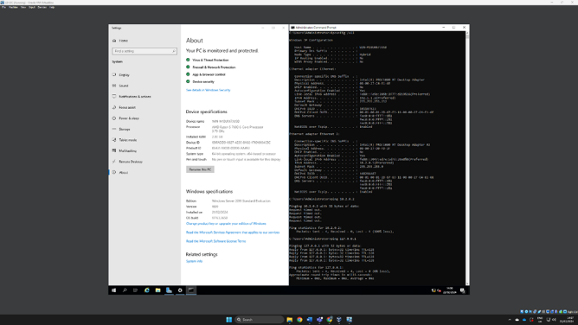
As the local loop was working on all four systems, the next stage was to determine the cause of the issue. To find the issue I turned off the Firewalls on both of the Swansea systems and then repeated the ping tests.
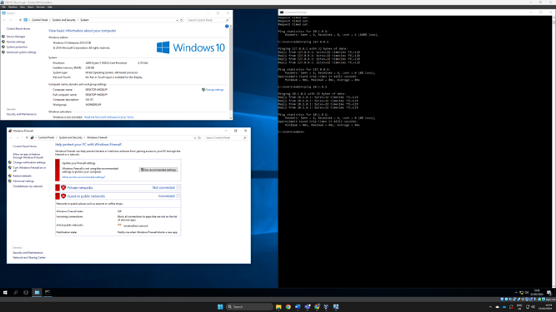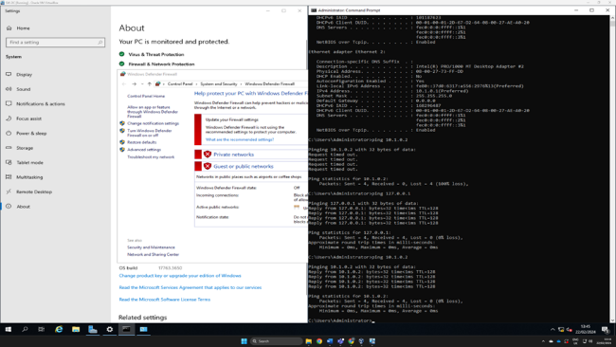
As can bee seen disabling the firewalls on both enabled a successful ping on both machines. Unfortunately operating without a firewall is not an option, but did allow me to determine that a firewall setting was most probably the issue. The setting in question was most likely the ICMP- Echo setting which many modern systems block by default. Using the London systems I was able to test this by creating a new rule in the firewall settings to allow ICMP Echo requests with the following results.
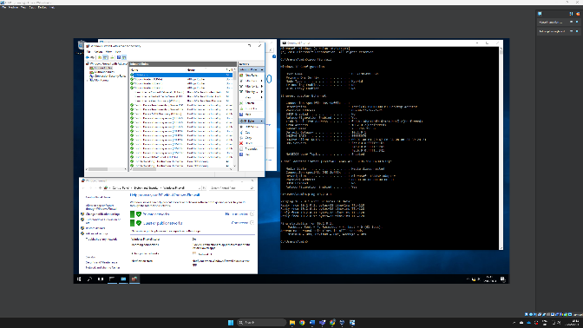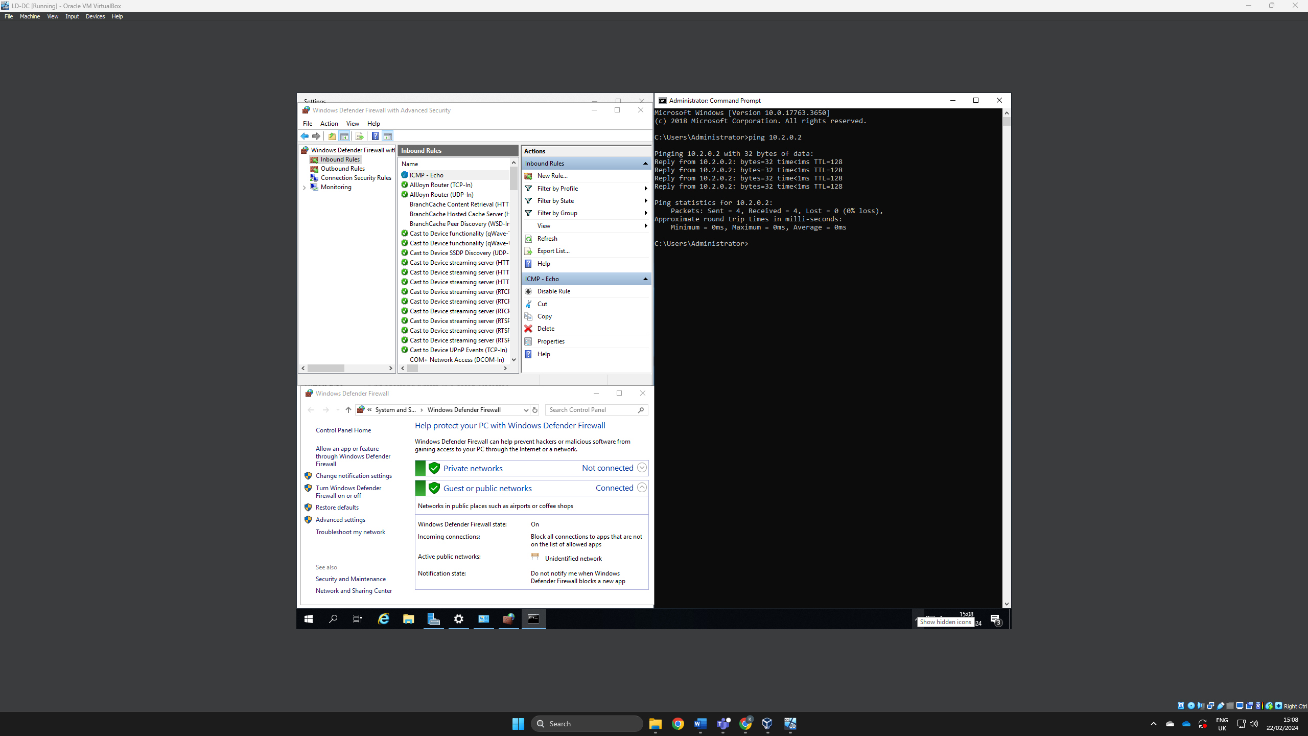
Both of these screenshots show active ICMP rules allowing echo’s which should be disabled after use as they pose a security issue.

Conclusion
The overriding conclusion from this project must be the importance of ensuring that any network development in planned thoroughly in advance, with due diligence given to proper documentation of all the processes involved. This will enable anyone who follows to understand the decisions made and the processes followed during the development process, as well as enabling them to fully understand the design and layout intentions of the network creator. Equally important is the documentation of the testing and troubleshooting stages of the project, again to ensure that if any of the issues that arose during the implementation of this project should occur again then there is sufficient documentation of the steps taken to resolve these issues.
Most notably is the fact that some times what should be plug and play setups can become more complicated by the fact that none of the usual intermediary devices such as switches and routers have been used during the implementation of this project which while it should have simplified the process it has at the same time brought its own issues to the fore. But in general this has been a practice in learning not to underestimate the potential complexities of even the smallest and most rudimentary of setups. The need to plan for all eventualities cannot be understated.

References
[1] J. Emspak, K.A. Zimmermann, “Internet history timeline: ARPANET to the World Wide Web,” [Online] https://www.livescience.com/20727-internet-history.html [Accessed Feb. 17, 2024].
[2] B.M. Leiner et al. “The Past and Future History of the Internet,” [Online] https://dl.acm.org/doi/pdf/10.1145/253671.253741 [Accessed Feb. 17, 2024].
[3] FutureTimeline.net “Global average Internet speed, 1990-2050,” [Online] https://futuretimeline.net/data-trends/2050-future-internet-speed-predictions.htm [Accessed Feb. 17, 2024].
[4] S.I. Bairagi, A.O. Bang, “Cloud Computing: History, Architecture, Security Issues,” International Journal of Advent Research in Computer and Electronics (IJARCE) (E-ISSN: 2348-5523) Special Issue National Conference “CONVERGENCE 2015,” 28 March 2015, [Online] https://www.researchgate.net/profile/Ankur-Bang/publication/323967455_Cloud_Computing_History_Architecture_Security_Issues/links/5ab52b4aa6fdcc46d3b2aa66/Cloud-Computing-History-Architecture-Security-Issues.pdf, [Accessed Feb. 17, 2024].
[5] R. Miller, “How AWS came to be,” [Online] https://techcrunch.com/2016/07/02/andy-jassys-brief-history-of-the-genesis-of-aws/?guccounter=1&guce_referrer=aHR0cHM6Ly93d3cuZ29vZ2xlLmNvbS8&guce_referrer_sig=AQAAAIS2HycKkQpK3Oseju90CjJVaK8J_fPbbwEBf2ljOgcXIXz-t_J8fHyBtixilKXqBMoaAuVqFv-0MFnb33LKYSP14v5wbhxWfW9OS2QjZNIYfiKS6WK43eSe_SBpNYOvQEJP4xJJSSQTVmv5XLf21NfREZzyAhooQxbvYQoJ0zLX, [Accessed Feb. 17, 2024].
[6] Broadcom, “What is a Hypervisor,” [Online] https://www.vmware.com/topics/glossary/content/hypervisor.html.html.html#:~:text=As%20cloud%20computing%20becomes%20pervasive,innovation%20in%20a%20cloud%20environment, [Accessed Feb. 17, 2024].
[7] AWS, "What’s the difference between Type 1 and Type 2 Hypervisors?,” [Online] https://aws.amazon.com/compare/the-difference-between-type-1-and-type-2-hypervisors/#:~:text=The%20type%201%20hypervisor%20sits,on%20the%20host%20operating%20system, [Accessed Feb. 17, 2024].
[8] O. Pankevych “Hypervisors: Type 1 vs Type 2. [PART 1],” [Online] https://www.starwindsoftware.com/blog/type-1-vs-type-2-hypervisor-what-is-the-difference,
[Accessed Feb. 17, 2024].
[9] K. Ward, “The Top 5 Enterprise Type 1 Hypervisors You Must Know,” [Online] https://www.actualtechmedia.com/io/top-5-enterprise-type-1-hypervisors/, [Accessed Feb. 17, 2024].
[10] Broadcom, “VMware Fusion 13,” [Online] https://www.vmware.com/uk/products/fusion/fusion-evaluation.html, [Accessed Feb. 17, 2024].
[11] Parallels, “Parallels Desktop 19 for Mac,” [Online] https://www.parallels.com/products/desktop/?utm_source=google&utm_medium=cpc&utm_campaign=pl-dd-all-paidads&utm_id=43693686&utm_content=1475700876&utm_term=parallels%20desktop&gad_source=1&gclid=Cj0KCQiAz8GuBhCxARIsAOpzk8wRAP5kZ0ixG9wX9nG5fjfTOdQUD8JAYhzBhtZDkwjavRH4fUochuwaArHPEALw_wcB, [Accessed Feb. 17, 2024].
[12] VirtualBox, “Welcome to VirtualBox.org!,” [Online] https://www.virtualbox.org, [Accessed Feb. 17, 2024].
[13] Broadcom, “VMware Workstation Player,” [Online] https://www.vmware.com/uk/products/workstation-player.html, [Accessed Feb. 17, 2024].
[14] Broadcom, “VMware Workstation Pro,” [Online] https://www.vmware.com/uk/products/workstation-pro.html, [Accessed Feb. 17, 2024].
[15] W. Stallings, “Data and Computer Communications,” 10th ed., Pearson Education, 2014, ch.2, pp.61-68.
[16] W. Odom, “CCNA 200-301Official Cert Guide,” Cisco Press, 2020, ch.1, pp.12-31.
[17] W. Stallings, “Data and Computer Communications,” 10th ed., Pearson Education, 2014, ch.9, pp.294-325.
[18] IPv4 Market Group, “A Brief History of IPv4,” [Online] https://ipv4marketgroup.com/a-brief-history-of-ipv4/, [Accessed Feb. 20, 2024].
[19] B. Dauti, “Windows Server 2019 Administration Fundamentals,” 2nd ed., Packt Publishing, 2017, ch.1, pp.9-30.
[20] RIPE NCC, “Understanding IP Addressing and CIDR Charts,” [Online] https://www.ripe.net/about-us/press-centre/understanding-ip-addressing/#:~:text=To%20give%20some%20perspective%2C%20it,the%20number%20of%20IPv6%20addresses., [Accessed Feb. 20, 2024].
[21] CompTia, “What Is Network Address Translation?”, [Online] https://www.comptia.org/content/guides/what-is-network-address-translation#school, [Accessed Feb. 20, 2024].
[22] Cisco, “Port Address Translation,” [Online] https://www.cisco.com/assets/sol/sb/RV320_Emulators/RV320_Emulator_v1-1-0-09/help/Setup13.html#:~:text=Port%20Address%20Translation%20(PAT)%20is,address%20to%20conserve%20IP%20addresses., [Accessed Feb. 20, 2024].
[23] Cisco, “What is IPv6?,” [Online] https://www.cisco.com/c/en/us/solutions/ipv6/overview.html, [Accessed Feb. 20, 2024].
[24] W. Odom, “CCNA 200-301Official Cert Guide,” Cisco Press, 2020, ch.22, pp.522-538.
[25] ThousandEyes, “IPv4 vs. IPv6,” [Online] https://www.thousandeyes.com/learning/techtorials/ipv4-vs-ipv6#:~:text=IPv6%20(Internet%20Protocol%20version%206,Internet%2Denabled%20devices%20to%20communicate., [Accessed Feb. 20, 2024].
[26] Z. Chen, C. Wang, G. Li, Z. Lou, S. Jiang and A. Galis, "NEW IP Framework and Protocol for Future Applications," NOMS 2020 - 2020 IEEE/IFIP Network Operations and Management Symposium, Budapest, Hungary, 2020, pp. 1-5, [Online] https://ieeexplore.ieee.org/abstract/document/9110352, [Accessed Feb. 21, 2024].
[27] Cisco, “What is a Switch vs a Router?,” [Online] https://www.cisco.com/c/en/us/solutions/small-business/resource-center/networking/network-switch-vs-router.html, [Accessed Feb. 21, 2024].
[28] Cloudflare, “What is a router?,” [Online] https://www.cloudflare.com/en-gb/learning/network-layer/what-is-a-router/, [Accessed Feb. 21, 2024].
[29] Medium, “Routers and Switches: “Routing Traffic and Managing Data Flow.”,” [Online] https://yoursmaddy.medium.com/routers-and-switches-routing-traffic-and-managing-data-flow-4f95dcbe812f#:~:text=Here's%20how%20a%20router%20works,receives%20to%20determine%20their%20destination, [Accessed Feb. 21, 2024].
[30] AWS, “Amazon VPC IP Address Manager Best Practices,” [Online] https://aws.amazon.com/blogs/networking-and-content-delivery/amazon-vpc-ip-address-manager-best-practices/, [Accessed Feb. 21, 2024].
[31] Cisco, “Cisco on Cisco best Practices Cisco IP Addressing Policy,” [Online] https://www.cisco.com/c/dam/en_us/about/ciscoitatwork/downloads/ciscoitatwork/pdf/Cisco_IT_IP_Addressing_Best_Practices.pdf, [Accessed Feb. 21, 2024].
[32] [24] W. Odom, “CCNA 200-301Official Cert Guide,” Cisco Press, 2020, ch.3, pp.58-80.
Image References
[1] Medium, “Top 10 Hypervisors: A Comprehensive Guide to Types, Advantages, and Disadvantages,” [Online] https://faun.pub/top-10-hypervisors-a-comprehensive-guide-to-types-advantages-and-disadvantages-c27da95c4e11, [Accessed Feb. 22, 2024].
[2]C, Wright, “All You Need to Know About Hypervisors,” [Online] https://blog.resellerclub.com/what-is-a-hypervisor-and-how-does-it-work/, [Accessed Feb. 22, 2024].
[3] Guru99.com, “TCP/IP Model: What are Layers & Protocol? TCP/IP Stack,” [Online] https://www.guru99.com/tcp-ip-model.html, [Accessed Feb. 20, 2024].
[4] M, Pramatarov, “What is IPv4? Everything you need to know,” [Online] https://www.cloudns.net/blog/what-is-ipv4-everything-you-need-to-know/, [Accessed Feb. 22, 2024].
[5] J. Rinaldi, “What is Network Address Translation?,” [Online] https://www.rtautomation.com/rtas-blog/what-is-network-address-translation/, [Accessed Feb. 22, 2024].
[6] Javapoint, “Switch Vs. Router | Difference between Switch and Router,” [Online] https://www.javatpoint.com/switch-vs-router, [Accessed Feb. 22, 2024].

