

LOCATION: /Swansea | LLEOLIAD: abertawe
LEVEL 6 | LEFEL 6
EXAMINATION PERIOD | CYFNOD ARHOLIADAU
FeB 2022 | 2022

MODULE CODE: ACMA6009
ADVANCED PROCESSES AND MATERIALS
TIME: 2 HOURS

answer Four QUESTIONS OUT OF FOUR

Equipment or materials required – None
Adnoddau neu ddefnyddiau sydd eu hangen - Dim

1 (a) Critically appraise the resistance solid state welding processes, which includes: Spot,
Seam and Projection welding.
Your answer should consider surface preparation, weld integrity,
exclusion of the atmosphere, potential defects, and distortion.
(10 marks)

1 (b) Discuss the significantly different modes of operation which are available in the
Metal Arc Gas Shielding process (namely: Dip, Spray and Pulse
Transfer mechanisms) Your answer should include reference to the
following:

i) The quality of the welds produced in each case

ii) The overall efficiency” of each of the transfer mechanisms.
(10 marks)

2 (a)
Distinguish between the two generic types of thermal spaying processes which are
based on temperature/heat produced by combustion and electricity in terms of:

i) The adhesion/bonding of the coating.

ii) The overall integrity of the coating (i.e. porosity, inclusion and oxide
content).

iii) The Health and Safety/COSHH implications.
(10 marks)

2 (b) Discuss the three stages of creep which occur in metals and suggest four ways by
which creep may be minimized in practice.
(10 marks)
3 (a) Critically appraise the production of steel using the electric arc process which used
steel scrap as its primary source of material.

Your answer should consider:

i) The energy required for the process to be carried out

ii) The effects that contamination has on the resultant properties of this recycled
steel.
(10 marks)

3 (b) Discuss the limitations of using stainless steel as a corrosion resistant alloy.

Your answer should refer to:

i) Typical corrosion mechanisms operating with these alloys

ii) The significance of the two major alloying additions made to nominal steel which
are chromium and nickel.

l
(10 marks)

Question 4 :

A mountain bike frame is to be made from natural materials.

- Based on what you know about the lifecycle and customer desired features of the frame, synthesise a list of qualitative requirements . (5 Marks)
- How do these translate to desired material properties for the frame material. (5 marks)
- With reference to the material selection charts below, which natural materials might be interesting to investigate for this application. (4 Marks)

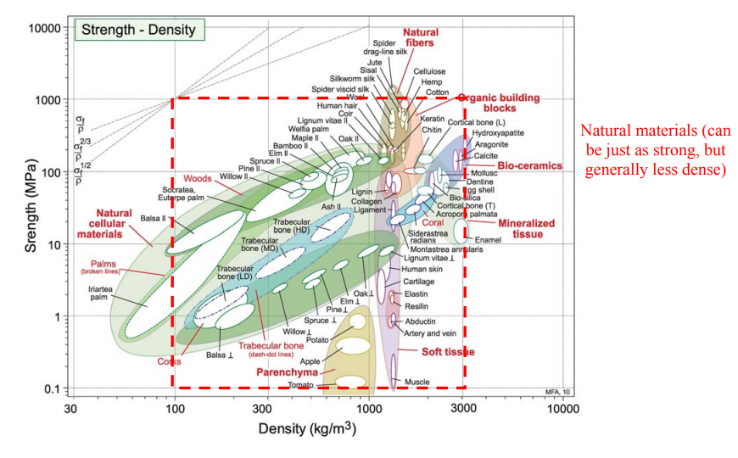
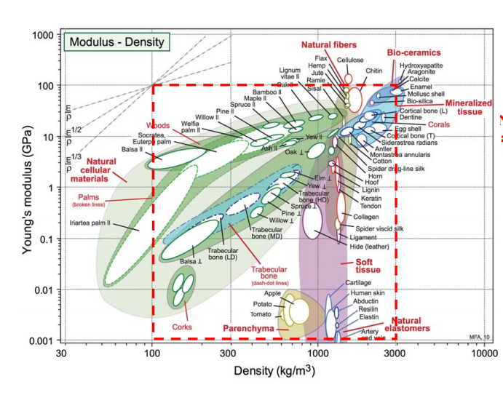

- Which of these potential choices would you reject immediately and on what grounds? (3 Marks)

- How does your choice compare with welded aluminium T6 tube section? (5 Marks)
Hint : look up the pertinent properties on the internet

- What other aspects of your natural material choice would you need to check out before you decided to make a mountain bike frame from it? (3 marks)

Diwedd/End

