Natasha John
1351144
Is there still a gender imbalance in art and design curricula?
ECPT6009

Introduction
Within art and design education, there is more undergraduate enrolment among women on such courses than men (Tatlow, 2023). By contrast, the professional creative industries are male-dominated, with most professional artists, award-winners, museum directors and others being male (Carlson, 2016). Historically, male artists have also been included in the curriculum more than female artists; from the Masters (Rembrandt, Da Vinci, Monet etc) to more other movements like Surrealism and Popart (Manray, Dali, Magritte, Warhol etc). It is much rarer to encounter female names in these lists (and rarer again to find non-binary names; research is scarce in this area).
This is largely owing to society’s traditional patriarchal attitudes to gender roles, which still have a legacy now in spite of social movements for women’s rights. Many women were denied access to many fields; however, in terms of art and design, numerous artistic fields that began as domestic crafts - so-called women’s work - see a great deal of interest from female students. An example of this is textiles; clothing manufacture was once the role of women in the home, while male pursuits were often restricted to more physical labour. Today, textiles students skew significantly female still, though male designers nevertheless dominate the fashion world.
Institutional academic hierarchies also are male-dominated, still. In the University of Wales Trinity St David (UWTSD), lecturer genders between courses have a gendered skew between subjects – technical subjects (e.g. photography, film, music etc) skew male, while the more ‘emotional’ subjects (fine art, surface pattern design, etc) have a female skew. I have been a technical demonstrator on the Art and Design Foundation course at UWTSD for five years, and this course skews female. Above this lecturer level, however, leadership roles in the university skew further and further male, with women in such positions of power becoming rarer. UWTSD, this year, got its first female vice chancellor – in 200 years of operation.
This pattern is then echoed in the material we teach. The history of artists has been very male-dominated, and these are primarily the artists that are taught or used as case studies (Carlson, 2016; Downing & Watson, 2004; Garber, 2003). But it is vital for institutions to start challenging this pattern. If the curriculum isn’t inclusive of non-male genders, then there is a lack of representation to challenge those structures. This then may have an impact on female or non-binary students later choosing whether to pursue a formal career in art.
This report aims to investigate the gender imbalance within art and design education versus the professional creative industry and critically reflecting on my own methods of addressing this to improve my inclusive practice in my own teaching environments. This will take the form of one cycle of action research.
The questions addressed by this research are:
- Do my teaching materials and learning activities contribute to this gender imbalance?
- If so, how can I improve my practice?

Literature Review

Gender and Conversion Rates into Professional Practice

Within the creative subjects, most undergraduate courses have a greater female population. Technical subjects, such as music and photography, have a more balanced range (Tatlow, 2023).
Table 1 Tatlow’s (2023) extraction of the HESA data (2020)
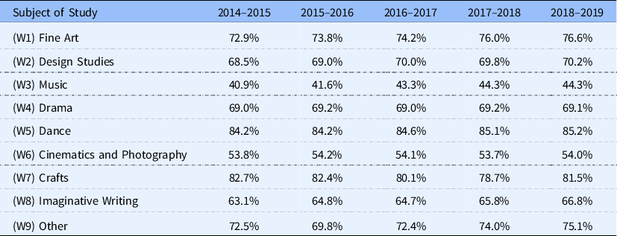
The table above shows the percentage of the female population studying creative subjects in Higher Education. Note that music is the only subject with a male majority, although with students the balance is still close to fifty-fifty. But professionally, male artists and groups also dominate. Only 10% of songwriters and 2% of producers are women in the UK (Werner et al., 2020).
The Freelands Foundation commission an annual report based on data that highlights the representation of women artists in the UK which has been consecutively for 7 years. Last year, they included intersectional data that explores how gender, ethnicity, disability and social factors can influence opportunities for artists. Bonham-Carter (2022) states that inclusion is a major issue in the art world. She goes on to say that the reason for the report every year is to “demand public accountability for, and transparency on, the lack of representation of women artists in the UK.”
“In the U.K., 64% of undergraduates and 65% of postgraduates in creative arts and design are women, but 68% of the artists represented at top London commercial galleries are men.” (Bonham-Carter, 2022) See Figure 1 for the data across 7 years.
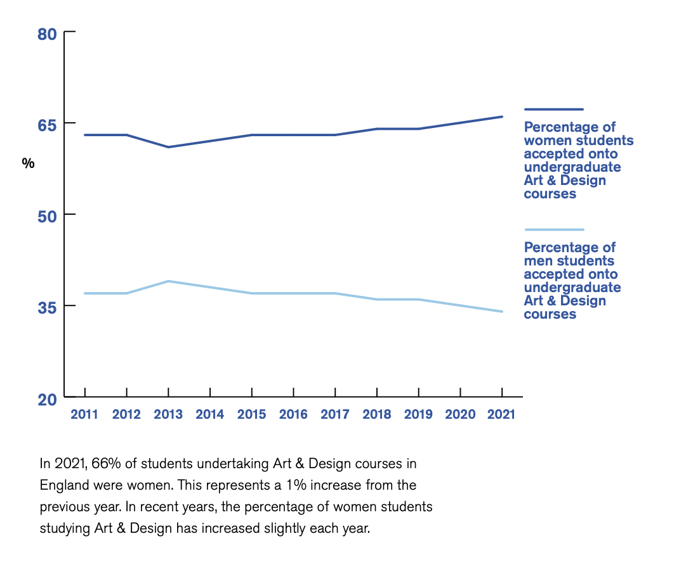
Figure 1 Extracted evidence from the Freelands Foundation report (2021)

According to the National Museum of Women in the Arts (NMWA), there has never been a female director of the three most popular museums in the world which are the British Museum, the Louvre and the Metropolitan Museum of Art. Within museums, specifically exhibition design, these are male-dominated spaces in spite of education being female-led. Therefore, male aesthetics and design features are the default setting (‘androcentrism’) while anything seen to have feminine traits (e.g. pastels, pink and flowers) are considered a deviation (Place, 2023).

Defiltering the Curriculum

Due to colonialism, it has left an imprint on modern society, which has resulted in gender inequality, racism, ableism, queerphobia and many other social issues (Morreira et al., 2020; Winter et al., 2024). Since the 1970s, the global south has discussed colonialism within higher education (Schilling et al., 1979), as have other areas that were affected heavily by colonial activity (Arday et al., 2021; Attas, 2019). The UK has been slow at making progress in this area, but due to student activism there has been increased interest in decolonising higher education over the last ten years (Bhambra et al., 2020; Liyanage, 2020). Even though there has been progress in women’s educational presence in higher education, the academic structures within universities are still strongly patriarchal (David, 2015).
Francis (2000) states that Science, Technology, Engineering and Mathematics (STEM) subjects are viewed as masculine while the opposite is said for the Arts, which are viewed as feminine subjects within education. Francis goes on to say that these subjects form a hierarchy. STEM subjects represent “rationality and objectivity”, while the Arts represent “emotion and subjectivity”. By observing these traits as gendered inevitably leads to these subjects being masculine or feminine. This makes it clear that is more female students studying the Arts while there is more of a male dominance in the STEM subjects (Hewitt 2020).
White (2019) argues that having a feminist pedagogical approach will create a more inclusive environment where people’s gender doesn’t limit their ability. Even though this notion will aid all areas of study, it is particularly important within Art Education to benefit culture. By introducing students to the work of women masters it will allow for historical accuracy and develop the understanding of all people regardless of their identity. Even though there is a shift within society in regards to gender roles, women have still been factored out from history. Therefore, women should be included within the history of art and the curricula needs to adapt to represent this.

Professional Artists in Education

Within art education, artists and case studies that are taught in the curriculum are mostly male and white, from secondary upwards (Downing & Watson, 2004). The ‘default’ art aesthetic and philosophy is often straight, white and male, which becomes a self-perpetuating cycle – as educators are teaching these male figures, their teaching streamlines into this default, which means white men are further considered the norm (Carlson, 2016). This could have a negative impact on students’ perceptions of the sphere of art and design, as it reaffirms gender bias.
Teaching resources often do not showcase the true diversity of students within the educational setting, which adds to a hidden curriculum that informs students that the straight, white man “holds the political power and have made almost all the important decisions and discoveries” (Garber, 2003).
The findings of the WomenCount Leaders in Higher Education Report (2018) (WCLHE) show that 29% of Higher Education Institutions have a woman Vice-Chancellor (this has grown by 12% since 2013). 37% of executive or senior teams are women, and 31% of top tier of academic faculties or schools are headed by a woman (Jarboe, 2018).
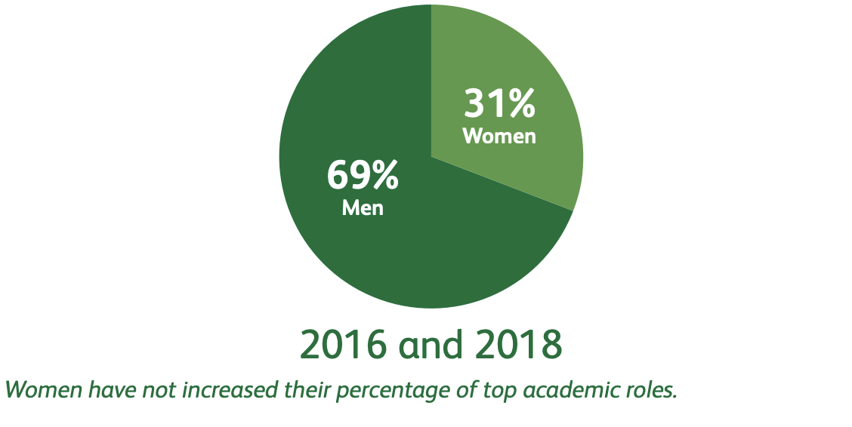
Figure 2 Data extracted from the WCLHE (2018) report
This data has been collected from 162 Higher Education Institutions (HEI) websites. This includes faculties, schools and academic departments. From looking at this data, we can see that there has been no change between 2016 and 2018 in the percentage of women within the academic hierarchy (Jarboe, 2018).

Methodology

The data gathered is drawn from the last five years of working on the Level 4 CertHE Art and Design Foundation course at UWTSD. The data are the gender breakdown of the students that have studied on the course over those five years. The categories are male, female or non-binary. Trans-identifying students are included within their chosen category (i.e. a trans woman would be included in the ‘female’ category.) No other data were collected, so no students can be personally identified. The students also consented for the university to record it at enrolment; as such, no further ethics permissions were required.
The data were then averaged in order to identify overall trends rather than simply viewing it year by year. I then produced graphs so display it visually.
I then produced a table by looking at my own practice and lecture materials. I recorded the genders of the artists that I teach to the students, or mention within case studies, tutorials, and other session. The reason for this is to see if there is any gender imbalance within my own teaching practice.
Finally, I compared these data from both of these methods to see if there are any discrepancies within my own teaching practice. I then found solutions to improve my inclusive practice in this area.

Results and Analysis

Figure 3 shows the results of the genders of students on the course from 2019 – 2024 (five years). This data is then averaged in Figure 4.

Figure3 . Gender of students from 2019-2024

Figure 4. Average gender numbers across five years
From these results, it shows that there has been gender imbalance in the Art and Design Foundation course over the past five years. There have been significantly more female students than male or non-binary. It is clear in Figure 3 that this has been consistent over the five years.
Table 2 shows a list of the artists I have taught by their gender identity. It is evident from this table that I have taught more male artists than female or non-binary.
Table 2. List of artists I have taught and their gender
Male | Female | Non-Binary
Grayson Perry | Frida Kahlo | Kae Tempest
Jonathan Hoefler | Vivienne Westwood
Alexander McQueen | Sophie Calle
David Hockney | Barbara Kruger
Gilbert and George
Andy Warhol
Jean Michel Basquiat
Keith Harring

Table 2 shows that there is a gender imbalance within my professional practice. Even though I would say that inclusivity and gender balance is important to me this table shows the opposite. This is because of unconscious bias within my practice.
Stereotypes are not always our conscious thoughts. Even though people can be aware and have knowledge of stereotypes they may not necessarily believe them. Regardless, unconscious thought patterns can influence current situations. This results in unconscious bias (Devine et al., 2012).
Oberai and Anand (2018) conducted a study on why gender bias is happening within society. They found that the issue is due to society's prehistoric beliefs about men and women. As an example, men are taught to be strong and assertive whereas women are seen as emotional and caring. These are generalised traits given to the different genders (Oberai & Anand, 2018).
Within the science research field they have discovered a variety of different possible origins for unconscious bias and how this can have a negative effect on education environments. Here are the insights from Dee & Gershenson’s (2017) paper:
- As humans we consciously and unconsciously keep encounters and experiences in our brains. These are our memories that at a later stage can influence our automatic responses. This is vital to cognitive functioning and cannot be switched off.
- If people are exposed to unconscious bias, it can change the behaviour or the stereotyped groups and they abide by the stereotypes where they are true or false.

Unconscious bias is particularly important for teachers to challenge, due to their job roles and responsibilities at the forefront of society as facilitators of student development. They have a duty to promote diversity and inclusivity, both as a duty of care and in accordance with the (Equality Act, 2010). If teachers do not challenge their own unconscious biases, this could have an impact on their perception and choices towards students, particularly of marginalised characteristics (Ashmore et al., 2019; Dee & Gershenson, 2017).

Potential Solutions

The first solution of these findings is to reduce my unconscious bias within my own teaching practice. If we are aware of our own unconscious bias, without blaming or shaming ourselves, then we can develop the motivation to reduce it (Devine & Monteith, 1993). We should be encouraged to apprise people through their individual unique characteristics instead of their social groups (Blair, 2002), by improving on our empathy and seeing things from different perspectives (Dovidio et al., 2004; Okonofua, Paunesku, & Walton, 2016).
I will do this by planning lessons and curricula that have gender parity in the case studies used. This is not an issue restricted to my own practice, of course, so I will also coordinate with colleagues across the department to work on this area to improve inclusivity and diversity. As part of continuing professional development I will seek training opportunities from the institution and also participate in any conferences based on these issues through the Universities and Colleges Union, which hold interactive webinars for members (UCU, 2024).
The second solution is that educators should also create safe spaces for students to feel able to challenge the status quo. Because of the controlled environment of the educational setting, these discussions can be amicable, respectful and constructive. Freedman (1994) argues that creating nurturing environments so that students can analyse visual culture will help students, no matter their age, understand the importance of different interpretations. I will do this through small group numbers and critiques. This would also then lead to interesting and progressive discussions. Art has a great role to challenge society, and can help to push boundaries; this could lead to greater support and recognition of marginalised voices (Ashmore et al., 2019; Freedman, 1994).
As this is a single cycle of action research, the next cycle will be exploring intersectionality and how certain factors such as race, sexual orientation, class, and disability combined can affect individuals' growth and opportunities.

Conclusion

In summary, there is an imbalance in the gender balance of conversion rates of students to professional practitioners in art and design. This may be owing to a lack of representation in professional artists studied in higher education, and to society’s biases.
In my own practice, I believed I was using an even balance of genders within my teaching material, but through looking at the data here discovered I was not because of unconscious bias. This is an area in which my curriculum needs to be unfiltered.
In future, I will include a gender balance in my teaching materials and encourage colleagues to do the same therefore increasing inclusivity in my practice. I will reduce my unconscious bias by attending CPD sessions on this subject area and any available training. I will also use small groups and critiques to create a safe space for my students to challenge the status quo in my classroom. The next cycle of research will include intersectionality.

References

Arday, J., Zoe Belluigi, D., & Thomas, D. (2021). Attempting to break the chain: reimaging inclusive pedagogy and decolonising the curriculum within the academy. Educational Philosophy and Theory, 53(3). https://doi.org/10.1080/00131857.2020.1773257
Ashmore, L., Avis, J., Dalton, J., Hadwen, D., Lavender, K., Noel, P., Rennie, S., Salter, E., Swindells, D., Terry, R., & Thomas, P. (2019). Equality and Diversity. In J. Avis, R. Fisher, & R. Thompson (Eds.), Teaching in lifelong learning: a guide to theory and practice (3rd ed., pp. 57–78). Open University Press.
Attas, R. (2019). Strategies for Settler Decolonization: Decolonial Pedagogies in a Popular Music Analysis Course. Canadian Journal of Higher Education, 49(1). https://doi.org/10.47678/cjhe.v49i1.188281
Bhambra, G. K., Nişancıoğlu, K., & Gebrial, D. (2020). Decolonising the university in 2020. In Identities (Vol. 27, Issue 4). https://doi.org/10.1080/1070289X.2020.1753415
Bonham-Carter, C. (2022). Representation of Women Artists in the UK. https://freelandsfoundation.imgix.net/documents/Representation-of-Women-Artists-in-the-UK-Research-in-2021.pdf
Carlson, A. (2016). Let’s Talk About the “Universal” (White, Male) Artist. Mn Artists. https://mnartists.walkerart.org/lets-talk-about-the-universal-white-male-artist
David, M. E. (2015). Women and gender equality in higher education? Education Sciences, 5(1). https://doi.org/10.3390/educsci5010010
Dee, T., & Gershenson, S. (2017). Unconscious Bias in the Classroom: Evidence and Opportunities. Stanford Center for Education Policy Analysis.
Devine, P. G., Forscher, P. S., Austin, A. J., & Cox, W. T. L. (2012). Long-term reduction in implicit race bias: A prejudice habit-breaking intervention. Journal of Experimental Social Psychology, 48(6). https://doi.org/10.1016/j.jesp.2012.06.003
Devine, P. G., & Monteith, M. J. (1993). The Role of Discrepancy-Associated Affect in Prejudice Reduction. In Affect, Cognition and Stereotyping. https://doi.org/10.1016/b978-0-08-088579-7.50018-1
Downing, D., & Watson, R. (2004). School art. What’s in it? Exploring visual art in secondary schools. https://www.nfer.ac.uk/publications/school-art-whats-in-it-exploring-visual-arts-in-secondary-schools/#:~:text=Exploring%20visual%20arts%20in%20secondary%20schools,-Dick%20Downing%2C%20Ruth&text=Based%20on%20interviews%20with%2054,looks%20the%20way%20it%20does.
Equality Act. (2010). Equality Act 2010. UK Public General Acts. https://www.legislation.gov.uk/ukpga/2010/15/contents
Freedman, K. (1994). Interpreting Gender and Visual Culture in Art Classrooms. Studies in Art Education, 35(3). https://doi.org/10.2307/1320217
Garber, E. (2003). Teaching about Gender Issues in the Art Education Classroom: Myra Sadker Day. Studies in Art Education, 45(1). https://doi.org/10.1080/00393541.2003.11651756
Jarboe, N. (2018). WomenCount Leaders in Higher Education 2018. https://women-count.org/wp-content/uploads/2018/11/womencount-report-2018_web-version_new-final.pdf
Liyanage, M. (2020). Miseducation: decolonising curricula, culture and pedagogy in UK universities. Higher Education Policy Institute.
Morreira, S., Luckett, K., Kumalo, S. H., & Ramgotra, M. (2020). Confronting the complexities of decolonising curricula and pedagogy in higher education. Third World Thematics: A TWQ Journal, 5(1–2). https://doi.org/10.1080/23802014.2020.1798278
Oberai, H., & Anand, I. M. (2018). Unconscious bias: thinking without thinking. In Human Resource Management International Digest (Vol. 26, Issue 6). https://doi.org/10.1108/HRMID-05-2018-0102
Place, A. (2023). Introduction: On the personal and the political in design. In Feminist Designer. https://doi.org/10.7551/mitpress/14269.003.0003
Schilling, D. G., Mazrui, A. A., & Wandira, A. (1979). Political Values and the Educated Class in Africa. The International Journal of African Historical Studies, 12(3). https://doi.org/10.2307/218429
Tatlow, S. (2023). Exploring issues in categorisation of higher music education courses through FOI surveys of gender demographics in UK higher education institutions. British Journal of Music Education, 40(2). https://doi.org/10.1017/S0265051722000249
UCU. (2024). UCU Continuing Professional Development. https://cpd.web.ucu.org.uk/about-ucus-cpd-programme/
Werner, A., Gadir, T., & De Boise, S. (2020). Broadening research in gender and music practice. Popular Music, 39(3–4). https://doi.org/10.1017/S0261143020000495
Winter, J., Webb, O., & Turner, R. (2024). Decolonising the curriculum: A survey of current practice in a modern UK university. Innovations in Education and Teaching International, 61(1). https://doi.org/10.1080/14703297.2022.2121305

